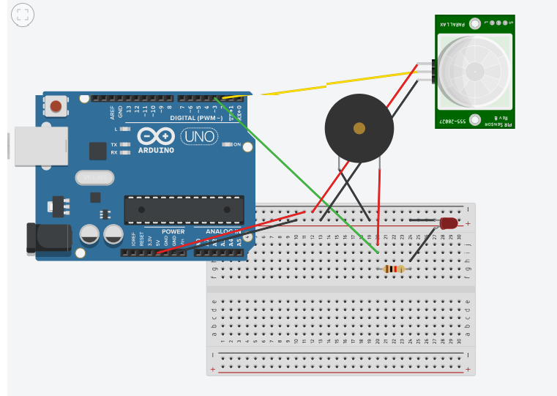

21.DESIGN A SYSTEM THAT AUTOMATICALLY RINGS A BELL FOR 2 MS WHENEVER SOMEONE ENTERS A TEMPLE,ASSUMING ONLY ONE PERSON CAN ENTER AT A TIME.

THEORY

CONCEPTS USED:

Connecting arduino and breadboard along with LED,BUZZER,RESISTOR(330 OHMS),SENSOR to run an automatic bell ring.

LEARNING AND OBSERVATION:

The buzzer makes sound as soon as the sensor senses any kind of object near it.As it is meat to work it has been right.

PROBLEMS AND TROUBLESHOOTING:

Attempt failed when connections of the buzzer were not right.

Attempt failed when only LED worked and the BUZZER did not.

Failed attempt when coding was not precise for the given experiment.

PRECAUTIONS:

Make sure the arduino is not connected to the breadboard while connecting the wires.

Try not to make complete contact with the arduino board after connecting everything.

LEARNING OUTCOMES:

The LED glows indicating the sensor is completely functional and all the given connections are working properly.

The buzzer makes sound as per the given delay time.