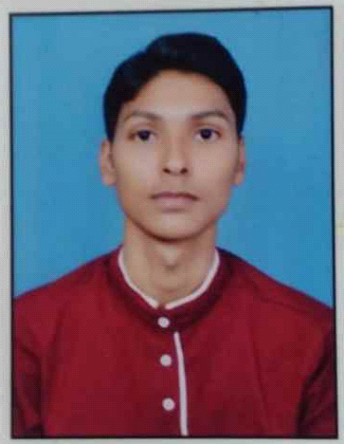
Resume

Ashiana Nagar , Phase-1
Patna 800025, Bihar
Mob:- 8092819213
Career Objective:
- I want to be a full stack web developer to stand on own feet so as to help my parents financially and contribute in the country’ GDP through my skills and Knowledge.
Educational Qualifications:
- 10th from Ashiana Residential Moral School (ARMS) in Ashiana.
- 12th from May Flower School in Digha.
- Currently Pursuing BCA from CIMAGE college Patna.
Skills Known:
HTML ,C, Core Python , CSS , Javascript , MS office suite, typing , Presentation making skills , Communication skills .
Work Experience:
- Fresher.
Personal Information:
Mother’s Name :- Rita Devi
Father’s Name :- Madhu Rajak
Date of birth :- 25-12-2005
Nationality :- Indian
Language Known :- Hindi/ English
Marital Status :- Bachelor

