# Instructions:

Intermediate Skills Evaluation [R’Cafe-Reciproci]

## Please find the Repository for the Evaluation, Please use the images in the folder for this assessment. The images have been sorted and categorized in various folders according to the modules.

1. Please **download** the Repository folder **on your desktop** to make it easier for you to upload images.
2. Here is the link to the Repository folder: [https://drive.google.com/drive/folders/1ABlLNwNM0P_wCwOtqtaKzGpqdsFazxMT?usp](https://drive.google.com/drive/folders/1ABlLNwNM0P_wCwOtqtaKzGpqdsFazxMT?usp=sharing)

[=sharing](https://drive.google.com/drive/folders/1ABlLNwNM0P_wCwOtqtaKzGpqdsFazxMT?usp=sharing)

1. The assessment is of 100 points the breakup of which is: **60 points for setup, 20 points for Demo (Including Order Management), 15 Points for Reports and 5 points for finishing on/or before the stipulated time**.
2. **Passing Marks 80%**
3. URL for the assessment: Admin Url: <https://staging.reciproci.com/admin>
4. Use your own credentials to log in, if you do not have credentials we will create one for you.
5. App details: Customer App IOS Link : [https://s3.amazonaws.com/reciproci.apps/rcafe/ota/mars_training_instance_rcafe_app.](https://s3.amazonaws.com/reciproci.apps/rcafe/ota/mars_training_instance_rcafe_app.html) html
6. Customer App Android Link :

<https://app.bitrise.io/artifact/115940505/p/3c44cb0078a7b6421e179c8d2d68dfb6>

## **App OTP** is hardcoded, please do not wait for OTP to be delivered, enter this: 111111

1. Delivery app Link:<https://app.bitrise.io/artifact/106146631/p/aeda269e228de4a6d98560d74781c49b>
2. Download the Apps and log In to Delivery app, create profile on Customer App before the Demo
3. The total evaluation time is 4 hours [Setup (including Delivery app + Customer app install and login), Demo and Reports]
4. 15 minutes will be provided to set up (apps) and read the paper included in the 4 hours allotted. Please read the paper **very carefully**.
5. After the exercise you will have to give a demo on the back-end and the app, and submit a document (Reports answers) with text and screenshots within 30 minutes of completing the demo. Total time for this exercise is 45 minutes included in the total time of 4 hours.Please make sure you are in ideal network conditions of minimum 5 MBPS network speed, please check here: <https://fast.com/> , else you may use your mobile network.
6. This is an assessment of your Skill and Expertise on our platform, please do not use unsolicited methods like asking someone for help apart from the certifier, or sharing this

paper with other candidates, or discussing questions or answers with others or in groups.

All the Best!!

Client Onboarding: - 1 Point

1. Create a client TechTree
2. Include Malls and Brands
3. Please note the Primary and secondary colors option is not working.
4. Base Country: India
5. Language: English
6. Delivery Charge: 100 Rs.

# **Masters > Malls - 2 Points**

1. Create a Mall
2. Mall Name: ISKPro Mall
3. Mall Code: 102
4. Mall Image: in the repository folder
5. Country: India
6. City: Noida.
7. To find Lat/Long you have to go to a mall location in Google Maps and take Lat/Long from the url. Here is an example for TechTree Headquarters Noida: https://[www.google.com/maps/place/Techtree+IT+Systems+Pvt+Ltd+Headquarters/@28.59187](mailto:www.google.com/maps/place/Techtree%2BIT%2BSystems%2BPvt%2BLtd%2BHeadquarters/@28.59187) 22,77.3187679,15z/data=!4m5!3m4!1s0x0:0x3460ad9737b7d8cc!8m2!3d28.5918096!4d77.318 8175 . This is the Lat/Long

8. Latitude: 28.5918722

9. Longitude: 77.3187679

# **Masters > FAQ Category - 1 Point**

1. Create 1 FAQ Category
2. Title: General Query Iskpro
3. Image in repository folder

# **Masters > About Us Category – 1 Point**

1. Create 1 About us category
2. Content for: Iskpro About

# **Delivery Charges – 1 Point**

1. Add two delivery charges a. 0 -5; 100 Rs.

b. 6-20; 250 Rs.

1. Order amount to waive off Delivery Charge: 1000 Rs.

# **Brand Management – 2 Point**

1. Create 1 Brand
2. Country: India
3. Mall: TechTree Mall
4. Brand Category: Food & Beverages
5. Brand Code: 1
6. Brand Name: Reciproci F&B
7. Brand Image in Repository
8. Keywords: Food and Beverage, Menu, Cuisine
9. Store type: F&B
10. Price for two: Medium
11. Cuisine: Multi
12. Wall Active for (days): 30
13. Content: Best F&B establishment
14. Video url: <https://youtu.be/s4eV0zYxzW4>

# **Banner Management – 2 Points**

1. Create 2 banners
   1. Doughnuts
   2. Shakes
2. Go to Add Banner
3. Banners will be Type 2
4. Images and Thumbnails are in the Repository
5. Detail Page Title: Doughnuts or Shakes as per title of the banner
6. Content:
   1. Doughnuts: Delectable Fresh Doughnuts
   2. Shakes: Refreshing and Delicious Shakes
7. Once you have uploaded the banners please go to the list select country : India from country dropdown, and click on the hyperlinked serial number say 1. Then you need to edit it. Select the Banner from “Select a banner to update” dropdown.
8. Banner click through:
   1. Doughnuts: Menu
   2. Shakes: Points Summary
9. Update
10. Repeat the same for Banner 2

# **Stores: – 5 points**

Create delivery area and name it **Noida All**:

**Coordinates (Copy with brackets)**: (28.3284 76.89001, 28.97074 76.71423, 29.0779 77.72623, 28.29846

77.87867, 28.3284 76.89001)

Please make sure to update Brand as Reciproci F&B

1. Create 1 store
2. Brand: Reciproci F&B
3. Brand Type: F&B
4. Store Type: Mall
5. Store Id: 101
6. City: Noida
7. Mall: TechTree Mall
8. Launch date: Today
9. Launch Time: 10:00 AM
10. Service Settings
    1. Pickup
    2. Delivery
11. Store Order Service > Area Mapping > Add > Noida All
12. Store Name: Reciproci Store
13. Address: D-45, D Block, Sector 6, Noida, Uttar Pradesh 110096
14. Keywords: Food and Beverage, Menu, Cuisine
15. 360 degree image not required
16. Store Admin Details: Please add your details
17. Contact Person on store: Please add your details
18. Employee id: 101
19. Business Hours: Open 8:00, Close 23:00 Sun to Sat
20. Delivery Hours: Open 8:30, Close 22:00 Sun to Sat
21. Update

# **Loyalty: – 10 points**

1. Set Loyalty 4 Tiers in Tier Qualifications
2. Country: India
3. Currency: INR
4. Active Engagement Days: 365
   1. Silver: 0 to 6000

b. Gold: 6001 to 10000

c. Black: 10001 to 50000

d. Platinum: 50001 to 100000

1. Go to Add Program
   1. Select program type as Base
   2. Fill in program name as Reward and appropriate description
   3. Select reward type as points
   4. Select points expiry as number of days
   5. Fill in the rest of the mandatory details
2. Go to the program and select +add earn rule (**Please note add earn and burn rule from inside the program and not the left navigation**)
   1. Rule name as base earn rule
   2. Select start/end date and time as per the programs start/end date and time
   3. Point expiry in Number of days
   4. Appropriate start date and times
   5. Action type purchase
   6. Action type transaction value
   7. Points table - sale (1,1,1,1) and non sale (2,3,5,8)
   8. Fill amounts as per discretion in one currency
3. Select +add burn rule under burn rule tab
   1. Rule name as base redemption rule
   2. Redeem type as points
   3. Value worth of one point - fill in 000.5
   4. Save all data

Submit Program for Approval and Approve the Program. Wait 10 minutes for the program to go live.

Check During Transactions if these rules are working

# **User Management (Add Yourself as a delivery user) – 5 points**

1. Select role : Delivery
2. Fill in you details
3. Use your Personal maid id and personal mobile number
4. User ID: yourname1
5. Access type Restricted
6. now Map the user to Recproci store
7. Finally Add
8. Login to the delivery app
9. If Resetting your personal pin from the backend please do not reset admin pin

# Menu Management – 8 Points

1. Add 4 Variants
   1. KG : 1KG, 2KG
   2. Gram : 500gm, 250gm
   3. Veg NonVeg: Veg, Egg, Non Veg
   4. Piece: 1Pc, 4Pc
2. Create 4 Category
   1. Cakes
   2. Cookies
   3. Packed Sweets
   4. Ready Snacks
3. Brand: Reciproci F&B
4. Parent: None
5. Available From: 8:00 AM To 11:00 PM
6. Map to Reciproci Store
7. This is example for one: Category Name: Cakes; Meta tag Keywords: Cakes; Description: Assortment of Delicious Cakes
8. **Create 1 product for each category (Total 4 products) and 2 variant for each product (use pictures from Products folder for Variants)**, product names are in repository (after creating product, variant, category make sure they are online)
9. For Variants please use your discretion
10. Quantity threshold: 100
11. Available from: 8:00 Am To 11:00 PM
12. Choose from Veg, Egg, Non Veg
13. Put any figure for calories
14. Leave discount and Packing charges as 0
15. Add Dietary or Allergen as per your discretion or leave it blank
16. Add description and ingredients
17. Make the Product Online
18. Finally ADD it
19. After that go back to product again and add a variant
20. Select Variant type from drop down list and APPLY
21. Map variant to Reciproci Store
22. Put any random and unique SKU code

# **Feedback Management – 5 Points**

1. Create 1 Feedback Flow: F&B Transactions
2. Flow Name: Delivery Flow
3. Feedback Flow For: F&B Transaction Delivery
4. Brand: Reciproci F&B
5. Country: India
6. Channels: Online
7. create 5 different **linked** pages :
   1. Star Rating
   2. NPS (Please do not use NPS slider please use only NPS)
   3. Sentiment
   4. Product rating (only this page should have submit button also)
   5. Thank you

# Marketing - 8 Points

1. Create a **Customer Segment**
   1. Use Segment Rule to create a Customer Segment
   2. Segment Name: Name it appropriately
   3. Description: Give appropriate description
   4. Rule: **AND** > Gender: in MALE > **AND** > Age: Greater or Equal 18 > **OR** > Brand Transacted With in Reciproci F&B
   5. Add
2. Create one Type 2 **Coupon** (Coupon Image in Repository) with the following details (for date use today’s date as start date and one month gap for end date):

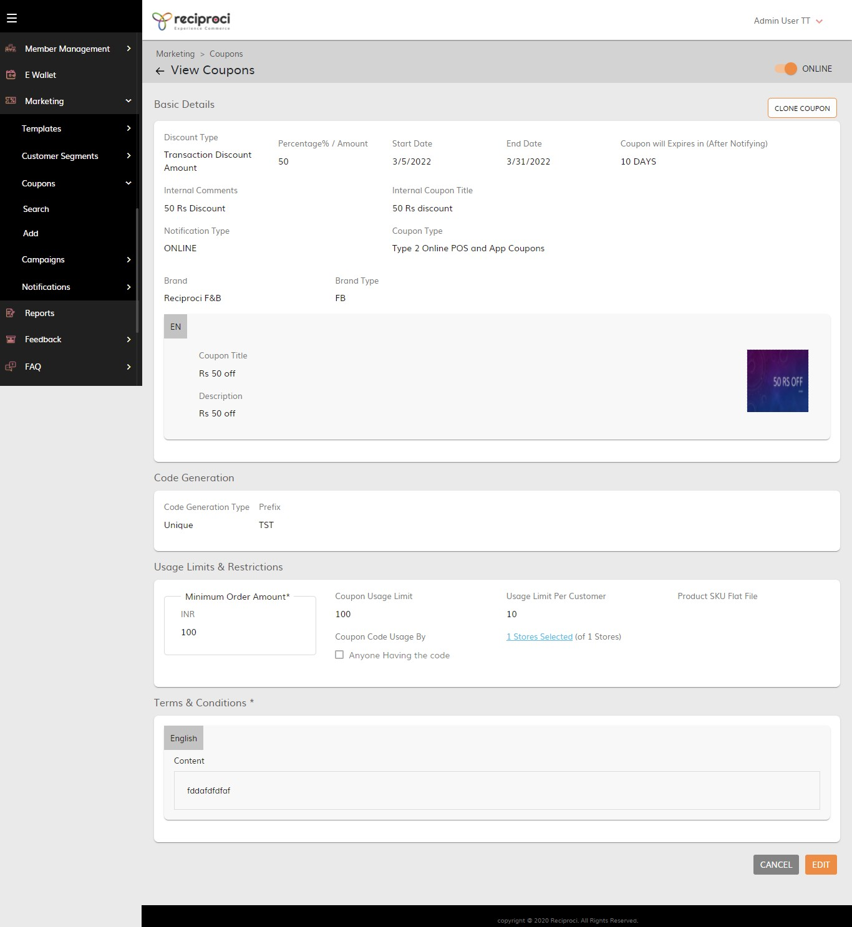

1. Create a **Campaign**
   1. Activity: Other
   2. Attach the Coupon created earlier to the campaign
   3. Communication Type: Push Notification
   4. Frequency: Immediate
   5. for Audience select the segment created
   6. Link to: Coupons
   7. For content use your discretion
   8. Finally: Add

# FAQ – 2 Points

1. Create 2 FAQ
2. FAQ Category: General Query
3. Country: India
4. Questions and Answers
   1. Q: What are the operating hours for the Store? A: 8 AM to 11 PM
   2. Q: What are delivery hours? A: 8:30 AM to 10:00 PM

# About US – 2 Points

1. Create 1 About Us story
2. Country: India
3. Content for: About
4. Content: We are a team of Tech Savants foraying into the Food and Beverage Industry.

# Press Release – 2 Points

1. Create 2 press releases (images in Repository)
2. Publish from Today for one month
3. Content use any
4. Publish From: current time to 11:00 PM

# E Wallet - 3 Points

1. Create an E Wallet
2. Wallet Name: INR
3. Currency: INR
4. Min/Max Balance use your discretion
5. Denominations: same as Above
6. T&C: any text
7. Map to store
8. Add and make online
9. Check if appearing in customer app

# DEMO - 20 points (please ping [amit.rautela@techtreeit.com](mailto:amit.rautela@techtreeit.com) on reaching this point for DEMO)

1. Back End Setup - 10
2. Order Management - 10
3. Make 2 transactions from the customer app (1 Delivery and 1 Pick up)
4. Accept new orders from Backend
5. Mange Live Orders
6. Assign Delivery Person From the Backend and Fulfill the order from delivery app
7. Check During Transactions if Earn/burn rules are working or not
8. And if Feedback flow is being displayed for completed orders

# Reports 16 points (These have to be mailed to the email id mentioned in the document.The answers have to be in the form of a word (pdf preferred) document. These have to be mailed with in half an hour of the finishing of the Demo) here is the link: [Reports Questions_Intermediate](https://docs.google.com/document/d/1ukgEzcTUqHnuivKLW_uavsrmk1ERPLY9nKjRwhmXApU/edit?usp=sharing)