**App Name:**

Gogoanime – Watch anime online

**Short description:**

Watch and Download anime from official gogo anime app.

**Long description:**

Watch and Download anime from official gogo anime app. We are the official partner of gogoanime to stream and download anime.

* Download anime from gogoanime app.
* Watch anime online from gogoanime app.
* Select the resolution of anime which is suitable for your mobile.
* Watch the sub anime online from the gogoanime.
* Download sub anime form the gogoanime
* Watch dub anime online from both gogoanime and kissanime.
* Download dub anime from both gogoanime and kissanime.

We are not an official partner of kiss anime streaming website but use api of their website.

**DISCLAIMER :**  
+ The content provides in this app is hosted by public video website and is available in the public domain.  
  
+ This app is not for streaming/watching drams movies. This app just helps you to find drama movies more easily  
  
+ All drama movies information and images are from TMDB.org licensed under CC BY-NC 4.0: https://creativecommons.org/licenses/by-nc/4.0/  
  
+ This app uses the TMDb API but is not endorsed or certified by TMDb: https://www.themoviedb.org/documentation/api/terms-of-use  
  
*** Note: This app does not store any video in own server, this app share link from other websites only. If you found your videos in this app please contact us our team will remove it.

**App Icon:**

lib\play_store_512.png



**Main Store Listing:**

lib\Untitled-30.png

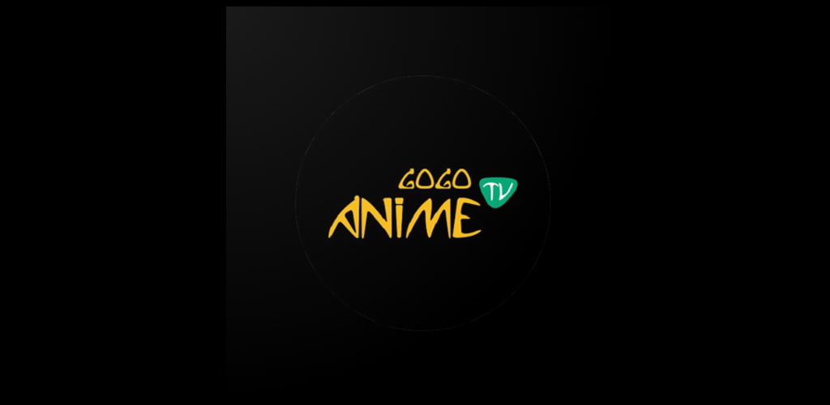

**Screenshots:**

lib\splash.png

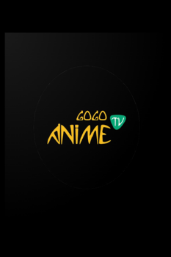

lib\sc-1.png

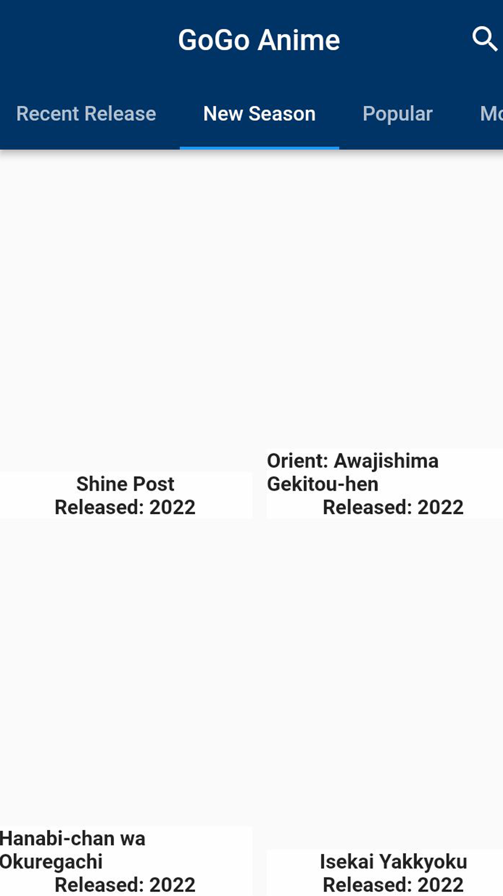

lib\sc-2.png

