AI Reviewer
Coin Deduction Architecture
Current Production Workflow
Feature request → Billing authorization → Membership check → Coin decision → Wallet → Transaction ledger
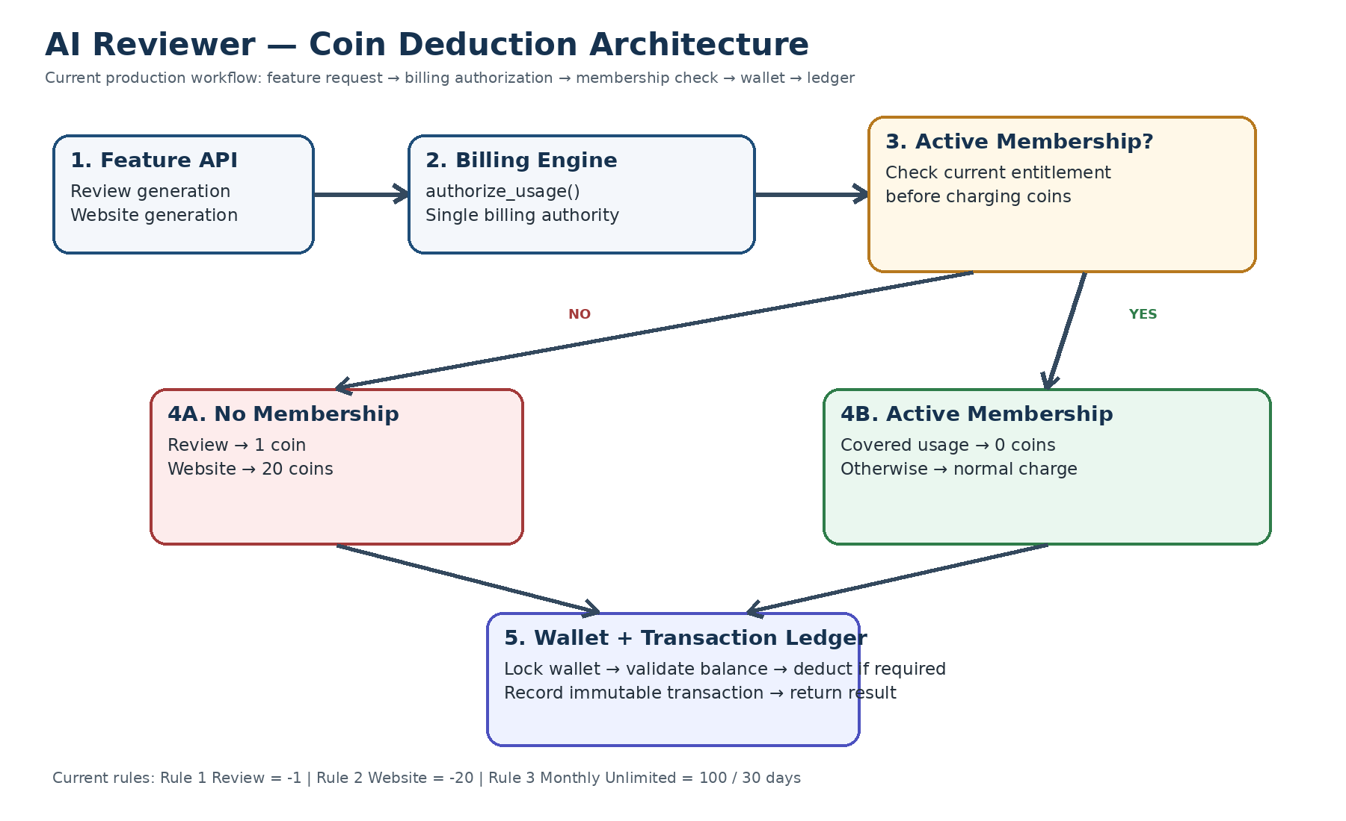

1. Architecture Overview
The coin system uses a centralized billing authority. Feature routes do not directly modify coin balances. They call the canonical billing function authorize_usage(), which resolves the configured rule, checks active membership entitlement, performs a coin deduction when required, and records the transaction.

2. Current Coin Rules
Rule | Purpose | Coin Impact | Type
Rule 1 | Review generated | -1 coin | Usage
Rule 2 | Website published | -20 coins | Usage
Rule 3 | Monthly unlimited membership | -100 coins on purchase | Subscription
Rule 3 is a subscription purchase. While an active membership covers the configured usage rules, the corresponding usage can proceed without an additional coin deduction.

3. End-to-End Deduction Workflow
Step | Action | Production behavior
1 | Feature API receives request | Example: generate a review or publish a website.
2 | Feature calls authorize_usage() | Supplies rule number and ownership/reference context.
3 | Billing engine resolves rule | Determines configured usage cost or subscription behavior.
4 | Active membership is resolved | Checks whether an active membership exists.
5 | Entitlement is evaluated | Covered usage costs 0 additional coins.
6 | Wallet is locked and validated | Protects balance during the billing decision.
7 | Coins are deducted when required | Insufficient balance rejects authorization.
8 | Immutable transaction is recorded | Ledger records the coin movement.
9 | Final billing result is returned | Feature continues and returns its API response.

4. Decision Logic
- Identify the usage rule (Rule 1 for review, Rule 2 for website).
- Resolve the applicable owner/business and wallet.
- Find an active membership, if one exists.
- Determine whether that membership covers the usage rule.
- If covered: authorize with zero additional coin deduction.
- If not covered: use the configured usage cost and deduct coins.
- If the user has insufficient coins: reject billing authorization.
- Record a transaction whenever a coin movement occurs.

5. Example — Review Generation
No membership: Review → Rule 1 → 1 coin required → wallet checked → 1 coin deducted → transaction recorded.
Active Rule 3 membership: Review → Rule 1 → membership covers review → 0 additional coins deducted → usage authorized.

6. Example — Website Generation
No membership: Website → Rule 2 → 20 coins required → wallet checked → 20 coins deducted → transaction recorded.
Active Rule 3 membership: Website → Rule 2 → membership covers website → 0 additional coins deducted → usage authorized.

7. Production Design Principles
- Single billing authority: coin_routes.py owns coin authorization and deduction logic.
- Feature isolation: feature routes call authorize_usage() instead of updating coin_balance directly.
- Server-side authorization: frontend balance is never trusted for billing decisions.
- Active membership is evaluated before a normal usage deduction.
- Wallet protection: the balance row is locked during deduction to prevent concurrent overspending.
- Immutable ledger: every coin movement is recorded as transaction history.
- Configured costs: feature costs are defined centrally in the billing rule registry.
- The current apply_coin_rule() alias can remain temporarily for backward compatibility while integrations migrate.

8. Current Architecture Boundary
The billing engine remains inside the FastAPI application rather than as a separate microservice. This keeps the current system simpler while maintaining a centralized billing authority.

9. Future Extension Direction
The current workflow can later evolve into independent usage rules and membership entitlements, allowing plans to define unlimited, limited, discounted, or excluded usage. That redesign is intentionally not part of the current workflow documented here.

10. One-Line Architecture
FEATURE → authorize_usage() → RULE → ACTIVE MEMBERSHIP → ENTITLEMENT DECISION → WALLET → LEDGER

