Front Page to look something like this



Customers, hauliers and administrators will get the same front page, they will get different menus after login

Hauliers will be entered into the system by administrators while customers can register themselves

User name will be email

Password (should be minimum 8 chars, a mix of characters and numbers)

There will be a ‘forgot password?’ link and facility to reset password through a link in the email

There will be a link to ‘Register’ with the following fields-

Company Name

Address

Tel

Email

Contact person

The Customer would get this after login

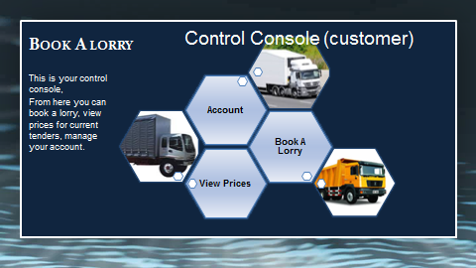

When they click on Account they go to this page

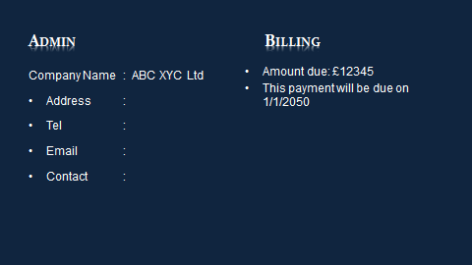

The customer can change details on the screen above

Amount due and payment due date needs to be entered manually by the site admin

When they click book a lorry this is what they get

Lorry required and vehicle type fields will be drop downs

Site address will be free text field where any address can be entered without any restriction

All date fields will be pop up calendars

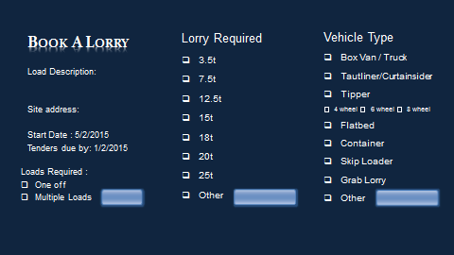

When they View get prices, they will see the quoted prices. There might be few tenders for which prices not have been quoted, customer will see ‘Awaiting prices’ against job which have not been quoted yet.

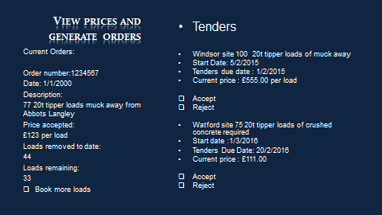

This is the haulier side

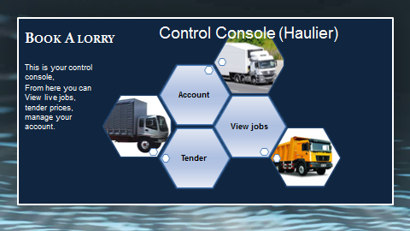

Account would take them here

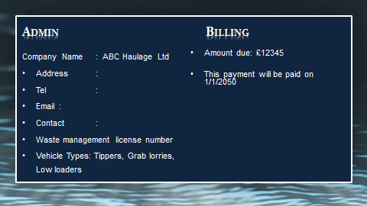

View jobs takes them here

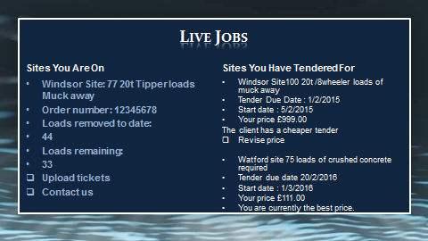

The tender button takes them here

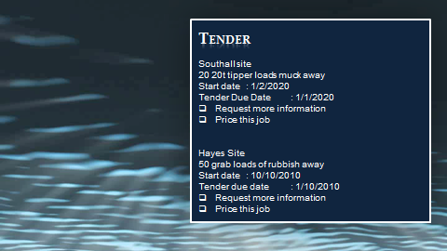

‘Request more information’ button will trigger an email to the admin.

**Admin screens-**

Incoming jobs review

Send job to selected suppliers for quotes

Quotes received against a job review

Assign a job to supplier

Suppliers management

**Reporting screens-**

Reports to show hauliers and customers

Jobs against hauliers and customers