Software Engineering Assignment

MODULE: 1 (SDLC)

1. What is software? What is software engineering?

- Software is a set of instructions and programs used to operate computers and execute specific task.

- Software engineering is a detailed study of engineering to the design, development and maintenance of software. Software engineering was introduced to address the issue of low quality software projects.

2. Explain types of software.

-> System software: - the system software is the main software that runs the computer. When you turn on the computer, it activates the hardware and controls and coordinates their functioning. The application programs are also controlled by system software.

-> Programming software: - it is a set or collection of tools that help developers in writing other software.it assists them in creating, debugging and maintaining software and applications. We can say that these are facilitator software that helps to translate programming language such as java, c++, python etc., into machine language code.

-> Application software: - application software is a set of programs designed to perform specific task.it does not control the working of computer as it is designed for end-users. A computer can run without application software.it can be easily installed or uninstalled as required.it can be a single program or collection of small programs.

3. What is SDLC? Explain each phase of SDLC

- software development life cycle is a framework that defines the steps involved in the development of software at each phase.it covers detailed plan for building, deploying and maintaining the software.

->Requirement gathering and analysis: - during this phase all relevant information is collected from the customer to develop a product as per their expectation.

->Design: - in this phase the requirement gathered in the srs document is used as an input and software that is used for implementing system development is derived.

->Coding: - coding starts once the developer gets the design document. The software design is translated into source code. All the component of software is implemented in this phase.

->Testing:- testing starts once the coding is complete and modules are released for testing.in this phase the developed software is tested and if any defects found are assigned to developers to get them fixed.

->Deployment: - once the product is tested, it is deployed in production environment for user acceptance testing depending on the customer expectation.

->Maintenance:- after the deployment of a product on the production environment, maintenance of the product i.e. if any issue come need to be fixed and is taken care by the developers.

4. What is DFD? Create a DFD diagram on Flipkart.

- A data flow diagram is a graphical or visual representation using a standardized set of symbols and notations to describe a business operation through data movement data flow diagrams are very popular because they help us to visualize major steps and data involved in software system processes.

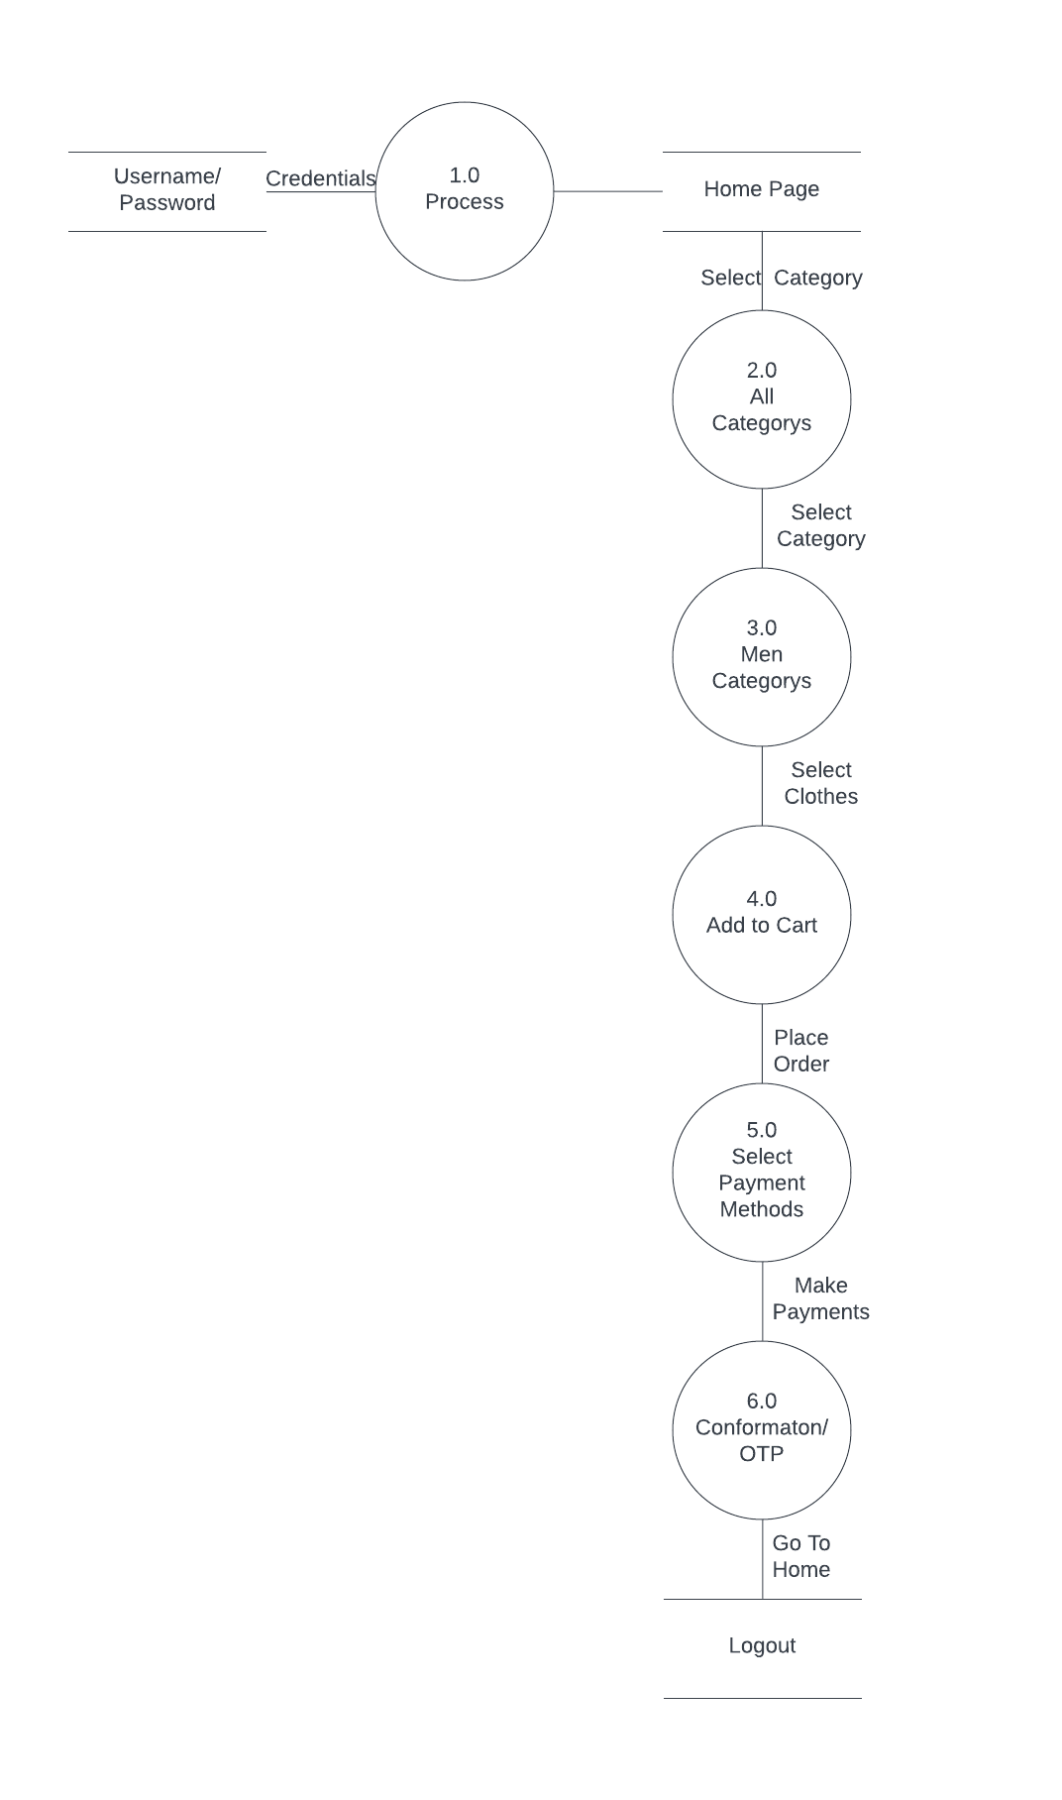

5. What is Flow chart? Create a flowchart to make addition of two numbers.

- A flowchart is a picture of the separate steps of a process in sequential order. It is a generic tool that can be adapted for a wide variety of purposes, and can be used to describe various processes, such as a manufacturing process, an administrative or service process, or a project plan.

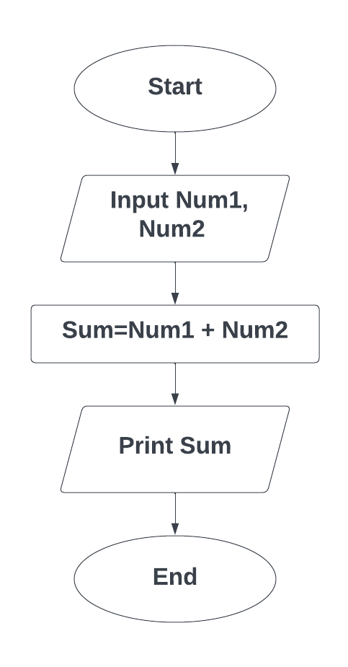

6. What is Use case Diagram? Create a use-case on bill payment on paytm.

- Use-case diagrams describe the high-level functions and scope of a system. These diagrams also identify the interactions between the system and its actors. The use cases and actors in use-case diagrams describe what the system does and how the actors use it, but not how the system operates internally.

