WEEK 3 TASK
Advanced Data Analysis and Visualization in Logistics
Exploratory Data Analysis, Visualization and Operational Insights using Python
Detail | Information
Student Name | ____________________________
Register Number | ____________________________
Programme | B.Tech – CSE
Task | Week 3 – Logistics Analysis
Tools | Python, Pandas, Matplotlib, Seaborn
Dataset | Synthetic logistics shipment dataset (60 records)

1. Introduction
This report presents an advanced exploratory data analysis (EDA) and visualization workflow for a hypothetical logistics operation. The goal is to convert shipment-level data into clear operational insights that can support decisions about delivery speed, transportation cost, carrier performance, vehicle utilization and service quality.
A synthetic dataset of 60 logistics orders is used so that the complete analytical process can be demonstrated without exposing confidential business information. Python, Pandas and Matplotlib are used for data analysis and visualization, with visualization designs selected to answer specific logistics questions.

2. Objectives
- Understand the structure and characteristics of a logistics dataset.
- Calculate central tendency and distribution statistics for key operational variables.
- Examine relationships and correlations between distance, time, cost, utilization and customer rating.
- Create multiple visualizations that reveal trends, distributions and relationships.
- Identify operational bottlenecks and potential cost drivers.
- Translate analytical findings into practical logistics recommendations.

3. Dataset Description
The dataset contains order date, warehouse, city, carrier, quantity, distance, traffic level, warehouse processing time, shipping time, transportation cost, vehicle utilization, late-delivery status and customer rating.
Variable | Meaning | Analysis role
quantity | Units in order | Demand/volume
distance_km | Route distance | Transportation workload
traffic_level | Traffic score 1–5 | Potential delay driver
warehouse_processing_hours | Processing time | Warehouse efficiency
shipping_time_hours | End-to-end shipping time | Service performance
transport_cost_inr | Transportation cost | Cost efficiency
vehicle_utilization_pct | Vehicle capacity utilization | Resource utilization
late_delivery | Binary late-delivery indicator | Reliability
customer_rating | Customer service rating | Customer outcome

4. Exploratory Data Analysis
Central tendency and dispersion provide a first view of typical logistics performance.
Variable | Mean | Median | Std. Dev. | Min | Max
quantity | 4.15 | 4.00 | 2.15 | 1.00 | 8.00
distance_km | 64.16 | 65.20 | 34.88 | 9.60 | 119.10
traffic_level | 3.07 | 3.00 | 1.52 | 1.00 | 5.00
warehouse_processing_hours | 5.14 | 4.75 | 2.73 | 1.20 | 9.80
shipping_time_hours | 8.91 | 9.00 | 2.35 | 2.90 | 13.10
transport_cost_inr | 708.50 | 689.41 | 239.92 | 264.76 | 1180.25
vehicle_utilization_pct | 76.53 | 76.40 | 12.54 | 50.00 | 100.00
customer_rating | 4.03 | 4.17 | 0.53 | 2.93 | 4.94

5. Visualization 1 – Shipping Time Distribution
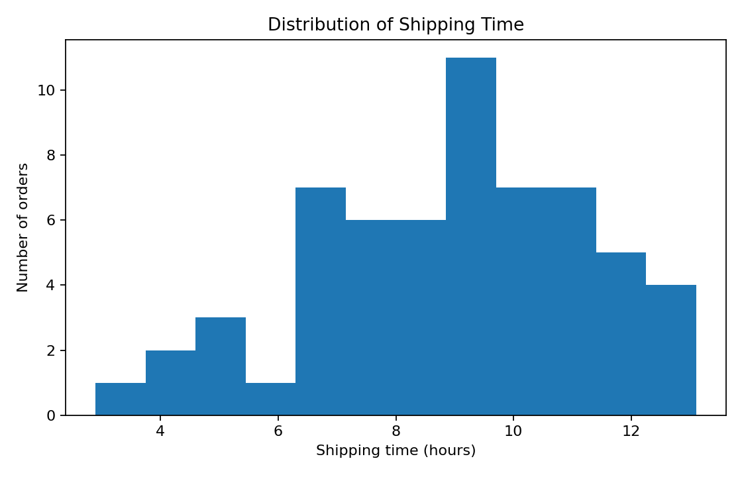
The histogram shows how shipping times are distributed across orders. A distribution plot is appropriate because it reveals the typical range, concentration and potential long-tail behavior. In logistics, a long right tail can indicate a smaller set of severely delayed shipments that may deserve separate investigation.

6. Visualization 2 – Average Shipping Time by City
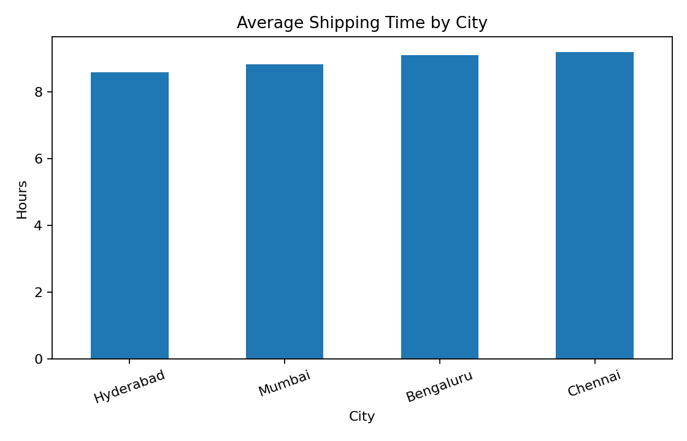
The bar chart compares average shipping time across cities. A bar chart is suitable for categorical comparisons. Cities with higher average shipping times may require route redesign, additional carrier capacity, better warehouse processing, or traffic-aware dispatch planning.
City | Orders | Avg shipping (h) | Avg cost (INR) | Late rate
Bengaluru | 13 | 9.11 | 736.06 | 38.5%
Chennai | 14 | 9.20 | 769.95 | 50.0%
Hyderabad | 16 | 8.59 | 607.73 | 31.2%
Mumbai | 17 | 8.83 | 731.65 | 47.1%

7. Visualization 3 – Distance vs Transportation Cost
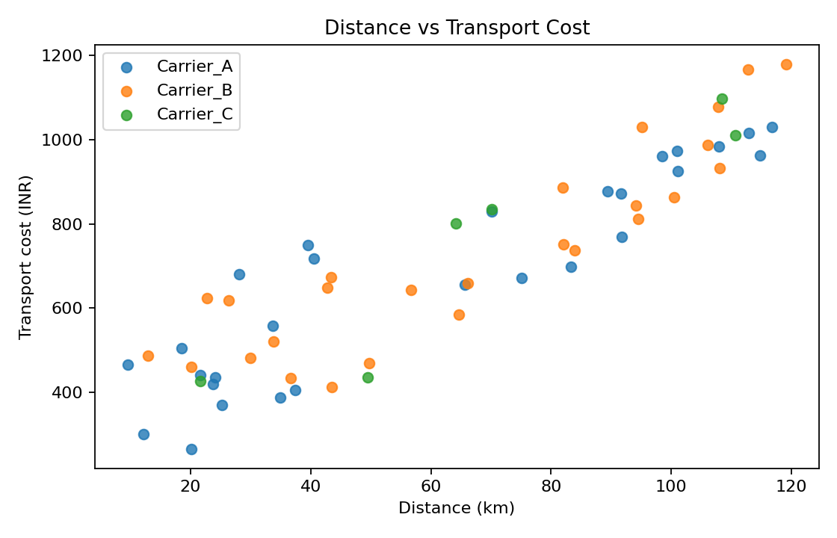
The scatter plot examines whether longer routes tend to cost more. Distance is expected to be an important cost driver, while differences between carriers may reveal pricing or operational-efficiency differences. A scatter plot is appropriate because it shows the relationship between two continuous variables and highlights unusual observations.

8. Visualization 4 – Correlation Matrix
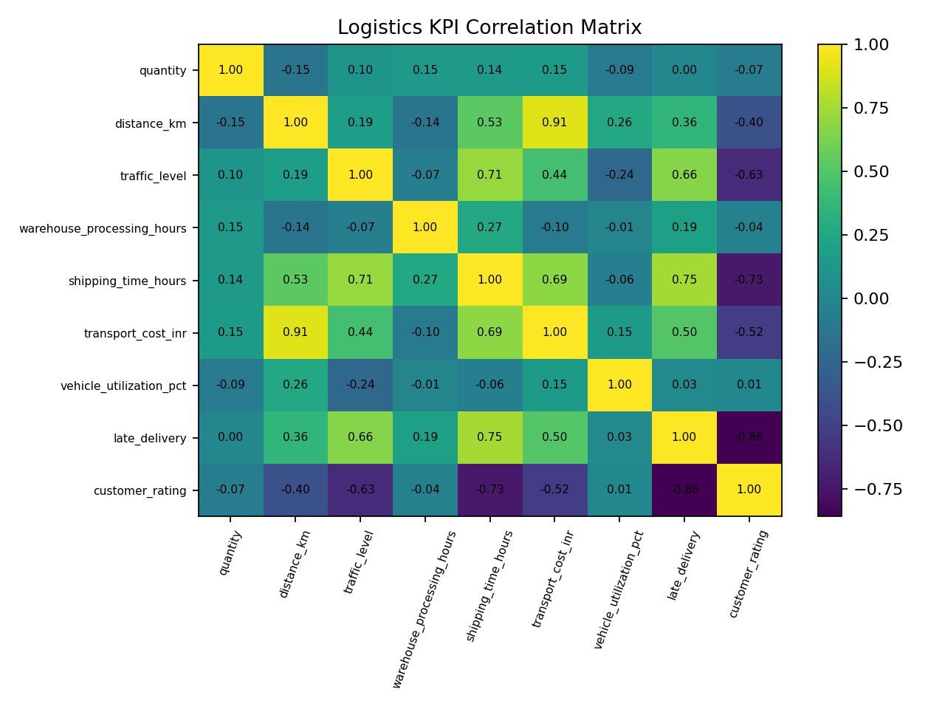
The correlation matrix summarizes linear relationships between numerical variables. Strong positive correlation between distance and transport cost would indicate that longer routes are associated with higher spending. A relationship between shipping time and customer rating can also help assess the service impact of delays. Correlation does not prove causation, so the results should be treated as evidence for further investigation.

9. Visualization 5 – Shipping Time by Carrier
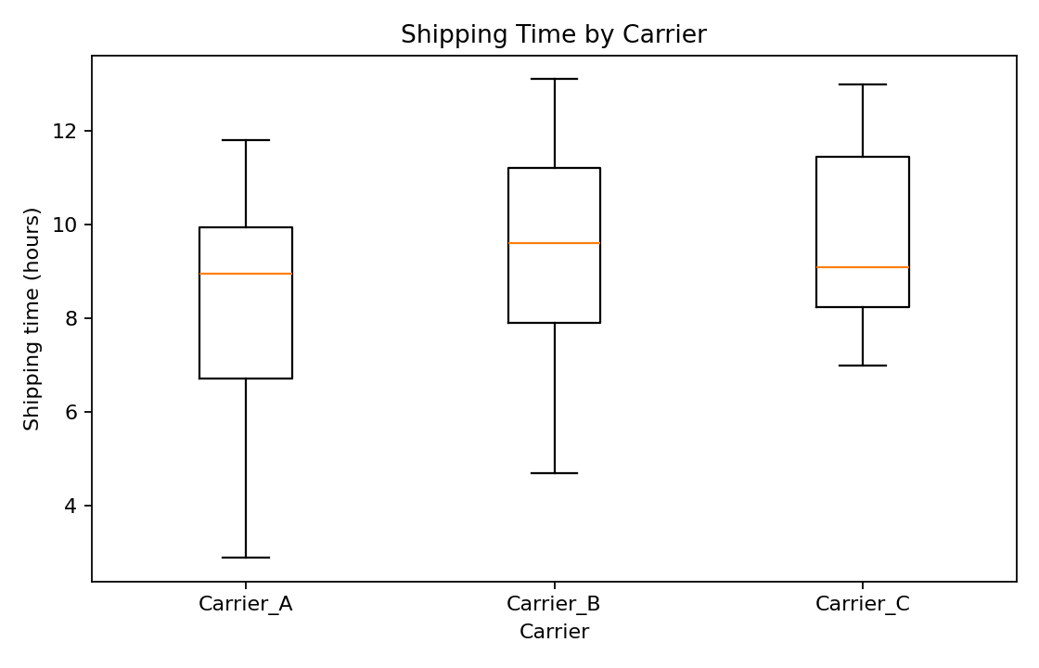
The box plot compares the distribution of shipping time for each carrier. Box plots are useful because they show median, spread and potential extreme observations. A carrier with a higher median or wider spread may need performance review, route-level investigation or revised service-level agreements.

10. Analytical Insights
- Distance and transportation cost have a correlation of approximately 0.91 in the simulated data, indicating the expected positive cost relationship.
- Distance and shipping time have a correlation of approximately 0.53, suggesting that route length contributes to delivery time.
- Shipping time and customer rating have a correlation of approximately -0.73; this can be used to investigate whether slower service is associated with lower customer satisfaction.
- Traffic level and warehouse processing time should be monitored because they can increase delivery time even when route distance is unchanged.
- Carrier-level distributions should be compared rather than relying only on overall averages, because a good overall mean can hide high variability for a particular carrier.
- High vehicle utilization can reduce the cost per shipment, but excessive utilization may reduce flexibility during demand peaks.

11. Recommendations
- Use city-level shipping-time dashboards to identify locations that consistently exceed service targets.
- Analyze high-cost routes and test consolidation or alternative routing before increasing fleet capacity.
- Track carrier performance using median shipping time, late rate and variability, not only average time.
- Combine traffic information with dispatch decisions to reduce avoidable delays.
- Monitor vehicle utilization and avoid both under-utilization and excessive loading.
- Repeat this EDA regularly and connect the findings to predictive delay models and route optimization from later project stages.

12. Python Code Used
import pandas as pd
import matplotlib.pyplot as plt
import seaborn as sns
df = pd.read_csv("data/logistics_week3_dataset.csv")
df["order_date"] = pd.to_datetime(df["order_date"])
print(df.describe(numeric_only=True))
print(df[["distance_km","shipping_time_hours","transport_cost_inr",
"vehicle_utilization_pct","customer_rating"]].corr().round(2))
# 1. Shipping-time distribution
sns.histplot(df["shipping_time_hours"], kde=True)
plt.title("Distribution of Shipping Time")
plt.xlabel("Shipping time (hours)")
plt.tight_layout()
plt.show()
# 2. Average shipping time by city
city_time = df.groupby("city")["shipping_time_hours"].mean().sort_values()
city_time.plot(kind="bar")
plt.title("Average Shipping Time by City")
plt.ylabel("Hours")
plt.tight_layout()
plt.show()
# 3. Distance vs transport cost
sns.scatterplot(data=df, x="distance_km", y="transport_cost_inr", hue="carrier")
plt.title("Distance vs Transport Cost")
plt.tight_layout()
plt.show()
# 4. Correlation heatmap
corr = df.select_dtypes("number").corr()
sns.heatmap(corr, annot=True, fmt=".2f", cmap="Blues")
plt.title("Logistics KPI Correlation Matrix")
plt.tight_layout()
plt.show()
# 5. Carrier performance
sns.boxplot(data=df, x="carrier", y="shipping_time_hours")
plt.title("Shipping Time by Carrier")
plt.tight_layout()
plt.show()

13. Limitations
- The dataset is synthetic and does not represent the confidential operations of a real company.
- Traffic, weather and real-time GPS data are not included.
- Correlation analysis identifies association, not causal relationships.
- Additional statistical testing and time-series analysis would be useful with a larger real-world dataset.

14. Conclusion
Advanced EDA and visualization make logistics data easier to understand and convert into operational insights. The analysis demonstrates how distributions, city comparisons, scatter plots, correlation analysis and carrier comparisons can reveal delivery patterns and potential cost drivers. These findings provide a practical bridge between raw logistics data and data-driven management decisions.
The next stage would be to combine these insights with predictive modelling and optimization. By continuously monitoring the same KPIs and visualizations, a logistics organization can identify bottlenecks earlier, allocate resources more effectively and improve delivery reliability while controlling transportation costs.

15. References
- World Bank – Logistics Performance Index: https://lpi.worldbank.org/
- Pandas documentation: https://pandas.pydata.org/docs/
- Matplotlib documentation: https://matplotlib.org/stable/
- Seaborn documentation: https://seaborn.pydata.org/
- Scikit-learn documentation: https://scikit-learn.org/stable/

