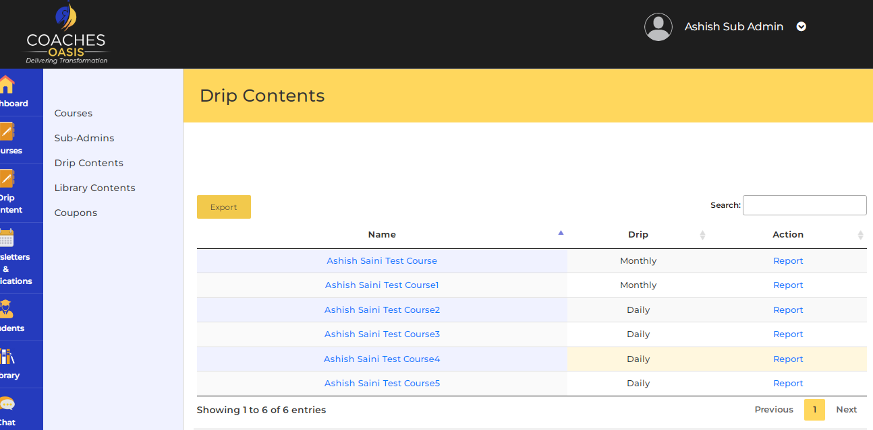
In drip content you have to click on name of the course, then select report under action. That will display drip content graphical report.

