**Compliance Safety Manager**

**Front End Modules –**

**Time Estimate – 30-40 Hours**

1. Login
2. Register to the portal
3. Payment for membership plan
4. Services info like:

Personnel Management

Asset management

Small feet

Large feet

Resellers

Partners

1. Who we server info
2. Screening Service info
3. Contact us
4. Blog
5. Pricing

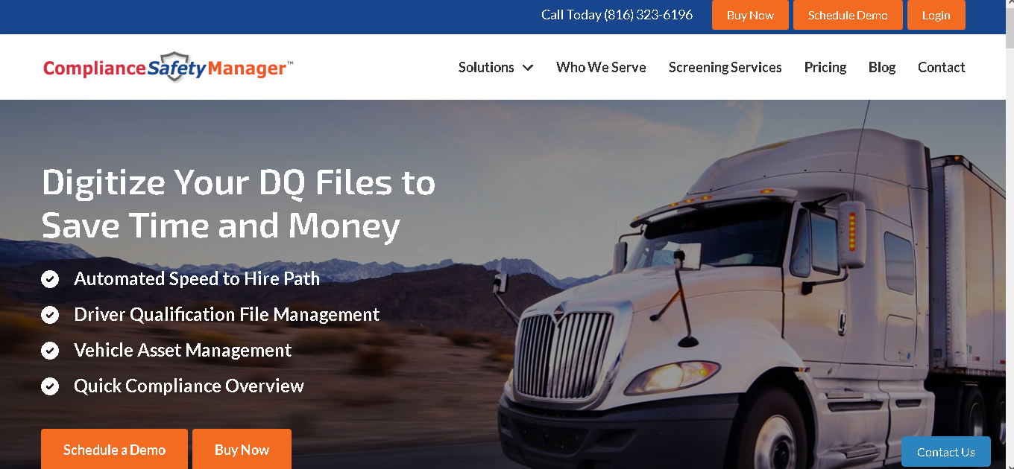

**Register process**

**Time Estimate – 20 hours**

1. Fill the form with detail
2. Choose Membership plan
3. Pay for the plan
4. Redirect on dashboard to manage vehicles or employee data

**Admin Panel**

**Time Estimate – 30-40 hours**

1. **Login**
2. **Dashboard to show stats of organization**
3. **Membership plan management**
4. **Content Management for informative pages**
5. **Archive data management**

**Organization Panel**

**Time Estimate – 250-300 hours**

***NOTE – API INTEGRATION TIME ESTIMATE WILL BE SEPARATE. NEED DRUG SCREENING INTERNAL PROCESS INFORMATION FOR THIS.***

**After registered to the portal organization can handle their Employees and Assets data here.**

**Reports will be available for downloading.**

**Hiring Path –**

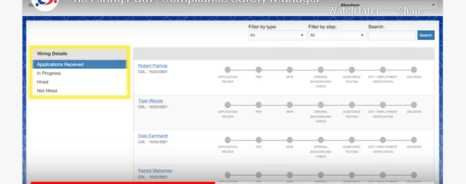

Get all type of information from the employees and get the track of the status updated by CSM.

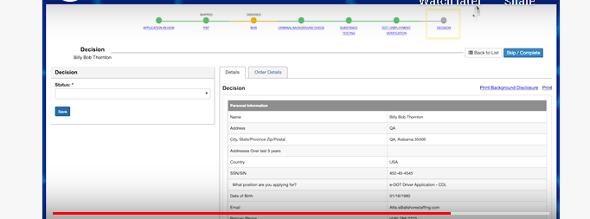

All step by step info updated for employee in the system

**Personnel Management**

Completely paperless Driver Qualification File management program. CSM seamlessly manages all the required DQ elements such as:

* Application For Employment
* MVRs
* DOT Medical Cards
* Certificate of Road Test
* Driver’s Annual List of Violations
* Supervisor Review of Violations
* Driver’s License
* Drug Screens

**-**Employees

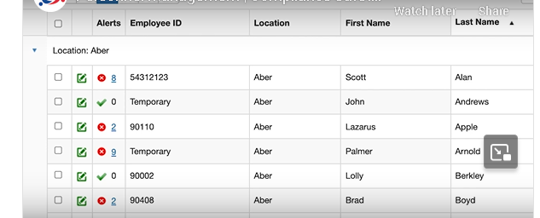

All employees listed with detail and click on employee name will be shown employee further details like documents, Events, Notes

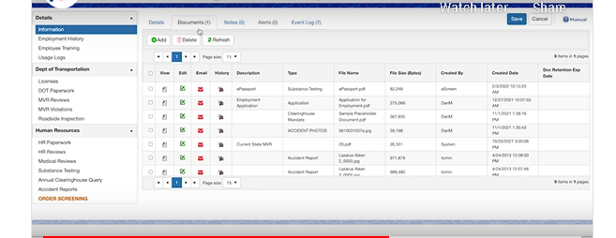

Employee can be import

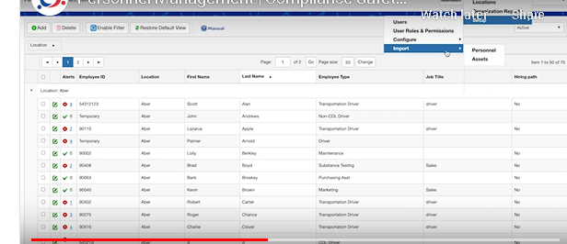

**-**Training

**-** Alerts

This section shown all type of expired alerts

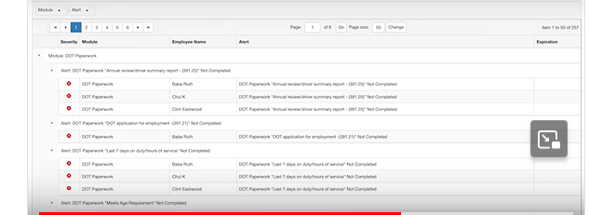

- Archive data

This shows all archived data of employees

**Asset Management**

track important Vehicle Asset information. CSM comes loaded with real-time notifications keeping your fleet safe, functioning, and profitable. CSM can track:

* Scheduled Maintenance
* Repairs
* Registration Renewals
* Inspections
* Warranties

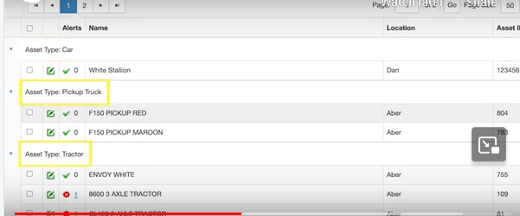

**On asset name click we can see asset specific details like purchase, license, documents, service records, parts:**

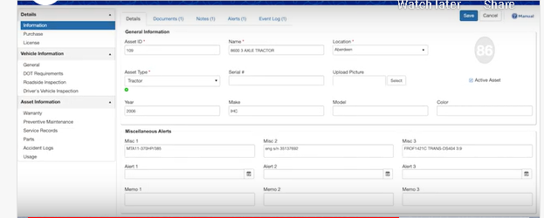

**The dashboard**

Dashboard provides a broad overview of all your most important information. Dashboard elements include summaries on:

* Electronic Application
* PSP
* Employees
* Vehicle Assets
* Alerts
* DOT Paperwork Checklist
* Hiring Path

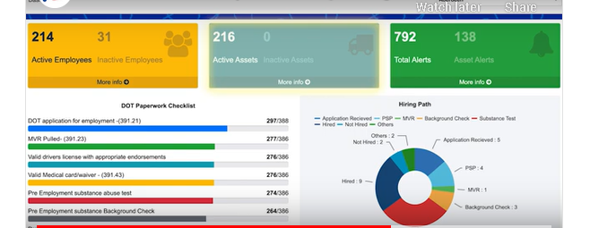

**Drug Screening services**

drug screening program features paperless drug screening and includes a vast collection site network, SAMHSA certified labs, and MRO services.

