

**Gurugram Police Summer Internship 2020**

**Tool Based Project**

**On**

**Criminal Records Management with Face Recognition**

**Submitted By:**

**Sonu Raghuwanshi**

**GPSI TEC 220**

**Supported by: Submitted To:**

**Society for Safe Gurgaon Mr. Rakshit Tandoon**

**SISL Infotech Pvt Ltd**

**Undertaking for Originality for the work**

I, **Sonu Raghuwanshi**, give undertaking that the project titled “**Criminal Record Management with Face Recognition**” submitted by me, towards the partial fulfilment of the requirements for the certificate of Gurugram Police Summer Internship 2020, is the original work carried out by me and I give assurance that no attempt of plagiarism has been made. I understand that in the event of similarity found subsequently with any published work or any dissertation work elsewhere; it will result in severe disciplinary action.

Sonu Raghuwanshi

Date: 10-Jul-2020

Place: Vidisha

## **ACKNOWLEDGEMENT**

I express my sincere gratitude to Gurugram police for providing us an opportunity to be part of this Gurugram Police Summer Internship 2020 to complete this Tool based Project on ‘‘**Criminal Records Management with Face Recognition**’’.

I sincerely thank

1. Sh. K.K. Rao (Commissioner of Police, Gurugram)
2. Ms Nikita Gehlawat (DCP)
3. Ms Pankhuri Kumar (ACP SO1)
4. Mr. Karan Goyal (ACP Cyber Crime)
5. Mr. Rakshit Tandon (Cyber Safety Advisor Cyber Crime, Director Council of Information Security, Consultant-Internet & Mobile Association of India)
6. Ms Akshita Jain (Systems Engineer)

for their guidance and encouragement in carrying out this project work. I also express our gratitude. I also thank to all the experts invited to GPCSSI 2020.

Lastly, I thank almighty, our parents, our siblings and friends and whole Gurugram Police Team for their constant support without which this project would not be possible.

TOPICS

### ABSTRACT

### INTRODUCTION

### MAIN CONTENT

1. PROPOSED SOLUTION
2. CONCLUSION
3. REFERENCES

Abstract

This “Criminal Records Management with Face Recognition” is a record management system. In this system we can store the details of the criminals along with their face id’s. These records get stored in the database server. We can retrieve the records in the two ways, by using Aadhar card number of criminals and by using their face or photos. In this system, we can see all the records of criminal in category wise. Like you can search for all the criminals who are involved in murder. This record system uses the machine learning algorithm to remember the face of criminals along with their records.

INTRODUCTION

Rules and regulations are paramount to all aspects of the life, and it accommodates both how one wishes to live, and how others should accommodate one’s lifestyle. We see that when a group or society is formed the people make some rules and laws, for the people and to the people. The purpose of these rules and laws are to give a peaceful life to all who are living in that society. Whenever any law is violated by anyone, we say that crime is committed and who break that law is called criminal. To have a peaceful life we need a well-organized law enforcement system

In modern years, as a result of the universal rise in application of computers in various aspects of life, desktop and laptop applications such as Microsoft Excel were adopted, thereby causing the approach to become both manual and considerably computerized in Somalia. However, this method of record keeping results in inconsistencies, wastage of disk space and poor control and management of data.

The proposed of Criminal Record Management with Face Recognition is enhances the crime recording operations of the police. The data used by the Criminal Record Management with Face Recognition is stored in a centralized database, which holds information about criminals and crimes. The database is the basis for all actions in the system and can be easily updated and used to aid in all of the system’s processes, that is, all of the required information is stored in one central location and thus is easily accessible. Furthermore, the correctness of the centralized database will allow functions such as criminal information record generation. This is a more effective storage method than a paper-based file system. In addition to the functions highlighted above, the system performs the basic functions of storage, retrieval and manipulation of crime and criminal data and information.

wishes to live, and how others should accommodate one’s lifestyle. (Mubaraka, Jirgi, &

MAIN CONTENT

**Existing System:**

System Analysis is a detailed study of the various operations performed by a system and their relationships within and outside of the system. Here the key question is:

**What all problems exist in the present system?**

**What must be done to solve the problem?**

Analysis begins when a user or manager begins a study of the program using or studying existing system. Today Police is using traditional files to maintain the record of the criminals. In some areas of country police is also using the computerized record management system.

**Problem in Existing System:**

It is hard to manage the record in the traditional records management. When it comes to find the details of the criminals, turning the pages will take a lot of time. The maintenance of these records is another big job. The stealing and mis placing of the records is common problem that is faced by the police.

The problem in the computerized records system is, that the criminal gives the wrong information about them. They carry duplicated identity so when it comes to find their records police doesn’t find anything. Police need to look into every record in the details.

In the existing management system, most of the operations are done manually. This system needs more manpower to track the records of crimes. The existing system doesn’t have system security. The existing system is time consuming. Retrieving old crime records is very time consuming. In the current system all work is done on papers, so it is very difficult to secure crime reports data.

PROPOSED SOLUTION

The proposed crime records management system can overcome all the limitations of the existing system. The system provides proper security and reduces the manual work. The efficiency of the police function and the effectiveness with which it tackles crime depend on what quality of information it can derive from its existing records and how fast it can have access to it. The existing system has several disadvantages and many more difficulties to work well. The proposed system tries to eliminate or reduce these difficulties up to some extent. It is proposed to centralize Information Management in Crime for the purposes of fast and efficient sharing of critical information across all Police Stations across the territory. The proposed system also has a Face Recognition feature. Through this feature, the police can retrieve all the previous records of the user through their face or by just photo.

This system has option to add the criminal in the database. This takes the details of the criminals and then take photos of the criminal. After this we just need to train machine by just a click of the button. This system learns about his face. Now using the Aadhar card number you can retrieve the data of the criminal. You can also retrieve the details of the criminals using their face or photos. In this criminal record management system with face recognition you can retrieve the criminal records based on crimes. You can also retrieve the all the records stored in the system along with criminal details.

**Technology Used:**

**Python**: For the Graphical User Interface of the application python’s tkinter modules have been used. Python is an interpreted, object-oriented, high-level programming language with dynamic semantics. Its high-level built in data structures, combined with dynamic typing and dynamic binding, make it very attractive for Rapid Application Development, as well as for use as a scripting or glue language to connect existing components together. Python's simple, easy to learn syntax emphasizes readability and therefore reduces the cost of program maintenance. Python supports modules and packages, which encourages program modularity and code reuse. The Python interpreter and the extensive standard library are available in source or binary form without charge for all major platforms and can be freely distributed.

**SQL Server:** To store the details of the criminals SQL server **(phpMyAdmin)** is used to host the database. phpMyAdmin is a free software tool written in PHP, intended to handle the administration of MySQL over the Web. phpMyAdmin supports a wide range of operations on MySQL and MariaDB. Frequently used operations (managing databases, tables, columns, relations, indexes, users, permissions, etc) can be performed via the user interface, while you still can directly execute any SQL statement. To ease usage to a wide range of people, phpMyAdmin is being translated into 72 languages and supports both LTR and RTL languages.

**OpenCV:** To recognise the faces of the criminals OpenCV has been used. OpenCV (Open Source Computer Vision Library) is an open source computer vision and machine learning software library. OpenCV was built to provide a common infrastructure for computer vision applications and to accelerate the use of machine perception in the commercial products. Being a BSD-licensed product, OpenCV makes it easy for businesses to utilize and modify the code.

The library has more than 2500 optimized algorithms, which includes a comprehensive set of both classic and state-of-the-art computer vision and machine learning algorithms. These algorithms can be used to detect and recognize faces, identify objects, classify human actions in videos, track camera movements, track moving objects, extract 3D models of objects, produce 3D point clouds from stereo cameras, stitch images together to produce a high resolution image of an entire scene, find similar images from an image database, remove red eyes from images taken using flash, follow eye movements, recognize scenery and establish markers to overlay it with augmented reality, etc. OpenCV has more than 47 thousand people of user community.

**Working:**

**1.** The information of criminal is taken as input in the system. This information is taken with the help of dialog boxes. This information includes Name, Aadhar Card no, Age, Address, Crime and description of the crime

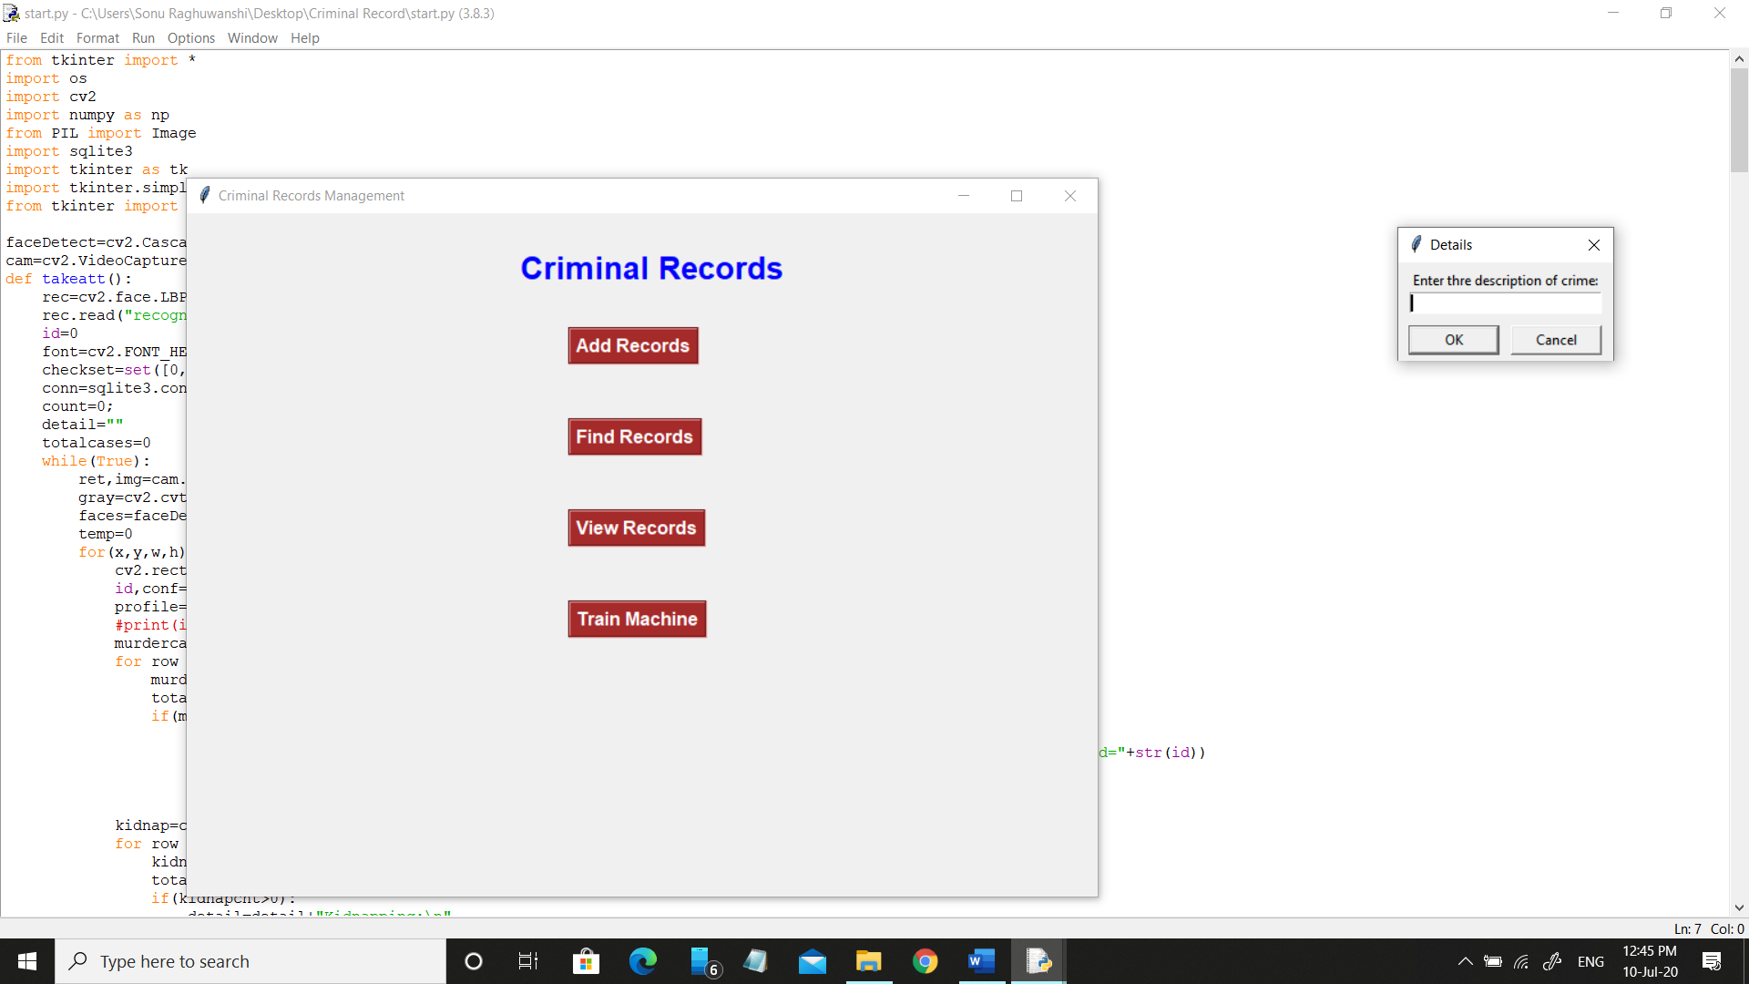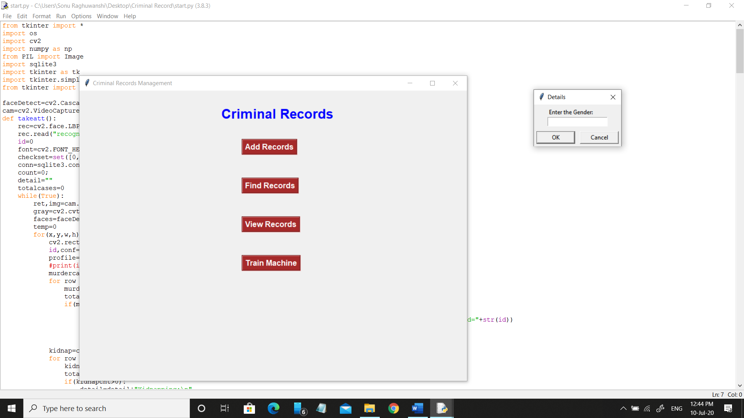

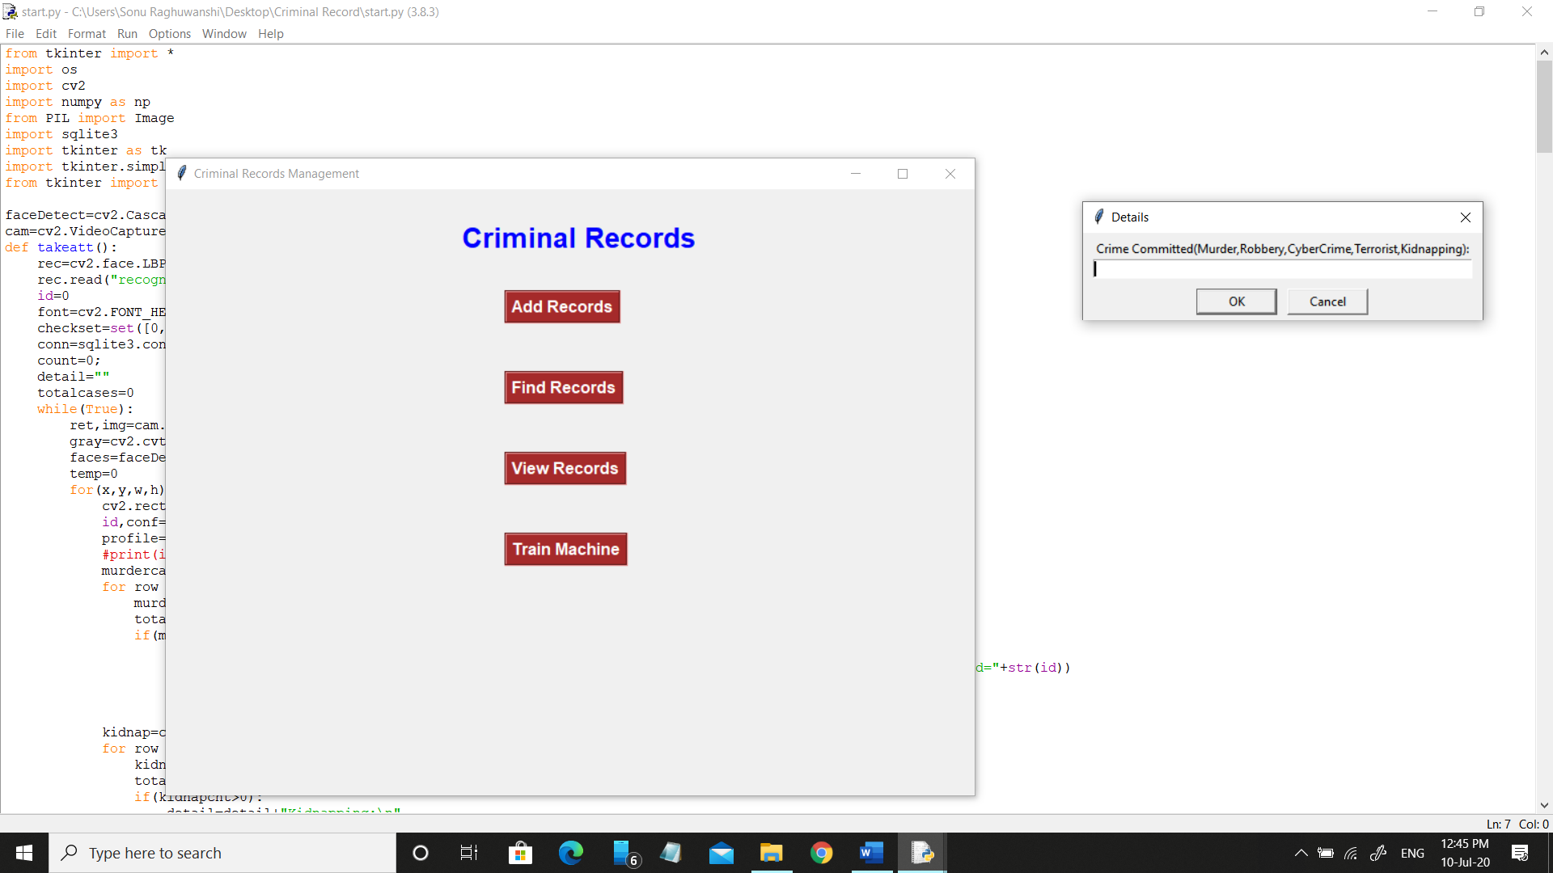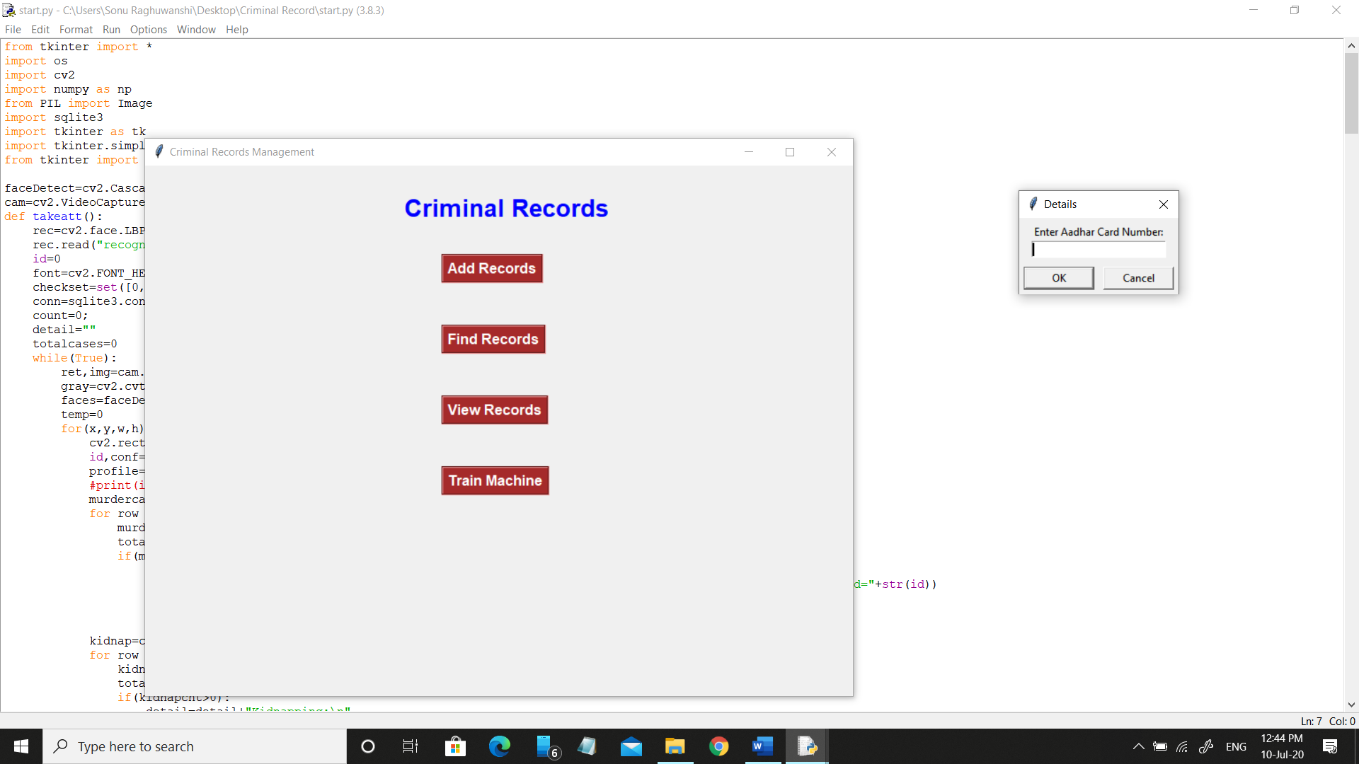

**2.** Now this system clicks some photographs of the criminal. And from these photographs face has been selected and stored in the dataset.

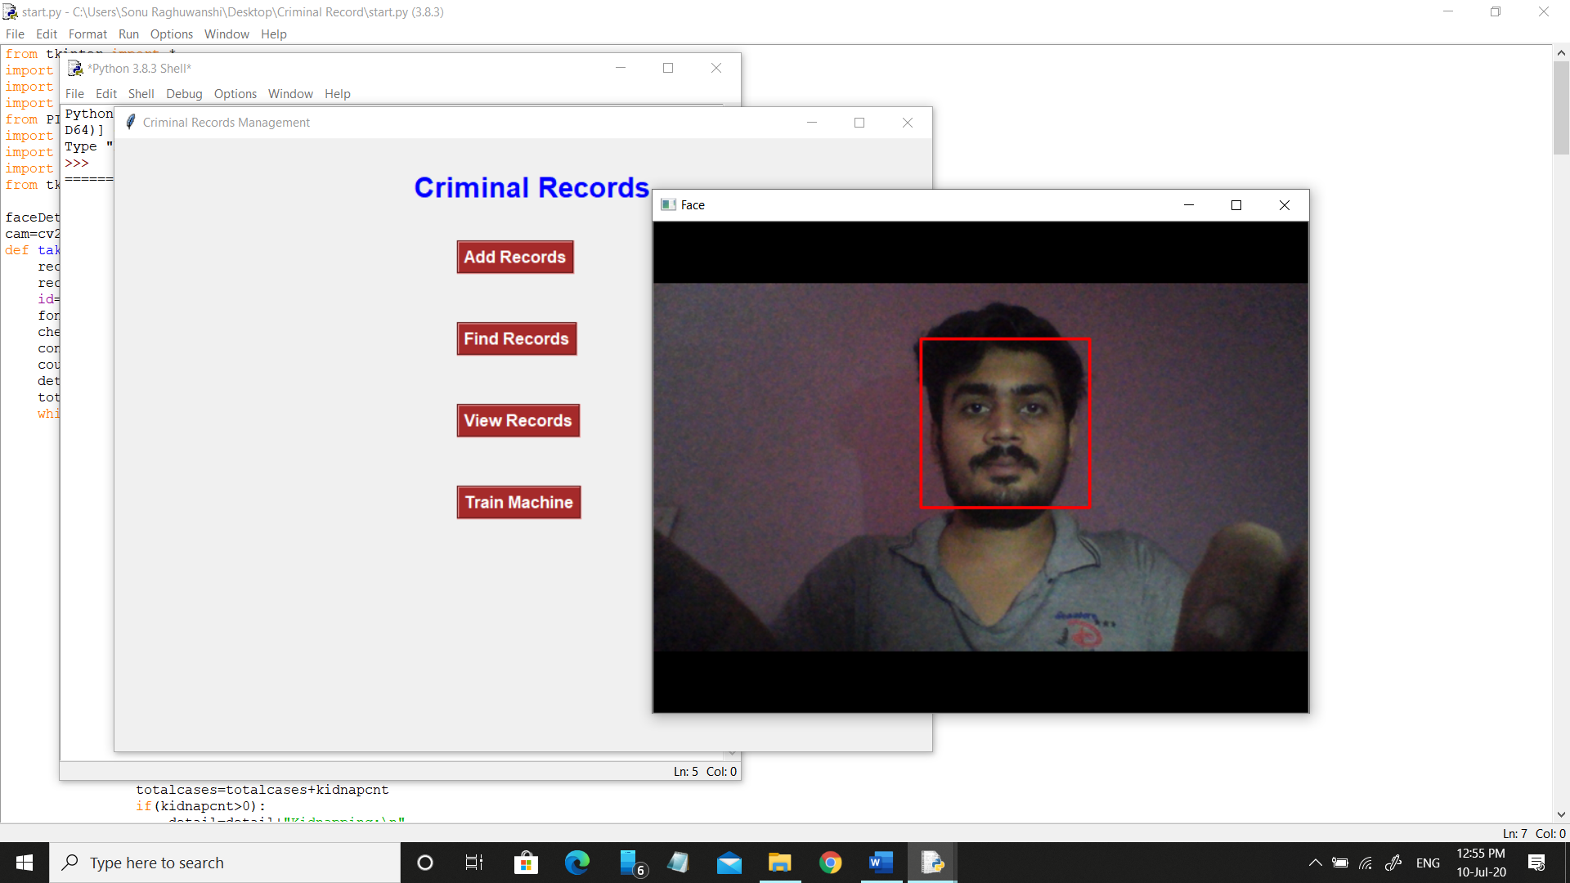



**3.** This dataset is used to train the model. This algorithm is used to train the model.

import os

import cv2

import numpy as np

from PIL import Image

recognizer=cv2.face.LBPHFaceRecognizer_create();

path='dataSet' #folder where all faces are stored

def getImagesWithID(path):

imagePaths=[os.path.join(path,f) for f in os.listdir(path)]

faces=[]

IDs=[]

for imagePath in imagePaths:

faceImg=Image.open(imagePath).convert('L');

faceNp=np.array(faceImg,'uint8')

ID=int(os.path.split(imagePath)[-1].split('.')[1])

faces.append(faceNp)

print(ID)

IDs.append(ID)

cv2.imshow("training",faceNp)

cv2.waitKey(10)

return IDs, faces

Ids,faces=getImagesWithID(path)

recognizer.train(faces,np.array(Ids))

recognizer.save('recognizer/trainningData.yml')

cv2.destroyAllWindows()

**4.** The collected information get stored on the SQL server. In this system I have used phpMyAdmin as SQL server.

**5.** To retrieve the criminal’s information we have two option, either we can use Aadhar card number or we can use face,

Retrieve

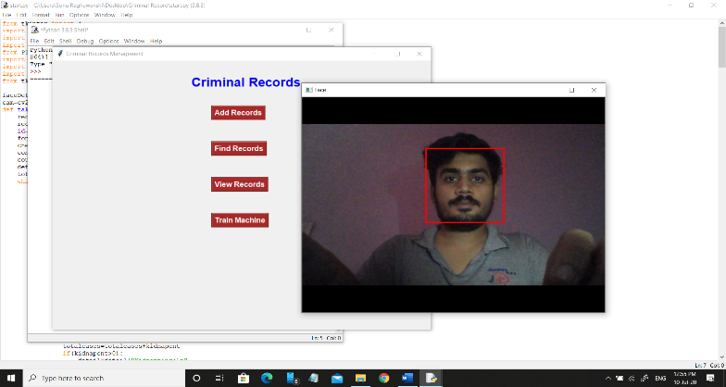

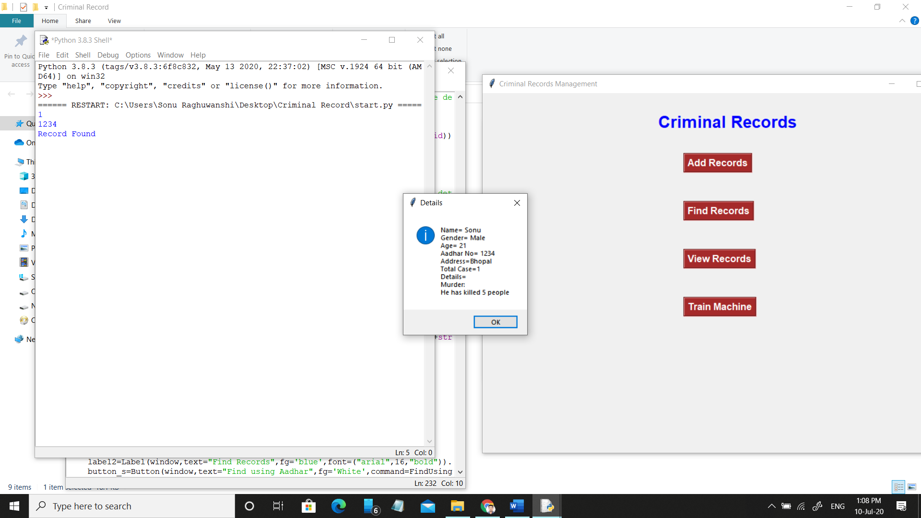

**6.** We can also retrieve all the information of the criminals based on the crimes.

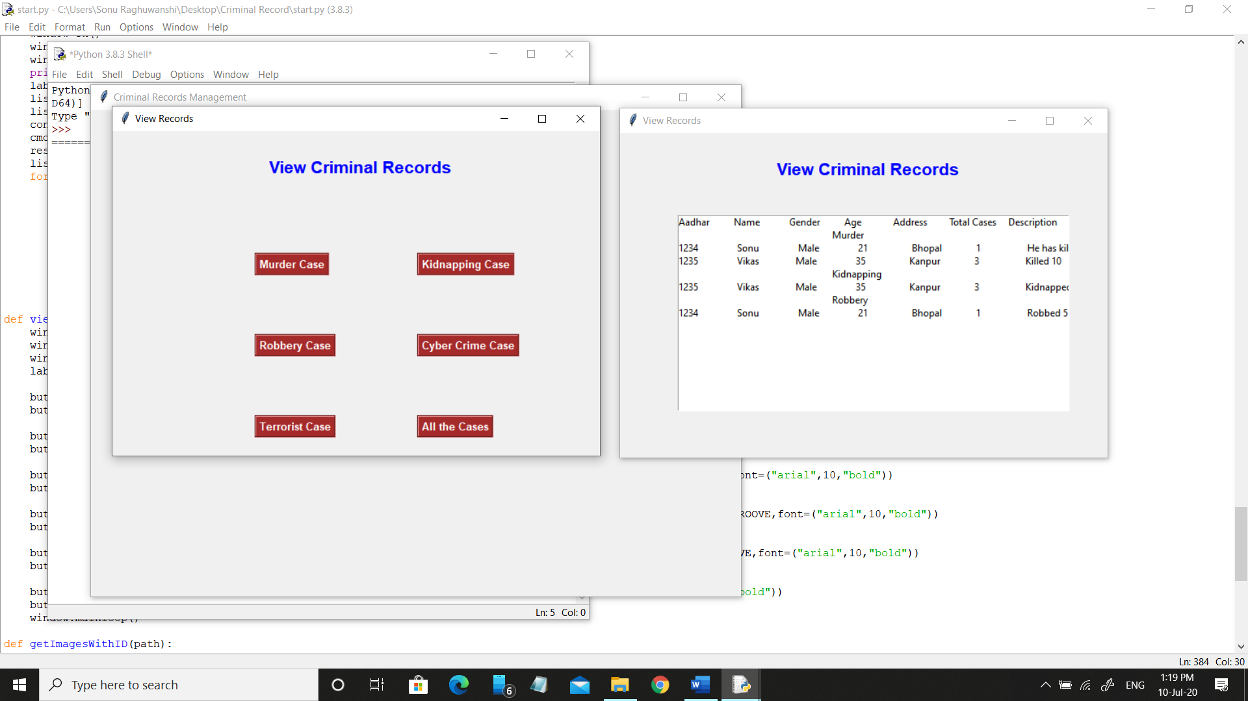

CONCLUSION

The Software/Tool developed is found to be working efficiently and effectively. It results in regular and timely action against criminal details. It can be observed that the information can be obtained easily and accurately. The Software is made user friendly to the maximum so that any lay man can run the software provided he could access to the system. It is also found that this software/tool eliminates all the problems of traditional criminal record managements. It is efficient, fast and easily accessible to all its users. The information stored in this system is also consistent and it can be effectively and efficiently retrieved whenever needed.

REFRENCES

1. <https://docs.python.org/3/>
2. <https://opencv-python-tutroals.readthedocs.io/en/latest/>
3. <https://stackoverflow.com/>
4. <https://docs.phpmyadmin.net/en/latest/>
5. <https://freesqldatabase.com>
6. <https://www.youtube.com/watch?v=g60QghtJmjY>