Cloud Architecture Design
DA III Project Report
Name: Sonu Raj
Regno: 24BPS1057

Project Screen Recording link:
click on this for screen recording https://drive.google.com/file/d/13piYVkzQJ3oP692g1dzN5LRtlYf95Dyw/view?usp=drive_link

CyberShield
AWS-Based Security Log Analysis Dashboard

Introduction
CyberShield is cloud-based security monitoring project. It accepts authentication log events, checks them against a few clear detection rules, and displays suspicious patterns for a person to review. The dashboard is designed how multiple AWS services can work together to process data without maintaining a dedicated server.
Imagine a small company’s website receives several failed sign-in attempts from the same IP address, followed by successful sign-in. an analyst could submit relevant authentication events to CyberShield. Then our system checks the events, marks patterns such as repeated failures, saves the result, and shows finding in dashboard. The analyst can investigate source and decide whether action is needed. In our project, events are synthetic demonstration data; a finding is warning for investigation, not proof that an attack occurred.

Architecture and working flow
First user opens the static website hosted by Amazon S3. Then dashboard sends a JSON batch of authentication events over HTTPS to Amazon API Gateway. API Gateway created invokes AWS Lambda function, which applies detection rules and writes any findings to Amazon DynamoDB. Lambda execution and errors can be inspected in Amazon CloudWatch Logs that are implemented. AWS IAM can also do permissions control which AWS resources the Lambda function can access.
User / Browser→ Amazon S3 website →API Gateway (HTTPS) → AWS Lambda
↓
CloudWatch Logs ← Lambda execution → DynamoDB findings
IAM controls service permissions

Website screenshots
The following screenshots show working dashboard. It displays event counts, suspicious findings, detection rules, input area, and results returned by AWS backend .
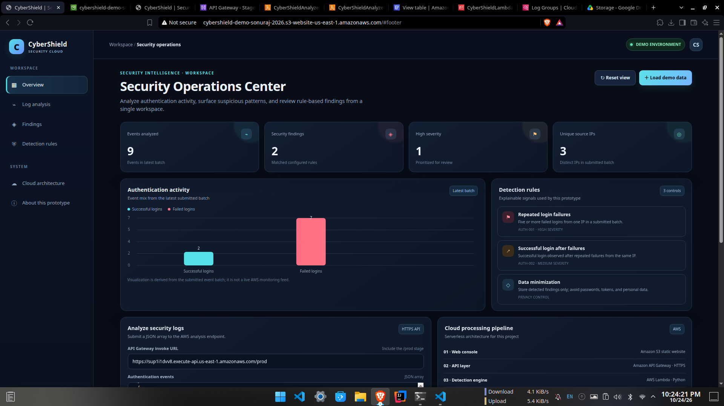
Figure 1. CyberShield overview showing event totals, security findings, severity, source IPs, and detection rules.
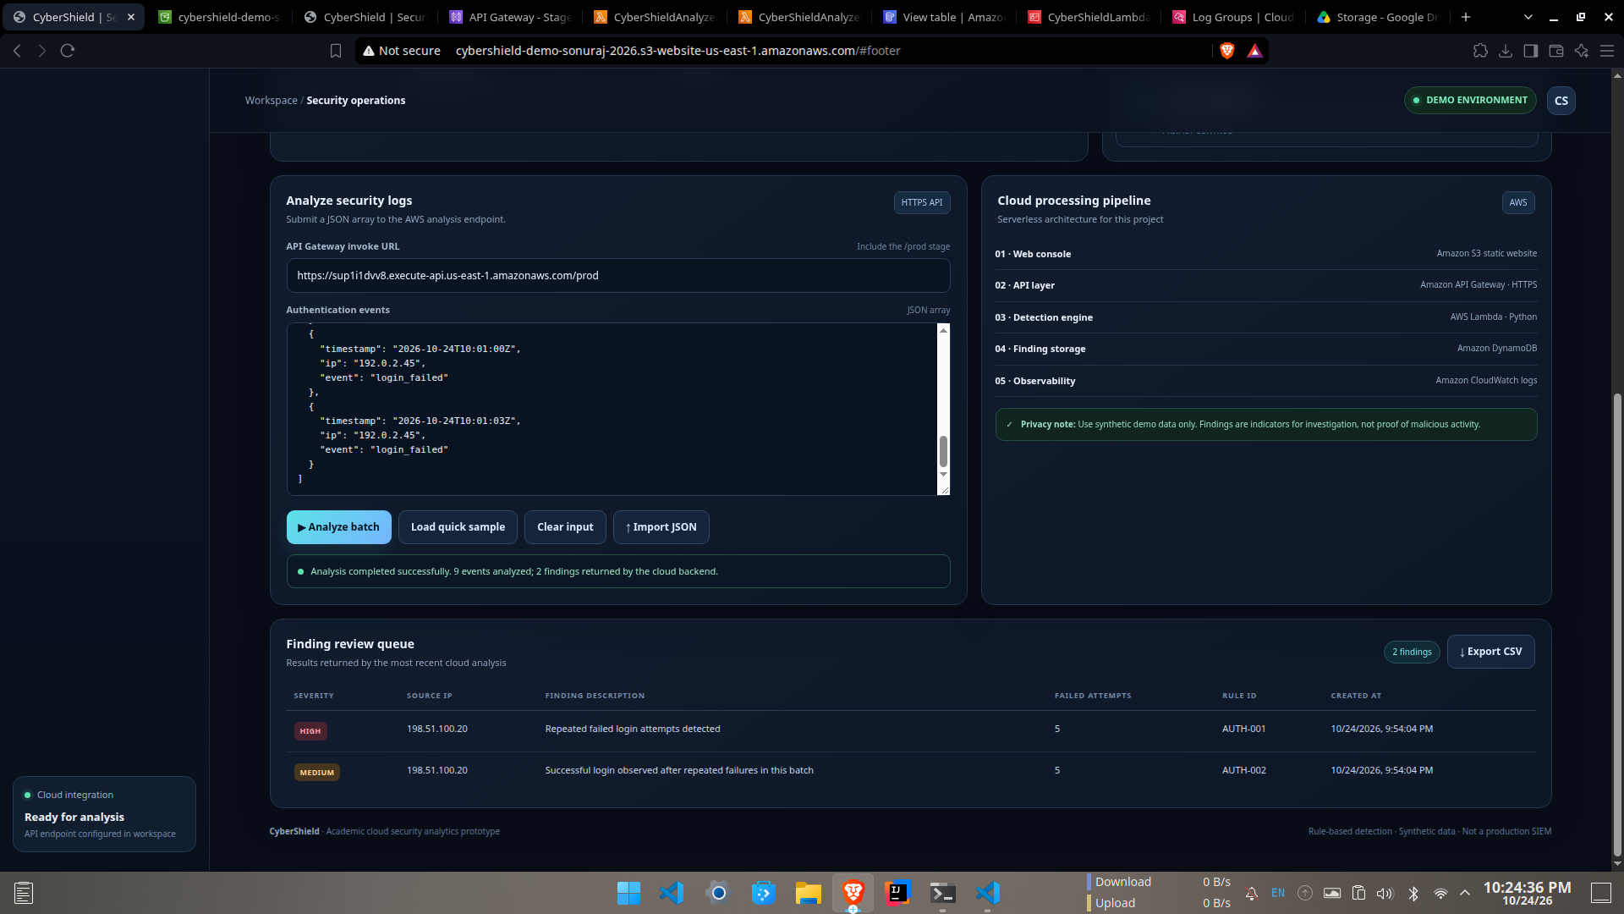
Figure 2. Log analysis form and finding review queue after successful cloud analysis.

AWS services used in the project

1. Amazon S3 — Website hosting
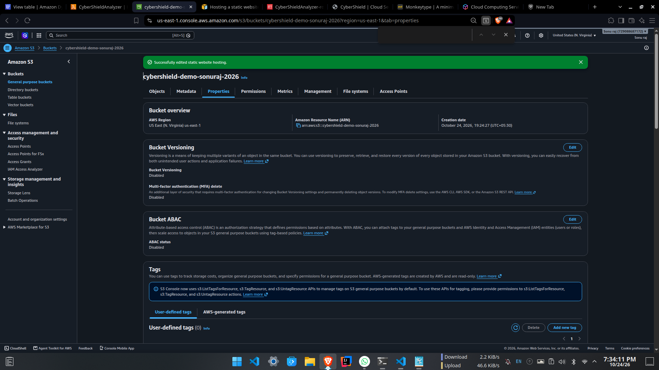
Amazon S3.
In my project , S3 stores the dashboard’s static HTML, CSS, and JavaScript files and serves website from its static website endpoint. it means a separate web server does not need to be maintained for this demonstration. Browser loads the interface from S3 and uses it to submit log events to API. Only website files intended for public viewing should be visible to public.

2. Amazon API Gateway — HTTPS API
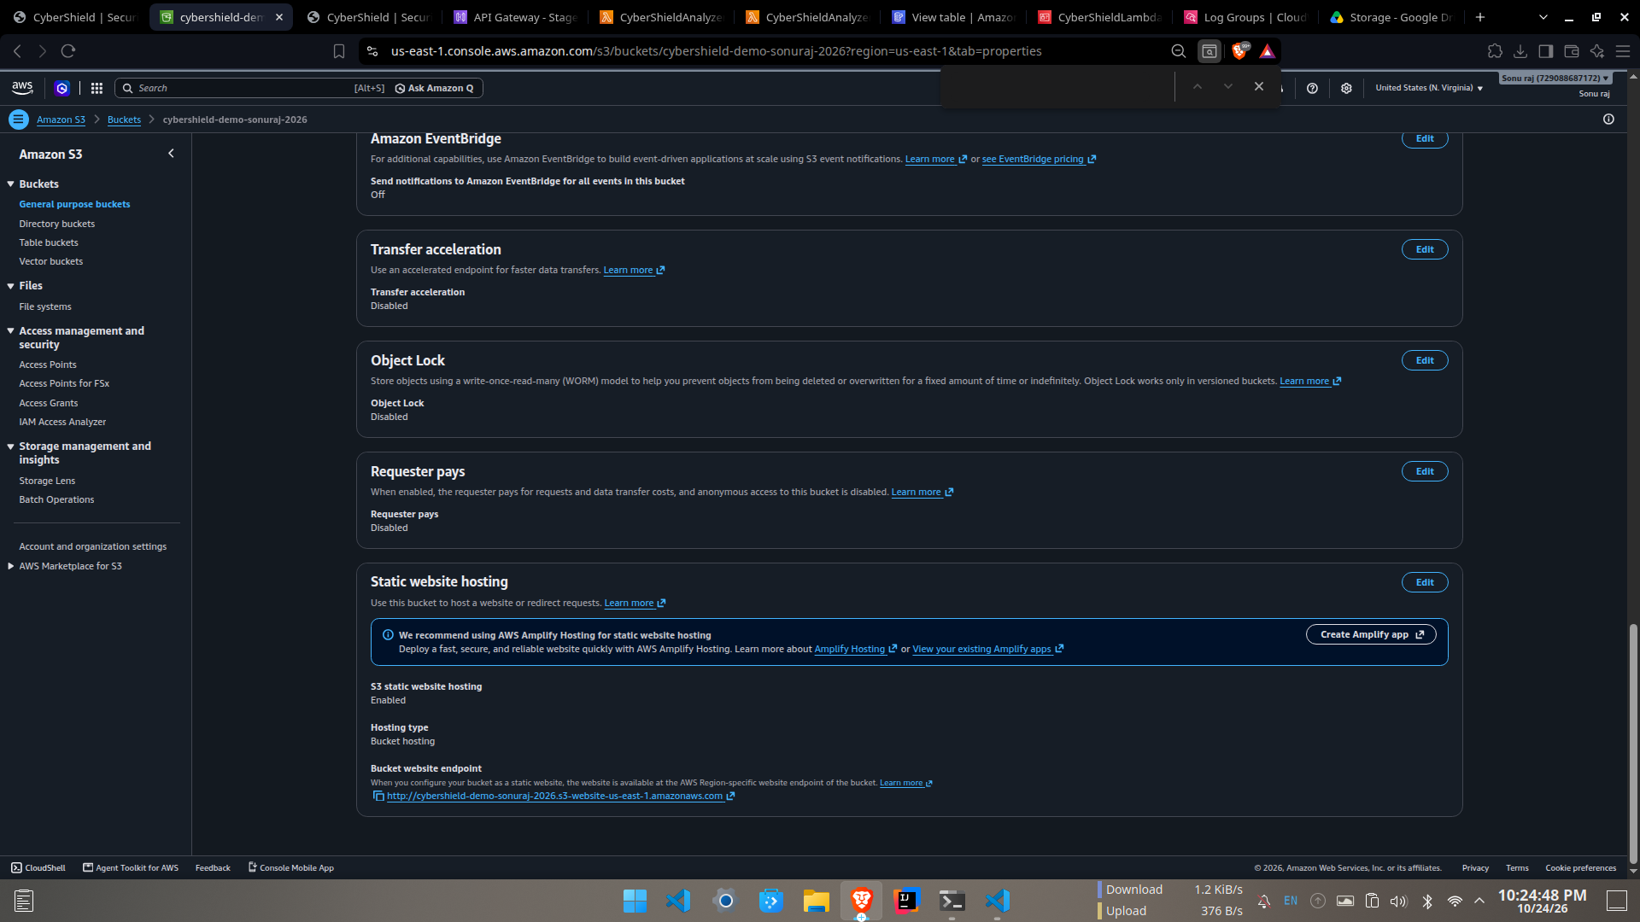
Amazon API Gateway.
Here, API Gateway provides HTTPS endpoint that the dashboard calls when user selects Analyse. It gets JSON request and route the POST /analyze request to given Lambda function. This separates the public web interface from backend processing code. CORS settings allows browser-hosted dashboards to call API from its website origin.

3. AWS Lambda — Detection engine
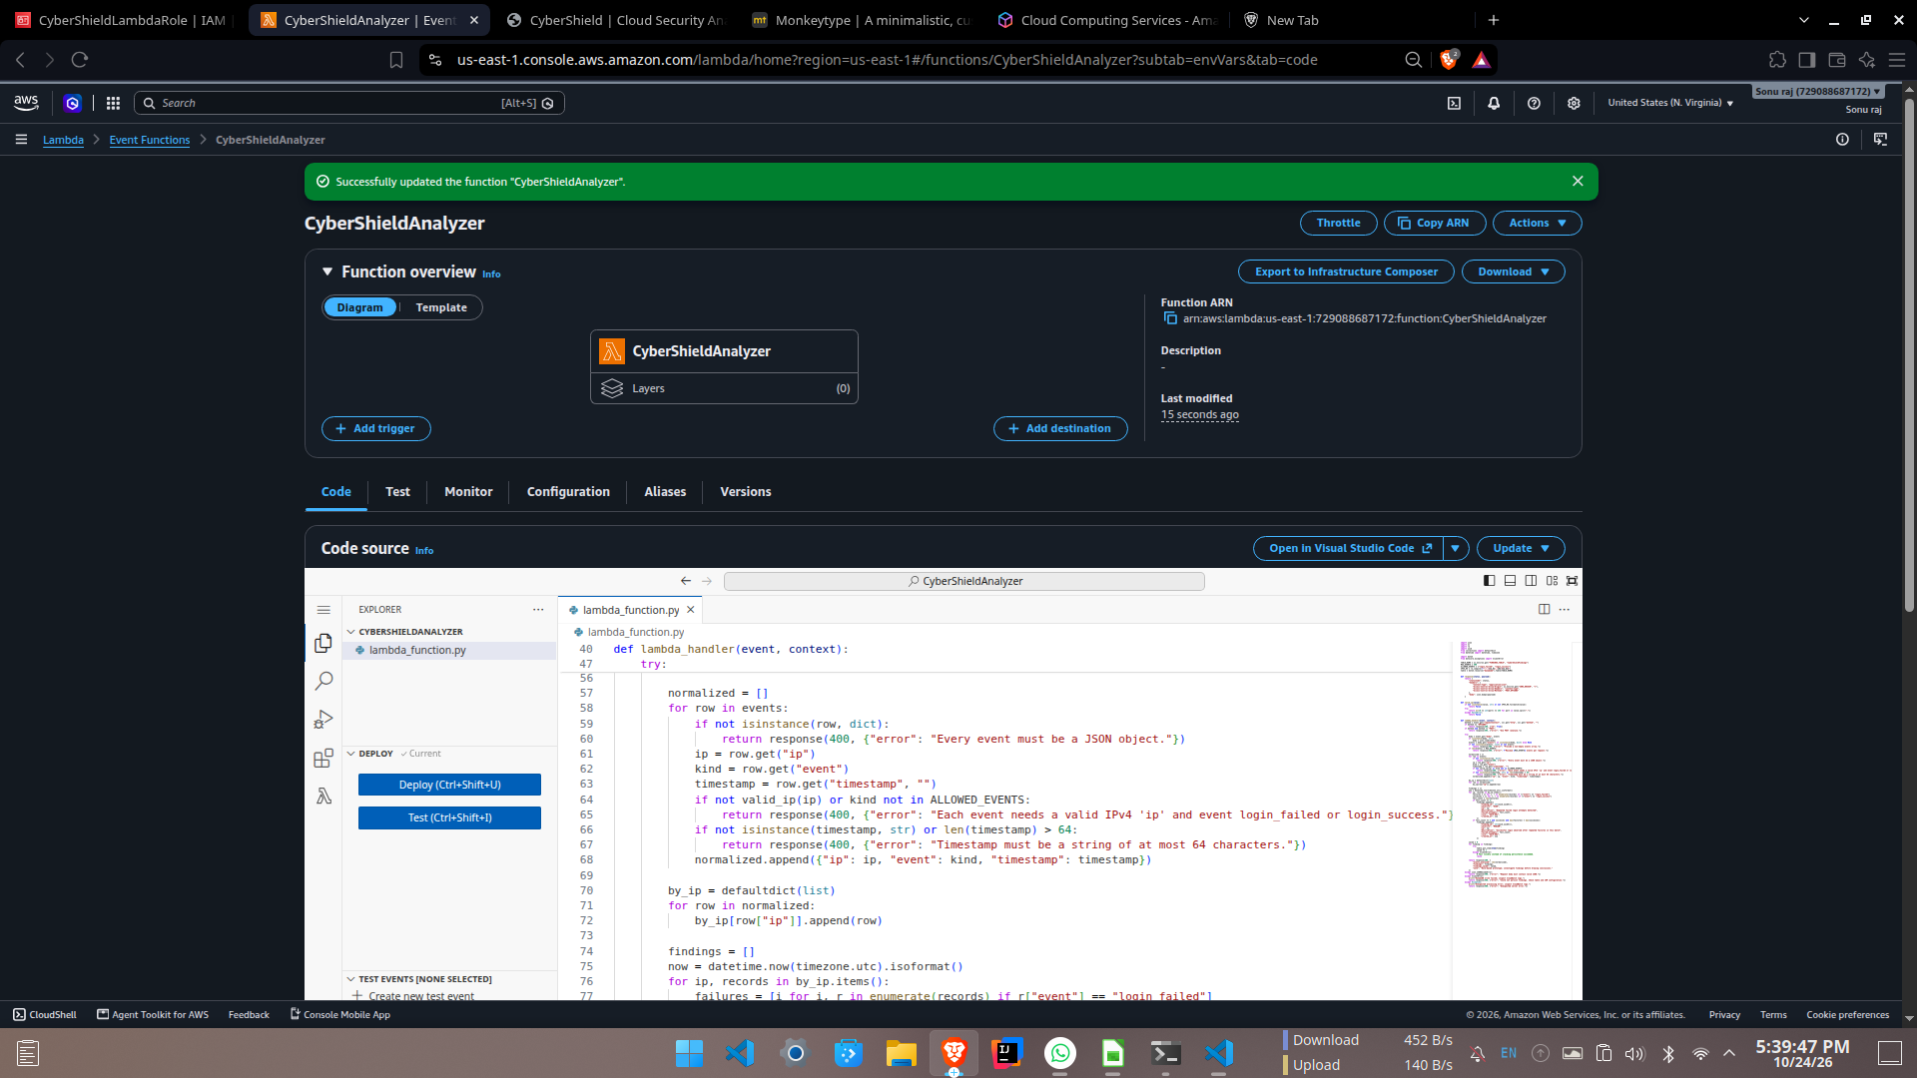
AWS Lambda.
Lambda services is used here that runs the Python backend only when an analysis request arrives, so a continuously running server is not required. This function checks the submitted events against simple rules, such as repeated failed logins from one IP address and a successful login after repeated failure. It also returns the findings and a short note explaining that alerts need investigation for the analysis.

4. Amazon DynamoDB A Findings storage
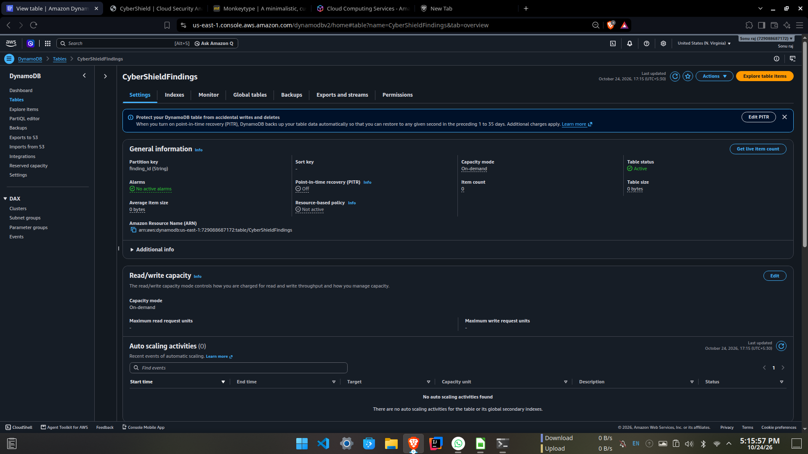
Amazon DynamoDB.
- Here, DynamoDB stores findings returned by the detection engine by creating a table. Each finding contains fields such as an ID, severity, source IP, description, rule identifier, failed-attempt count, and creation time which makes it possible to inspect saved results after an analysis request. Then table is configured with on-demand capacity for this small demonstration.

5. Amazon CloudWatch — Logs and troubleshooting
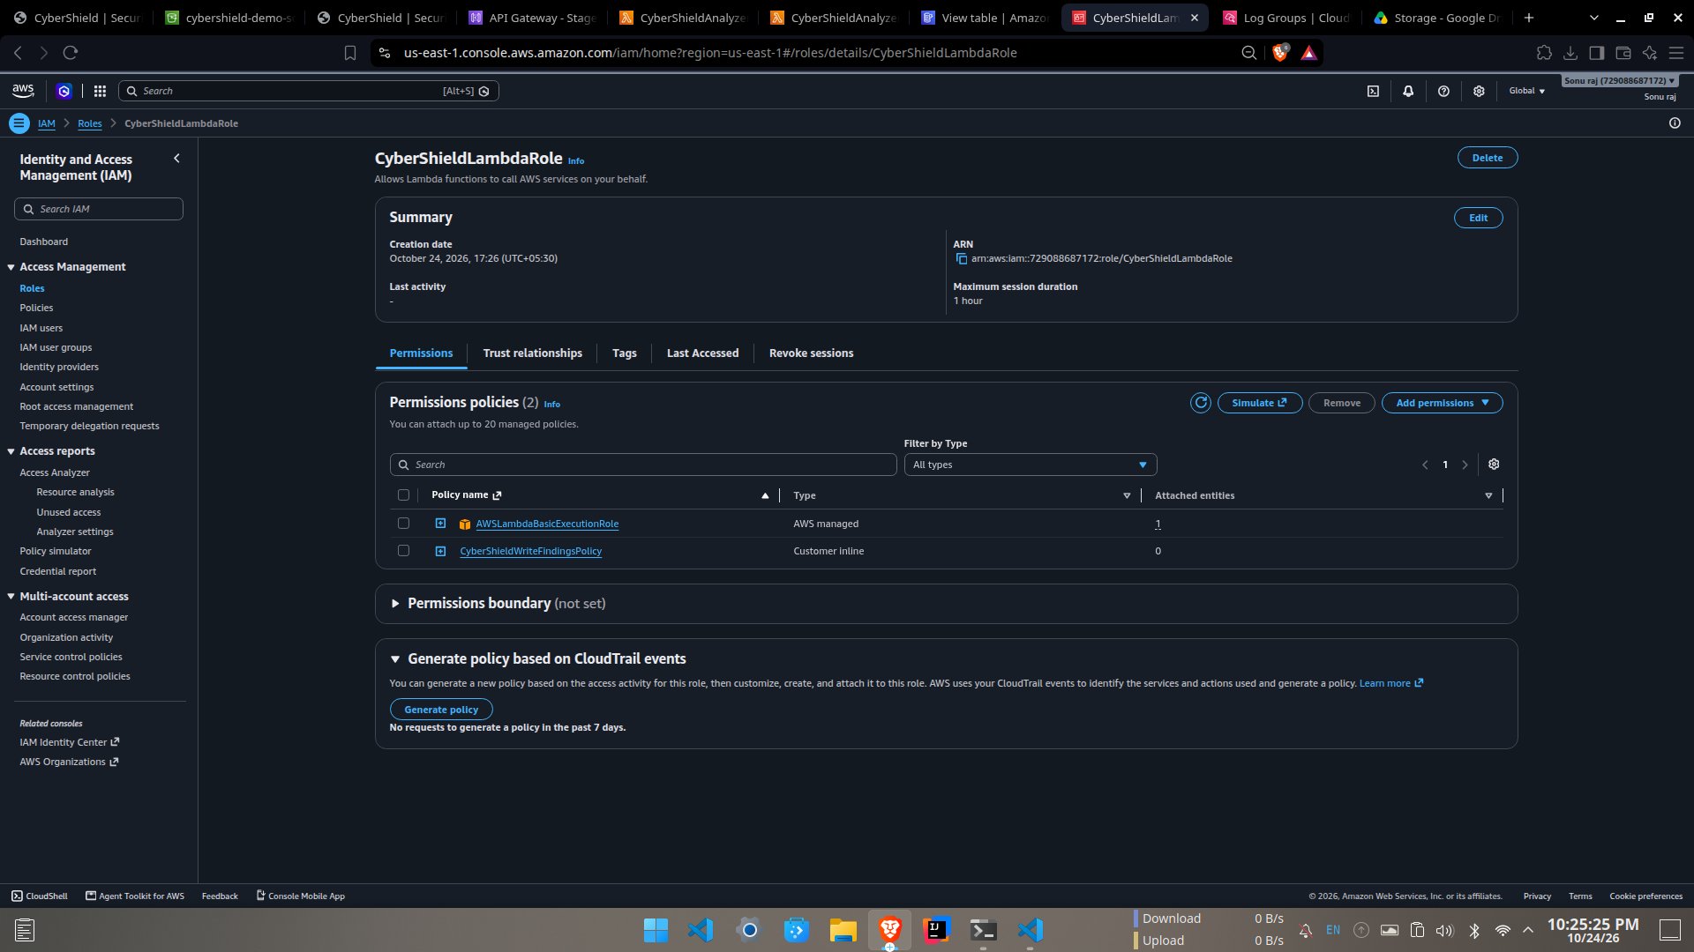
Amazon CloudWatch.
Then CloudWatch Logs records output from the Lambda function, including execution details and errors. These logs help a developer confirm which function was invoked and troubleshoot problems such as missing permissions or invalid input. CloudWatch is used here for operational visibility dashboards chart is based on submitted batch and is not a live AWS monitoring feed.

6. AWS IAM — Access permissions
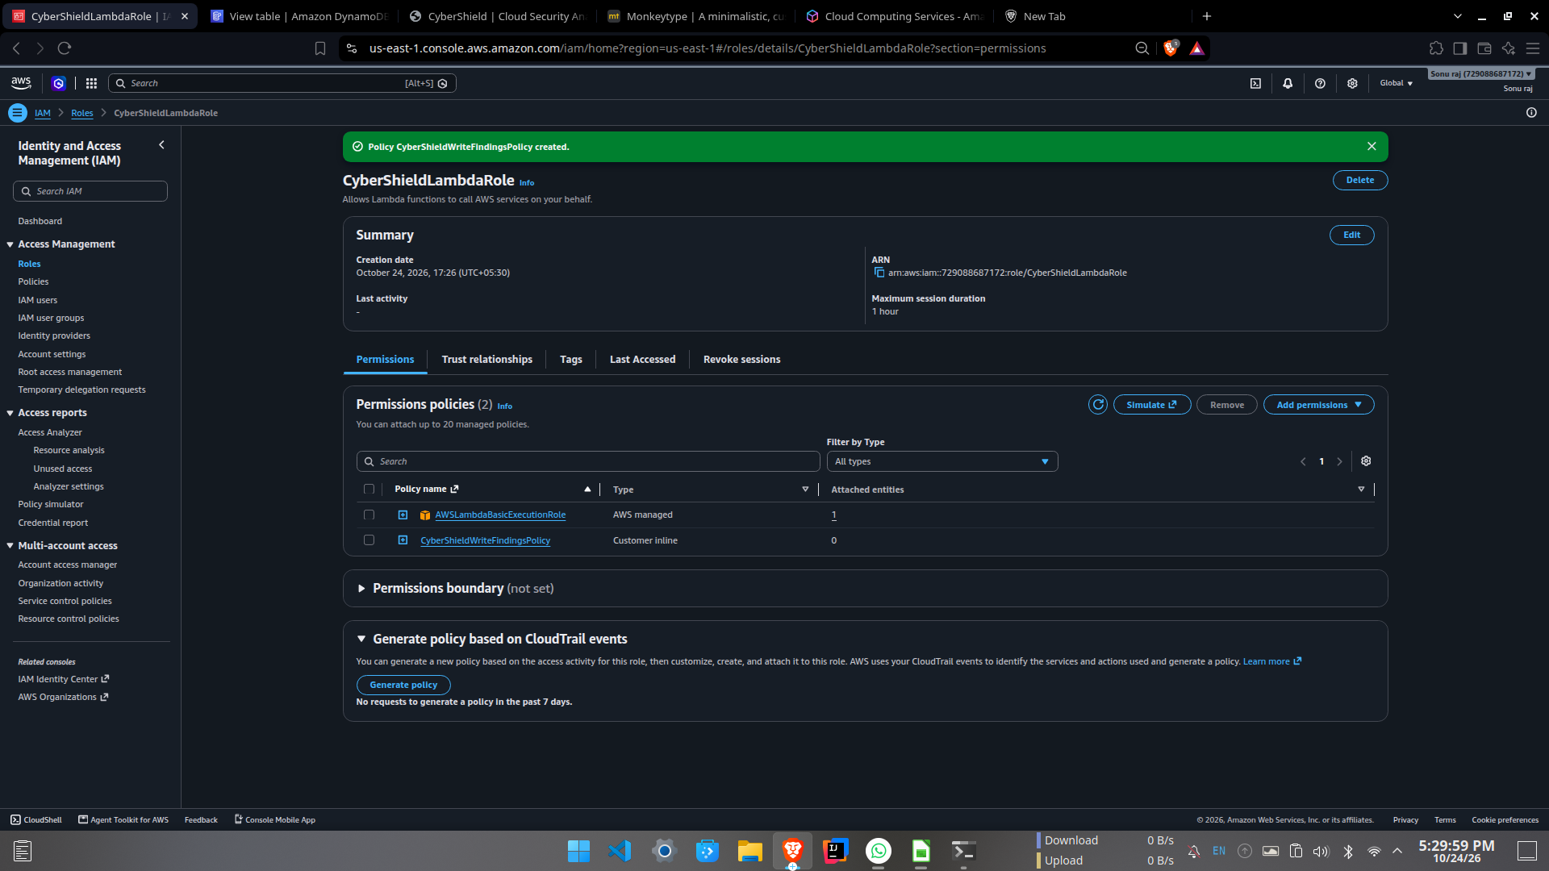
AWS IAM.
IAM defines what Lambda execution role is allowed to do. In this project,role has permission to write findings to particular specific DynamoDB table and to publish execution logs directly to CloudWatch. Limiting permissions to the resources needed by the function follows principle of least privilege. This role does not need broad administrator access to perform this particular task.

Project result
The completed project connects a static dashboard to a serverless AWS backend. In the demonstrated batch, the website reported 9 events analyzed and 2 findings, which includes one high severity repeated login failure finding and one medium severity successful login-after-failures finding. The results were returned by cloud backend and saved in DynamoDB.
This is a production Security Information and Event Management (SIEM) platform. It invents the events supplied in each request and does not independently collect log from company systems or correlate activity across separate request. Real deployment may need authenticated access, stricter origin and input validation, monitoring and retention policies, and integration with approved log sources for the future use.

