**21 When implementing linear regression of some dependent variable 𝑦 on the set of independent variables 𝐱 = (𝑥₁, …, 𝑥ᵣ), where 𝑟 is the number of predictors, which of the following statements will be true?**

1. **𝛽₀, 𝛽₁, …, 𝛽ᵣ are the regression coefficients.**
2. **Linear regression is about determining the best predicted weights by using the method of ordinary least squares.**
3. **E is the random interval**
4. **Both and b**

Ans:- d) Both a and b are true statements about linear regression.

22

What indicates that you have a **perfect fit** in linear regression?

1. The value 𝑅² < 1, which corresponds to SSR = 0
2. The value 𝑅² = 0, which corresponds to SSR = 1
3. The value 𝑅² > 0, which corresponds to SSR = 1
4. The value 𝑅² = 1, which corresponds to SSR = 0.

Ans:-The value R2=1, which corresponds ti SSR =0

23)

In simple linear regression, the value of **what** shows the point where the estimated regression line crosses the 𝑦 axis?

1. Y
2. B0
3. B1
4. F

Ans:- b) m the intercept, shows the point where the estimated regression line crosses the y axis.

24)

Check out these four linear regression plots:

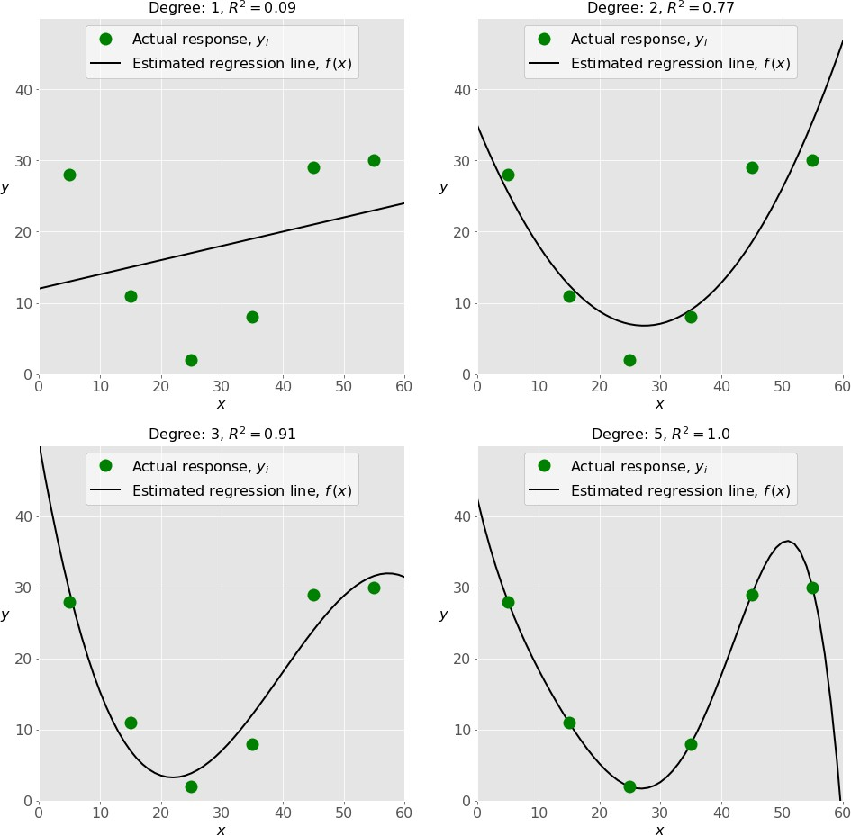

Which one represents an **underfitted** model?

1. The bottom-left plot
2. The top-right plot
3. The bottom-right plot
4. The top-left plot

Ans:- a) the bottom- left plot represents an underfitted modle.

25)

There are five basic steps when you’re implementing linear regression:

* + **a.** Check the results of model fitting to know whether the model is satisfactory.
  + **b.** Provide data to work with, and eventually do appropriate transformations.
  + **c.** Apply the model for predictions.
  + **d.** Import the packages and classes that you need.
  + **e.** Create a regression model and fit it with existing data.

However, those steps are currently listed in the wrong order. What’s the correct order?

1. e, c, a, b, d
2. e, d, b, a, c
3. d, e, c, b, a
4. d, b, e, a, c

Ans:- b) The correct order for implementing linear regression is: d ) import the pakages and classes that uou need, b) provide data to work with, and eventually do appropriate transformations,e) Create a regression model and fit it with existing data,a) Apply the model for predictions.

26 ) Which of the following are optional parameters to LinearRegression in scikit-learn?

1. Fit
2. fit_intercept
3. normalize
4. copy_X
5. n_jobs
6. reshape

Ans:- b) fit_intercept,c) normalize, d) copy_X,and e) n _jobs are optional parameters to LinearRegression in scikit-learn. A) Fit and f) reshape are not parameters for LinearRegression in scikit-learn.

1. While working with scikit-learn, in which type of regression do you need to transform the array of inputs to include nonlinear terms such as 𝑥²?
2. Multiple linear regression
3. Simple linear regression
4. Polynomial regression

Ans:- c) polynomial regression requies transforming the array of inputs to include nonliner

1. You should choose statsmodels over scikit-learn when:

A)You want graphical representations of your data.

1. You’re working with nonlinear terms.
2. You need more detailed results.
3. You need to include optional parameters.

Ans:- c) you should chose statsmodels over scikit-learn when you need more detailed results.

1. is a fundamental package for scientific computing with Python. It offers comprehensive mathematical functions, random number generators, linear algebra routines, Fourier transforms, and more. It provides a high-level syntax that makes it accessible and productive.
2. Pandas
3. Numpy
4. Statsmodel
5. scipy

Ans:- b) Numpy is a fundamental pakage for scientific computing with python

30 ) is a Python data visualization library based on Matplotlib. It provides a high-level interface for drawing attractive and informative statistical graphics that allow you to explore and understand your data. It integrates closely with pandas data structures.

1. Bokeh
2. Seaborn
3. Matplotlib
4. Dash

Ans:- b) Seaborn is python data visualization library based on matplotlib