LibroSphere - Digital Library Hub

Aim : To apply project scheduling and tracking techniques (CPM, PERT, and Gantt Chart) to analyze and manage the development of a Library Management System .

Objectives:
1. To break down website development into well-defined activities.
2. To calculate project completion time using PERT.
3. To identify the Critical Path using CPM.
4. To prepare a Gantt chart for project visualization and tracking.

Step 1: Define Activities & Dependencies

Code | Activity | Predecessor
A | Requirement Gathering & Analysis | -
B | System Design | A
C | Database Design | B
D | Frontend Development | C
E | Backend Development | C
F | System Integration | D,E
G | Testing & Debugging | F
H | Deployment & Maintenance Plan | G

Step 2: PERT Time Estimation

Using PERT Formula :
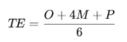
Activity | O (Days) | M (Days) | P (Days) | TE (Days)
A | 2 | 3 | 4 | 3
B | 2 | 4 | 6 | 4
C | 1 | 2 | 3 | 2
D | 3 | 5 | 7 | 5
E | 4 | 6 | 8 | 6
F | 2 | 3 | 4 | 3
G | 3 | 5 | 7 | 5
H | 1 | 2 | 3 | 2

Step 3: Draw PERT / CPM Network Diagram

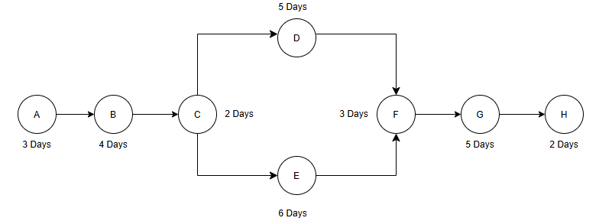

A → B → C → {D, E} → F → G → H

Critical Path : A → B → C → E → F → G → H

Project Completion Time : 25 Days

Step 4: Gantt Chart (Timeline Representation)

Activity | Duration (Days) | Start | End
A | 3 | Day 1 | Day 3
B | 4 | Day 4 | Day 7
C | 2 | Day 8 | Day 9
D | 5 | Day 10 | Day 14
E | 6 | Day 10 | Day 15
F | 3 | Day 16 | Day 18
G | 5 | Day 19 | Day 23
H | 2 | Day 24 | Day 25

