CONTEXT DIAGRAM

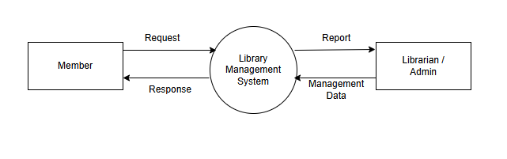

DFD LEVEL 1

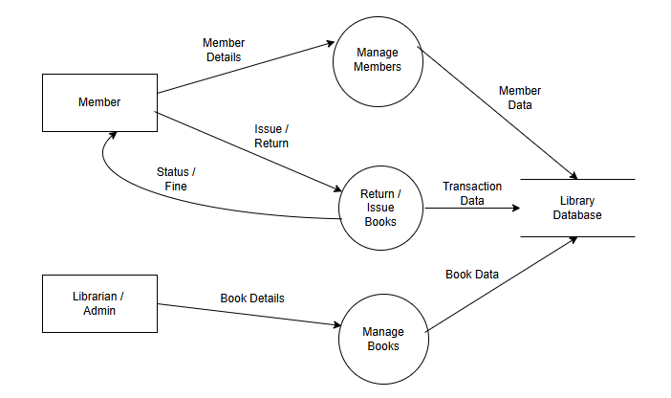

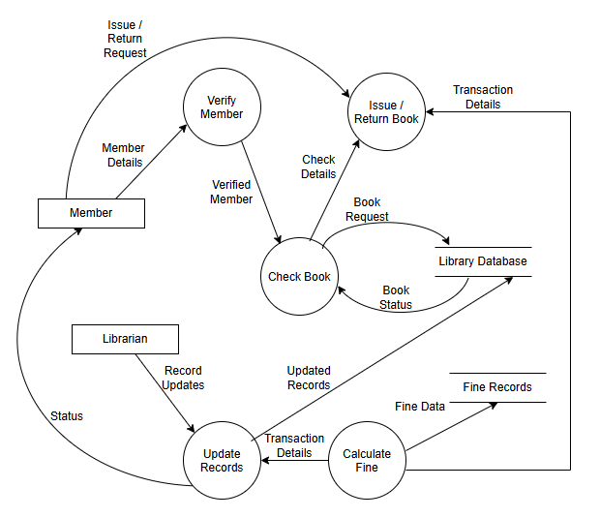

DFD LEVEL 2

