Experiment No. 08

Aim: To Explore Agile Methodology Tools (Trello) and create a Kanban board for the selected project.

Procedure:
Step 1: Open Trello
1. Open a web browser.
2. Visit the Trello website.
3. Log in using an existing account or create a new account.
4. Open the Trello workspace.

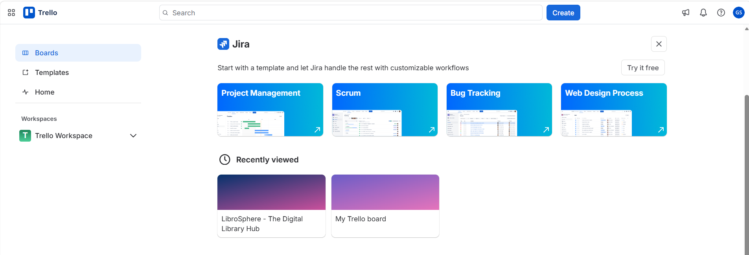

Step 2: Create a New Board
1. Click on Create.
2. Select Create Board.
3. Select a suitable background for the board.
4. Enter the name of the selected software project as the board title.
5. Click on Create.

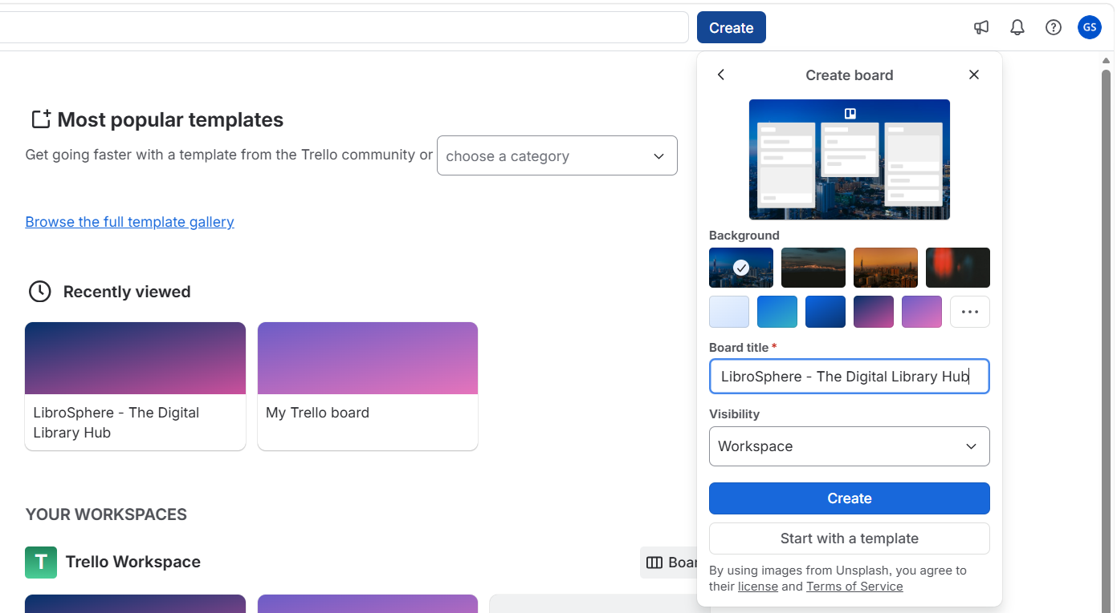

Step 3: Create Kanban Lists
Create the following lists on the board:
1. To Do
2. In Progress
3. Testing / Review
4. Done

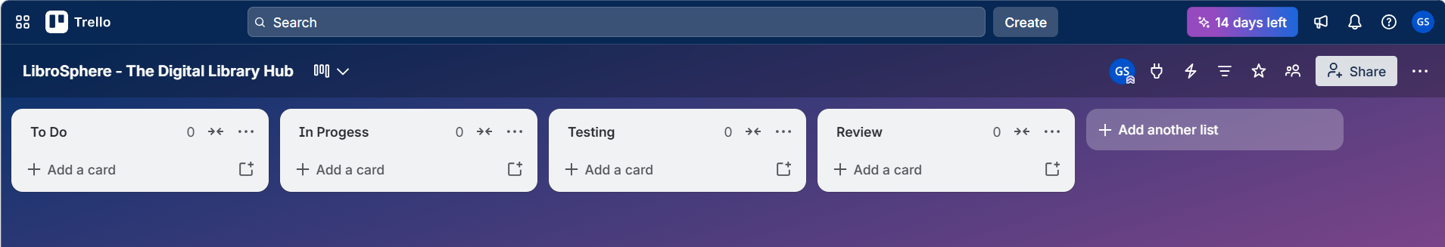

Step 4: Add Task Cards
1. Click Add a card under the To Do list.
2. Enter the name of a project task.
3. Add all the major tasks required for the project.
4. Repeat the process until all identified tasks are added.

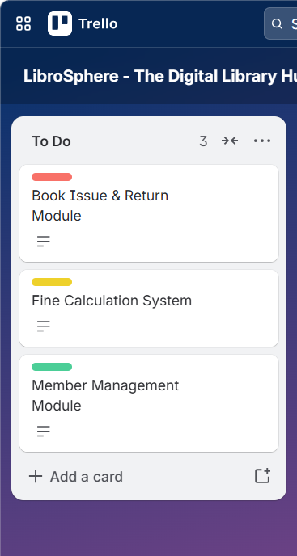

Step 5: Add Task Information
For each card:
1. Open the task card.
2. Add a brief description of the task.
3. Add a checklist if the task contains multiple subtasks.
4. Assign the card to the responsible team member (if working in a team).
5. Add a due date if required.
6. Add labels to indicate priority (e.g., High, Medium, Low) or task category.

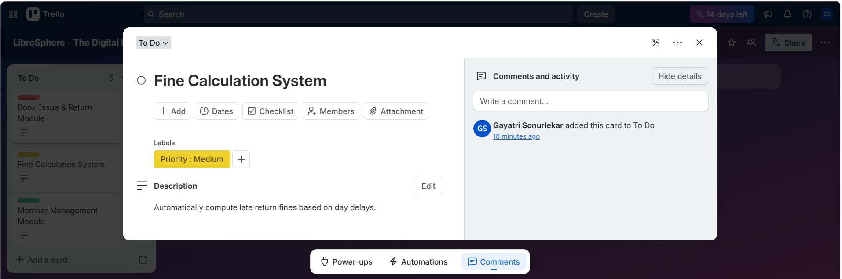

Step 6: Move Tasks Through the Workflow
As work progresses, move each card between the lists according to its current
status.
The general workflow is:
To Do → In Progress → Testing / Review → Done
1. Keep newly identified tasks in To Do.
2. Move a task to In Progress when development starts.
3. Move the task to Testing / Review after development is completed.
4. Move the task to Done after successful testing and completion.

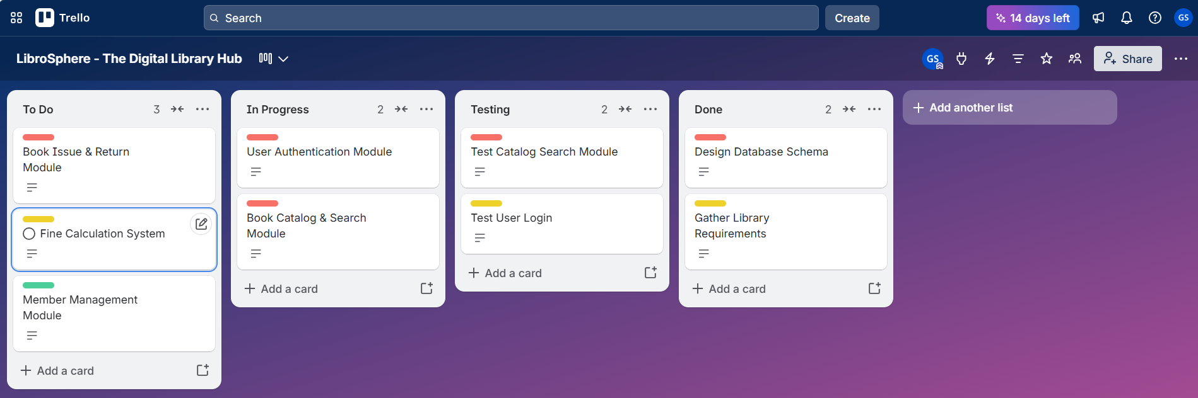

Step 7: Monitor the Kanban Board
1. Review the board regularly.
2. Check the number of pending, ongoing, testing, and completed tasks.
3. Identify tasks that are delayed or require attention.
4. Update task cards whenever their status changes.
5. Ensure that completed tasks are moved to the Done list.
Step 8: Finalize the Kanban Board
1. Verify that all major project tasks have been added.
2. Check that tasks are assigned correctly.
3. Ensure that the workflow lists are properly organized.
4. Review the completed tasks in the Done list.
5. Use the final board to track the overall progress of the project.

Result:
A Kanban board was successfully created in Trello for the selected software project.
The project tasks were organized into different stages, and their progress was
tracked using the Agile Kanban workflow.

