Model Used:
Waterfall Model

Problem Statement
A college library requires a Library Management System to maintain records of books, members, book issues, returns, fines, and librarian activities. The system should allow the librarian to efficiently manage the library database while enabling students to search for books, check availability, and maintain borrowing records. The software should be reliable, user-friendly, and capable of reducing manual work and improving the overall efficiency of library operations.

Waterfall Model

Why Waterfall Model is chosen:
The Waterfall Model is selected because the requirements of the Library Management System are clearly defined before the development begins. The project follows a sequential approach where each phase is completed and documented before moving to the next one. Since the functionality of the system, such as managing books, members, issuing and returning books, and generating reports, is stable and unlikely to change frequently, the Waterfall Model provides a systematic and organized method of software development. It also helps in proper planning, easy project management, detailed documentation, and thorough testing before deployment.

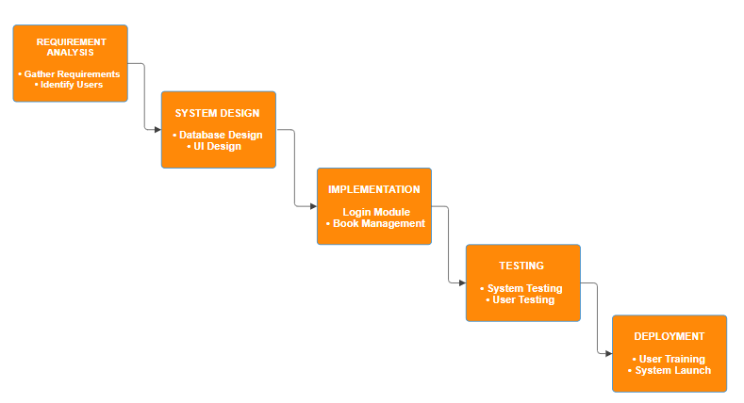
Phases

Requirement Analysis

Objective:
To gather and analyze all functional and non-functional requirements of the Library Management System before starting the design and development process.
During this phase, meetings are conducted with the librarian and management to understand their requirements. The software should allow the librarian to add, update, and remove book records, maintain member information, issue and return books, calculate fines for overdue books, and generate reports. The system should also provide secure login facilities for the administrator and ensure that only authorized users can access sensitive information. All these requirements are documented carefully so that they can be used in the next phase without ambiguity.

Technology Consideration:
• Front-end: React.js, Bootstrap
• Back-end: Node.js, Express.js
• Database: MongoDB

System Design

Objective:
To prepare the complete design of the Library Management System before implementation.
In this phase, the overall architecture of the software is prepared. User interfaces for book management, member registration, issue and return sections, fine management, and report generation are designed. Database tables are created to store details of books, members, transactions, fines, and administrators. ER diagrams and Data Flow Diagrams are also prepared to represent the relationship between different entities and the flow of information within the system. This design acts as the blueprint for software development.

Database Design Includes:
- Book Table
- Member Table
- Issue and Return Table
- Fine Table
- Librarian Table
- Admin Login Table

Implementation (Coding)

Objective:
To develop the Library Management System according to the approved design.
In this phase, the actual coding of the software begins. Each module is developed separately according to the design specifications. The book management module is created to add, update, delete, and search books. The member management module stores student information and membership details. The issue and return module records book transactions and automatically calculates due dates. The fine management module calculates penalties for overdue books, while the report module generates various reports required by the librarian. After developing each module, it is integrated into the complete system.

Technology Used:
• React.js
• Node.js
• Express.js
• MongoDB
• Bootstrap

Testing

Objective:
To verify that the software functions correctly and satisfies all user requirements.
Once the coding is completed, the Library Management System undergoes different levels of testing. Unit testing is performed to verify that each module functions independently without errors. Integration testing ensures that all modules communicate properly with each other. System testing verifies the complete functionality of the software under different operating conditions. Finally, User Acceptance Testing (UAT) is carried out by the librarian, who checks whether the software fulfills all the specified requirements before it is deployed for actual use.

Testing Types:
- Unit Testing
- Integration Testing
- System Testing
- User Acceptance Testing (UAT)

Deployment

Objective:
To install the completed software and make it available for daily library operations.
After successful testing, the Library Management System is installed on the library computer or server. The database is configured, administrator accounts are created, and all existing library records are entered into the system. Librarians are trained to use the software efficiently for managing books, issuing and returning books, and generating reports. Once the installation and configuration are completed successfully, the software is made available for regular use in the library.

Maintenance

Objective:
To provide continuous support after the system has been deployed.
After deployment, regular maintenance is carried out to ensure the smooth functioning of the software. Any errors or bugs reported by users are fixed promptly. The database is updated whenever new books or members are added. Security patches are applied regularly to protect library data from unauthorized access. Performance improvements are made whenever necessary, and additional features such as barcode scanning, online book reservation, or email notifications can be added in future versions of the software according to the library's requirements.

Outcome

By following the Waterfall Software Process Model, the Library Management System is developed in a systematic and well-documented manner. Each phase is completed before moving to the next, ensuring that the software is reliable, easy to maintain, and meets all the requirements of the library. The completed system simplifies library operations by automating book management, member registration, issue and return processes, fine calculation, and report generation, thereby improving efficiency and reducing manual effort.

