%Program For Filter Realization.

%Sonu Shrama

%TE EXTC B Roll No.:630

%Direct Form 1

a=[1,-1,0.166]

b=[1,1,0.125]

DF=dfilt.df1sos(b,a)

realizemdl(DF)

Direct Form 1 Output:

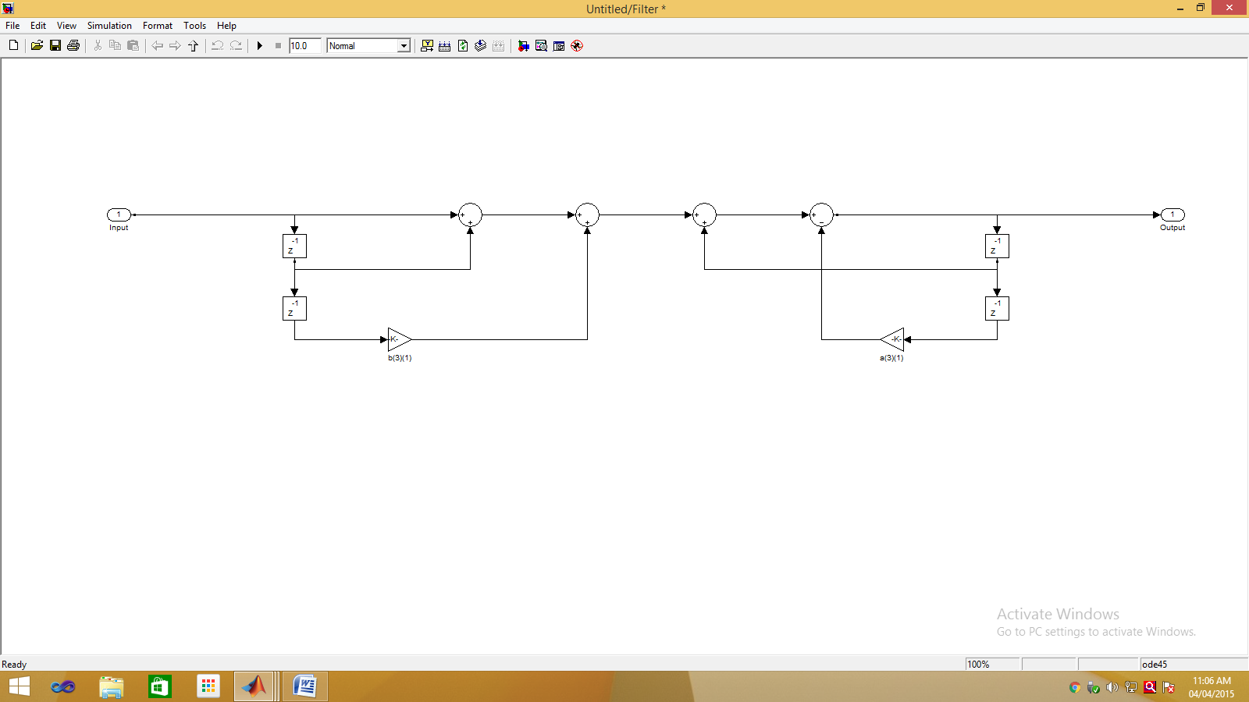

%Direct Form 2

a1=[1,-1,0.166]

b1=[1,1,0.125]

DF1=dfilt.df2sos(b1,a1)

realizemdl(DF1)

Direct Form 2 Output:

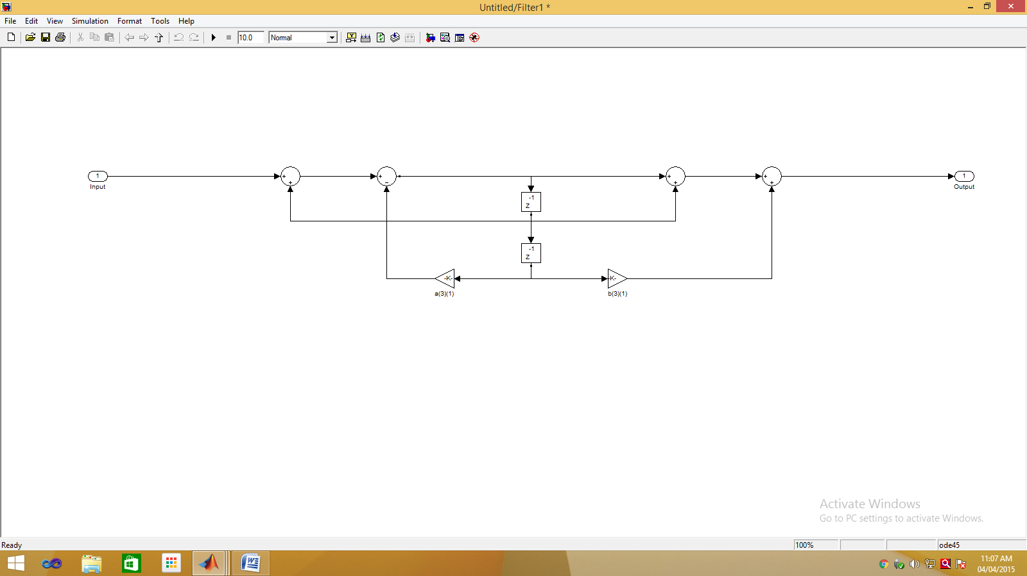

%Cascade Form

a2=[1,-0.7886]

b2=[1,0.146]

H1=dfilt.df2sos(b2,a2)

a3=[1,-0.2113]

b3=[1,0.8535]

H2=dfilt.df2sos(b3,a3)

DF2=dfilt.cascade(H1,H2)

realizemdl(DF2)

Cascade Form Output:

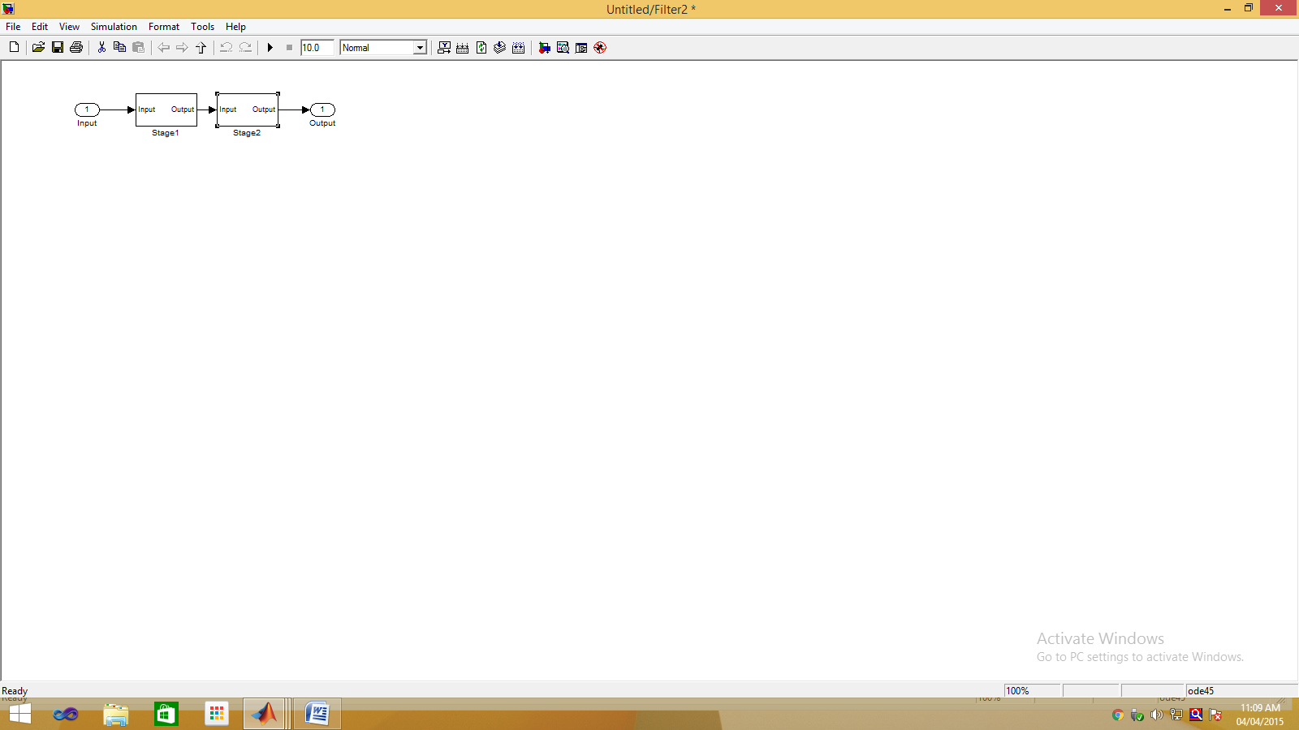

Stage 1 Output:

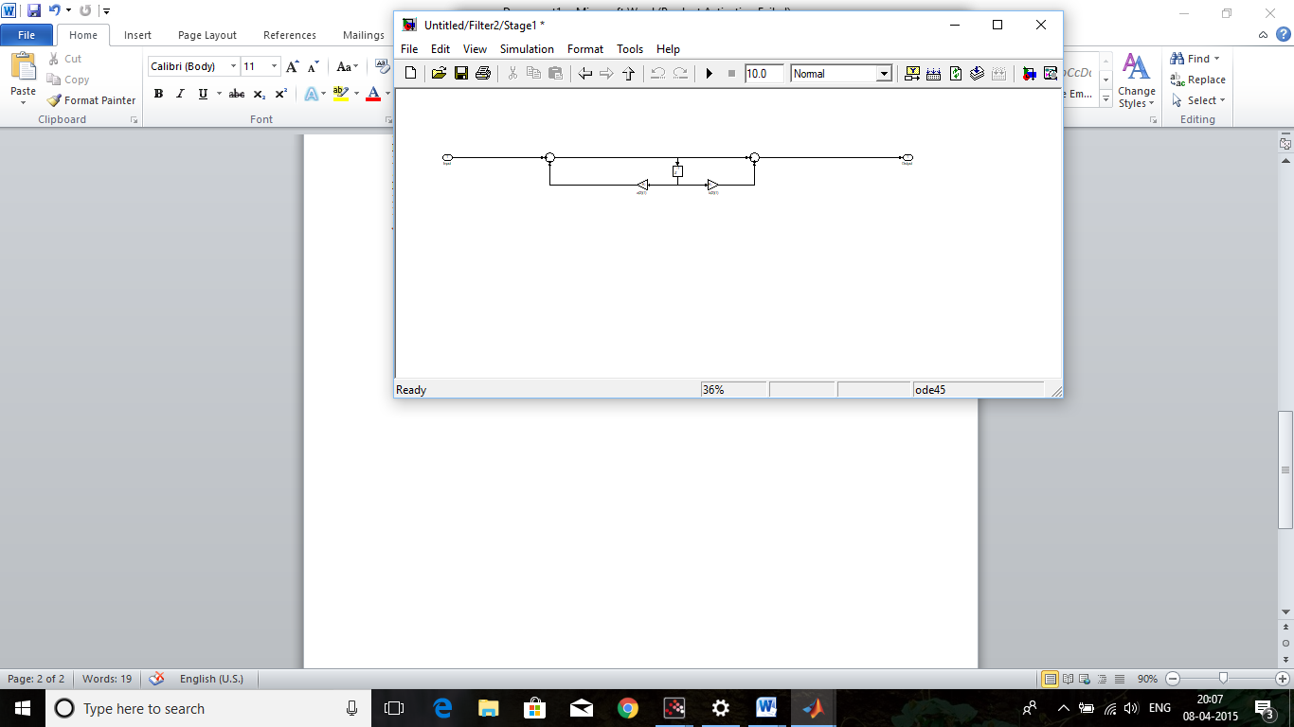

Stage 2 Output:

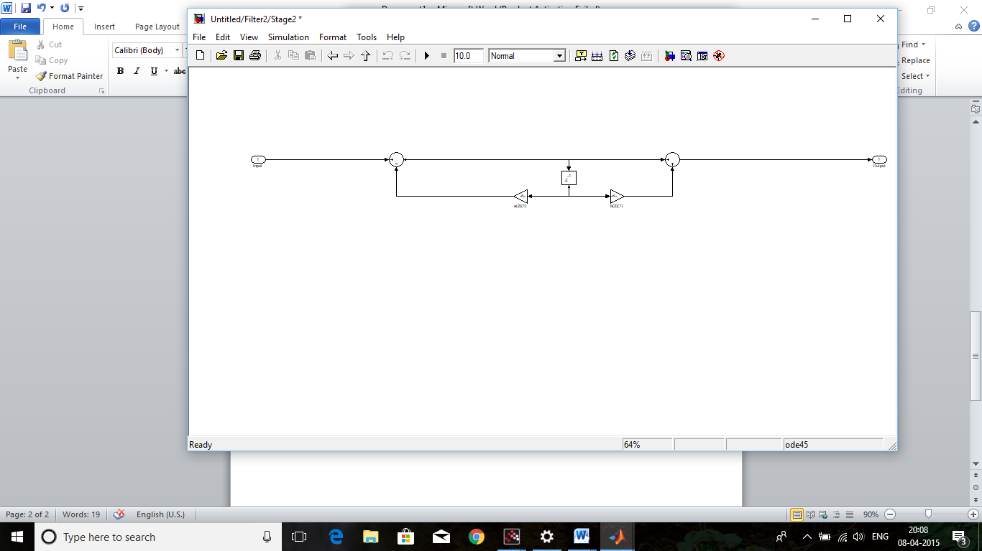

%Parallel Form

c1=[1]

d1=[0.75]

P1=dfilt.df2sos(c1,d1)

c2=[1,-0.7886]

d2=[3.337]

P2=dfilt.df2sos(c2,d2)

c3=[1,0.2113]

d3=[3.12]

P3=dfilt.df2sos(c3,d3)

X=dfilt.parallel(P1,P2,P3)

realizemdl(X)

Parallel Form Output: Stage 1 Output:

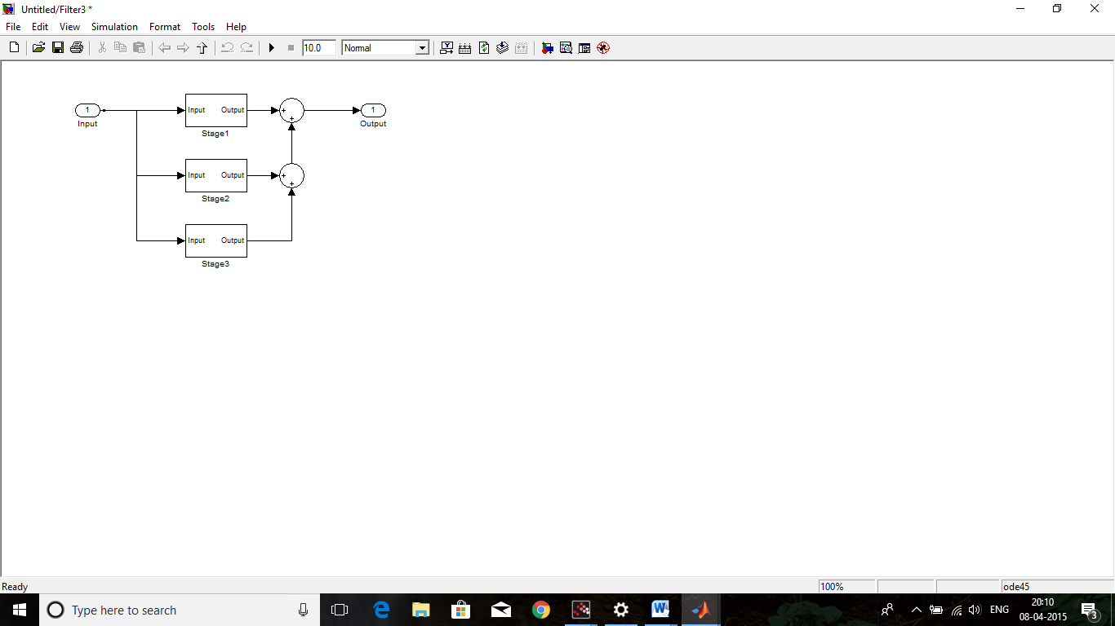

Stage 2 Output: Stage 3 Output:

