Corporate customer:

Figure Corporate customer

Requests:

Disputes:

Bill:

Transactions:

Balance share:

Interaction:

Notification:

Billing account:

click on BB1 BA details open:

Account info:

Contracts & address:

Documents:

Usage:

Contracts;

View plan:

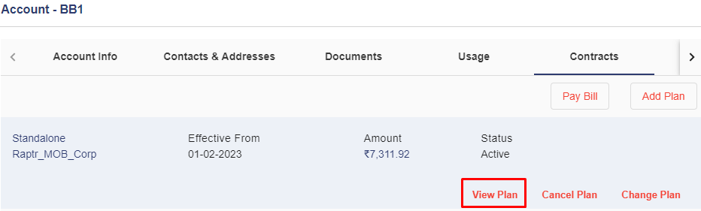

Cancel plan:

Change plan:

Add plan:

Pay bill:

After clicking the icon in highlighted.

Devices:

Click on replacement.

Requests:

Disputes:

Transactions:

Bills:

Coupons:

Relations:

Auto debit:

Ownership details:

Orders:

After click on eye icon:

After click on work order information:

Compare with:

Interaction:

Notification:

3.2 **View corporate customer**.

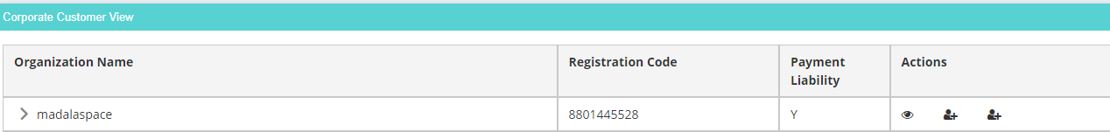

After clicking on eye icon

Create account : button

Node creation:

