淘宝网登陆

①Overview
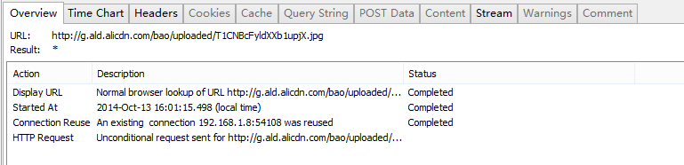
②Time Chart
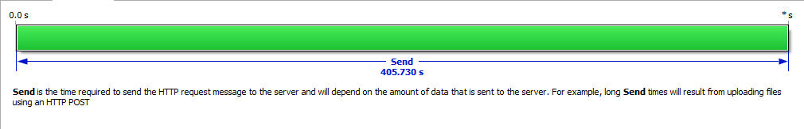
③Header
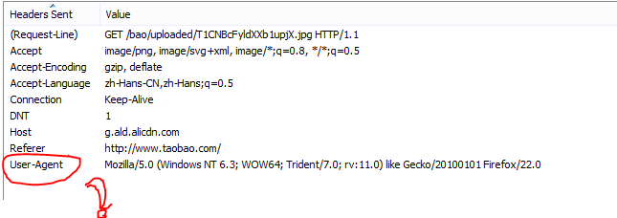
④Cookies
⑤Cache
⑥Query String
⑦Post Data
⑧Stream

