Software Requirements Specification

20 June, 2016

Gadgetsmend

Team members:

Sonu Tiwari

Mayank Dhiman

Shimona Arora

Prepared By:

Shimona Arora

# Table of Contents

Table of Contents 2

List of Figures 3

1.0. Introduction 4

1.1. Purpose 4

1.2. Scope of Project 4

1.3. Glossary 4

1.4. References 5

1.5. Overview of Document 5

2.0. Overall Description 6

2.1 System Environment 6

2.2 Functional Requirements Specification 6

2.2.1 Customer’s use case 7

Use case: Place order 7

Use case: Ask about time 7

Use case: Ask about cost 8

Use case: Give feedbacks 8

2.2.2 Employee’s Use case 9

Use case: Send request to engineer 9

Use case: Send confirmation email 10

Use case: Notify time to customers 10

Use case: Notify cost to customers 11

2.2.3 Engineer’s use case 11

Use case: Accept or decline order 11

2.2.4 Delivery boy’s use case 12

Use case: Pickup gadget 12

Use case: Deliver gadget 13

2.3 User Characteristics 14

2.4 Non-Functional Requirements 14

3.0. Requirements Specification 14

3.1 External Interface Requirements 14

3.2 Functional Requirements 15

3.2.1 Customer’s use cases 15

3.2.2 Employee’s use cases 17

3.2.3 Engineer’s use case 19

3.2.4 Delivery boy’s use cases 20

3.3 Detailed Non-Functional Requirements 21

3.3.1 Logical Structure of the Data 21

3.3.2 Security 25

# List of Figures

Figure 1 - System Environment 6

Figure 2 – Customer’s use cases 7

Figure 3 – Employee’s use cases 9

Figure 4 – Engineer’s use cases 11

Figure 5 –Delivery boy’s use cases 12

# 1.0. Introduction

## 1.1. Purpose

The purpose of this document is to present a detailed description of the Web application ‘Gadgetsmend’. This document will explain the purpose and features of the system, the interfaces of the system, what the system will do, the constraints under which it must operate and how the system will react to external stimuli. This document is intended for both the stakeholders and the Employees of the system and will be proposed to for its approval.

## 1.2. Scope of Project

Web application Gadgetsmend will be such an application in which customers can place an order to repair or service their damaged gadgets like Mobile Phones, Laptops, TV and Refrigerators etc. This system will be helpful for those people who live busy lives and have no time to go to engineers for repairing or servicing their gadgets. This system is designed to provide an online interaction between engineers and customers.

More specifically customers can explain problems in their gadgets to the engineers without manually approaching them. This system has been prepared by a start-up company Gadgetsmend. This web application can be helpful for customers in saving their precious time. For maintaining integrity between customers’ order and assigned engineer a relational database system will be used.

## 1.3. Glossary

|  |  |
| --- | --- |
| **Term** | **Definition** |
| Damaged device | A device that has to be serviced or repaired. |
| Engineer/Mechanic | A person who will repair gadget. |
| Database | Collection of all the information monitored by this system. |
| Delivery Boy | A person who will pick up gadget from your home and deliver the repaired gadget to your home. |
| Customer | A person who wants his gadget serviced or repaired. |
| Software Requirements Specification | A document that completely describes all of the functions of a proposed system and the constraints under which it must operate. For example, this document. |
| Stakeholder | Any person with an interest in the project who is not a Employee. |

## 1.4. References

IEEE Std 830-1998 IEEE Recommended Practice for Software Requirements Specifications. IEEE Computer Society, 1998.

## 1.5. Overview of Document

The next chapter, the Overall Description section provides an overview of the functionality of the web application. It describes the requirements in an informal manner and in simplest language. This section of the document can be understood by both non IT and IT people. This section is helpful in changing the informal requirements to the technical specifications which will be used in next chapter of this document.

The third chapter, Requirements Specification section, of this document is written primarily for the Employees and describes the functionality of the product in technical terms so that Employees can understand that what kind of system they have to develop.

## 

# 2. Overall Description

## 2.1 System Environment

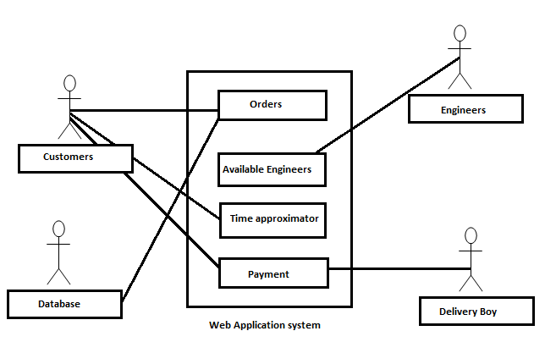

Figure-1: System Environment

The Web Application ‘Gadgetsmend’ has four active actors and one cooperating system. Customers can place order, check the tie approximation and pay money. Database is updated when an order is placed. Available engineer’s component is used to check the availability of engineers. Delivery boy collects payment from customer.

<< Web Application System has divided into four component parts, the Customers, the time approximate, the Delivery boy and the Database >>

## 2.2 Functional Requirements Specification

This section outlines the use cases for each of the stakeholders of Gadgetsmend web application.

**2.2.1 Customers’ use case:**

#### 1) Use case: Place Order

**Diagram:**

Customer

Place order

**Figure – 2.2.1.1**

**Brief Description**

A Customer can place order through web application.

**Initial Step-By-Step Description**

Before initiation of use case place order, user has already accessed web application through Internet.

1. The customer selects the gadgets option in web application.
2. Then he/she selects the appropriate gadget.
3. Then he/she selects one of the options from service or repair.
4. If repair option has been selected then user will have to write a note on what is the problem with his/her gadget or he/she can also describe the problem to the web application team on a phone call.
5. After it he/she will place order.

#### 2) Use case: Ask about time

**Diagram:**

Customer

Ask about time period

**Figure – 2.2.1.2**

**Brief Description**

If the customer wants to know the predicted time period in which his/her gadget will be repaired then he/she can raise the request by pressing the button ‘approximated time’.

**Initial Step-By-Step Description**

Before this use case can be initiated, customer has already selected the device that is to be repaired or serviced. If the device is to be repaired then customer has also described about the problem to the Employee either by a note or by a phone call.

1. Customer presses the button ‘approximated time’.
2. Employee checks the time and responds to the customers’ request.

#### 3) Use case: Asks about cost of repair/service

**Diagram:**

Customer

Asks cost of repairing/servicing

**Figure – 2.2.1.3**

**Brief Description**

Customer wants to know in how much cost his device will be repaired or serviced.

**Initial Step-By-Step Description**

1. Customer selects the option of ‘predict cost’.
2. Employee sends the request to the Engineer to know about the cost of repair.
3. Employee responds back to the customer about predicted cost.
4. Customer has also been told that if any additional expense would be used then he will be notified through a phone call or via an email. Now it will be customers’ choice to accept or decline that additional expense.

#### 4) Use case: Give feedback

**Diagram:** **Figure – 2.2.1.4**

Customer

Give feedback

**Brief Description**

Customers’ device has been repaired or serviced and now he/she wants to give some feedback to the Employee team.

**Initial Step-By-Step Description**

Before this use case can be initiated, customer has received his/her repaired or serviced gadget.

1. Customers can do rating of web application.
2. They can suggest what should be improved in web application either by an email or writing comments.
3. They can also notify about what was the good quality in the application.

2.2.2**Employee’s use case**

#### 1) Use case: Send request to engineer

**Diagram:**

Employee

Send request to engineer

**Figure – 2.2.2.1**

**Brief Description**

Employee accepts the orders placed by customer and send request to intended engineers.

**Initial Step-By-Step Description**

Before this use case can be initiated, Employees are connected to web application and have pressed ‘check intended engineer’ button.

1. Customer places the order.
2. The Employee sends the request to intended engineer.

#### 2) Use case: send confirmation email

**Diagram:** **Figure – 2.2.2.2**

Employee

Send confirmation email

**Brief Description**

If engineer accepts the order placed by customer then Employee sends confirmation email to the customer.

**Initial Step-By-Step Description**

Before this use case can be initiated, the Employee has already sent the request to the Engineer.

1. If the engineer accepted the request then employee sends the confirmation email to the customer.
2. If engineer has declined the request then declination message or notification will be sent to the customer.

#### 3) Use case: notify approximate time

**Diagram:**

Employee

Notify approximate time

**Figure – 2.2.2.3**

**Brief Description**

Here customer has requested to know the approximate time information. Employee will use some automated tool to calculate time approximation.

**Initial Step-By-Step Description**

Before this use case was generated, customer has raised the request to know about time approximation.

1. Employee finds that customer wants to know the amount of time within which his/her device will be repaired or serviced.
2. Employee uses some automated tools like calculators and schedulers to find the approximate time period.
3. After calculating he notifies the customer about what will be the estimated time period.

#### 4) Use case: notify predicted cost

**Diagram:**

Employee

Notify predicted cost

**Figure – 2.2.2.4**

**Brief Description**

Here customer has requested to know the approximate that will he will have to spend on repairing or servicing his/her gadget.

**Initial Step-By-Step Description**

Before this use case was generated customer has selected the option ‘predict cost’.

1. Employee finds that customer wants to know the amount of cost within which his/her device will be repaired or serviced.
2. Employee takes the help of engineer to know about the approximated cost.
3. After that he notifies the customer about predicted cost.
4. Employee also notifies the customer that if any additional expense would be needed then team will contact with customer and ask about his confirmation.
   * 1. **Engineers’ use case**

#### Use case: Accept order

Engineer

Accept or decline order

**Diagram:**

**Figure – 2.2.3.1**

**Brief Description**

Engineer accepts or declines the order placed by customer. One Engineer can accept more than one order.

**Initial Step-By-Step Description**

Before this use case can be initiated, the engineer is already connected to the web application and pressed the button ‘accept order’. The button ‘accept order’ is only provided to the engineers of web application but not to anyone else.

1. A request has arrived by employee to the engineer.
2. If engineer finds that he/she would be able to repair or service the device then he/she will select acceptance option.
3. If engineer finds that he/she would not be able to repair the device for some reasons then he/she will select declination option.

### Delivery boy’s Use Case

#### 1) Use case: Pick up gadget

**Diagram:**

Delivery Boy

Pick Up gadget

**Figure – 2.2.4.1**

**Brief Description**

The delivery boy picks up the gadget from the address filled by the customer in customers’ information.

**Initial Step-By-Step Description**

Before this use case can be initiated, the delivery boy has given the contact number and home address of the customer by web application team.

1. Delivery boy checks the house address and reaches there.
2. He shows his identity card to customer.
3. Customer gives his gadget to delivery boy.
4. He picks up the gadget from house and gives it to the web application team.
5. Another thing also can happen that delivery boy himself can repair the gadget at customer’s house.

#### 2) Use case: Deliver gadget

**Diagram:**

**Figure – 2.2.4.2**

Delivery Boy

Deliver gadget

**Brief Description**

The delivery boy delivers the gadget to the customers’ house and takes the payment if customer has selected cash on delivery option.

**Initial Step-By-Step Description**

Before this use case can be initiated, the delivery boy has given the contact number and home address of the customer by web application team.

1. Delivery boy checks the house address and reaches there.
2. He takes the signature of the customer.
3. Delivery boy gives gadget to the customer.
4. If cash on delivery option for the payment was selected by the customer then delivery boy collects the money from customer and gives it back to the web application team.

.

## 2.3 User Characteristics

Users of this document should have characteristics as follows:

1. Customers of this web application should know how to use Internet and download the application in their digital devices.
2. Engineers should have proper knowledge about how to repair or service the gadget.
3. Employee should know all of the technical aspects of the web application so that they can develop as well as they can maintain it.
4. Employees also should have the proper knowledge of relational database that is being used so that integrity and consistency is preserved throughout the use of web application.

## 2.4 Non-Functional Requirements

Gadgetsmend application will be high speed software that will take less response time. It will have a good graphical user interface so that non IT people can also learn how to use it. When a user wants to place an order then he will have to provide the correct information about him/her. Customer can select any of the gadgets available in the list provided by the company. If customer places an order then relational database will be updated. If customer wants to cancel his order before device has been picked up from his house then record of that customer will be deleted from the database. Thus integrity and consistency will be remained throughout the software. This web application will be platform independent.

# 3.0. Requirements Specification

## 3.1 External Interface Requirement

Web application have different graphical user interface for different stake holders like customers, employees, database managers, repairing engineers. Each and every GUI will have different options and features according to the category of stake holder. Customer will have an option of repair and service. Engineer will have an option for accept/decline order. Database designer will have special options which will increase remove, add or modify records in database.

Every Interface will be secure so that no one can penetrate through the secure parts of web application.

## 3.2 Functional Requirements

The Logical Structure of the Data is contained in this section.

3.2 .1 **Customer’s use cases:**

### 3.2.1.1 Place order

|  |  |
| --- | --- |
| **Use Case Name** | Place order |
| **Trigger** | The user selects the gadget option. |
| **Precondition** | The user has connected through web application by proper authentication of username and password. |
| **Basic Path** | User will select gadget option and then will select appropriate gadget. After that he will select whether he wants to repair or service his gadget. |
| **Alternative Paths** | User can directly open the link of specific gadget through a link. |
| **Post condition** | Email of confirmation or declination is sent to him. |
| **Exception Paths** | The attempt may be abandoned at any time. |
| **Other** | None |

### 3.2.1.2 Asks about time

|  |  |
| --- | --- |
| **Use Case Name** | Asks about time |
| **Trigger** | The user presses the button ‘approximate time of repair’ |
| **Precondition** | The user has selected the appropriate gadget and then an option from service or repair. |
| **Basic Path** | After selecting an appropriate option within gadgets and then from service or repair, customer will press button ‘approximate time’. |
| **Alternative Paths** | User can call on the contact number or email Employee team to ask about predicted time. |
| **Post condition** | User will get a notification of predicted amount of time on the screen. |
| **Exception Paths** | None |
| **Other** | None |

### 3.2.1.3 Asks about cost

|  |  |
| --- | --- |
| **Use Case Name** | Asks about cost |
| **Trigger** | The user presses the button ‘predict cost’ |
| **Precondition** | The user has selected the appropriate gadget and then an option from service or repair. |
| **Basic Path** | After selecting an appropriate option within gadgets and then from service or repair, customer will press button ‘predict cost of repair/service.’ |
| **Alternative Paths** | User can call on the contact number or email Employee team to ask about predicted time. |
| **Post condition** | User will get a notification of predicted cost on the screen. |
| **Exception Paths** | None |
| **Other** | None |

### 3.2.1.4 Give feedbacks

|  |  |
| --- | --- |
| **Use Case Name** | Give feedbacks |
| **Trigger** | The user rates the star on webpage or opens the feedback form. |
| **Precondition** | The device of user has been repaired or serviced . |
| **Basic Path** | User gives the star rating for the webpage . |
| **Alternative Paths** | User can fill the feedback form having questions about team and team members’ performance. |
| **Post condition** | Employee team will be notified. |
| **Exception Paths** | User can upgrade or downgrade his rating. |
| **Other** | None |

* + 1. **Employee’s use case:**

### 3.2.2.1 Sends request to engineer

|  |  |
| --- | --- |
| **Use Case Name** | Send request to engineer. |
| **Trigger** | Employee sends the request of specific order to engineer who will be assigned that task. |
| **Precondition** | Employee gets a request of place order from customer site. |
| **Basic Path** | Employee will ask the engineer whether the request of customer can be fulfilled or not. |
| **Alternative Paths** | None |
| **Post condition** | After it employee will get an acceptance or rejection message from the engineer. |
| **Exception Paths** | None |
| **Other** | None |

### 3.2.2.2 Sends confirmation/declination email

|  |  |
| --- | --- |
| **Use Case Name** | Send confirmation/declination email |
| **Trigger** | Employee will get a message from the engineer and he responds back to the customer by sending him an email of either confirmation or declination. |
| **Precondition** | Employee gets a response message from engineer. |
| **Basic Path** | Employee will send an email to customer about engineer’s response on his /her intended order.. |
| **Alternative Paths** | Employee can either call customer to assure him that either his order has been accepted or rejected. |
| **Post condition** | Employee will have notified the customer. |
| **Exception Paths** | None |
| **Other** | None |

### 3.2.2.3 Notify approximate time

|  |  |
| --- | --- |
| **Use Case Name** | Notify approximate time. |
| **Trigger** | Employee will run an automated approximation tool scheduled according to previous order to notify the customer about predicted time. |
| **Precondition** | Employee has asked about approximate time from the customer. |
| **Basic Path** | Employee will run an approximation tool according to schedule of previous orders and she/he will notify the answer to the customer. |
| **Alternative Paths** | Customer can also call employee team to ask about predicted time. |
| **Post condition** | Employee will have notified the customer about approximate time. |
| **Exception Paths** | None |
| **Other** | None |

### 3.2.2.4 Notify predicted cost

|  |  |
| --- | --- |
| **Use Case Name** | Notify predicted cost. |
| **Trigger** | Employee will ask about the repairing cost from the engineer. |
| **Precondition** | Customer has asked about approximate cost from the customer. |
| **Basic Path** | Employee will get an answer from the engineer and then reply back to the customer on the online interface. |
| **Alternative Paths** | Customer can also call Employee team to ask about predicted cost. |
| **Post condition** | Employee will have notified the customer about approximate time. |
| **Exception Paths** | None |
| **Other** | None |

* + 1. **Engineer’s use case:**

### 3.2.2.1 Accept or decline order

|  |  |
| --- | --- |
| **Use Case Name** | Accept or decline order. |
| **Trigger** | Engineer will accept or decline the request. |
| **Precondition** | Employee has sent the request of placing order of a customer to the engineer. |
| **Basic Path** | Employee will ask from engineer about his response and then engineer either accepts or declines the request. |
| **Alternative Paths** | None |
| **Post condition** | After this Employee will get engineer’s response. |
| **Exception Paths** | In between customer he/she can abandon his/her order. |
| **Other** | None |

**3.2 .4 Delivery** **boy’s use cases:**

### 3.2.4.2 Pick Up gadget

|  |  |
| --- | --- |
| **Use Case Name** | Pick up gadget |
| **Trigger** | The delivery boy picks up the gadget from customer’s house. |
| **Precondition** | Customer has confirmed his order. |
| **Basic Path** | Delivery boy has reached to the customer’s house. He shows his identity card to the customer. Customer gives his gadget to him. |
| **Alternative Paths** | Delivery boy himself is a mechanic and repairs the gadget on customer’s house. |
| **Post condition** | Gadget has been picked up by the delivery boy to the repairing store. |
| **Exception Paths** | None |
| **Other** | None |

### 3.2.4.3 Deliver gadget

|  |  |
| --- | --- |
| **Use Case Name** | Delivery gadget |
| **Trigger** | Delivery boy returns the repaired gadget to the customer’s home. |
| **Precondition** | Gadget has been repaired. |
| **Basic Path** | Delivery boy takes the repaired gadget from the repairing store and then return it back to the customer. |
| **Alternative Paths** | Delivery boy himself is a mechanic and repairs the gadget on customer’s house and return it back to the customer. |
| **Post condition** | Gadget has been delivered to the customer. |
| **Exception Paths** | None |
| **Other** | None |

## 

## 3 Non functional requirements

**3.1 Logical structure of entities**

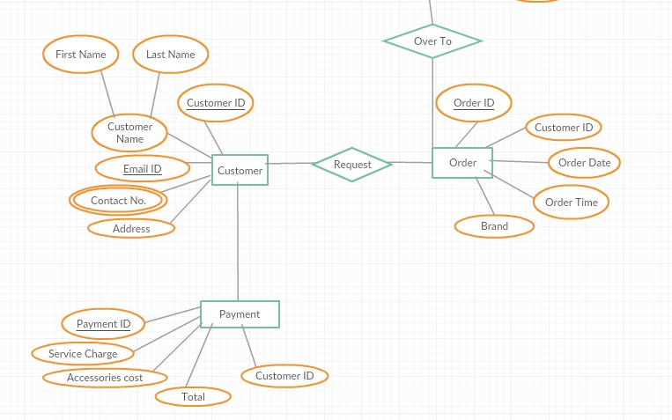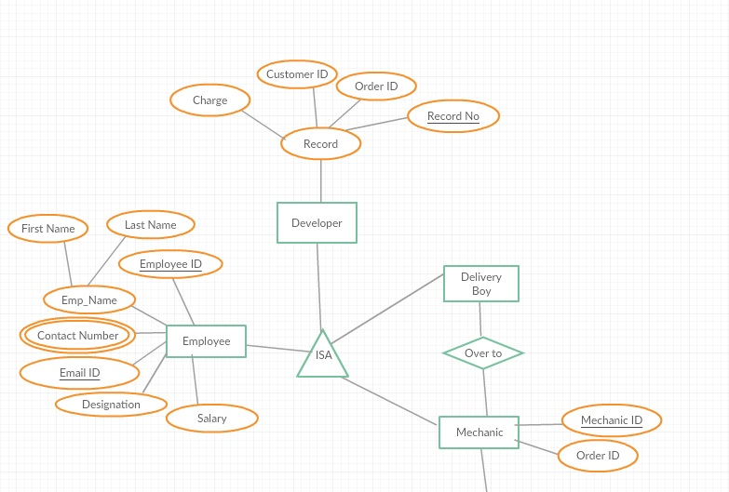

### “Logical structure of entities”

**Registration Data Entity**

|  |  |  |  |
| --- | --- | --- | --- |
| **Data Item** | **Type** | **Description** | **Comment** |
| Name | Text | Name of customer | First name and last name |
| Address | Text | Address of customer |  |
| Customer Id | Text | Customer’s unique identification number | Primary key |
| Contact number | Number | Customer’s contact number | Several contact numbers |
| Email Id | Text | Customer’s email address |  |
| Password | Text | Customer’s password |  |

**Login Data Entity**

|  |  |  |  |
| --- | --- | --- | --- |
| **Data Item** | **Type** | **Description** | **Comment** |
| Email Id | Text | Name of customer | First name and last name |
| Password | Text | Password of customer |  |
| Customer Id | Text | Customer’s unique identification number | Primary key |

**Mechanic Data Entity**

|  |  |  |  |
| --- | --- | --- | --- |
| **Data Item** | **Type** | **Description** | **Comment** |
| Mechanic name | Text | Name of mechanic | First name and last name |
| Mechanic Id | Text | Unique identification number of mechanic | Primary key |
| Contact number | Text | Mechanic’s contact number | Several contact numbers |
| Salary | Number | Mechanic’s salary per month |  |
| Address | Text | Address of mechanic’s resident |  |
| Specification | Text | Mechanic’s specification details | Several specifications |

**Review Data Entity**

|  |  |  |  |
| --- | --- | --- | --- |
| **Data Item** | **Type** | **Description** | **Comment** |
| Customer Name | Text | Name of principle customer | First name and last name |
| Customer Id | Text | Address of customer | Primary key |
| Contact number | Text | Customer’s unique identification number | Several |
| Email Id | Text | Customer’s email Id |  |
| Review | Text | Customer’s review |  |

**Employee Data Entity**

|  |  |  |  |
| --- | --- | --- | --- |
| **Data Item** | **Type** | **Description** | **Comment** |
| Employee name | Text | Name of employee | First name and last name |
| Employee Address | Text | Address of employee’s residence |  |
| Contact number | Text | Employee’s contact number | Several |
| Designation | Text | Employee’s designation |  |
| Employee ID | Text | Employee’s unique identification number | Primary key composite with email address |
| Email Id | Text | Employee’s email address | Primary key in composition with Employee Id |
| Salary | Number | Salary of employee per month |  |

**Admin Data Entity**

|  |  |  |  |
| --- | --- | --- | --- |
| **Data Item** | **Type** | **Description** | **Comment** |
| Admin name | Text | Name of Admin | First name and last name |
| Password | Text | Password of admin |  |

**Order Data Entity**

|  |  |  |  |
| --- | --- | --- | --- |
| **Data Item** | **Type** | **Description** | **Comment** |
| Order ID | Text | Unique order Id | Primary Key |
| Mechanic Id | Text | Unique mechanic id |  |
| Customer Id | Text | Unique customer id |  |
| Status | Text | Status of the gadget |  |
| Order Date | Date | Date on which order was placed |  |
| Order time | Time | Time on which order was placed. |  |

**Payment Data Entity**

|  |  |  |  |
| --- | --- | --- | --- |
| **Data Item** | **Type** | **Description** | **Comment** |
| Order Id | Text | Order Id |  |
| Customer Id | Text | Id of customer |  |
| Payment mode | Text | Mode of payment |  |
| Payment ID | Text | Id of payment | Primary key |
| INR | Number | Money paid by customer |  |

**Query Data Entity**

|  |  |  |  |
| --- | --- | --- | --- |
| **Data Item** | **Type** | **Description** | **Comment** |
| Order Id | Text | Order Id |  |
| Customer Id | Text | Customer Id | Primary key |

### 3.3.2 Security

Only the Employee that has been assigned the role of database administrator only can access, modify and delete the records in database according to customer’s responses.

Customer can access the website only after he has logged into his account with appropriate user name and password.

Employee’s can log into their account with appropriate user name and password.