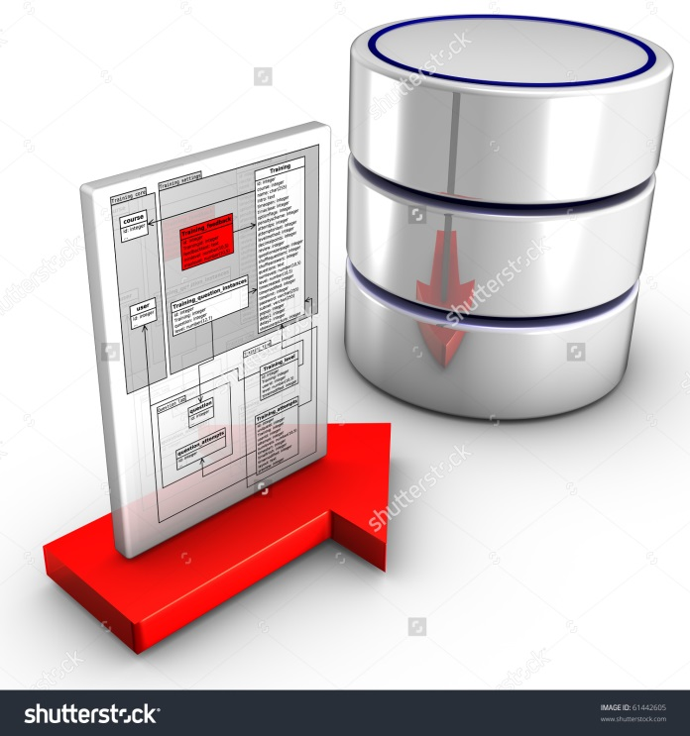**ER MODEL**

Prepared By: Team Members:

Dhiman Mayank Shimona Arora

Sonu Tiwari

Dhiman Mayank

**Registration Entity**

Registration

**Log In Entity**

Log In

Mechanic Entity

Mechanic

Review Entity

Review

Employee Entity

Employee

Admin Entity

Admin

Orders Entity

Orders

Payment

Payment

Query Entity

Query

**Final ER Diagram**

