SafeDrive Insurance Claim Prediction Report
- Sakshi Ghodeswar
Business Report for Insurance Claim Risk Analysis
Prepared for: SafeDrive Insurance Ltd.
Project Title: Analysing Insurance Claims for SafeDrive Insurance Ltd.
Prepared by: Sakshi Ghodeswar
Dashboard Tool Used: Power BI
Programming Environment: Python / Jupyter Notebook
Final Dashboard File: dashboard_report.pdf
Final Prediction File: prediction_output.csv
Final Business Report File: business_report.docx

Table of Contents
- Executive Summary
- Business Problem and Context
- Analytical Objective and Target Audience
- Business Questions and Success Metrics
- Dataset Overview
- Data Preprocessing Overview
- Feature Engineering Summary
- Exploratory Analysis and Dashboard Insights
- Model Building and Validation
- Model Comparison, Tracking and Explainability
- Final Prediction Output and Risk Segmentation
- Business Recommendations
- Limitations
- Next Steps
- Conclusion

1. Executive Summary
SafeDrive Insurance Ltd. is facing increasing financial risk due to rising insurance claim frequency. In the insurance industry, every claim directly affects profitability because the company has to pay claim amounts, manage operational costs and maintain fair premium pricing. Traditional underwriting processes often depend on manual assessment, which can be time-consuming and may lead to inconsistent risk evaluation across policyholders.
The objective of this capstone project is to build a machine learning based claim prediction solution that can identify policyholders who are more likely to file an insurance claim during the policy period. The project uses policyholder details, vehicle specifications, geographic information and vehicle safety features to predict claim likelihood.
The complete analytics workflow followed in this project includes business understanding, data cleaning, exploratory data analysis, feature engineering, model building, model validation, model comparison, experiment tracking, explainability and dashboard reporting. The final model output includes predicted claim class, claim probability score and risk category for each policyholder.
The dashboard created in Power BI presents management-friendly insights such as total policies, predicted claim rate, high-risk customers, average claim probability, risk-level distribution, area-wise risk and vehicle segment-wise risk. These insights can support underwriting teams, pricing teams and risk management teams in identifying high-risk policies and making more informed business decisions.
Overall, this project shows how predictive analytics can be used as a decision-support tool for insurance claim risk management. The model should not be used as the only basis for policy approval or rejection, but it can help SafeDrive prioritise policyholders for closer review and risk monitoring.

2. Business Problem and Context
2.1 Business Context
Insurance companies collect premiums from policyholders and provide financial protection against uncertain events such as vehicle damage, accidents or other covered losses. The profitability of an insurance company depends on its ability to correctly estimate risk and price policies accordingly.
SafeDrive Insurance Ltd. has observed rising claim payouts over the last two years. This creates financial pressure because higher claim frequency can reduce margins and increase uncertainty in portfolio performance. If risky policyholders are not identified early, the company may underprice policies or fail to apply necessary underwriting checks.
2.2 Business Problem
The main business problem is that SafeDrive wants to identify which policyholders are more likely to submit an insurance claim during the policy period. The company wants to move from purely manual risk assessment toward a more data-driven underwriting process.
Manual underwriting can create the following issues:
- Risk assessment may vary from one reviewer to another.
- High-risk policyholders may not be identified early.
- Premium pricing may not fully reflect claim probability.
- Underwriting teams may spend equal effort on low-risk and high-risk customers.
- Management may not have a clear view of portfolio-level risk.
Therefore, SafeDrive needs a predictive model that can assign each policyholder a claim probability score and classify them into Low, Medium or High-risk categories.

2.3 Expected Business Value
The expected value of this project is to help SafeDrive:
- Identify high-risk policyholders early.
- Prioritise underwriting review for risky policies.
- Improve premium pricing decisions.
- Reduce claim-related losses over time.
- Monitor high-risk area clusters and vehicle segments.
- Use data-driven insights for portfolio risk management.

3. Analytical Objective and Target Audience
3.1 Analytical Objective
The analytical objective is to predict whether a policyholder is likely to file a claim using available policy, vehicle, location and safety-related information.
The model output is designed to provide three business-ready results:
- Predicted claim class — whether the policy is predicted as Claim or No Claim.
- Claim probability score — the predicted probability that a policyholder may file a claim.
- Risk level — Low, Medium or High-risk category based on the probability score.
This allows management to go beyond simple claim/no-claim classification and understand the degree of risk associated with each policyholder.
3.2 Target Audience
The target audience for this report includes:
- Underwriting Team: To review high-risk policyholders before policy approval or renewal.
- Risk Management Team: To monitor claim risk across customer groups, locations and vehicle segments.
- Pricing Team: To support premium pricing decisions using claim probability scores.
- Senior Management: To understand portfolio-level risk and take strategic business decisions.
- Analytics Team: To maintain, monitor and improve the predictive model over time.

4. Business Questions and Success Metrics
4.1 Business Questions
This project aims to answer the following business questions:
- Which policyholders are more likely to file an insurance claim?
- What proportion of policies are predicted as claim cases?
- Which risk level has the highest average claim probability?
- Which area clusters show higher predicted claim risk?
- Which vehicle segments show higher claim probability?
- How can SafeDrive use prediction scores to improve underwriting and risk monitoring?

4.2 Business Success Metrics

Business Success Metric | Description | Business Importance
High-risk customer identification | Ability to identify policyholders with higher claim probability | Helps underwriting teams prioritise risky policies
Claim risk segmentation | Classifying customers into Low, Medium and High-risk categories | Helps management take targeted actions
improved underwriting efficiency | Using model scores to support manual review | Reduces effort spent on low-risk policies
Risk-based pricing support | Using probability scores to support premium decisions | Helps align premium pricing with risk level

4.3 Model Evaluation Metrics
The model was evaluated using classification metrics suitable for claim prediction.

Model Metric | Meaning | Why it matters for SafeDrive
Accuracy | Overall percentage of correct predictions | Gives a general performance view
Precision | Out of predicted claim cases, how many were actually claims | Important to avoid too many false alarms
Recall | Out of actual claim cases, how many were correctly identified | Important because missing risky customers can be costly
F1 Score | Balance between precision and recall | Useful when data is imbalanced
ROC-AUC | Ability to separate claim and no-claim cases | Shows ranking quality of the model

For this business problem, recall is especially important because missing high-risk policyholders may lead to financial losses. However, precision is also important because too many false positives can increase unnecessary manual review workload.

5. Dataset Overview
5.1 Dataset Description
The dataset contains policy-level information for SafeDrive Insurance Ltd. Each row represents one insurance policyholder record. The dataset includes information related to policy tenure, policyholder age, geographic area, vehicle specifications, vehicle safety features and claim status.
The target variable is:
is_claim
It indicates whether a claim was filed or not.

0 = No Claim
1 = Claim Filed

5.2 Dataset Structure
Category | Example Columns
Policy Information | policy_id, policy_tenure
Policyholder Information | age_of_policyholder, area_cluster, population_density
Vehicle Information | age_of_car, make, segment, model, fuel_type, engine_type
Vehicle Specifications | displacement, cylinder, transmission_type, gear_box, gross_weight
Safety Features | airbags, is_esc, is_brake_assist, is_speed_alert, ncap_rating
Target Variable | is_claim

5.3 Dataset Size
The original dataset contained:
Item | Value
Total records | 58,592
Original columns | 44
Target variable | is_claim
Claim cases | 3,748
No-claim cases | 54,844
Claim rate | Approximately 6.40%

The dataset is highly imbalanced because the number of no-claim cases is much higher than claim cases. This is common in insurance claim prediction because most policyholders do not file claims during a given policy period.

5.4 Target Variable Distribution
The target distribution shows that only a small portion of policyholders filed a claim. This imbalance makes model building more challenging because a simple model may predict most policies as no-claim and still get high accuracy. Therefore, recall, precision, F1 score and ROC-AUC were considered along with accuracy.

6. Data Preprocessing Overview
6.1 Data Inspection
The raw dataset was loaded using Python and inspected for basic structure. The following checks were performed:
- Shape of the dataset
- Column names
- Data types
- Missing values
- Duplicate records
- Target variable distribution
- Numeric and categorical columns
- Data consistency

6.2 Missing Value Treatment
The dataset was checked for missing values across all columns. No major missing value issue was found. Since missing values were not a significant problem, no heavy imputation was required.

6.3 Duplicate Record Check
Duplicate records were checked to ensure that the same policyholder record was not repeated multiple times. No duplicate records were found in the dataset.

6.4 Data Type Correction
Data types were reviewed to ensure each column was stored in a suitable format. Numeric fields were retained as numeric variables and categorical fields were treated as categorical variables.
Some columns such as maximum torque and maximum power contained text mixed with numeric values. These were processed to extract useful numeric information wherever required.

6.5 Categorical Encoding
Machine learning models cannot directly use text categories. Therefore, categorical variables such as area cluster, segment, model, fuel type, engine type, transmission type and safety feature indicators were converted into machine-readable numeric form using encoding techniques.
One-hot encoding was applied to categorical variables so that the model could use them effectively.
6.6 Final Cleaned Dataset
After preprocessing and feature engineering, the cleaned dataset was exported as:

cleaned_dataset.csv

The cleaned dataset contained:
Item | Value
Rows | 58,592
Columns after encoding and feature engineering | 102
Missing values | 0
Duplicate records | 0
Target variable retained | Yes
Policy ID retained | Yes

This cleaned dataset was used for model building and validation.

7. Feature Engineering Summary
7.1 Purpose of Feature Engineering
Feature engineering was performed to create more meaningful variables from the existing dataset. These features were designed to improve model learning and provide better business interpretation.
Instead of using only raw columns, additional features were created to capture vehicle age, policyholder age, safety profile and vehicle performance characteristics.
7.2 Engineered Features
The following engineered features were created:
Engineered Feature | Description | Business Relevance
car_age_group | Groups vehicles based on age | Older vehicles may carry different claim risk
policyholder_age_group | Groups policyholders by age range | Age profile may influence claim likelihood
safety_score | Combined score based on safety features | Helps measure vehicle safety strength
safety_score_group | Categorises safety score into levels | Helps compare lower and higher safety vehicles
vehicle_volume | Derived from length, width and height | Represents vehicle size
power_to_weight_ratio | Power divided by vehicle weight | Captures performance intensity
torque_to_weight_ratio | Torque divided by vehicle weight | Captures vehicle pulling strength relative to weight

7.3 Feature Engineering Rationale
The feature engineering approach was business-driven. Vehicle age, vehicle safety and vehicle performance can influence claim risk. For example, vehicles with lower safety features may be more vulnerable in accidents, while certain vehicle segments may show different claim behaviour.
Safety-related features were especially important because insurance risk is closely connected to the probability and severity of accidents. Similarly, area cluster and vehicle segment were retained because dashboard insights showed visible differences in average claim probability across these groups.

8. Exploratory Analysis and Dashboard Insights
8.1 Purpose of Exploratory Analysis
Exploratory Data Analysis was performed to understand the structure and patterns in the data before modelling. The objective was to identify claim distribution, risk patterns, vehicle-related trends and location-based differences.
The dashboard was created in Power BI to present the model output and business insights in a management-friendly format.

8.2 KPI Summary
The dashboard shows the following key performance indicators:
KPI | Value
Total Policies in prediction output | Approximately 12K
High-risk Customers | Approximately 4K
Average Claim Probability | 46.20%
Predicted Claim Rate | 42.08%
Predicted Claims | Approximately 5K

These KPIs help management quickly understand the overall prediction output and risk exposure.

8.3 Claim Prediction Distribution
Insert Image Here: Predicted Claim Distribution dashboard page
Caption: Figure 1: Predicted claim and no-claim distribution
The predicted claim distribution shows the split between policies predicted as claim and no-claim cases. The model predicted approximately 42.08% of policies as claim cases and approximately 57.92% as no-claim cases in the prediction output.
This does not mean that all predicted claim cases will definitely file a claim. Instead, it means that the model has flagged these policyholders as higher-risk based on the patterns learned from historical data. This output can be used to prioritise policies for review.
Business Interpretation:
SafeDrive can use this view to estimate potential claim exposure in the current portfolio. Policies predicted as claim cases can be reviewed more closely by underwriting and risk teams.

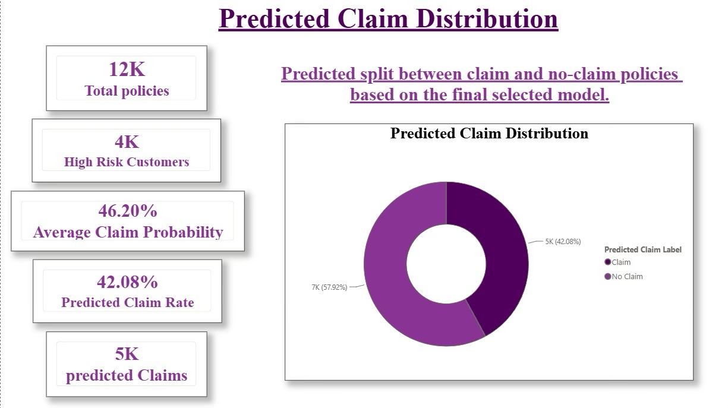

8.4 Average Claim Probability by Risk Level
Insert Image Here: Average Claim Probability by Risk Level dashboard page
Caption: Figure 2: Risk segmentation based on predicted claim probability
The risk segmentation chart shows that average claim probability increases from Low to Medium to High-risk categories.
The observed average claim probabilities are approximately:
Risk Level | Average Claim Probability
Low | 0.27
Medium | 0.49
High | 0.62

This shows that the risk classification is meaningful because high-risk policies have the highest average predicted claim probability.
Business Interpretation:
High-risk policyholders should be prioritised for underwriting review. Medium-risk policyholders can be monitored, while low-risk policyholders may require fewer manual checks.
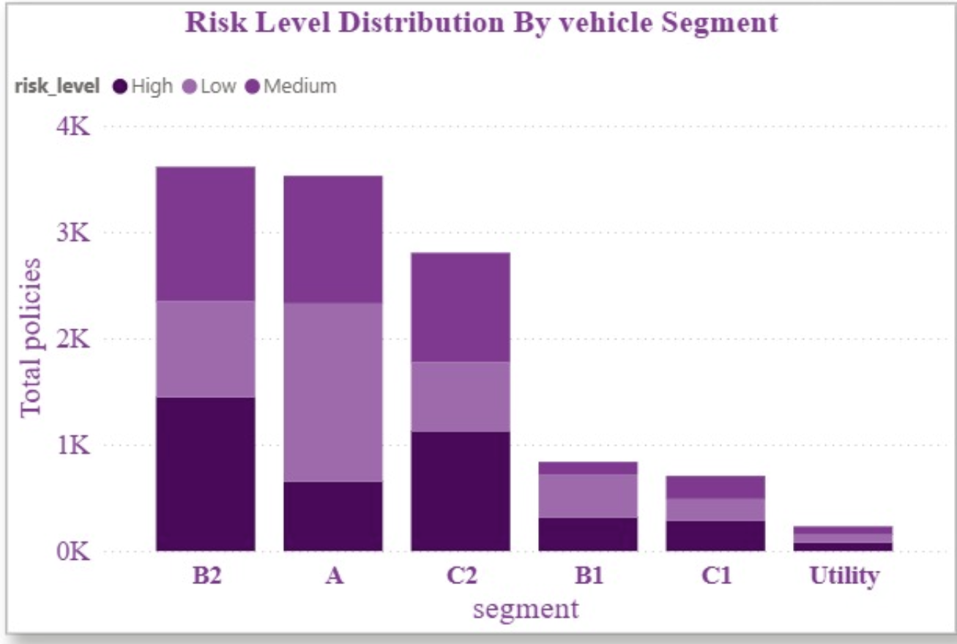

8.5 Claim Probability Distribution
Insert Image Here: Claim Probability Distribution dashboard page
Caption: Figure 3: Distribution of policies across claim probability bands
The claim probability distribution shows how policies are spread across different predicted probability bands. A large number of policies are concentrated between the 30% and 60% probability range.
This suggests that many policyholders fall into a moderate-risk zone rather than being clearly very low-risk or very high-risk. Such customers may need further review using supporting factors such as area cluster, vehicle segment, safety score and claim history.
Business Interpretation:
The moderate-risk group is important because it contains many customers. SafeDrive can create separate monitoring rules for this group instead of treating all customers equally.
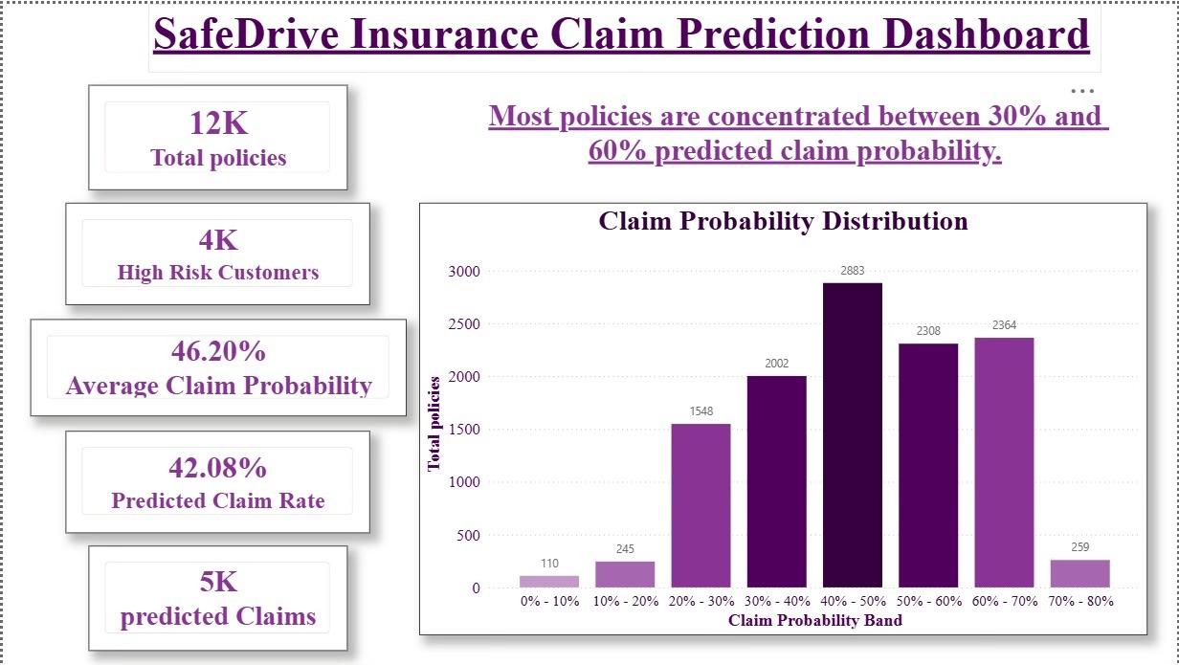

8.6 Area-wise Risk Insights
Insert Image Here: Risk Insight Dashboard page
Caption: Figure 4: Area-wise and vehicle-wise claim risk insights
The area cluster chart shows the top area clusters by average claim probability. Area clusters such as C14, C19 and C18 show relatively higher average predicted claim probability.
This indicates that geographic location may influence claim risk. Higher-risk areas may be linked to factors such as traffic density, road conditions, accident frequency or driving environment. Although these external details are not directly available in the dataset, the model output suggests that area-level monitoring can be useful.
Business Interpretation:
SafeDrive can use area-wise risk insights for portfolio monitoring, underwriting prioritisation and location-based risk review.

8.7 Vehicle Segment-wise Risk Insights
Insert Image Here: Vehicle Risk Insights Dashboard page
Caption: Figure 5: Vehicle segment-wise predicted claim risk analysis
The vehicle segment chart shows that some vehicle segments have higher average predicted claim probability than others. Segments such as C2, B2 and C1 show relatively higher average risk compared with other segments.
The risk level distribution by vehicle segment also shows how Low, Medium and High-risk policies are distributed across different vehicle categories.
Business Interpretation:
Vehicle segment information can help SafeDrive identify categories of vehicles that may need closer underwriting checks or pricing review. However, this should be used along with other risk factors rather than as a standalone decision rule.

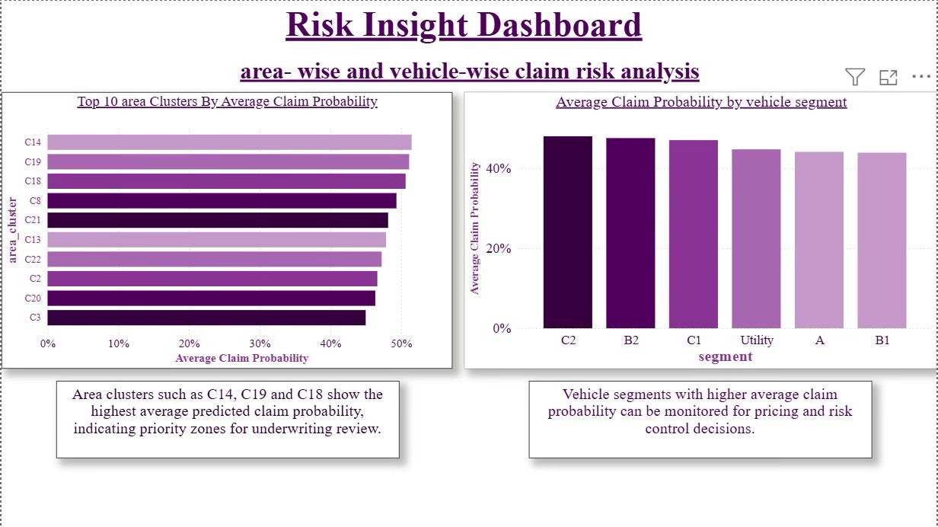

8.8 Policyholder-level Prediction Output
Insert Image Here: Policyholder Risk Prediction Details dashboard page
Caption: Figure 6: Policy-level prediction output with probability score and risk level
The policyholder details table shows the final prediction output at individual policy level. It includes policy ID, predicted claim label, claim probability, risk level, area cluster, vehicle segment and fuel type.
This is one of the most useful dashboard views because it allows business teams to move from summary-level insights to policy-level action.
Business Interpretation:
Underwriting teams can use this table to identify specific high-risk policyholders and decide whether additional review, documentation, pricing adjustment or monitoring is required.
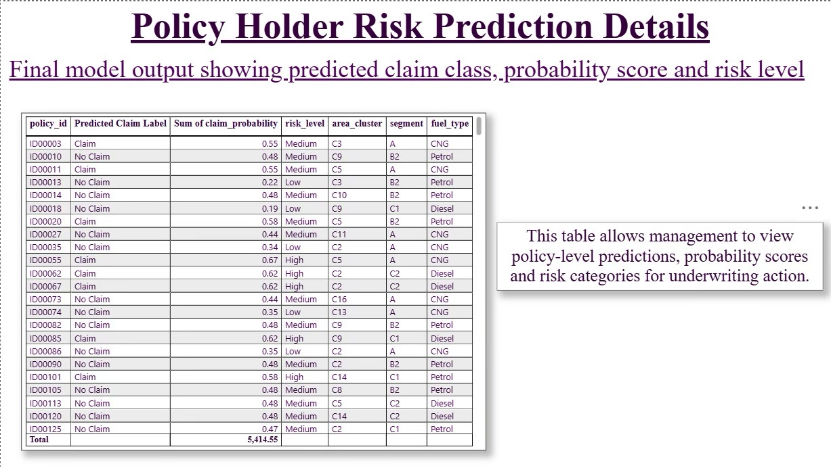

9. Model Building and Validation
9.1 Modelling Objective
The modelling objective was to build a binary classification model that predicts whether a policyholder is likely to file a claim.
The target variable used for modelling was:

is_claim

Where:

0 = No Claim
1 = Claim Filed

9.2 Train-Test Split
The cleaned dataset was split into training and testing sets using an 80/20 split.
Dataset Part | Purpose
Training Data | Used to train the model and learn patterns
Testing Data | Used to evaluate model performance on unseen data

The test set was kept separate to check whether the model could generalise to new policyholder records.

9.3 Leakage Prevention
Leakage prevention was applied during modelling. Any transformation such as scaling was fitted only on the training data and then applied to the test data. This prevents information from the test set from influencing the model during training.
This step is important because leakage can make model performance look better than it actually is.

9.4 Baseline Model
Logistic Regression was used as the baseline model. It is suitable for binary classification problems and provides interpretable results.
A baseline model is important because it provides a benchmark against which other models can be compared.

9.5 Class Imbalance Handling
The dataset was imbalanced because claim cases were much fewer than no-claim cases. To address this, class balancing was considered during model building.
This helped the model pay more attention to the minority class, which is the claim class.

9.6 Baseline Model Results
The baseline Logistic Regression model produced the following test-set performance:
Metric | Value
Accuracy | 57.47%
Precision | 8.21%
Recall | 55.46%
F1 Score | 14.30%
ROC-AUC | 59.14%

9.7 Interpretation of Model Results
The model achieved moderate recall, which means it was able to identify a meaningful portion of actual claim cases. This is useful for SafeDrive because missing risky policyholders can lead to financial losses.
Precision was low because the dataset is highly imbalanced. Since claim cases are rare, the model may flag some no-claim customers as potential claim cases. This is a common challenge in insurance claim prediction.
Accuracy alone is not sufficient for this problem because a model can achieve high accuracy by predicting most customers as no-claim. Therefore, recall, F1 score and ROC-AUC are more meaningful for this business context.
9.8 Business View of Model Performance
The model should be used as a risk prioritisation tool rather than a fully automated decision-making system. It can help underwriting teams identify which policyholders need closer review, but final decisions should include business rules and human judgement.

10. Model Comparison, Tracking and Explainability
10.1 Model Comparison
In Stage 3, a Decision Tree model was compared with the Logistic Regression baseline. The purpose of model comparison was to check whether a more flexible model could improve prediction performance.
The models were compared using the same evaluation metrics:
- ROC-AUC
- Precision
- Recall
- F1 Score
Cross-validation was used to evaluate model stability and reduce dependency on a single train-test split.
10.2 Hyperparameter Tuning
Hyperparameter tuning was performed for the Decision Tree model using automated tuning methods. The objective was to improve model performance by selecting better model parameters such as tree depth, minimum samples split and minimum samples leaf.
Tuning helps avoid overfitting and improves the practical usability of the model.
10.3 Experiment Tracking
MLflow was used to track model experiments. This helped record model parameters, metrics and artifacts in a structured way.
Experiment tracking is important because it supports reproducibility. It allows the analytics team to understand which model version was trained, what parameters were used and what performance was achieved.
10.4 Model Versioning
The final selected model was saved along with supporting metadata such as model name, version details, training data reference, metric summary and approval status.
This ensures that the selected model can be reused for final prediction generation and future monitoring.

10.5 Explainability Using SHAP
SHAP was used to explain model predictions in business terms. Explainability is important because business users need to understand why a policyholder is predicted as high-risk.
The SHAP analysis helped identify influential features that contributed to model predictions. These features can help management understand the main drivers of claim probability.
10.6 Final Model Selection Rationale
The final selected model was chosen based on validation performance and business usefulness. Since the business objective is to identify high-risk policyholders, the model selection focused on recall, ROC-AUC and practical interpretability rather than accuracy alone.
The selected model was then used to generate final predictions on the held-out test set.

11. Final Prediction Output and Risk Segmentation
11.1 Final Prediction File
The final prediction output was exported as:

prediction_output.csv

This file contains policy-level model predictions and is used as the source for the Power BI dashboard.

11.2 Prediction Output Columns
The final prediction output includes the following important columns:
Column | Meaning
policy_id | Unique identifier for each policy
actual_is_claim | Actual claim status from test data
predicted_is_claim | Model-predicted claim class
Predicted Claim Label | Claim or No Claim
claim_probability | Probability score predicted by the model
risk_level | Low, Medium or High-risk category
area_cluster | Area cluster of policyholder
segment | Vehicle segment
fuel_type | Vehicle fuel type

11.3 Risk Segmentation Method
Policyholders were categorised into three risk levels based on predicted claim probability:
Risk Level | Meaning
Low | Lower predicted claim probability
Medium | Moderate predicted claim probability
High | Higher predicted claim probability

This segmentation helps business teams understand risk in a simple and actionable way.
11.4 Dashboard Output
The Power BI dashboard was created using the prediction output file. It includes KPI cards, claim distribution, risk level analysis, probability distribution, area-wise insights, vehicle-wise insights and policy-level prediction details.
The dashboard was exported as:

dashboard_report.pdf

11.5 Management Use of Prediction Output
Management can use the prediction output in the following ways:
- Review high-risk policies before approval or renewal.
- Identify area clusters with higher average claim probability.
- Monitor vehicle segments with higher risk concentration.
- Use probability scores to support premium pricing.
- Use policy-level predictions for underwriting prioritisation.

12. Business Recommendations
Based on the analysis, model output and dashboard insights, the following recommendations are suggested for SafeDrive Insurance Ltd.

12.1 Prioritise High-risk Policyholders
SafeDrive should prioritise policyholders classified as High-risk for underwriting review. These customers show the highest average predicted claim probability and may require closer evaluation before policy approval or renewal.
Recommended actions:
- Review high-risk policies manually.
- Check policyholder and vehicle details carefully.
- Ask for additional documentation if needed.
- Apply risk-based approval rules.

12.2 Use Probability Scores for Risk-based Pricing
Claim probability scores can help pricing teams make more informed premium decisions. Policies with higher claim probability may require pricing adjustments, while low-risk policies may be priced more competitively.
Recommended actions:
- Use probability scores as pricing support.
- Avoid using model output as the only pricing factor.
- Combine model scores with existing actuarial and underwriting rules.

12.3 Monitor High-risk Area Clusters
The dashboard shows that some area clusters have higher average claim probability. SafeDrive should monitor these clusters more closely.
Recommended actions:
- Track claim patterns by area cluster.
- Review underwriting rules for high-risk locations.
- Investigate whether traffic density or accident-prone zones explain higher risk.

12.4 Review Vehicle Segment Risk
Some vehicle segments show higher average predicted claim probability. This indicates that vehicle category can be an important risk indicator.
Recommended actions:
- Monitor high-risk vehicle segments.
- Compare claim frequency by vehicle segment over time.
- Consider additional checks for higher-risk segments.

12.5 Use Dashboard for Management Monitoring
The Power BI dashboard should be used as a management reporting tool. It provides a quick view of risk exposure and allows business users to interpret prediction outputs visually.
Recommended actions:
- Update dashboard regularly with new prediction data.
- Share dashboard with underwriting and risk teams.
- Use dashboard insights in monthly risk review meetings.

12.6 Use Model as Decision Support, Not Final Decision
The model should support business decisions but should not replace human judgement. Insurance underwriting involves financial, legal and customer-service considerations that require careful review.
Recommended actions:
- Use model output as an early warning signal.
- Keep human review for final underwriting decisions.
- Combine model predictions with policy rules and business expertise.

13. Limitations
13.1 Class Imbalance
The dataset is highly imbalanced because claim cases are much fewer than no-claim cases. This affects model performance, especially precision. The model may flag some no-claim policies as possible claim cases.
13.2 Limited External Data
The dataset does not include some important external risk factors such as:
- Driver behaviour
- Accident history details
- Road conditions
- Weather conditions
- Traffic violations
- Repair cost
- Claim severity
- Driving frequency
- Telematics data
Including these variables in the future may improve model performance.

13.3 Model Performance Limitation
The model provides useful risk prioritisation but does not perfectly separate claim and no-claim cases. Therefore, it should not be used as a fully automated decision engine.
13.4 Business Interpretation Limitation
Some variables may show association with claim risk, but this does not always mean direct causation. For example, a vehicle segment or area cluster may show higher risk due to underlying factors not available in the dataset.
13.5 Dashboard Limitation
The dashboard is based on the held-out prediction output and not a live production data pipeline. For real business use, the dashboard would need regular refresh and integration with updated policy data.

14. Next Steps
14.1 Improve Data Collection
SafeDrive should collect additional data that may improve claim prediction accuracy.
Recommended additional data:
- Historical accident records
- Past claim amount
- Claim severity
- Driving behaviour
- Traffic violation history
- Vehicle usage pattern
- Weather and road condition data
- Telematics data if available

14.2 Improve Model Performance
Future work can test more advanced models and model improvement techniques.
Possible improvements:
- Advanced class imbalance handling
- Threshold tuning
- Random Forest
- Gradient Boosting
- XGBoost or LightGBM
- Better feature selection
- Additional interaction features

14.3 Monitor Model Drift
Model performance should be monitored over time because customer behaviour, claim patterns and portfolio risk may change.
Recommended actions:
- Use Evidently reports for drift monitoring.
- Compare new data with training data.
- Track performance metrics over time.
- Retrain the model periodically.

14.4 Deploy Dashboard for Business Use
The dashboard can be improved into a regular business monitoring tool.
Recommended actions:
- Connect dashboard to updated prediction output.
- Add filters for area cluster, vehicle segment and risk level.
- Add monthly refresh process.
- Share dashboard with underwriting and risk management teams.

14.5 Build an Underwriting Review Workflow
SafeDrive can create a workflow where High-risk policies are automatically flagged for manual review.
Suggested workflow:
- Generate prediction output for new policies.
- Assign each policy a claim probability score.
- Categorise policy into Low, Medium or High-risk.
- Send High-risk policies to underwriting review.
- Monitor final business decision and actual claim outcome.
- Use new results to improve future models.

15. Conclusion
This capstone project demonstrates how data analytics and machine learning can support insurance claim risk management for SafeDrive Insurance Ltd.
The project converted raw insurance policy data into a clean, model-ready dataset, developed predictive models, generated policy-level claim probability scores and created a Power BI dashboard for stakeholder communication.
The final output helps SafeDrive identify high-risk policyholders, understand risk patterns across area clusters and vehicle segments and support underwriting and pricing decisions.
The model should be used as a decision-support tool rather than a fully automated decision system. With additional data, regular monitoring and future model improvements, SafeDrive can make its underwriting process more data-driven, consistent and efficient.

