

***ARCHITECTURE DESIGN***

***FOR***

***Residential Communication Channel System***

***Version 1.3***

***Team 2 - GENTLEMAN***

***Revision***

|  |  |  |  |
| --- | --- | --- | --- |
| *Author* | *Version* | *Date* | *Content* |
| *Vinh Nguyen* | ***1.1*** | *7/12/2018* | *Initiate Draft View* |
| *Vinh Nguyen* | ***1.1*** | *14/12/2018* | *Update Static, Dynamic View and System Context* |
|  |  |  |  |

Table of Contents

***1.*** ***Document Overview*** 2

***a.*** ***Purpose*** 2

***b.*** ***Audience*** 2

***2.*** ***Architectural Document Overview*** 2

***a.*** ***Introduction*** 2

***b.*** ***UML 2.0 Notation and Software Architecture Style*** 3

***3.*** ***System Context ( Context Diagram )*** 3

***4.*** ***Component-and-Connector Views*** 3

***a.*** ***Decomposition Level 0*** 3

***i.*** ***Decomposition Rationale*** 3

***ii.*** ***Element Responsibilities Catalog*** 3

***iii.*** ***Relationship Responsibilities Catalog*** 3

***b.*** ***Decomposition Level 1*** 3

***i.*** ***Decomposition Rationale*** 3

***ii.*** ***Element Responsibilities Catalog*** 3

***iii.*** ***Relationship Responsibilities Catalog*** 3

***5.*** ***Module Views*** 3

***a.*** ***Decomposition Level 0*** 3

***i.*** ***Decomposition Rationale*** 3

***ii.*** ***Element Responsibilities Catalog*** 3

***iii.*** ***Relationship Responsibilities Catalog*** 3

***6.*** ***Allocation Views*** 3

***a.*** ***Decomposition Level 0*** 3

***i.*** ***Decomposition Rationale*** 3

***ii.*** ***Element Responsibilities Catalog*** 3

***iii.*** ***Relationship Responsibilities Catalog*** 3

1. ***Document Overview***
   1. ***Purpose***
      1. This document contains the software architecture analyze and design for the Resident Communication Channel
   2. ***Audience***

|  |  |  |
| --- | --- | --- |
| **Intended Audience** | **Name** | **Reading Suggestions** |
| GENTLEMAN – Team Member | * Manh Truong * Quan Ngo * Hao Vo * Lam To * An Pham | Review Document and report |
| Mentor | * Quoc Nguyen | Review Document |
| Project Manager | * Vinh Nguyen | Initiate and Document Specification |

1. ***Architectural Document Overview***
   1. ***Introduction***

This section contains architectural diagrams and accompanying responsibility catalogs. Except the context diagram and collaboration diagrams every other subsection represents a decomposition level. Each decomposition level diagram is accompanied with a decomposition rationale, element responsibilities catalog and relationship responsibilities catalog.

* 1. ***UML 2.0 Notation and Software Architecture Style***

All architectural views have been documented using UML 2.0 notation and Architecture Style. Some view can combine UML 2.0 and Architecture Style.Component Diagram and event-based style have been used for the component-and-connector views, package diagrams and layered style for module views,network architecture diagram and deployment diagrams for allocation views.

1. 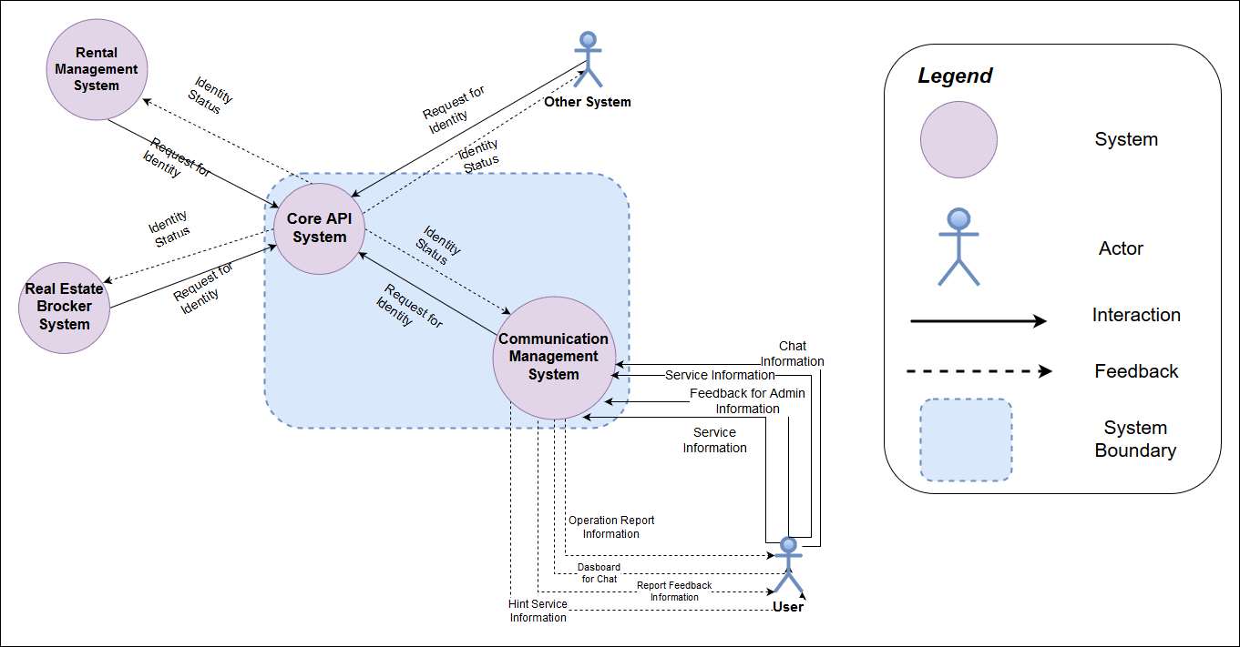***System Context ( Context Diagram )***
2. ***Component-and-Connector Views*** 
   1. ***Decomposition Level 0***

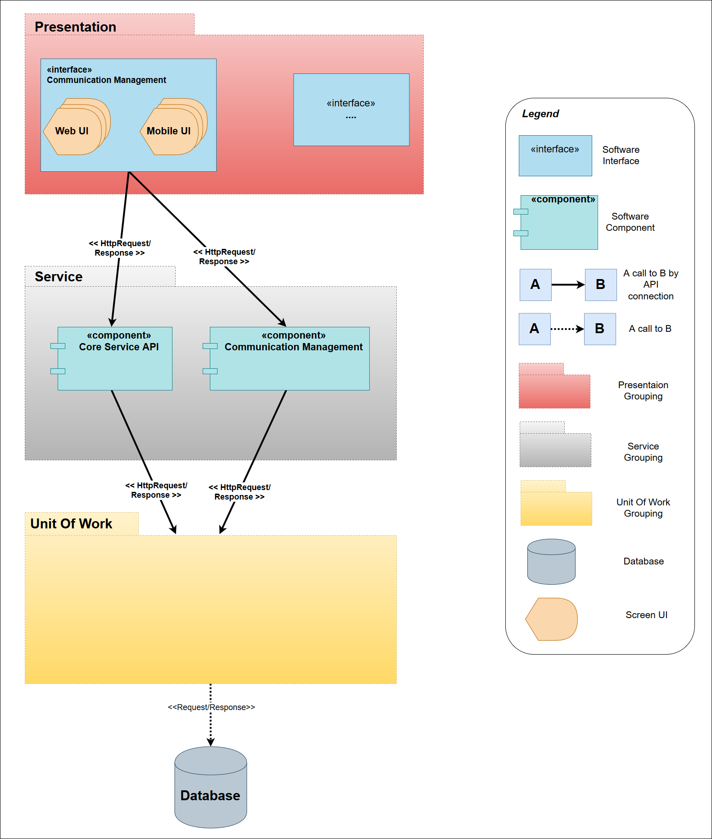

* + 1. ***Decomposition Rationale***

|  |  |
| --- | --- |
| **Perspective** | **Dynamic** |
| In order to meet the business requirements at the client's high level, and demonstrate the scope of the system located in two modules: Core Service API and Communication Management. In addition, the decomposition design at level 0 will meet the system constraint on operating on Mobile and Web platforms. | |

* + 1. ***Element Responsibilities Catalog***

|  |  |
| --- | --- |
| **Perspective:** Component-and-Connector | |
| **Element** | **Responsibilities** |
| <<interface>  Communication Management | * Grouping interfaces of Communication Management system |
| <<component>>  Core Service API | * Contains classes and methods to handling Core Service API business functions using the Restful API method |
| <<component>>  Communication Management | * Contains classes and methos to handling Core Service API business functions |
| Presentation grouping | * Layer grouping module related Presentation of System ( Front – End ) |
| Service grouping | * Layer grouping module related Business Access of System ( Back – End ) |
| Unit of Work grouping | * Layer grouping module related Data Access of System |
| Database | * The Server Central to store data |
| Mobile UI | * The interface is displayed on the Mobile platform |
| Web UI | * The interface is displayed on the Web platform |

* + 1. ***Relationship Responsibilities Catalog***

|  |  |
| --- | --- |
| **Perspective:** Component-and-Connector | |
| **Relationship** | **Responsibilities** |
| <<interface>  Communication Management call to <<component>>  Core Service API | * Send Request about User, Role, Domain from UI by HttpMessage * Receive Data in Json Format from Core Service |
| <<interface>  Communication Management call to <<component>>  Communication Management | * Send Request about Business Flow from UI by HttpMessage * Receive Data in Json Format from Communication Management |
| <<component>>  Core Service API call to Unit Of Work | * Request message about CRUD entity ( Create, Read,Update, Delete,..) * Receive data through Repository Classes |
| <<component>>  Communication Management call to Unit Of Work | * Request message about CRUD entity ( Create, Read,Update, Delete,..) * Receive data through Repository Classes |
| Unit of Work call to Database | * Send request for Database through Model * Receive data from database through Model |

* 1. ***Decomposition Level 1***

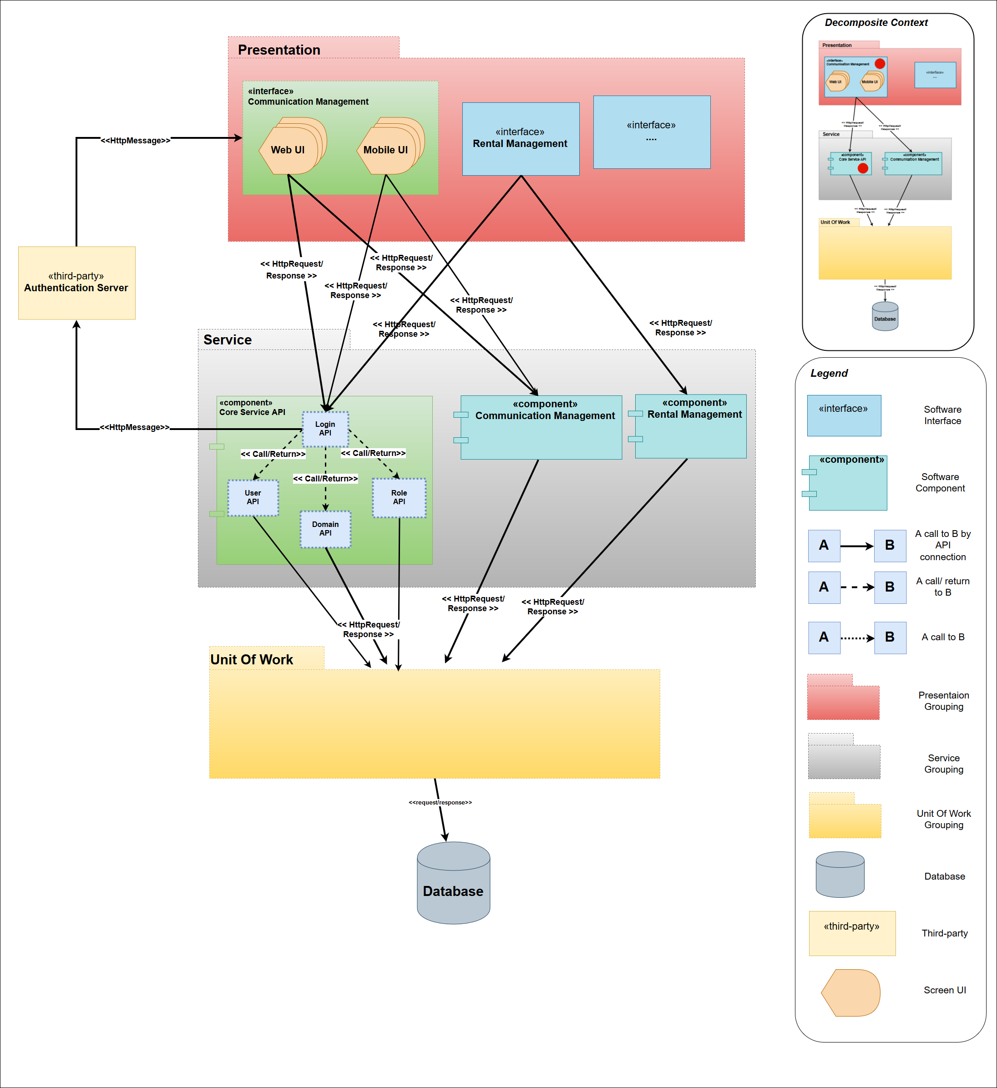

* + 1. ***Decomposition Rationale***

|  |  |
| --- | --- |
| **Perspective** | **Dynamic** |
| To meet quality attributes about Security - Confidentiality and Authenticity, the design decomposition at level 1 | |

* + 1. ***Element Responsibilities Catalog***
    2. ***Relationship Responsibilities Catalog***

1. ***Module Views***
   1. 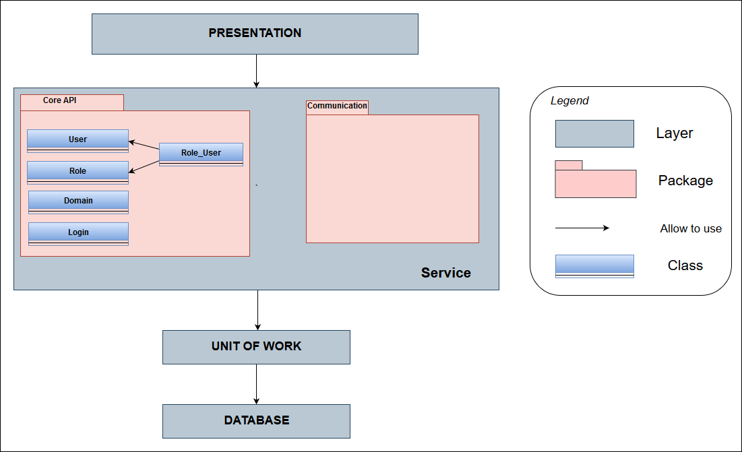***Decomposition Level 0***
      1. ***Decomposition Rationale***
      2. ***Element Responsibilities Catalog***
      3. ***Relationship Responsibilities Catalog***
2. ***Allocation Views***
   1. ***Decomposition Level 0***
      1. ***Decomposition Rationale***
      2. ***Element Responsibilities Catalog***
      3. ***Relationship Responsibilities Catalog***