CSI Bridge Instruction:

The purpose of this document is to teach how to use some available tools in the CSI Bridge software that can be helpful for doing this project. These tools are not clearly explained in the tutorials available on the website. These are learned after lots of trial and error and it is aimed to help future model users to learn quickly how to perform. For beginners, it is recommended to watch the general tutorials on the website before reading this document. See the link below:

https://www.csiamerica.com/products/csibridge/videos/csi-spotlight

As explained in the dissertation authored by Amin Moghadam, two spans of the Varina-Enon bridge Is modeled here in the CSI Bridge software. See Figure 1. It is assumed that this model has already been analyzed using a time history analysis and now, we are going to see where and how to manipulate some parameters per our need. This is an intact bridge model. To simulate a damaged bridge, one can select an element and press delete button on the keyboard.

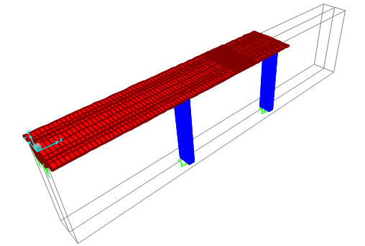
Fig. 1. The model simulated in the CSI Bridge

Figure 2 shows where to display force diagrams, stresses/strains and deformed and undeformed bridge.

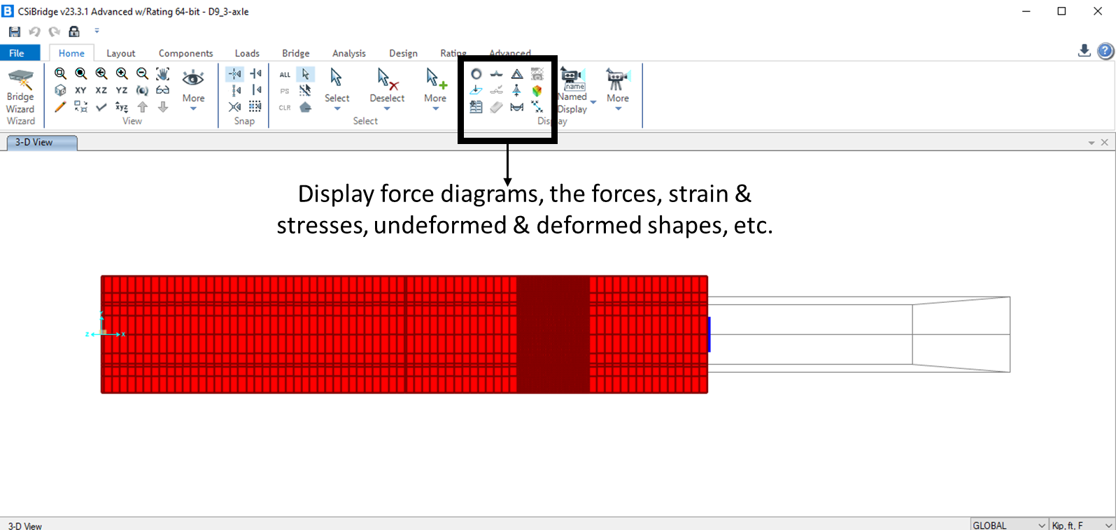
Fig. 2. Display the forces, stresses, strains, and deflected/undeflected shapes
Figure 3 shows how to obtain the data such as strains, forces, etc., in a table format. These tables can later be exported to excel or etc. It should be noted that a desired element on the bridge should be first selected before using this window. Figure 3 also shows how to change its setting to obtain the data vs. time when a proper time-history analysis is performed.
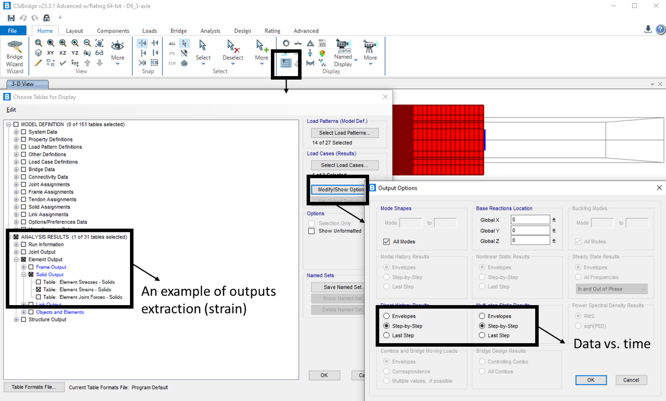
Fig. 3. How to obtain the data table
When click on OK in Figure 3, the window in Figure 4 pops up. This is where the data table for the recorded response vss. Time can be obtained. To sort the data per each joint, some additional manipulation shown in Figure 4 is needed.
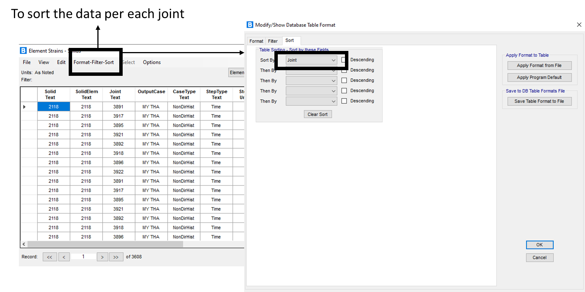
Fig. 4. How to sort the data per each joint number
Figure 5 shows how to change the lanes characteristics such as start/end points, width, etc. This is also shown where one can actually change the transverse position of each lane and accordingly the transverse position of each truck. Figure 6 illustrate how to visually evaluate the position of the lanes.
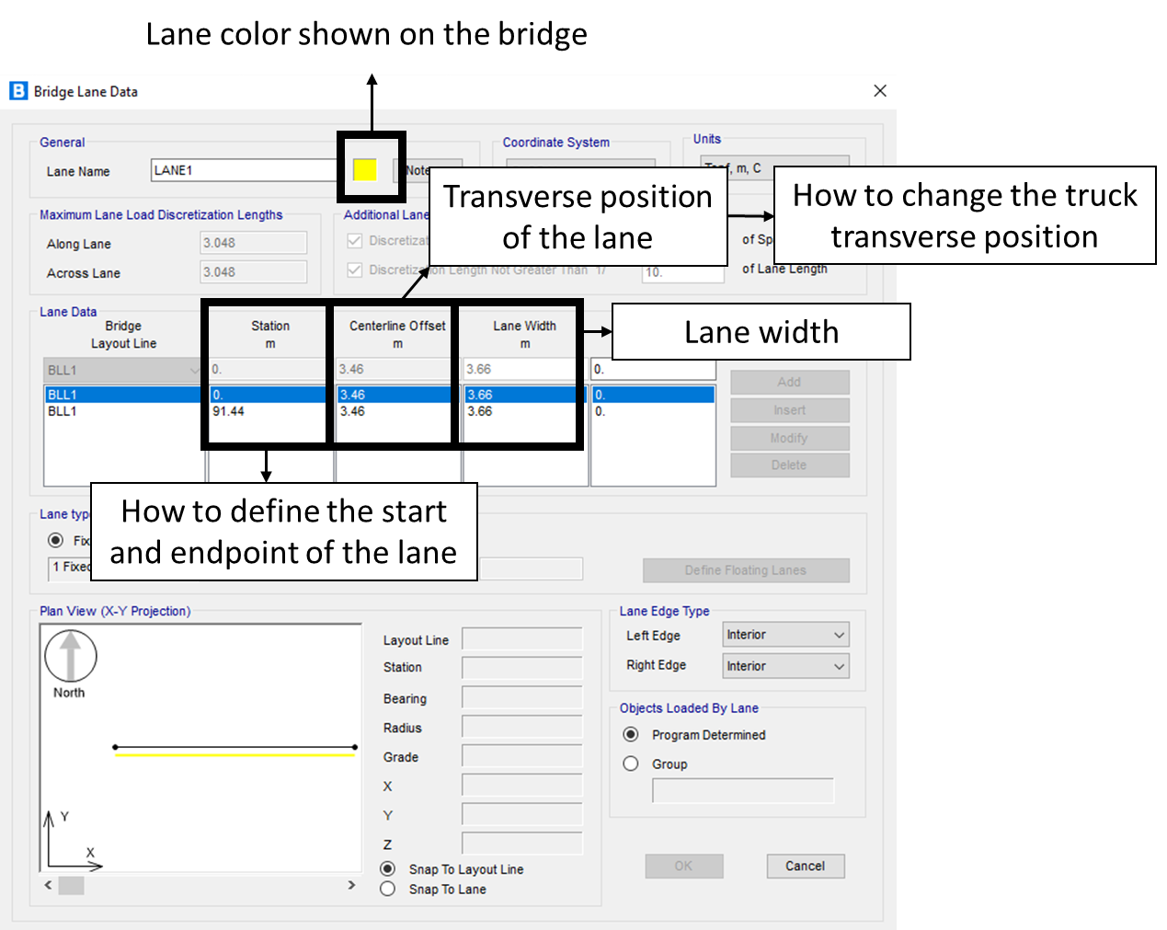
Fig. 5. Lane characteristics and transverse position

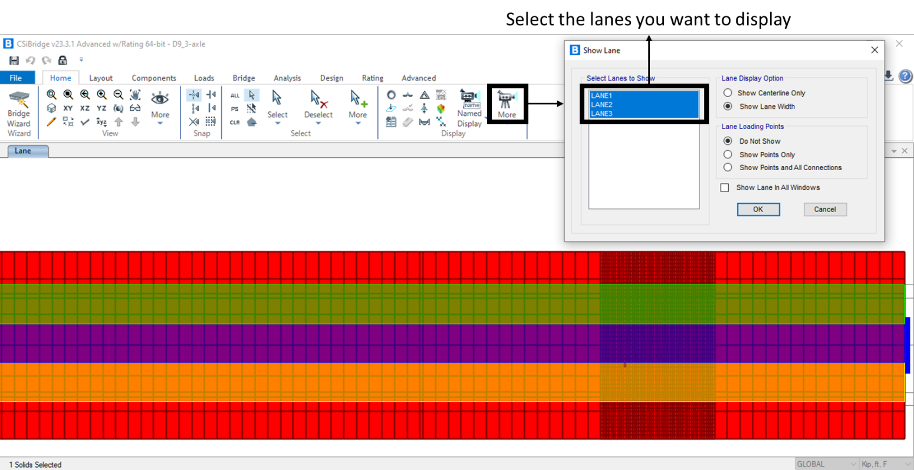
Fig. 6. Lanes visualization

Figure 7 shows how and where to set the materials properties and bearing stiffness in all directions
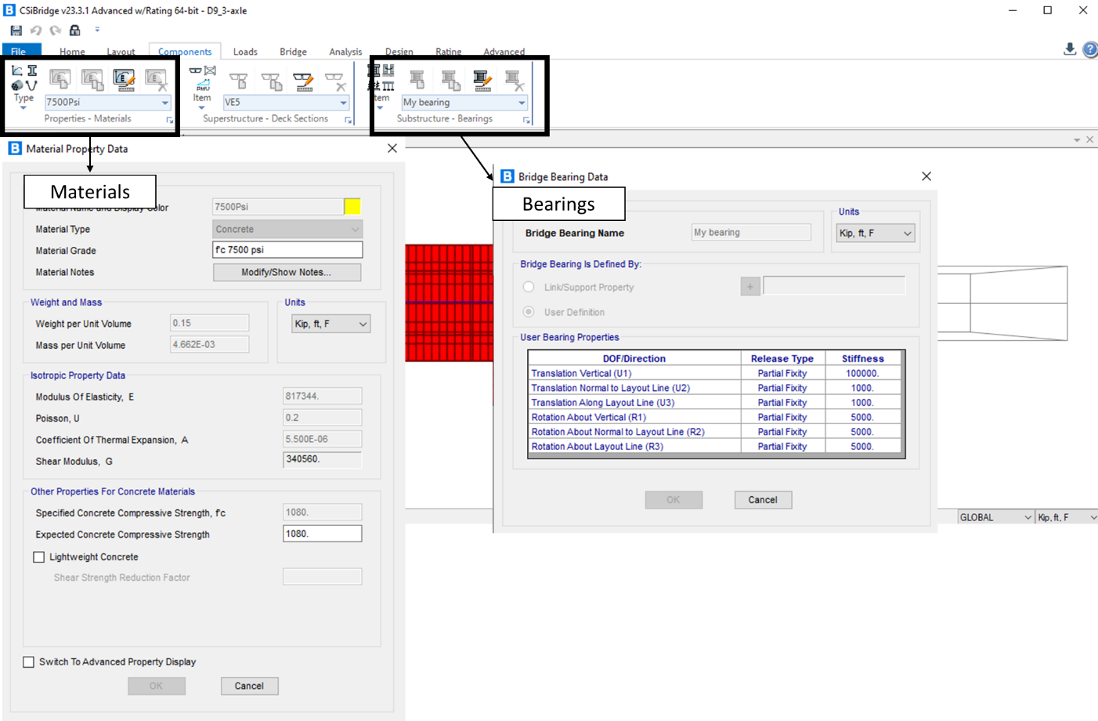
Fig. 7. Bearing stiffness and material properties

The left side of Figure 8 shows where to change the deck coordinates to adjust its geometry per our need. This can be manually done in the box shown. However, sometimes, the geometry should be changed more significantly and this should be done in the “section designer” shown in Figure 8. A key point here is that all the layouts shown on the right side (Spine, Area, and Solid) should necessarily be adjusted on top of each other, otherwise an error occurs. This should be done manually.
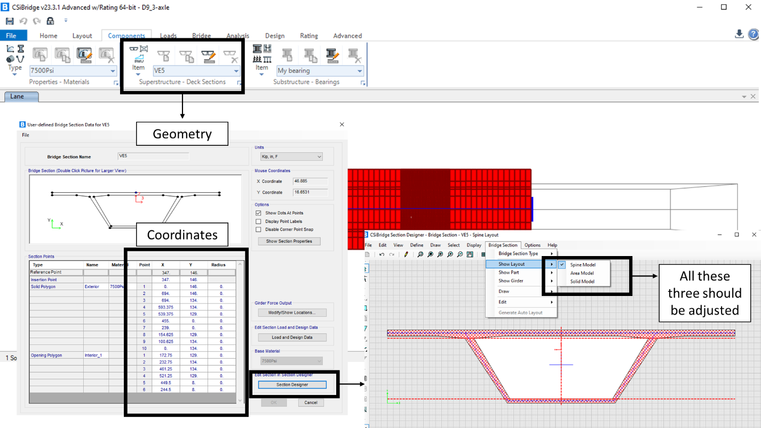
Fig. 8. How to create a proper section for the concrete box
Figure 9 shows how to define a custom truck with specific axle weights, axle spacings, axle width, etc.
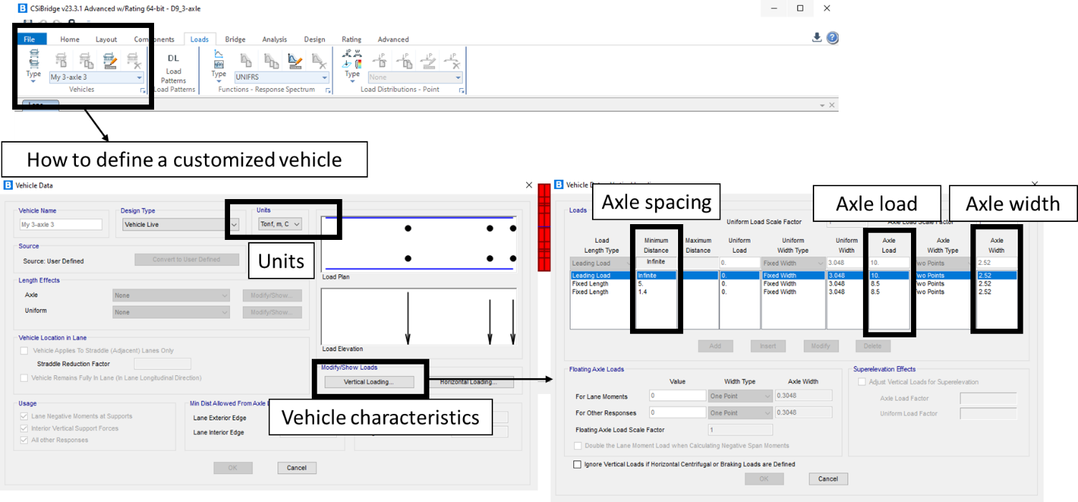
Fig. 9. How to define a custom vehicle

Figure 10 demonstrates how make a custom multiple/single-truck event using the defined vehicles. The number of vehicles, their distance, speed, lanes, etc. can be selected here for instance, Figure 10 shows an in-one-row events consisting of two truck on the same lane (lane 2). But other events such as side-by-side and even more complex can also be defined here.
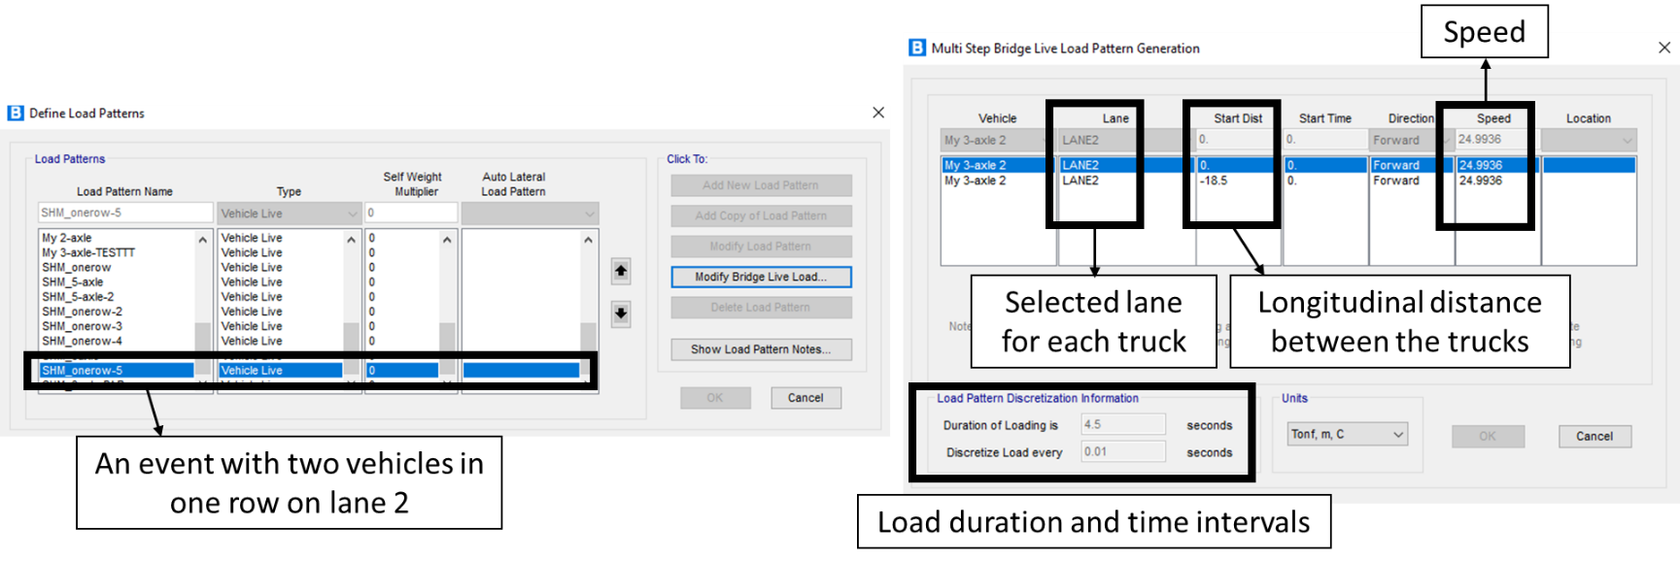
Fig. 10. How to define a custom multiple-vehicle event

Figure 11 shows where the deck properties should be assigned.

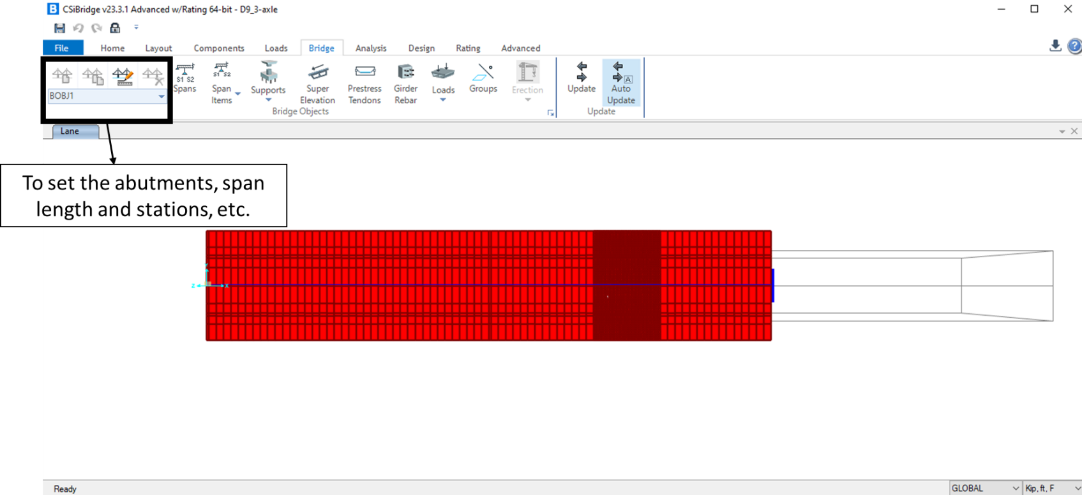
Fig. 11. Where the deck characteristics should be assigned

Figure 12 shows the tendon properties. In this project all tendons were modeled as a one equivalent tendon with equivalent section area.
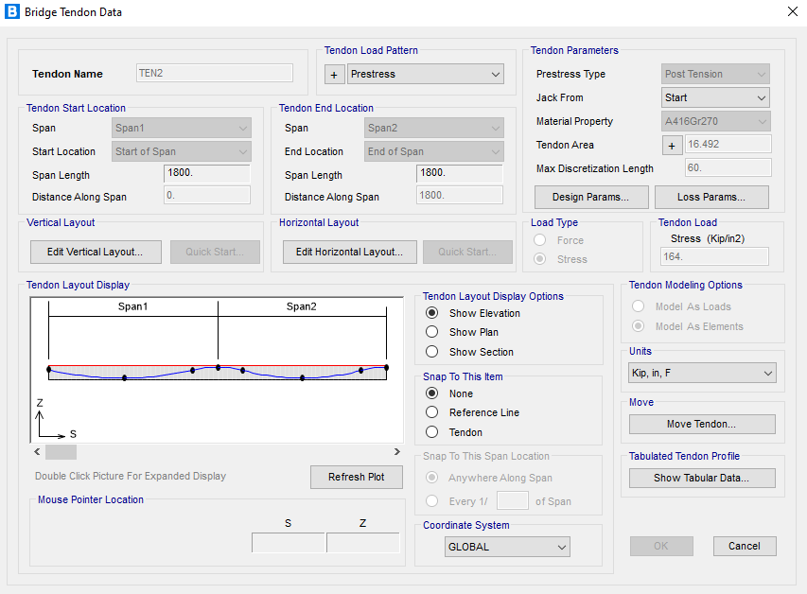
Fig. 12. Prestress tendons properties

Figure 13 shows where to define a time-history analysis and how to set the type of analysis and sampling rate. It was observed in this study that linear and nonlinear analyses provide the same results. The analysis time length should be determined based on the speed of the truck and how long it takes to entirely pass over the bridge. Then, as shown in Figure 14, the time history analysis should be enabled where the model should be run for analysis.

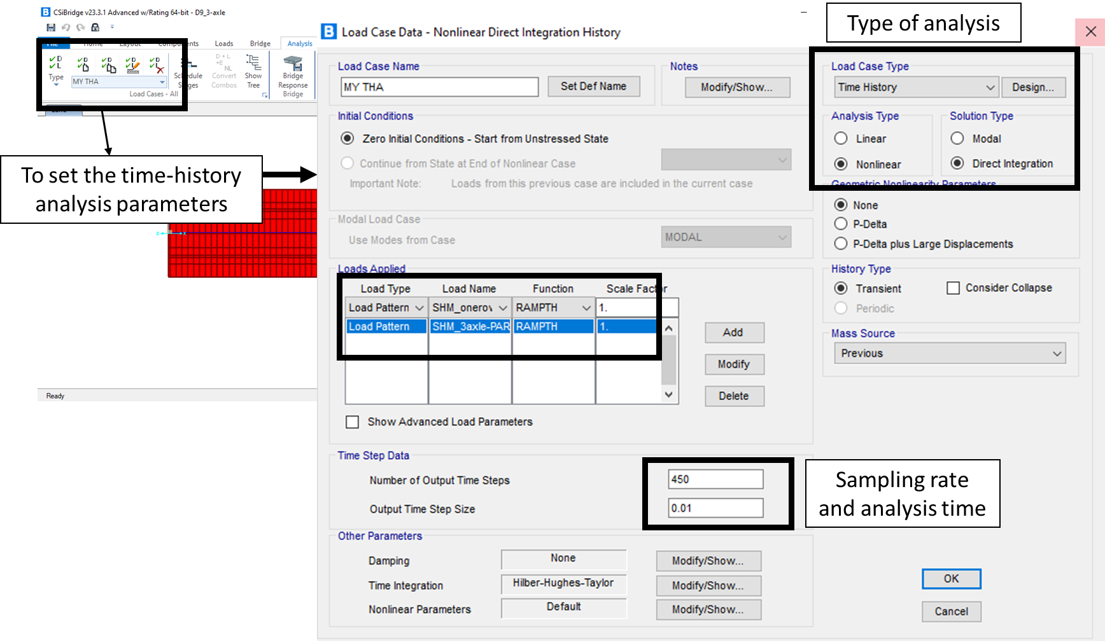
Fig. 13. Time history analysis settings
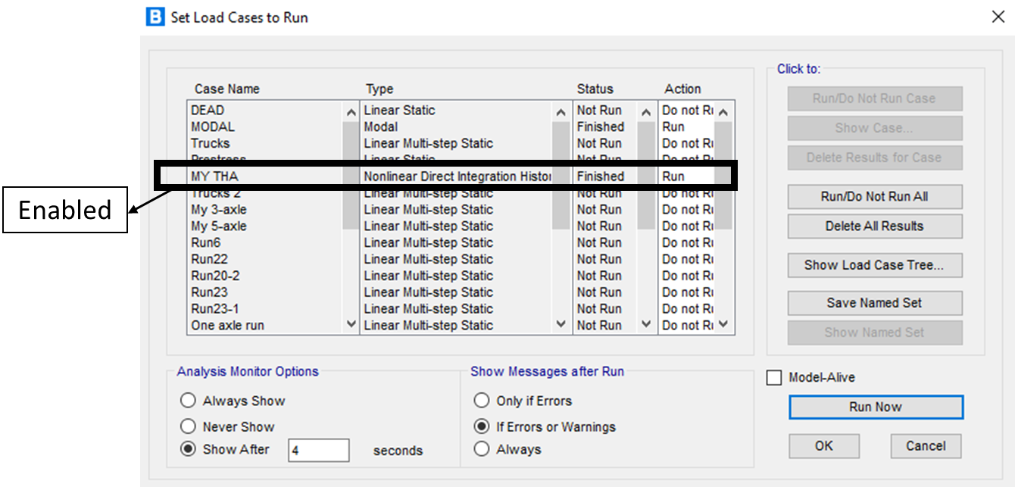
Fig. 14. Where the time history analysis should be enabled

Figure 15 shows where and how the meshes should be refined. In this window, the number of meshes in each direction (horizontal, vertical and thickness) should be selected. The default directions are shown below in this figure.
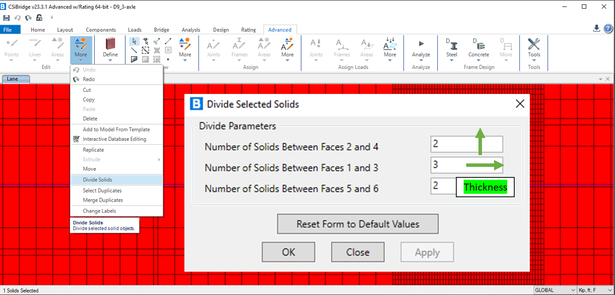
Fig. 15. Mesh refinement

