Instruction for the data from CSI Bridge:

Dataset 1: 4-axle.xlsx
This dataset provides the strain responses of the Varina_Enon bridge under a single 4-axle truck and two in-one-row 4-axle trucks on the intact and damaged bridge. This file has several tabs defined below:
Single_Intact= A single 4-axle truck on the intact bridge and the strain response is extracted from nodes 4631, 6035, and 7439 which are in an area close to tires’ paths.
These nodes are on the elements shown below:
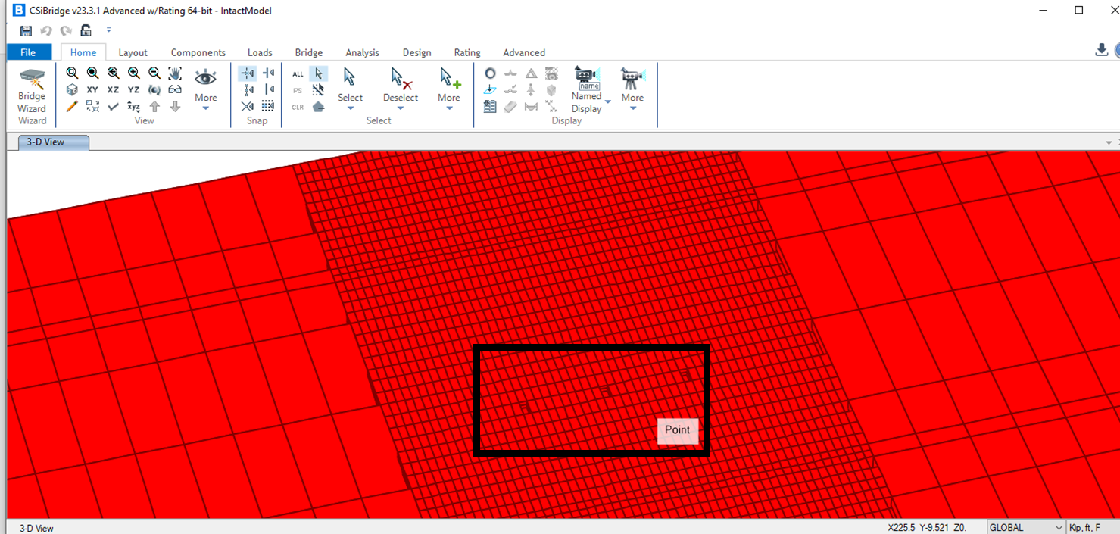The truck characteristics are provided in the dissertation and below:
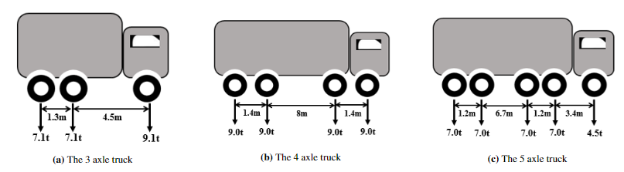
Single_onelement=A single 4-axle truck on the damaged bridge and the strain response is extracted from nodes 4631, 6035, and 7439. Dam1= Damage scenario 1, shown below. This happens when element 1 is deleted. This is going to be similar for other damage scenarios.
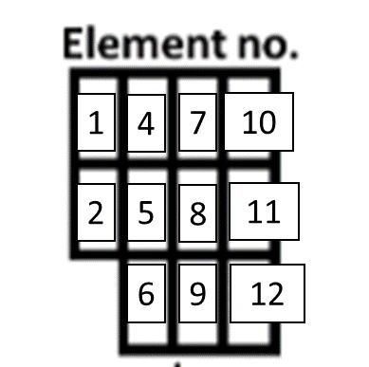
Multiple_intact= two in-one-row 4-axle trucks moved on the intact bridge.
Multiple_oneelement= two in-one-row 4-axle trucks moved on the damaged bridge. The damage scenarios were introduced above.

Dataset 2: 3-axle.xlsx
Similar dataset to dataset 1 but under a single and two in-one-row 3-axle trucks.

Dataset 3: 5-axle.xlsx
Similar dataset to dataset 1 but under a single and two in-one-row 5-axle trucks.

Dataset 4: Transverse position.xlsx
This dataset provides the strain data of the intact bridge under 3, 4, and 5-axle trucks when we have 0.3m transverse position change for lane 2. There are several tabs in this file:
Single_intact_transverse= Provides the strain data when we have transverse position change for the trucks on the second lane. In this tab, TP1= transverse position 1 (when centerline offset in the CSI Bridge for lane 2 is set to be +0.1), TP2= transverse position 2 (when there is no transverse position change for Lane 2 that is when centerline offset in the CSI Bridge for lane 2 is set to be -0.2), and TP3= transverse position 3 (when centerline offset in the CSI Bridge for lane 2 is set to be -0.5). (This is explained in the CSI Bridge Instruction how to change the transverse position.)

multiple(4ax)_intact_transverse=two in-one-row 4-axle trucks on the intact bridge and in three transverse positions explained above.
multiple(3ax)_intact_transverse=two in-one-row 3-axle trucks on the intact bridge and in three transverse positions explained above.
multiple(5ax)_intact_transverse=two in-one-row 5-axle trucks on the intact bridge and in three transverse positions explained above.
Par study.xlsx= This dataset shows the strain responses of a 3-axle truck when different parameters (axle spacings, axle weights, GVW) are changed (parametric study). This file has two tabs explained below:
For Damage 9_one element= 3-axle trucks on the damaged bridge with damage scenario 9 (shown below).
Intatc_single trucks_3-axle=3-axle trucks on the intact bridge. Trucks 1 through 11 characteristics are introduced in the following table:

