Data analysis.py
import pandas as pd
import numpy as np
import matplotlib.pyplot as plt
import plotly.express as px
import boto3 # For AWS S3 integration
import psycopg2 # For PostgreSQL integration
from io import StringIO

# Sample server log data (replace with actual log data)
data = {
"timestamp": ["2023-10-01 12:00", "2023-10-01 12:05", "2023-10-01 12:10", "2023-10-01 12:15"],
"server_id": ["srv1", "srv2", "srv1", "srv2"],
"cpu_usage": [75, 60, 85, 90],
"memory_usage": [50, 45, 55, 65],
"status": ["ok", "ok", "high_cpu", "high_memory"]
}

# Convert to Pandas DataFrame
df = pd.DataFrame(data)

# Data Analysis with Pandas and NumPy
print("Server Logs Summary:")
print(df.describe())

# Calculate average CPU and memory usage
avg_cpu = np.mean(df["cpu_usage"])
avg_memory = np.mean(df["memory_usage"])
print(f"\nAverage CPU Usage: {avg_cpu}%")
print(f"Average Memory Usage: {avg_memory}%")

# Data Visualization with Matplotlib
plt.figure(figsize=(10, 5))
plt.plot(df["timestamp"], df["cpu_usage"], label="CPU Usage", marker="o")
plt.plot(df["timestamp"], df["memory_usage"], label="Memory Usage", marker="x")
plt.title("Server CPU and Memory Usage Over Time")
plt.xlabel("Timestamp")
plt.ylabel("Usage (%)")
plt.legend()
plt.grid()
plt.show()

# Data Visualization with Plotly (Interactive)
fig = px.line(df, x="timestamp", y=["cpu_usage", "memory_usage"], title="Server Usage Over Time")
fig.show()

# Cloud Integration: Upload logs to AWS S3
def upload_to_s3(dataframe, bucket_name, file_name):
s3 = boto3.client("s3")
csv_buffer = StringIO()
dataframe.to_csv(csv_buffer, index=False)
s3.put_object(Bucket=bucket_name, Key=file_name, Body=csv_buffer.getvalue())
print(f"Uploaded {file_name} to S3 bucket {bucket_name}")

# Replace with your S3 bucket name and file name
upload_to_s3(df, "your-s3-bucket-name", "server_logs.csv")

# Database Management: Store logs in PostgreSQL
def insert_logs_to_postgres(dataframe, table_name):
conn = psycopg2.connect(
dbname="your_db_name",
user="your_db_user",
password="your_db_password",
host="your_db_host",
port="your_db_port"
)
cursor = conn.cursor()

# Create table if it doesn't exist
cursor.execute(f"""
CREATE TABLE IF NOT EXISTS {table_name} (
timestamp TIMESTAMP,
server_id VARCHAR(50),
cpu_usage FLOAT,
memory_usage FLOAT,
status VARCHAR(50)
""")

# Insert data into the table
for _, row in dataframe.iterrows():
cursor.execute(f"""
INSERT INTO {table_name} (timestamp, server_id, cpu_usage, memory_usage, status)
VALUES (%s, %s, %s, %s, %s)
""", (row["timestamp"], row["server_id"], row["cpu_usage"], row["memory_usage"], row["status"]))

conn.commit()
cursor.close()
conn.close()
print(f"Inserted logs into PostgreSQL table {table_name}")

# Replace with your table name
insert_logs_to_postgres(df, "server_logs")

Output :
Server Logs Summary:
cpu_usage memory_usage
count 4.000000 4.000000
mean 77.500000 53.750000
std 13.228757 8.539126
min 60.000000 45.000000
25% 71.250000 48.750000
50% 80.000000 52.500000
75% 86.250000 57.500000
max 90.000000 65.000000

Average CPU Usage: 77.5%
Average Memory Usage: 53.75

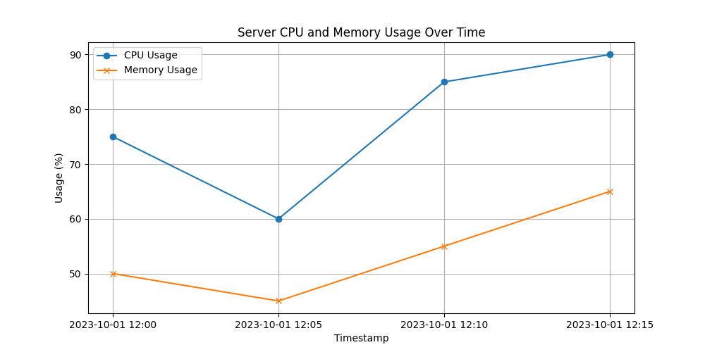

Visualization.py
import time
import random
import threading
from datetime import datetime

# --- Hypothetical Data Sources and Libraries ---
class InfrastructureData:
def get_server_metrics(self, server_id):
return {
"cpu_usage": random.uniform(10, 95),
"memory_usage": random.uniform(20, 90),
"disk_io": random.uniform(5, 80),
"network_traffic": random.uniform(100, 1000),
}

def get_database_metrics(self, db_cluster_id):
return {
"query_latency": random.uniform(1, 100),
"active_connections": random.randint(50, 500),
}

class AnomalyDetector:
def detect_cpu_anomaly(self, cpu_usage):
if cpu_usage > 90:
return "High CPU Usage Alert", 95, "high"
return None

def detect_latency_anomaly(self, latency):
if latency > 80:
return "High Latency Alert", 90, "critical"
return None

def predict_disk_failure(self, disk_io):
if disk_io > 70:
if random.random() < 0.2: # 20% chance of prediction.
return "Predicted Disk Failure", 98, "critical"
return None

# --- Visualization (Simplified) ---
class Visualization:
def __init__(self):
self.server_status = {} # Initialize as a dictionary
self.db_status = {} # Initialize for database statuses
self.alerts = [] # Initialize alerts as an empty list

def update_server_status(self, server_id, status):
self.server_status[server_id] = status

def update_db_status(self, db_id, metrics):
latency = metrics["query_latency"]
if latency > 80:
status = "red"
elif latency > 60:
status = "yellow"
else:
status = "green"
self.db_status[db_id] = status
print(f"DB {db_id} status: {status}")

def add_alert(self, message, severity, timestamp):
self.alerts.append({"message": message, "severity": severity, "timestamp": timestamp})

# --- Customizable Dashboard (Simplified) ---
class Dashboard:
def __init__(self, visualization):
self.visualization = visualization
self.widgets = [] # Store widgets in a list

def add_widget(self, widget):
self.widgets.append(widget)
print(f"Widget '{widget}' added to the dashboard.")

def display(self):
print("\n--- Dashboard View ---")
print(f"Server Status: {self.visualization.server_status}")
print(f"DB Status: {self.visualization.db_status}")
print(f"Alerts: {self.visualization.alerts}\n")

# --- Main Program ---
def main():
data_source = InfrastructureData()
anomaly_detector = AnomalyDetector()
visualization = Visualization()
dashboard = Dashboard(visualization)

dashboard.add_widget("server_status")
dashboard.add_widget("db_status")
dashboard.add_widget("alerts")

servers = ["SRV-001", "SRV-002", "SRV-003"]
databases = ["DB-Cluster-01", "DB-Cluster-02"]

def monitor():
while True:
for server in servers:
metrics = data_source.get_server_metrics(server)
visualization.update_server_status(server, metrics)

anomaly = anomaly_detector.detect_cpu_anomaly(metrics["cpu_usage"])
prediction = anomaly_detector.predict_disk_failure(metrics["disk_io"])

if anomaly:
visualization.add_alert(anomaly[0], anomaly[2], datetime.now())
if prediction:
visualization.add_alert(prediction[0], prediction[2], datetime.now())

for db in databases:
metrics = data_source.get_database_metrics(db)
visualization.update_db_status(db, metrics)

anomaly = anomaly_detector.detect_latency_anomaly(metrics["query_latency"])
if anomaly:
visualization.add_alert(anomaly[0], anomaly[2], datetime.now())

dashboard.display()
time.sleep(2)

monitor_thread = threading.Thread(target=monitor)
monitor_thread.daemon = True # Allow program to exit even if thread is running
monitor_thread.start()

try:
while True:
time.sleep(1) # Keeps main thread alive.
except KeyboardInterrupt:
print("Monitoring stopped.")

if __name__ == "__main__":
main()

OUTPUT :
tical', 'timestamp': datetime.datetime(2025, 3, 6, 13, 40, 9, 300754)}, {'message': 'High Latency Alert', 'severity': 'critical', 'timestamp': datetime.datetime(2025, 3, 6, 13, 40, 11, 313325)}, {'message': 'High CPU Usage Alert', 'severity': 'high', 'timestamp': datetime.datetime(2025, 3, 6, 13, 40, 13, 318261)}, {'message': 'High Latency Alert', 'severity': 'critical', 'timestamp': datetime.datetime(2025, 3, 6, 13, 40, 17, 324721)}]

DB DB-Cluster-01 status: green
DB DB-Cluster-02 status: green

--- Dashboard View ---
Server Status: {'SRV-001': {'cpu_usage': 65.58037417209809, 'memory_usage': 54.33555323675775, 'disk_io': 14.475976372236058, 'network_traffic': 118.91986780193265}, 'SRV-002': {'cpu_usage': 84.76552893080749, 'memory_usage': 57.48045226871046, 'disk_io': 52.95620438212628, 'network_traffic': 296.85416394676406}, 'SRV-003': {'cpu_usage': 51.29573449422377, 'memory_usage': 43.10535166954207, 'disk_io': 33.69952732475104, 'network_traffic': 595.8864154646035}}
DB Status: {'DB-Cluster-01': 'green', 'DB-Cluster-02': 'green'}
Alerts: [{'message': 'Predicted Disk Failure', 'severity': 'critical', 'timestamp': datetime.datetime(2025, 3, 6, 13, 37, 48, 848487)}, {'message': 'Predicted Disk Failure', 'severity': 'critical', 'timestamp': datetime.datetime(2025, 3, 6, 13, 37, 54, 864408)}, {'message': 'Predicted Disk Failure', 'severity': 'critical', 'timestamp': datetime.datetime(2025, 3, 6, 13, 37, 58, 874477)}, {'message': 'High Latency Alert', 'severity': 'critical', 'timestamp': datetime.datetime(2025, 3, 6, 13, 37, 58, 874477)}, {'message': 'High Latency Alert', 'severity': 'critical', 'timestamp': datetime.datetime(2025, 3, 6, 13, 38, 0, 878425)}, {'message': 'High CPU Usage Alert', 'severity': 'high', 'timestamp': datetime.datetime(2025, 3, 6, 13, 38, 2, 881524)}, {'message': 'High Latency Alert', 'severity': 'critical', 'timestamp': datetime.datetime(2025, 3, 6, 13, 38, 2, 881524)}, {'message': 'High CPU Usage Alert', 'severity': 'high', 'timestamp': datetime.datetime(2025, 3, 6, 13, 38, 4, 885228)}, {'message': 'High Latency Alert', 'severity': 'critical', 'timestamp': datetime.datetime(2025, 3, 6, 13, 38, 6, 889539)}, {'message': 'High Latency Alert', 'severity': 'critical', 'timestamp': datetime.datetime(2025, 3, 6, 13, 38, 6, 889539)}, {'message': 'High CPU Usage Alert', 'severity': 'high', 'timestamp': datetime.datetime(2025, 3, 6, 13, 38, 8, 894738)}, {'message': 'High CPU Usage Alert', 'severity': 'high', 'timestamp': datetime.datetime(2025, 3, 6, 13, 38, 14, 937478)}, {'message': 'High Latency Alert', 'severity': 'critical', 'timestamp': datetime.datetime(2025, 3, 6, 13, 38, 14, 937478)}, {'message': 'High Latency Alert', 'severity': 'critical', 'timestamp': datetime.datetime(2025, 3, 6, 13, 38, 16, 943647)}, {'message': 'Predicted Disk Failure', 'severity': 'critical', 'timestamp': datetime.datetime(2025, 3, 6, 13, 38, 31, 10549)}, {'message': 'High Latency Alert', 'severity': 'critical', 'timestamp': datetime.datetime(2025, 3, 6, 13, 38, 39, 29753)}, {'message': 'High Latency Alert', 'severity': 'critical', 'timestamp': datetime.datetime(2025, 3, 6, 13, 38, 39, 29753)}, {'message': 'High CPU Usage Alert', 'severity': 'high', 'timestamp': datetime.datetime(2025, 3, 6, 13, 38, 41, 32762)}, {'message': 'High Latency Alert', 'severity': 'critical', 'timestamp': datetime.datetime(2025, 3, 6, 13, 38, 43, 37473)}, {'message': 'High Latency Alert', 'severity': 'critical', 'timestamp': datetime.datetime(2025, 3, 6, 13, 38, 45, 40445)}, {'message': 'High Latency Alert', 'severity': 'critical', 'timestamp': datetime.datetime(2025, 3, 6, 13, 38, 49, 47389)}, {'message': 'High Latency Alert', 'severity': 'critical', 'timestamp': datetime.datetime(2025, 3, 6, 13, 38, 51, 52687)}, {'message': 'Predicted Disk Failure', 'severity': 'critical', 'timestamp': datetime.datetime(2025, 3, 6, 13, 38, 53, 57808)}, {'message': 'Predicted Disk Failure', 'severity': 'critical', 'timestamp': datetime.datetime(2025, 3, 6, 13, 38, 55, 63155)}, {'message': 'High Latency Alert', 'severity': 'critical', 'timestamp': datetime.datetime(2025, 3, 6, 13, 38, 55, 63155)}, {'message': 'High Latency Alert', 'severity': 'critical', 'timestamp': datetime.datetime(2025, 3, 6, 13, 38, 57, 67362)}, {'message': 'High CPU Usage Alert', 'severity': 'high', 'timestamp': datetime.datetime(2025, 3, 6, 13, 38, 59, 71369)}, {'message': 'High Latency Alert', 'severity': 'critical', 'timestamp': datetime.datetime(2025, 3, 6, 13, 39, 19, 118230)}, {'message': 'High CPU Usage Alert', 'severity': 'high', 'timestamp': datetime.datetime(2025, 3, 6, 13, 39, 21, 121106)}, {'message': 'Predicted Disk Failure', 'severity': 'critical', 'timestamp': datetime.datetime(2025, 3, 6, 13, 39, 21, 121106)}, {'message': 'High Latency Alert', 'severity': 'critical', 'timestamp': datetime.datetime(2025, 3, 6, 13, 39, 23, 124671)}, {'message': 'Predicted Disk Failure', 'severity': 'critical', 'timestamp': datetime.datetime(2025, 3, 6, 13, 39, 33, 154594)}, {'message': 'High CPU Usage Alert', 'severity': 'high', 'timestamp': datetime.datetime(2025, 3, 6, 13, 39, 33, 154594)}, {'message': 'High CPU Usage Alert', 'severity': 'high', 'timestamp': datetime.datetime(2025, 3, 6, 13, 39, 41, 174158)}, {'message': 'Predicted Disk Failure', 'severity': 'critical', 'timestamp': datetime.datetime(2025, 3, 6, 13, 39, 41, 174158)}, {'message': 'High CPU Usage Alert', 'severity': 'high', 'timestamp': datetime.datetime(2025, 3, 6, 13, 39, 45, 184947)}, {'message': 'High Latency Alert', 'severity': 'critical', 'timestamp': datetime.datetime(2025, 3, 6, 13, 39, 47, 209514)}, {'message': 'High Latency Alert', 'severity': 'critical', 'timestamp': datetime.datetime(2025, 3, 6, 13, 39, 55, 264264)}, {'message': 'High Latency Alert', 'severity': 'critical', 'timestamp': datetime.datetime(2025, 3, 6, 13, 39, 57, 268541)}, {'message': 'High CPU Usage Alert', 'severity': 'high', 'timestamp': datetime.datetime(2025, 3, 6, 13, 39, 59, 277844)}, {'message': 'High CPU Usage Alert', 'severity': 'high', 'timestamp': datetime.datetime(2025, 3, 6, 13, 40, 1, 282075)}, {'message': 'High Latency Alert', 'severity': 'critical', 'timestamp': datetime.datetime(2025, 3, 6, 13, 40, 1, 282075)}, {'message': 'High CPU Usage Alert', 'severity': 'high', 'timestamp': datetime.datetime(2025, 3, 6, 13, 40, 5, 290932)}, {'message': 'Predicted Disk Failure', 'severity': 'critical', 'timestamp': datetime.datetime(2025, 3, 6, 13, 40, 9, 300754)}, {'message': 'High Latency Alert', 'severity': 'critical', 'timestamp': datetime.datetime(2025, 3, 6, 13, 40, 11, 313325)}, {'message': 'High CPU Usage Alert', 'severity': 'high', 'timestamp': datetime.datetime(2025, 3, 6, 13, 40, 13, 318261)}, {'message': 'High Latency Alert', 'severity': 'critical', 'timestamp': datetime.datetime(2025, 3, 6, 13, 40, 17, 324721)}]

DB DB-Cluster-01 status: yellow
DB DB-Cluster-02 status: green

--- Dashboard View ---
Server Status: {'SRV-001': {'cpu_usage': 86.88416539712946, 'memory_usage': 52.10882264413986, 'disk_io': 20.1873124679649, 'network_traffic': 590.7451733116084}, 'SRV-002': {'cpu_usage': 45.265745853531236, 'memory_usage': 43.22626335575461, 'disk_io': 45.36835668514759, 'network_traffic': 165.43754062129557}, 'SRV-003': {'cpu_usage': 34.66667459766009, 'memory_usage': 48.595662036741246, 'disk_io': 21.088530785731965, 'network_traffic': 687.5629762381094}}
DB Status: {'DB-Cluster-01': 'yellow', 'DB-Cluster-02': 'green'}
Alerts: [{'message': 'Predicted Disk Failure', 'severity': 'critical', 'timestamp': datetime.datetime(2025, 3, 6, 13, 37, 48, 848487)}, {'message': 'Predicted Disk Failure', 'severity': 'critical', 'timestamp': datetime.datetime(2025, 3, 6, 13, 37, 54, 864408)}, {'message': 'Predicted Disk Failure', 'severity': 'critical', 'timestamp': datetime.datetime(2025, 3, 6, 13, 37, 58, 874477)}, {'message': 'High Latency Alert', 'severity': 'critical', 'timestamp': datetime.datetime(2025, 3, 6, 13, 37, 58, 874477)}, {'message': 'High Latency Alert', 'severity': 'critical', 'timestamp': datetime.datetime(2025, 3, 6, 13, 38, 0, 878425)}, {'message': 'High CPU Usage Alert', 'severity': 'high', 'timestamp': datetime.datetime(2025, 3, 6, 13, 38, 2, 881524)}, {'message': 'High Latency Alert', 'severity': 'critical', 'timestamp': datetime.datetime(2025, 3, 6, 13, 38, 2, 881524)}, {'message': 'High CPU Usage Alert', 'severity': 'high', 'timestamp': datetime.datetime(2025, 3, 6, 13, 38, 4, 885228)}, {'message': 'High Latency Alert', 'severity': 'critical', 'timestamp': datetime.datetime(2025, 3, 6, 13, 38, 6, 889539)}, {'message': 'High Latency Alert', 'severity': 'critical', 'timestamp': datetime.datetime(2025, 3, 6, 13, 38, 6, 889539)}, {'message': 'High CPU Usage Alert', 'severity': 'high', 'timestamp': datetime.datetime(2025, 3, 6, 13, 38, 8, 894738)}, {'message': 'High CPU Usage Alert', 'severity': 'high', 'timestamp': datetime.datetime(2025, 3, 6, 13, 38, 14, 937478)}, {'message': 'High Latency Alert', 'severity': 'critical', 'timestamp': datetime.datetime(2025, 3, 6, 13, 38, 14, 937478)}, {'message': 'High Latency Alert', 'severity': 'critical', 'timestamp': datetime.datetime(2025, 3, 6, 13, 38, 16, 943647)}, {'message': 'Predicted Disk Failure', 'severity': 'critical', 'timestamp': datetime.datetime(2025, 3, 6, 13, 38, 31, 10549)}, {'message': 'High Latency Alert', 'severity': 'critical', 'timestamp': datetime.datetime(2025, 3, 6, 13, 38, 39, 29753)}, {'message': 'High Latency Alert', 'severity': 'critical', 'timestamp': datetime.datetime(2025, 3, 6, 13, 38, 39, 29753)}, {'message': 'High CPU Usage Alert', 'severity': 'high', 'timestamp': datetime.datetime(2025, 3, 6, 13, 38, 41, 32762)}, {'message': 'High Latency Alert', 'severity': 'critical', 'timestamp': datetime.datetime(2025, 3, 6, 13, 38, 43, 37473)}, {'message': 'High Latency Alert', 'severity': 'critical', 'timestamp': datetime.datetime(2025, 3, 6, 13, 38, 45, 40445)}, {'message': 'High Latency Alert', 'severity': 'critical', 'timestamp': datetime.datetime(2025, 3, 6, 13, 38, 49, 47389)}, {'message': 'High Latency Alert', 'severity': 'critical', 'timestamp': datetime.datetime(2025, 3, 6, 13, 38, 51, 52687)}, {'message': 'Predicted Disk Failure', 'severity': 'critical', 'timestamp': datetime.datetime(2025, 3, 6, 13, 38, 53, 57808)}, {'message': 'Predicted Disk Failure', 'severity': 'critical', 'timestamp': datetime.datetime(2025, 3, 6, 13, 38, 55, 63155)}, {'message': 'High Latency Alert', 'severity': 'critical', 'timestamp': datetime.datetime(2025, 3, 6, 13, 38, 55, 63155)}, {'message': 'High Latency Alert', 'severity': 'critical', 'timestamp': datetime.datetime(2025, 3, 6, 13, 38, 57, 67362)}, {'message': 'High CPU Usage Alert', 'severity': 'high', 'timestamp': datetime.datetime(2025, 3, 6, 13, 38, 59, 71369)}, {'message': 'High Latency Alert', 'severity': 'critical', 'timestamp': datetime.datetime(2025, 3, 6, 13, 39, 19, 118230)}, {'message': 'High CPU Usage Alert', 'severity': 'high', 'timestamp': datetime.datetime(2025, 3, 6, 13, 39, 21, 121106)}, {'message': 'Predicted Disk Failure', 'severity': 'critical', 'timestamp': datetime.datetime(2025, 3, 6, 13, 39, 21, 121106)}, {'message': 'High Latency Alert', 'severity': 'critical', 'timestamp': datetime.datetime(2025, 3, 6, 13, 39, 23, 124671)}, {'message': 'Predicted Disk Failure', 'severity': 'critical', 'timestamp': datetime.datetime(2025, 3, 6, 13, 39, 33, 154594)}, {'message': 'High CPU Usage Alert', 'severity': 'high', 'timestamp': datetime.datetime(2025, 3, 6, 13, 39, 33, 154594)}, {'message': 'High CPU Usage Alert', 'severity': 'high', 'timestamp': datetime.datetime(2025, 3, 6, 13, 39, 41, 174158)}, {'message': 'Predicted Disk Failure', 'severity': 'critical', 'timestamp': datetime.datetime(2025, 3, 6, 13, 39, 41, 174158)}, {'message': 'High CPU Usage Alert', 'severity': 'high', 'timestamp': datetime.datetime(2025, 3, 6, 13, 39, 45, 184947)}, {'message': 'High Latency Alert', 'severity': 'critical', 'timestamp': datetime.datetime(2025, 3, 6, 13, 39, 47, 209514)}, {'message': 'High Latency Alert', 'severity': 'critical', 'timestamp': datetime.datetime(2025, 3, 6, 13, 39, 55, 264264)}, {'message': 'High Latency Alert', 'severity': 'critical', 'timestamp': datetime.datetime(2025, 3, 6, 13, 39, 57, 268541)}, {'message': 'High CPU Usage Alert', 'severity': 'high', 'timestamp': datetime.datetime(2025, 3, 6, 13, 39, 59, 277844)}, {'message': 'High CPU Usage Alert', 'severity': 'high', 'timestamp': datetime.datetime(2025, 3, 6, 13, 40, 1, 282075)}, {'message': 'High Latency Alert', 'severity': 'critical', 'timestamp': datetime.datetime(2025, 3, 6, 13, 40, 1, 282075)}, {'message': 'High CPU Usage Alert', 'severity': 'high', 'timestamp': datetime.datetime(2025, 3, 6, 13, 40, 5, 290932)}, {'message': 'Predicted Disk Failure', 'severity': 'critical', 'timestamp': datetime.datetime(2025, 3, 6, 13, 40, 9, 300754)}, {'message': 'High Latency Alert', 'severity': 'critical', 'timestamp': datetime.datetime(2025, 3, 6, 13, 40, 11, 313325)}, {'message': 'High CPU Usage Alert', 'severity': 'high', 'timestamp': datetime.datetime(2025, 3, 6, 13, 40, 13, 318261)}, {'message': 'High Latency Alert', 'severity': 'critical', 'timestamp': datetime.datetime(2025, 3, 6, 13, 40, 17, 324721)}]

DB DB-Cluster-01 status: green
DB DB-Cluster-02 status: green

--- Dashboard View ---
Server Status: {'SRV-001': {'cpu_usage': 34.422971085087596, 'memory_usage': 32.519992981465734, 'disk_io': 26.62510068032267, 'network_traffic': 739.6291615858086}, 'SRV-002': {'cpu_usage': 78.4228613505935, 'memory_usage': 42.92781452742204, 'disk_io': 33.77502565352653, 'network_traffic': 767.3227495203773}, 'SRV-003': {'cpu_usage': 53.17241611203543, 'memory_usage': 39.124360438656296, 'disk_io': 71.57397869526223, 'network_traffic': 671.5937391613264}}
DB Status: {'DB-Cluster-01': 'green', 'DB-Cluster-02': 'green'}
Alerts: [{'message': 'Predicted Disk Failure', 'severity': 'critical', 'timestamp': datetime.datetime(2025, 3, 6, 13, 37, 48, 848487)}, {'message': 'Predicted Disk Failure', 'severity': 'critical', 'timestamp': datetime.datetime(2025, 3, 6, 13, 37, 54, 864408)}, {'message': 'Predicted Disk Failure', 'severity': 'critical', 'timestamp': datetime.datetime(2025, 3, 6, 13, 37, 58, 874477)}, {'message': 'High Latency Alert', 'severity': 'critical', 'timestamp': datetime.datetime(2025, 3, 6, 13, 37, 58, 874477)}, {'message': 'High Latency Alert', 'severity': 'critical', 'timestamp': datetime.datetime(2025, 3, 6, 13, 38, 0, 878425)}, {'message': 'High CPU Usage Alert', 'severity': 'high', 'timestamp': datetime.datetime(2025, 3, 6, 13, 38, 2, 881524)}, {'message': 'High Latency Alert', 'severity': 'critical', 'timestamp': datetime.datetime(2025, 3, 6, 13, 38, 2, 881524)}, {'message': 'High CPU Usage Alert', 'severity': 'high', 'timestamp': datetime.datetime(2025, 3, 6, 13, 38, 4, 885228)}, {'message': 'High Latency Alert', 'severity': 'critical', 'timestamp': datetime.datetime(2025, 3, 6, 13, 38, 6, 889539)}, {'message': 'High Latency Alert', 'severity': 'critical', 'timestamp': datetime.datetime(2025, 3, 6, 13, 38, 6, 889539)}, {'message': 'High CPU Usage Alert', 'severity': 'high', 'timestamp': datetime.datetime(2025, 3, 6, 13, 38, 8, 894738)}, {'message': 'High CPU Usage Alert', 'severity': 'high', 'timestamp': datetime.datetime(2025, 3, 6, 13, 38, 14, 937478)}, {'message': 'High Latency Alert', 'severity': 'critical', 'timestamp': datetime.datetime(2025, 3, 6, 13, 38, 14, 937478)}, {'message': 'High Latency Alert', 'severity': 'critical', 'timestamp': datetime.datetime(2025, 3, 6, 13, 38, 16, 943647)}, {'message': 'Predicted Disk Failure', 'severity': 'critical', 'timestamp': datetime.datetime(2025, 3, 6, 13, 38, 31, 10549)}, {'message': 'High Latency Alert', 'severity': 'critical', 'timestamp': datetime.datetime(2025, 3, 6, 13, 38, 39, 29753)}, {'message': 'High Latency Alert', 'severity': 'critical', 'timestamp': datetime.datetime(2025, 3, 6, 13, 38, 39, 29753)}, {'message': 'High CPU Usage Alert', 'severity': 'high', 'timestamp': datetime.datetime(2025, 3, 6, 13, 38, 41, 32762)}, {'message': 'High Latency Alert', 'severity': 'critical', 'timestamp': datetime.datetime(2025, 3, 6, 13, 38, 43, 37473)}, {'message': 'High Latency Alert', 'severity': 'critical', 'timestamp': datetime.datetime(2025, 3, 6, 13, 38, 45, 40445)}, {'message': 'High Latency Alert', 'severity': 'critical', 'timestamp': datetime.datetime(2025, 3, 6, 13, 38, 49, 47389)}, {'message': 'High Latency Alert', 'severity': 'critical', 'timestamp': datetime.datetime(2025, 3, 6, 13, 38, 51, 52687)}, {'message': 'Predicted Disk Failure', 'severity': 'critical', 'timestamp': datetime.datetime(2025, 3, 6, 13, 38, 53, 57808)}, {'message': 'Predicted Disk Failure', 'severity': 'critical', 'timestamp': datetime.datetime(2025, 3, 6, 13, 38, 55, 63155)}, {'message': 'High Latency Alert', 'severity': 'critical', 'timestamp': datetime.datetime(2025, 3, 6, 13, 38, 55, 63155)}, {'message': 'High Latency Alert', 'severity': 'critical', 'timestamp': datetime.datetime(2025, 3, 6, 13, 38, 57, 67362)}, {'message': 'High CPU Usage Alert', 'severity': 'high', 'timestamp': datetime.datetime(2025, 3, 6, 13, 38, 59, 71369)}, {'message': 'High Latency Alert', 'severity': 'critical', 'timestamp': datetime.datetime(2025, 3, 6, 13, 39, 19, 118230)}, {'message': 'High CPU Usage Alert', 'severity': 'high', 'timestamp': datetime.datetime(2025, 3, 6, 13, 39, 21, 121106)}, {'message': 'Predicted Disk Failure', 'severity': 'critical', 'timestamp': datetime.datetime(2025, 3, 6, 13, 39, 21, 121106)}, {'message': 'High Latency Alert', 'severity': 'critical', 'timestamp': datetime.datetime(2025, 3, 6, 13, 39, 23, 124671)}, {'message': 'Predicted Disk Failure', 'severity': 'critical', 'timestamp': datetime.datetime(2025, 3, 6, 13, 39, 33, 154594)}, {'message': 'High CPU Usage Alert', 'severity': 'high', 'timestamp': datetime.datetime(2025, 3, 6, 13, 39, 33, 154594)}, {'message': 'High CPU Usage Alert', 'severity': 'high', 'timestamp': datetime.datetime(2025, 3, 6, 13, 39, 41, 174158)}, {'message': 'Predicted Disk Failure', 'severity': 'critical', 'timestamp': datetime.datetime(2025, 3, 6, 13, 39, 41, 174158)}, {'message': 'High CPU Usage Alert', 'severity': 'high', 'timestamp': datetime.datetime(2025, 3, 6, 13, 39, 45, 184947)}, {'message': 'High Latency Alert', 'severity': 'critical', 'timestamp': datetime.datetime(2025, 3, 6, 13, 39, 47, 209514)}, {'message': 'High Latency Alert', 'severity': 'critical', 'timestamp': datetime.datetime(2025, 3, 6, 13, 39, 55, 264264)}, {'message': 'High Latency Alert', 'severity': 'critical', 'timestamp': datetime.datetime(2025, 3, 6, 13, 39, 57, 268541)}, {'message': 'High CPU Usage Alert', 'severity': 'high', 'timestamp': datetime.datetime(2025, 3, 6, 13, 39, 59, 277844)}, {'message': 'High CPU Usage Alert', 'severity': 'high', 'timestamp': datetime.datetime(2025, 3, 6, 13, 40, 1, 282075)}, {'message': 'High Latency Alert', 'severity': 'critical', 'timestamp': datetime.datetime(2025, 3, 6, 13, 40, 1, 282075)}, {'message': 'High CPU Usage Alert', 'severity': 'high', 'timestamp': datetime.datetime(2025, 3, 6, 13, 40, 5, 290932)}, {'message': 'Predicted Disk Failure', 'severity': 'critical', 'timestamp': datetime.datetime(2025, 3, 6, 13, 40, 9, 300754)}, {'message': 'High Latency Alert', 'severity': 'critical', 'timestamp': datetime.datetime(2025, 3, 6, 13, 40, 11, 313325)}, {'message': 'High CPU Usage Alert', 'severity': 'high', 'timestamp': datetime.datetime(2025, 3, 6, 13, 40, 13, 318261)}, {'message': 'High Latency Alert', 'severity': 'critical', 'timestamp': datetime.datetime(2025, 3, 6, 13, 40, 17, 324721)}]

Anomaly detection.py
import pandas as pd
import numpy as np
import matplotlib.pyplot as plt
import seaborn as sns
import plotly.express as px
import plotly.graph_objects as go

# Sample Data Generation (Replace with your actual data source)
np.random.seed(42)
time_index = pd.date_range('2023-01-01', periods=1000, freq='H')
cpu_usage = np.random.normal(50, 10, 1000)
memory_usage = np.random.normal(60, 15, 1000)
network_traffic = np.random.normal(100, 20, 1000)
database_latency = np.random.normal(5, 1, 1000)
df = pd.DataFrame({
'timestamp': time_index,
'cpu_usage': cpu_usage,
'memory_usage': memory_usage,
'network_traffic': network_traffic,
'database_latency': database_latency
})
df.set_index('timestamp', inplace=True)

# Add Anomaly Detection (using a simplified threshold example for visualization)
df['cpu_anomaly'] = df['cpu_usage'].apply(lambda x: 1 if abs(x - df['cpu_usage'].mean()) > 2 * df['cpu_usage'].std() else 0)
df['latency_anomaly'] = df['database_latency'].apply(lambda x: 1 if abs(x - df['database_latency'].mean()) > 2 * df['database_latency'].std() else 0)

# 1. Matplotlib: Time Series with Anomalies
def plot_time_series_matplotlib(df, column, anomaly_column):
"""Plots time series with anomalies using Matplotlib."""
anomalies = df[df[anomaly_column] == 1]
plt.figure(figsize=(12, 6))
plt.plot(df[column], label=column)
plt.scatter(anomalies.index, anomalies[column], color='red', label='Anomaly')
plt.title(f'{column} Time Series with Anomalies (Matplotlib)')
plt.legend()
plt.show()

plot_time_series_matplotlib(df, 'cpu_usage', 'cpu_anomaly')

# 2. Seaborn: Distribution and Correlation
def plot_distribution_seaborn(df, column):
"""Plots distribution using Seaborn."""
plt.figure(figsize=(8, 6))
sns.histplot(df[column], kde=True)
plt.title(f'{column} Distribution (Seaborn)')
plt.show()

plot_distribution_seaborn(df, 'network_traffic')

def plot_correlation_seaborn(df, col1, col2):
"""Plots correlation using Seaborn."""
plt.figure(figsize=(8, 6))
sns.scatterplot(x=col1, y=col2, data=df)
plt.title(f'{col1} vs {col2} (Seaborn)')
plt.show()

plot_correlation_seaborn(df, 'cpu_usage', 'memory_usage')

# 3. Plotly: Interactive Time Series and Scatter Plots
def plot_time_series_plotly(df, column, anomaly_column):
"""Plots interactive time series with anomalies using Plotly."""
fig = px.line(df, x=df.index, y=column, title=f'{column} Time Series (Plotly)')
anomalies = df[df[anomaly_column] == 1]
fig.add_trace(go.Scatter(x=anomalies.index, y=anomalies[column], mode='markers', marker=dict(color='red'), name='Anomaly'))
fig.show()

plot_time_series_plotly(df, 'database_latency', 'latency_anomaly')

def plot_scatter_plotly(df, col1, col2):
"""Plots interactive scatter plot using Plotly."""
fig = px.scatter(df, x=col1, y=col2, title=f'{col1} vs {col2} (Plotly)')
fig.show()

plot_scatter_plotly(df, 'network_traffic', 'cpu_usage')

# 4. Plotly: Interactive Dashboard (Example)
def create_dashboard_plotly(df):
"""Creates a simple interactive dashboard using Plotly."""
fig_cpu = px.line(df, x=df.index, y='cpu_usage', title='CPU Usage')
fig_memory = px.line(df, x=df.index, y='memory_usage', title='Memory Usage')
fig_network = px.line(df, x=df.index, y='network_traffic', title='Network Traffic')
fig_latency = px.line(df, x=df.index, y='database_latency', title='Database Latency')

from plotly.subplots import make_subplots
fig = make_subplots(rows=2, cols=2, subplot_titles=('CPU Usage', 'Memory Usage', 'Network Traffic', 'Database Latency'))

fig.add_trace(fig_cpu.data[0], row=1, col=1)
fig.add_trace(fig_memory.data[0], row=1, col=2)
fig.add_trace(fig_network.data[0], row=2, col=1)
fig.add_trace(fig_latency.data[0], row=2, col=2)

fig.update_layout(height=800, width=1200, title_text="IT Infrastructure Dashboard")
fig.show()

create_dashboard_plotly(df)

OUTPUT:
FutureWarning: 'H' is deprecated and will be removed in a future version, please use 'h' instead.
time_index = pd.date_range('2023-01-01', periods=1000, freq='H')

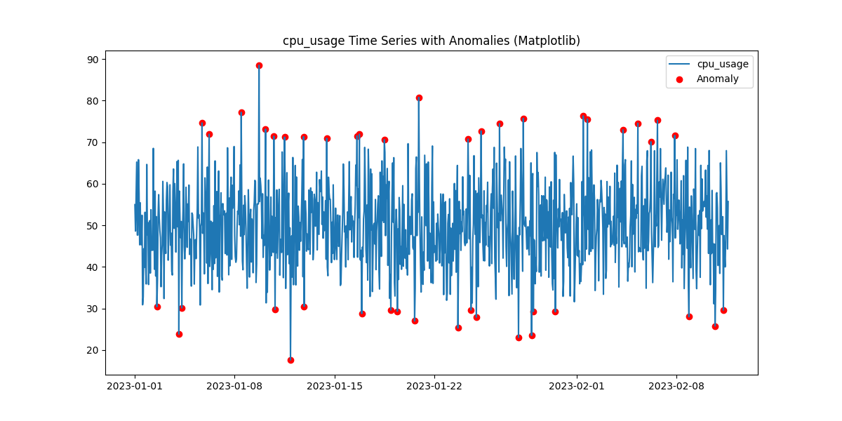
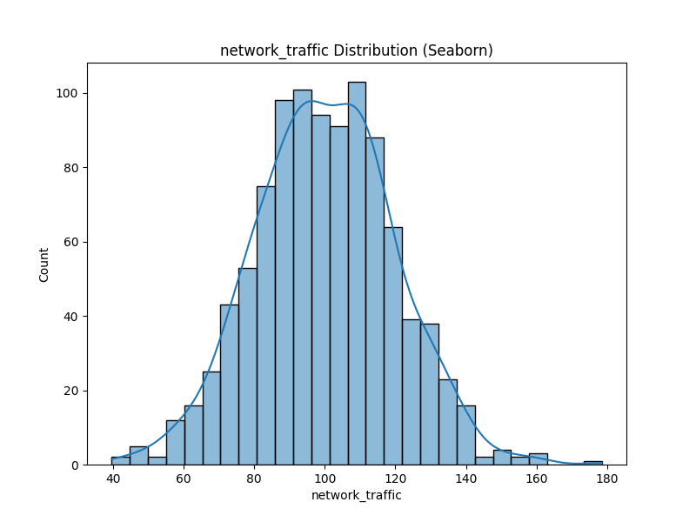

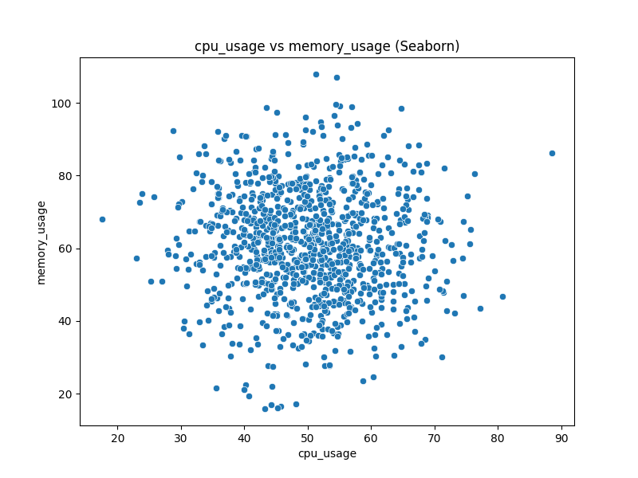

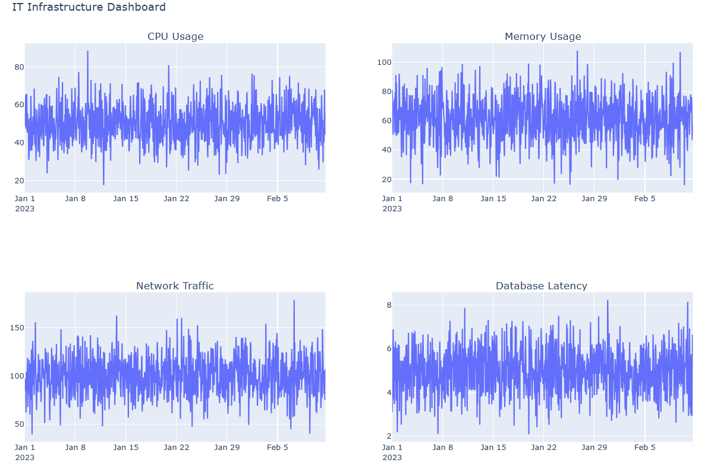

Cloud platform.py
import pandas as pd
import numpy as np
import datetime

# Sample Data Generation
np.random.seed(42)
time_index = pd.date_range('2023-01-01', periods=1000, freq='H')
cpu_usage = np.random.normal(50, 10, 1000)
memory_usage = np.random.normal(60, 15, 1000)
network_traffic = np.random.normal(100, 20, 1000)
database_latency = np.random.normal(5, 1, 1000)

df = pd.DataFrame({
'timestamp': time_index,
'cpu_usage': cpu_usage,
'memory_usage': memory_usage,
'network_traffic': network_traffic,
'database_latency': database_latency
})

# Preprocessing: Example (Add a day of week column)
df['day_of_week'] = df['timestamp'].dt.day_name()

# Output
print("Sample Preprocessed Data:")
print(df.head())

# --- Cloud Platform Examples (Conceptual) ---

# AWS (Conceptual)
def aws_data_pipeline(df, bucket_name, file_key):
"""Conceptual AWS data pipeline (S3, Glue, Athena)."""
# 1. Store data in S3
# s3_client.put_object(Bucket=bucket_name, Key=file_key, Body=df.to_csv(index=False))
print(f"AWS: Data stored in S3 bucket '{bucket_name}', key '{file_key}'.")

# 2. AWS Glue (ETL) - Example: Run a Glue job to transform data
# glue_client.start_job_run(JobName='my_glue_job')
print("AWS: Glue job triggered (conceptual).")

# 3. AWS Athena (Query) - Example: Query the data
# athena_client.start_query_execution(QueryString='SELECT * FROM my_table', ResultConfiguration={'OutputLocation': 's3://...'})
print("AWS: Athena query executed (conceptual).")

# Azure (Conceptual)
def azure_data_pipeline(df, container_name, file_name):
"""Conceptual Azure data pipeline (Blob Storage, Data Factory, Synapse)."""
# 1. Store data in Blob Storage
# blob_service_client.get_blob_client(container=container_name, blob=file_name).upload_blob(df.to_csv(index=False))
print(f"Azure: Data stored in Blob Storage container '{container_name}', file '{file_name}'.")

# 2. Azure Data Factory (ETL) - Example: Run a Data Factory pipeline
# data_factory_client.create_pipeline_run(resource_group_name='...', factory_name='...', pipeline_name='...')
print("Azure: Data Factory pipeline triggered (conceptual).")

# 3. Azure Synapse Analytics (Query) - Example: Query the data
# synapse_client.execute_query(workspace_name='...', sql_query='SELECT * FROM my_table')
print("Azure: Synapse query executed (conceptual).")

# GCP (Conceptual)
def gcp_data_pipeline(df, bucket_name, blob_name):
"""Conceptual GCP data pipeline (Cloud Storage, Dataflow, BigQuery)."""
# 1. Store data in Cloud Storage
# bucket = storage_client.bucket(bucket_name)
# blob = bucket.blob(blob_name)
# blob.upload_from_string(df.to_csv(index=False))
print(f"GCP: Data stored in Cloud Storage bucket '{bucket_name}', blob '{blob_name}'.")

# 2. Google Cloud Dataflow (ETL) - Example: Run a Dataflow job
# dataflow_client.projects().locations().templates().create(body={'gcsPath': 'gs://...'}, projectId='...', location='...')
print("GCP: Dataflow job triggered (conceptual).")

# 3. Google BigQuery (Query) - Example: Query the data
# query_job = bigquery_client.query('SELECT * FROM my_dataset.my_table')
print("GCP: BigQuery query executed (conceptual).")

# Example Usage (Conceptual)
aws_data_pipeline(df, 'my-monitoring-bucket', 'monitoring_data.csv')
azure_data_pipeline(df, 'monitoring-container', 'monitoring_data.csv')
gcp_data_pipeline(df, 'my-monitoring-bucket', 'monitoring_data.csv')

OUTPUT :
FutureWarning: 'H' is deprecated and will be removed in a future version, please use 'h' instead.
use 'h' instead.
time_index = pd.date_range('2023-01-01', periods=1000, freq='H')
Sample Preprocessed Data:
timestamp cpu_usage memory_usage network_traffic database_latency day_of_week
0 2023-01-01 00:00:00 54.967142 80.990332 86.496435 3.092192 Sunday
1 2023-01-01 01:00:00 48.617357 73.869505 97.109627 4.139615 Sunday
2 2023-01-01 02:00:00 56.476885 60.894456 84.151602 4.586394 Sunday
3 2023-01-01 03:00:00 65.230299 50.295948 93.840769 6.887688 Sunday
4 2023-01-01 04:00:00 47.658466 70.473350 62.127707 5.556553 Sunday
AWS: Data stored in S3 bucket 'my-monitoring-bucket', key 'monitoring_data.csv'.
AWS: Glue job triggered (conceptual).
AWS: Athena query executed (conceptual).
Azure: Data stored in Blob Storage container 'monitoring-container', file 'monitoring_data.csv'.
Azure: Data Factory pipeline triggered (conceptual).
Azure: Synapse query executed (conceptual).
GCP: Data stored in Cloud Storage bucket 'my-monitoring-bucket', blob 'monitoring_data.csv'.
GCP: Dataflow job triggered (conceptual).
GCP: BigQuery query executed (conceptual).

Database1.py
from flask import Flask, request, jsonify, render_template
from flask_sqlalchemy import SQLAlchemy
import pickle
import numpy as np

# Initialize Flask app
app = Flask(__name__)

# Configure SQLite database
app.config['SQLALCHEMY_DATABASE_URI'] = 'sqlite:///predictions.db'
app.config['SQLALCHEMY_TRACK_MODIFICATIONS'] = False

# Initialize the database
db = SQLAlchemy(app)

# Define the Prediction model
class Prediction(db.Model):
id = db.Column(db.Integer, primary_key=True)
cpu_usage = db.Column(db.Float, nullable=False)
memory_usage = db.Column(db.Float, nullable=False)
disk_usage = db.Column(db.Float, nullable=False)
network_usage = db.Column(db.Float, nullable=False)
predicted_capacity = db.Column(db.Float, nullable=False)

def __repr__(self):
return f"<Prediction {self.id}>"

# Create the database and tables
with app.app_context():
db.create_all()

# Load the trained model
try:
with open('model.pkl', 'rb') as f:
model = pickle.load(f)
print("Model loaded successfully!")
except Exception as e:
print(f"Error loading model: {e}")

# Route to serve the frontend
@app.route('/')
def home():
return render_template('index.html') # Serve the index.html template

# Route to handle prediction requests
@app.route('/predict', methods=['POST'])
def predict():
try:
# Get input data from the request
data = request.get_json()
cpu_usage = data['cpu_usage']
memory_usage = data['memory_usage']
disk_usage = data['disk_usage']
network_usage = data['network_usage']

# Prepare input for the model
input_data = np.array([[cpu_usage, memory_usage, disk_usage, network_usage]])

# Make prediction
predicted_capacity = model.predict(input_data)[0]

# Save the prediction to the database
prediction = Prediction(
cpu_usage=cpu_usage,
memory_usage=memory_usage,
disk_usage=disk_usage,
network_usage=network_usage,
predicted_capacity=predicted_capacity
)
db.session.add(prediction)
db.session.commit()

# Return the result
return jsonify({
'predicted_capacity': predicted_capacity
})
except Exception as e:
return jsonify({
'error': str(e)
}), 500

# Route to view all predictions
@app.route('/predictions', methods=['GET'])
def get_predictions():
try:
# Fetch all predictions from the database
predictions = Prediction.query.all()
predictions_list = []
for prediction in predictions:
predictions_list.append({
'id': prediction.id,
'cpu_usage': prediction.cpu_usage,
'memory_usage': prediction.memory_usage,
'disk_usage': prediction.disk_usage,
'network_usage': prediction.network_usage,
'predicted_capacity': prediction.predicted_capacity
})
return jsonify(predictions_list)
except Exception as e:
return jsonify({
'error': str(e)
}), 500

# Run the Flask app
if __name__ == '__main__':
app.run(debug=True)

Index.html
<!DOCTYPE html>
<html lang="en">
<head>
<meta charset="UTF-8">
<meta name="viewport" content="width=device-width, initial-scale=1.0">
<title>Capacity Planning</title>
<link href="https://fonts.googleapis.com/css2?family=Poppins:wght@400;500;600&display=swap" rel="stylesheet">
<link rel="stylesheet" href="{{ url_for('static', filename='styles.css') }}">
</head>
<body>
<div class="container">
<h1>Capacity Planning for Predictive Maintenance</h1>
<form id="capacityForm">
<label for="cpuUsage">CPU Usage (%):</label>
<input type="number" id="cpuUsage" name="cpuUsage" required>

<label for="memoryUsage">Memory Usage (%):</label>
<input type="number" id="memoryUsage" name="memoryUsage" required>

<label for="diskUsage">Disk Usage (%):</label>
<input type="number" id="diskUsage" name="diskUsage" required>

<label for="networkUsage">Network Usage (%):</label>
<input type="number" id="networkUsage" name="networkUsage" required>

<button type="submit">Predict Capacity Requirement</button>
</form>

<h2>Predicted Capacity Requirement:</h2>
<p id="predictionResult"></p>
<h2>Predicted Capacity Requirement:</h2>
<p id="predictionResult"></p>

<!-- Add a canvas for the graph -->
<canvas id="capacityChart" width="400" height="200"></canvas>

<button id="viewPredictions">View All Predictions</button>
<div id="predictionsList"></div>
</div>

<script src="{{ url_for('static', filename='script.js') }}"></script>
</body>
</html>

Styles.css
/* General Styles */
body {
font-family: 'Poppins', sans-serif;
background: linear-gradient(135deg, #f5f7fa 0%, #c3cfe2 100%);
margin: 0;
padding: 0;
display: flex;
justify-content: center;
align-items: center;
height: 100vh;
color: #333;
overflow: hidden;
}

/* Container */
.container {
background: rgba(255, 255, 255, 0.9);
padding: 30px;
border-radius: 20px;
box-shadow: 0 8px 32px rgba(0, 0, 0, 0.1);
backdrop-filter: blur(10px);
border: 1px solid rgba(255, 255, 255, 0.2);
width: 400px;
text-align: center;
animation: fadeIn 1s ease, slideIn 0.8s ease;
}

/* Heading */
h1 {
margin-bottom: 20px;
font-size: 32px;
font-weight: 600;
color: #4a90e2;
text-shadow: 2px 2px 4px rgba(0, 0, 0, 0.1);
}

/* Labels */
label {
display: block;
margin-bottom: 10px;
font-weight: 500;
color: #555;
}

/* Input Fields */
input {
width: 100%;
padding: 12px;
margin-bottom: 20px;
border: 1px solid rgba(0, 0, 0, 0.1);
border-radius: 10px;
background: rgba(255, 255, 255, 0.9);
color: #333;
font-size: 16px;
transition: all 0.3s ease;
}

input:focus {
border-color: #4a90e2;
outline: none;
background: rgba(255, 255, 255, 1);
box-shadow: 0 0 10px rgba(74, 144, 226, 0.3);
}

/* Buttons */
button {
width: 100%;
padding: 12px;
background: linear-gradient(135deg, #4a90e2 0%, #6a5acd 100%);
color: #fff;
border: none;
border-radius: 10px;
font-size: 16px;
font-weight: 600;
cursor: pointer;
transition: all 0.3s ease;
box-shadow: 0 4px 6px rgba(0, 0, 0, 0.1);
}

button:hover {
background: linear-gradient(135deg, #6a5acd 0%, #4a90e2 100%);
transform: translateY(-3px);
box-shadow: 0 6px 8px rgba(0, 0, 0, 0.2);
}

button:active {
transform: translateY(0);
box-shadow: 0 4px 6px rgba(0, 0, 0, 0.1);
}

/* Prediction Result */
#predictionResult {
font-size: 20px;
font-weight: 600;
margin-top: 20px;
color: #4a90e2;
text-shadow: 1px 1px 2px rgba(0, 0, 0, 0.1);
animation: fadeIn 0.5s ease;
}

/* View Predictions Button */
#viewPredictions {
margin-top: 20px;
background: linear-gradient(135deg, #ff7e5f 0%, #feb47b 100%);
}

#viewPredictions:hover {
background: linear-gradient(135deg, #feb47b 0%, #ff7e5f 100%);
}

/* Predictions Table */
#predictionsList {
margin-top: 20px;
animation: fadeIn 0.8s ease;
}

table {
width: 100%;
border-collapse: collapse;
margin-top: 20px;
background: rgba(255, 255, 255, 0.9);
border-radius: 10px;
overflow: hidden;
box-shadow: 0 4px 6px rgba(0, 0, 0, 0.1);
}

th, td {
padding: 12px;
text-align: center;
border-bottom: 1px solid rgba(0, 0, 0, 0.1);
}

th {
background: rgba(74, 144, 226, 0.1);
font-weight: 600;
color: #4a90e2;
}

tr:hover {
background: rgba(74, 144, 226, 0.05);
transform: scale(1.02);
transition: all 0.3s ease;
}

/* Animations */
@keyframes fadeIn {
from {
opacity: 0;
}
to {
opacity: 1;
}
}

@keyframes slideIn {
from {
transform: translateY(-20px);
}
to {
transform: translateY(0);
}
}

/* Background Animation */
body::before {
content: '';
position: absolute;
top: 0;
left: 0;
width: 100%;
height: 100%;
background: linear-gradient(135deg, rgba(245, 247, 250, 0.8) 0%, rgba(195, 207, 226, 0.8) 100%);
z-index: -1;
animation: moveBackground 10s infinite alternate;
}

@keyframes moveBackground {
0% {
transform: translateY(0);
}
100% {
transform: translateY(-20px);
}
}

/* Add a subtle pulse animation to the container */
@keyframes pulse {
0% {
transform: scale(1);
}
50% {
transform: scale(1.02);
}
100% {
transform: scale(1);
}
}

.container:hover {
animation: pulse 2s infinite;
}
Script.js
document.getElementById('capacityForm').addEventListener('submit', async function (event) {
event.preventDefault();

// Get input values
const cpuUsage = parseFloat(document.getElementById('cpuUsage').value);
const memoryUsage = parseFloat(document.getElementById('memoryUsage').value);
const diskUsage = parseFloat(document.getElementById('diskUsage').value);
const networkUsage = parseFloat(document.getElementById('networkUsage').value);

// Prepare data for the API request
const inputData = {
cpu_usage: cpuUsage,
memory_usage: memoryUsage,
disk_usage: diskUsage,
network_usage: networkUsage
};

try {
// Send data to the backend API
const response = await fetch('/predict', {
method: 'POST',
headers: {
'Content-Type': 'application/json'
},
body: JSON.stringify(inputData)
});

if (!response.ok) {
throw new Error('Network response was not ok');
}

// Get the prediction result
const result = await response.json();
document.getElementById('predictionResult').textContent = `Predicted Capacity Requirement: ${result.predicted_capacity.toFixed(2)}`;
} catch (error) {
console.error('Error:', error);
document.getElementById('predictionResult').textContent = 'Error predicting capacity requirement.';
}
});

// Fetch and display all predictions
document.getElementById('viewPredictions').addEventListener('click', async function () {
try {
const response = await fetch('/predictions');
if (!response.ok) {
throw new Error('Network response was not ok');
}

const predictions = await response.json();
const predictionsList = document.getElementById('predictionsList');
predictionsList.innerHTML = '<h2>All Predictions</h2>';

if (predictions.length === 0) {
predictionsList.innerHTML += '<p>No predictions found.</p>';
} else {
const table = document.createElement('table');
table.innerHTML = `
<tr>
<th>ID</th>
<th>CPU Usage</th>
<th>Memory Usage</th>
<th>Disk Usage</th>
<th>Network Usage</th>
<th>Predicted Capacity</th>
</tr>
`;

predictions.forEach(prediction => {
table.innerHTML += `
<tr>
<td>${prediction.id}</td>
<td>${prediction.cpu_usage}</td>
<td>${prediction.memory_usage}</td>
<td>${prediction.disk_usage}</td>
<td>${prediction.network_usage}</td>
<td>${prediction.predicted_capacity.toFixed(2)}</td>
</tr>
`;
});

predictionsList.appendChild(table);
}
} catch (error) {
console.error('Error:', error);
}
});

Output :

