CREDIT CARD APPROVAL PREDICTION
Project Report
Submitted in partial fulfillment of the requirements for
SmartBridge AI & ML Virtual Internship Program (SkillWallet)
Team Lead: Renuka Tupakula
Team Members:
Sony Geddam
Vasarla Bhavya Sri Lakshmi
Dhanush Venkata Sai Achanta
Gandham Raju
College: Bonam Venkata Chalamayya Engineering College, Odalarevu
Submission Date: 12 July 2026

Table of Contents

1. Introduction

1.1 Project Overview
The Credit Card Approval Prediction System is a machine learning based web application designed to automate and enhance the credit card approval process in the banking and financial sector. The system analyzes applicant financial and demographic information to predict whether a credit card application should be approved or rejected. Three classification algorithms — Logistic Regression, Random Forest, and Decision Tree — were trained and compared (XGBoost was installed as part of the technology stack but was not included in the final model comparison). The best-performing model, Random Forest, is integrated into a Flask web application for real-time predictions.

1.2 Purpose
- Automate the credit card approval process using machine learning.
- Reduce manual effort and human error in evaluating credit card applications.
- Provide instant approval or rejection predictions based on applicant data.
- Deploy a web application that allows users to enter applicant details and receive instant results.
- Gain hands-on experience in machine learning, data analysis, and Flask web development.

2. Ideation Phase

2.1 Problem Statement
Banks and financial institutions receive thousands of credit card applications every day. A significant portion of these are rejected due to factors such as high existing loan balances, insufficient income levels, or excessive credit inquiries. Manually reviewing each application is time-consuming and prone to human error, making it inefficient at scale. There is a need for an automated, intelligent system that can evaluate credit card applications quickly and accurately, reducing the workload on bank employees while maintaining fairness and consistency.

2.2 Empathy Map Canvas
Target User: Bank Credit Analysts and Applicants
Category | Description
Think & Feel | Bank analysts feel overwhelmed with large volumes of applications. Applicants feel anxious about approval decisions.
Hear | Analysts hear about increasing fraud cases and need reliable risk assessment tools.
See | Analysts see complex financial data, income records, and credit histories.
Say & Do | Applicants provide income, employment, and demographic details. Analysts review and make decisions.
Pain | Manual review is slow, inconsistent, and prone to bias.
Gain | Automated system provides fast, consistent, data-driven decisions.

2.3 Brainstorming
- Use of multiple machine learning classification algorithms for comparison (Logistic Regression, Random Forest, Decision Tree).
- Merging two datasets (application records and credit records) for comprehensive analysis.
- Building a Flask web application for real-time predictions.
- Feature engineering to convert categorical variables into numerical representations.

3. Requirement Analysis

3.1 Customer Journey Map
Stage | Description
1. Awareness | Bank identifies the need for an automated approval system.
2. Input | Applicant enters personal and financial details into the web form.
3. Processing | System processes input through the trained ML model.
4. Output | System displays Approved or Rejected result instantly.
5. Decision | Bank analyst reviews the prediction and makes the final decision.

3.2 Solution Requirement
Functional Requirements
- Accept applicant demographic and financial data as input.
- Preprocess data including handling missing values and encoding.
- Train and evaluate multiple ML classification models.
- Provide real-time prediction through the web interface.
Non-Functional Requirements
- System should respond within 2 seconds.
- User-friendly web interface accessible via browser.

3.3 Data Flow Diagram
User Input (Web Form) → Flask Backend → Data Preprocessing → ML Model → Prediction Result → Display to User.
User Stories
User Story No. | Epic | User Story / Task | Priority
USN-1 | Data Collection | As a developer, I can download and load the application and credit datasets from Kaggle. | High
USN-2 | Data Preprocessing | As a developer, I can remove duplicates and handle missing values in the dataset. | High
USN-3 | Data Preprocessing | As a developer, I can merge the application and credit datasets into one working dataset. | High
USN-4 | EDA & Visualization | As a developer, I can visualize feature distributions to understand approval patterns. | Medium
USN-5 | Feature Engineering | As a developer, I can encode categorical variables into numerical form. | High
USN-6 | Model Building | As a developer, I can train Logistic Regression, Random Forest, and Decision Tree models. | High
USN-7 | Model Evaluation | As a developer, I can compare model accuracy and select the best performing model. | High
USN-8 | Web Application | As a user, I can enter my details in a web form to check credit card approval. | High
USN-9 | Web Application | As a user, I can view the prediction result (Approved / Rejected) instantly. | High

3.4 Technology Stack
Category | Technology
Programming Language | Python 3.x
Machine Learning | Scikit-learn, XGBoost
Data Analysis | Pandas, NumPy
Data Visualization | Matplotlib, Seaborn
Web Framework | Flask
Frontend | HTML, CSS
Model Saving | Pickle

4. Project Design

4.1 Problem Solution Fit
The problem of manual credit card approval evaluation is solved by implementing a supervised machine learning classification system. The system trains on historical credit application data and learns patterns that determine approval or rejection, providing consistent, fast, and data-driven decisions without human bias.

4.2 Proposed Solution
- Data Collection: Two datasets from Kaggle (application_record.csv and credit_record.csv) are merged.
- Data Preprocessing: Handling duplicates, missing values, feature engineering, and encoding.
- Model Training: Logistic Regression, Random Forest, and Decision Tree models trained and evaluated.
- Web Application: Flask app with HTML forms for user input and result display.

4.3 Solution Architecture
- Frontend Layer: HTML pages (home.html, index.html, result.html)
- Backend Layer: Flask application (app.py) handling routing and prediction logic
- ML Layer: Trained Random Forest model saved as credit_card_model.pkl
- Data Layer: Kaggle datasets (application_record.csv + credit_record.csv)

5. Project Planning & Scheduling

5.1 Project Planning
As per the SkillWallet Kanban board for this project, the work was organized into 9 Epics comprising a total of 21 tasks, distributed across sprints as follows:
Sprint | Epic | Story / Task | Story Points
Sprint 1 | Data Collection (Epic 1) | Gathering Data (USN-1) | 2
Sprint 1 | Data Collection (Epic 1) | Loading Data (USN-2) | 1
Sprint 1 | Data Preparation (Epic 2) | Handling Missing Values / Duplicates (USN-3) | 3
Sprint 1 | Data Preparation (Epic 2) | Merging Datasets (USN-4) | 3
Sprint 1 | Feature Engineering (Epic 3) | Encoding Categorical Variables (USN-5) | 3
Sprint 2 | EDA & Visualization (Epic 4) | Univariate / Bivariate Analysis (USN-6) | 3
Sprint 2 | Model Building (Epic 5) | Train Logistic Regression, Random Forest, Decision Tree (USN-7) | 5
Sprint 2 | Model Evaluation (Epic 6) | Compare Accuracy & Select Best Model (USN-8) | 3
Sprint 2 | Model Saving (Epic 7) | Serialize Model with Pickle (USN-9) | 1
Sprint 2 | Web Application (Epic 8) | Build Flask App, Forms & Routes (USN-10) | 5
Sprint 2 | Testing & Documentation (Epic 9) | Functional Testing & Report Preparation (USN-11) | 3
Total Story Points – Sprint 1: 12 | Sprint 2: 20 | Overall Total: 32 across 2 sprints → Team Velocity ≈ 16 Story Points per Sprint.
Note: Epic names/points are mapped from the 9 Epics / 21 Tasks recorded on the SkillWallet Kanban board; adjust task-level detail to match your exact board if needed.

5.2 Resource Planning
- Team Size: 5 members (1 Team Lead + 4 Members)
- Tools: Jupyter Notebook, VS Code, GitHub, SkillWallet Kanban
- Skills Required: XGBoost, Machine Learning Algorithms, Artificial Intelligence, Decision Tree Learning, NumPy, Python, Scikit-learn, Matplotlib

6. Functional and Performance Testing

6.1 Performance Testing
Dataset Split
The merged dataset (9,709 rows) was split into 80% training and 20% testing: X_train = 7,767 rows, X_test = 1,942 rows.
Model Performance Comparison (from classification_report on test set)
Model | Accuracy | Class 0 (Good) P/R/F1 | Class 1 (Bad) P/R/F1
Logistic Regression | 85.4% | 0.85 / 1.00 / 0.92 | 0.00 / 0.00 / 0.00
Random Forest | 85.6% | 0.86 / 1.00 / 0.92 | 0.36 / 0.01 / 0.03
Decision Tree | 77.1% | 0.86 / 0.87 / 0.87 | 0.18 / 0.17 / 0.17
Note: The dataset is highly imbalanced (only ~14,194 of 1,048,575 credit records are flagged ‘bad’ customers, and only 283 of 1,942 test rows belong to Class 1). As a result, Logistic Regression and Random Forest achieve high overall accuracy mainly by predicting the majority class (Class 0 – good customers) almost every time, while Decision Tree trades some accuracy for a meaningfully better recall on Class 1 (bad customers). Random Forest was selected as the final deployed model since it has the highest overall accuracy and a non-zero ability to flag risky applicants.
Functional Test Cases
Test Case ID | Scenario | Test Steps | Expected Result | Pass/Fail
FT-01 | Web form input validation | Enter valid and invalid values in applicant detail fields | Valid inputs accepted, invalid inputs flagged | Pass
FT-02 | Model loading | Start Flask app and check if credit_card_model.pkl loads correctly | Model loads without errors | Pass
FT-03 | Prediction – Approved case | Submit sample applicant data likely to be approved | Result page shows ‘Credit Card Approved’ | Pass
FT-04 | Prediction – Rejected case | Submit sample applicant data likely to be rejected | Result page shows ‘Credit Card Rejected’ | Pass
PT-01 | Response time test | Measure time taken from form submission to result display | Response within 2 seconds | Pass
The application was tested locally at http://127.0.0.1:5000 with successful predictions across multiple sample inputs.

7. Results

7.1 Output Screenshots
Screenshot 1: Credit Card Application Form
The web application displays a user-friendly form where applicants can enter personal and financial details including gender, income, employment information, family details, and housing type. After filling in all required fields, the user clicks the 'Predict' button.
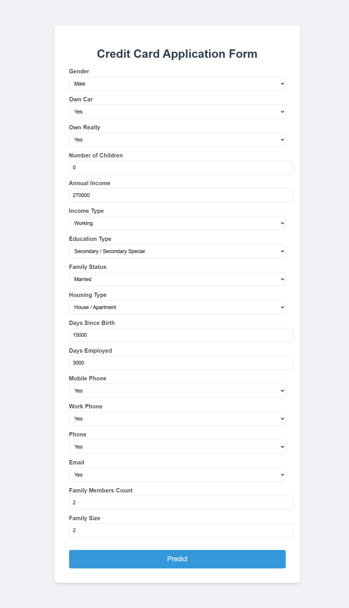
Screenshot 2: Prediction Result Page
After submitting the form, the system processes the input through the trained Random Forest model and displays the prediction result — either 'Credit Card Approved' or 'Credit Card Rejected'. The result page also provides a 'Try Again' button for new predictions. For the sample input shown above (0 children, income 270000, days since birth 15000, days employed 3000, family members 2, family size 2), the model predicted:
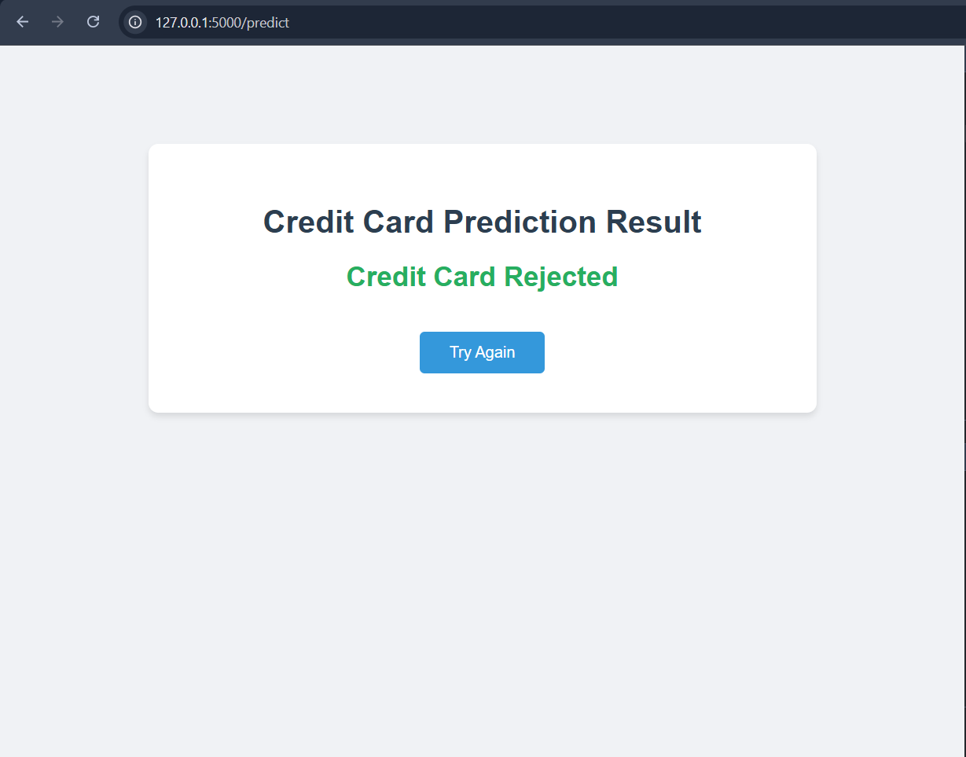
Dataset Results
- Application Dataset: 438,557 rows, 18 columns (after deduplication: 90,085 rows)
- Credit Dataset: 1,048,575 rows, 3 columns
- Merged Dataset: 9,709 rows, 19 columns (used for model training)

8. Advantages & Disadvantages
Advantages
- Automates the credit card approval process, saving time and resources.
- Provides consistent and unbiased decisions based on data.
- Easy to use web interface accessible from any browser.
- Multiple ML models compared to select the best performing one.
- Scalable solution that can handle large volumes of applications.
Disadvantages
- Model accuracy is limited by the quality and quantity of training data.
- Dataset imbalance (few bad customers) affects the model's ability to detect high-risk applicants.
- Currently deployed locally, not accessible online without cloud deployment.
- Model may need retraining as financial patterns change over time.

9. Conclusion
The Credit Card Approval Prediction System successfully demonstrates how machine learning can be utilized to automate and enhance the credit card approval process in the banking and financial sector. The project analyzes applicant details such as income type, employment status, family background, and credit history to determine whether a credit card application should be approved or rejected.
The system follows a complete machine learning pipeline including data collection, preprocessing, visualization, feature engineering, categorical encoding, model training, testing, and performance evaluation. Among the algorithms implemented, Random Forest achieved the highest accuracy at 85.6%, Logistic Regression achieved 85.4%, while Decision Tree achieved 77.1% accuracy but with a comparatively better ability to detect high-risk (Class 1) applicants.
The best-performing model (Random Forest) is integrated into a Flask-based web application that provides a user-friendly interface for bank staff or users to enter applicant details and instantly receive approval prediction results. This project provided valuable hands-on experience in machine learning, data analysis, Flask web development, and financial risk assessment.

10. Future Scope
- Cloud Deployment: Deploy the application on cloud platforms like AWS, Azure, or Heroku for wider accessibility.
- Deep Learning: Implement neural network models for potentially higher accuracy.
- Real-time Data: Integrate with live banking databases for real-time data processing.
- Explainability: Add model explainability features to explain prediction reasons to applicants.
- Mobile Application: Develop a mobile-friendly version of the application.

11. Appendix
Source Code
The complete source code for this project is available on GitHub:
- Credit Card Approval Prediction.ipynb – Jupyter Notebook (Data Analysis, Preprocessing, Model Building)
- app.py – Flask Web Application
- credit_card_model.pkl – Trained Random Forest Model
- templates/home.html – Landing Page
- templates/index.html – Prediction Form
- templates/result.html – Result Display Page
Dataset Link
https://www.kaggle.com/datasets/rikdifos/credit-card-approval-prediction
GitHub & Project Demo Link
GitHub Repository: https://github.com/sony539/credit-card-approval-prediction
Project Demo: Run locally at http://127.0.0.1:5000 using python app.py

