# **To Do Application**

## Application Requirement

Create a production level – ‘To Do List’ app with CRUD functionality (Add/Complete/Edit/Delete/View Tasks).Use - Backend (WebAPI) and frontend Typescript/JavaScript, knockout optional.

# Design

## Technologies used

### Framework

Asp.Net MVC 5, C#

Entity Framework 4.6

### Frontend

HTML, JavaScript, jQuery, knockout js

### Backend

WebAPI 2

### Database

MS SQL Application database (.mdf)

### Others

Unity Container IOC for dependency injection

NUnit testing using both dependency injection and Moq framework 4.9

LINQ

Server caching using output caching technique.

# Database design

MS SQL in application database is used in the project. This gives an advantage that the database is present in the solution project/folder itself.

Added new table ‘ToDo’ to store the values in the database.

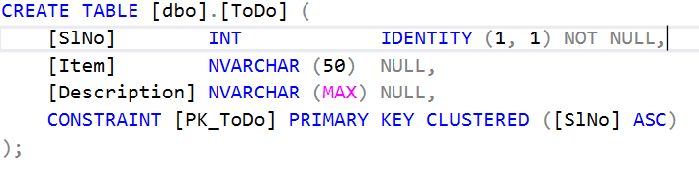

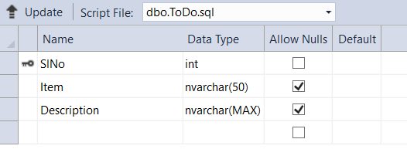

# **Scope for enhancing the db by adding created timestamp, update timestamp, assigned to etc. Also to improve performance we can index the rows based the select criteria.**

# Application UI

This is the Initial landing Page when the application is launched.

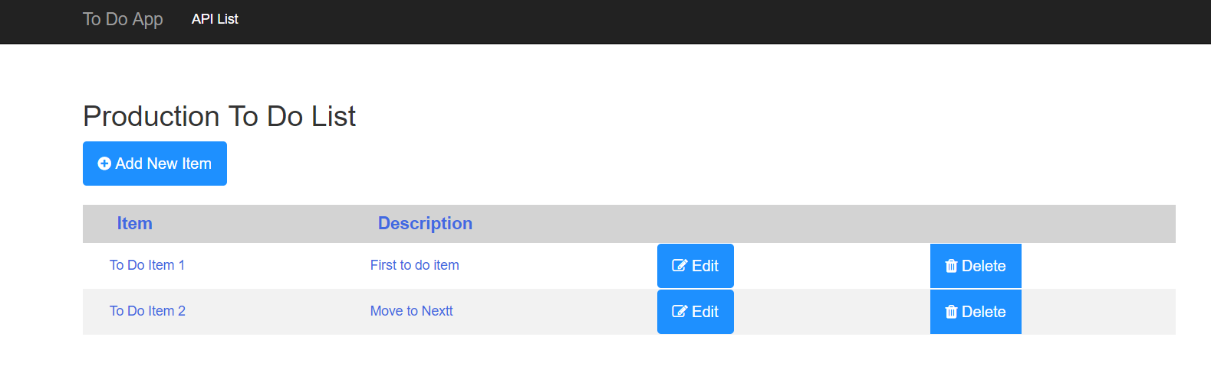

# Testing of application

Startup project need to be ‘ToDoApp’ for launching the application.

Testing of application has been done using

1. Nunit (mocking the dependent classes manually as well as using moq framework)
2. Integration test.
3. Postman testing
4. UI

### Get operation

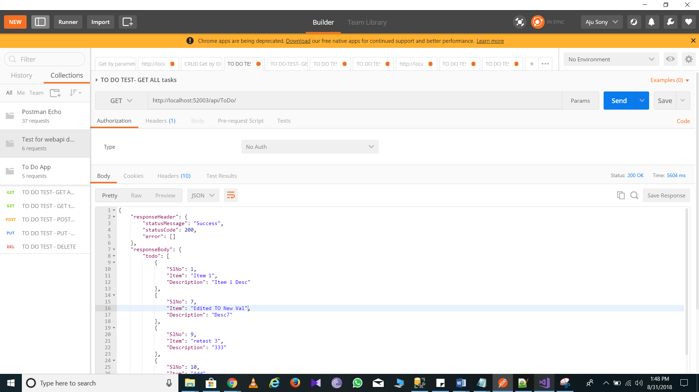

### POST operation

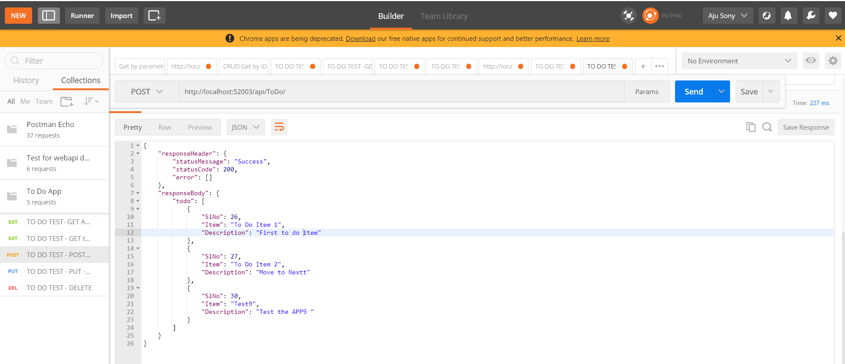

### PUT operation

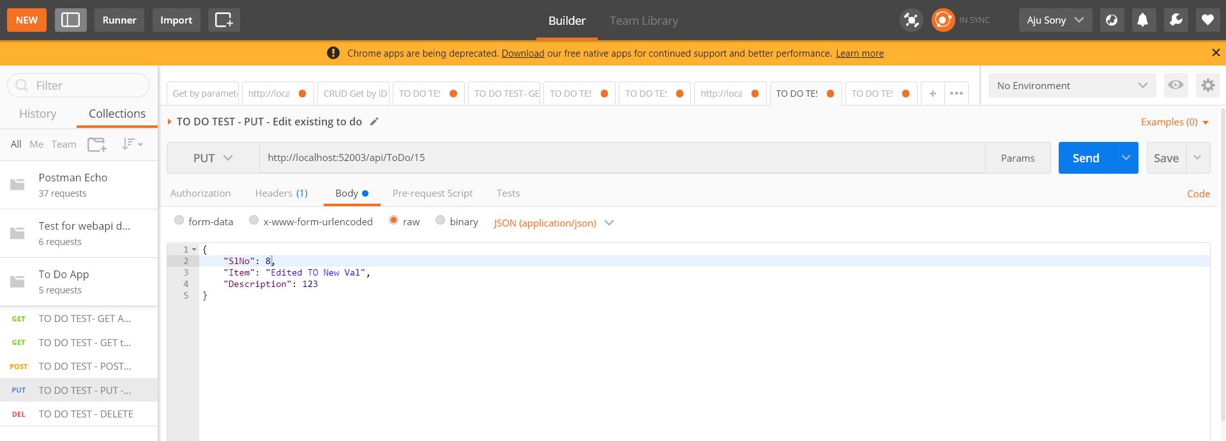

### DELETE operation

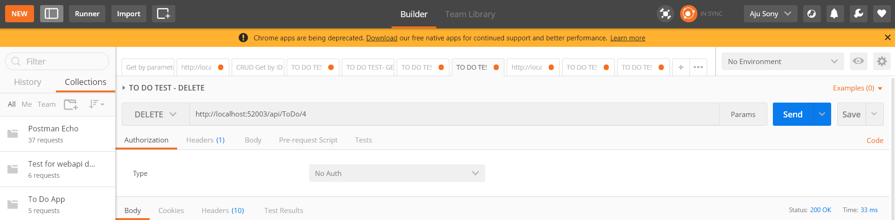

# Web API

**Web API 2** has been used and information is available as below. It can also be accessed from the below link once the service is running in the local machine, kindly replace the port number with the local port available.

<http://localhost:52003/Help>

Below are the available APIs

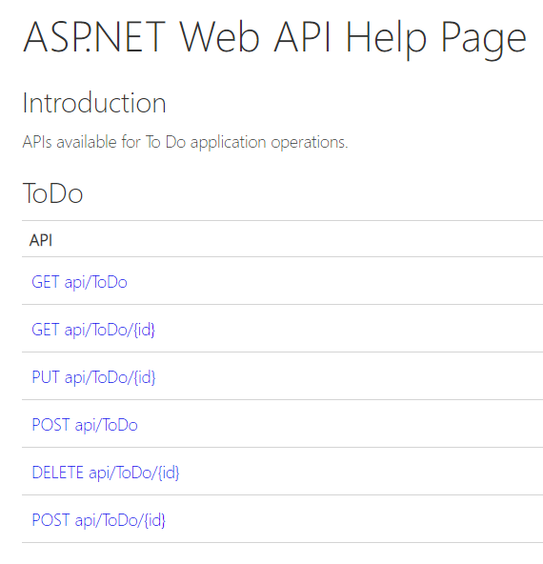

# **GET api/ToDo**

## **Request Information**

### **URI Parameters**

None.

### **Body Parameters**

None.

## **Response Information**

### **Resource Description**

[TodoResponse](http://localhost:52003/Help/ResourceModel?modelName=TodoResponse)

| **Name** | **Description** | **Type** | **Additional information** |
| --- | --- | --- | --- |
| responseHeader |  | [ResponseHeader](http://localhost:52003/Help/ResourceModel?modelName=ResponseHeader) | None. |
| responseBody |  | [ResponseBody](http://localhost:52003/Help/ResourceModel?modelName=ResponseBody) | None. |

### **Response Formats**

#### **application/json, text/json**

**Sample:**

{

"responseHeader": {

"statusMessage": "sample string 1",

"statusCode": 100,

"error": null

},

"responseBody": {

"todo": [

{

"SlNo": 1,

"Item": "sample string 2",

"Description": "sample string 3"

},

{

"SlNo": 1,

"Item": "sample string 2",

"Description": "sample string 3"

}

]

}

}

# **GET api/ToDo/{id}**

## **Request Information**

### **URI Parameters**

| **Name** | **Description** | **Type** | **Additional information** |
| --- | --- | --- | --- |
| id |  | integer | Required |

### **Body Parameters**

None.

## **Response Information**

### **Resource Description**

[ToDo](http://localhost:52003/Help/ResourceModel?modelName=ToDo)

| **Name** | **Description** | **Type** | **Additional information** |
| --- | --- | --- | --- |
| SlNo |  | integer | None. |
| Item |  | string | Required |
| Description |  | string | Required |

### **Response Formats**

#### **application/json, text/json**

**Sample:**

{

"SlNo": 1,

"Item": "sample string 2",

"Description": "sample string 3"

}

# **PUT api/ToDo/{id}**

## **Request Information**

### **URI Parameters**

| **Name** | **Description** | **Type** | **Additional information** |
| --- | --- | --- | --- |
| id |  | integer | Required |

### **Body Parameters**

[ToDo](http://localhost:52003/Help/ResourceModel?modelName=ToDo)

| **Name** | **Description** | **Type** | **Additional information** |
| --- | --- | --- | --- |
| SlNo |  | integer | None. |
| Item |  | string | Required |
| Description |  | string | Required |

### **Request Formats**

#### **application/json, text/json**

**Sample:**

{

"SlNo": 1,

"Item": "sample string 2",

"Description": "sample string 3"

}

## **Response Information**

### **Resource Description**

[ToDo](http://localhost:52003/Help/ResourceModel?modelName=ToDo)

| **Name** | **Description** | **Type** | **Additional information** |
| --- | --- | --- | --- |
| SlNo |  | integer | None. |
| Item |  | string | Required |
| Description |  | string | Required |

### **Response Formats**

#### **application/json, text/json**

**Sample:**

{

"SlNo": 1,

"Item": "sample string 2",

"Description": "sample string 3"

}

# **POST api/ToDo**

## **Request Information**

### **URI Parameters**

None.

### **Body Parameters**

[ToDo](http://localhost:52003/Help/ResourceModel?modelName=ToDo)

| **Name** | **Description** | **Type** | **Additional information** |
| --- | --- | --- | --- |
| SlNo |  | integer | None. |
| Item |  | string | Required |
| Description |  | string | Required |

### **Request Formats**

#### **application/json, text/json**

**Sample:**

{

"SlNo": 1,

"Item": "sample string 2",

"Description": "sample string 3"

}

## **Response Information**

### **Resource Description**

[ToDo](http://localhost:52003/Help/ResourceModel?modelName=ToDo)

| **Name** | **Description** | **Type** | **Additional information** |
| --- | --- | --- | --- |
| SlNo |  | integer | None. |
| Item |  | string | Required |
| Description |  | string | Required |

### **Response Formats**

#### **application/json, text/json**

**Sample:**

{

"SlNo": 1,

"Item": "sample string 2",

"Description": "sample string 3"

}

# **DELETE api/ToDo/{id}**

## **Request Information**

### **URI Parameters**

| **Name** | **Description** | **Type** | **Additional information** |
| --- | --- | --- | --- |
| id |  | integer | Required |

### **Body Parameters**

None.

## **Response Information**

### **Resource Description**

[ToDo](http://localhost:52003/Help/ResourceModel?modelName=ToDo)

| **Name** | **Description** | **Type** | **Additional information** |
| --- | --- | --- | --- |
| SlNo |  | integer | None. |
| Item |  | string | Required |
| Description |  | string | Required |

### **Response Formats**

#### **application/json, text/json**

**Sample:**

{

"SlNo": 1,

"Item": "sample string 2",

"Description": "sample string 3"

}