**Weekly Diary Entries**

Table of Contents

Week 9 1

Week 10 3

Week 11 4

Week 12 5

Concepts & Challenges 6

# Week 9

After exploring many different topics and finding available datasets, I finally decided on a topic that is interesting, feasible and relatable! I decided on something closer to home, and intriguing for people of my generation. It’s also a question that I have been thinking about for the longest time…

“Would I be able to own a house in Singapore after I graduate?”

“Is there enough space left for me in Singapore?”

I also chose this topic because of the abundance of data surrounding it that I may use for my investigation and analysis of the question. A lot of population data is available on SingStat, plus I can use other housing and job data which would be useful as well.

I decided to name my project SPACE since the central theme of my data story surrounds spatial availability/scarcity.

When storyboarding, I only managed to come up with answering the first 3 parts:

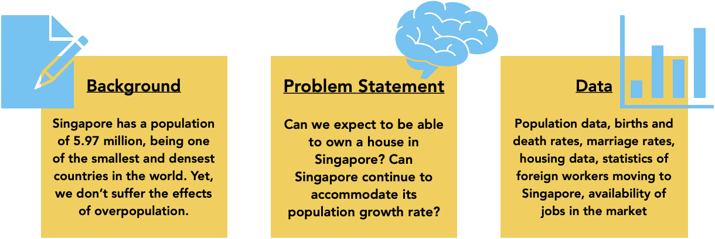

# Week 10

**What is your project about?** Spatial availability in Singapore

**What is the data you plan to use?** A data set with population indicators and housing. Here’s a link to the full data set: <../datasets/cleandataset.xlsx>

**What is the question you plan to answer?** “How much space is there left in Singapore?” It aims to investigate whether Singapore can continue to accommodate the growth rate of its population in years to come.

**Why is this an important question?** According to World Data.info, the population of Singapore had grown from 1.65 million in 1960 to 5.45 million in 2021. As one of the smallest countries in the world with a land area of 728km2, we are also one of the most densely populated countries with approximately 8000 people per square kilometer. With this overarching threat of overcrowding and overpopulation, Singapore still encourages a high influx of immigrants. Therefore, can Singapore really ensure that quality of life is not sacrificed as the population keeps growing?

**Which rows and columns of the dataset do you plan to use, to answer this question?** I plan to use the most recent available data from 1990 – 2022 since I plan to answer a question that involves looking into the future. Therefore, a wider range of data dating back to 1990 up until 2022 can provide clearer trends for more accurate predictions. I acknowledge that there will be anomalies in my dataset between 2020 and 2021 due to the impact of the Covid-19 pandemic which left a significant effect on the general trends seen.

1. Total Population, Resident Population, Citizen Population, PR Population and Non-PR Population.
2. Residents 65 years old and above, Youths aged 0-19 years old.
3. Life Expectancy
4. Total Fertility Rate (Per Female).
5. Total Marriages (Number), Total Divorces (Number).
6. Resident Households owned by Married Couples with children

# Week 11

This week, I spent a lot of time diving deep into the data and trying to make sense of it to form logical connections to my research question. I prepped the data to ensure it was suitable for processing and analysis.

Since a lot of my data surrounds a significant trend over 20 years, I believe it was most suitable to use line graphs/bar charts to highlight the increasing/decreasing nature of the data. Pie charts are also an apt visualisation method to show a breakdown of the category within a single year, therefore I plan to use a pie chart to show the comparison between marriages and divorces within a single year.

Furthermore, since my project is on space, I wanted to add geographical visualisations such as map charts with degrees of colour shading to show population density and changes over 20 years. I tried to explore methods to do this, however many different softwares do not support or contain the database of detailed regional areas in Singapore. As seen below, there are missing regions within the population map. Therefore, for this visualisation, instead of making it interactive where readers can click on views to change this visualisation, I might do a presentation of the data in a way that is set (e.g. a showing of the population changes over time, like in the gun violence deaths example done in Week 10 Tutorial).

I added draft visualisations that I made in Excel below.

# Week 12

I decided to recode from scratch since making drastic changes to my code felt slightly daunting. I worked on an “indexdraft.html” that was linked to the same main.js and appstyle.css files as my previous HTML file where I tried new layouts and tweaked details here and there.

I faced some minor issues such as a non-working ‘text-align: center’ on the banner element, and misaligned list items in the navigation bar. Thus, I did some guess-and-check work on my CSS file to figure out what was wrong. I found that removing the display element (appstyle.css:120) fixed the text-alignment issue, and adding the margin-top and -bottom properties (appstyle.css:44-45) were the only things that, when changed, allowed my code to work in the way I wanted it to.

I have added a Leaflet map of Singapore with population density on my homepage, using code from a tutorial made by GIS Tech Adventurer. I tried to do a Plotly map but was unable to do so because of the lack of Singapore map data and location codes. There were no tutorials I could find as well, thus I resorted to following another reference using Leaflet instead.

Also, I finally found a solution to the problem where my header banner was going in front of my sticky navigation bar when scrolling on the page. I added “z-index:1000” to the navbar CSS (appstyle.css:40).

# Concepts & Challenges

encountered while making the data story; documentation of coding

|  |  |
| --- | --- |
| Week/Topic | Utilisation of Concepts |
| 2/ Paths, HTML, CSS | Used CSS styling to create the general look of my page.  Created buttons for users to toggle intuitively.  Used <div> tag to separate content and organize it.  Used <li> tag to create a list for my navigation bar.  Used <img src> to embed images and charts into my page.  Used different <h1> and <h2> tags to organize the header titles on my page.  There were underlines on my nav bar menu items as they were links. Therefore, used CSS and changed text-decoration to “none” so that it would not appear to have been clicked before.  Created classes for different components on my page and gave them special attributes in CSS. For e.g., mouse hover on the navigation bar will make words pop bigger.  Created a form in my homepage for interaction with audience. |
| 3/ JS | Created variables for my functions.  Created variables to store my data arrays.  Created a nav bar but found it hard to access it as I had to scroll all the way up/down to click on it. Therefore, used JS functions to make a sticky navigation bar, with the ‘if…else…’ statement.  Created a click counter that is linked to an if… else function such that users can toggle between 2 views using the same button.  I encountered a break in my code when I was trying to code functions for 3 buttons that could provide 3 different views. One of the views was a .push( ) function that added a new dataset to the array. However, because there were 3 buttons, clicking the third button > second button > first button > third button, breaks the code and the chart line disappears because the if…else function had a “.pop( )” function within it. Did some problem-solving and came up with a condition for array.length === 2 before “.pop( )” function is called. |
| 4,5,6/ JS | Created a function to change the graph shown when the button is clicked.  Created data objects for chart creation, and stored data arrays within these objects.  Used DOM, and “getElementById”, to attribute to a specific button, and event listeners to change the graph shown when the button is clicked.  Added DOM and event listener to my form input on the homepage so that I can interact with users.  Debugging through outputs of console.log. I left in my console.log statements in the code where I needed to debug my functions.  Commenting Code to make problem solving easier for myself, and to signpost my code so that it becomes easier for me to find.  Made global variables that could be reused in another chart construction, and unique global and local variables for the functions of chart creation.  Made arrays within main.js to store data for charts or to store variables and/or colours.  Used lists for the navigation bar.  Accessed objects and properties within loops using the “.string( )” |
| 7/ Charts | Used chart.js to create bar charts, line plots, scatter plots, bubble charts, pie and donut charts and stacked area line charts.  Customised their legends to fit the theme and aesthetic of the page better. |
| 8/ Charts | Data visualisation through parsing and sub-setting data from the large dataset. Storyboarded and came up with methods of presenting the data in a way that would be clear to the reader. I chose many line graphs as trends are best shown on line plots over time. |