Machine Learning Model Deployment with IBM Cloud Watson Studio

Development Part 2

In this part we are developing a ML model using Watson Studio and deploying into the IBM Cloud. This is continued into the step by step process from model developing onwards,
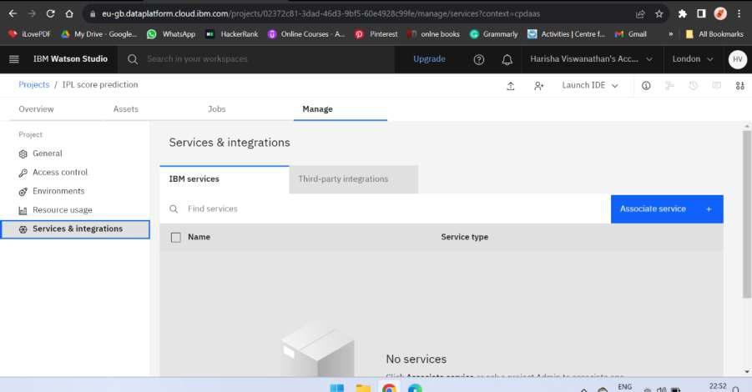

STEP 1:

From the above picture we can see that previously created project, now here we associating services which is previously existed.
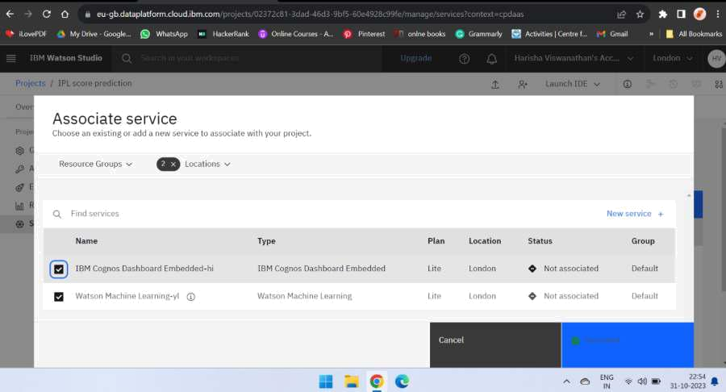

Now press the Associate to Associate the services. after that we can see the list of Associated Services.
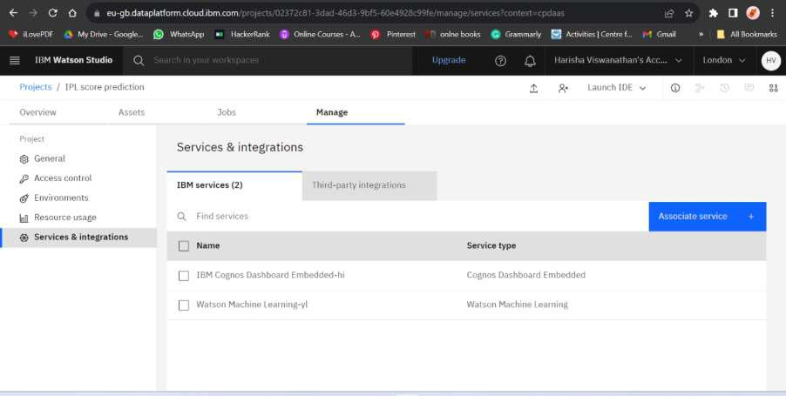

STEP 2:

It is process of creating model by New asset it displays like a below page from there we need select the Model
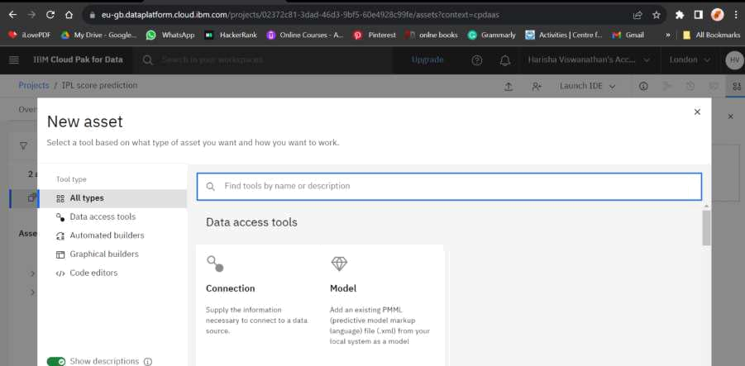

After pressing model it displays next page, Here we need to choose the Gallery sample
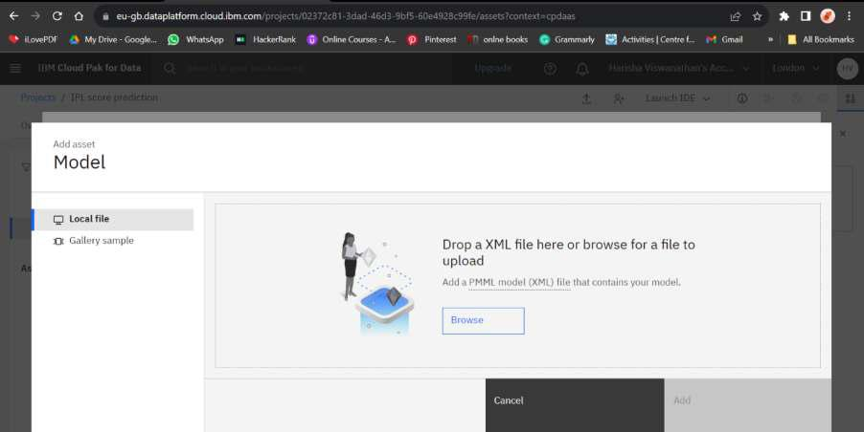

Next it gives two options in that we need to choose the credit Risk , Then press NEXT option for the further process
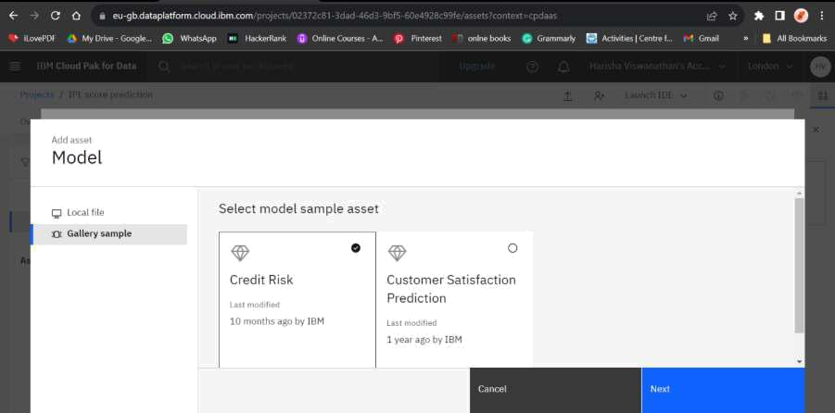

STEP 3:

It is the process of giving name of the model, here I am model as Credit Risk.
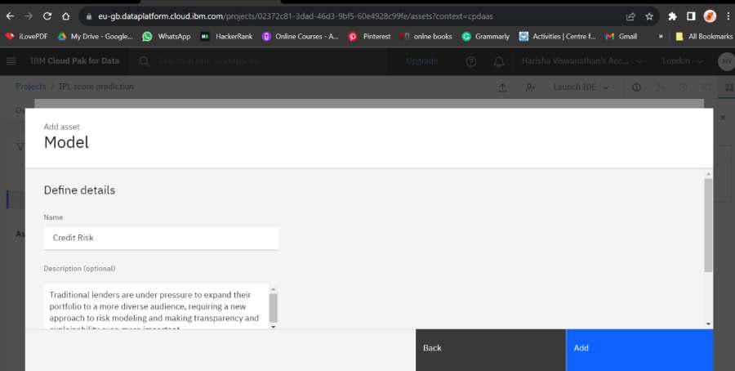

Then press the Add to move next process

STEP 4:
It is process of deploying the developed model, Here press the promote to deployment space.
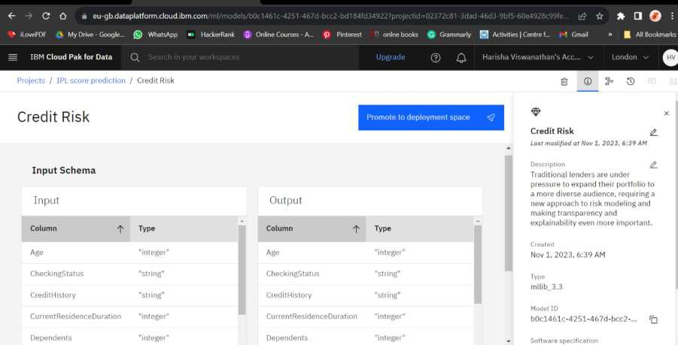

Now we need to Promote to space ,to promote space we need to create a target space. Then press promote
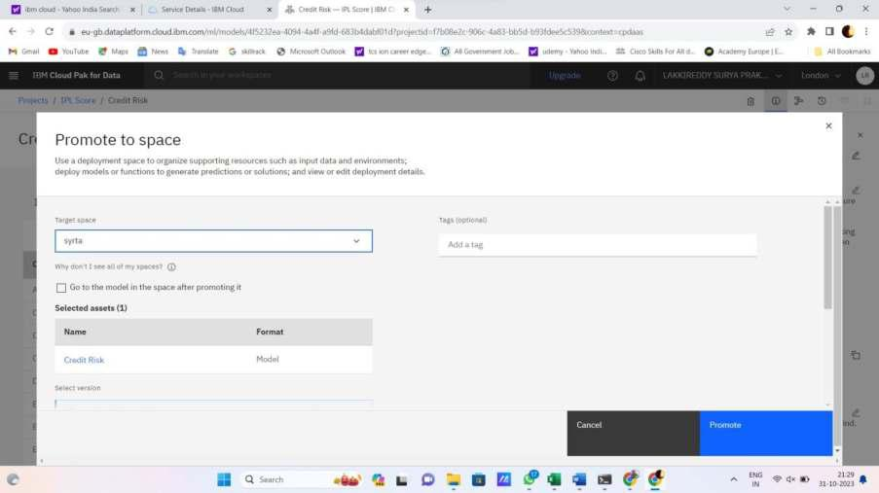

STEP 5:

Here we can see the list of models created using Watson Studio
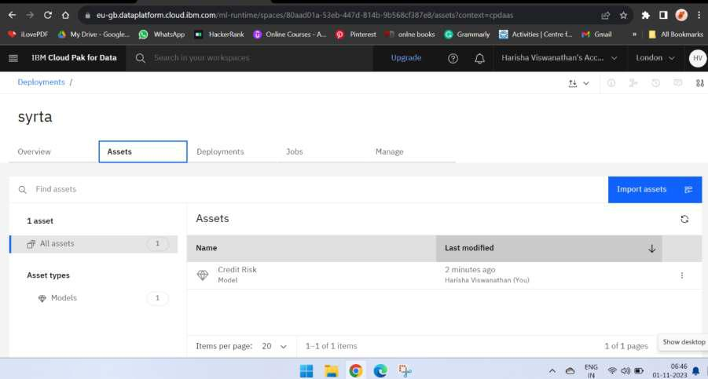

Now choose the developed model from the above list of models
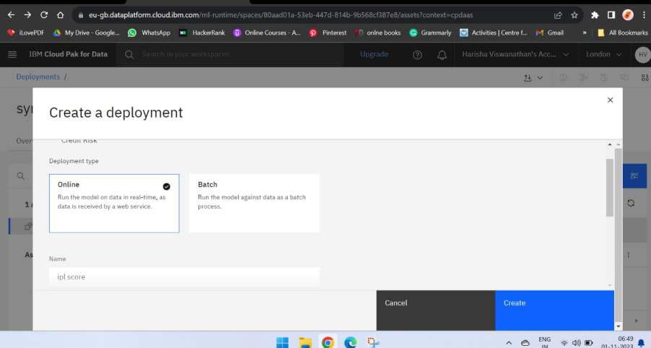

Choose as online to deployment the model and give the name of a model , then press the Create

STEP 6 :

It is the process of Initialising the Deployements of a model
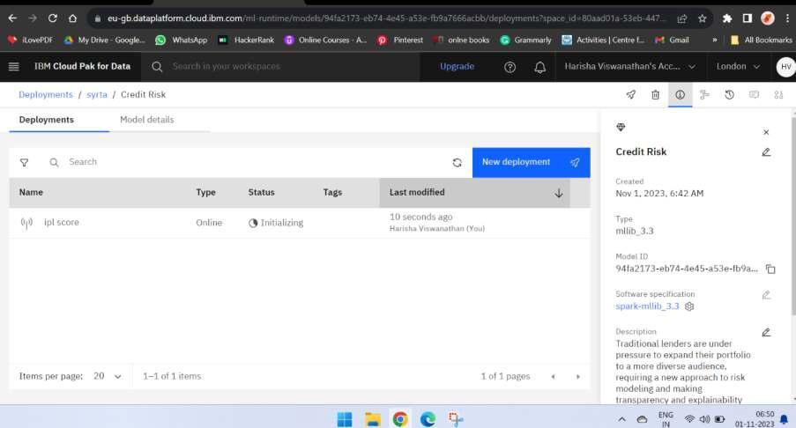

After Initialising the model
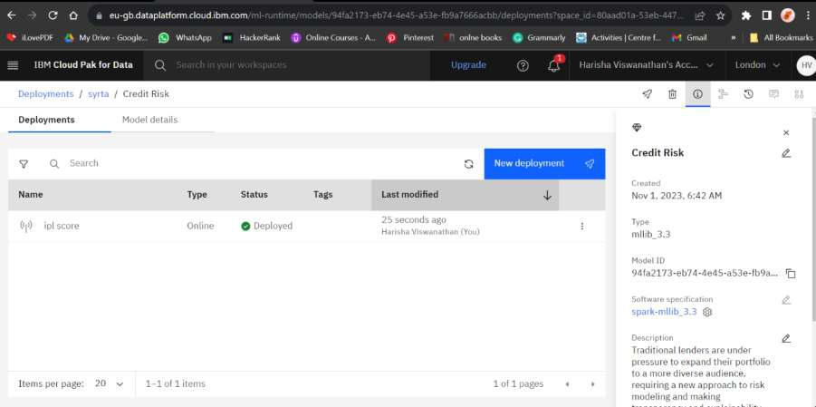

STEP 7:

It is the process of testing the model
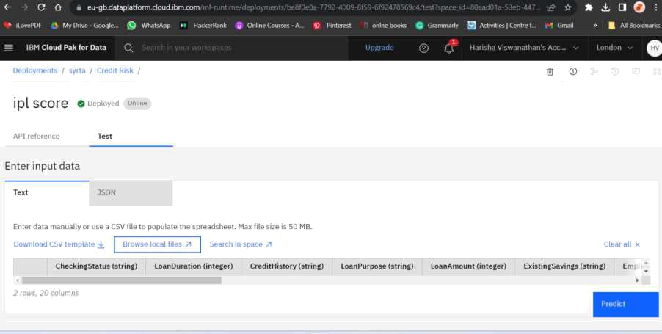

STEP 8:

The model is successfully deployed into the IBM Colud
