BOQ FINAL – PROVISIONING INFRASTRUCTURE
DTI Data Center – Lantai 3

- Baseline Assumption
Item | Baseline
Phase | Phase-1 (Year-1)
Platform | FishOS – Private Cloud Provisioning
Tenant | 10–15
VM target | ±150 VM
SLA | 99.9%
Rack | 1 rack (expandable)
Power IT load | ±18 kW (dengan buffer)
Network uplink | 1–2 Gbps
Public IP | /29 (opsi upgrade /28)

- Logical Architecture
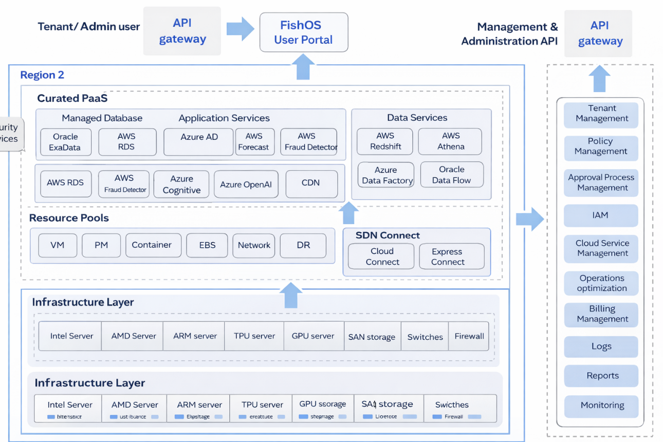

- Physical Architecture
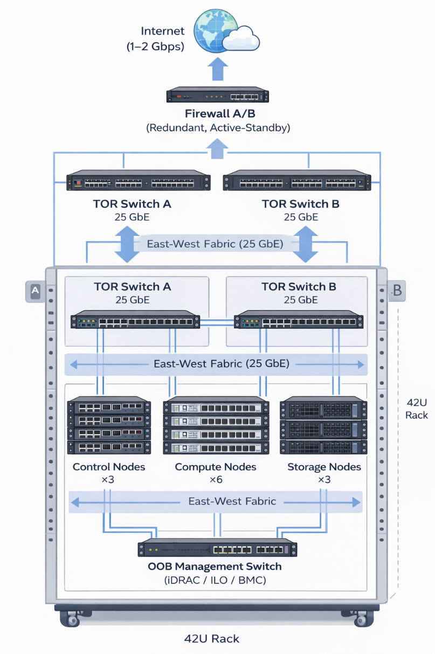

- BOQ – Server
D1. Control Plane Cluster (HA)
No | Item | Spesifikasi Ringkas | Qty
1 | Control Node | 2U, 2×CPU 16 Core, RAM 128 GB | 3
2 | OS Disk | 2×480 GB SSD (RAID-1) | incl
3 | Data Disk | NVMe 1–2 TB | incl
4 | NIC | Dual 25 GbE | incl

Catatan:
- 3 node = quorum & HA
- Isolated dari workload tenant → stabilitas provisioning

D2. Compute Pool (VM Workload)
No | Item | Spesifikasi Ringkas | Qty
1 | Compute Node | 2U, 2×CPU 32 Core | 6
2 | Memory | 256 GB RAM / node | incl
3 | OS Disk | SSD | incl
4 | NIC | Dual 25 GbE | incl

Capacity note:
- ±384 core fisik

D3. Storage Pool
No | Item | Spesifikasi Ringkas | Qty
1 | Storage Node | 2U | 3
2 | Data Disk | 8×3.84 TB SSD / node | incl
3 | OS Disk | 2×480 GB SSD (RAID-1) | incl
4 | NIC | Dual 25 GbE | incl

Capacity note:
- Raw ±92 TB
- Usable ±30 TB (replica 3)

- BOQ – NETWORK & SECURITY
E1. Data Center Fabric
No | Item | Spesifikasi | Qty
1 | TOR Switch | 25 GbE, redundant (A/B) | 2
2 | Uplink | 40/100 GbE ke core DC | 2
3 | OOB Switch | 1 GbE (iDRAC/iLO) | 1

Catatan:
25 GbE dipilih karena Ceph + east-west traffic (10 GbE berisiko bottleneck).

E2. Perimeter & Connectivity
No | Item | Spesifikasi | Qty
1 | Firewall | Enterprise FW, HA (Active-Standby) | 2
2 | VPN | IPSec / SSL VPN | incl
3 | NAT / Floating IP | Via FW / platform | incl

- BOQ – RACK, POWER & DC SUPPORT
F1. Rack & Power
No | Item | Spesifikasi | Qty
1 | Rack | 42U | 1
2 | Intelligent PDU | Dual A/B feed | 2
3 | Power Budget | Design 15–18 kW / rack | —

Power context:
- Phase-1 IT load ±12 kW
- Dengan buffer → ±18 kW

F2. Cooling & Monitoring
No | Item | Spesifikasi | Qty
1 | Cooling | Existing DC (validated) | —
2 | Env Monitoring | Temp / humidity / power | incl

- BOQ – NETWORK BANDWIDTH & IP
G1. Internet / WAN
Item | Baseline | Upgrade Option
Dedicated Internet | 1 Gbps | 2×1 Gbps (dual ISP)
Latency target | Enterprise-grade | Same
SLA | ≥99.9% | ≥99.9%

G2. IP Addressing
Network Type | Allocation
Management Network | Private (RFC1918)
Storage Network | Private, isolated VLAN
Tenant Network | Private (large CIDR)
Public / Floating IP | /29 (5 usable)
Upgrade option | /28 (13 usable)

Penggunaan Public IP (/29):
- Portal / landing page
- API endpoint
- VPN endpoint
- NAT gateway
- Reserve / future

- Summary
Kategori | Jumlah
Total server | 12 unit
Rack | 1 rack
TOR switch | 2 unit
Firewall | 2 unit (HA)
Internet | 1–2 Gbps
Power design | ≤18 kW
Public IP | /29 (baseline)

