BOQ FINAL – PROVISIONING INFRASTRUCTURE
DTI Data Center – Lantai 3
- TECHNICAL SPECIFICATION
- Baseline Assumption
Item | Baseline
Phase | Phase-1 (Year-1)
Platform | FishOS – Private Cloud Provisioning
Tenant | 10–15
VM target | ±150 VM
SLA | 99.9%
Rack | 1 rack (expandable)
Power IT load | ±18 kW (dengan buffer)
Network uplink | 1–2 Gbps
Public IP | /29 (opsi upgrade /28)

- Logical Architecture
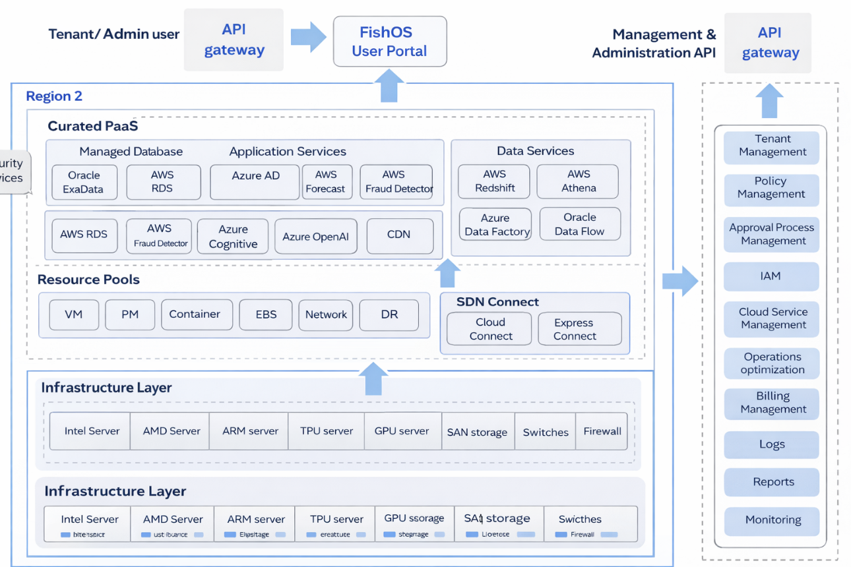

- Physical Architecture
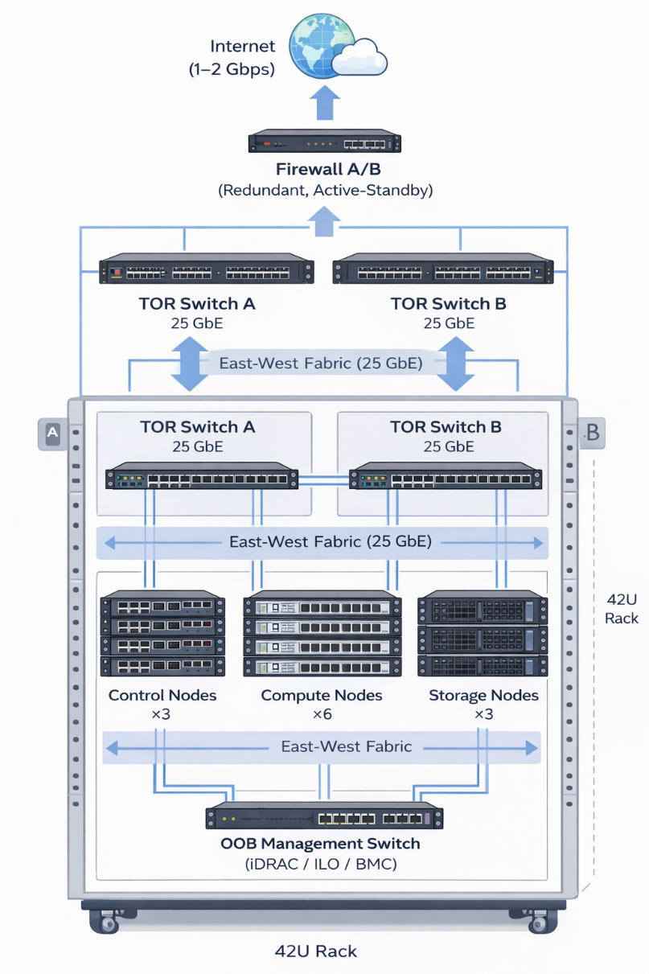

- BOQ – Server
D1. Control Plane Cluster (HA)
No | Item | Spesifikasi Ringkas | Qty
1 | Control Node | 2U, 2×CPU 16 Core, RAM 128 GB | 3
2 | OS Disk | 2×480 GB SSD (RAID-1) | incl
3 | Data Disk | NVMe 1–2 TB | incl
4 | NIC | Dual 25 GbE | incl

Catatan:
- 3 node = quorum & HA
- Isolated dari workload tenant → stabilitas provisioning

D2. Compute Pool (VM Workload)
No | Item | Spesifikasi Ringkas | Qty
1 | Compute Node | 2U, 2×CPU 32 Core | 6
2 | Memory | 256 GB RAM / node | incl
3 | OS Disk | SSD | incl
4 | NIC | Dual 25 GbE | incl

Capacity note:
- ±384 core fisik

D3. Storage Pool
No | Item | Spesifikasi Ringkas | Qty
1 | Storage Node | 2U | 3
2 | Data Disk | 8×3.84 TB SSD / node | incl
3 | OS Disk | 2×480 GB SSD (RAID-1) | incl
4 | NIC | Dual 25 GbE | incl

Capacity note:
- Raw ±92 TB
- Usable ±30 TB (replica 3)

- BOQ – NETWORK & SECURITY
E1. Data Center Fabric
No | Item | Spesifikasi | Qty
1 | TOR Switch | 25 GbE, redundant (A/B) | 2
2 | Uplink | 40/100 GbE ke core DC | 2
3 | OOB Switch | 1 GbE (iDRAC/iLO) | 1

Catatan:
25 GbE dipilih karena Ceph + east-west traffic (10 GbE berisiko bottleneck).

E2. Perimeter & Connectivity
No | Item | Spesifikasi | Qty
1 | Firewall | Enterprise FW, HA (Active-Standby) | 2
2 | VPN | IPSec / SSL VPN | incl
3 | NAT / Floating IP | Via FW / platform | incl

- BOQ – RACK, POWER & DC SUPPORT
F1. Rack & Power
No | Item | Spesifikasi | Qty
1 | Rack | 42U | 1
2 | Intelligent PDU | Dual A/B feed | 2
3 | Power Budget | Design 15–18 kW / rack | —

Power context:
- Phase-1 IT load ±12 kW
- Dengan buffer → ±18 kW

F2. Cooling & Monitoring
No | Item | Spesifikasi | Qty
1 | Cooling | Existing DC (validated) | —
2 | Env Monitoring | Temp / humidity / power | incl

- BOQ – NETWORK BANDWIDTH & IP
G1. Internet / WAN
Item | Baseline | Upgrade Option
Dedicated Internet | 1 Gbps | 2×1 Gbps (dual ISP)
Latency target | Enterprise-grade | Same
SLA | ≥99.9% | ≥99.9%

G2. IP Addressing
Network Type | Allocation
Management Network | Private (RFC1918)
Storage Network | Private, isolated VLAN
Tenant Network | Private (large CIDR)
Public / Floating IP | /29 (5 usable)
Upgrade option | /28 (13 usable)

Penggunaan Public IP (/29):
- Portal / landing page
- API endpoint
- VPN endpoint
- NAT gateway
- Reserve / future

- Summary
Kategori | Jumlah
Total server | 12 unit
Rack | 1 rack
TOR switch | 2 unit
Firewall | 2 unit (HA)
Internet | 1–2 Gbps
Power design | ≤18 kW
Public IP | /29 (baseline)

- COST STRUCTURE
  - Cost Category

No. | Category | Type
1 | Hardware Infrastructure | CAPEX
2 | Software / Platform License | CAPEX / OPEX
3 | Implementation (SI) | CAPEX
4 | Hardware Maintenance | OPEX
5 | Platform Support | OPEX
6 | Power & Cooling | OPEX
7 | Network & IP | OPEX

  - CAPEX (One-Time)
    - Hardware Infrastructure (Server and Storage)
      - Server – Control Plane (3 Unit)
Spesifikasi ringkas
- 2U server
- 2× CPU 16 core (Xeon / EPYC class)
- RAM 128 GB
- OS SSD RAID-1 + NVMe
- Dual PSU, OOB, Dual 25GbE NIC
Estimasi harga/unit
Komponen | Estimasi (IDR)
Base server chassis + mobo | 120 jt
CPU (2× mid-range) | 90 jt
RAM 128 GB | 35 jt
SSD + NVMe | 25 jt
NIC 25GbE + OOB | 20 jt
PSU, rail kit, misc | 10 jt
Total / unit | 300 jt
Subtotal 3 × 300 jt = 900 jt

      - Server – Compute Node (6 Unit)
Spesifikasi
- 2U
- 2× CPU 32 core
- RAM 256 GB
- OS SSD
- Dual 25GbE
Estimasi harga/unit
Komponen | Estimasi
Base server | 130 jt
CPU (2× high core) | 140 jt
RAM 256 GB | 65 jt
OS SSD | 15 jt
NIC 25GbE | 20 jt
PSU, rail, misc | 10 jt
Total / unit | 380 jt
Subtotal 6 × 380 jt = 2.280 jt

      - Server – Storage Node (3 Unit)
Spesifikasi
- 2U
- 8× 3.84 TB SSD (enterprise)
- OS SSD RAID-1
- Dual 25GbE
Estimasi harga/unit
Komponen | Estimasi
Base storage server | 140 jt
SSD data (8×3.84 TB) | 160 jt
OS SSD | 15 jt
NIC 25GbE | 20 jt
RAID / HBA | 15 jt
PSU, rail, misc | 10 jt
Total / unit | 360 jt
Subtotal 3 × 360 jt = 1.080 jt

    - Network – TOR & OOB Switch (Network, firewall, rack, PDU)
2.3.2.1TOR Switch 25GbE (2 unit)
- 25GbE enterprise switch
- ≥24 port
- Redundant A/B
Item | Estimasi
TOR Switch 25GbE | 150 jt / unit
Optics / DAC | 40 jt / unit
Subtotal | 380 jt

2.3.2.2 OOB Management Switch (1 unit)
Item | Estimasi
1GbE switch + cable | 30 jt

2.3.2.3 Security – Firewall HA (2 UNIT)
Enterprise firewall
- HA active-standby
- IPS/VPN ready
Item | Estimasi
Firewall appliance | 120 jt / unit
License year-1 | 30 jt / unit
Subtotal

2.3.2.4 Rack & Power
Item | Estimasi
Rack 42U | 50 jt
Intelligent PDU A/B | 25 jt × 2 = 50 jt
Cabling & accessories | 30 jt
Subtotal | 130 jt

GRAND TOTAL HARDWARE CAPEX
Category | IDR (juta)
Server (12 unit) | 4.260
TOR + OOB Switch | 410
Firewall HA | 300
Rack & PDU | 130
TOTAL | 5.100

  - Software / Platform License (Fish OS)
- Setup / initial license
- One-time enablement
👉 Asumsi: IDR 500 juta

  - Implementation
- Install & deploy FishOS
- Integration infra
- HA, security hardening
- UAT & KT
👉 Asumsi: IDR 500 juta

TOTAL CAPEX
Hardware : 5.100.000.000
Platform setup : 500.000.000
SI implementation : 500.000.000
------------------------------------
TOTAL CAPEX : 6.100.000.000 IDR

  - OPEX (Annual)
2.5.1 Hardware Maintenance
Asumsi: 10% × 5.0 M = 500 juta / tahun

2.5.2 Platform Support / License
- Support
- Patch & upgrade
- Escalation
Asumsi: 300 juta / tahun

2.5.3 Power & Cooling
- IT load ±18 kW
- 24×7
- DC internal charge
Asumsi:
18 kW × 24 × 365 ≈ 157.680 kWh
× IDR 1.600 ≈ 252 juta / tahun
(round up)
250 juta / tahun

2.5.4 Network & IP
- Internet dedicated 1–2 Gbps
- IP public (/29)
Asumsi:
- Internet: 200–300 juta / tahun
- IP & misc: 50 juta / tahun
350 juta / tahun

TOTAL OPEX / TAHUN
Hardware maintenance : 500.000.000
Platform support : 300.000.000
Power & cooling : 250.000.000
Network & IP : 350.000.000
------------------------------------
TOTAL OPEX / YEAR : 1.400.000.000 IDR

2.6 TCO 3 TAHUN
CAPEX : 6.100.000.000
OPEX 3 tahun : 1.400.000.000 × 3
= 4.200.000.000
------------------------------------
TOTAL TCO 3 TAHUN : 10.300.000.000 IDR

- Breakdown Price – Business Model
3.1 Target Recovery
- Break-even ≤ 3 tahun
- Margin minimal 20–30%
Revenue target 3 tahun ≈ 13.5 – 14 M

3.2 Revenue per Tahun (Target)
14.000.000.000 / 3 ≈ 4.700.000.000 / tahun

3.3 Revenue per Bulan
≈ 390.000.000 / bulan

3.4 Turunkan ke Pricing Service
a. Model 1 – VM-based
Asumsi:
- 150 VM
- Utilisasi efektif 70% → 105 VM billable
390 juta / 105 VM ≈ 3.7 juta / VM / bulan
👉 Bisa dibulatkan jadi:
- Small VM: 2.0 – 2.5 jt
- Medium VM: 3.5 – 4.0 jt
- Large VM: 6.0 – 7.0 jt

b. Model 2 – Tenant-based (Enterprise friendly)
Asumsi:
- 12 tenant aktif
390 juta / 12 ≈ 32.5 juta / tenant / bulan
👉 Target segment customer:
- Enterprise
- Regulated customer
- Contract-based

c. Model 3 – Hybrid
- Base fee per tenant (platform)
  - usage VM
Contoh:
- Platform fee: 10–15 jt / tenant / bulan
- VM usage: sesuai size

“Dengan investasi ±6.2 M di awal dan OPEX ±1.5 M per tahun, platform provisioning ini membutuhkan revenue sekitar 4.5–5 M per tahun untuk break-even 3 tahun dengan margin sehat. Model pricing hybrid tenant + usage memberikan fleksibilitas dan menjaga utilisasi aset.”

