The Future of Knowledge & Content
Meeting the customer where they are — with AI
A self-evolving, agent-native knowledge system: a fleet of AI agents continuously sources community, product, code and release signals into a living knowledge graph, and every customer query is understood by intent, diagnosed against that graph, and answered accurately on the customer’s own channel.
July 2026 · Version 3.0 (Future Vision) · Confidential — Internal Draft

Contents

1 · The North Star: the customer’s outcome
The vision is bigger than any single support team. It is about the end customer who reaches out for help and needs their problem solved. Content health is the input that makes the answer accurate; it is not the goal. The goal is the customer’s resolved query — reached on whatever channel they used, and understood using the intelligence we already have about their problem.
North Star. Every customer who reaches support gets an accurate, easy-to-consume answer — understood through the intelligence we already have, delivered on their channel, and made better by every question that came before.
Reframed around the customer, the journey has five steps: the customer reaches out; we understand their problem; we resolve it accurately; we deliver it easy to consume on their channel; and the outcome — plus the ask itself — feeds the next answer. The rest of this document describes the AI-native engine that makes that loop real, and how the wider industry is converging on the same design.

2 · How the industry is changing the knowledge and content world
The way organizations manage knowledge and serve answers is being re-founded around AI. Five shifts, visible across the industry in 2025–2026, define the direction and set the bar this vision must meet.

From documents to a living knowledge graph (GraphRAG)
Retrieval is moving from pure vector similarity to GraphRAG — large language models grounded on a knowledge graph. Graphs let the system reason over relationships and answer multi-hop questions (“which fix applies to this symptom, on this version, given this evidence?”) that flat document search cannot. Knowledge stops being a static repository and becomes a continuously updated, “living” structure.

From one bot to a fleet of specialized agents
Instead of a single monolithic assistant, requests are handled by teams of specialized agents — some extract entities, some resolve conflicts, some retrieve from distinct sources — that coordinate to produce one answer. The same pattern runs on the supply side: autonomous agents construct and maintain the graph, inferring schema and choosing retrieval strategy by context rather than by hand-built rules.

From static memory to agentic, self-evolving memory
Modern systems preserve long-term organizational and conversational context and recompute answers as the underlying data changes. Reused assets regenerate when their source changes, so they are never silently stale — a leap beyond static knowledge bases toward a continuously learning environment.

From deflection to resolution quality
AI now handles a large share of tier-1 contacts, but industry leaders have publicly retired deflection as the headline metric. Re-contact rate and holistic resolution quality are replacing it — exactly the discipline this vision encodes with Gap Rate as the leading indicator.

From reactive answers to intent, diagnosis and personalization
Leading agents combine multimodal input (chat, voice, image, document), classify intent at high accuracy, and personalize using customer history and real-time context — moving from reactive replies toward proactive, even predictive intervention. Human experts are re-skilled to own the ambiguous, high-risk cases and to supervise the AI.
The takeaway: the market is converging on agent-native, graph-grounded, self-evolving knowledge measured by resolution. The vision below adopts that frame and extends it to the specific shape of enterprise support.

3 · The future vision: a self-evolving knowledge system
Under the customer-facing North Star sits the engine. Rather than a content repository that people write and search, the future state is a self-evolving system with four moving parts: a multi-agent fleet that sources signals, a living knowledge graph that stores what is known, an understanding layer that turns a query into a diagnosed intent, and a delivery layer that shapes one grounded answer to any channel — all wrapped in governance and reflection guardrails.
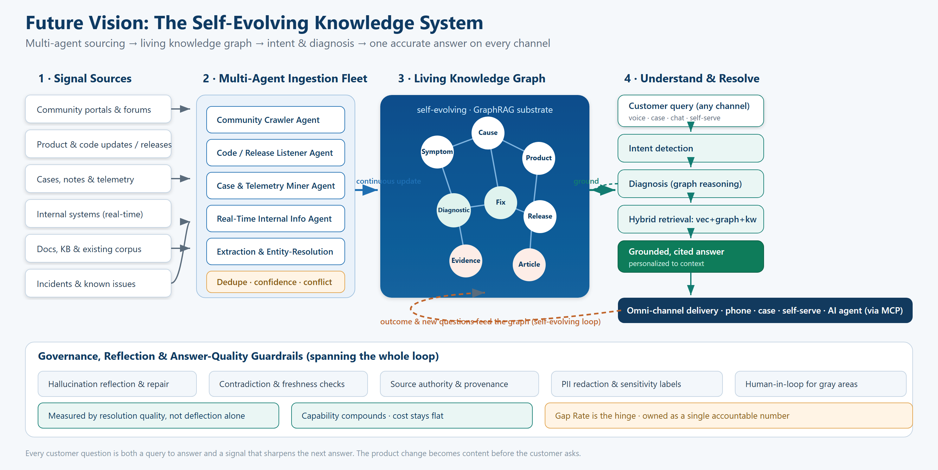
Figure 1 — The self-evolving knowledge system: multi-agent sourcing → living knowledge graph → intent & diagnosis → one accurate answer on every channel, under governance and reflection guardrails.

4 · The capabilities that make it real
Five capabilities move this from a reactive content program to a proactive, AI-native system. They are the additions the earlier model implied but did not name.

4.1 A multi-agent ingestion fleet
No single crawler can keep knowledge current. A fleet of specialized, always-on agents each owns a source and runs continuously:
- Community Crawler Agent — scans community portals and forums on a rolling (e.g., weekly) basis to learn what customers are actually asking, and flags trending questions with no adequate answer.
- Code / Release Listener Agent — watches production-bound commits and release trains; maps each change to the content it will impact before the change reaches customers.
- Case & Telemetry Miner Agent — extracts recurring symptoms, resolutions and known issues from cases, notes and product telemetry.
- Real-Time Internal Information Agent — queries internal systems live at the moment of need, so the answer reflects the current state (entitlement, configuration, incident status), not a cached snapshot.
- Extraction & Entity-Resolution Agent — turns raw signal into graph nodes and edges, deduplicates, resolves entities, and attaches a confidence score and provenance to every claim.
The fleet is orchestrated: agents hand off to one another, and a coordinator resolves conflicts, deduplicates, and decides what is promoted into the graph.

4.2 A living knowledge graph as the substrate
At the center sits a knowledge graph — not a folder of articles. Nodes are Symptoms, Causes, Diagnostics, Fixes, Products, Releases, Evidence and Articles; edges carry the relationships and applicability rules that let the system reason. It is self-evolving: as agents discover new content, the graph updates — new nodes appear, confidence changes, contradictions are resolved, and dependent articles regenerate. This is the GraphRAG substrate that makes answers explainable and multi-hop, and it is what keeps content from going stale.

4.3 Query → intent → diagnosis → customized response
When a customer asks, the system does not jump straight to search. It runs an understanding pipeline:
- Understand the query and detect intent — including multimodal input (voice, chat, image, case), enriched by existing work-context signals and the discovery context gathered at the point of contact.
- Diagnose against the graph — traverse Symptom → Cause → Diagnostic → Fix, filtered by the customer’s product version, environment and entitlement, to rank the most likely cause instead of returning a generic article.
- Retrieve hybridly — combine vector, graph and keyword search with reranking to assemble the evidence.
- Compose one grounded, cited answer — personalized to context and traceable to authoritative sources.
The design principle: reuse the intelligence we already have — don’t rebuild it. Context is what turns a pile of articles into the one correct answer for this customer, in this situation.

4.4 One accurate answer, every channel
The knowledge loop produces one grounded answer; the delivery layer shapes it to the channel — spoken on a phone call, structured in a support case, concise in self-serve, or grounded for an AI agent via MCP so M365 and IDE agents can consume it. Accuracy is non-negotiable — every answer traceable to an authoritative source — while ease-of-consumption is what actually resolves the query rather than merely appearing to.

4.5 The community-signal loop
Every customer ask is a signal. The Community Crawler and case miners aggregate what people ask, then scan the existing corpus: if adequate content exists, verify and reuse it; if not, create new content or update the closest asset that addresses the emerging FAQ. Where a question traces to a product release, route a notification to the product team. That insight is the demand side of the loop — it tells us which content to create or fix next, ranked by how many customers it will resolve.

5 · The engine: a supply-and-demand loop
The system reads as an economy with two sides and a bridge. Customer Demand tells us what content is needed; Coverage measures whether we actually have it; Supply creates and maintains it; and Impact measures what the content moved — which reshapes Demand. Coverage is the hinge.
Figure 2 — The closed-loop content-health model. Coverage / Gap Rate is the hinge between demand and supply.
The causal spine everything hangs on: Context → Correct Content → Resolution → Fewer Touches.
Stage | Question it answers | Primary signals
1 · Demand | Why does the customer reach out? | Customer asks by channel; work-context + discovery context; most-asked questions; agent-handled cases
2 · Coverage | Do we have the content they need? | Coverage Rate; Gap Rate; the Demand ↔ Supply match
3 · Supply | Who creates and maintains it? | Managed Content → SME → Evergreen; case notes; New Product Introduction / product team; Community
4 · Impact | Did the customer’s problem get solved? | Resolution across channels; deflection; AHT / TTC; CSAT

The hinge: Coverage Rate and Gap Rate
Coverage Rate answers “of what customers are asking, how much do we have good content for?” Its inverse, the Gap Rate, is the share of customer demand with no adequate content behind it. Measured across the primary self-serve surfaces and pulled by business unit / line of business / product category, this converts a vague “write more articles” into a ranked, demand-weighted backlog. If the program instruments one thing first, it should be this hinge.

The metric ladder: leading → lagging
Read left to right: fix the leading indicator and the lagging one follows.
Metric | Role | Why it sits here
Gap Rate | Leading indicator | Unmet customer demand you can see today — the earliest warning that the loop is slipping.
Deflection Rate | Mechanism | How much demand self-serves once coverage improves — the lever between content and cost.
AHT / TTC | Efficiency | Effort to resolve what still reaches an agent — falls as the right content is found faster.
Resolution quality / CSAT | Experience (lagging) | Whether the problem actually got solved and how it felt — the outcome that follows once upstream metrics move.
The discipline this enforces: do not celebrate a CSAT move without a Gap-Rate move behind it. In line with the industry shift, resolution quality — not deflection — is the headline outcome.

6 · Proactive supply: content before the customer asks
Most of the model is reactive — customers ask, we measure coverage, we supply and retire. The New Product Introduction (NPI) pipeline is proactive Supply: it creates and updates content from an upstream product signal so the answer exists before the customer even asks.
The flow: a production-bound code commit raises a change signal; an always-on listener detects and evaluates it; it crawls the primary self-serve surfaces to find every asset the change could impact; it auto-generates a work-item ticket with an AI draft of each affected asset, assigned to the right product and support SMEs; the SMEs review and iterate; and publishing is scheduled to the product deploy date. Two AI-generated outputs fall out of it — a “pre-release notes” forward view of what is launching, and a short training video of the changes and how customers will use them.
- An upstream code / release listener maps a change to the impacted self-serve assets — the demand trigger.
- Auto-drafted, SME-validated updates via a work-item ticket, published to the deploy date — the supply path, human-validated.
- Pre-release notes for the support team as a first-class deliverable — proactive readiness no reactive pipeline produces.

7 · The economic reframe: capability compounds, cost stays flat
Today support cost is linear — every additional question needs a person, so cost scales with volume. The bet is to break that line: capability compounds while cost stays flat. Reused articles improve and regenerate when their source changes, curation and governance are automated rather than staffed, and the goal is to keep the cost of the article constant. The outcome is not only a better CSAT number — it is decoupling support cost from customer question volume.

Knowledge that serves humans and agents
Knowledge is re-architected so it serves both people and AI agents — “knowledge as AI fuel” exposed through MCP services and consumed by M365 and IDE agents. AI agents are both consumer and producer of content. A reflection step remediates inaccurate or false information generated by LLMs — the guardrail that keeps the agent loop from silently degrading coverage, where content health meets answer-quality evaluation.

8 · What this means to the customer
Today | Future vision
Search a pile of articles and self-diagnose. | Ask in your own words on any channel; the system detects intent and diagnoses for you.
Generic article that may not fit your version or setup. | Answer personalized to your product version, environment and entitlement.
Content goes stale after a release; you hit the outdated page. | Content regenerates from the source change — often before you even ask.
Repeat your story every time you switch channel. | One grounded answer, shaped to phone, case, self-serve or AI agent, with full context carried across.
Success measured by whether you were deflected. | Success measured by whether your problem was actually resolved.

9 · Interactive prototype & visual
An interactive concept prototype accompanies this document (km-future-vision-prototype.html). It is a self-contained, clickable demonstration of the concept, not a production implementation. It lets a reviewer:
- Watch the multi-agent fleet ingest a new signal and update the living knowledge graph in real time.
- Type or pick a customer query and see intent detection, graph-based diagnosis, hybrid retrieval and a grounded, cited answer.
- Trigger a product/code change and watch proactive content appear before the customer asks.
- See the governance and reflection guardrails flag a low-confidence or contradicted claim.
Open it in Edge or Chrome. The architecture in Figure 1 is the map; the prototype is the same concept made clickable.

10 · Open tensions & next steps
Tension | Status | How the vision addresses it
Freshness vs. coverage | Largely addressed | The Knowledge Asset Lifecycle makes decay a first-class state (Fresh → Near-Stale → Stale) and regenerates from source.
AI agents as consumer and producer | Now the centerpiece | Knowledge is re-architected for agents and treated as AI fuel; a reflection step guards quality.
Ownership of the gap | Still open | Gap Rate must be owned as a single accountable number, not diffused across content lines.
Hallucination & trust | Open / managed | Reflection, provenance, confidence thresholds and human-in-loop for gray areas keep accuracy at the customer’s bar.
Next steps: instrument Gap Rate as the first metric; stand up the living knowledge graph and one ingestion agent end-to-end; pilot the query → intent → diagnosis pipeline on a high-volume scenario; and measure resolution quality, not deflection.

GraphRAG and autonomous knowledge-graph construction as the emerging enterprise pattern (industry analyses, 2025–2026).
Multi-agent orchestration in customer support and agentic memory (industry AI-agent trend reports, 2026).
Support leaders re-framing deflection toward resolution quality and re-contact rate (industry surveys and reports, 2026).

