WHITE PAPER

Knowledge Management

Eval Rehydration
A Control Plane for Real-Time, Gap-Driven Knowledge Verification
Building a controlled, continuously-tested knowledge system that rehydrates and re-runs its own evaluations wherever a gap appears — across product releases, community, ADO, and more — ahead of the customer.

Version 1.0 · July 2026
Author: Knowledge Management Center of Excellence
Companion prototype & video: sonymanay.github.io/KM-Graph

Contents

1. Executive Summary
Knowledge Management (KM) has become the front line of customer support in the AI era. When a customer reaches a support portal, an agent, or an in-product assistant, an AI system must answer in real time using knowledge that is correct, current, and grounded in verifiable sources. The hard problem is no longer generating an answer — it is guaranteeing that the answer is right, and staying right as products, code, and community knowledge change every day.
This paper proposes a control discipline for AI-era KM: treat evaluations (“evals”) as the control layer, and rehydrate them in real time. Whenever a gap is detected across any source — a product release, a spiking community thread, a newly-shipped ADO fix — the relevant eval set is automatically regenerated, re-run against the KM agents, and scored against a human-verified golden baseline before the knowledge is ever served to a customer. Content that clears every gate is promoted; content that fails is quarantined and routed to remediation. The result is a knowledge system that is continuously tested, ahead of time, rather than reactively patched after customers hit a gap.
We define the vision and North Star, explain the concept and the closed control loop, describe the multi-dimensional eval fabric (golden dataset, similar cases, community content, ADO, training, and product releases), and map the approach to established industry standards, methods, and metrics. We close with a prioritized set of recommended techniques and a phased implementation methodology.
Thesis: Evals are not a test you run once before launch. They are a live control plane. Rehydrated continuously and driven by detected gaps, they let KM stay correct in real time — measuring agent quality and model drift so “what good looks like” is enforced before the customer, not discovered after.

2. The Problem: Why Traditional KM Breaks in the AI Era
Classic KM was built for a slower world: humans authored articles, humans reviewed them, and freshness was managed on quarterly cycles. Three forces break that model when an AI agent is answering customers directly:
- Velocity of change. Product releases, code changes, and deprecations ship continuously. A correct answer today can become actively harmful next week when a step is deprecated.
- Distributed truth. The best current knowledge often lives outside the official KB — in community threads, MVP blogs, resolved tickets, and ADO fixes — long before it is formally documented.
- Non-deterministic answerers. LLM-based agents drift. The same model can regress silently as prompts, retrieval, and underlying models change, producing ungrounded or stale answers with high confidence.
The consequence is a widening gap between what the customer is experiencing and what KM can verify. Traditional KM discovers these gaps reactively — through re-contacts, escalations, and CSAT drops — after customers are already affected. The AI era demands the opposite: detect and close gaps ahead of the customer, under measurable control.

3. Vision & North Star

3.1 Vision Statement
“A self-evolving knowledge system that verifies itself in real time — rehydrating and re-running its own evaluations wherever a gap appears, so every customer answer is grounded, current, and provably correct before it is served.”

3.2 North Star
The North Star is a KM capability that moves from reactive and manually-curated to continuous, gap-driven, and drift-controlled — what we call Self-Evolving KM (Level 4). Progress is measured along a maturity model:
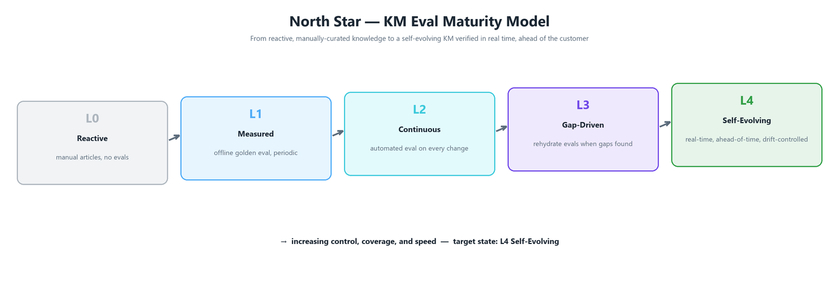
Figure 1. KM Eval maturity model — from reactive knowledge (L0) to a self-evolving, drift-controlled system verified ahead of the customer (L4).

3.3 Guiding Principles
- Evals are the control plane. Knowledge is only promoted when it passes measurable gates, never on trust alone.
- Ahead of the customer. Gaps are detected and verified before first customer contact, tracked by lead time.
- Golden anchors truth. A human-verified golden dataset defines “what good looks like”; other sources add coverage and recency but never redefine correctness.
- Grounded or nothing. Every answer must trace to a cited, current source node in the knowledge graph.
- Controlled autonomy. Agents act automatically, but within gates, guardrails, and drift thresholds that trigger review and auto-remediation.

4. The Concept: Evals as the Control Layer

4.1 What “Rehydration” Means
Rehydration is the act of regenerating a fresh, executable evaluation set from a source the moment that source changes or a gap is found. Instead of a static, hand-written test suite that ages, the eval corpus is continuously re-hydrated: new eval cases are synthesized from the triggering source (e.g., a release note or a community thread), combined with the golden rubric, and immediately run against the KM agents. Evals become a living, real-time control — not a one-time gate at launch.

4.2 The Control Loop
The system runs a continuous closed loop. Each detected gap becomes a rehydration job that flows through five stages; only content that clears every promotion gate is published, and the outcome writes back into the knowledge graph and the metrics store.
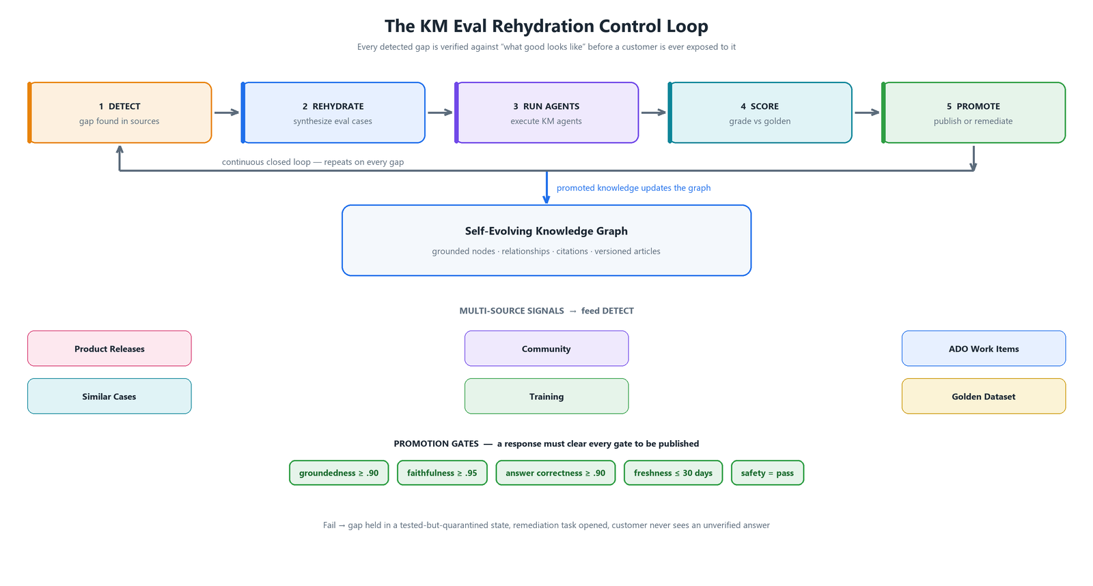
Figure 2. The KM Eval Rehydration control loop — detect, rehydrate, run agents, score against golden, and promote or remediate, on a continuous cycle fed by six sources.
- Detect. Continuously diff live sources against the KM graph and golden coverage map to surface gaps, each with a severity and a projected lead time.
- Rehydrate. Synthesize eval cases from the triggering source plus the golden rubric — query, expected resolution, required citations, and gates.
- Run agents. Execute the KM agents (retrieval, diagnosis, grounding, answer synthesis) against the rehydrated cases.
- Score. Grade outputs against the golden gates using LLM-as-judge plus deterministic checks (citation match, freshness, safety).
- Promote or remediate. Passing content is promoted to the live graph; failing content is held in a tested-but-quarantined state and a remediation task is opened. The customer never sees an unverified answer.

4.3 Worked Example
A support article covers troubleshooting Microsoft Entra seamless single sign-on. A new release note changes the key-roll procedure and a matching ADO fix ships. The Release Watcher and ADO agents detect the divergence between the live sources and the current article — a gap, caught 5 days before the change reaches most customers.
- The gap triggers rehydration: 24 eval cases are synthesized from the release note, the ADO fix, and the golden case for this scenario.
- The KM agents re-answer the rehydrated cases; a new step (“verify device time sync within 5 minutes via w32tm /resync”) is drafted and grounded to the updated sources.
- The Eval Judge scores the new answer at 94% — above every gate — with correct citations and freshness inside SLA.
- The article is auto-promoted from v1 to v2 with the corrected procedure, and the outcome is logged to the drift/metrics store — all before the customer ever asks.

5. The Multi-Dimensional Eval Fabric
Robust evaluation cannot rest on a single source. The eval corpus is hydrated from six independent dimensions. The golden dataset anchors correctness; the others contribute coverage, recency, and authentic customer phrasing. Each source is independently monitored for freshness and open gaps, and can be rehydrated on demand.
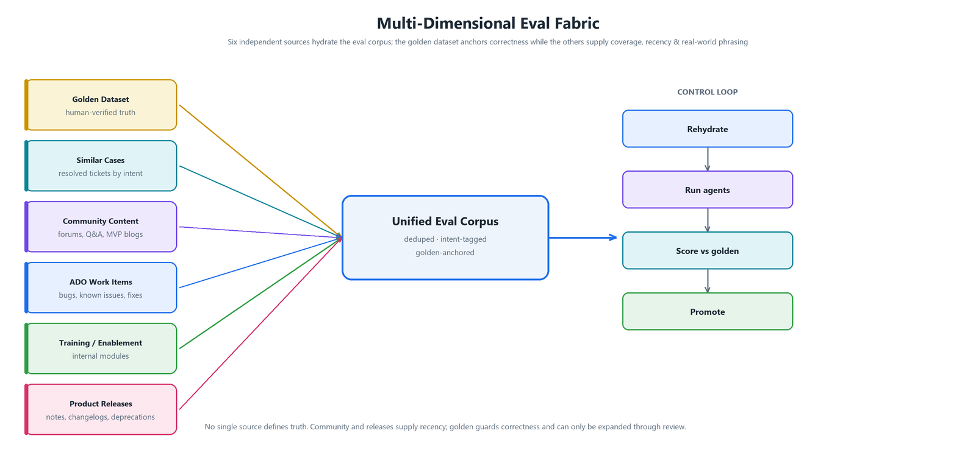
Figure 3. The multi-dimensional eval fabric — six sources feed a unified, golden-anchored eval corpus that drives the control loop.
Source | Role | What it hydrates into evals | Freshness signal
Golden Dataset | Truth anchor | Human-verified queries, expected resolutions, required citations, gate thresholds | Review cadence
Similar Cases | Coverage | Resolved support tickets clustered by intent; real customer phrasing and edge cases | Ticket recency
Community Content | Recency & reach | Forum threads, Q&A, MVP blogs; emerging issues before formal docs exist | Post velocity / spikes
ADO Work Items | Ground truth of fixes | Bugs, known issues, and shipped fixes with authoritative resolution steps | Work-item state
Training / Enablement | Canonical procedure | Internal enablement modules and certified guidance | Module version
Product Releases | Change signal | Release notes, changelogs, deprecations that invalidate or add steps | Release date / deprecation

Governance note: rehydrated cases from community, releases, ADO, and similar cases are scored against the golden set — they are never allowed to silently redefine it. When a rehydrated case reveals that the golden itself is stale (for example, a release deprecates a documented step), it is flagged for golden-set promotion through review, keeping “what good looks like” both current and controlled.

6. Agent Quality & Model-Drift Monitoring
Every KM agent is scored on each eval sweep across both offline (golden) and online (production-sampled) evaluations. Beyond answer quality, the system tracks model drift — shifts in the distribution of agent outputs over time — because an LLM-based agent can regress silently even when code does not change. Drift crossing an alert band flags a model for review; crossing the retrain band auto-opens a remediation job.
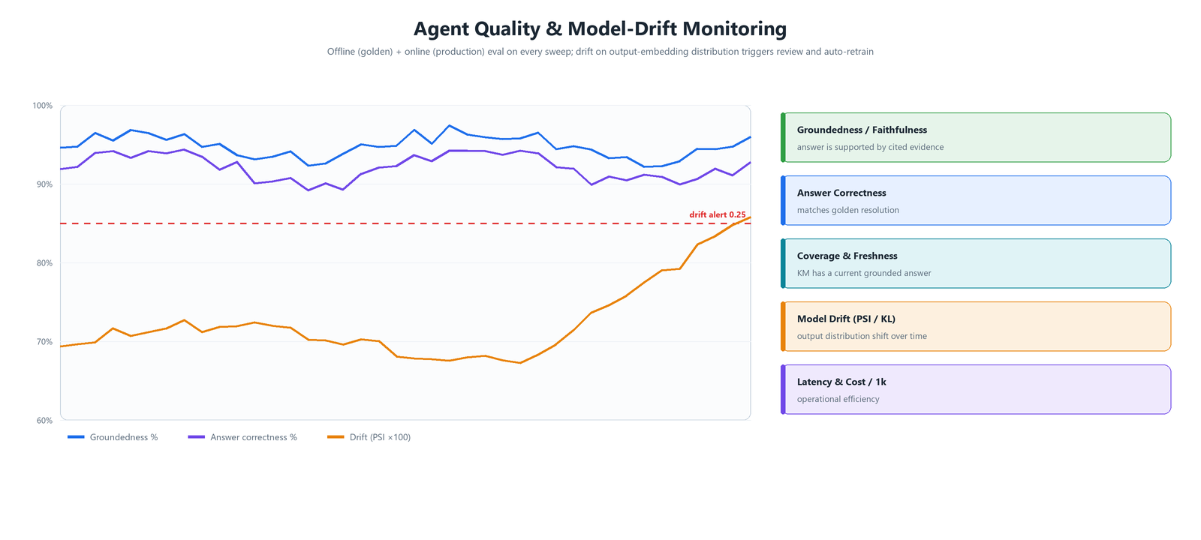
Figure 4. Continuous agent-quality and model-drift monitoring — rolling groundedness and correctness against a drift (PSI) alert band, with the core metric families.
- Quality metrics track whether answers are grounded, faithful, correct, and complete against golden.
- Drift metrics (PSI, KL/JS divergence on output-embedding distributions) detect silent regression and data/concept shift.
- Operational metrics (latency p50/p95, cost per 1k, throughput) keep the control loop affordable and fast.
- Outcome metrics (deflection, re-contact rate, CSAT, gaps caught ahead-of-time) tie eval health to customer impact.

7. Industry Standards, Methods & Metrics
The approach aligns with established practice in LLM/RAG evaluation, MLOps/LLMOps, and AI governance. This section catalogs the relevant frameworks, the methods that underpin them, and the concrete metrics used for this use case.

7.1 Standards & Frameworks
Framework / Standard | Type | Relevance to KM Eval Rehydration
RAGAS | RAG eval library | Reference metrics for faithfulness, answer relevancy, context precision & recall over retrieval-augmented answers.
TruLens | Eval / feedback fns | The “RAG triad” — groundedness, context relevance, answer relevance — as programmatic feedback functions.
DeepEval / promptfoo | Eval harness | Assertion-style, CI-friendly test cases and regression gates for prompts and pipelines.
Azure AI Foundry Evaluation SDK | Enterprise eval | Built-in groundedness, relevance, coherence, fluency & safety evaluators; offline + online (continuous) eval.
MLflow LLM Evaluate | Eval orchestration | Experiment tracking and standardized LLM metric logging across model/prompt versions.
LangSmith / OpenAI Evals | Datasets & tracing | Versioned eval datasets, tracing, and pairwise/LLM-judge scoring registries.
NIST AI RMF | Governance | Map–Measure–Manage–Govern functions; validity, reliability, and monitoring for trustworthy AI.
ISO/IEC 42001 | AI management system | Organizational controls, lifecycle management, and continual improvement for AI systems.
Microsoft Responsible AI Standard | Governance | Reliability & safety, transparency, and accountability requirements for deployed AI.

7.2 Methods
- Golden dataset curation & versioning — human-verified, version-controlled ground truth expanded only through review.
- LLM-as-a-judge — rubric-based and pairwise grading, calibrated against human labels (inter-rater agreement / Cohen’s kappa) to control judge bias.
- Offline + online evaluation — pre-deployment gates on golden, plus continuous sampling of live production traffic.
- Continuous eval in CI (eval-as-a-gate) — regression suites block promotion when quality drops below threshold.
- Synthetic eval generation — the rehydration technique: auto-generate eval cases from changed sources.
- RAG triad evaluation — jointly score context relevance, groundedness, and answer relevance.
- Guardrails & policy checks — deterministic safety, PII, and compliance gates alongside model-graded metrics.
- Drift detection — scheduled PSI/KL/JS on output-embedding distributions to catch silent regression; distinguish data drift from concept drift.
- A/B, shadow & canary testing with auto-rollback — validate changes on live traffic safely before full promotion.
- Red-teaming / adversarial evaluation — probe for hallucination, jailbreaks, and unsafe guidance.
- Human-in-the-loop feedback & active learning — use thumbs, re-contacts, and hard cases to grow the golden set over time.

7.3 Metrics Catalog
Metric | What it measures | Method / technique | Target
Groundedness | Answer is supported by retrieved, cited evidence | NLI / LLM-judge (RAG triad) | ≥ 0.90
Faithfulness | No unsupported or fabricated claims | RAGAS faithfulness / LLM-judge | ≥ 0.95
Answer correctness | Matches the golden resolution | Semantic similarity + LLM-judge vs golden | ≥ 0.90
Context precision / recall | Retrieval surfaces the right, sufficient context | RAGAS context metrics | ≥ 0.85
Intent accuracy | Correct problem identified | Classification vs labeled intent | ≥ 0.88
Coverage | Share of queries with a grounded answer | Graph coverage diff | ≥ 0.85
Freshness / staleness | Source age within SLA window | Timestamp vs SLA | ≤ 30 days
Hallucination rate | Frequency of ungrounded claims | Groundedness inversion / red-team | ≤ 2%
Citation accuracy | Citations resolve to correct source | Deterministic link check | ≥ 0.95
Model drift (PSI) | Output-distribution shift over time | PSI on output embeddings | alert ≥ 0.25
Drift (KL / JS) | Distributional divergence vs baseline | KL / Jensen–Shannon divergence | monitor
Judge agreement | LLM-judge vs human labels | Cohen’s kappa | ≥ 0.8
Latency / cost | Operational efficiency | p50/p95, cost per 1k | SLA-bound
Safety / guardrail pass | No unsafe or non-compliant guidance | Policy classifiers | = 100%
Re-contact / deflection | Business outcome of KM quality | Production analytics | improving

8. Recommended Techniques & Methodology

8.1 Prioritized Techniques
Technique | Why it matters for this use case | When | Priority
Versioned golden dataset | Defines “what good looks like”; the anchor every rehydrated eval scores against | Foundation | P0
RAG triad + LLM-as-judge | Core quality signal for grounded, faithful, relevant answers | Foundation | P0
Eval-as-a-gate in CI | Blocks regressions before promotion; makes evals a control, not a report | Foundation | P0
Judge calibration vs human | Prevents biased/uncalibrated automated scoring | Foundation | P1
Synthetic eval generation (rehydration) | Turns any changed source into fresh, executable eval cases in real time | Differentiator | P1
Gap detection & lead-time tracking | Surfaces gaps ahead of the customer; drives the loop | Differentiator | P1
Drift detection (PSI/KL/JS) | Catches silent agent regression that quality-only checks miss | Differentiator | P1
Online eval on sampled traffic | Confirms offline gains hold in production | Scale | P2
Canary + shadow + auto-rollback | Safe promotion of rehydrated knowledge under live load | Scale | P2
Guardrails & safety classifiers | Deterministic backstop for compliance and safety | Scale | P2
Active learning to expand golden | Converts hard production cases into new ground truth | Continuous | P2

8.2 Implementation Methodology (Phased)
Phase | Focus | Key deliverables
Phase 0 | Baseline & instrumentation | Trace agents; log inputs/outputs/citations; define outcome metrics (re-contact, deflection).
Phase 1 | Golden + offline gates | Curate versioned golden set; implement RAG triad + LLM-judge; add eval-as-a-gate to CI.
Phase 2 | Continuous evaluation | Calibrate judges; add online eval on sampled traffic; publish the eval-health dashboard.
Phase 3 | Gap-driven rehydration | Wire multi-source gap detection; synthesize eval cases on change; track lead time ahead-of-customer.
Phase 4 | Drift control & autonomy | PSI/KL drift monitoring; auto-remediation & retrain jobs; canary + auto-rollback — Self-Evolving KM.

9. Governance & Controls
- Gate-based promotion. No knowledge is served unless it clears every eval gate; failures are quarantined, not published.
- Golden integrity. The golden set is version-controlled; changes require review and are auditable.
- Auditability. Every promotion carries its eval scores, citations, and source lineage for traceability (aligned with NIST AI RMF and ISO/IEC 42001).
- Drift thresholds. Defined alert and retrain bands convert model drift into automatic, controlled action.
- Safety backstop. Deterministic guardrails run alongside model-graded metrics for compliance-critical checks.

10. Glossary
Rehydration — Regenerating executable eval cases from a source the moment it changes or a gap is found.
Golden dataset — Human-verified ground truth defining expected answers, citations, and gate thresholds.
RAG triad — Groundedness, context relevance, and answer relevance — the core RAG quality signals.
LLM-as-a-judge — Using an LLM, guided by a rubric, to grade another model’s output; calibrated to human labels.
Model drift — Change in an agent’s output distribution over time, detected via PSI/KL/JS divergence.
PSI — Population Stability Index — a measure of distribution shift between a baseline and current window.
Lead time — How far ahead of first customer contact a gap was detected and verified.

11. References & Further Reading
- RAGAS — Evaluation framework for retrieval-augmented generation.
- TruLens — Feedback functions and the RAG triad for LLM app evaluation.
- DeepEval / promptfoo — Open-source LLM evaluation and testing harnesses.
- Azure AI Foundry — Evaluation SDK: groundedness, relevance, safety, and continuous online evaluation.
- MLflow — LLM evaluation and experiment tracking.
- NIST AI Risk Management Framework (AI RMF 1.0).
- ISO/IEC 42001:2023 — AI management systems.
- Microsoft Responsible AI Standard.

