For test, you can run two cmd window, one is for client and other is for server.

For main functions and test, I added test buffers, but it is comment.
If you need, you can change the code and test.(line 19~25 in udpserver_multiclient.py)

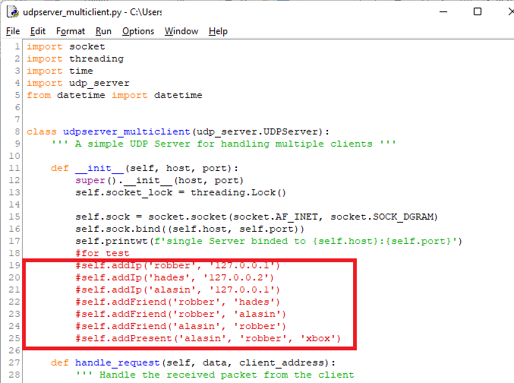

To test this, you can also change line 155,156 in udp_server.py.
This part is related to 25 th. If today is not 25th, even though you changed the above buffers, it doesn’t mean. Therefore confirm this part.
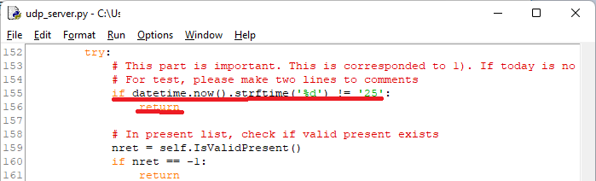
When you test with it, you can do as following.
- On client cmd window, set name to <robber>
Then server send present to client and client responds to it.
You can see such messages. After you checked the messages, go 2.

Client’s log is as following.
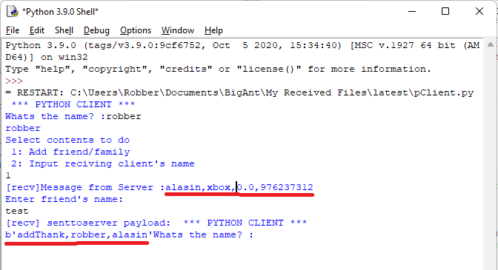
Server’s log is as following.
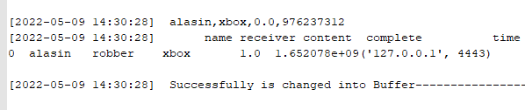
- Terminate client cmd window and run new cmd windows
- After then, set name to alasin.
Then server send that robber received alasin’s present, and alasin responds to it.
This actions also can see via log of programme.
Client’s log is as following.
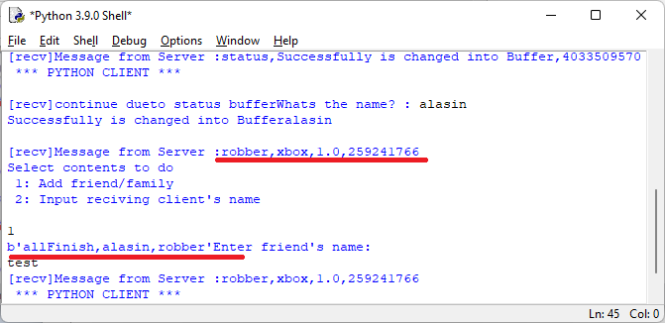
Server’s log is as following.
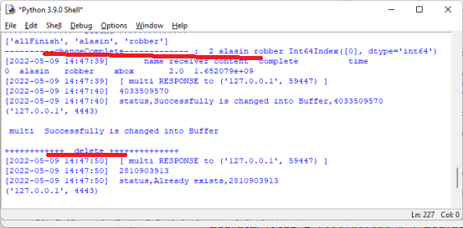
If server receives the response from alasin, server delete the present from present buffer.

Of course you can test with yourself planing.

Client can perform actions such as name setting, friend/family adding, present sending.
Server has various buffers such as friend buffer, ip buffer, present buffer.
And server respond to client’s requests and manage buffers according to conditions.

Name setting and friend adding
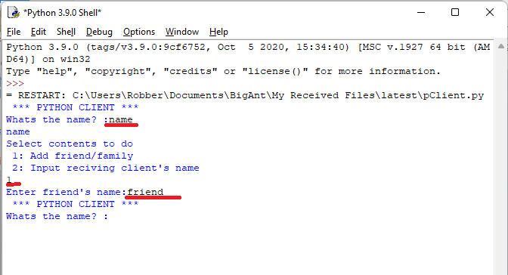

Present sending
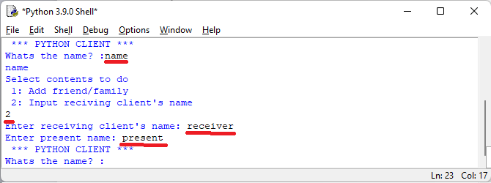

Red underline part is one that you must input.

Comments is added within code.
On each code functions or important parts, I added the comments.

