JETPOOL 상용 플랫폼
모듈 설계·아키텍처 기술 백서 v2
  - WONT Travel Club 리플랫폼 · Paid Stay + Home Exchange + Guide Friend + Travel Commerce + Payment/Settlement + Trust/Operations

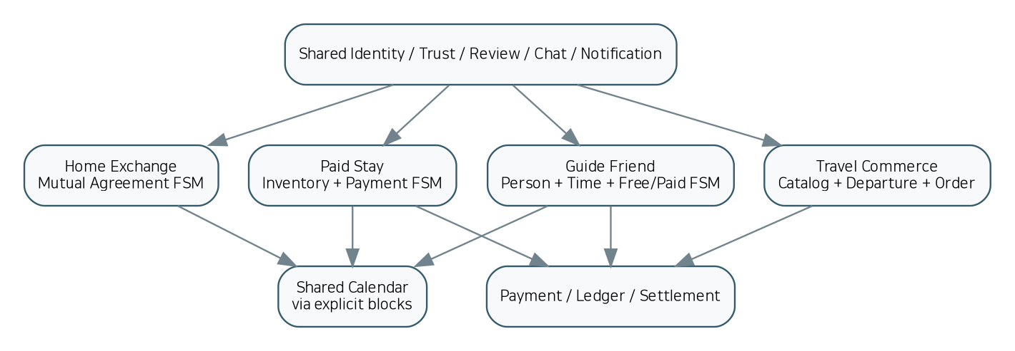
2차 목표: 1차 기술 백서를 “설명 문서”에서 “AI가 코드·테스트·인프라까지 생성할 수 있는 구현 계약”으로 승격
항목 | 기준
기준일 | 2026-10-08
기준 문서 | 첨부: 제트풀 상용 플랫폼 마이그레이션·리모델링 기술 백서 초안
상용화 원칙 | Staging까지 자동화, Production은 승인 Gate
핵심 Source of Truth | PostgreSQL 거래 원장
배포 단위 | 8개 repository + 계약/인프라 중앙화

1. Executive Summary
1차 백서는 JETPOOL을 단일 Airbnb Clone 확장이 아니라 Paid Stay, Home Exchange, Guide Friend, Travel Commerce를 하나의 ID·신뢰·결제·채팅·운영 체계로 묶는 다중 Marketplace로 정의하고, 예약/교환/가이드의 상태와 법적 책임을 분리해야 한다는 구조를 제시했다. 2차 백서는 이 방향을 유지하면서 실제 개발 단계에서 AI와 사람 개발팀이 해석을 달리하지 않도록 기능, UI, API, 데이터, 이벤트, 상태머신, 테스트, Release Gate를 하나의 추적 가능한 구현 명세로 통합한다.
2차 핵심 결론
“원클릭 개발”의 실질적 의미는 모든 기능을 한 번에 무검증으로 Production에 넣는 것이 아니라, 명세를 Source of Truth로 삼아 코드·테스트·IaC를 반복 생성하고 Staging까지 자동 검증한 후 Production만 사람이 승인하는 구조다. 이 방식이 기능 누락과 AI 임의 해석을 최소화한다.

- Paid Stay는 재고·Hold·결제·취소·환불이 결합된 Reservation FSM으로 구현한다.
- Home Exchange는 상호 제안·반대제안·상호수락·검증·동일 약정 버전 동의·두 숙소 Calendar lock을 갖는 별도 Aggregate로 구현한다.
- Guide Friend는 FRIEND / VOLUNTEER / PAID / PROFESSIONAL 유형을 분리하고 유료 유형만 결제·사업자/자격 Gate를 연계한다.
- 기존 WONT의 여행 콘텐츠·멤버십·전세기 공유 브랜드 자산은 버리지 않고 IA로 이전하되, 전세기 직접 거래 기능은 사업·법적 범위 승인 전 Feature Flag OFF로 둔다.
- PostgreSQL은 거래 사실의 권위 데이터이며, Meilisearch/Redis/Realtime/AI 추천은 재생성 가능한 보조 계층이다.
- Payment/Refund/Ledger/Settlement는 예약 상태와 분리된 금융 도메인으로 만들고, PG 결과를 서버에서 재검증한 후 예약을 확정한다.

2. 1차 백서 분석과 2차 보완 범위
1차에서 이미 확립된 기반 | 2차에서 구현 가능 수준으로 추가 고정
4개 Marketplace 및 공통 Trust/Operations | 48개 구현 모듈 ID, 책임, 소유 데이터, API, 이벤트, UI, 완료조건
Next.js / PostgreSQL / Supabase / Meilisearch / MapLibre / Toss / Payload / Novu / Chatwoot | Repository별 경계, 계약 우선 생성 순서, 배포·버전·Feature Flag 규칙
Booking/Exchange 상태머신 | Guide/Payment/Refund/Settlement/Dispute/Compliance까지 상태 전이·Gate 확대
핵심 DB 테이블 | 실행 가능한 PostgreSQL schema seed, 제약조건, idempotency/outbox/audit 구조
API 요약 | OpenAPI 3.1 seed, AsyncAPI 3.0 seed, 공통 오류/인증 규약
보안 체크리스트 | 보안 Release Gate, 권한 negative test, secrets/SBOM/DAST/AAL2 기준
마이그레이션 절차 | field/ID/URL/consent/password/media reconciliation 기준과 cutover 승인조건
원클릭 AI 방향 | AGENTS_MASTER + MASTER_BUILD_SPEC + traceability + AI 병렬 에이전트 분할

2.1 반드시 사람이 결정해야 하는 Release Decision
- 숙소 유형·지역별 유료 영업 허용 조건 및 Home Exchange의 법률 분류
- FRIEND/VOLUNTEER/PAID/PROFESSIONAL 가이드 유형별 허용 활동·자격·보험
- 여행상품별 seller / intermediary / merchant_of_record
- Host/Guide/Supplier 정산·세금·증빙·원천징수/부가세 적용 정책
- 전세기 공유를 단순 정보/리드로 유지할지 직접 거래로 확장할지
- 기존 Sixshop 데이터의 공식 Export 범위와 기존 비밀번호 이전 방식
- PG 외 실제 지급(payout) 실행 주체 및 계좌 검증 방식

3. 목표 시스템 아키텍처
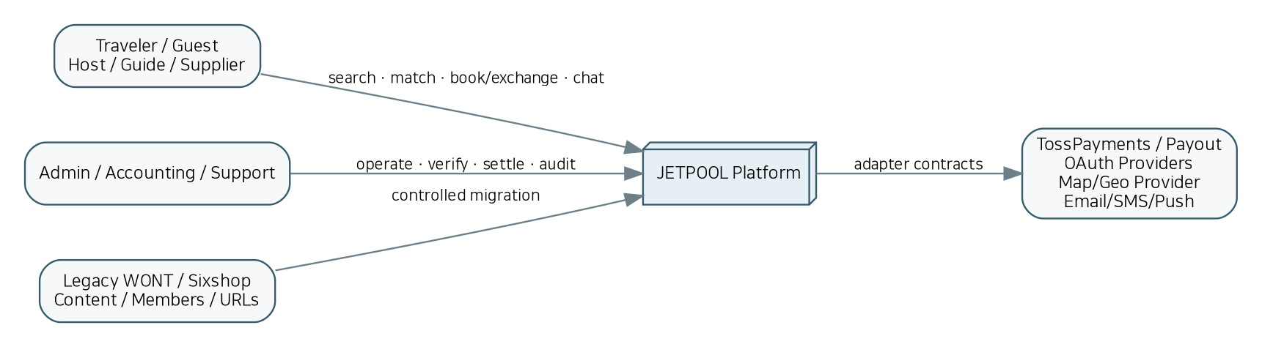
그림 1. JETPOOL 시스템 컨텍스트
JETPOOL은 고객·공급자·운영자를 하나의 플랫폼으로 연결하되 외부 결제·OAuth·지도·메시지 공급자는 Adapter 뒤에 격리한다. 기존 WONT/Sixshop 자산은 신규 시스템의 데이터와 URL로 통제된 마이그레이션을 수행한다.
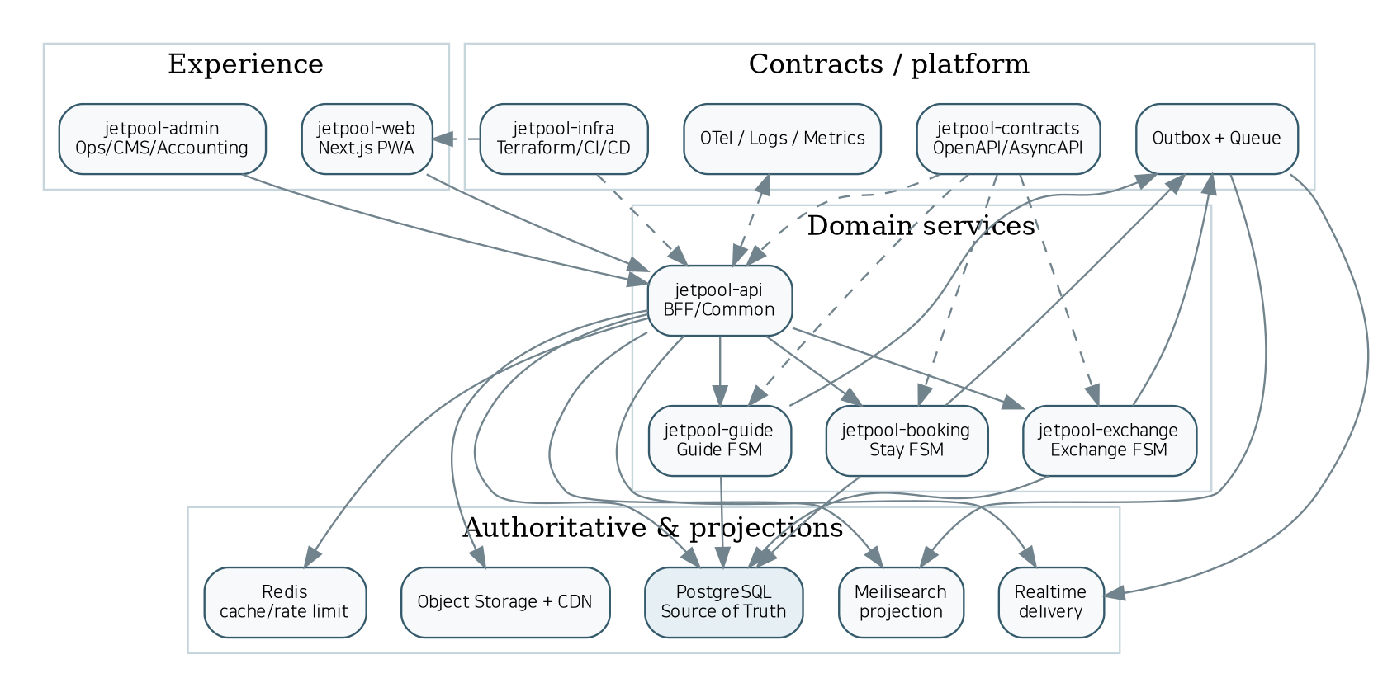
그림 2. 논리 컨테이너/서비스 구조

3.1 경계 원칙
- 비즈니스 상태는 각 도메인 서비스와 PostgreSQL에만 기록한다.
- BFF는 UI 편의용 조합을 제공하지만 Booking/Exchange/Guide의 핵심 상태를 중복 소유하지 않는다.
- 서비스 간 동기 호출은 사용자 요청의 즉시 검증에 한정하고, 검색 동기화·알림·분석·비핵심 후처리는 Outbox 이벤트로 분리한다.
- 초기에는 동일 Managed PostgreSQL cluster 내 schema 분리를 허용하지만 테이블 소유권을 명확히 하여 향후 분리 가능성을 보장한다.
- Kubernetes는 성장 단계에서 도입 가능하도록 컨테이너/healthcheck/12-factor 규칙을 지키되 MVP부터 운영 복잡도를 강제하지 않는다.

4. Repository 및 코드 소유권
Repository | 책임
jetpool-web | Customer Web/PWA; public marketplace; traveler/host/guide self-service UI
jetpool-api | BFF/common APIs; identity; profile; listing; travel commerce; orchestration
jetpool-booking | Availability, quote, hold, reservation, cancellation and inventory concurrency
jetpool-exchange | Home Exchange request, counter, verification, agreement and calendar locking
jetpool-guide | Guide Friend profile, availability, matching, offers and bookings
jetpool-admin | Admin/backoffice, compliance, disputes, accounting, CMS integration
jetpool-contracts | OpenAPI, AsyncAPI, JSON Schema, enums, generated clients/types
jetpool-infra | Terraform, CI/CD, environment bootstrap, observability, runbooks, one-click orchestrator

Repository 간 변경 규칙
다른 repo의 데이터 모델을 직접 import하지 않는다. 공유되는 것은 `jetpool-contracts`가 생성한 API/Event DTO와 enum뿐이다. API breaking change는 contracts version과 CHANGELOG를 먼저 변경하고 consumer compatibility test를 통과해야 한다.

jetpool-contracts/
openapi/
asyncapi/
schemas/
enums/
generated/
jetpool-infra/
scripts/
templates/
terraform/environments/{dev,staging,prod}/
runbooks/
release-gates/

5. 전체 기능 모듈 카탈로그
ID | 모듈 | 우선 | 소유 Repo | 핵심 책임
CORE-01 | Identity & Authentication | P0 | jetpool-api | Email/password/OTP/social login, account linking, session management, MFA policy and recovery.
CORE-02 | Profile, Locale & Preferences | P0 | jetpool-api | Canonical profile, names, phone, locale, timezone, accessibility and travel preferences.
CORE-03 | Roles, Entitlements & Policy | P0 | jetpool-api | RBAC plus scoped entitlements for USER/HOST/GUIDE/SUPPLIER/ADMIN/ACCOUNTING/SUPPORT.
CORE-04 | Consent & Privacy Lifecycle | P0 | jetpool-api | Terms/privacy/marketing consent versioning, retention, export, deletion and restricted processing.
TRUST-01 | Identity / Business Verification | P0 | jetpool-admin | User identity, host/guide/supplier business and payout-account verification state.
TRUST-02 | Reviews & Reputation | P0 | jetpool-api | Transaction-bound reviews, bilateral exchange reviews, guide reviews, host responses, moderation.
TRUST-03 | Safety, Reports & Disputes | P0 | jetpool-admin | Safety reports, evidence, disputes, case ownership, escalation, sanctions and audited access.
HOST-01 | Host Onboarding | P0 | jetpool-api | Host application, verification checklist, payout profile reference and host status.
STAY-01 | Property / Listing Management | P0 | jetpool-api | Property draft, address, geo, occupancy, amenities, house rules, rental/exchange switches and lifecycle.
STAY-02 | Media Pipeline | P0 | jetpool-api | Presigned uploads, private staging, image/video metadata, transformation/moderation and CDN publication.
STAY-03 | Accommodation Compliance Gate | P0 | jetpool-admin | Permit types, jurisdiction rules, guest eligibility, expiry and publish/booking block decisions.
STAY-04 | Stay Search & Discovery | P0 | jetpool-api | Text/geo/facet search projection, ranking, filters, map viewport and date-aware candidate retrieval.
STAY-05 | Favorites & Collections | P1 | jetpool-api | Saved properties, guides, trips and shareable collections.
STAY-06 | Availability & Calendar | P0 | jetpool-booking | Authoritative availability rules, host blocks, rate overrides, min stay and calendar projection.
STAY-07 | Pricing & Quote | P0 | jetpool-booking | Nightly/base price, fees, taxes as rules, promotions, quote expiry and price breakdown.
STAY-08 | Inventory Hold | P0 | jetpool-booking | Transactional hold acquisition, TTL expiry, idempotency and collision protection.
STAY-09 | Reservation FSM | P0 | jetpool-booking | DRAFT→QUOTED→HELD→PAYMENT_PENDING→CONFIRMED→CHECKED_IN→COMPLETED plus failure/cancel/refund branches.
STAY-10 | Cancellation / No-show / Check-in | P0 | jetpool-booking | Cancellation policy evaluation, no-show, check-in/out and refund intent generation.
EXCH-01 | Exchange Eligibility | P0 | jetpool-exchange | Exchange-enabled property eligibility, household preferences, legal classification and safety prerequisites.
EXCH-02 | Exchange Request & Counter | P0 | jetpool-exchange | A↔B request, dates, property pair, terms, counter-offer version chain and withdrawal/decline.
EXCH-03 | Exchange Verification Gate | P0 | jetpool-exchange | Mutual-acceptance verification checklist before contract generation.
EXCH-04 | Exchange Agreement & E-consent | P0 | jetpool-exchange | Versioned terms snapshot, deposit/damage policy, bilateral acceptance timestamps and evidence.
EXCH-05 | Exchange Calendar Lock | P0 | jetpool-exchange | Atomic calendar blocks on both properties and rollback if either block fails.
EXCH-06 | Exchange Completion & Review | P0 | jetpool-exchange | In-progress/completed/disputed/reviewed lifecycle and bilateral review eligibility.
GUIDE-01 | Guide Profile & Type | P0 | jetpool-guide | FRIEND/VOLUNTEER/PAID/PROFESSIONAL classification, bio, languages, areas, specialties, price and verification.
GUIDE-02 | Guide Availability | P0 | jetpool-guide | Time windows, timezone-aware schedule, blackout and booking locks.
GUIDE-03 | Guide Search & Matching | P0 | jetpool-guide | Location, language, interest, type, price, trust, availability and response-time ranking.
GUIDE-04 | Guide Request & Offer | P0 | jetpool-guide | Traveler request, guide offer/counter, scope, duration, price or free confirmation.
GUIDE-05 | Guide Booking FSM | P0 | jetpool-guide | Confirmed activity, payment dependency for paid types, start/complete/cancel/dispute.
TRAVEL-01 | Travel Catalog & Supplier | P1 | jetpool-api | Tours/tickets/activities/packages, supplier profile, options, terms and publish workflow.
TRAVEL-02 | Departure / Inventory | P1 | jetpool-api | Departure dates, capacity, minimum participants, inventory allocations and cutoff rules.
TRAVEL-03 | Itinerary Builder | P1 | jetpool-api | Day/activity itinerary, map points, attachments and customer-facing schedule.
TRAVEL-04 | Commerce Order / Cart | P1 | jetpool-api | Mixed travel-product order, line items, buyer, seller role, totals and cancellation linkage.
JET-01 | Legacy Charter / Flight Share Scope Gate | P1 | jetpool-api | Preserve existing JETPOOL charter-sharing brand IA as content/lead/request flow; transactional air-charter booking remains disabled until business/legal scope is approved.
PAY-01 | Payment Orchestrator | P0 | jetpool-api | PG adapter, prepare/confirm, server-side amount check, webhook reconciliation and payment state.
PAY-02 | Refund Orchestrator | P0 | jetpool-api | Full/partial refund intents, provider execution, retries, reconciliation and audit.
FIN-01 | Double-entry Ledger | P0 | jetpool-admin | Immutable financial transaction journal for gross, fee, refund, tax adjustment, payable and payout.
FIN-02 | Settlement & Payout | P1 | jetpool-admin | Settlement periods, payee statement, approval, payout execution/reconciliation and holds.
FIN-03 | Fee / Tax / Evidence Rule Engine | P1 | jetpool-admin | Configurable fee and tax evidence rules by merchant/supplier type; no unverified hard-coded universal tax rate.
COMMS-01 | P2P Messaging | P0 | jetpool-api | Context-bound conversation, message persistence, realtime delivery, attachments, read state and abuse controls.
COMMS-02 | Notification Orchestration | P0 | jetpool-api | Email/SMS/push/in-app preferences, templates, retries and event-driven delivery.
OPS-01 | Customer Support / Case Desk | P0 | jetpool-admin | Chatwoot-backed support intake linked to user/booking/exchange/dispute context.
OPS-02 | Admin / Backoffice | P0 | jetpool-admin | Operational console for users, listings, compliance, reservations, exchanges, guides, payments, refunds and settlements.
OPS-03 | CMS, Content & SEO | P0 | jetpool-admin | Destination/story/FAQ/promotion/legacy WONT content, redirects, metadata and structured content.
OPS-04 | Analytics & Audit | P0 | jetpool-admin | GMV, conversion, cancellation, search, compliance, disputes, finance dashboards and immutable audit trail.
PLAT-01 | Search Projection Service | P0 | jetpool-api | Project PostgreSQL entities into Meilisearch; reindex, version, lag monitoring and recovery.
PLAT-02 | Map / Geo Adapter | P0 | jetpool-api | MapLibre rendering support, geocoding abstraction, viewport search and provider cost controls.
PLAT-03 | Transactional Outbox & Async Jobs | P0 | jetpool-api | Outbox in same transaction, durable queue, retries, dead-letter handling, event correlation and schema version.
PLAT-04 | Observability / SRE | P0 | jetpool-infra | OpenTelemetry traces, metrics, logs, synthetic checks, SLOs, alerting and incident runbooks.
PLAT-05 | Security / Risk Controls | P0 | jetpool-infra | WAF/rate-limit, bot protection, secret management, SAST/SCA/SBOM, DAST, upload scanning and risk flags.
PLAT-06 | Configuration & Feature Flags | P0 | jetpool-api | Environment-safe feature flags, business rules, percentage rollout and kill switches.
MIG-01 | Legacy WONT/Sixshop Migration | P0 | jetpool-infra | Inventory existing URLs/content/member/order assets, official export, ID mapping, media import, consent audit, 301s and cutover reconciliation.
AI-01 | AI Travel Assistant | P1 | jetpool-api | Intent parsing, trip planning, explainable suggestions using live search/availability; never autonomously commits paid transactions.
AI-02 | Recommendation & Personalization | P1 | jetpool-api | Behavioral/explicit preference ranking with cold-start rules, opt-out and non-authoritative recommendations.
INT-01 | PMS / Supplier Integrations | P2 | jetpool-api | External PMS/channel/supplier adapter framework, polling/webhooks, mapping and conflict handling.

6. 모듈 상세 설계

6.1 Core / Trust

CORE-01 · Identity & Authentication
책임: Email/password/OTP/social login, account linking, session management, MFA policy and recovery.
구분 | 명세
Priority / Owner | P0 / jetpool-api
Dependencies | 없음/공통 플랫폼
Primary data | users, oauth_identities, mfa_factors, sessions
API / interfaces | /v1/auth/*, /v1/me
Events | identity.user.created, identity.mfa.changed
UI / routes | /login, /signup, /account/security
Definition of Done | OAuth login, logout, account-linking and AAL2-gated admin actions pass positive/negative tests.

CORE-02 · Profile, Locale & Preferences
책임: Canonical profile, names, phone, locale, timezone, accessibility and travel preferences.
구분 | 명세
Priority / Owner | P0 / jetpool-api
Dependencies | CORE-01
Primary data | user_profiles, user_preferences
API / interfaces | GET/PATCH /v1/me/profile, GET/PATCH /v1/me/preferences
Events | profile.updated
UI / routes | /account/profile, /account/preferences
Definition of Done | Profile updates are audited, validated and reflected across customer/host/guide views.

CORE-03 · Roles, Entitlements & Policy
책임: RBAC plus scoped entitlements for USER/HOST/GUIDE/SUPPLIER/ADMIN/ACCOUNTING/SUPPORT.
구분 | 명세
Priority / Owner | P0 / jetpool-api
Dependencies | CORE-01
Primary data | user_roles, role_grants, policy_overrides
API / interfaces | /v1/me/roles, /v1/admin/users/{id}/roles
Events | role.granted, role.revoked
UI / routes | /admin/access
Definition of Done | Server-side authorization denies every unauthorized API regardless of UI visibility.

CORE-04 · Consent & Privacy Lifecycle
책임: Terms/privacy/marketing consent versioning, retention, export, deletion and restricted processing.
구분 | 명세
Priority / Owner | P0 / jetpool-api
Dependencies | CORE-01
Primary data | consent_records, privacy_requests, retention_jobs
API / interfaces | /v1/consents, /v1/privacy/export, /v1/privacy/delete
Events | consent.recorded, privacy.requested, privacy.completed
UI / routes | /account/privacy
Definition of Done | Consent evidence is versioned; deletion/export workflows are reproducible and auditable.

TRUST-01 · Identity / Business Verification
책임: User identity, host/guide/supplier business and payout-account verification state.
구분 | 명세
Priority / Owner | P0 / jetpool-admin
Dependencies | CORE-01
Primary data | verification_cases, verification_documents, business_profiles
API / interfaces | /v1/verifications/*, /v1/admin/verifications/*
Events | verification.submitted, verification.approved, verification.rejected
UI / routes | /verification, /admin/verifications
Definition of Done | Restricted actions remain blocked until required verification predicates are true.

TRUST-02 · Reviews & Reputation
책임: Transaction-bound reviews, bilateral exchange reviews, guide reviews, host responses, moderation.
구분 | 명세
Priority / Owner | P0 / jetpool-api
Dependencies | CORE-01
Primary data | reviews, review_responses, reputation_scores
API / interfaces | /v1/reviews, /v1/reviews/{id}/report
Events | review.created, review.moderated
UI / routes | /reviews, /account/reviews
Definition of Done | Only eligible completed transactions can create one review per review target/policy window.

TRUST-03 · Safety, Reports & Disputes
책임: Safety reports, evidence, disputes, case ownership, escalation, sanctions and audited access.
구분 | 명세
Priority / Owner | P0 / jetpool-admin
Dependencies | CORE-03
Primary data | disputes, dispute_evidence, safety_reports, sanctions
API / interfaces | /v1/disputes, /v1/admin/disputes/*
Events | dispute.opened, dispute.resolved, sanction.applied
UI / routes | /support/disputes, /admin/disputes
Definition of Done | Cases retain immutable evidence hashes and sensitive message access requires audited elevation.

6.2 Host / Stay

HOST-01 · Host Onboarding
책임: Host application, verification checklist, payout profile reference and host status.
구분 | 명세
Priority / Owner | P0 / jetpool-api
Dependencies | CORE-01, TRUST-01
Primary data | host_profiles, host_applications
API / interfaces | /v1/host-applications, /v1/hosts/{id}
Events | host.applied, host.approved
UI / routes | /host/onboarding, /host/dashboard
Definition of Done | Host cannot publish paid inventory until role, verification and compliance predicates are satisfied.

STAY-01 · Property / Listing Management
책임: Property draft, address, geo, occupancy, amenities, house rules, rental/exchange switches and lifecycle.
구분 | 명세
Priority / Owner | P0 / jetpool-api
Dependencies | HOST-01
Primary data | properties, property_addresses, property_amenities, house_rules
API / interfaces | /v1/properties, /v1/properties/{id}/publish
Events | property.created, property.updated, property.published
UI / routes | /host/listings, /stay/{slug}
Definition of Done | Draft-to-publish flow validates required content and compliance gate before public visibility.

STAY-02 · Media Pipeline
책임: Presigned uploads, private staging, image/video metadata, transformation/moderation and CDN publication.
구분 | 명세
Priority / Owner | P0 / jetpool-api
Dependencies | CORE-01
Primary data | media_assets, property_media
API / interfaces | /v1/media/upload-url, /v1/media/{id}/complete
Events | media.uploaded, media.ready
UI / routes | /host/listings/{id}/media
Definition of Done | MIME/size/ownership validation and private-to-public promotion occur only after successful processing.

STAY-03 · Accommodation Compliance Gate
책임: Permit types, jurisdiction rules, guest eligibility, expiry and publish/booking block decisions.
구분 | 명세
Priority / Owner | P0 / jetpool-admin
Dependencies | STAY-01, TRUST-01
Primary data | property_permits, compliance_rules, compliance_decisions
API / interfaces | /v1/properties/{id}/permits, /v1/compliance/evaluate
Events | compliance.verified, compliance.expired, listing.blocked
UI / routes | /host/listings/{id}/compliance, /admin/compliance
Definition of Done | Paid booking cannot be enabled when required permit/eligibility checks are missing, expired or rejected.

STAY-04 · Stay Search & Discovery
책임: Text/geo/facet search projection, ranking, filters, map viewport and date-aware candidate retrieval.
구분 | 명세
Priority / Owner | P0 / jetpool-api
Dependencies | STAY-01, STAY-06
Primary data | search_sync_state
API / interfaces | /v1/search/properties
Events | search.reindex.requested
UI / routes | /stay, /map
Definition of Done | Search produces candidates but checkout revalidates authoritative availability in booking DB.

STAY-05 · Favorites & Collections
책임: Saved properties, guides, trips and shareable collections.
구분 | 명세
Priority / Owner | P1 / jetpool-api
Dependencies | CORE-01
Primary data | favorites, collections, collection_items
API / interfaces | /v1/favorites, /v1/collections
Events | favorite.added
UI / routes | /saved
Definition of Done | Idempotent add/remove and privacy controls work across web/mobile PWA sessions.

STAY-06 · Availability & Calendar
책임: Authoritative availability rules, host blocks, rate overrides, min stay and calendar projection.
구분 | 명세
Priority / Owner | P0 / jetpool-booking
Dependencies | STAY-01
Primary data | availability_days, inventory_blocks
API / interfaces | /v1/properties/{id}/calendar, /v1/properties/{id}/availability
Events | availability.changed
UI / routes | /host/calendar, /stay/{slug}/calendar
Definition of Done | Calendar reads and writes preserve no-overlap invariant across paid stay/exchange/host blocks.

STAY-07 · Pricing & Quote
책임: Nightly/base price, fees, taxes as rules, promotions, quote expiry and price breakdown.
구분 | 명세
Priority / Owner | P0 / jetpool-booking
Dependencies | STAY-06, FIN-03
Primary data | rate_rules, fee_rules, booking_quotes
API / interfaces | POST /v1/booking/quotes
Events | quote.created, quote.expired
UI / routes | /stay/{slug}/checkout
Definition of Done | Quote is deterministic, currency-safe, itemized, time-bounded and immutable after booking confirmation.

STAY-08 · Inventory Hold
책임: Transactional hold acquisition, TTL expiry, idempotency and collision protection.
구분 | 명세
Priority / Owner | P0 / jetpool-booking
Dependencies | STAY-06, STAY-07
Primary data | reservation_holds, inventory_blocks, idempotency_keys
API / interfaces | POST/DELETE /v1/booking/holds
Events | reservation.held, reservation.hold_expired
UI / routes | checkout internal
Definition of Done | Concurrent hold tests prove capacity cannot be exceeded for overlapping dates.

STAY-09 · Reservation FSM
책임: DRAFT→QUOTED→HELD→PAYMENT_PENDING→CONFIRMED→CHECKED_IN→COMPLETED plus failure/cancel/refund branches.
구분 | 명세
Priority / Owner | P0 / jetpool-booking
Dependencies | STAY-08, PAY-01
Primary data | reservations, reservation_state_history
API / interfaces | /v1/reservations, /v1/reservations/{id}/cancel, /check-in, /complete
Events | reservation.confirmed, reservation.cancelled, reservation.completed
UI / routes | /trips/{id}, /host/reservations
Definition of Done | Only enumerated transitions are accepted; all transitions store actor, reason and correlation id.

STAY-10 · Cancellation / No-show / Check-in
책임: Cancellation policy evaluation, no-show, check-in/out and refund intent generation.
구분 | 명세
Priority / Owner | P0 / jetpool-booking
Dependencies | STAY-09, PAY-02
Primary data | cancellation_policies, reservation_adjustments
API / interfaces | /v1/reservations/{id}/cancel, /v1/reservations/{id}/check-in
Events | reservation.cancellation_requested, reservation.no_show
UI / routes | /trips/{id}/manage
Definition of Done | Policy calculation is tested at boundary dates and never mutates historical quote breakdown.

6.3 Home Exchange

EXCH-01 · Exchange Eligibility
책임: Exchange-enabled property eligibility, household preferences, legal classification and safety prerequisites.
구분 | 명세
Priority / Owner | P0 / jetpool-exchange
Dependencies | STAY-01, STAY-03, TRUST-01
Primary data | exchange_profiles, exchange_eligibility
API / interfaces | /v1/exchange/eligibility
Events | exchange.eligibility.updated
UI / routes | /exchange/onboarding
Definition of Done | No exchange request can enter agreement stage unless both sides satisfy configured legal/safety policy.

EXCH-02 · Exchange Request & Counter
책임: A↔B request, dates, property pair, terms, counter-offer version chain and withdrawal/decline.
구분 | 명세
Priority / Owner | P0 / jetpool-exchange
Dependencies | EXCH-01
Primary data | exchange_requests, exchange_offers
API / interfaces | /v1/exchanges, /v1/exchanges/{id}/counter, /accept
Events | exchange.requested, exchange.countered, exchange.mutual_accepted
UI / routes | /exchange, /exchange/{id}
Definition of Done | Both parties see one canonical offer version; stale-version acceptance is rejected.

EXCH-03 · Exchange Verification Gate
책임: Mutual-acceptance verification checklist before contract generation.
구분 | 명세
Priority / Owner | P0 / jetpool-exchange
Dependencies | EXCH-02, TRUST-01
Primary data | exchange_verifications
API / interfaces | /v1/exchanges/{id}/verify
Events | exchange.verification_pending, exchange.verified
UI / routes | /exchange/{id}/verification
Definition of Done | Agreement generation is impossible until required identity/property checks are approved.

EXCH-04 · Exchange Agreement & E-consent
책임: Versioned terms snapshot, deposit/damage policy, bilateral acceptance timestamps and evidence.
구분 | 명세
Priority / Owner | P0 / jetpool-exchange
Dependencies | EXCH-03
Primary data | exchange_agreements, agreement_acceptances
API / interfaces | /v1/exchanges/{id}/agreement, /v1/exchanges/{id}/confirm
Events | exchange.agreement.created, exchange.confirmed
UI / routes | /exchange/{id}/agreement
Definition of Done | Both parties accept exactly the same terms_version; acceptance evidence cannot be overwritten.

EXCH-05 · Exchange Calendar Lock
책임: Atomic calendar blocks on both properties and rollback if either block fails.
구분 | 명세
Priority / Owner | P0 / jetpool-exchange
Dependencies | EXCH-04, STAY-06
Primary data | inventory_blocks
API / interfaces | internal calendar lock API
Events | exchange.calendar_blocked, exchange.cancelled
UI / routes | internal
Definition of Done | Confirmed exchange blocks both homes without colliding with paid reservations or host blocks.

EXCH-06 · Exchange Completion & Review
책임: In-progress/completed/disputed/reviewed lifecycle and bilateral review eligibility.
구분 | 명세
Priority / Owner | P0 / jetpool-exchange
Dependencies | EXCH-05, TRUST-02, TRUST-03
Primary data | exchange_state_history
API / interfaces | /v1/exchanges/{id}/complete
Events | exchange.completed, exchange.disputed
UI / routes | /exchange/{id}/trip
Definition of Done | Completion unlocks reviews; dispute preserves evidence and blocks premature settlement/deposit release.

6.4 Guide Friend

GUIDE-01 · Guide Profile & Type
책임: FRIEND/VOLUNTEER/PAID/PROFESSIONAL classification, bio, languages, areas, specialties, price and verification.
구분 | 명세
Priority / Owner | P0 / jetpool-guide
Dependencies | CORE-01, TRUST-01
Primary data | guide_profiles, guide_languages, guide_specialties
API / interfaces | /v1/guides/profile, /v1/guides/{id}
Events | guide.profile.updated, guide.verified
UI / routes | /guide/onboarding, /guides/{id}
Definition of Done | Paid/professional offerings are blocked until required business/qualification gates are satisfied.

GUIDE-02 · Guide Availability
책임: Time windows, timezone-aware schedule, blackout and booking locks.
구분 | 명세
Priority / Owner | P0 / jetpool-guide
Dependencies | GUIDE-01
Primary data | guide_availability, guide_time_blocks
API / interfaces | /v1/guides/{id}/availability
Events | guide.availability.changed
UI / routes | /guide/calendar
Definition of Done | Overlapping confirmed guide bookings cannot exceed capacity and timezone conversions are deterministic.

GUIDE-03 · Guide Search & Matching
책임: Location, language, interest, type, price, trust, availability and response-time ranking.
구분 | 명세
Priority / Owner | P0 / jetpool-guide
Dependencies | GUIDE-01, GUIDE-02
Primary data | guide_search_projection
API / interfaces | /v1/search/guides
Events | guide.search.reindex
UI / routes | /guide-friends
Definition of Done | Result candidates are filtered by eligibility and authoritative availability is rechecked before booking.

GUIDE-04 · Guide Request & Offer
책임: Traveler request, guide offer/counter, scope, duration, price or free confirmation.
구분 | 명세
Priority / Owner | P0 / jetpool-guide
Dependencies | GUIDE-03
Primary data | guide_requests, guide_offers
API / interfaces | /v1/guide-requests, /v1/guide-requests/{id}/offers
Events | guide.requested, guide.offer.created, guide.offer.accepted
UI / routes | /guide-requests/{id}
Definition of Done | Offer acceptance uses version checks; free and paid paths are explicit and never conflated.

GUIDE-05 · Guide Booking FSM
책임: Confirmed activity, payment dependency for paid types, start/complete/cancel/dispute.
구분 | 명세
Priority / Owner | P0 / jetpool-guide
Dependencies | GUIDE-04, PAY-01
Primary data | guide_bookings, guide_booking_history
API / interfaces | /v1/guide-bookings, /cancel, /complete
Events | guide.booking.confirmed, guide.booking.completed
UI / routes | /guide-bookings/{id}
Definition of Done | Paid booking confirms only after server-verified payment; free booking confirms with no payment object.

6.5 Travel / Legacy JETPOOL

TRAVEL-01 · Travel Catalog & Supplier
책임: Tours/tickets/activities/packages, supplier profile, options, terms and publish workflow.
구분 | 명세
Priority / Owner | P1 / jetpool-api
Dependencies | TRUST-01
Primary data | suppliers, travel_products, travel_product_options
API / interfaces | /v1/travel-products, /v1/admin/travel-products
Events | travel.product.published
UI / routes | /travel, /supplier/products
Definition of Done | Published product identifies seller/merchant role and has valid supplier/compliance status.

TRAVEL-02 · Departure / Inventory
책임: Departure dates, capacity, minimum participants, inventory allocations and cutoff rules.
구분 | 명세
Priority / Owner | P1 / jetpool-api
Dependencies | TRAVEL-01
Primary data | travel_departures, travel_inventory
API / interfaces | /v1/travel-products/{id}/departures
Events | travel.inventory.changed
UI / routes | /travel/{id}
Definition of Done | Checkout cannot oversell departure capacity and minimum-participant status is explicit.

TRAVEL-03 · Itinerary Builder
책임: Day/activity itinerary, map points, attachments and customer-facing schedule.
구분 | 명세
Priority / Owner | P1 / jetpool-api
Dependencies | TRAVEL-01
Primary data | itineraries, itinerary_days, itinerary_activities
API / interfaces | /v1/itineraries
Events | itinerary.updated
UI / routes | /travel/{id}/itinerary, /trip-planner
Definition of Done | Versioned itinerary edits preserve booked-customer snapshot when required.

TRAVEL-04 · Commerce Order / Cart
책임: Mixed travel-product order, line items, buyer, seller role, totals and cancellation linkage.
구분 | 명세
Priority / Owner | P1 / jetpool-api
Dependencies | TRAVEL-02, PAY-01
Primary data | orders, order_items
API / interfaces | /v1/orders, /v1/orders/{id}
Events | order.created, order.paid, order.cancelled
UI / routes | /checkout, /orders/{id}
Definition of Done | Server recalculates totals; client amount is never authoritative.

JET-01 · Legacy Charter / Flight Share Scope Gate
책임: Preserve existing JETPOOL charter-sharing brand IA as content/lead/request flow; transactional air-charter booking remains disabled until business/legal scope is approved.
구분 | 명세
Priority / Owner | P1 / jetpool-api
Dependencies | CORE-01, OPS-03
Primary data | charter_requests, charter_content
API / interfaces | /v1/charter/requests, /v1/content/charter
Events | charter.requested
UI / routes | /jetpool-charter
Definition of Done | Existing brand/content is migrated; direct booking/payment flag remains OFF until an explicit release ADR and compliance approval.

6.6 Payment / Finance

PAY-01 · Payment Orchestrator
책임: PG adapter, prepare/confirm, server-side amount check, webhook reconciliation and payment state.
구분 | 명세
Priority / Owner | P0 / jetpool-api
Dependencies | CORE-01
Primary data | payments, payment_attempts, webhook_events
API / interfaces | /v1/payments/toss/prepare, /confirm, /v1/webhooks/toss
Events | payment.approved, payment.failed, payment.reconciled
UI / routes | checkout embedded
Definition of Done | Success redirect alone never confirms a transaction; server confirmation and idempotent webhook reconciliation do.

PAY-02 · Refund Orchestrator
책임: Full/partial refund intents, provider execution, retries, reconciliation and audit.
구분 | 명세
Priority / Owner | P0 / jetpool-api
Dependencies | PAY-01
Primary data | refunds
API / interfaces | /v1/payments/{id}/refunds
Events | payment.refund_requested, payment.refunded
UI / routes | /admin/refunds
Definition of Done | Refund amount cannot exceed refundable balance; duplicate provider callbacks are harmless.

FIN-01 · Double-entry Ledger
책임: Immutable financial transaction journal for gross, fee, refund, tax adjustment, payable and payout.
구분 | 명세
Priority / Owner | P0 / jetpool-admin
Dependencies | PAY-01, PAY-02
Primary data | ledger_accounts, ledger_transactions, ledger_entries
API / interfaces | internal finance API
Events | ledger.posted
UI / routes | /admin/ledger
Definition of Done | Every posted transaction balances debit/credit per currency; corrections are compensating entries, not edits.

FIN-02 · Settlement & Payout
책임: Settlement periods, payee statement, approval, payout execution/reconciliation and holds.
구분 | 명세
Priority / Owner | P1 / jetpool-admin
Dependencies | FIN-01, TRUST-01
Primary data | settlements, payouts, payout_accounts
API / interfaces | /v1/provider/settlements, /v1/admin/settlements/{id}/approve
Events | settlement.ready, payout.sent, payout.reconciled
UI / routes | /earnings, /admin/settlements
Definition of Done | Settlement net derives from ledger; payout account changes require AAL2 and audit.

FIN-03 · Fee / Tax / Evidence Rule Engine
책임: Configurable fee and tax evidence rules by merchant/supplier type; no unverified hard-coded universal tax rate.
구분 | 명세
Priority / Owner | P1 / jetpool-admin
Dependencies | CORE-03
Primary data | fee_rules, tax_rules, receipt_records
API / interfaces | /v1/finance/rules, /v1/receipts
Events | finance.rule.changed
UI / routes | /admin/finance/rules
Definition of Done | Rules are effective-dated/versioned and changes do not retroactively mutate historical transactions.

6.7 Communication / Operations

COMMS-01 · P2P Messaging
책임: Context-bound conversation, message persistence, realtime delivery, attachments, read state and abuse controls.
구분 | 명세
Priority / Owner | P0 / jetpool-api
Dependencies | CORE-01
Primary data | conversations, conversation_members, messages
API / interfaces | /v1/conversations, /v1/conversations/{id}/messages
Events | message.created, message.reported
UI / routes | /messages
Definition of Done | RLS/API policy prevents non-members from reading/subscribing; admin access requires case-based audited elevation.

COMMS-02 · Notification Orchestration
책임: Email/SMS/push/in-app preferences, templates, retries and event-driven delivery.
구분 | 명세
Priority / Owner | P0 / jetpool-api
Dependencies | PLAT-03
Primary data | notifications, notification_preferences, notification_deliveries
API / interfaces | /v1/notifications, /v1/notification-preferences
Events | notification.requested, notification.delivered
UI / routes | /notifications, /account/notifications
Definition of Done | Critical booking/payment notices ignore marketing opt-out but honor mandatory-channel policy and delivery audit.

OPS-01 · Customer Support / Case Desk
책임: Chatwoot-backed support intake linked to user/booking/exchange/dispute context.
구분 | 명세
Priority / Owner | P0 / jetpool-admin
Dependencies | TRUST-03, COMMS-01
Primary data | support_case_links
API / interfaces | /v1/support/cases
Events | support.case.opened
UI / routes | /support, /admin/support
Definition of Done | Support agent access is scoped and sensitive data is masked unless elevation is granted.

OPS-02 · Admin / Backoffice
책임: Operational console for users, listings, compliance, reservations, exchanges, guides, payments, refunds and settlements.
구분 | 명세
Priority / Owner | P0 / jetpool-admin
Dependencies | CORE-03
Primary data | admin_saved_views
API / interfaces | /v1/admin/*
Events | admin.action.performed
UI / routes | /admin/*
Definition of Done | Every money/permission/compliance mutation is AAL2-gated and append-only audited.

OPS-03 · CMS, Content & SEO
책임: Destination/story/FAQ/promotion/legacy WONT content, redirects, metadata and structured content.
구분 | 명세
Priority / Owner | P0 / jetpool-admin
Dependencies | 없음/공통 플랫폼
Primary data | cms_external_refs, seo_redirects
API / interfaces | Payload API, /v1/seo/redirects
Events | content.published
UI / routes | /discover, /stories, /admin/cms
Definition of Done | Legacy high-value URLs have 301 mappings and content publication is separated from transaction truth.

OPS-04 · Analytics & Audit
책임: GMV, conversion, cancellation, search, compliance, disputes, finance dashboards and immutable audit trail.
구분 | 명세
Priority / Owner | P0 / jetpool-admin
Dependencies | PLAT-03
Primary data | audit_logs, analytics_events
API / interfaces | /v1/admin/analytics/*, /v1/admin/audit-logs
Events | audit.recorded
UI / routes | /admin/analytics, /admin/audit
Definition of Done | Operational metrics reconcile against source tables; audit logs exclude secrets while retaining actor/resource/effect.

6.8 Platform / Migration / AI / Integration

PLAT-01 · Search Projection Service
책임: Project PostgreSQL entities into Meilisearch; reindex, version, lag monitoring and recovery.
구분 | 명세
Priority / Owner | P0 / jetpool-api
Dependencies | PLAT-03
Primary data | search_projection_offsets
API / interfaces | internal /search-sync
Events | search.projection.updated
UI / routes | internal
Definition of Done | Index can be rebuilt from PostgreSQL and never acts as final authority for sellable availability.

PLAT-02 · Map / Geo Adapter
책임: MapLibre rendering support, geocoding abstraction, viewport search and provider cost controls.
구분 | 명세
Priority / Owner | P0 / jetpool-api
Dependencies | 없음/공통 플랫폼
Primary data | geo_cache
API / interfaces | /v1/geo/geocode, /v1/geo/reverse
Events | geo.cache.updated
UI / routes | map components
Definition of Done | Provider is replaceable behind adapter; address precision exposure follows privacy policy.

PLAT-03 · Transactional Outbox & Async Jobs
책임: Outbox in same transaction, durable queue, retries, dead-letter handling, event correlation and schema version.
구분 | 명세
Priority / Owner | P0 / jetpool-api
Dependencies | 없음/공통 플랫폼
Primary data | outbox_events, job_runs, dead_letters
API / interfaces | internal
Events | * domain events
UI / routes | internal
Definition of Done | No domain mutation emits only an in-memory event; retries are idempotent and observable.

PLAT-04 · Observability / SRE
책임: OpenTelemetry traces, metrics, logs, synthetic checks, SLOs, alerting and incident runbooks.
구분 | 명세
Priority / Owner | P0 / jetpool-infra
Dependencies | 없음/공통 플랫폼
Primary data | none
API / interfaces | /health, /ready, /metrics
Events | incident.opened
UI / routes | /admin/ops
Definition of Done | Dashboards cover p95 latency, error rate, queue lag, payment reconciliation lag and booking collision errors.

PLAT-05 · Security / Risk Controls
책임: WAF/rate-limit, bot protection, secret management, SAST/SCA/SBOM, DAST, upload scanning and risk flags.
구분 | 명세
Priority / Owner | P0 / jetpool-infra
Dependencies | CORE-01
Primary data | risk_events, security_incidents
API / interfaces | internal risk API
Events | risk.detected, security.incident
UI / routes | /admin/security
Definition of Done | Release blocks on critical vulnerabilities, leaked secrets, failed permission-negative tests or missing SBOM.

PLAT-06 · Configuration & Feature Flags
책임: Environment-safe feature flags, business rules, percentage rollout and kill switches.
구분 | 명세
Priority / Owner | P0 / jetpool-api
Dependencies | CORE-03
Primary data | feature_flags, config_versions
API / interfaces | /v1/admin/feature-flags
Events | config.changed
UI / routes | /admin/config
Definition of Done | Critical features such as paid charter flow can remain OFF independently of deployment.

MIG-01 · Legacy WONT/Sixshop Migration
책임: Inventory existing URLs/content/member/order assets, official export, ID mapping, media import, consent audit, 301s and cutover reconciliation.
구분 | 명세
Priority / Owner | P0 / jetpool-infra
Dependencies | OPS-03, CORE-01
Primary data | migration_id_map, migration_audit, seo_redirects
API / interfaces | migration CLI
Events | migration.batch.completed
UI / routes | internal migration dashboard
Definition of Done | Dry-run reconciliation proves row counts, amounts, media references and URL mappings before cutover.

AI-01 · AI Travel Assistant
책임: Intent parsing, trip planning, explainable suggestions using live search/availability; never autonomously commits paid transactions.
구분 | 명세
Priority / Owner | P1 / jetpool-api
Dependencies | STAY-04, GUIDE-03, TRAVEL-01
Primary data | ai_sessions, ai_recommendations
API / interfaces | /v1/ai/travel-assistant
Events | ai.recommendation.created
UI / routes | /assistant
Definition of Done | AI suggestions cite live availability snapshot and require explicit user confirmation before hold/payment.

AI-02 · Recommendation & Personalization
책임: Behavioral/explicit preference ranking with cold-start rules, opt-out and non-authoritative recommendations.
구분 | 명세
Priority / Owner | P1 / jetpool-api
Dependencies | CORE-02, OPS-04
Primary data | recommendation_features, recommendation_impressions
API / interfaces | /v1/recommendations
Events | recommendation.impression
UI / routes | home/discovery rails
Definition of Done | Opt-out removes behavioral personalization; ranking never bypasses legal/compliance/availability filters.

INT-01 · PMS / Supplier Integrations
책임: External PMS/channel/supplier adapter framework, polling/webhooks, mapping and conflict handling.
구분 | 명세
Priority / Owner | P2 / jetpool-api
Dependencies | STAY-06, PLAT-03
Primary data | integration_accounts, integration_mappings, integration_events
API / interfaces | /v1/integrations/*
Events | integration.sync.completed
UI / routes | /host/integrations
Definition of Done | External state is reconciled into Jetpool authority rules with clear conflict policy and audit.

7. 상태머신 및 도메인 불변식

7.1 Paid Stay 예약
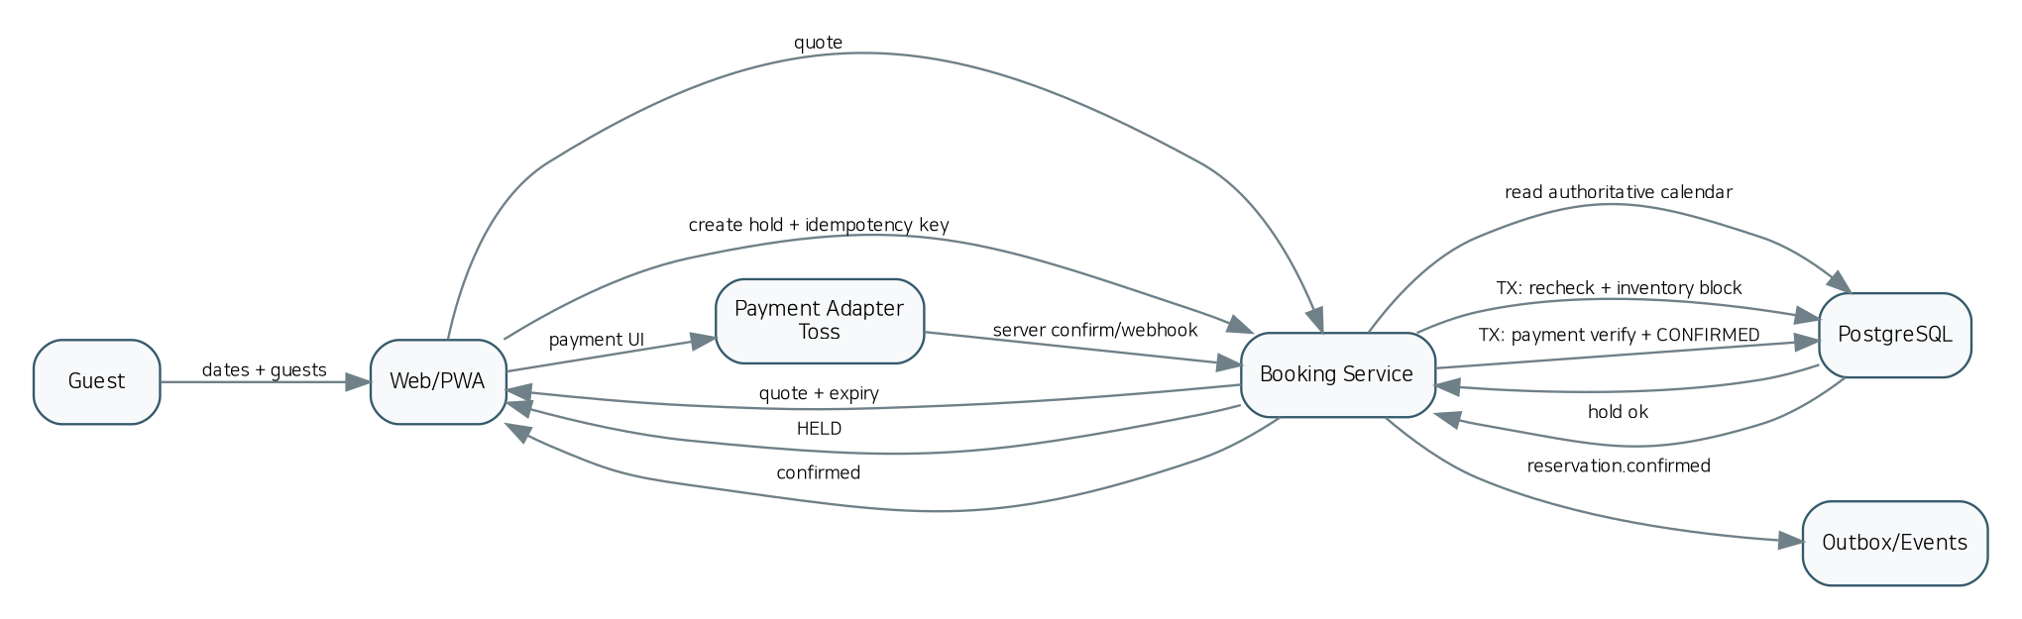
그림 3. 예약/결제 핵심 시퀀스
DRAFT → QUOTED → HELD → PAYMENT_PENDING → CONFIRMED → CHECKED_IN → COMPLETED
↘ PAYMENT_FAILED / EXPIRED
CONFIRMED → CANCELLED → REFUND_PENDING → PARTIALLY_REFUNDED | REFUNDED
COMPLETED → DISPUTED
- 동일 property와 겹치는 기간의 ACTIVE inventory block은 capacity를 초과하지 않는다.
- Hold는 TTL이 있고 만료 시 block을 해제한다. 결제 처리 중 TTL 정책은 별도 ADR로 고정한다.
- CONFIRMED 전이는 서버의 PG 승인/조회 결과, 내부 order/quote 금액, currency, subject ID가 일치할 때만 허용한다.
- 환불은 Payment 도메인에서 처리하고 Reservation은 환불 결과 이벤트를 받아 표시 상태를 갱신한다.

7.2 Home Exchange
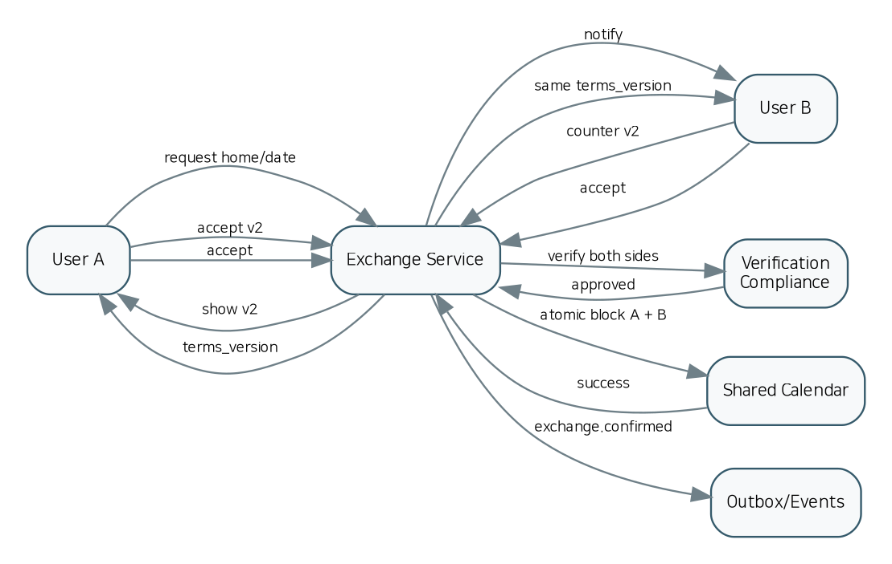
그림 4. Home Exchange 상호 합의/Calendar lock 시퀀스
REQUESTED ↔ COUNTERED → MUTUAL_ACCEPTED → VERIFICATION_PENDING → AGREEMENT_PENDING → CONFIRMED → IN_PROGRESS → COMPLETED → REVIEWED
REQUESTED/COUNTERED → DECLINED | WITHDRAWN
CONFIRMED/IN_PROGRESS → DISPUTED
- accept는 current_offer_version에 대해 낙관적 버전검사를 수행한다.
- 양측은 동일 terms_version을 수락해야 한다.
- Calendar block A/B는 한 트랜잭션/보상 가능한 saga로 처리하고 어느 한쪽만 잠긴 상태를 허용하지 않는다.

7.3 Guide Friend
REQUESTED → OFFERED/COUNTERED → ACCEPTED → [PAID: PAYMENT_PENDING → CONFIRMED] | [FREE: CONFIRMED] → IN_PROGRESS → COMPLETED → REVIEWED
각 단계에서 CANCELLED / DISPUTED 분기 가능
FRIEND/VOLUNTEER는 원칙적으로 무료 흐름, PAID/PROFESSIONAL은 가격·결제·자격/사업 검증이 필요한 흐름으로 분리한다.

7.4 Payment / Refund / Settlement
Payment: CREATED → CONFIRMING → APPROVED | FAILED | CANCELLED
Refund: REQUESTED → PROVIDER_PENDING → PARTIAL/REFUNDED | FAILED
Settlement: DRAFT → READY → APPROVAL_PENDING → APPROVED → PAYOUT_PENDING → PAID → RECONCILED | HELD

8. 데이터 모델·무결성·인덱스
본 패키지의 `JETPOOL_DB_SCHEMA_BLUEPRINT.sql`은 실제 migration 작성 전에 사용할 schema seed다. 핵심 무결성은 “응용프로그램 코드가 실수해도 DB가 위험 거래를 거부”하는 방향으로 설계한다.
Invariant | DB / Service enforcement
숙소 중복 점유 금지 | `inventory_blocks(property_id, daterange)` exclusion constraint + ACTIVE state
동일 거래 중복 호출 방지 | `idempotency_keys(scope,key)` unique + request hash
Webhook 중복 처리 방지 | provider + external_event_id 또는 payload hash unique
Exchange stale acceptance 금지 | exchange_id + offer version unique + current_offer_version compare
리뷰 중복 금지 | author + transaction + target unique
Ledger 불변성 | append-only transaction/entries; balancing validation; no update/delete in normal role
계약 증거 | agreement terms snapshot + terms_version + bilateral accepted_at
감사 가능성 | correlation_id, actor, reason, before/after on privileged mutations

8.1 데이터 분류와 보존
- Class A: 금융·감사·계약 증거 — 법적/회계 보존 정책에 따라 삭제 대신 제한·분리보관 가능하도록 설계.
- Class B: 계정 PII — 목적/동의/보존기간에 따라 암호화·접근로그·삭제 workflow.
- Class C: 공개 Marketplace 콘텐츠 — publish 상태와 moderation 기록 유지.
- Class D: 캐시/검색/추천 feature — 원천 데이터에서 재구축 가능해야 하며 권위 데이터로 사용하지 않음.

9. API / Event Contract 규약
- OpenAPI 3.1을 동기 API Source of Truth로 사용하고 generated client/type을 직접 수정하지 않는다.
- AsyncAPI 3.0을 도메인 이벤트 카탈로그로 사용한다. 이벤트에는 eventId, eventType, version, aggregateId, correlationId, causationId, occurredAt을 포함한다.
- Mutation API는 중요한 중복 위험이 있는 경우 `Idempotency-Key`를 요구한다.
- 오류는 RFC 7807 형태의 Problem object를 기본으로 사용하고 correlationId를 노출한다.
- 외부 provider webhook은 raw body 검증 요구를 고려하고 처리 결과와 원본 hash를 보존한다.
계약 파일
`JETPOOL_OPENAPI_SKELETON.yaml`과 `JETPOOL_ASYNCAPI_SKELETON.yaml`은 코드 생성용 시작점이다. 실제 구현 전에 request/response payload, enum, auth scope, examples, error codes를 모듈별 ADR과 함께 완성해야 한다.

10. UI/UX Information Architecture
영역 | 대표 Route | 사용자 가치
Public | / | Unified discovery home
Public | /stay | Stay search
Public | /stay/{slug} | Stay detail
Public | /exchange | Home Exchange discovery
Public | /guide-friends | Guide Friend discovery
Public | /travel | Tours/tickets/packages
Public | /jetpool-charter | Legacy charter/flight share
Auth | /login /signup | Authentication
Traveler | /trips | Traveler dashboard
Traveler | /messages | Messaging
Traveler | /payments | Payments/refunds
Host | /host/onboarding | Host onboarding
Host | /host/listings | Listing management
Host | /host/calendar | Calendar
Host | /host/reservations | Reservation operations
Host | /earnings | Earnings
Guide | /guide/onboarding | Guide onboarding
Guide | /guide/calendar | Guide schedule
Guide | /guide/requests | Requests/offers
Supplier | /supplier/products | Travel supplier extranet
Admin | /admin | Ops overview
Admin | /admin/compliance | Compliance workbench
Admin | /admin/disputes | Dispute workbench
Admin | /admin/payments | Payment/refund ops
Admin | /admin/settlements | Settlement ops
Admin | /admin/cms | Content/SEO
Admin | /admin/audit | Audit logs

10.1 UX 공통 원칙
- 모바일 우선 PWA이며 데스크톱에서는 지도+리스트, 운영자에서는 고밀도 업무 테이블을 사용한다.
- 한 계정이 Traveler/Host/Guide/Supplier 역할을 동시에 가질 수 있으므로 계정 분리를 강제하지 않고 역할별 Dashboard context를 제공한다.
- 각 화면은 loading / empty / error / offline / permission denied / verification required 상태를 명시한다.
- 결제·교환계약·정산계좌 변경·관리자 중요작업에는 일반 CTA와 다른 단계적 확인을 제공한다.
- 한국어/영어를 초기 언어로 설계하고 텍스트를 코드에 직접 박지 않고 locale resource로 분리한다.
- 접근성 목표는 키보드 탐색, 명확한 focus, form label/error, contrast, semantic landmark를 포함한 WCAG 2.2 AA 수준을 Release QA 기준으로 권장한다.

10.2 핵심 사용자 여정
1. Paid Stay: 검색 → 상세 → 날짜/인원 → Quote → Hold → PG → Server confirm → 예약 → 채팅 → 체크인 → 완료 → 리뷰 → 정산
2. Home Exchange: Exchange 홈 탐색 → A가 B에게 제안 → B 반대제안 → 양측 수락 → 검증 → 약정 → 양측 서명 → 두 숙소 일정 잠금 → 교환 → 상호 리뷰
3. Guide Friend: 지역/언어/관심사 검색 → 요청 → Offer/Counter → 무료/유료 분기 → 확정 → 채팅 → 활동 → 완료 → 리뷰
4. Travel Commerce: 상품/출발일 → 옵션/인원 → order → 결제 → 바우처/일정 → 취소/환불 → supplier settlement
5. Host: 신청/검증 → 숙소 작성 → 미디어 → 인허가 → publish → calendar/pricing → 예약 운영 → review/settlement
6. Guide: 유형선택/검증 → profile/availability → request/offer → booking → activity → review/settlement

11. 검색·매칭·추천 설계
도메인 | 1차 필터 | Ranking signals | 최종 확정
Stay | 지역/날짜/인원/법적 eligibility | 거리, 가격, 품질, 리뷰, 응답성, 개인화 | Booking DB에서 availability 재검증
Exchange | 교환 활성화/날짜/숙소 적합/검증 | 상호 지역 선호, household fit, amenities, trust | 양측 수락 + verification + agreement + dual block
Guide | 지역/언어/시간/유형/검증 | 관심사 match, rating, response, price, trust | Guide DB availability + offer version
Travel | 출발일/재고/공급자 status | 관련도, 가격, 인기, 일정 적합성 | Travel inventory + order calculation
AI | 사용자 intent + 위 검색 결과 | 선호/과거행동/설명가능성 | 사용자 명시 확인 후 hold/payment

12. 결제·환불·원장·정산
PG 결제와 공급자 정산을 분리한다. Payment는 provider fact를 기록하고, Ledger는 플랫폼 경제적 사실을 기록하며, Settlement는 Ledger에서 특정 payee/기간의 지급 가능 잔액을 집계한다. 예약·가이드·여행 주문은 Payment ID를 참조하지만 금융 원장을 직접 수정하지 않는다.
- 금액은 minor unit integer로 저장하고 currency를 항상 함께 저장한다.
- 결제 confirm은 order/quote 내부 금액과 provider 금액 일치 검증 후 승인한다.
- 부분 환불 누계는 승인 결제액을 초과할 수 없다.
- 정산은 gross, platform fee, refund, tax adjustment, reserve/hold, net payout을 분리 표시한다.
- 정산계좌 변경, 수동 refund, settlement approve, payout execute는 AAL2 + 감사로그 + 최소권한 정책을 적용한다.

13. 보안·개인정보·신뢰
영역 | 상용 Release Gate
Auth | Google/Kakao/Naver 전략, session rotation, account-linking hijack 방지, Admin/Accounting AAL2
Authorization | API RBAC/ABAC + DB RLS 적용 지점 정의; frontend-only 권한 금지
Payment | PAN/CVC 미저장, server confirm, webhook validation/replay protection
Uploads | presigned private upload, MIME/size, malware/moderation pipeline, ownership check
PII | 최소수집, encryption, retention, access log, export/delete workflow
Secrets | repo/log 노출 금지, secret manager, OIDC-based CI access
Supply chain | lockfile, SCA, SBOM, license scan, critical CVE block
Admin | AAL2, timeout, risk control, audited elevation, high-risk dual approval 검토
Incident | security incident runbook, evidence preservation, contact tree, postmortem

14. 사업·법규 Compliance Gate 설계
1차 백서가 제시한 한국 숙박·여행·전자상거래·개인정보 요구는 코드에 “법률을 자동 해석하는 로직”으로 넣기보다, 법률/세무 자문에서 확정된 정책을 버전 관리 가능한 rule data로 반영해야 한다. 아래 항목은 출시 전 반드시 확정되어야 하는 제품 Gate다.
Gate | 질문 | 시스템 동작
Accommodation | 이 property type/jurisdiction/guest 조건에서 유료 숙박이 가능한가? | publish 또는 paid booking enable/disable
Home Exchange | 대가성/반복성/주택형태/지역에 따른 운영 허용정책은? | exchange_legal_classification + region feature flag
Guide | 유료/전문 guide의 사업/자격/보험 조건은? | paid/pro publish and booking gate
Travel | JETPOOL이 seller인지 intermediary인지, 여행업/보증 요건은? | merchant_of_record + supplier/compliance state
Tax/Settlement | 개인/사업자/외국인 공급자별 지급·증빙·세금 정책은? | effective-dated finance rule
Charter | 전세기 공유가 content/lead인지 직접 거래인지? | JET-01 transactional flag default OFF

15. WONT/Sixshop 마이그레이션
1. Discovery inventory: URL, menu, content, products, members, orders/inquiries, media, policies, SEO metadata.
2. Official export: 가능한 공식 Export/API 우선. 비밀번호/결제민감정보를 임의 scraping하지 않는다.
3. Canonicalization: legacy ID → UUID map, email/phone normalization, duplicate rules.
4. Account transition: hash 호환 불명 시 secure password reset/invite flow.
5. Media import: original fetch → object storage → checksum → transformed assets → CDN URLs.
6. SEO: 301 map, canonical, structured data, sitemap, important inbound URLs.
7. Dry run: row count, unique identities, amount totals, media broken links, consent evidence, redirect coverage reconciliation.
8. Cutover: write freeze → final delta → DB backup → DNS/CDN switch → smoke → rollback window.
9. Post-cutover: auth/payment/404/error monitoring and migration audit report.

16. 인프라·배포·DR
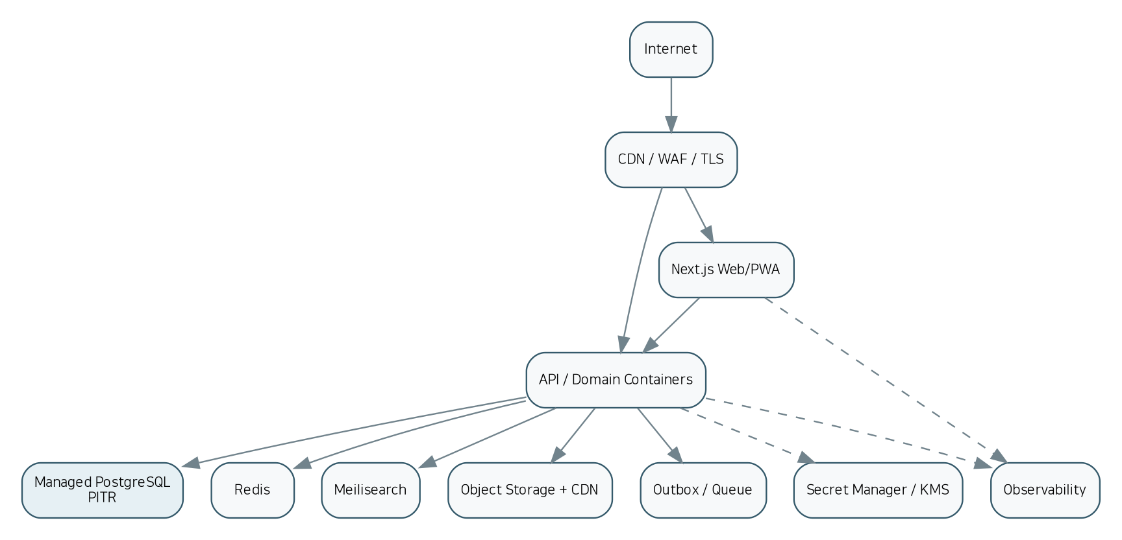
그림 5. MVP/성장 공통 배포 토폴로지
영역 | MVP | 성장 이후
App | Managed containers/serverless + Docker | Independent autoscaling; Kubernetes when justified
DB | Managed PostgreSQL + PITR | HA/read replica/partitioning as needed
Cache | Redis | Redis HA/cluster
Search | Dedicated Meilisearch + snapshot | HA/replicated search
Queue | Transactional Outbox + PostgreSQL/Supabase queue | NATS/Kafka/managed queue when volume requires
Storage | S3-compatible + CDN + versioning | Cross-region replication where RPO requires
Observability | logs/errors/uptime + OTel | centralized traces/metrics/logs, SLO burn alerts
IaC | Terraform + GitHub Actions | Terraform + Helm/GitOps

16.1 SLO / RPO / RTO 초기 기준
항목 | 목표
Search API | p95 < 500 ms (load test로 확정)
General read API | p95 < 300 ms
Booking write | p95 < 1 s, 외부 PG 시간 제외
API availability | 월 99.9%+ 초기 SLO
Reservation/Payment RPO | 5–15분 이하 권고
Reservation/Payment RTO | 1시간 이하 권고
Ledger/Settlement | PITR + immutable export; RPO 5분 이하 권고
Quarterly DR | 실제 restore + checksum/reconciliation 필수

17. 테스트 전략과 상용 완료 기준
Test layer | Required coverage
Unit | price/fee/cancellation policy, role policy, pure FSM transitions
Property-based | invalid state transitions, monetary invariants, quote determinism
DB integration | transaction, RLS, overlap exclusion, idempotency
Contract | OpenAPI provider/consumer, AsyncAPI schema compatibility
Payment | sandbox approve/cancel/partial refund/webhook replay/reconciliation
Search | Postgres→Meili projection lag/rebuild and authoritative recheck
Realtime | conversation membership/RLS unauthorized subscription denial
E2E Stay | signup→listing→search→hold→pay→confirm→cancel/refund
E2E Exchange | two browsers: request→counter→accept→verify→terms→dual block
E2E Guide | search→request→offer→free/paid confirm→complete
Concurrency | dozens/hundreds of overlapping hold attempts; no oversell
Load | search/availability/checkout profiles; queue and DB saturation
Security | SAST/SCA/secret scan/DAST/permission-negative/AAL2
DR | restore backup and reconcile critical totals
Migration | legacy/new counts, amount totals, media, URLs, consent evidence

상용 MVP Done
“화면이 있다”가 아니라 Paid Stay, Home Exchange, Guide Friend의 end-to-end 거래가 각각 감사로그·알림·분쟁 경로를 포함해 끝까지 실행되고, 유료 흐름은 Payment→Ledger→Settlement까지 대사되는 상태가 기준이다.

18. 원클릭 AI 개발 오케스트레이션
그림 6. Spec-driven AI build pipeline
./scripts/bootstrap.sh
./scripts/validate-spec.sh
./scripts/generate-contracts.sh
./scripts/db-migrate.sh --env dev
./scripts/generate-services.sh
./scripts/generate-web.sh
./scripts/generate-tests.sh
./scripts/deploy.sh staging
./scripts/run-gates.sh G0..G8
# 사람이 G9/G10 승인 후
./scripts/deploy.sh production --immutable-sha <SHA>

18.1 AI 작업 분할
Agent | 전담 산출물 | 금지
Contracts | OpenAPI/AsyncAPI/JSON Schema/enums | 도메인 로직 임의 작성
Data | migrations/constraints/indexes/RLS | UI/API 변경
Booking | availability/quote/hold/reservation FSM | Exchange 상태 재사용
Exchange | request/counter/agreement/dual calendar lock | Reservation 테이블에 흡수
Guide | profile/match/request/offer/booking | 무료/유료 경로 혼합
Finance | payment/refund/ledger/settlement | client payment success 신뢰
Web | public/traveler/host/guide/supplier UX | server auth 대체
Admin | ops/compliance/dispute/accounting/audit | 무감사 메시지 열람
Platform | IaC/CI/observability/security/outbox | business state 직접 수정
QA | contract/E2E/concurrency/security/DR/migration | 실패 테스트 무시

18.2 AI가 반드시 중단하고 결정을 요청할 조건
- 법률/세무/merchant_of_record 정책이 없는데 결제/정산 코드를 확정해야 하는 경우
- Home Exchange의 지역별 허용 여부를 추정해야 하는 경우
- PAID/PROFESSIONAL guide 자격요건을 추정해야 하는 경우
- 전세기 직접 거래를 켜야 하는 경우
- legacy 비밀번호/민감 결제데이터를 비공식 방식으로 이관해야 하는 경우
- Production secret/approval 없이 배포하라는 지시가 들어오는 경우

19. Release Gates
Gate | 이름 | 핵심 통과 조건
G0 | Spec integrity | All P0 modules have owner, API, data, event, UI and acceptance criteria / No unresolved contract references
G1 | Contracts | OpenAPI/AsyncAPI lint pass / Generated client/types compile / Breaking changes explicitly versioned
G2 | Data | Migrations up/down or forward-fix tested / Constraints/invariants enabled / Seed data deterministic
G3 | Domain | Unit/property/integration tests pass / State transition negative tests pass / Idempotency tests pass
G4 | End-to-end | Stay paid flow passes / Exchange bilateral flow passes / Guide free/paid flow passes / Travel order flow passes where enabled
G5 | Security | SAST/SCA/secret scan pass / Permission-negative tests pass / AAL2 gates pass / No PAN/CVC storage
G6 | Performance | Search/read/write SLO targets meet load-test plan / No oversell under concurrency test
G7 | Migration | Dry-run reconciliation approved / 301 URL map approved / Consent/password migration strategy approved
G8 | DR & Ops | Restore drill successful / Runbooks and alert routes tested / Payment reconciliation tested
G9 | Legal/Business approval | Accommodation/guide/travel/charter gates signed off / Merchant-of-record and settlement policy approved / Terms/privacy/refund policies published
G10 | Production approval | Immutable release artifact / GitHub Environment manual approval / Canary + smoke + rollback readiness

20. 개발 로드맵 — 18~20주 병렬 MVP 기준
Sprint | 기간 | 주요 결과
0 Discovery | 2주 | legacy inventory/export 조사, ADR, legal decision register, UX IA, spec freeze
1 Foundation | 2주 | 8 repos, CI, dev/staging, auth/RBAC/AAL2, contracts pipeline
2 Marketplace | 2주 | property/media/host/compliance, public detail
3 Discovery | 2주 | Meilisearch/MapLibre, filters, calendar read model
4 Booking | 2주 | quote/hold/FSM/concurrency/cancellation
5 Payment & Finance | 2주 | Toss confirm/webhook/refund, ledger seed
6 Exchange | 2주 | request/counter/verification/agreement/dual block
7 Guide | 2주 | types/profile/search/request/offer/free-paid booking
8 Travel/Ops | 2주 | travel products/itinerary/admin/CMS/notifications/support/reviews
9 Hardening/Launch | 2주 | migration rehearsal, security/load/E2E, settlement, DR, UAT, legal/business release gates

21. 운영 KPI / Observability 대시보드
대시보드 | 지표
Marketplace | search success, zero-result rate, detail→quote, map interactions
Booking | quote→hold, hold collision, hold expiry, payment approval, confirmation latency, cancellation
Exchange | request→counter, mutual accept, verification drop-off, agreement completion, dispute
Guide | search→request, offer response, paid/free split, completion, review
Finance | GMV, take rate, refund rate, unreconciled payments, settlement aging, payout failure
Trust | verification backlog, report rate, dispute resolution time, sanctions
Platform | API p95/error, DB saturation, queue lag, outbox lag, Meili sync lag, realtime error, storage failures
Migration | 404 rate, login reset completion, legacy/new reconciliation deltas

22. 2차 산출물 목록과 사용법
파일 | 용도
JETPOOL_2차_상용화_모듈_아키텍처_기술백서.docx | 사람/개발사/RFP용 통합 설명·설계 문서
JETPOOL_AI_ONECLICK_BUILD_SPEC.md | AI 코딩 에이전트가 읽는 실행 규칙
AGENTS_MASTER.md | 모든 repo에 공통 적용하는 불변식/금지사항
JETPOOL_MASTER_BUILD_SPEC.yaml | 모듈/의존성/API/data/event/UI/acceptance의 machine-readable master
JETPOOL_MODULE_TRACEABILITY.csv | 기능 누락 검산용 traceability matrix
JETPOOL_UI_ROUTE_MAP.csv | 화면/역할/필수 콘텐츠 IA
JETPOOL_OPENAPI_SKELETON.yaml | API contract seed
JETPOOL_ASYNCAPI_SKELETON.yaml | domain event contract seed
JETPOOL_DB_SCHEMA_BLUEPRINT.sql | PostgreSQL migration seed
JETPOOL_RELEASE_GATES.yaml | 상용 출시 gate 자동화 입력
diagrams/*.svg + *.dot | 편집 가능한 vector 아키텍처 구조도

부록 A. 1차 문서 보존 원칙
- 기존 WONT 콘텐츠/회원/미디어/SEO URL/운영 데이터를 공식 경로로 추출하여 리플랫폼한다.
- Airbnb clone/QloApps/Medusa 등 외부 코드는 전체 병합하지 않고 UI/업무규칙/commerce primitive를 선택적으로 참조한다.
- Booking, Exchange, Guide, Compliance, Settlement의 핵심 IP/업무규칙은 JETPOOL 자체 도메인으로 유지한다.
- 검색·Realtime·캐시보다 PostgreSQL 거래 데이터가 우선한다.
- 법률/세무 미확정 영역은 임의 결론이 아니라 configurable Gate로 남긴다.

부록 B. 상용화 직전 체크리스트
☐ P0 module traceability 100%
☐ OpenAPI/AsyncAPI lint 0 errors
☐ DB migrations clean on empty + previous staging snapshot
☐ all auth/permission negative tests pass
☐ concurrency test: no oversell
☐ payment webhook replay safe
☐ refund cumulative amount bounded
☐ ledger balanced and immutable
☐ exchange dual calendar lock atomic
☐ guide paid/free route separation
☐ compliance blocks unverified paid supply
☐ message privacy/elevated access audit
☐ PII retention/export/delete workflow
☐ SAST/SCA/SBOM/secret/DAST pass
☐ backup restore drill passed
☐ legacy migration reconciliation signed
☐ SEO redirect coverage approved
☐ support/dispute runbooks tested
☐ monitoring/alerts on-call routing tested
☐ terms/privacy/refund/cancellation policy published
☐ legal/tax/merchant-of-record decisions signed
☐ production environment approval enabled
☐ canary + rollback procedure tested

부록 C. 출처 및 변경 구분
본 v2의 베이스는 사용자가 첨부한 「제트풀 상용 플랫폼 마이그레이션·리모델링 기술 백서 초안」이다. 해당 문서가 정의한 목표, 도메인 분리, 핵심 스택, 상태머신, 마이그레이션, 보안, 한국 규제 Gate, 테스트, 8-repository 방향과 원클릭 AI 원칙을 유지했다. v2에서 추가된 내용은 기능 추적성, UI route inventory, machine-readable build spec, API/Event/DB seed, 추가 상태머신, Release Gate, AI agent 역할 분할 및 운영 KPI다. 외부 법률·서비스 버전은 본 작업에서 재검증하지 않았으므로 실제 출시 직전 최신 공식 자료로 재확인해야 한다.

