**Name:** Sood, Dhruv **Date:** 12th February ‘2024

**NYU ID:** N14488523

**Course Section Number:** csgi-ga.2662-001

**Lab #2 – Application Layer**

**Total in points (100 points total):**

**Professor’s comments:**

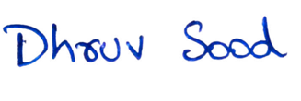

**I completed my assignment independently, showcasing my self-reliance and dedication to the task**

**Ques 1.**

**(a) Use a packet sniffer (e.g., Wireshark) to capture the sequence of ASCII characters that are sent and received by a web browser as a result of a request of your choice to a web server. Provide a screen capture of these sequences and add carriage return and line feed characters as needed to improve readability.**

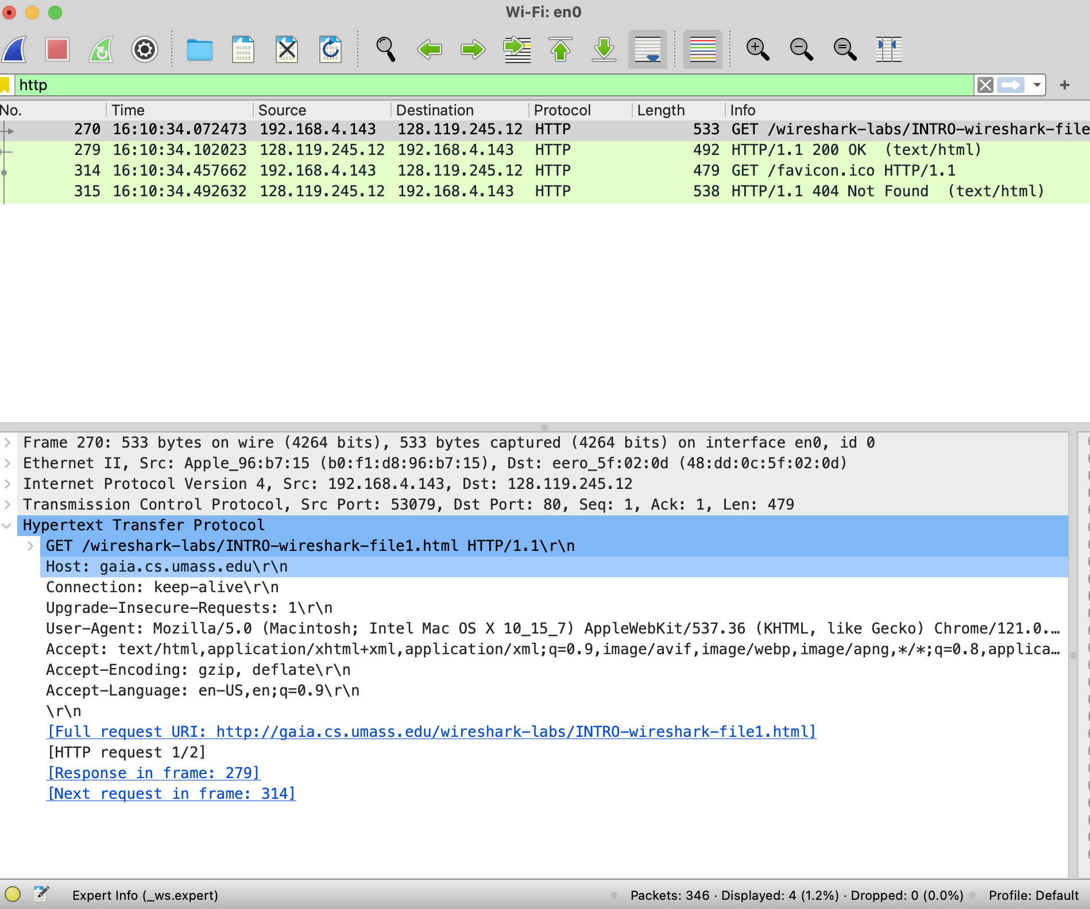

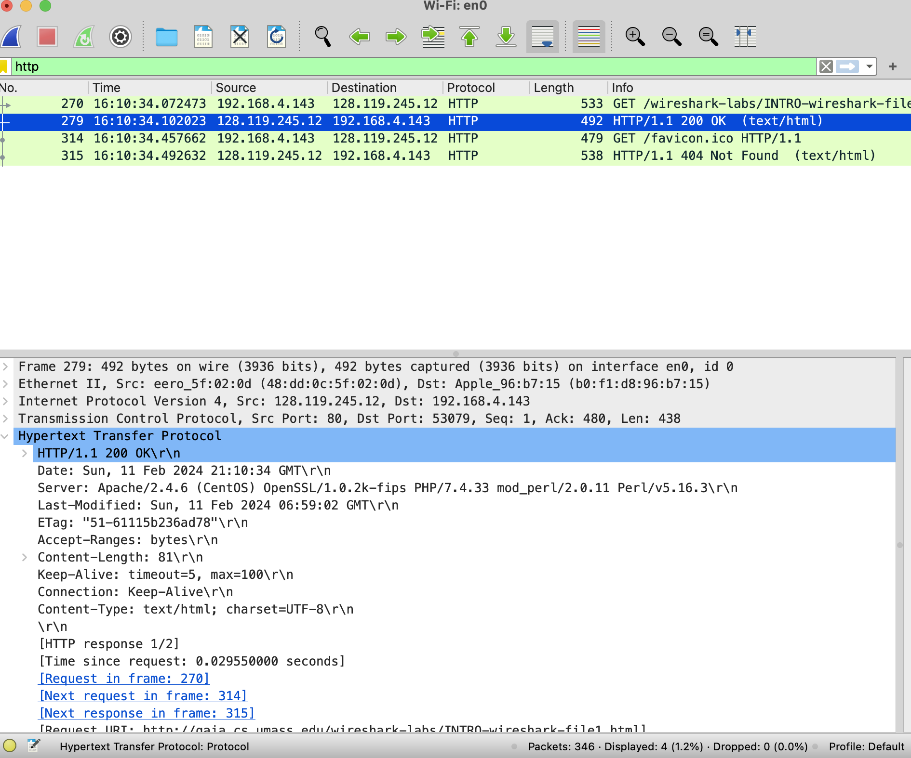

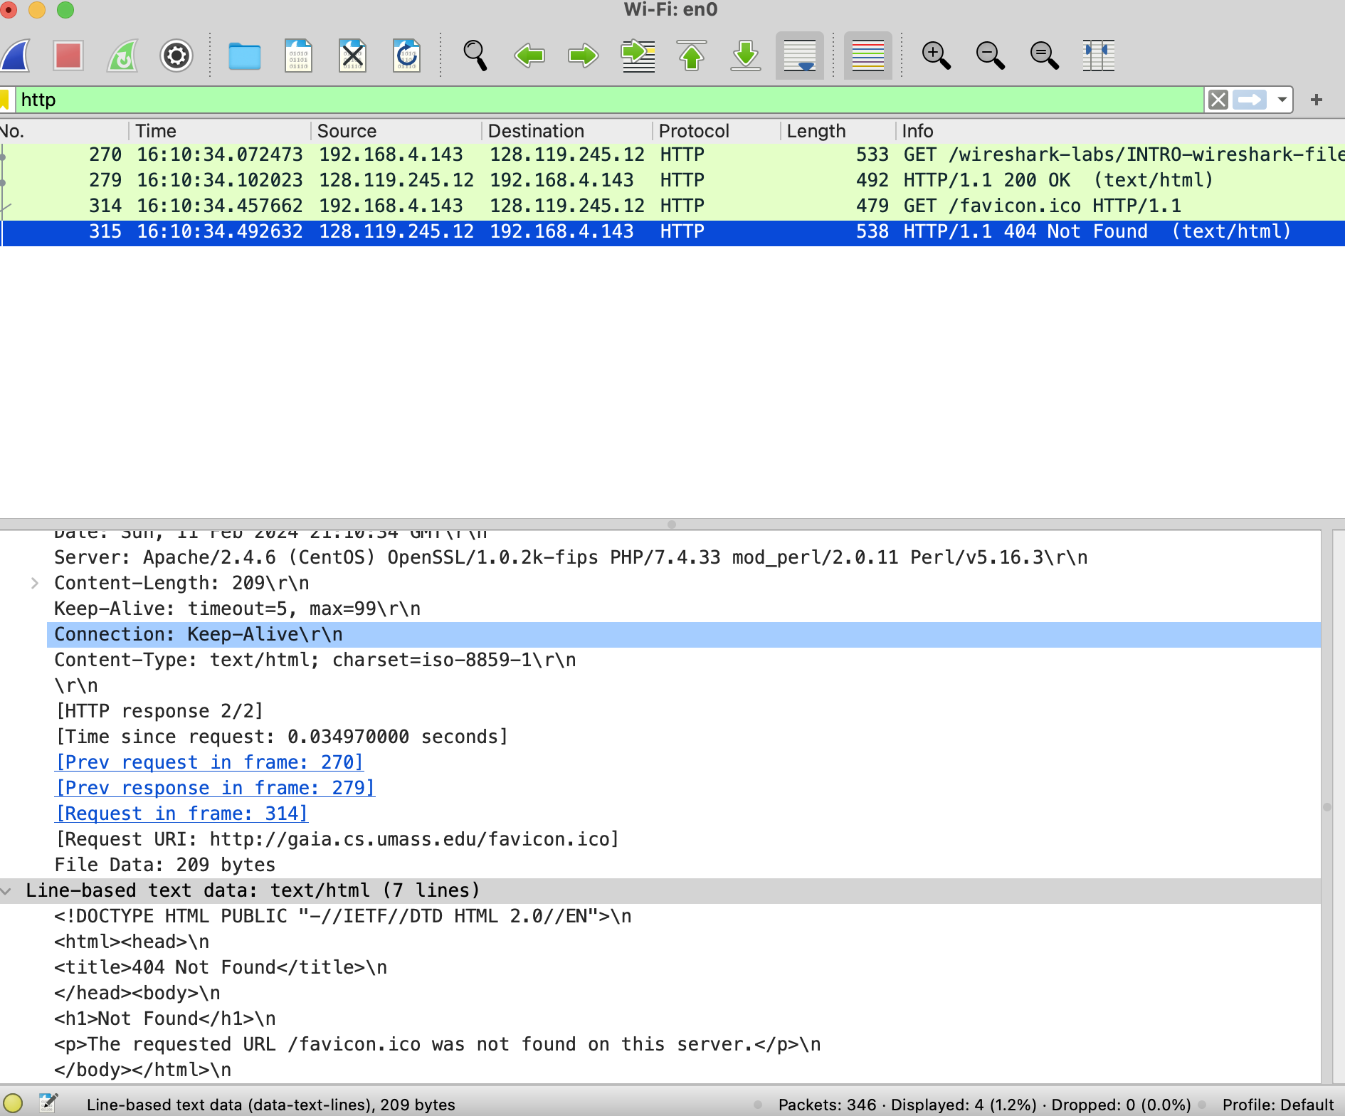

**b)**

The requested URL was favicon.ico

Response Protocol Version: HTTP/1.1

The kind of web server that answered the question was Apache.

**c)** Yes, the “keep alive” status indicates that the connection was persistent.

**d)** The browser that sent the request was "Mozilla/5.0 (Windows NT 10.0; Win64; x64) AppleWebKit/537.36 (KHTML, like Gecko) Chrome/116.0.0.0 Safari/537.36."

**e)** The provided HTTP request received a successful response with an HTTP status code of "200 OK” as indicated here “HTTP/1.1 200 OK\r\n”

**Question 2.**

**a)**

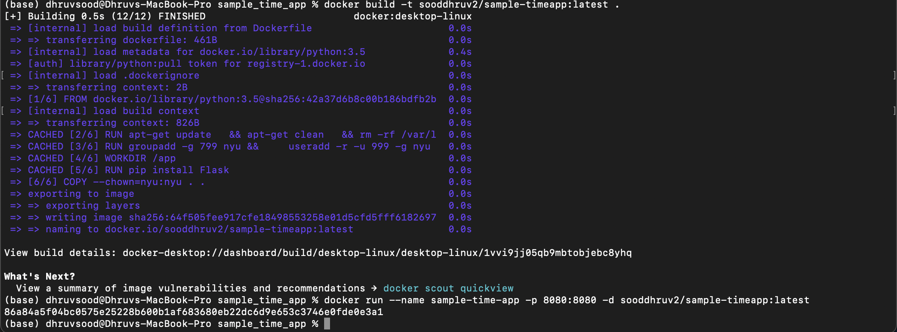

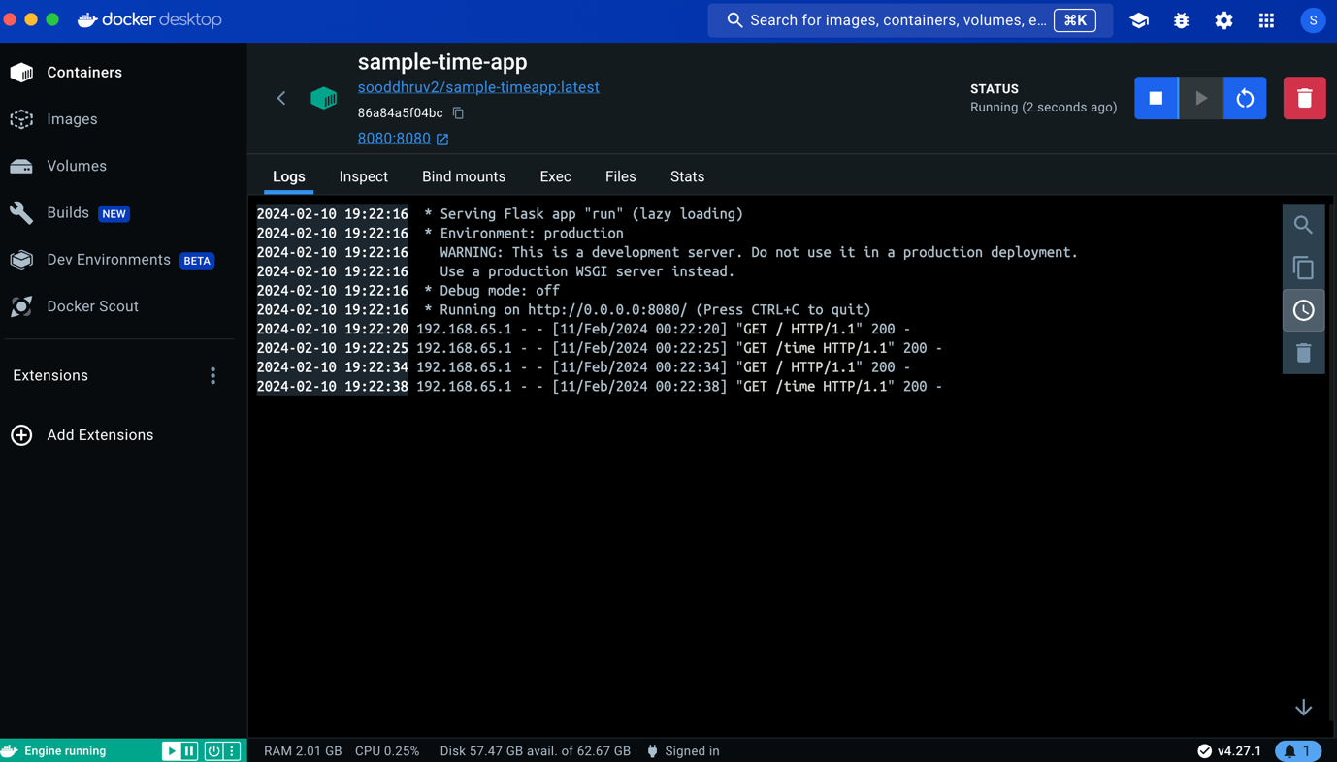

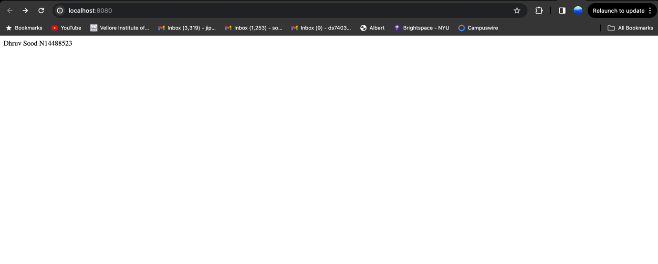

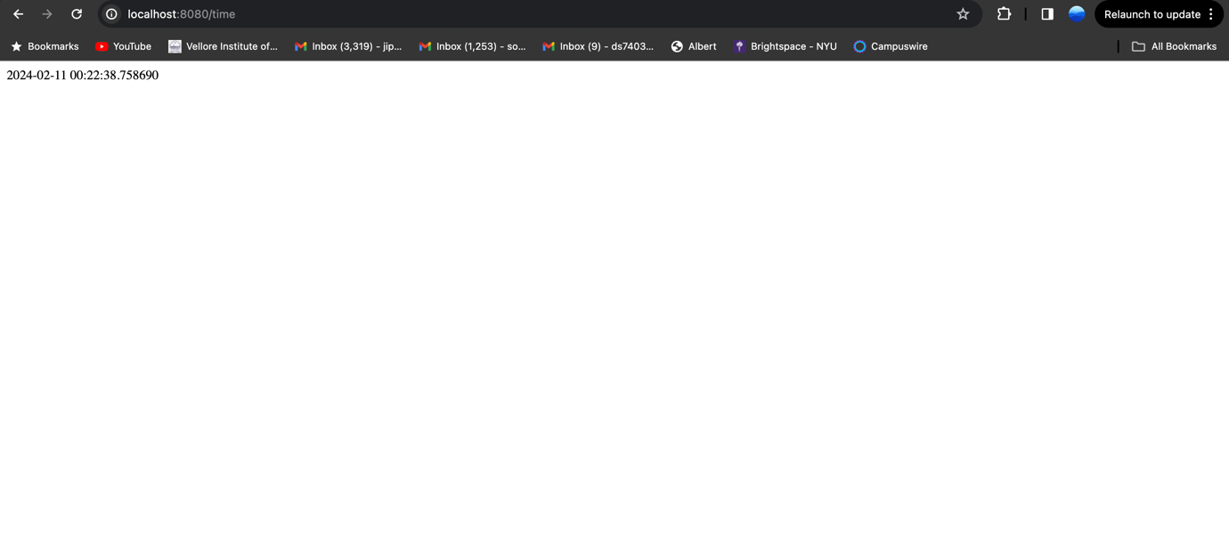

**b)**

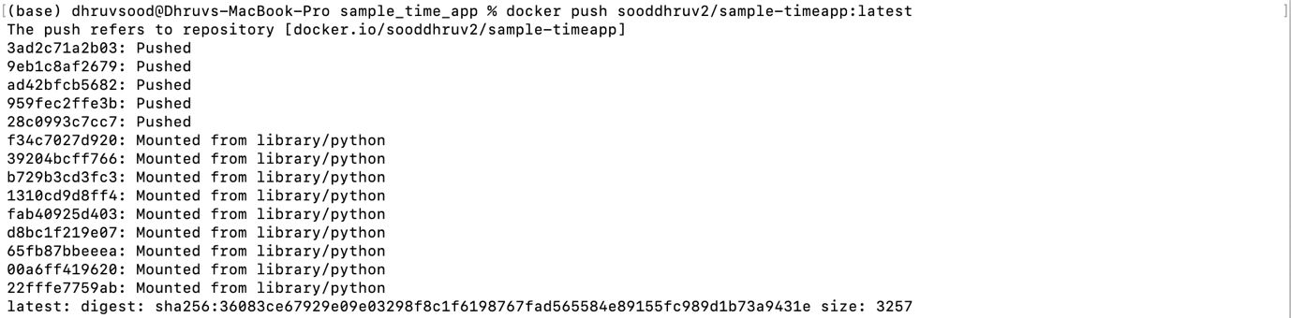

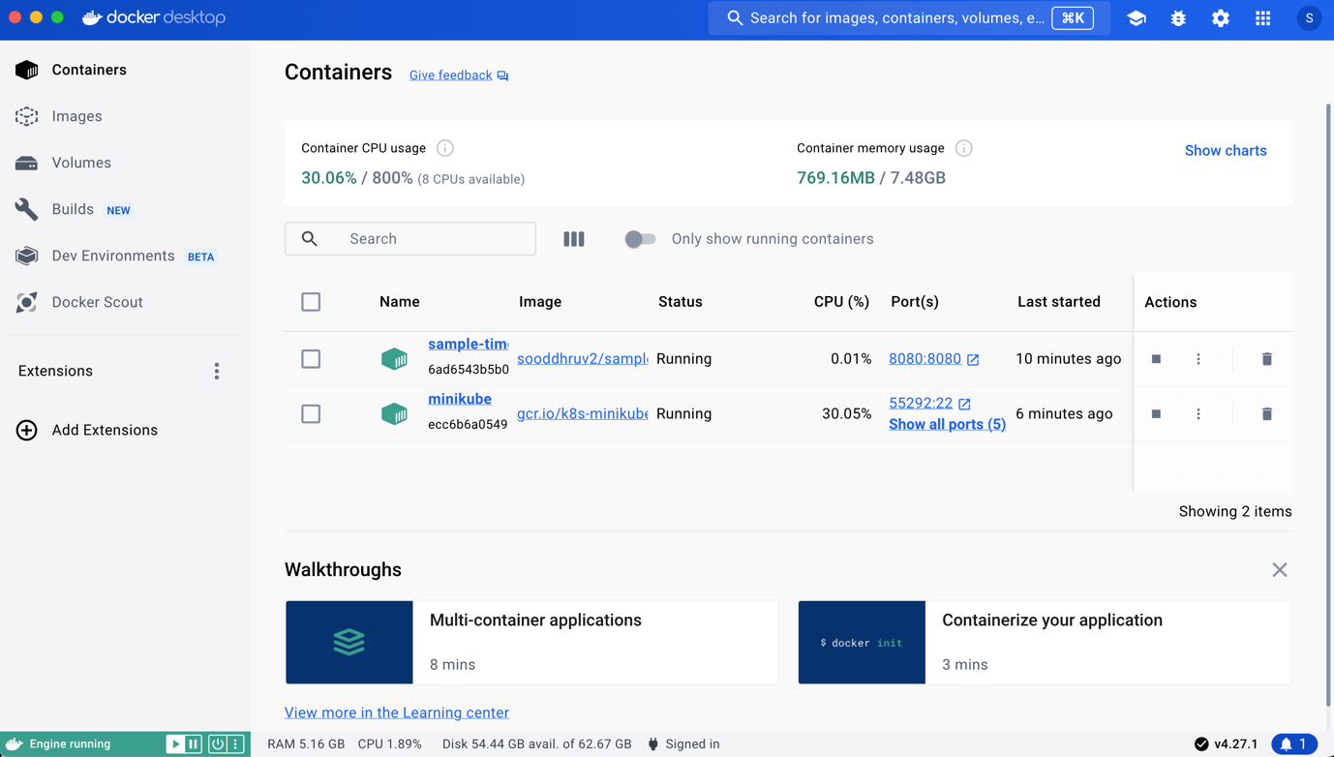

**c)**

