Table of Contents

Appendix A: DOP Surveys 4
Pretest Baseline Survey: Deliberative Online Poll 4
Pretest Follow-up Survey: Deliberative Online Poll 16
Wave 1 Baseline Survey: Deliberative Online Poll 28
Wave 1 Follow-up Survey: Deliberative Online Poll 52
Wave 2 Baseline and Follow-up Survey: Deliberative Online Poll 71
Wave 3 Baseline and Followup Survey: Deliberative Online Poll 104
Wave 4 Baseline and Follow-up Survey: Deliberative Online Poll 120
2004 CDROM Survey: Deliberative Online Poll 139
Appendix C: Codebook 150
Pretest Experimental Group – Baseline Survey 150
Pretest Experimental Group – Follow-up Survey Codebook 170
Pretest Control Group – Baseline Survey 198
Pretest Control Group – Follow-up Survey 218
General Dataset Variables (dopall_final_wsummer_tracking_data.sav) 247
Wave 1 Baseline/Follow-up/Brief Survey Follow-up Codebook 254
Wave 2 Baseline/Follow-up Survey Codebook 404
Wave 3 Baseline/Follow-up Survey Codebook 595
Wave 3 Baseline/Follow-up Survey Codebook 595
Wave 4 Baseline/Follow-up Survey/CD Tracking Information Codebook 708
Wave 4 Baseline/Follow-up Survey/CD Tracking Information Codebook 708
Wave 4 CDROM Tracking File Information from Stanford 831
Summer CDROM Follow-up Survey 894
Summer 2004 CDROM Tracking File Information from Stanford 923
Standard Demographics 981

Appendix A: DOP Surveys

Pretest Baseline Survey: Deliberative Online Poll
Experimental and Control (differences noted)

[Control]
INTROC
You have been selected to participate in a two-part study on important national issues.
You will receive $10 for completing this survey, which is the first part of the two-part study. We will send you the second part of the study at the end of November if you complete this survey. You will also receive $10 for completing the second survey. We appreciation your participation in this research.

[Experimental]
INTRO1
Stanford University is conducting an exciting new research project where people like you “chat” online about issues that concern you and all Americans. You have been selected for this new and novel approach for bringing Americans together to talk about current political issues. For the next five weeks, you will be asked to participate in this innovate project called the Online Deliberative Poll. During this time, you will not be sent any other surveys by Knowledge Networks. Because the chat sessions take longer than most surveys, you will be given up to $100 for your time for participating in this study. In addition, we will give you a multimedia headset for your computer!

[Experimental]

INTRO2
We hope that you find participating in this new project interesting and stimulating. It will be unlike anything you have ever done as a Knowledge Networks panel member. You will use your own home computer connected to the Internet for this study, and you will use a multimedia headset (which you get to keep) so that you can “chat” using your real voice and also hear what other poll participants are saying. A moderator from Stanford University will guide the conversation. You will be receiving or will have already received materials in the mail that describe how to participate in this study.

[Experimental]
INTRO3
Before joining in for the first online “chat,” please answer the survey questions that follow below. The survey, which asks you to select the time most convenient for you for online chats, needs to be completed before the first online chat session. This survey also asks about your opinion about important issues that are in the news. You will be given $10 for participating in this first survey.

[Experimental]
[use samvar xtime to display correct time zone 1=EST, 2=CST, 3=MST, 4=PST,
the response list below is in PST ]
[Prompt if NA]
[Radio Button]
S1. Now we would like you to tell us when will be a good time for you to participate in the online chat. The first three chat sessions will last one hour, and the last one will last 30 minutes. We’d like you to pick a time that is convenient for you for the next three weeks starting on Wednesday October 30. Please select the best time for you. Example: If you selected Wednesday October 30, then your online chat session schedule will be for these Wednesdays: October 30, November 6, November 13, and November 20, all starting at the same time. Please note, all times are listed in your local time zone, [enter time zone, EST, CST, MST, PST].

Wednesdays 6-7pm (10/30, 11/6, 11/13, 11/20)
Sundays 5-6pm (11/3, 11/10, 11/17, 11/24)
Sundays 7-8pm (11/3, 11/10, 11/17, 11/24)
Tuesday 6:30-7:30pm (10/29, 11/5, 11/12, 11/19)

[Experimental]
[Prompt if NA]
[Radio Button]
[REMOVE THE OPTION THAT WAS SELECTED ABOVE]
S2. Please select your second favorite time.

Wednesdays 6-7pm (10/30, 11/6, 11/13, 11/20)
Sundays 5-6pm (11/3, 11/10, 11/17, 11/24)
Sundays 7-8pm (11/3, 11/10, 11/17, 11/24)
Tuesday 6:30-7:30pm (10/29, 11/5, 11/12, 11/19)

[Experimental]
INTRO4
Thanks for letting us know which times work best for you. We will send you an email that will let you know when to join in the online chat sessions. Please refer to the materials we sent you in the mail for more information about how to participate!

[Experimental]
INTRO5
Now we have some questions about your opinions about issues that are in the news.

[Radio Button]
Q1. These opening questions are about international affairs and U.S. foreign policy in general. First, thinking back to the terrorist attacks of Sept. 11th, 2001, how would you say America has changed as a result?

Changed a lot for the better 1
Changed a little for the better 2
Changed a little for the worse 3
Changed a lot for the worse, or 4
Not much change in either direction 5
Can’t say 6

Grid Answer
[Grid: Radio Buttons Across/Down]
Q2. The list below includes several possible long-range foreign policy goals. On a scale from 0 to 6, where 0 is no priority at all, 3 is average priority, and 6 is the top priority, how high a priority do you think the U.S. should give to:

LOW HIGH Can’t say

0 1 2 3 4 5 6
Protecting the global environment?
Ensuring adequate energy supplies
Promoting democracy in other
countries
Preventing the spread of weapons
of mass destruction
Fighting terrorism
Providing food & medical help
to poor countries
Protecting human rights in
other countries
Protecting weaker nations against
foreign aggression
Reducing world poverty
[introq3]
For each of the following statements, please indicate whether you agree, disagree, are in between, or you haven't thought much about it.

[Radio Button]
Q3. This country would be better off if we just stayed home and did not concern ourselves with problems in other areas of the world.

Agree strongly 1
Agree 2
Somewhere in between 3
Disagree 4
Disagree strongly 5
Haven’t thought much about it/can’t say 6

[Radio Button]
Q4. It is the job of the U.S. as a global leader to protect the world from countries that are likely to use weapons of mass destruction.

Agree strongly 1
Agree 2
Somewhere in between 3
Disagree 4
Disagree strongly 5
Haven’t thought much about it/can’t say 6

[Radio Button]
Q5. It is the responsibility of the U.S. as a global leader to protect the world from countries that are likely to assist terrorists.

Agree strongly 1
Agree 2
Somewhere in between 3
Disagree 4
Disagree strongly 5
Haven’t thought much about it/can’t say 6

[Radio Button]
Q6. The U.S. should intervene to protect the world from countries that are likely to use weapons of mass destruction only if we have support from our key allies or the United Nations.

Agree strongly 1
Agree 2
Somewhere in between 3
Disagree 4
Disagree strongly 5
Haven’t thought much about it/can’t say 6

[introq7]
If the U.S. succeeds in changing a government like Iraq's by military intervention, how important is it that we work to do each of the following.

[Radio Button]
Q7. Rebuild the Country's economy -

Very important 1
Somewhat important 2
Not very important 3
Not important at all 4
Haven't thought much about this 5

[Radio Button]
Q8. Make the new government friendly to U.S. interests –

Very important 1
Somewhat important 2
Not very important 3
Not important at all 4
Haven't thought much about this 5

[Radio Button]
Q9. Make the new government democratic -

Very important 1
Somewhat important 2
Not very important 3
Not important at all 4
Haven't thought much about this 5

[Radio Button]
Q10. Involve international organizations like the United Nations in accomplishing these goals -

Very important 1
Somewhat important 2
Not very important 3
Not important at all 4
Haven't thought much about this 5

[Radio Button]
Q11. How serious a threat is global warming to the quality of life in the U.S.?

Very serious 1
Somewhat serious 2
Not too serious 3
Not serious at all 4
Can’t say/don’t know 5

[Radio Button]
Q12. Which of the following is closest to what you believe is true about global warming:

It is caused mostly by human activities, like driving cars and burning fuel 1
It is caused mostly by natural changes in the climate 2
It is not occurring at all 3
Haven't thought much about this 4

Multiple Number Box Answer
[Number Box]
Range 0 – 10
Displaya 11 point scale, with labels over 0 and 10 (Not a Problem vs A Serious Problem)
Q13. Some people think that global warming is not really a problem so there is no need to do anything about it. Others think it's a serious problem and we need to act now. On a scale from 0 to 10, where 0 is doing nothing, 10 is acting now and 5 is midway between.

Where would you place yourself? ___

Where would you put the Democratic Party? ___

Where would you put the Republican Party? ___

[Radio Button]
Q14. As far as you know, does President Bush support or oppose new international agreements to control greenhouse gases, or haven't you heard much about this?

Bush supports international agreements 1
Bush opposes international agreements 2
Haven't thought much about this 3

[Radio Button]
Q15. How serious a problem would you say world hunger is?

Very serious 1
Somewhat serious 2
Not too serious 3
Not serious at all 4
Haven’t thought much about it 5

[Radio Button]
Q16. Here are two statements. Which one you agree with more strongly, or do you agree with them about equally

(1) "As a global leader, the U.S. has a responsibility to spend more money to help fight world hunger in developing countries."

(2) "The U.S. should address problems at home first rather than spending more money to deal with world hunger in developing countries."

Agree with (1) more than (2) 1
Agree with (2) more than (1) 2
Agree with (1) and (2) equally 3
Can’t say 4

[Radio Button]
Q17. How about this pair of statements? Which do you agree with more strongly, or do you agree with them about equally

(1) "As a global leader, the U.S. has a responsibility to spend more money to help fight the AIDS epidemic in developing countries."

(2) "The U.S. should address problems at home first rather than spending more money to deal with the AIDS epidemic in developing countries."

Agree with (1) more than (2) 1
Agree with (2) more than (1) 2
Agree with (1) and (2) equally 3
Can’t say 4

Multiple Number Box Answer
[Number Box]
Range 0 – 10
[Display a 11 point scale, with labels over 0 and 10 (No importance at all vs most importance)]
Q18. Now we’d like to talk about promoting democracy outside the U.S as a goal of U.S. foreign policy. On a scale from 0 to 10, where 0 is no importance at all, 5 is average importance, and 10 is the most importance, how much importance should the U.S. place on each of the following as ways of promoting democracy in other countries.

Help with building democratic institutions___
Increasing trade___
Foreign Aid___
Provide troops to help keep the peace___
Increase support for organizations like the Peace
Corps that send Americans abroad to help other
countries___

[Radio Button]
Q19. Do you think the amount of money the U.S. is now devoting to foreign aid should be increased, reduced, or kept about the same?

Increased 1
Reduced 2
Kept about the same 3
Can’t say 3

[Radio Button]
Q20. As far as you know, does President Bush want to increase foreign aid, decrease foreign aid, or keep it the same, or haven't you heard anything about this?

Wants to increase aid 1
Wants to decrease aid 2
Wants to keep it at the same level 3
Can’t say 4

Multiple Number Box Answer
[Number Box]
Range 0 – 10
[Display a 11 point scale, with labels over 0 and 10 (Not important at all vs most important)]
Q21. Here are some ways the US might reduce the problem of terrorism. On a scale from 0 to 10, where 0 is not important at all, 10 is the most important and 5 is midway between, how much importance should the U.S. place on each of the following:

Encouraging democracy in Middle East countries like Egypt & Saudi Arabia___
Increasing foreign aid to countries that may be breeding grounds for terrorism___
Adopting policies more favorable to the Palestinians___
Working with other countries to identify & combat terrorism___
Strengthening our intelligence capabilities___

[Radio Button]
Q22. Here are some questions about the US federal budget. Out of every $100 in the federal budget, about how many dollars go to MILITARY SPENDING?

1 dollar 1
5 dollars 2
10 dollars 3
20 dollars 4
30 dollars 5
Don't have much idea about that 6

[Radio Button]
Q23. Out of every $100 in the federal budget, about how many dollars go to FOREIGN AID?

1 dollar 1
5 dollars 2
10 dollars 3
20 dollars 4
30 dollars 5
Don't have much idea about that 6

[Radio Button]
Q24. Please indicate whether you think the following statements are true or false.

"The U.S. has a veto on World Trade Organization decisions."

True 1
False 2
Don’t Know 3

[Radio Button]
Q25. "The U.S. has a veto on the United Nations Security Council."

True 1
False 2
Don’t Know 3

[Radio Button]
Q26. For each of the following statements, please indicate whether you agree or disagree.

"I consider myself a typical American."

Agree strongly 1
Agree 2
In-between 3
Disagree 4
Disagree strongly 5
Can’t say 6

"If someone said something bad about the American people, I’d feel almost as if they said something bad about me."

Agree strongly 1
Agree 2
In-between 3
Disagree 4
Disagree strongly 5
Can’t say 6

[Radio Button]
Q26. In general, do you think of yourself as:

Extremely liberal 1
Liberal 2
Slightly liberal 3
Moderate, middle of the road 4
Slightly conservative 5
Conservative 6
Extremely conservative 7

[Radio Button]
Q27. Where would you put the Democrats?

Extremely liberal 1
Liberal 2
Slightly liberal 3
Moderate, middle of the road 4
Slightly conservative 5
Conservative 6
Extremely conservative 7
[Radio Button]
Q28. Where would you put the Republicans?

Extremely liberal 1
Liberal 2
Slightly liberal 3
Moderate, middle of the road 4
Slightly conservative 5
Conservative 6
Extremely conservative 7

[INTROQ29]
Next we have a few questions about news you might watch or read.

[Radio Button]
Q29. In the last 7 days, how many days did you watch the news on TV?

1-2 days 1
3-4 days 2
Almost every day 3

[Radio Button]
Q30. In the last 7 days, how much attention did you pay to news TV about foreign affairs?

A great deal 1
Quite a bit 2
Some 3
Very little 4
None 5

[Radio Button]
Q31. In the last 7 days, how many days did you read a daily newspaper?

1-2 days 1
3-4 days 2
Almost every day 3

[Radio Button]
Q32. In the last 7 days, how much attention did you pay to newspaper articles about foreign affairs?

A great deal 1
Quite a bit 2
Some 3
Very little 4
None 5

[Radio Button]
Q33. Generally speaking, how interested would you say you are in foreign affairs?

Very interested 1
Somewhat interested 2
Not very interested 3
Not at all interested 4

[Radio Button]
Q34. On average, how often do you participate in a conversation about public affairs?

Almost every day 1
Several times a week 2
At least once a week 3
At least once a month 4
Practically never 5

[introq35]
Finally, we just need some background information about you.

[Radio Button]
Q35. Do you have children under 18 living at home?

Yes 1
No 2

[IF Q35 = 1 ]
[Radio Button]
One Number Box Answer
[Number Box]
Range 0 - 12
Q36. How many children are currently living at home?

[Radio Button]
Q37. Were both of your parents born in the United States?

Yes 1
No 2

[Radio Button]
Q38. In your life, have you spent a total of more than 6 months in other countries? Keep in mind that could be over 6 months at one time, or many different times adding up to over 6 months.

Yes 1
No 2

Pretest Follow-up Survey: Deliberative Online Poll
Experimental and Control (differences noted)

Control INTRO:

A few weeks ago, you completed a questionnaire that asked about your opinions on contemporary global and national issues. In this survey, we would like to check in with you again regarding some of those same topics. While some of these questions may seem familiar, please choose answers that reflect the way you presently view the issue at hand.

Do not try to recall the answers given in the previous survey; we are interested in your current opinion.

Experimental INTRO:

We would like to thank you for your participation in the Deliberative Online Poll project. Knowledge Networks appreciates the time and effort that you contributed to make this research successful.

You may recall that at the start of the project we sent you we sent you a questionnaire that asked about your opinions on contemporary global and national issues. In this survey, we would like to check in again with you regarding some of those same topics. While some of these questions may seem familiar, please choose answers that reflect the way you presently view the issue at hand.

Do not try to recall the answers given in the previous survey; we are interested in your current opinion.

[Radio Button]
Q1. These opening questions are about international affairs and U.S. foreign policy in general. First, thinking back to the terrorist attacks of Sept. 11th, 2001, how would you say America has changed as a result?

Changed a lot for the better 1
Changed a little for the better 2
Changed a little for the worse 3
Changed a lot for the worse, or 4
Not much change in either direction 5
Can’t say 6

Grid Answer
[Grid: Radio Buttons Across/Down]
Q2. The list below includes several possible long-range foreign policy goals. On a scale from 0 to 6, where 0 is no priority at all, 3 is average priority, and 6 is the top priority, how high a priority do you think the U.S. should give to:

LOW HIGH Can’t say

0 1 2 3 4 5 6
Protecting the global environment?
Ensuring adequate energy supplies
Promoting democracy in other
countries
Preventing the spread of weapons
of mass destruction
Fighting terrorism
Providing food & medical help
to poor countries
Protecting human rights in
other countries
Protecting weaker nations against
foreign aggression
Reducing world poverty
[introq3]
For each of the following statements, please indicate whether you agree, disagree, are in between, or you haven't thought much about it.

[Radio Button]
Q3. This country would be better off if we just stayed home and did not concern ourselves with problems in other areas of the world.

Agree strongly 1
Agree 2
Somewhere in between 3
Disagree 4
Disagree strongly 5
Haven’t thought much about it/can’t say 6

[Radio Button]
Q4. It is the job of the U.S. as a global leader to protect the world from countries that are likely to use weapons of mass destruction.

Agree strongly 1
Agree 2
Somewhere in between 3
Disagree 4
Disagree strongly 5
Haven’t thought much about it/can’t say 6

[Radio Button]
Q5. It is the responsibility of the U.S. as a global leader to protect the world from countries that are likely to assist terrorists.

Agree strongly 1
Agree 2
Somewhere in between 3
Disagree 4
Disagree strongly 5
Haven’t thought much about it/can’t say 6

[Radio Button]
Q6. The U.S. should intervene to protect the world from countries that are likely to use weapons of mass destruction only if we have support from our key allies or the United Nations.

Agree strongly 1
Agree 2
Somewhere in between 3
Disagree 4
Disagree strongly 5
Haven’t thought much about it/can’t say 6

[introq7]
If the U.S. succeeds in changing a government like Iraq's by military intervention, how important is it that we work to do each of the following.

[Radio Button]
Q7. Rebuild the Country's economy -

Very important 1
Somewhat important 2
Not very important 3
Not important at all 4
Haven't thought much about this 5

[Radio Button]
Q8. Make the new government friendly to U.S. interests –

Very important 1
Somewhat important 2
Not very important 3
Not important at all 4
Haven't thought much about this 5

[Radio Button]
Q9. Make the new government democratic -

Very important 1
Somewhat important 2
Not very important 3
Not important at all 4
Haven't thought much about this 5

[Radio Button]
Q10. Involve international organizations like the United Nations in accomplishing these goals -

Very important 1
Somewhat important 2
Not very important 3
Not important at all 4
Haven't thought much about this 5

[Radio Button]
Q11. How serious a threat is global warming to the quality of life in the U.S.?

Very serious 1
Somewhat serious 2
Not too serious 3
Not serious at all 4
Can’t say/don’t know 5

[Radio Button]
Q12. Which of the following is closest to what you believe is true about global warming:

It is caused mostly by human activities, like driving cars and burning fuel 1
It is caused mostly by natural changes in the climate 2
It is not occurring at all 3
Haven't thought much about this 4

Multiple Number Box Answer
[Number Box]
Range 0 – 10
Displaya 11 point scale, with labels over 0 and 10 (Not a Problem vs A Serious Problem)
Q13. Some people think that global warming is not really a problem so there is no need to do anything about it. Others think it's a serious problem and we need to act now. On a scale from 0 to 10, where 0 is doing nothing, 10 is acting now and 5 is midway between.

Where would you place yourself? ___

Where would you put the Democratic Party? ___

Where would you put the Republican Party? ___

[Radio Button]
Q14. As far as you know, does President Bush support or oppose new international agreements to control greenhouse gases, or haven't you heard much about this?

Bush supports international agreements 1
Bush opposes international agreements 2
Haven't thought much about this 3

[Radio Button]
Q15. How serious a problem would you say world hunger is?

Very serious 1
Somewhat serious 2
Not too serious 3
Not serious at all 4
Haven’t thought much about it 5

[Radio Button]
Q16. Here are two statements. Which one you agree with more strongly, or do you agree with them about equally

(1) "As a global leader, the U.S. has a responsibility to spend more money to help fight world hunger in developing countries."

(2) "The U.S. should address problems at home first rather than spending more money to deal with world hunger in developing countries."

Agree with (1) more than (2) 1
Agree with (2) more than (1) 2
Agree with (1) and (2) equally 3
Can’t say 4

[Radio Button]
Q17. How about this pair of statements? Which do you agree with more strongly, or do you agree with them about equally

(1) "As a global leader, the U.S. has a responsibility to spend more money to help fight the AIDS epidemic in developing countries."

(2) "The U.S. should address problems at home first rather than spending more money to deal with the AIDS epidemic in developing countries."

Agree with (1) more than (2) 1
Agree with (2) more than (1) 2
Agree with (1) and (2) equally 3
Can’t say 4

Multiple Number Box Answer
[Number Box]
Range 0 – 10
[Display a 11 point scale, with labels over 0 and 10 (No importance at all vs most importance)]
Q18. Now we’d like to talk about promoting democracy outside the U.S as a goal of U.S. foreign policy. On a scale from 0 to 10, where 0 is no importance at all, 5 is average importance, and 10 is the most importance, how much importance should the U.S. place on each of the following as ways of promoting democracy in other countries.

Help with building democratic institutions___
Increasing trade___
Foreign Aid___
Provide troops to help keep the peace___
Increase support for organizations like the Peace
Corps that send Americans abroad to help other
countries___

[Radio Button]
Q19. Do you think the amount of money the U.S. is now devoting to foreign aid should be increased, reduced, or kept about the same?

Increased 1
Reduced 2
Kept about the same 3
Can’t say 3

[Radio Button]
Q20. As far as you know, does President Bush want to increase foreign aid, decrease foreign aid, or keep it the same, or haven't you heard anything about this?

Wants to increase aid 1
Wants to decrease aid 2
Wants to keep it at the same level 3
Can’t say 4

Multiple Number Box Answer
[Number Box]
Range 0 – 10
[Display a 11 point scale, with labels over 0 and 10 (Not important at all vs most important)]
Q21. Here are some ways the US might reduce the problem of terrorism. On a scale from 0 to 10, where 0 is not important at all, 10 is the most important and 5 is midway between, how much importance should the U.S. place on each of the following:

Encouraging democracy in Middle East countries like Egypt & Saudi Arabia___
Increasing foreign aid to countries that may be breeding grounds for terrorism___
Adopting policies more favorable to the Palestinians___
Working with other countries to identify & combat terrorism___
Strengthening our intelligence capabilities___

[Radio Button]
Q22. Here are some questions about the US federal budget. Out of every $100 in the federal budget, about how many dollars go to MILITARY SPENDING?

1 dollar 1
5 dollars 2
10 dollars 3
20 dollars 4
30 dollars 5
Don't have much idea about that 6

[Radio Button]
Q23. Out of every $100 in the federal budget, about how many dollars go to FOREIGN AID?

1 dollar 1
5 dollars 2
10 dollars 3
20 dollars 4
30 dollars 5
Don't have much idea about that 6

[Radio Button]
Q24. Please indicate whether you think the following statements are true or false.

"The U.S. has a veto on World Trade Organization decisions."

True 1
False 2
Don’t Know 3

[Radio Button]
Q25. "The U.S. has a veto on the United Nations Security Council."

True 1
False 2
Don’t Know 3

[Radio Button]
Q26. For each of the following statements, please indicate whether you agree or disagree.

"I consider myself a typical American."

Agree strongly 1
Agree 2
In-between 3
Disagree 4
Disagree strongly 5
Can’t say 6

"If someone said something bad about the American people, I’d feel almost as if they said something bad about me."

Agree strongly 1
Agree 2
In-between 3
Disagree 4
Disagree strongly 5
Can’t say 6

[Radio Button]
Q26. In general, do you think of yourself as:

Extremely liberal 1
Liberal 2
Slightly liberal 3
Moderate, middle of the road 4
Slightly conservative 5
Conservative 6
Extremely conservative 7

[Radio Button]
Q27. Where would you put the Democrats?

Extremely liberal 1
Liberal 2
Slightly liberal 3
Moderate, middle of the road 4
Slightly conservative 5
Conservative 6
Extremely conservative 7
[Radio Button]
Q28. Where would you put the Republicans?

Extremely liberal 1
Liberal 2
Slightly liberal 3
Moderate, middle of the road 4
Slightly conservative 5
Conservative 6
Extremely conservative 7

[INTROQ29]
Next we have a few questions about news you might watch or read.

[Radio Button]
Q29. In the last 7 days, how many days did you watch the news on TV?

1-2 days 1
3-4 days 2
Almost every day 3

[Radio Button]
Q30. In the last 7 days, how much attention did you pay to news TV about foreign affairs?

A great deal 1
Quite a bit 2
Some 3
Very little 4
None 5

[Radio Button]
Q31. In the last 7 days, how many days did you read a daily newspaper?

1-2 days 1
3-4 days 2
Almost every day 3

[Radio Button]
Q32. In the last 7 days, how much attention did you pay to newspaper articles about foreign affairs?

A great deal 1
Quite a bit 2
Some 3
Very little 4
None 5

[Radio Button]
Q33. Generally speaking, how interested would you say you are in foreign affairs?

Very interested 1
Somewhat interested 2
Not very interested 3
Not at all interested 4

[Radio Button]
Q34. On average, how often do you participate in a conversation about public affairs?

Almost every day 1
Several times a week 2
At least once a week 3
At least once a month 4
Practically never 5

[introq35]
Finally, we just need some background information about you.

[Radio Button]
Q35. Do you have children under 18 living at home?

Yes 1
No 2

[IF Q35 = 1 ]
[Radio Button]
One Number Box Answer
[Number Box]
Range 0 - 12
Q36. How many children are currently living at home?

[Radio Button]
Q37. Were both of your parents born in the United States?

Yes 1
No 2

[Radio Button]
Q38. In your life, have you spent a total of more than 6 months in other countries? Keep in mind that could be over 6 months at one time, or many different times adding up to over 6 months.

Yes 1
No 2

for Del Online Participants
[Large Text Box]

Now we would like to ask you a few questions about your experience participating in the Deliberative Online Poll.

Q39. Please tell us in your own words about your experience participating in the Deliberative Online poll. What are some of the things you liked and/or didn’t like about your experience?

for Del Online Participants
[Large Text Box]

Q41. Please describe any problems or difficulties you experienced while participating in the Deliberative Online Poll.

for Del Online Participants
[Large Text Box]

Q41. Do you have any recommendations that would help us improve the experience of others in future Deliberative Online Poll chat sessions?

for Del Online Participants
Thanks for your participation in this project. We hope it has been an enjoyable and educational experience for you.

for Control Participants

Thanks for your participation in this survey. . We hope it has been an enjoyable and educational experience for you.

Wave 1 Baseline Survey: Deliberative Online Poll
(Experimental Group Only)
INTRO1
After this first survey is done, we'll ask you to participate in eight online chat sessions. You will participate in two sessions a week spread out over four weeks. Note that there will be a two-week break in the chat session calendar due to the holidays. Your scheduled weekday and times will be the same for each week.
You are scheduled to participate in the following sessions:

[Display scheduled time here]

It is very important that you attend each of these sessions. If you have a scheduling conflict, we encourage you to make the chat session a priority. If you are absolutely unable to attend a chat session, please contact deliberativepoll@knowledgenetworks.com immediately. Please note this may affect your eligibility to participate in the project.

After the last chat session is over, we'll ask you to complete a final survey so that we can get your feedback on what it was like to participate in the chat groups.

Q1
Our first questions are about international affairs and foreign policy.

Thinking back on the terrorist attacks of Sept. 11th, 2001, how would you say America has changed as a result? Would you say it has changed...

a lot for the better,
somewhat for the better,
somewhat for the worse,
a lot for the worse,
not much in either direction,
haven't thought much about this

Q2
Here are several possible long range foreign policy goals the U.S. might have. Please select how high a priority you feel we should give to each one by using a number from 0 to 10, where 0 is no priority at all, 5 is average priority, and 10 is the top priority.
On a scale from 0-10, how high a priority should each of the following be as a long range foreign policy goal?
protecting the global environment
ensuring adequate energy supplies for the U.S.
preventing the spread of weapons of mass destruction
aiding the interests of U.S. business abroad
fighting terrorism
providing food and medical help to poor countries
protecting the U.S. from attack
protecting human rights in other countries
protecting weaker nations against foreign aggression
reducing world poverty

INTROQ3
For each of the following statements, please select whether you agree strongly, agree somewhat, fall somewhere in between, disagree somewhat, disagree strongly, or you haven't thought much about it.

Q3
"This country would be better off if we just stayed home and did not concern ourselves with problems in other areas of the world."
Do you...
agree strongly,
agree somewhat,
fall somewhere in between,
disagree somewhat,
disagree strongly,
or haven't you thought much about this?

Q4
"It is the job of the U.S. as a global leader to protect the world from countries that are likely to use weapons of mass destruction."
Do you...
agree strongly,
agree somewhat,
fall somewhere in between,
disagree somewhat,
disagree strongly,
or haven't you thought much about this?

Q5
"It is the job of the U.S. as a global leader to protect the world from countries that are likely to assist terrorists."
Do you...
agree strongly,
agree somewhat,
fall somewhere in between,
disagree somewhat,
disagree strongly,
or haven't you thought much about this?

Q6
"The U.S. should intervene to protect the world from countries that are likely to use weapons of mass destruction ONLY if we have support from our key allies or the United Nations."
Do you...
agree strongly,
agree somewhat,
fall somewhere in between,
disagree somewhat,
disagree strongly,
or haven't you thought much about this?

INTROQ7
If the U.S. succeeds in changing a government like Iraq's by military intervention, how important is it that we work to do each of the following.

Q7
How about "Build the Country's economy"
Is it...
very important,
somewhat important,
not very important,
not important at all, or
haven't you thought much about this?

Q8
How about "Make the new government friendly to U.S. interests"
Is it...
very important,
somewhat important,
not very important,
not important at all, or
haven't you thought much about this?

Q9
How about "Make the new government democratic"
Is it...
very important,
somewhat important,
not very important,
not important at all, or
haven't you thought much about this?

Q10
How about "Involve international organizations like the United Nations in accomplishing these goals"
Is it...
very important,
somewhat important,
not very important,
not important at all, or
haven't you thought much about this?

Q11
Now we would like to talk about global warming as a foreign policy issue. How serious a threat is global warming to the quality of life here in the U.S.? Would you say it is...
very serious,
somewhat serious,
not too serious,
not serious at all,
haven't thought much about this

Q12
Which of the following is closest to what you believe is true about global warming
it is caused mostly by human activities, like driving cars and burning fuel,
it is caused mostly by natural changes in the climate,
it is not occurring at all, or
haven't you thought much about this?

INTROQ13
Here are a couple of ways that have been suggested for reducing greenhouse gases like carbon dioxide produced by burning fuel. For each one, please select whether you support it, oppose it, neither support nor oppose it, or you haven't thought much about it.

Q13
How about "Requiring higher mileage from automobiles (as a way of reducing greenhouse gases) even if that means less powerful automobile engines."
Do you...
support,
oppose,
neither support nor oppose,
or haven't you thought much about this?

Q14
How about "Requiring cleaner production of electricity (as a way of reducing greenhouse gases), even if that means higher electricity rates."
Do you...
support,
oppose,
neither support nor oppose,
or haven't you thought much about this?

Q15
Some people think that global warming is not really a problem so there is no need to do anything about it. Others think it's a serious problem and we need to act now. On a scale from 0 to 10, where 0 is doing nothing, 10 is acting now and 5 is midway between, where would you place...
Yourself
The Democratic Party
The Republican Party

INTROQ16
For each of the following statements about global warming, please select whether you agree strongly, agree somewhat, fall somewhere in between, disagree somewhat, disagree strongly, or you haven't thought much about it.

Q16
"The only way to solve environmental problems like global warming is through international agreements, requiring countries to work together."
Do you...
agree strongly,
agree somewhat,
fall somewhere in between,
disagree somewhat,
disagree strongly,
or haven't you thought much about this?

Q17
"An agreement on global warming with other countries would hurt the U.S. economy."
Do you...
agree strongly,
agree somewhat,
fall somewhere in between,
disagree somewhat,
disagree strongly,
or haven't you thought much about this?

Q18
As far as you know, does President Bush support or oppose recent international agreements to control greenhouse gases, or haven't you heard anything about this?
Supports
Opposes
Haven't heard anything about this

Q19
The next topic is hunger around the world. How serious a problem would you say world hunger is? Is it...
very serious,
somewhat serious,
not too serious,
not serious at all,
haven't thought much about this

Q20
Please read the two statements below.
(1) "As a global leader, the U.S. should spend more money to help fight world hunger in developing countries."
(2) "The U.S. should concentrate on dealing with problems at home first."
Which one of the two statements do you agree with more strongly, OR do you agree with them about equally?

Agree with (1) more strongly
Agree with (2) more strongly
Agree with both about equally
Haven't thought much about this
Q21
Again, please read another pair of statements below.
(1) "As a global leader, the U.S. should spend more money to help fight the AIDS epidemic in developing countries,"
(2) "The U.S. should concentrate on dealing with problems at home first."
Which one of the two statements do you agree with more strongly, OR do you agree with them about equally?
Agree with (1) more strongly
Agree with (2) more strongly
Agree with both about equally
Haven't thought much about this

Q22
Again, please read another pair of statements below.
(1) "The U.S. should be promoting democracy in other countries."
(2) "How other countries are governed is not our concern."

Which one of the two statements do you agree with more strongly, OR do you agree with them about equally?
Agree with (1) more strongly
Agree with (2) more strongly
Agree with both about equally
Haven't thought much about this

Q23
Below is a list of possible ways the U.S. might promote democracy outside of the U.S. Please enter how much importance the U.S. should place on each, by using a number between 0 and 10 where 0 is no importance at all, 5 is average importance, and 10 is the most importance.
help with building democratic institutions?
increasing trade?
trade penalties for human rights violations?
foreign aid?
provide U.S. troops to help keep the peace?
increased support for organizations like the Peace Corps that send Americans abroad to help other countries?

Q24
Do you think the amount of money the U.S. is now devoting to foreign aid should be increased, reduced, or kept about the same?
Increased
Reduced
Kept about the same
Haven't thought much about this

Q25
Below is a list of reasons why the U.S. may want to provide foreign aid to other countries. Again, by using a number between 0 and 10 where 0 is no priority at all, 5 is average priority, and 10 is the top priority, please enter how high a priority the U.S. should give to each.
increasing U.S. influence over other countries?
discouraging countries from trying to develop nuclear weapons?
helping newly democratic countries develop their democratic institutions?
reducing hunger and disease in poor countries?
helping poor countries develop their economies?

Q26
As far as you know, does President Bush want to increase foreign aid, decrease foreign aid, or keep it the same, OR haven't you heard anything about this?
Increase
Decrease
Keep it the same
Haven't heard anything about this

INTROQ27
The following questions are going to describe some situations in which the U.S. might take military action in other countries. For each one, please select if you would support strongly, support somewhat, neither support nor oppose, oppose somewhat, oppose strongly, or haven't you thought much about this.

Q27
How about...
"American military action WITH UNITED NATIONS SUPPORT to prevent mass killings in foreign countries."
Do you...
support strongly,
support somewhat,
neither support nor oppose this,
oppose somewhat,
oppose strongly,
or haven't you thought much about this?

Q28
How about..
"American military action WITH UNITED NATIONS SUPPORT to prevent the spread of weapons of mass destruction to countries that might use them."
Do you...
support strongly,
support somewhat,
neither support nor oppose this,
oppose somewhat,
oppose strongly,
or haven't you thought much about this?

Q29
How about...

"American military action WITH UNITED NATIONS SUPPORT to disrupt networks of international terrorists."

Do you...

support strongly,
support somewhat,
neither support nor oppose this,
oppose somewhat,
oppose strongly,
or haven't you thought much about this?

Q30
How about...
"American military action ACTING ALONE to prevent mass killings in foreign countries."
Do you...
support strongly,
support somewhat,
neither support nor oppose this,
oppose somewhat,
oppose strongly,
or haven't you thought much about this?

Q31
How about...
"American military action ACTING ALONE to prevent the spread of weapons of mass destruction to countries that might use them."
Do you...
support strongly,
support somewhat,
neither support nor oppose this,
oppose somewhat,
oppose strongly,
or haven't you thought much about this?

Q32A
Below are three different ways the U.S. might deal with international trade. Please select which you feel is the best option.
In dealing with international trade, is it better for the U.S. -
to work with other countries one by one to establish agreements,
to work with groups of countries through international institutions like the World Trade Organization,
to leave things as they are,
haven't thought much about this

IF Q32A = 1,2,3
Q32B
Now of the remaining options, please select which you feel is the best.
In dealing with international trade, is it better for the U.S. -

[Display Items NOT selected in Q32A]

Q33
What do you think we should do about free trade in the Americas -

repeal the North American Free Trade Agreement, called NAFTA,
leave NAFTA the way it is,
adopt agreements like NAFTA but with more Latin American countries,
haven't thought much about this

Q34
Do you think that making it easier to IMPORT foreign products into the U.S. means -

the LOSS OF many jobs in this country,
some jobs,
only a few jobs,
the loss of no jobs,
haven't thought much about this
Q35
Do you think that making it easier to EXPORT U.S. products to other countries means -
the CREATION OF many jobs in this country,
some jobs,
only a few jobs,
the creation of no jobs,
haven't thought much about this

Q36
When it comes to trade barriers, would you say that the U.S. has -
higher trade barriers (than most other countries),
lower trade barriers (than most other countries),
about the same, or
haven't you heard anything about this?

Q37
Now we'd like you to think about reducing terrorism. Again using a scale from 0 to 10, where 0 is no importance at all, 10 is the most importance, and 5 is midway between, how much importance should the U.S. place on each of the following as ways of reducing FUTURE terrorism directed against the U.S.?
encouraging more democracy in Middle East countries like Egypt & Saudi Arabia?
increased foreign aid to countries that may be breeding grounds for terrorism?
adopting policies more favorable to the Palestinians?
building up our military capabilities?
working with other countries to identify & combat terrorism?
building up our intelligence capabilities?

Q38
Generally speaking, who do you think should take the lead in trying to resolve international conflicts? Should...
the U.S. take the lead acting by itself,
should the U.S. take the lead acting with close allies like NATO,
should the U.S. & its close allies take the lead acting through the United Nations,
should the United Nations take the lead,
should nobody take the lead,
haven't thought much about this

Q39
Generally speaking, who do you think should take the lead in providing foreign assistance to other countries? Should...

the U.S. take the lead acting by itself,
should the U.S. take the lead acting with close allies like NATO,
should the U.S. & its close allies take the lead acting through international organizations like the United Nations & the World Bank,
should the United Nations & the World Bank take the lead,
should nobody take the lead,
haven't thought much about this

INTROQ40
Now here are some difficult factual questions. If you don't know the answer, please indicate you have no idea and move on to the next one.

Q40
Out of every $100 in the federal budget, about how many dollars would you say goes to MILITARY SPENDING -

1 dollar,
5 dollars,
10 dollars,
20 dollars,
30 dollars or more, or
don't you have much idea about that?

Q41
Out of every $100 in the federal budget, about how many dollars would you say goes go to FOREIGN AID -

1 dollar,
5 dollars,
10 dollars,
20 dollars,
30 dollars or more, or
don't you have much idea about that?

Q42
For every $100 in goods & services produced by the U.S., how many dollars worth would you say are sold to customers abroad -

4 dollars worth,
8 dollars,
12 dollars,
24 dollars or more, or
don't you have much idea about that?

Q43
In those African countries with the highest rates of infection with the AIDS virus, roughly how many adults out of every 100 would you say have AIDS or the AIDS virus -

fewer than 5 out of 100,
about 10 of 100,
about 20 of 100,
30 or more out of 100, or
don't you have much idea about that?

INTROQ44
Please select whether you think the following statements are true or false.

Q44
"The U.S. has a veto on World Trade Organization decisions."

True
False

Q45
"The U.S. has a veto on the United Nations Security Council."

True
False

Q46A
Generally speaking, do you think of yourself as a...

Republican
Democrat
Independent
Other - please specify
No preference

IF Q46A = 1
Q46B
Would you call yourself a...

Strong Republican
Not very strong Republican

IF Q46A = 2
Q46C
Would you call yourself a...

Strong Democrat
Not very strong Democrat

IF Q42A NOT EQUAL TO 1 or 2
Q46D
Do you think of yourself as closer to the...

Republican Party
Democratic Party
Neither

INTROQ47
The following questions are about how you feel about being American. For each statement, please select whether you agree strongly, agree somewhat, fall somewhere in between, disagree somewhat, disagree strongly, or you haven't thought much about it.

Q47
"I consider myself a typical American."

Do you...

agree strongly,
agree somewhat,
fall somewhere in between,
disagree somewhat,
disagree strongly,
or haven't you thought much about this?

Q48
How about - "If someone said something bad about the American people, I'd feel almost as if they said something bad about me."

Do you...

agree strongly,
agree somewhat,
fall somewhere in between,
disagree somewhat,
disagree strongly,
or haven't you thought much about this?

Q49
Please think about political views as a whole.
On a scale from 0-10, where 0 is about as liberal as they come, 10 is about as conservative as they come and 5 is exactly in the middle, where would you place yourself?

Q50
On the same scale, where 0 is about as liberal as they come, 10 is about as conservative as they come and 5 is exactly in the middle, where would you place Democrats?

Q51
On the same scale, where 0 is about as liberal as they come, 10 is about as conservative as they come and 5 is exactly in the middle, where would you place Republicans?

Q52
In the last 7 days, how many days did you watch the news on TV?

IF answer(Q52) > 0
Q53
In the last 7 days, how much attention did you pay to news on TV about foreign affairs -

a great deal,
quite a bit,
some,
very little, or
none?

Q54
In the last 7 days, how many days did you read a daily newspaper?

IF answer(Q54) > 0
Q55
In the last 7 days, how much attention did you pay to newspaper articles about foreign affairs -

a great deal,
quite a bit,
some,
very little, or
none?

Q56
Generally speaking, how interested would you say you are in foreign affairs -

very interested,
somewhat interested,
not very interested, or
not at all interested?

Q57
How about politics in the U.S.? Generally speaking, how interested would you say you are in politics in the U.S. -

very interested,
somewhat interested,
not very interested, or
not at all interested?

Q58
On average, how often do you participate in a conversation about public affairs? Would you say...

almost every day,
several times a week,
at least once a week,
at least once a month,
only a few times a year, or
practically never?

INTROQ59
For each of the following statements, please select whether you agree, disagree, you fall somewhere in between, or haven't thought much about this.

Q59
"It is important to help other people even if it requires some sacrifice for your family."

Do you...

agree,
disagree,
do you fall somewhere in between,
haven't thought much about this

Q60
"When voting, people should always put their own interests or the interests of their families ahead of the community or the country."

Do you...

agree,
disagree,
do you fall somewhere in between,
haven't thought much about this

Q61
"We should be willing to make sacrifices to help solve the world's problems."

Do you...

agree,
disagree,
do you fall somewhere in between,
haven't thought much about this

Q62
"I have opinions about foreign policy that are worth listening to."

Do you...

agree,
disagree,
do you fall somewhere in between,
haven't thought much about this

Q63
Now here are a pair of statements. Please indicate which one you agree with more strongly, OR if you agree with them about equally.

(1) "America's interests should ALWAYS come first."
(2) "The interests of people in other countries should be considered too."

Agree with (1) more strongly
Agree with (2) more strongly
Agree with both about equally
Haven't thought much about this

IF Q63 = 1,2,3
Q64
Do you agree with this position strongly or somewhat?

Strongly
Somewhat

Q65
Now we'd like you to think about people who completely disagree with you about foreign policy and why they see things so differently.

How much would you agree or disagree that it is because...

agree strongly
agree somewhat
neither agree nor disagree
disagree somewhat
disagree strongly

they don't know the facts
they see the costs and benefits differently
they haven't thought it through properly
they are looking out for their own interest
they aren't patriotic enough

Q66
Now before we finish, we just need some background information about you.

Do you have any children under 18 living at home?

Yes
No

IF Q66=1
Q67
How many children under 18 are currently living at home?

Q68
Were both of your parents born in the United States?

Yes
No

IF Q68=2
Q69
In what country was your mother born?

United States
Mexico
El Salvador
Guatemala
Taiwan
China
Vietnam
Philippines
India
Iran (Persian)
Palestine
Other (Specify)

IF Q68=2
Q70
In what country was your father born?

United States
Mexico
El Salvador
Guatemala
Taiwan
China
Vietnam
Philippines
India
Iran (Persian)
Palestine
Other (Specify)

Q71
We'd like to know if you are working now, temporarily laid off, or are you unemployed, retired, permanently disabled, a homemaker, a student, or what?

Working now
Temporarily laid off
Unemployed
Retired
Disabled
Homemaker (not working)
Student
Other (Specify)

IF Q71 NOT EQUAL 1
Q72
When was the last time you worked at a REGULAR job for pay, or haven't you ever had that kind of job?

In the last 12 months
More than 12 months ago, but within the last 2 years
More than 2 years ago
Never worked at a regular job

IF Q71 = 1
Q73
Are you self employed, in private employment, do you work for federal, state, or local government, or do you work in a family business or farm?

Self-employed
Work for private employer
Work for federal government
Work for state government
Work for a local government
Work in a family business or farm

IF Q72 NOT EQUAL 4
Q74
At the last job you worked at, were you self employed, in private employment, did you work for federal, state, or local government, or did you work in a family business or farm?

Self-employed
Work for private employer
Work for federal government
Work for state government
Work for a local government
Work in a family business or farm

IF Q71 = 1
Q75
Please select from the following list the term that best describes your job.

professional or technical,
manager or administrator,
sales worker,
clerical worker,
skilled worker or craftsman,
machine operator,
laborer,
farmer or farm manager,
farm laborer,
service worker, or
something else? (Specify)

Q76
Have you ever served in the military of the United States?

Yes
No

Q77
IF Q76 = 1
How long were you in active service?

less than 6 months,
6 months to a year,
1 to 2 years,
3 to 5 years, or
more than 5 years?

Q78
IF Q76 = 1
How long were you in the reserves?

less than 6 months,
6 months to a year,
1 to 2 years,
3 to 5 years, or
more than 5 years?

Q79
In your life, have you spent a total of more than 6 months in other countries? Keep in mind that could be over 6 months at one time, or many different times adding up to over 6 months.

Yes
No

Q80
IF Q79 = 1
Have you spent a total of more than 2 years in other countries?

Yes
No

Q81
Lots of things come up that keep people from attending religious services even if they want to. Thinking about your life these days, do you ever attend religious services, apart from occasional weddings, baptisms or funerals?

Yes
No

Q82
Regardless of whether you now attend any religious services, do you ever think of yourself as part of a particular church or denomination?

Yes
No

Q83
Do you go to religious services...

every week,
almost every week,
once or twice a month,
a few times a year, or
never?

Q84
Do you consider yourself Protestant, Roman Catholic, Jewish, Muslim, or what?

Protestant
Roman Catholic
Jewish
Muslim
Other (Specify)

Q85
Does anyone in your immediate family belong to a labor union?

Yes
No

Q86
Do you personally belong to a labor union?

Yes
No

Wave 1 Follow-up Survey: Deliberative Online Poll
Experimental and Control Group

Q1
Our first questions are about international affairs and foreign policy.

Thinking back on the terrorist attacks of Sept. 11th, 2001, how would you say America has changed as a result? Would you say it has changed...

a lot for the better,
somewhat for the better,
somewhat for the worse,
a lot for the worse,
not much in either direction,
haven't thought much about this

Q2
Here are several possible long range foreign policy goals the U.S. might have. Please select how high a priority you feel we should give to each one by using a number from 0 to 10, where 0 is no priority at all, 5 is average priority, and 10 is the top priority.
On a scale from 0-10, how high a priority should each of the following be as a long range foreign policy goal?

protecting the global environment
ensuring adequate energy supplies for the U.S.
preventing the spread of weapons of mass destruction
aiding the interests of U.S. business abroad
fighting terrorism
providing food and medical help to poor countries
protecting the U.S. from attack
protecting human rights in other countries
protecting weaker nations against foreign aggression
reducing world poverty

INTROQ3
For each of the following statements, please select whether you agree strongly, agree somewhat, fall somewhere in between, disagree somewhat, disagree strongly, or you haven't thought much about it.

Q3
"This country would be better off if we just stayed home and did not concern ourselves with problems in other areas of the world."
Do you...

agree strongly,
agree somewhat,
fall somewhere in between,
disagree somewhat,
disagree strongly,
or haven't you thought much about this?

Q4
"It is the job of the U.S. as a global leader to protect the world from countries that are likely to use weapons of mass destruction."
Do you...

agree strongly,
agree somewhat,
fall somewhere in between,
disagree somewhat,
disagree strongly,
or haven't you thought much about this?

Q5
"It is the job of the U.S. as a global leader to protect the world from countries that are likely to assist terrorists."
Do you...

agree strongly,
agree somewhat,
fall somewhere in between,
disagree somewhat,
disagree strongly,
or haven't you thought much about this?

Q6
"The U.S. should intervene to protect the world from countries that are likely to use weapons of mass destruction ONLY if we have support from our key allies or the United Nations."
Do you...

agree strongly,
agree somewhat,
fall somewhere in between,
disagree somewhat,
disagree strongly,
or haven't you thought much about this?

INTROQ7
If the U.S. succeeds in changing a government like Iraq's by military intervention, how important is it that we work to do each of the following.

Q7
How about "Build the Country's economy"
Is it...

very important,
somewhat important,
not very important,
not important at all, or
haven't you thought much about this?

Q8
How about "Make the new government friendly to U.S. interests"
Is it...

very important,
somewhat important,
not very important,
not important at all, or
haven't you thought much about this?

Q9
How about "Make the new government democratic"
Is it...

very important,
somewhat important,
not very important,
not important at all, or
haven't you thought much about this?

Q10
How about "Involve international organizations like the United Nations in accomplishing these goals"
Is it...

very important,
somewhat important,
not very important,
not important at all, or
haven't you thought much about this?

Q11
Now we would like to talk about global warming as a foreign policy issue. How serious a threat is global warming to the quality of life here in the U.S.? Would you say it is...

very serious,
somewhat serious,
not too serious,
not serious at all,
haven't thought much about this

Q12
Which of the following is closest to what you believe is true about global warming

it is caused mostly by human activities, like driving cars and burning fuel,
it is caused mostly by natural changes in the climate,
it is not occurring at all, or
haven't you thought much about this?

INTROQ13
Here are a couple of ways that have been suggested for reducing greenhouse gases like carbon dioxide produced by burning fuel. For each one, please select whether you support it, oppose it, neither support nor oppose it, or you haven't thought much about it.

Q13
How about "Requiring higher mileage from automobiles (as a way of reducing greenhouse gases) even if that means less powerful automobile engines."
Do you...

support,
oppose,
neither support nor oppose,
or haven't you thought much about this?

Q14
How about "Requiring cleaner production of electricity (as a way of reducing greenhouse gases), even if that means higher electricity rates."
Do you...

support,
oppose,
neither support nor oppose,
or haven't you thought much about this?

Q15
Some people think that global warming is not really a problem so there is no need to do anything about it. Others think it's a serious problem and we need to act now.

On a scale from 0 to 10, where 0 is doing nothing, 10 is acting now and 5 is midway between, where would you place...

yourself
the Democratic Party
the Republican Party

INTROQ16
For each of the following statements about global warming, please select whether you agree strongly, agree somewhat, fall somewhere in between, disagree somewhat, disagree strongly, or you haven't thought much about it.

Q16
"The only way to solve environmental problems like global warming is through international agreements, requiring countries to work together."
Do you...

agree strongly,
agree somewhat,
fall somewhere in between,
disagree somewhat,
disagree strongly,
or haven't you thought much about this?

Q17
"An agreement on global warming with other countries would hurt the U.S. economy."
Do you...

agree strongly,
agree somewhat,
fall somewhere in between,
disagree somewhat,
disagree strongly,
or haven't you thought much about this?

Q18
As far as you know, does President Bush support or oppose recent international agreements to control greenhouse gases, or haven't you heard anything about this?

Supports
Opposes
Haven't heard anything about this

Q19
The next topic is hunger around the world.

How serious a problem would you say world hunger is?
Is it...

very serious,
somewhat serious,
not too serious,
not serious at all,
haven't thought much about this

Q20
Please read the two statements below.
(1) "As a global leader, the U.S. should spend more money to help fight world hunger in developing countries."

(2) "The U.S. should concentrate on dealing with problems at home first."

Which one of the two statements do you agree with more strongly, OR do you agree with them about equally?

Agree with (1) more strongly
Agree with (2) more strongly
Agree with both about equally
Haven't thought much about this
Q21
Again, please read another pair of statements below.
(1) "As a global leader, the U.S. should spend more money to help fight the AIDS epidemic in developing countries,"

(2) "The U.S. should concentrate on dealing with problems at home first."

Which one of the two statements do you agree with more strongly, OR do you agree with them about equally?

Agree with (1) more strongly
Agree with (2) more strongly
Agree with both about equally
Haven't thought much about this

Q22
Again, please read another pair of statements below.
(1) "The U.S. should be promoting democracy in other countries."

(2) "How other countries are governed is not our concern."

Which one of the two statements do you agree with more strongly, OR do you agree with them about equally?

Agree with (1) more strongly
Agree with (2) more strongly
Agree with both about equally
Haven't thought much about this

Q23
Below is a list of possible ways the U.S. might promote democracy outside of the U.S. Please enter how much importance the U.S. should place on each, by using a number between 0 and 10 where 0 is no importance at all, 5 is average importance, and 10 is the most importance.
help with building democratic institutions?
increasing trade?
trade penalties for human rights violations?
foreign aid?
provide U.S. troops to help keep the peace?
increased support for organizations like the Peace Corps that send Americans abroad to help other countries?

Q24
Do you think the amount of money the U.S. is now devoting to foreign aid should be increased, reduced, or kept about the same?

Increased
Reduced
Kept about the same
Haven't thought much about this

Q25
Below is a list of reasons why the U.S. may want to provide foreign aid to other countries. Again, by using a number between 0 and 10 where 0 is no priority at all, 5 is average priority, and 10 is the top priority, please enter how high a priority the U.S. should give to each.

increasing U.S. influence over other countries?
discouraging countries from trying to develop nuclear weapons?
helping newly democratic countries develop their democratic institutions?
reducing hunger and disease in poor countries?
helping poor countries develop their economies?

Q26
As far as you know, does President Bush want to increase foreign aid, decrease foreign aid, or keep it the same, OR haven't you heard anything about this?

Increase
Decrease
Keep it the same
Haven't heard anything about this

INTROQ27
The following questions are going to describe some situations in which the U.S. might take military action in other countries. For each one, please select if you would support strongly, support somewhat, neither support nor oppose, oppose somewhat, oppose strongly, or haven't you thought much about this.

Q27
How about... "American military action WITH UNITED NATIONS SUPPORT to prevent mass killings in foreign countries."
Do you...

support strongly,
support somewhat,
neither support nor oppose this,
oppose somewhat,
oppose strongly,
or haven't you thought much about this?

Q28
How about.. "American military action WITH UNITED NATIONS SUPPORT to prevent the spread of weapons of mass destruction to countries that might use them."
Do you...

support strongly,
support somewhat,
neither support nor oppose this,
oppose somewhat,
oppose strongly,
or haven't you thought much about this?

Q29
How about... "American military action WITH UNITED NATIONS SUPPORT to disrupt networks of international terrorists."
Do you...

support strongly,
support somewhat,
neither support nor oppose this,
oppose somewhat,
oppose strongly,
or haven't you thought much about this?

Q30
How about..."American military action ACTING ALONE to prevent mass killings in foreign countries."
Do you...

support strongly,
support somewhat,
neither support nor oppose this,
oppose somewhat,
oppose strongly,
or haven't you thought much about this?

Q31
How about... "American military action ACTING ALONE to prevent the spread of weapons of mass destruction to countries that might use them."

Do you...

support strongly,
support somewhat,
neither support nor oppose this,
oppose somewhat,
oppose strongly,
or haven't you thought much about this?

Q32A
Below are three different ways the U.S. might deal with international trade. Please select which you feel is the best option.

In dealing with international trade, is it better for the U.S. -

to work with other countries one by one to establish agreements,
to work with groups of countries through international institutions like the World Trade Organization,
to leave things as they are,
haven't thought much about this

IF Q32A = 1,2,3
Q32B
Now of the remaining options, please select which you feel is the best.

In dealing with international trade, is it better for the U.S. -

[Display Items NOT selected in Q32A]

Q33
What do you think we should do about free trade in the Americas -

repeal the North American Free Trade Agreement, called NAFTA,
leave NAFTA the way it is,
adopt agreements like NAFTA but with more Latin American countries,
haven't thought much about this

Q34
Do you think that making it easier to IMPORT foreign products into the U.S. means -

the LOSS OF many jobs in this country,
some jobs,
only a few jobs,
the loss of no jobs,
haven't thought much about this

Q35
Do you think that making it easier to EXPORT U.S. products to other countries means -

the CREATION OF many jobs in this country,
some jobs,
only a few jobs,
the creation of no jobs,
haven't thought much about this

Q36
When it comes to trade barriers, would you say that the U.S. has -

higher trade barriers (than most other countries),
lower trade barriers (than most other countries),
about the same, or
haven't you heard anything about this?

Q37
Now we'd like you to think about reducing terrorism. Again using a scale from 0 to 10, where 0 is no importance at all, 10 is the most importance, and 5 is midway between, how much importance should the U.S. place on each of the following as ways of reducing FUTURE terrorism directed against the U.S.?
encouraging more democracy in Middle East countries like Egypt & Saudi Arabia?
increased foreign aid to countries that may be breeding grounds for terrorism?
adopting policies more favorable to the Palestinians?
building up our military capabilities?
working with other countries to identify & combat terrorism?
building up our intelligence capabilities?

Q38
Generally speaking, who do you think should take the lead in trying to resolve international conflicts? Should...

the U.S. take the lead acting by itself,
should the U.S. take the lead acting with close allies like NATO,
should the U.S. & its close allies take the lead acting through the United Nations,
should the United Nations take the lead,
should nobody take the lead,
haven't thought much about this

Q39
Generally speaking, who do you think should take the lead in providing foreign assistance to other countries? Should...

the U.S. take the lead acting by itself,
should the U.S. take the lead acting with close allies like NATO,
should the U.S. & its close allies take the lead acting through international organizations like the United Nations & the World Bank,
should the United Nations & the World Bank take the lead,
should nobody take the lead,
haven't thought much about this

INTROQ40
Now here are some difficult factual questions. If you don't know the answer, please indicate you have no idea and move on to the next one.

Q40
Out of every $100 in the federal budget, about how many dollars would you say goes to MILITARY SPENDING -

1 dollar,
5 dollars,
10 dollars,
20 dollars,
30 dollars or more, or
don't you have much idea about that?

Q41
Out of every $100 in the federal budget, about how many dollars would you say goes go to FOREIGN AID -

1 dollar,
5 dollars,
10 dollars,
20 dollars,
30 dollars or more, or
don't you have much idea about that?

Q42
For every $100 in goods & services produced by the U.S., how many dollars worth would you say are sold to customers abroad -

4 dollars worth,
8 dollars,
12 dollars,
24 dollars or more, or
don't you have much idea about that?

Q43
In those African countries with the highest rates of infection with the AIDS virus, roughly how many adults out of every 100 would you say have AIDS or the AIDS virus -

fewer than 5 out of 100,
about 10 of 100,
about 20 of 100,
30 or more out of 100, or
don't you have much idea about that?

INTROQ44
Please select whether you think the following statements are true or false.

Q44
"The U.S. has a veto on World Trade Organization decisions."

True
False

Q45
"The U.S. has a veto on the United Nations Security Council."

True
False
INTROQ47
The following questions are about how you feel about being American. For each statement, please select whether you agree strongly, agree somewhat, fall somewhere in between, disagree somewhat, disagree strongly, or you haven't thought much about it.

Q47
"I consider myself a typical American."
Do you...

agree strongly,
agree somewhat,
fall somewhere in between,
disagree somewhat,
disagree strongly,
or haven't you thought much about this?

Q48
How about -"If someone said something bad about the American people, I'd feel almost as if they said something bad about me."
Do you...

agree strongly,
agree somewhat,
fall somewhere in between,
disagree somewhat,
disagree strongly,
or haven't you thought much about this?

Q52
In the last 7 days, how many days did you watch the news on TV?

IF answer(Q52) > 0
Q53
In the last 7 days, how much attention did you pay to news on TV about foreign affairs -

a great deal,
quite a bit,
some,
very little, or
none?

INTROQ59
For each of the following statements, please select whether you agree, disagree, you fall somewhere in between, or haven't thought much about this.

Q59
"It is important to help other people even if it requires some sacrifice for your family."
Do you...

agree,
disagree,
do you fall somewhere in between,
haven't thought much about this

Q60
"When voting, people should always put their own interests or the interests of their families ahead of the community or the country."
Do you...

agree,
disagree,
do you fall somewhere in between,
haven't thought much about this

Q61
"We should be willing to make sacrifices to help solve the world's problems."
Do you...

agree,
disagree,
do you fall somewhere in between,
haven't thought much about this

Q62
"I have opinions about foreign policy that are worth listening to."
Do you...

agree,
disagree,
do you fall somewhere in between,
haven't thought much about this

Q63
Now here are a pair of statements. Please indicate which one you agree with more strongly, OR if you agree with them about equally.

(1) "America's interests should ALWAYS come first."
(2) "The interests of people in other countries should be considered too."

Agree with (1) more strongly
Agree with (2) more strongly
Agree with both about equally
Haven't thought much about this

IF Q63 = 1,2,3
Q64
Do you agree with this position strongly or somewhat?

Strongly
Somewhat

Q65
Now we'd like you to think about people who completely disagree with you about foreign policy and why they see things so differently.

How much would you agree or disagree that it is because...

agree strongly
agree somewhat
neither agree nor disagree
disagree somewhat
disagree strongly

they don't know the facts
they see the costs and benefits differently
they haven't thought it through properly
they are looking out for their own interest
they aren't patriotic enough

QIR1
If the US invades Iraq, what importance should we place on each of the following goals? Please rate each on a scale from 0 to 10, where 0 represents no importance at all, 10 represents the greatest possible importance, and 5 is average importance.

Preventing Saddam Hussein from having any weapons of mass destruction
Removing Saddam Hussein from power
Making Iraq a democracy

QIR2INTRO
How strongly would you agree or disagree with each of the following statements.

QIR2A
The US should invade Iraq if the UN inspectors find evidence that convinces both the US and the UN Security Council that Iraq has weapons of mass destruction.

Strongly Agree
Agree
Neither agree nor disagree
Disagree
Strongly Disagree

QIR2B
The US should invade Iraq if the UN inspectors find evidence that convinces the US but not the UN Security Council that Iraq has weapons of mass destruction.

Strongly Agree
Agree
Neither agree nor disagree
Disagree
Strongly Disagree

QIR3C
The US should invade Iraq if the US has reason to believe that Iraq has weapons of mass destruction, even though the UN inspectors have found no new evidence establishing that.

Strongly Agree
Agree
Neither agree nor disagree
Disagree
Strongly Disagree

QIR3D
The US should not invade Iraq under any circumstances but should rely on diplomacy and economic sanctions instead.

Strongly Agree
Agree
Neither Agree nor Disagree
Disagree
Strongly Disagree

QQ QIR4
On a scale from 0 to 10, where 0 means no threat at all, 10 means the most serious possible threat, and 5 means an average threat, how would you rate the threat posed to the U.S. by:

Iran
Russia
Iraq
North Korea
China
Terrorists like those responsible for 9/11

QIR5
If the US successfully invades Iraq, how much would you say that will help or hurt the war against terrorists like those responsible for 9/11? Will it ...

help a lot
help a little
neither help nor hurt
hurt a little
hurt a lot

QIR6INTRO
And how strongly would you agree or disagree with the following statements?

QIR6A
The U.S. should focus less on Iraq and more on the war on terror.

Agree strongly
Agree
Neither agree nor disagree
Disagree
Disagree strongly

QIR6B
The U.S. should focus less on Iraq and more on North Korea.

Agree strongly
Agree
Neither agree nor disagree
Disagree
Disagree strongly

Wave 2 Baseline and Follow-up Survey: Deliberative Online Poll
Deliberative Online Poll Phase 2 Baseline and Follow-up Survey
Experimental and Control Group

(Experimental Group Only)
INTRO1
After this first survey is done, we'll ask you to participate in three online chat sessions over the next week and a half. Your scheduled weekday and times will be the same for each week.
You are scheduled to participate in the following sessions:

[Display scheduled time here]

It is very important that you attend each of these sessions. If you have a scheduling conflict, we encourage you to make the chat session a priority. If you are absolutely unable to attend a chat session, please contact deliberativepoll@knowledgenetworks.com immediately. Please note this may affect your eligibility to participate in the project.

After the last chat session is over, we'll ask you to complete a final survey so that we can get your feedback on what it was like to participate in the chat groups.

Q1
Our first questions are about international affairs and foreign policy.

Thinking back on the terrorist attacks of Sept. 11th, 2001, how would you say America has changed as a result? Would you say it has changed...

a lot for the better,
somewhat for the better,
somewhat for the worse,
a lot for the worse,
not much in either direction,
haven't thought much about this

Q2
Here are several possible long range foreign policy goals the U.S. might have. Please select how high a priority you feel we should give to each one by using a number from 0 to 10, where 0 is no priority at all, 5 is average priority, and 10 is the top priority. On a scale from 0-10, how high a priority should each of the following be as a long range foreign policy goal?

protecting the global environment
ensuring adequate energy supplies for the U.S.
preventing the spread of weapons of mass destruction
aiding the interests of U.S. business abroad
fighting terrorism
providing food and medical help to poor countries
protecting the U.S. from attack
protecting human rights in other countries
protecting weaker nations against foreign aggression
reducing world poverty

INTROQ3
For each of the following statements, please select whether you agree strongly, agree somewhat, fall somewhere in between, disagree somewhat, disagree strongly, or you haven't thought much about it.

Q3
"This country would be better off if we just stayed home and did not concern ourselves with problems in other areas of the world."
Do you...

agree strongly,
agree somewhat,
fall somewhere in between,
disagree somewhat,
disagree strongly,
or haven't you thought much about this?

Q4
"It is the job of the U.S. as a global leader to protect the world from countries that are likely to use weapons of mass destruction."
Do you...

agree strongly,
agree somewhat,
fall somewhere in between,
disagree somewhat,
disagree strongly,
or haven't you thought much about this?

Q5
"It is the job of the U.S. as a global leader to protect the world from countries that are likely to assist terrorists."
Do you...

agree strongly,
agree somewhat,
fall somewhere in between,
disagree somewhat,
disagree strongly,
or haven't you thought much about this?

Q6
"The U.S. should intervene to protect the world from countries that are likely to use weapons of mass destruction ONLY if we have support from our key allies or the United Nations."
Do you...

agree strongly,
agree somewhat,
fall somewhere in between,
disagree somewhat,
disagree strongly,
or haven't you thought much about this?

INTROQ7
The next questions are about the post-war situation in Iraq. From where things stand right, how important is it that the U.S. work to do each of the following in Iraq?.

Q7
How about "Build the Country's economy"
Is it...

very important,
somewhat important,
not very important,
not important at all, or
haven't you thought much about this?

Q8
How about "Make the new government friendly to U.S. interests"
Is it...

very important,
somewhat important,
not very important,
not important at all, or
haven't you thought much about this?

Q9
How about "Make the new government democratic"
Is it...

very important,
somewhat important,
not very important,
not important at all, or
haven't you thought much about this?

Q9a

How about "Restore basic services and amenities like electricity and water"

Q9b

How about "Find and punish Saddam Hussein and his key associates"

Q10
How about "Involve international organizations like the United Nations in accomplishing these goals."
Is it...

very important,
somewhat important,
not very important,
not important at all, or
haven't you thought much about this?

Q10A
How would you assess President Bush’s performance with respect to the war in Iraq?
(1) Very Good___ (2) Good (3) Fair (4) Poor (5) Very Poor (9) Not sure/can’t really say

Q10B
Has the war in Iraq made you more or less likely to support President Bush in 2004?
More likely to support Bush____ Less likely to support Bush__ Made no difference__ Don’t Know/Can’t Say__

Q11
Now we would like to talk about global warming as a foreign policy issue. How serious a threat is global warming to the quality of life here in the U.S.? Would you say it is...

very serious,
somewhat serious,
not too serious,
not serious at all,
haven't thought much about this

Q12
Which of the following is closest to what you believe is true about global warming

it is caused mostly by human activities, like driving cars and burning fuel,
it is caused mostly by natural changes in the climate,
it is not occurring at all, or
haven't you thought much about this?

INTROQ13
Here are a couple of ways that have been suggested for reducing greenhouse gases like carbon dioxide produced by burning fuel. For each one, please select whether you support it, oppose it, neither support nor oppose it, or you haven't thought much about it.

Q13
How about "Requiring higher mileage from automobiles (as a way of reducing greenhouse gases) even if that means less powerful automobile engines."
Do you...

support,
oppose,
neither support nor oppose,
or haven't you thought much about this?

Q14
How about "Requiring cleaner production of electricity (as a way of reducing greenhouse gases), even if that means higher electricity rates."
Do you...

support,
oppose,
neither support nor oppose,
or haven't you thought much about this?

Q15
Some people think that global warming is not really a problem so there is no need to do anything about it. Others think it's a serious problem and we need to act now.

On a scale from 0 to 10, where 0 is doing nothing, 10 is acting now and 5 is midway between, where would you place...

yourself
the Democratic Party
the Republican Party

INTROQ16
For each of the following statements about global warming, please select whether you agree strongly, agree somewhat, fall somewhere in between, disagree somewhat, disagree strongly, or you haven't thought much about it.

Q16
"The only way to solve environmental problems like global warming is through international agreements, requiring countries to work together."
Do you...

agree strongly,
agree somewhat,
fall somewhere in between,
disagree somewhat,
disagree strongly,
or haven't you thought much about this?

Q17
"An agreement on global warming with other countries would hurt the U.S. economy."
Do you...

agree strongly,
agree somewhat,
fall somewhere in between,
disagree somewhat,
disagree strongly,
or haven't you thought much about this?

Q18
As far as you know, does President Bush support or oppose recent international agreements to control greenhouse gases, or haven't you heard anything about this?

Supports
Opposes
Haven't heard anything about this

Q19
The next topic is hunger around the world.

How serious a problem would you say world hunger is?
Is it...

very serious,
somewhat serious,
not too serious,
not serious at all,
haven't thought much about this

Q20
Please read the two statements below.
(1) "As a global leader, the U.S. should spend more money to help fight world hunger in developing countries."

(2) "The U.S. should concentrate on dealing with problems at home first."

Which one of the two statements do you agree with more strongly, OR do you agree with them about equally?

Agree with (1) more strongly
Agree with (2) more strongly
Agree with both about equally
Haven't thought much about this

Q21
Again, please read another pair of statements below.
(1) "As a global leader, the U.S. should spend more money to help fight the AIDS epidemic in developing countries,"

(2) "The U.S. should concentrate on dealing with problems at home first."

Which one of the two statements do you agree with more strongly, OR do you agree with them about equally?

Agree with (1) more strongly
Agree with (2) more strongly
Agree with both about equally
Haven't thought much about this

Q22
Again, please read another pair of statements below.
(1) "The U.S. should be promoting democracy in other countries."

(2) "How other countries are governed is not our concern."

Which one of the two statements do you agree with more strongly, OR do you agree with them about equally?

Agree with (1) more strongly
Agree with (2) more strongly
Agree with both about equally
Haven't thought much about this

Q23
Below is a list of possible ways the U.S. might promote democracy outside of the U.S. Please enter how much importance the U.S. should place on each, by using a number between 0 and 10 where 0 is no importance at all, 5 is average importance, and 10 is the most importance.
help with building democratic institutions?
increasing trade?
trade penalties for human rights violations?
foreign aid?
provide U.S. troops to help keep the peace?
increased support for organizations like the Peace Corps that send Americans abroad to help other countries?

Q24
Do you think the amount of money the U.S. is now devoting to foreign aid should be increased, reduced, or kept about the same?

Increased
Reduced
Kept about the same
Haven't thought much about this

Q25
Below is a list of reasons why the U.S. may want to provide foreign aid to other countries. Again, by using a number between 0 and 10 where 0 is no priority at all, 5 is average priority, and 10 is the top priority, please enter how high a priority the U.S. should give to each.

increasing U.S. influence over other countries?
discouraging countries from trying to develop nuclear weapons?
helping newly democratic countries develop their democratic institutions?
reducing hunger and disease in poor countries?
helping poor countries develop their economies?

Q26
As far as you know, does President Bush want to increase foreign aid, decrease foreign aid, or keep it the same, OR haven't you heard anything about this?

Increase
Decrease
Keep it the same
Haven't heard anything about this

INTROQ27
The following questions are going to describe some situations in which the U.S. might take military action in other countries. For each one, please indicate if you would support strongly, support somewhat, neither support nor oppose, oppose somewhat, oppose strongly, or haven't you thought much about this.

Q27
How about...
"American military action WITH UNITED NATIONS SUPPORT to prevent mass killings in foreign countries."
Do you...

support strongly,
support somewhat,
neither support nor oppose this,
oppose somewhat,
oppose strongly,
or haven't you thought much about this?

Q28
How about..

"American military action WITH UNITED NATIONS SUPPORT to prevent the spread of weapons of mass destruction to countries that might use them."

Do you...

support strongly,
support somewhat,
neither support nor oppose this,
oppose somewhat,
oppose strongly,
or haven't you thought much about this?

Q29
How about...

"American military action WITH UNITED NATIONS SUPPORT to disrupt networks of international terrorists."

Do you...

support strongly,
support somewhat,
neither support nor oppose this,
oppose somewhat,
oppose strongly,
or haven't you thought much about this?

Q30
How about...

"American military action ACTING ALONE to prevent mass killings in foreign countries."

Do you...

support strongly,
support somewhat,
neither support nor oppose this,
oppose somewhat,
oppose strongly,
or haven't you thought much about this?

Q31
How about...

"American military action ACTING ALONE to prevent the spread of weapons of mass destruction to countries that might use them."

Do you...

support strongly,
support somewhat,
neither support nor oppose this,
oppose somewhat,
oppose strongly,
or haven't you thought much about this?

Q31AINTRO: Now we’d like to ask you some more questions about Iraq.

Q31A
First, what was your position concerning the decision to invade Iraq?

I supported the decision strongly
I generally supported the decision
I generally opposed the decision
I strongly opposed the decision
Wasn’t sure/had no opinion

Q31B

As far as you are aware, has the U.S. found evidence of Iraq’s having weapons of mass destruction, or haven’t you really heard anything about that, one way or the other?

1.Yes, US has found evidence
2. No, US has yet to find evidence
3. Haven’t really heard/don’t know

Q31C
How long do you think American soldiers should remain in Iraq?
for a few more months 2. for 1-2 years 3. for more than 2 years 4. can’t say

Q31D
Do you think the U.S. made the right decision or the wrong decision in
using military force against Iraq?

Right decision
Wrong decision
Don't know/Refused

Q31E
How well is the U.S. military effort in Iraq going? Very well
Fairly well
Not too well
Not at all well
DK/Refused

Q31F
Thinking now about the rest of the world, on average, how do you think people in other countries would rate how well the US is managing the situation in Iraq? Please answer on a scale of 0 to 10, with 0 being very poorly and 10 being very well.

Q31GINTRO
How strongly would you agree or disagree with the following statements?

Q31G
“Going to war was the best thing for to do even if Iraq did not actually have weapons of mass destruction.”
Agree strongly
Agree somewhat
Neither agree nor disagree
Disagree somewhat
Disagree strongly
Q31H
“We shouldn't spend money on rebuilding Iraq when we have so many problems here at home.”

Agree strongly
Agree somewhat
Neither agree nor disagree
Disagree somewhat
Disagree strongly
Q31I
Below is listed a country. Given what you know, how much would you support or oppose military intervention against it, or haven’t you thought much about it?

North Korea?

Support strongly
Support somewhat
Neither support nor oppose
Oppose somewhat
Oppose strongly
Haven’t thought much about it or DK

Q31J
Below is listed a country. Given what you know, how much would you support or oppose military intervention against it, or haven’t you thought much about it?

Iran?

Support strongly
Support somewhat
Neither support nor oppose
Oppose somewhat
Oppose strongly
Haven’t thought much about it or DK

Q31K (GRID of NUMBER BOXES)
On a scale from 0 to 10, where 10 is extremely important, 0 is not important at all, and 5 is halfway between, how important should each of the following be in deciding whether to intervene militarily in other countries?

Having the support of the UN or key allies
How many American lives the war might cost
How expensive the war might be
Whether the country has or is developing weapons of mass destruction
The extent to which the country’s government is supporting terrorists
The extent to which the country’s government is violating the human rights of its people

Q31L (GRID)
Here is a series of statements. Please indicate whether, as far as you know, each is either true or false. Or if you haven’t heard much about it either way, you should just say so.

True False Haven’t heard much about it

The US has found evidence of weapons of mass destruction in Iraq
Iraq used chemical weapons against U.S. troops during the war in Iraq
Saddam Hussein did NOT help organize the attack on the World Trade Center on 9-11.
There have been significant pro-democracy demonstrations this year in Iran.
The US-sponsored "Road Map" for settling the Israeli-Palestinian conflict does NOT include an independent Palestinian state.
The U.S. has asked the European Union to support the dollar against the Euro.

Q31M

Compared with how you felt at the beginning of the war, knowing what you know now, would you say you are more or less supportive of the decision to go to war with Iraq?
More supportive
Less supportive
Don't Know/Can't say

Q31N
Please indicate your position on the question of whether, just before the war, Iraq had weapons of mass destruction. Please answer on a scale of 0 to 10, with 0 meaning you are completely certain that Iraq did NOT have weapons of mass destruction, 10 meaning that you are completely certain that Iraq DID have weapons of mass destruction, and 5 meaning you are unsure.

Q31O
Is it your impression that when the US government presented the evidence to justify going to war with Iraq, it was being misleading or not being misleading?
Being misleading
Not being misleading
Don't Know/Can't Say

Q31P
Is it your impression that when the US government presented evidence of Iraq having weapons of mass destruction to justify going to war with Iraq, it was presenting evidence they knew was false?

Knew was false
Stretching the truth, but not making false statements
Being fully truthful
Don't Know/Can't Say

Q31Q
Another question: as far as you know, did the government of Germany support or oppose the invasion of Iraq, or haven’t you heard much about that?

Supported
Opposed
Haven’t heard much about that, don’t know

Q31R

How about the government of Spain? Did it support or oppose the invasion of Iraq, or haven’t you heard much about that?

Supported
Opposed
Haven’t heard much about that, don’t know

Q31S

The government of Canada?

Supported
Opposed
Haven’t heard much about that, don’t know

Q31T
Please select if you agree or disagree with the following statement.

“In the future, the US should feel free to use military force without UN authorization."

Agree strongly
Agree somewhat
Neither agree nor disagree
Disagree somewhat
Disagree strongly

Q31U
Please select if you agree or disagree with the following statement.

"The US should be willing to take military action to stop large-scale human rights violations by other governments, even when they are not threatening US security."

Agree strongly
Agree somewhat
Neither agree nor disagree
Disagree somewhat
Disagree strongly

Q31V

How concerned are you do you feel about the possibility that the United States will get bogged down in a long and costly peacekeeping mission in Iraq? Would you say you' are:

very concerned about that
somewhat concerned
not too concerned
not concerned at all
Don't Know/Can't Say

Q32A
Below are three different ways the U.S. might deal with international trade. Please select which you feel is the best option.

In dealing with international trade, is it better for the U.S. -

to work with other countries one by one to establish agreements,
to work with groups of countries through international institutions like the World Trade Organization,
to leave things as they are,
haven't thought much about this

IF Q32A = 1,2,3
Q32B
Now of the remaining options, please select which you feel is the best.

In dealing with international trade, is it better for the U.S. -

[Display Items NOT selected in Q32A]

Q33
What do you think we should do about free trade in the Americas -

repeal the North American Free Trade Agreement, called NAFTA,
leave NAFTA the way it is,
adopt agreements like NAFTA but with more Latin American countries,
haven't thought much about this

Q34
Do you think that making it easier to IMPORT foreign products into the U.S. means -

the LOSS OF many jobs in this country,
some jobs,
only a few jobs,
the loss of no jobs,
haven't thought much about this

Q35
Do you think that making it easier to EXPORT U.S. products to other countries means -

the CREATION OF many jobs in this country,
some jobs,
only a few jobs,
the creation of no jobs,
haven't thought much about this

Q36
When it comes to trade barriers, would you say that the U.S. has -

higher trade barriers (than most other countries),
lower trade barriers (than most other countries),
about the same, or
haven't you heard anything about this?

Q37
Now we'd like you to think about reducing terrorism. Again using a scale from 0 to 10, where 0 is no importance at all, 10 is the most importance, and 5 is midway between, how much importance should the U.S. place on each of the following as ways of reducing FUTURE terrorism directed against the U.S.?
encouraging more democracy in Middle East countries like Egypt & Saudi Arabia?
increased foreign aid to countries that may be breeding grounds for terrorism?
adopting policies more favorable to the Palestinians?
building up our military capabilities?
working with other countries to identify & combat terrorism?
building up our intelligence capabilities?

Q38
Generally speaking, who do you think should take the lead in trying to resolve international conflicts? Should...

the U.S. take the lead acting by itself,
should the U.S. take the lead acting with close allies like NATO,
should the U.S. & its close allies take the lead acting through the United Nations,
should the United Nations take the lead,
should nobody take the lead,
haven't thought much about this

Q39
Generally speaking, who do you think should take the lead in providing foreign assistance to other countries? Should...

the U.S. take the lead acting by itself,
should the U.S. take the lead acting with close allies like NATO,
should the U.S. & its close allies take the lead acting through international organizations like the United Nations & the World Bank,
should the United Nations & the World Bank take the lead,
should nobody take the lead,
haven't thought much about this

INTROQ40
Now here are some difficult factual questions. If you don't know the answer, please indicate you have no idea and move on to the next one.

Q40
Out of every $100 in the federal budget, about how many dollars would you say goes to MILITARY SPENDING -

1 dollar,
5 dollars,
10 dollars,
20 dollars,
30 dollars or more, or
don't you have much idea about that?

Q41
Out of every $100 in the federal budget, about how many dollars would you say goes go to FOREIGN AID -

1 dollar,
5 dollars,
10 dollars,
20 dollars,
30 dollars or more, or
don't you have much idea about that?

Q42
For every $100 in goods & services produced by the U.S., how many dollars worth would you say are sold to customers abroad -

4 dollars worth,
8 dollars,
12 dollars,
24 dollars or more, or
don't you have much idea about that?

Q43
In those African countries with the highest rates of infection with the AIDS virus, roughly how many adults out of every 100 would you say have AIDS or the AIDS virus -

fewer than 5 out of 100,
about 10 of 100,
about 20 of 100,
30 or more out of 100, or
don't you have much idea about that?

INTROQ44
Please select whether you think the following statements are true or false.

Q44
"The U.S. has a veto on World Trade Organization decisions."

True
False

Q45
"The U.S. has a veto on the United Nations Security Council."

True
False

Q46A
Generally speaking, do you think of yourself as a...

Republican
Democrat
Independent
Other - please specify
No preference

IF Q46A = 1
Q46B
Would you call yourself a...

Strong Republican
Not very strong Republican

IF Q46A = 2
Q46C
Would you call yourself a...

Strong Democrat
Not very strong Democrat

IF Q42A NOT EQUAL TO 1 or 2
Q46D
Do you think of yourself as closer to the...

Republican Party
Democratic Party
Neither

Using the scale below, please indicate which political party generally does a better job of formulating and managing American foreign policy?

1. Democrats much better 2. Democrats slightly better 3. No Difference 4. Republicans slightly better 5. Republicans much better
Don't Know/Can't Say

Q49
Please think about political views as a whole.
On a scale from 0-10, where 0 is about as liberal as they come, 10 is about as conservative as they come and 5 is exactly in the middle, where would you place yourself?

Q50
On the same scale, where 0 is about as liberal as they come, 10 is about as conservative as they come and 5 is exactly in the middle, where would you place Democrats?

Q51
On the same scale, where 0 is about as liberal as they come, 10 is about as conservative as they come and 5 is exactly in the middle, where would you place Republicans?

Q51A

Most political issues are so complicated that a person like me can't really understand what's going on.

Agree strongly 1
Agree somewhat 2
Neither agree nor disagree 3
Disagree somewhat 4
Disagree strongly 5
Don't Know 6

Q51B

. Because most people don't really know much about what's happening in the world, US foreign policy is best left to experts and government officials.

Agree strongly 1
Agree somewhat 2
Neither agree nor disagree 3
Disagree somewhat 4
Disagree strongly 5
Don't Know 6

Q51C

People like me don't have any say about what the government does.

Agree strongly 1
Agree somewhat 2
Neither agree nor disagree 3
Disagree somewhat 4
Disagree strongly 5
Don't Know 6
--

Q52
In the last 7 days, how many days did you watch the news on TV?

IF answer(Q52) > 0
Q53
In the last 7 days, how much attention did you pay to news on TV about foreign affairs -

a great deal,
quite a bit,
some,
very little, or
none?

Q54
In the last 7 days, how many days did you read a daily newspaper?

IF answer(Q54) > 0
Q55
In the last 7 days, how much attention did you pay to newspaper articles about foreign affairs -

a great deal,
quite a bit,
some,
very little, or
none?

Q56
Generally speaking, how interested would you say you are in foreign affairs -

very interested,
somewhat interested,
not very interested, or
not at all interested?

Q57
How about politics in the U.S.? Generally speaking, how interested would you say you are in politics in the U.S. -

very interested,
somewhat interested,
not very interested, or
not at all interested?

Q58
On average, how often do you participate in a conversation about public affairs? Would you say...

almost every day,
several times a week,
at least once a week,
at least once a month,
only a few times a year, or
practically never?

INTROQ59
For each of the following statements, please select whether you agree, disagree, you fall somewhere in between, or haven't thought much about this.

Q59
"It is important to help other people even if it requires some sacrifice for your family."

Do you...

agree,
disagree,
do you fall somewhere in between,
haven't thought much about this

Q60
"When voting, people should always put their own interests or the interests of their families ahead of the community or the country."

Do you...

agree,
disagree,
do you fall somewhere in between,
haven't thought much about this

Q61
"We should be willing to make sacrifices to help solve the world's problems."

Do you...

agree,
disagree,
do you fall somewhere in between,
haven't thought much about this

Q62
"I have opinions about foreign policy that are worth listening to."

Do you...

agree,
disagree,
do you fall somewhere in between,
haven't thought much about this

Q63
Now here are a pair of statements. Please indicate which one you agree with more strongly, OR if you agree with them about equally.

(1) "America's interests should ALWAYS come first."

(2) "The interests of people in other countries should be considered too."

Agree with (1) more strongly
Agree with (2) more strongly
Agree with both about equally
Haven't thought much about this

IF Q63 = 1,2,3
Q64
Do you agree with this position strongly or somewhat?

Strongly
Somewhat

Q65
Now we'd like you to think about people who completely disagree with you about foreign policy and why they see things so differently.

How much would you agree or disagree that it is because...

agree strongly
agree somewhat
neither agree nor disagree
disagree somewhat
disagree strongly

they don't know the facts
they see the costs and benefits differently
they haven't thought it through properly
they are looking out for their own interest
they aren't patriotic enough

Q66
Now before we finish, we just need some background information about you.

Do you have any children under 18 living at home?

Yes
No

IF Q66=1
Q67
How many children under 18 are currently living at home?

Q68
Were both of your parents born in the United States?

Yes
No

IF Q68=2
Q69
In what country was your mother born?

United States
Mexico
El Salvador
Guatemala
Taiwan
China
Vietnam
Philippines
India
Iran (Persian)
Palestine
Other (Specify)

IF Q68=2
Q70
In what country was your father born?

United States
Mexico
El Salvador
Guatemala
Taiwan
China
Vietnam
Philippines
India
Iran (Persian)
Palestine
Other (Specify)

Q71
We'd like to know if you are working now, temporarily laid off, or are you unemployed, retired, permanently disabled, a homemaker, a student, or what?

Working now
Temporarily laid off
Unemployed
Retired
Disabled
Homemaker (not working)
Student
Other (Specify)

IF Q71 NOT EQUAL 1
Q72
When was the last time you worked at a REGULAR job for pay, or haven't you ever had that kind of job?

In the last 12 months
More than 12 months ago, but within the last 2 years
More than 2 years ago
Never worked at a regular job

IF Q71 = 1
Q73
Are you self employed, in private employment, do you work for federal, state, or local government, or do you work in a family business or farm?

Self-employed
Work for private employer
Work for federal government
Work for state government
Work for a local government
Work in a family business or farm

IF Q72 NOT EQUAL 4
Q74
At the last job you worked at, were you self employed, in private employment, did you work for federal, state, or local government, or did you work in a family business or farm?

Self-employed
Work for private employer
Work for federal government
Work for state government
Work for a local government
Work in a family business or farm

IF Q71 = 1
Q75
Please select from the following list the term that best describes your job.

professional or technical,
manager or administrator,
sales worker,
clerical worker,
skilled worker or craftsman,
machine operator,
laborer,
farmer or farm manager,
farm laborer,
service worker, or
something else? (Specify)

Q76
Have you ever served in the military of the United States?

Yes
No

Q77
IF Q76 = 1
How long were you in active service?

less than 6 months,
6 months to a year,
1 to 2 years,
3 to 5 years, or
more than 5 years?

Q78
IF Q76 = 1
How long were you in the reserves?

less than 6 months,
6 months to a year,
1 to 2 years,
3 to 5 years, or
more than 5 years?

Q79
In your life, have you spent a total of more than 6 months in other countries? Keep in mind that could be over 6 months at one time, or many different times adding up to over 6 months.

Yes
No

Q80
IF Q79 = 1
Have you spent a total of more than 2 years in other countries?

Yes
No

Q81
Lots of things come up that keep people from attending religious services even if they want to. Thinking about your life these days, do you ever attend religious services, apart from occasional weddings, baptisms or funerals?

Yes
No

Q82
Regardless of whether you now attend any religious services, do you ever think of yourself as part of a particular church or denomination?

Yes
No

Q83
Do you go to religious services...

every week,
almost every week,
once or twice a month,
a few times a year, or
never?

Q84
Do you consider yourself Protestant, Roman Catholic, Jewish, Muslim, or what?

Protestant
Roman Catholic
Jewish
Muslim
Other (Specify)

Q85
Does anyone in your immediate family belong to a labor union?

Yes
No

Q86
Do you personally belong to a labor union?

Yes
No

Wave 3 Baseline and Followup Survey: Deliberative Online Poll

Q1INTRO
Our first questions are about U.S. foreign policy and the current situation in Iraq.

Here are a few statements. We'd like to know how strongly you agree or disagree with each.

Q1
By the time we leave Iraq, the results will have been worth the cost in lives and dollars.

agree strongly
agree somewhat
neither agree nor disagree
disagree somewhat
disagree strongly
haven't thought much about that

Q2
The US should share its control of Iraq with other countries or the U.N. in return for their sharing more of the military and financial burden.

agree strongly
agree somewhat
neither agree nor disagree
disagree somewhat
disagree strongly
haven't thought much about that

Q3
In general, the US should be willing to invade other countries we believe pose a serious and immediate threat, even if we don't have a lot of international support.

agree strongly
agree somewhat
neither agree nor disagree
disagree somewhat
disagree strongly
haven't thought much about that

Q4
The war in Iraq has got in the way of the war on terror.

agree strongly
agree somewhat
neither agree nor disagree
disagree somewhat
disagree strongly
haven't thought much about that

Q5
The next section concerns issues of international trade and the U.S. economy.

What sort of impact would you say that NAFTA - the North American Free Trade Agreement - has had so far on the American economy? Would you say it has:

helped a lot
helped somewhat
not had much effect
hurt somewhat,
hurt a lot
haven't thought much about that

Q6
And how strongly would you agree or disagree with the following statements about trade?

The US should reduce government subsidies protecting US farms and industries from competition.

agree strongly
agree somewhat
neither agree nor disagree
disagree somewhat
disagree strongly
haven't thought much about that

Q7
On the whole, more free trade means more jobs, because we can sell more goods abroad.

agree strongly
agree somewhat
neither agree nor disagree
disagree somewhat
disagree strongly
haven't thought much about that

Q8
Protecting existing American jobs and industries is more important than lowering prices and creating new jobs through free trade.

agree strongly
agree somewhat
neither agree nor disagree
disagree somewhat
disagree strongly
haven't thought much about that

Q9
Thinking back over the past few months, would you say the national economy is:

in much better shape
in somewhat better shape
about the same
in somewhat worse shape
in much worse shape
haven't thought much about it

Q10
Now looking forward to the next few months, do you expect the national economy to get better or worse?

get much better
get somewhat better
stay about the same
get somewhat worse
get much worse
haven't thought much about that

Q11
Generally speaking, do you think of yourself as a Republican, Democrat, or what?

Republican
Democrat
Independent
Some other party

IF Q11=1
Q11A
Would you say you are a:

Strong Republican
Not very strong Republican

IF Q11=2
Q11B
Would you say you are a:

Strong Democrat
Not very strong Democrat

Q12
On a scale of 1 to 7, where 1 is "very liberal," 7 is "very conservative," and 4 is exactly in the middle, where would you place yourself? Or haven't you thought much about this?

Very  Liberal |  |  |  |  |  | Very  Conservative | Haven’t thought  About this
1 | 2 | 3 | 4 | 5 | 6 | 7 | 8

Q12A
In the last presidential election in 2000, did you vote, or did something come up that prevented you from voting?

Yes, I did vote
No, something came up
Can't remember

IF Q12A=1
Q12B
Did you vote for Bush, Gore, or some other candidate?
Bush
Gore
Some other candidate

Q13
Here are a few more statements with which we'd like to know how strongly you agree or disagree. Here's the first.

Most political issues are so complicated that a person like me can't really understand what's going on.

agree strongly
agree somewhat
neither agree nor disagree
disagree somewhat
disagree strongly
haven't thought much about that

Q14
Because most people don't really know much about what's happening in the world, US foreign policy is best left to experts and government officials.

agree strongly
agree somewhat
neither agree nor disagree
disagree somewhat
disagree strongly
haven't thought much about that

Q15
People like me don't have any say about what the government does.

agree strongly
agree somewhat
neither agree nor disagree
disagree somewhat
disagree strongly
haven't thought much about that

Q16
On average, how often would you say you participate in conversations about public affairs?

almost every day
several times a week
at least once a week
at least once a month
only a few times a year
practically never

Q17
During the last week, how many days did you watch the news on TV?

every day
four or five times
a couple of times
not at all

Q18
How interested would you say you generally are in politics in the U.S.

very interested
somewhat interested
not very interested
not at all interested

[RANDOMIZE LIST OF CANDIATES, KEEP THIS RANDOMIZED ORDER FOR REST OF CANDIDATE LISTS]
Q19
The next section concerns your impressions of the various candidates running for President. First we have a set of questions about how you would describe some of these candidates. For each candidate we want to know first if the word "sincere" describes him extremely well, quite well, not too well, or not well at all? Please indicate your answer by checking the appropriate column for each candidate. Or if you don't feel you've seen enough of the candidate to say, just check "don't know."

Does "sincere" describe each candidate:

 | Extremely well | Pretty well | Not too well | Not well at all | Don't know
George W. Bush
Howard Dean
John Kerry
Wesley Clark
Richard Gephardt
John Edwards
Joe Lieberman
Al Sharpton

Q20
The next word is "intelligent." Does intelligent describe each of them:

 | Extremely well | Pretty well | Not too well | Not well at all | Don't know
George W. Bush
Howard Dean
John Kerry
Wesley Clark
Richard Gephardt
John Edwards
Joe Lieberman
Al Sharpton

Q21
Next, how well does “thinks like I do" describe each of them:

 | Extremely well | Pretty well | Not too well | Not well at all | Don't know
George W. Bush
Howard Dean
John Kerry
Wesley Clark
Richard Gephardt
John Edwards
Joe Lieberman
Al Sharpton

Q22
Next, we'd like to get your feelings toward the presidential candidates using what is sometimes called a "feeling thermometer." Ratings between 50 degrees and 100 degrees mean that you feel favorable and warm toward the candidates. Ratings between 0 degrees and 50 degrees mean that you don't feel favorable that you don't care too much for that candidate. You would rate the candidate at the 50 degree mark if you don't feel particularly warm or cold. If you don't know enough to rate a given candidate, just check "can't say."

 | 0 - 100 | Can’t Say
George W. Bush
Howard Dean
John Kerry
Wesley Clark
Richard Gephardt
John Edwards
Joe Lieberman
Al Sharpton
Carol Moseley Braun
Dennis Kucinich

Q23
Next are a couple of questions about President's Bush's performance as president.

How would you evaluate President Bush's performance with respect to the war in Iraq?

Very Good
Good
Fair
Poor
Very Poor
Not sure/can't say

Q24
How about Bush's handing of the economy?

Very Good
Good
Fair
Poor
Very Poor
Not sure/can't say

Q25
Now we'd like you to think about some important issues. Some people think the federal government should provide fewer services such as health and education in order to lower taxes. Suppose these people are at one end of a scale, at point 1. Other people feel it is important for the federal government to provide more services even if it means higher taxes. Suppose these people are at the other end, at point 7. People who are exactly in the middle are at point 4, and of course other people have positions at points 2,3,5, or 6. Where would you place yourself on this scale, or haven't you thought much about this?

Fewer Services/  Lower  Taxes |  |  |  |  |  | More Services/  Higher  Taxes | Haven’t thought  about this
1 | 2 | 3 | 4 | 5 | 6 | 7 | 8

Q26
Now, using the same scale, where would you place the following candidates? If you don't feel you know enough about a given candidate to say, just mark "Can't Say".

 | Fewer Services/  Lower  Taxes |  |  |  |  |  | More Services/  Higher  Taxes | Can’t  Say
 | 1 | 2 | 3 | 4 | 5 | 6 | 7 | 8
George W. Bush
Howard Dean
John Kerry
Wesley Clark
Richard Gephardt
John Edwards
Joe Lieberman
Al Sharpton

Q27
Next think about the federal budget. Some people believe that we should spend much less money for defense and focus much more on solving domestic problems. Suppose these people are at one end of a scale, at point 1. Other people feel that defense spending should be greatly increased even if it means reduced spending on domestic problems. Suppose these people are at the other end, at point 7. People who are exactly in the middle are at point 4, and of course other people have positions at points 2,3,5, or 6. Where would you place yourself on this scale, or haven't you thought much about this?

Increase Defense Spending/ Decrease Domestic Spending |  |  |  |  |  | Decrease Defense Spending/ Increase Domestic Spending | Haven’t thought  about this
1 | 2 | 3 | 4 | 5 | 6 | 7 | 8

Q28
Now, using the same scale, where would you place the following candidates? If you don't feel you know enough about a given candidate to say, just mark "Can't Say".

 | Increase Defense Spending/ Decrease Domestic Spending |  |  |  |  |  | Decrease Defense Spending/ Increase Domestic Spending | Can’t  Say
 | 1 | 2 | 3 | 4 | 5 | 6 | 7 | 8
George W. Bush
Howard Dean
John Kerry
Wesley Clark
Richard Gephardt
John Edwards
Joe Lieberman
Al Sharpton

Q29
Here's the next issue. Some people feel the United States should intervene militarily when its interests are threatened without working through international organizations such as the U.N and NATO. Other people feel that we should not intervene without first obtaining international approval and cooperation. Using the scale shown below, where would you place yourself, or haven't you thought much about this?

Intervene on our own |  |  |  |  |  | Intervene with UN approval | Haven’t thought  about this
1 | 2 | 3 | 4 | 5 | 6 | 7 | 8

Q30
Now, using the same scale, where would you place the following candidates? If you don't feel you know enough about a given candidate to say, just mark "Can't Say".
 | Intervene on our own |  |  |  |  |  | Intervene with UN approval | Can’t  Say
 | 1 | 2 | 3 | 4 | 5 | 6 | 7 | 8
George W. Bush
Howard Dean
John Kerry
Wesley Clark
Richard Gephardt
John Edwards
Joe Lieberman
Al Sharpton

Q31
Here's the next one. Some people feel that we should pursue increased free trade even if we may lose some existing jobs. Other people feel that we should subsidize American industries even if that means we lose markets for our goods abroad. And of course, other people fall somewhere in between. Where would you place yourself on this issue, or haven't you thought much about this?

Support Free Trade |  |  |  |  |  | Protect US Industries | Haven’t thought  about this
1 | 2 | 3 | 4 | 5 | 6 | 7 | 8

Q32
Now, using the same scale, where would you place the following candidates? If you don't feel you know enough about a given candidate to say, just mark "Can't Say".

 | Support Free Trade |  |  |  |  |  | Protect US Industries | Can’t  Say
 | 1 | 2 | 3 | 4 | 5 | 6 | 7 | 8
George W. Bush
Howard Dean
John Kerry
Wesley Clark
Richard Gephardt
John Edwards
Joe Lieberman
Al Sharpton

Q33
Now we have some last questions about the upcoming election.

Who do you think will be elected President in November?

George W. Bush
Howard Dean
John Kerry
Wesley Clark
Richard Gephardt
John Edwards
Joe Lieberman
Al Sharpton

Q34
How close do you think the Presidential vote will be?

extremely close
somewhat close
not close at all
don't know

Q37
If your state has a primary election, do you intend to vote?

Yes
No
Can't Say

IF Q37=1
Q38
Which presidential candidate will you vote for in the primary?
[TEXT BOX]

Q39
We'd like to know how you intend to vote in the November presidential election.
Do you expect to...

Vote for George W. Bush
Vote for the Democratic nominee
Vote for some other party's candidate
Not vote

IF Q39=1 or 2
Q40
How certain do you feel you will vote that way? Are you:

Very certain
Somewhat certain
Not very certain

IF Q39=2 or 3
Q41A
Among the Democrats, who would you most like to see win the nomination?

Howard Dean
John Kerry
Wesley Clark
Richard Gephardt
John Edwards
Joe Lieberman
Al Sharpton
Carol Moseley Braun
Dennis Kucinich
Don't Know

IF Q41A NOT Don’t Know or NA
Q41B
Of the remaining candidates, who would you most like to see win the nomination?

[Q41A LIST, REMOVE CANDIDATE SELECTED IN Q41A]

IF Q41B NOT NA
Q41C
Of the remaining candidates, who would <U>you most like to see win</U> the nomination?

[Q41A LIST, REMOVE CANDIDATE SELECTED IN Q41A, Q41B]

IF Q39=2 or 3
Q42A
Among the Democrats running for President, who do you think has the best chance of winning the nomination?

Howard Dean
John Kerry
Wesley Clark
Richard Gephardt
John Edwards
Joe Lieberman
Al Sharpton
Carol Moseley Braun
Dennis Kucinich
Don't Know

IF Q42A NOT Don’t Know or NA
Q42B

Of the remaining candidates, who do you think has the best chance of winning the nomination?

[Q42A LIST, REMOVE CANDIDATE SELECTED IN Q42A]

IF Q42B NOT NA
Q42C Of the remaining candidates, who do you think has the best chance of winning the nomination?

[Q42A LIST, REMOVE CANDIDATE SELECTED IN Q42A, Q42B]

Q43
Finally, we're interested in how much information people have picked up about the candidates and issues so far in the campaign.

As far as you know, what did President Bush's tax cut do to the tax rate on income from investments such as dividends and capital gains? Did it...

Lower it
Keep it the same
Raise it
Don't know

Q44
As far as you know, what was Wesley Clark's most recent position in government?

Senator from Arkansas
Secretary of the Air Force
Supreme Allied Commander of NATO
National Security Advisor to the President
Don't Know

Q45
As far as you know, did President Bush end U.S. tariffs on imported steel because...

The steel industry and steelworkers unions objected
He wanted to avoid increased tariffs by the European Union on American exports
Domestic steel production is insufficient to meet demand, thus raising the price of steel
He has never supported tariffs
Don't Know

Q46
Which one of the Democratic presidential candidates served as Majority Leader in the House of Representatives?

John Edwards
Howard Dean
Joe Lieberman
Richard Gephardt
Don't know

Q47
Since President Bush took office, would you say that the rate of unemployment in the US has

decreased
stayed about the same
increased
don't know

Q48
So far the number of Americans killed in action in Iraq can be numbered as:

fewer than a hundred
several hundred
several thousand
more than twenty thousand
don't know

Q49
As far as you know, what is the Bush administration's position on creating a new Free Trade Area of the Americas? Does the Bush administration...

Support it
Neither support nor oppose it
Oppose it
Don't know

Wave 4 Baseline and Follow-up Survey: Deliberative Online Poll

Single Punch Answer
Q1. First of all, how likely are you to vote in the presidential election this November 2? Would you say you are ...
Certain to vote
Likely to vote
About as likely to vote as not
Likely not to vote
Certain not to vote

Single Punch Answer
Q2. Assuming you vote, how would you expect to vote? Would you vote for ...
- George W. Bush
- John Kerry
- Ralph Nader
- Someone else

- Not sure

Single Punch Answer
Q3. How sure are you of that choice? Would you say you are...
- Completely sure
- Reasonably sure
- Not very sure

Now could you tell us how strongly you agree or disagree with each of the following statements:

Single Punch Answer
Q4. We must not hesitate to invade other countries when we think they pose a serious threat to the U.S., even if we are not completely sure. Would you...

- Agree strongly
- Agree somewhat
- Neither agree nor disagree
- Disagree somewhat
- Disagree strongly

- I haven’t thought much about this

Single Punch Answer
Q5. We must not hesitate to invade other countries that pose a serious threat to the U.S., even if we do not have the support of most of our allies. Would you ...

- Agree strongly
- Agree somewhat
- Neither agree nor disagree
- Disagree somewhat
- Disagree strongly

- I haven’t thought much about this

Single Punch Answer
Q6. The U.S. should be willing to intervene in the affairs of other countries to make them more democratic. Would you...

- Agree strongly
- Agree somewhat
- Neither agree nor disagree
- Disagree somewhat
- Disagree strongly

- I haven’t thought much about this

Next, some questions about the war with Iraq and the way things are going there. How strongly would you agree or disagree with the following statements:

Single Punch Answer
Q7. By the time we leave Iraq, the results will have been worth the cost in lives and dollars. Would you...

- Agree strongly
- Agree somewhat
- Neither agree nor disagree
- Disagree somewhat
- Disagree strongly

- I haven’t thought much about this

Single Punch Answer
Q8. The war in Iraq has gotten in the way of the war on terror. Would you…

- Agree strongly
- Agree somewhat
- Neither agree nor disagree
- Disagree somewhat
- Disagree strongly

- I haven’t thought much about this

Single Punch Answer
Q9. Next, how much, on the whole, would you say that the war with Iraq has strengthened or weakened our national security? On the whole, has it…

- Strengthened it a lot
- Strengthened it somewhat
- Neither strengthened nor weakened it
- Weakened it somewhat
- Weakened it a lot

- I haven’t thought much about this

Single Punch Answer
Q10. And how much, on the whole, would you say the war with Iraq has increased or decreased the power of Al Qaeda and similar terrorist groups? On the whole, has it...

- Increased their power a lot
- Increased their power somewhat
- Neither increased nor decreased their power
- Decreased their power somewhat
- Decreased their power a lot

- I haven’t thought much about this

Single Punch Answer
Q11. How successful or unsuccessful would you say the U.S. has been at keeping leaders hostile to the U.S. from being likely to regain power in Iraq? Have our efforts been …

- Very successful
- Somewhat successful
- Neither successful nor unsuccessful
- Somewhat unsuccessful
- Very unsuccessful

- I haven’t thought much about this

Single Punch Answer
Q12. And how about Afghanistan? How successful or unsuccessful would you say the U.S. has been at keeping leaders hostile to the U.S. from being likely to regain power in Afghanistan? Have our efforts been …

- Very successful
- Somewhat successful
- Neither successful nor unsuccessful
- Somewhat unsuccessful
- Very unsuccessful

- I haven’t thought much about this

How much would you agree or disagree with these statements?

Single Punch Answer
Q13. Protecting existing American jobs and industries is more important than lowering prices and creating new jobs through free trade. Would you...

- Agree strongly
- Agree somewhat
- Neither agree nor disagree
- Disagree somewhat
- Disagree strongly

- I haven’t thought much about this

Single Punch Answer
Q14. The U.S. should actively pursue more free trade agreements like NAFTA?

- Agree strongly
- Agree somewhat
- Neither agree nor disagree
- Disagree somewhat
- Disagree strongly

- I haven’t thought much about this

Single Punch Answer
Q15. American companies should be penalized for moving jobs to other countries. Would you...

- Agree strongly
- Agree somewhat
- Neither agree nor disagree
- Disagree somewhat
- Disagree strongly

- I haven’t thought much about this

How strongly would you agree or disagree with the following statements:

Single Punch Answer
Q16. The Bush Administration tax cuts should be made permanent. Would you

- Agree strongly
- Agree somewhat
- Neither agree nor disagree
- Disagree somewhat
- Disagree strongly

- I haven’t thought much about this

Single Punch Answer
Q17. The Bush Administration's tax cuts have helped most taxpayers. Would you …

- Agree strongly
- Agree somewhat
- Neither agree nor disagree
- Disagree somewhat
- Disagree strongly

- I haven’t thought much about this

Single Punch Answer
Q18. The Bush Administration’s tax cuts have made the federal deficit too large. Would you …

- Agree strongly
- Agree somewhat
- Neither agree nor disagree
- Disagree somewhat
- Disagree strongly

- I haven’t thought much about this

Single Punch Answer
Q19. The Bush administrations tax cuts have stimulated the economy. Would you …

- Agree strongly
- Agree somewhat
- Neither agree nor disagree
- Disagree somewhat
- Disagree strongly

- I haven’t thought much about this

Single Punch Answer
Q20. The Bush administration tax cuts have mainly helped the rich. Would you …

- Agree strongly
- Agree somewhat
- Neither agree nor disagree
- Disagree somewhat
- Disagree strongly

- I haven’t thought much about this

The next section concerns your impressions of the presidential candidates. First we have a set of questions about how you would describe the candidates. For example, we’d like to know first how well the word "sincere" describes each candidate—extremely well, pretty well, not too well, or not well at all? Please indicate your answer by checking the appropriate column for each candidate. Or if you don't feel you've seen enough of a given candidate to say how well “sincere” applies to him, just check "don't know."

Grid Answer
[Grid: Radio Buttons Across/Down]
How well does "sincere" describe …
 | Extremely well | Pretty well | Not too well | Not well at all | Don't know
Q21. George W. Bush
Q22. John Kerry

Grid Answer
[Grid: Radio Buttons Across/Down]
"Intelligent"?
 | Extremely well | Pretty well | Not too well | Not well at all | Don't know
Q23. George W. Bush
Q24. John Kerry

Grid Answer
[Grid: Radio Buttons Across/Down]
“Thinks like I do"
 | Extremely well | Pretty well | Not too well | Not well at all | Don't know
Q25. George W. Bush
Q26. John Kerry

Grid Answer
[Grid: Radio Buttons Across/Down]
“Strong leader”
 | Extremely well | Pretty well | Not too well | Not well at all | Don't know
Q27. George W. Bush
Q28. John Kerry

Grid Answer
[Grid: Radio Buttons Across/Down]
“Religious”
 | Extremely well | Pretty well | Not too well | Not well at all | Don't know
Q29. George W. Bush
Q30. John Kerry

[THERMOMETER]
Next, we'd like to get your feelings toward the presidential and vice presidential candidates using what is sometimes called a "feeling thermometer." Ratings between 50 degrees and 100 degrees mean that you feel favorable and warm toward the person. Ratings between 0 degrees and 50 degrees mean that you don't feel favorable, that you don't care too much for that person. You would rate the person at the 50 degree mark if you don't feel particularly warm or cold toward him. If you don't know a person well enough to rate him, just check "can't say."

 | 0 - 100 | Can’t Say
Q31. George W. Bush
Q32. John Kerry

How well do you think George W. Bush and John Kerry would handle each of these issues, on a scale of 0 to 10, where 0 is not well at all, 5 is about averagely well and 10 is extremely well? Please enter each candidate’s scores in the appropriate column.

 | Bush | Kerry
Q33. Fighting Terrorism
Q34. Getting the U.S. military out of Iraq
Q35. Protecting the environment
Q36. Improving public schools
Q37. Reducing the cost of health care
Q38. Creating jobs

Single Punch Answer
Q39. How well or poorly would you say that things in general have been going in the U.S. over the past year? Would you say that they’ve been going …

Very well
Pretty well
Neither well nor poorly
Pretty poorly
Very Poorly

I haven't thought much about this

Single Punch Answer
Q40. And much better or worse would you say the nation's economy has gotten over the past year? Is it …

Much better
Somewhat better
Neither better nor worse
Somewhat worse
Much worse

I haven't thought much about this

Single Punch Answer
Q41. And what about you and your family? How much better or worse off financially are you and your family than a year ago? Are you …

Much better off
Somewhat Better off
Neither better nor worse off
Somewhat worse off
Much worse off

I haven't thought much about this

Now we'd like you to think about some other important issues.

Grid Answer
[Grid: Radio Buttons Across]
Q42. Some people think the federal government should lower taxes, even if that means providing fewer services like health care and education. Suppose these people are at one end of a scale, at point 1. Other people think the federal government should provide more services like health care and education, even if even that means raising taxes. Suppose these people are at the other end, at point 7. People who are exactly in the middle are at point 4, and of course other people have positions at points 2, 3, 5, or 6. Where would you place yourself on this scale, or haven't you thought much about this?

Fewer Services/  Lower  Taxes |  |  |  |  |  | More Services/  Higher  Taxes | Haven’t thought much  about this
1 | 2 | 3 | 4 | 5 | 6 | 7 | 8

Grid Answer
[Grid: Radio Buttons Across]
Now, using the same scale, where would you place the presidential candidates? If you don't feel you know enough about a given candidate to say, just mark "Can't Say".

 | Fewer Services/  Lower  Taxes |  |  |  |  |  | More Services/  Higher  Taxes | Can’t  Say
 | 1 | 2 | 3 | 4 | 5 | 6 | 7 | 8
Q43. George W. Bush
Q44. John Kerry

Grid Answer
[Grid: Radio Buttons Across]
Q45. Here's the next issue. Some people feel the United States should intervene militarily when its interests are threatened without working through international organizations such as the U.N and NATO. Suppose these people are at point 1. Other people feel that we should not intervene without first obtaining international approval and cooperation. Suppose these people are at point 7. Using the scale shown below, where would you place yourself, or haven't you thought much about this?

Intervene on our own |  |  |  |  |  | Intervene with UN approval | Haven’t thought much  about this
1 | 2 | 3 | 4 | 5 | 6 | 7 | 8

Grid Answer
[Grid: Radio Buttons Across/Down]
Now, using the same scale, where would you place the following candidates? If you don't feel you know enough about a given candidate to say, just mark "Can't Say".

 | Intervene on our own |  |  |  |  |  | Intervene with UN approval | Can’t  Say
 | 1 | 2 | 3 | 4 | 5 | 6 | 7 | 8
Q46. George W. Bush
Q47. John Kerry

Grid Answer
[Grid: Radio Buttons Across]
Q48. Here's the next one. Some people feel that we should pursue free trade even if that means some current American jobs are lost to companies abroad. Other people feel that we should protect American industries even if that means we lose markets for our goods abroad. And of course, other people fall somewhere in between. Where would you place yourself on this issue, or haven't you thought much about this?

Pursue Free Trade |  |  |  |  |  | Protect US Industries | Haven’t thought much  about this
1 | 2 | 3 | 4 | 5 | 6 | 7 | 8

Grid Answer
[Grid: Radio Buttons Across/down]
Now, using the same scale, where would you place the following candidates? If you don't feel you know enough about a given candidate to say, just mark "Can't Say".

 | Pursue Free Trade |  |  |  |  |  | Protect US Industries | Can’t  Say
 | 1 | 2 | 3 | 4 | 5 | 6 | 7 | 8
Q49. George W. Bush
Q50. John Kerry

Grid Answer
[Grid: Radio Buttons Across]
Q51. When it comes to protecting the country from terrorism, some people say it is important to ensure people’s constitutional rights, even if it means that some suspected terrorists aren’t found. Suppose these people are at point 1. Others say it s important to find every potential terrorist, even if some innocent people are falsely accused, interrogated, or imprisoned. Suppose these people are at point 7. Where would you place yourself on this scale, or haven't you thought much about this?

Ensure Constitutional Rights |  |  |  |  |  | Find Every Terrorist | Haven’t thought much  about this
1 | 2 | 3 | 4 | 5 | 6 | 7 | 8

Grid Answer
[Grid: Radio Buttons Across/Down]
Now, using the same scale, where would you place the following candidates? If you don't feel you know enough about a given candidate to say, just mark "Can't Say".

 | Ensure Constitutional Rights |  |  |  |  |  | Find Every Terrorist | Can’t  Say
 | 1 | 2 | 3 | 4 | 5 | 6 | 7 | 8
Q52. George W. Bush
Q53. John Kerry

Grid Answer
[Grid: Radio Buttons Across]
Q54. Some people feel that the federal government should make sure that everyone has adequate health insurance. Suppose these people are at one end of a scale, at point 1. Other people feel that health insurance should be left up to individuals and their employers. Suppose these people are at point 7. Where would you place yourself on this scale, or haven't you thought much about this?

Government plan |  |  |  |  |  | Individuals & insurance companies | Haven’t thought much  about this
1 | 2 | 3 | 4 | 5 | 6 | 7 | 8

Grid Answer
[Grid: Radio Buttons Across/Down]
Now, using the same scale, where would you place the following candidates? If you don't feel you know enough about a given candidate to say, just mark "Can't Say".

 | Government plan |  |  |  |  |  | Individuals & insurance companies | Can’t  Say
 | 1 | 2 | 3 | 4 | 5 | 6 | 7 | 8
Q55. George W. Bush
Q56. John Kerry

Grid Answer
[Grid: Radio Buttons Across]
Q57. Finally, some people believe that two people of the same sex should be able to marry just like anyone else. Suppose these people are at point 1. Other people think there should be a constitutional amendment to prohibit gay marriage. Suppose these people are at point 7. Where would you place yourself on this scale, or haven't you thought much about this?
Marry like anyone else |  |  |  |  |  | Constitutional amendment to prohibit gay marriage | Haven’t thought much  about this
1 | 2 | 3 | 4 | 5 | 6 | 7 | 8

Grid Answer
[Grid: Radio Buttons Across/Down]
Now, using the same scale, where would you place the following candidates? If you don't feel you know enough about a given candidate to say, just mark "Can't Say".

 | Marry like anyone else |  |  |  |  |  | constitutional  Amendment to prohibit gay marriage | Can’t  Say
 | 1 | 2 | 3 | 4 | 5 | 6 | 7 | 8
Q58. George W. Bush
Q59. John Kerry

Here are some questions to which a lot of people may not know the answer. If you know the answer please tell us. If you don’t, just say so, and we’ll move on.

Single Punch Answer
Q60. How did John Kerry vote in the Senate on the resolution authorizing President Bush to go to war with Iraq? Did he …

Vote for it
Vote against it
Not vote on it

Don’t know

Single Punch Answer
Q61. Which of the following countries now harbors the most Al Qaeda and Taliban fighters?

- India
- Pakistan
- Sri Lanka
- Indonesia

- Don’t know

How about the following statements? Could you tell us if each is true or false?

Single Punch Answer
Q62. Iraq was directly involved in the attacks on the World Trade Center and the Pentagon on 9-11-2001.

True
False

Don’t know

Single Punch Answer
Q63. Large quantities of weapons of mass destruction have been found in Iraq.

True
False

Don’t know

Single Punch Answer
Q64. On average, prescription drugs cost more in Canada than in the U.S.

True
False

Don’t know

Single Punch Answer
Q65. Which of the following was true of George W. Bush during the Vietnam War?

  - He was drafted but never went to Vietnam
  - He was a decorated officer serving in Vietnam
  - He was ineligible to serve in the military because of a medical deferment
  - He served in the Texas Air National Guard

  - Don’t know

Single Punch Answer
Q66. Which of the following was true of John Kerry during the Vietnam War?

- He was drafted but never went to Vietnam
- He was a decorated officer serving in Vietnam
- He was ineligible to serve in the military because of a medical deferment
- He served in the Massachusetts Air National Guard

- Don’t know

Single Punch Answer
Q67. Which of the Presidential candidates has endorsed all of the recommendations of the 911 commission:

Bush but not Kerry
Kerry but not Bush
Both Kerry and Bush
Neither Kerry nor Bush

Don’t know

Single Punch Answer
Q68. A major destination for white collar jobs that have gone to other countries is:
- South Africa
2. Japan
- Brazil
- India

- Don’t know

Single Punch Answer
Q69. Which of the following is closest to the number of Americans killed in Iraq since the war began:

100
500
1,000
10,000

Don’t know

Now here are a few questions about some more general topics. Here’s the first:

Grid Answer
[Grid: Radio Buttons Across]
Q70. Some people think that America's interests should always come first. Let these people be at point 1 on the scale below. Others think that people should consider the interests of people in other countries too. Let them be at point 7. Where would you put yourself on this scale?

America’s interests always first |  |  |  |  |  | Other countries’ interests too | Haven’t thought much  about this
1 | 2 | 3 | 4 | 5 | 6 | 7 | 8

Grid Answer
[Grid: Radio Buttons Across]
Q71. Some people think you should help other people, even if that requires some sacrifice for you and your family. Let these people be at point 1 on the scale below. Others think that you should look out for your family, even if that means failing to help other people. Let them be at point 7. Where would you put yourself on this scale?

Help others |  |  |  |  |  | Look out for family | Haven’t thought much  about this
1 | 2 | 3 | 4 | 5 | 6 | 7 | 8

Grid Answer
[Grid: Radio Buttons Across]
Q72. Some people think that people should be able to do whatever they want with their property. Let them be at point 1 on the scale below. Others think that sometimes the community should be able to tell people what they can and can't do with their property. Let them be at point 7. Where would you put yourself on this scale?

Do whatever you want |  |  |  |  |  | Community can sometimes say | Haven’t thought much  about this
1 | 2 | 3 | 4 | 5 | 6 | 7 | 8

Here are a few more statements with which we'd like to know how strongly you agree or disagree. Here's the first.

Single Punch Answer
Q73. Most political issues are so complicated that a person like me can't really understand what's going on. Would you ...

Agree strongly
Agree somewhat
Neither agree nor disagree
Disagree somewhat
Disagree strongly

I haven’t thought much about this

Single Punch Answer
Q74. Because most people don't really know much about what's happening in the world, US foreign policy is best left to experts and government officials.

- Agree strongly
- Agree somewhat
- Neither agree nor disagree
- Disagree somewhat
- Disagree strongly

- I haven’t thought much about this

Single Punch Answer
Q75. People like me don’t have any say about what the government does. Would you …

Agree strongly
Agree somewhat
Neither agree nor disagree
Disagree somewhat
Disagree strongly

I haven’t thought much about this

Now before we finish up, I'd like to ask a few questions to make sure we're talking to a genuine cross-section of the US.

Single Punch Answer
Q76. Generally speaking do you usually think of yourself as a Democrat, a Republican, an Independent, or what?

Democrat
Republican
Independent
Other
No preference

Single Punch Answer
Q77. Where would you place yourself on the following scale, where 1 is very liberal, 7 is very conservative, and 4 is moderate or middle-of-the-road, or haven’t you thought much about this?

Very liberal
Liberal
Slightly liberal
Moderate
Slightly conservative
Conservative
Very conservative

I haven’t thought much about this

Single Punch Answer
Q78. Have you ever served in the military of the United States?

Yes
No

Single Punch Answer
Q79. Would you say you attend religious services...

Every week
Almost every week
Once or twice a month
A few times a year
Never

Single Punch Answer
Q80. Here are four statements about the Bible. Please indicate which one is closest to your view:

The Bible is God's word and all it says is true
The Bible was written by men inspired by God but contains some human errors
The Bible is a good book because it was written by wise men, but God had nothing to do with it
The Bible was written by men who lived so long ago that it is worth very little today, or

I haven’t thought much about this

[ask only if xvet = 2]
Single Punch Answer
Q81. Have you ever served on active duty in the U.S. Armed Forces, Military Reserves, or National Guard?

1 I am now on active duty
2 I was on active duty in the past, but not now
3 I have trained for the Reserves or National Guard, but have
4 I have never served in the military

2004 CDROM Survey: Deliberative Online Poll

[there are two different intro screens which key off of the samvar “xletter”]

[xletter = 1]
As you know, the 2004 Election season is fast on the approach. As a past participant in Decision 2004, we would like to thank you for your continued involvement. In preparation for the Fall chat sessions, we recently sent you a CD intended to inform you about the main presidential candidates and important issues that will be at the center of the November 2004 presidential election.

If you installed the CDROM but have not yet uploaded the file, please take a moment to do so now. The process is very simple, requires only a single click, and is completely harmless to your system. In order to upload this file, first make sure that you are connected to the Internet (this process cannot be performed through WebTV). Insert the CD into your computer and, once the disc has loaded, click on the “Knowledge Networks (KN)” logo at the bottom left corner of the screen. This link will automatically send the information to our servers; no further action is necessary. Once this has been completed, please continue with this survey.

If you already have uploaded the file, or if you do not have an Internet connection from the computer on which the CD is installed, please feel free to proceed with the survey at this time.

[xletter = 2]
As you know, Knowledge Networks, on behalf of The Center for Deliberative Democracy at Stanford University, has invited you to be a part of a continuing research project that seeks to find out what citizens like you think about current policy issues. We recently sent you a CD intended to inform you about the main presidential candidates and important issues that will be at the center of the November 2004 presidential election.

If you installed the CDROM but have not yet uploaded the file, please take a moment to do so now. The process is very simple, requires only a single click, and is completely harmless to your system. In order to upload this file, first make sure that you are connected to the Internet (this process cannot be performed through WebTV). Insert the CD into your computer and, once the disc has loaded, click on the “Knowledge Networks (KN)” logo at the bottom left corner of the screen. This link will automatically send the information to our servers; no further action is necessary. Once this has been completed, please continue with this survey.

If you already have uploaded the file, or if you do not have an Internet connection from the computer on which the CD is installed, please feel free to proceed with the survey at this time.

Grid Answer
[Grid: Radio Buttons Across/Down]
Q1. Here are some issues. Please indicate how important each is to you by using a number from 0 to 10, where 0 means the issue is not important at all, 5 means it is of average importance, and 10 indicates that the it is of utmost importance. On that 0 to 10 scale, how important an issue is:

[show rating scale using 0, 5, and 10 as anchors]
Terrorism
International trade
The environment
Energy
Healthcare
Iraq
Unemployment
Crime

Feeling thermometer
grid answer
Screen for each Candidate
Q2. Next, we'd like to get your feelings toward some public figures and groups using what is sometimes called a "feeling thermometer." Ratings between 50 degrees and 100 degrees mean that you feel favorable and warm toward the person. Ratings between 0 degrees and 50 degrees mean that you don't feel favorable that you don't care too much for that person. You would rate the person at the 50 degree mark if you don't feel particularly warm or cold toward him. If you don't know a person well enough to rate him, just check "can't say.

 | 0 - 100 | Can’t Say
George W. Bush
John Kerry
Donald Rumsfeld
Ted Kennedy
Rush Limbaugh
Bill Clinton
The Republican Party
The Democratic Party

[Horizontal scale: Radio Button]
Q3a. Now we'd like you to think about some other important issues. Some people think the federal government should provide fewer services such as health and education in order to lower taxes. Suppose these people are at one end of a scale, at point 1. Other people feel it is important for the federal government to provide more services even if it means higher taxes. Suppose these people are at the other end, at point 7. People who are exactly in the middle are at point 4, and of course other people have positions at points 2, 3, 5, or 6. Where would you place yourself on this scale, or haven't you thought much about this?

Fewer Services/  Lower  Taxes |  |  |  |  |  | More Services/  Higher  Taxes | Haven’t thought much  about this
1 | 2 | 3 | 4 | 5 | 6 | 7 | 8

[Horizontal scale: Radio Button]
[Grid: Radio Buttons Across/Down]
Q3b. Now, using the same scale, where would you place the presidential candidates? If you don't feel you know enough about a given candidate to say, just mark "Can't Say".

 | Fewer Services/  Lower  Taxes |  |  |  |  |  | More Services/  Higher  Taxes | Can’t  Say
 | 1 | 2 | 3 | 4 | 5 | 6 | 7 | 8
George W. Bush
John Kerry

[Horizontal scale: Radio Button]
Q4a. Here's the next issue. Some people feel the United States should feel free to intervene militarily when its interests are threatened without necessarily working through international organizations such as the U.N and NATO. Other people feel that we should not intervene without first obtaining international approval and cooperation. Using the scale shown below, where would you place yourself, or haven't you thought much about this?

Intervene on our own |  |  |  |  |  | Intervene with approval & cooperation | Haven’t thought much  about this
1 | 2 | 3 | 4 | 5 | 6 | 7 | 8

Horizontal scale: Radio Button]
[Grid: Radio Buttons Across/Down]
Q4b. Now, using the same scale, where would you place the following candidates? If you don't feel you know enough about a given candidate to say, just mark "Can't Say".

 | Intervene on our own |  |  |  |  |  | Intervene with approval & cooperation | Can’t  Say
 | 1 | 2 | 3 | 4 | 5 | 6 | 7 | 8
George W. Bush
John Kerry

Horizontal scale: Radio Button]
Q5a. Here's the next one. Some people feel that we should pursue free trade even if that means some current American jobs are lost to companies abroad. Other people feel that we should protect American industries even if that means we lose markets for our goods abroad. And of course other people fall somewhere in between. Where would you place yourself on this issue, or haven't you thought much about this?

Pursue Free Trade |  |  |  |  |  | Protect US Industries | Haven’t thought much  about this
1 | 2 | 3 | 4 | 5 | 6 | 7 | 8

Horizontal scale: Radio Button]
[Grid: Radio Buttons Across/Down]
Q5b. Now, using the same scale, where would you place the following candidates? If you don't feel you know enough about a given candidate to say, just mark "Can't Say".

 | Pursue Free Trade |  |  |  |  |  | Protect US Industries | Can’t  Say
 | 1 | 2 | 3 | 4 | 5 | 6 | 7 | 8
George W. Bush
John Kerry

Horizontal scale: Radio Button]
Q6a. Here's the next one. There is concern these days about medical and hospital costs. Some people feel there should be a government plan to cover all medical and hospital expenses for everyone. Suppose these people are at one end of a scale, at point 1. Other people feel that all medical and hospital expenses should be paid by individuals or private insurance companies. Suppose these people are at the other end, at point 7. And, of course, some other people have opinions somewhere in between, at points 2, 3, 4 ,5, or 6. Where would you place yourself on this issue, or haven't you thought much about this?

Govt. plan |  |  |  |  |  | Private plans | Haven’t thought much  about this
1 | 2 | 3 | 4 | 5 | 6 | 7 | 8

Horizontal scale: Radio Button]
[Grid: Radio Buttons Across/Down]
Q6b. Now, using the same scale, where would you place the following candidates? If you don't feel you know enough about a given candidate to say, just mark "Can't Say".

 | Govt. plan |  |  |  |  |  | Private plans | Can’t  Say
 | 1 | 2 | 3 | 4 | 5 | 6 | 7 | 8
George W. Bush
John Kerry

Single Punch Answer
Q7a. Do you intend to vote in the upcoming presidential election?

Yes
No
Not sure
DK

[Prompt if skipped]
[ASK IF Q7A=1]
Single Punch Answer
Q7b. If the election were held today, whom would you vote for?

George W. Bush
John Kerry
Ralph Nader
Another candidate
Would not vote

[ask only if q7b is answered]
Single Punch Answer
Q7c How certain are you of this choice?

Absolutely certain
Reasonably certain
Not very certain
Very uncertain

Single Punch Answer
Q8. We're interested in how much information people have picked up about the issues so far in the campaign and in the past couple of months. Can you tell us which of the following is the President of Pakistan?
Kofi Annan
Pervez Musharaff
Ahmed Chalabi
Hosni Mubarak

Single Punch Answer
Q9. There is a place called Abu Ghraib. Can you tell us whether it is:

A Taliban stronghold
A terrorist training camp
A prison
The site of a terrorist attack

Single Punch Answer
Q10. Which of the following countries is in a state of civil war?

Bangladesh
Costa Rica
Sudan
Bulgaria

Single Punch Answer
Q11. Which of the following was true of George W. Bush during the Vietnam War?

He was drafted but never went to Vietnam
He was a decorated officer serving in Vietnam
He was ineligible to serve in the military because of a medical deferment
He served in the Texas Air National Guard

Single Punch Answer
Q12. Which of the following was true of John Kerry during the Vietnam War?

He was drafted but never went to Vietnam
He was a decorated officer serving in Vietnam
He was ineligible to serve in the military because of a medical deferment
He served in the Massachusetts Air National Guard

Single Punch Answer
Q13. A major destination for white collar jobs that have gone to other countries is:
South Africa
Bulgaria
Brazil
India

Multi Punch Answer
Q14. Is anyone in your immediate family, or anybody you know currently serving in the military?

Someone in my family
Someone I know
I don’t know anyone currently serving in the military

Single Punch Answer
Q15. On average, how many miles do you drive each week?

Fewer than 30
Between 30 and 100
more than 100 but less than 200
more than 200

Single Punch Answer
Q16. Now thinking about the economy in the country as a whole, would you say that over the past few months the nation's economy has gotten much worse, somewhat worse, stayed about the same, gotten somewhat better, or gotten much better?
Gotten much worse
Somewhat worse
Stayed about the same
Gotten somewhat better
Gotten much better

Single Punch Answer
Q17. Now think about the war in Iraq. Would you say that, over the past few months, the military situation in Iraq has gotten much worse, somewhat worse, stayed about the same, gotten somewhat better, or gotten much better?
Gotten much worse
Somewhat worse
Stayed about the same
Gotten somewhat better
Gotten much better

Single Punch Answer
Q18. Over the past year, have you been covered continuously by some form of health insurance?

Yes, I have been covered by my employer/a family member’s employer
Yes, I or a member of my family has been purchasing individual coverage
No, I have not been covered continuously

Single Punch Answer
Q19. Next are a couple of questions about President Bush's performance as president.
How would you rate Bush’s performance as president overall?

Very Good
Good
Fair
Poor
Very Poor
Not sure/can't say

Single Punch Answer
Q20. How would you evaluate President Bush's performance with respect to the war in Iraq?

Very Good
Good
Fair
Poor
Very Poor
Not sure/can't say

Single Punch Answer
Q21. How about Bush's handing of the economy?

Very Good
Good
Fair
Poor
Very Poor
Not sure/can't say

Single Punch Answer
Q22. How about Bush's handing of the war on terrorism?

Very Good
Good
Fair
Poor
Very Poor
Not sure/can't say

Single Punch Answer
Q23a. We're interested in your use of the CD we sent you containing information about the various presidential candidates. Did you receive the CD?

Yes
No

[IF Q23a=YES]
Single Punch Answer
Q23b. How many times did you actually use the CD?

Never
Once or twice
About once a week
Several times

[IF Q23b=Never]
Single Punch Answer
Q23b. Why did you not use the CD?
I did not use the CD as I did not have access to a computer
I did not use the CD for some other reason

[IF Q23=Yes]
Single Punch Answer
Q23c. Did the CD help you make a decision, or move closer to making a decision, about which presidential candidate to vote for?

Yes
No

[if q23b = “Once or twice”, “About once a week”, or “Several times”]
Q23d. Were you able to successfully upload the tracking file for the usage of the CD?

Yes, the file has been uploaded
No, I have not yet uploaded the file
No, I am unable to upload the file

[if q23d = yes}
Thank you very much for your cooperation and your participation in this process.

[if q23d = no, not yet uploaded]
Please remember to follow the directions for uploading the file as soon as possible. This information is very valuable to the researchers of this study, and your cooperation will be greatly appreciated.

[if q23d = no, unable to upload]
[Text Box]
Q23e. Why were you unable to upload the file?

[medium Text Box]

[if q23d = no, unable to upload]
Thank you for your response and your participation in this survey.

Appendix C: Codebook

Pretest Experimental Group – Baseline Survey
SERIAL Case Identification Number

DT_START Date interview started

TM_START Time interview started

DT_END Date interview ended

TM_END Time interview ended

DURATION Duration of interview in minute

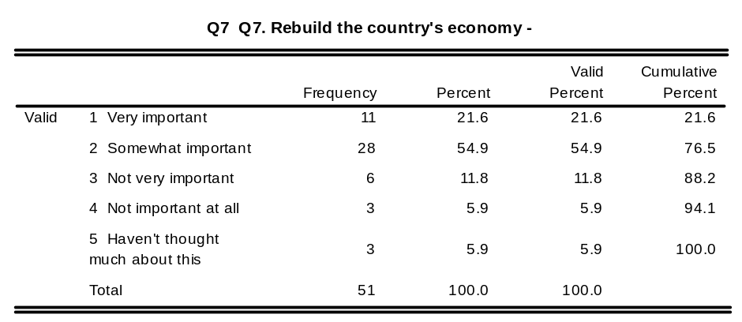
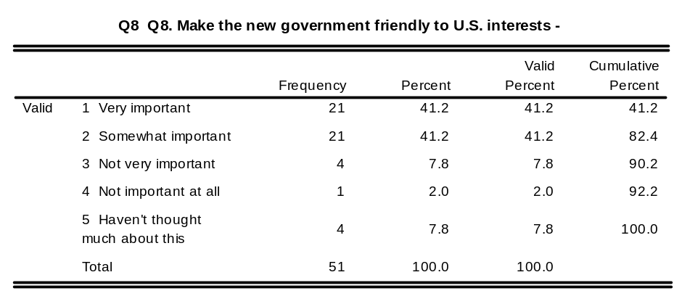
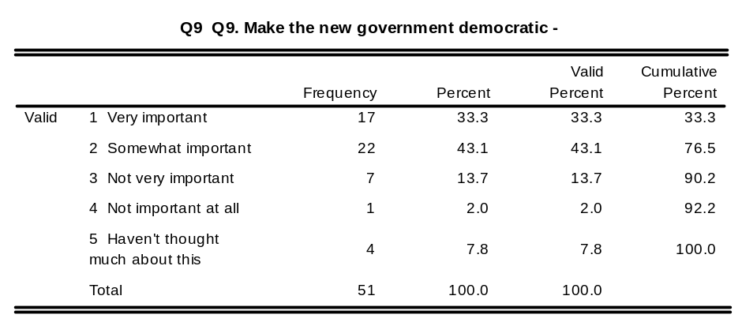

Pretest Experimental Group – Follow-up Survey Codebook

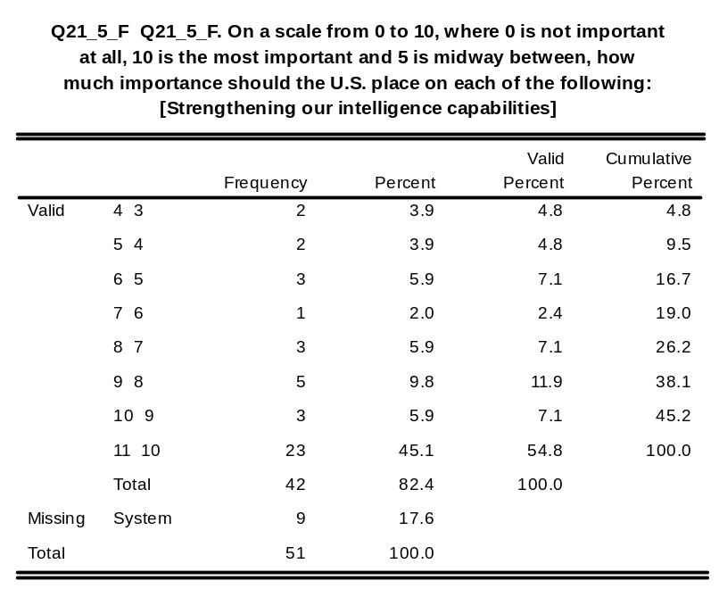
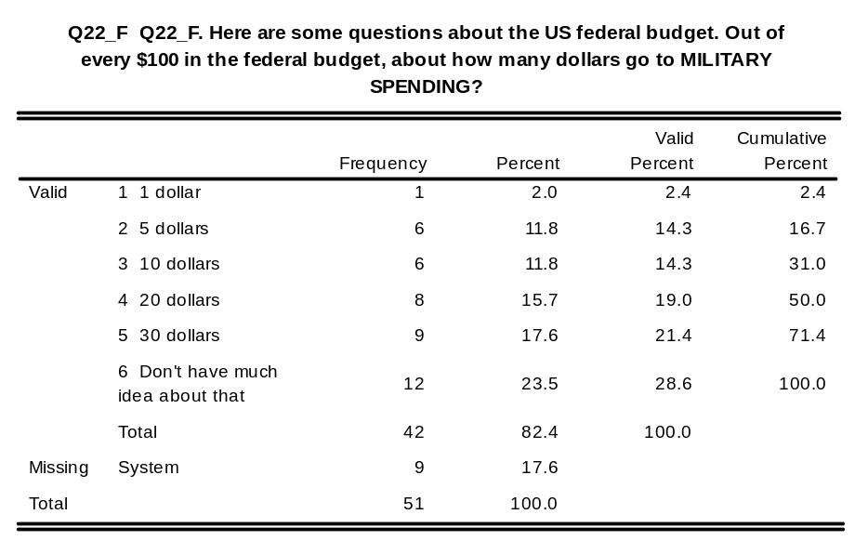
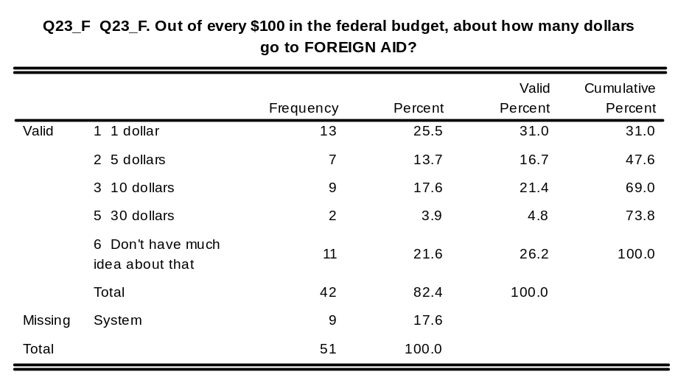
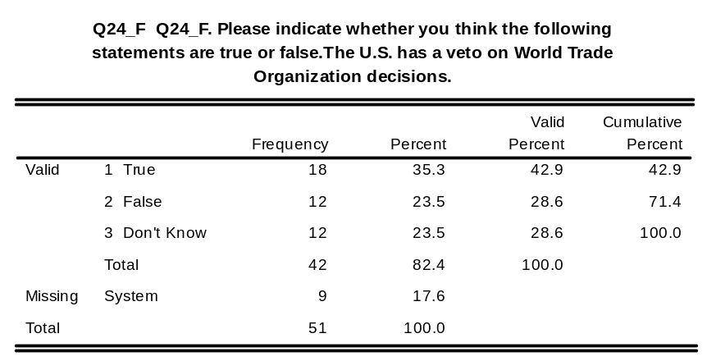
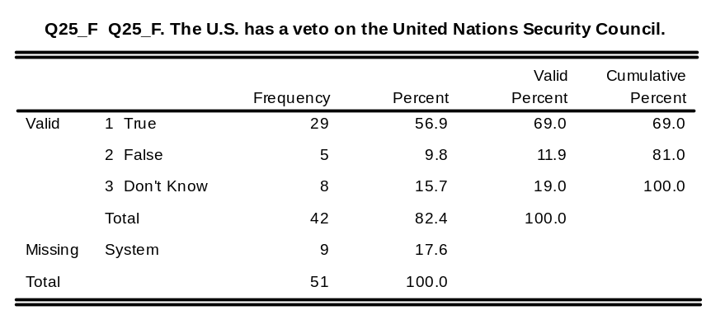
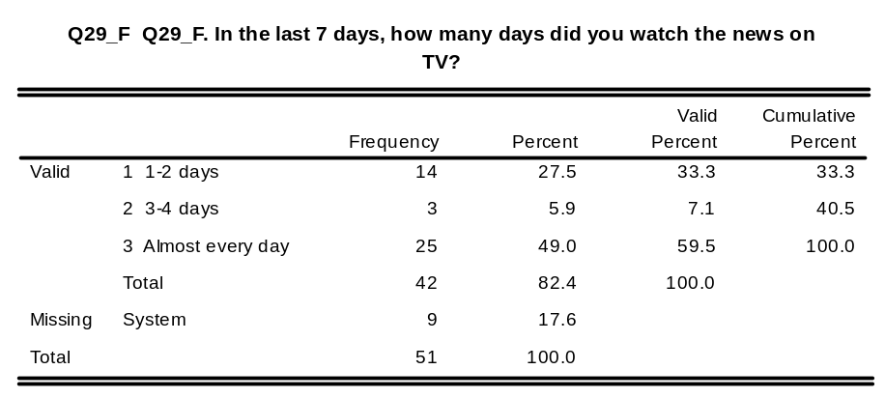
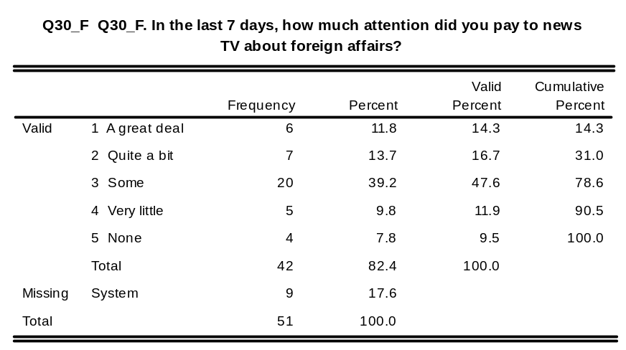
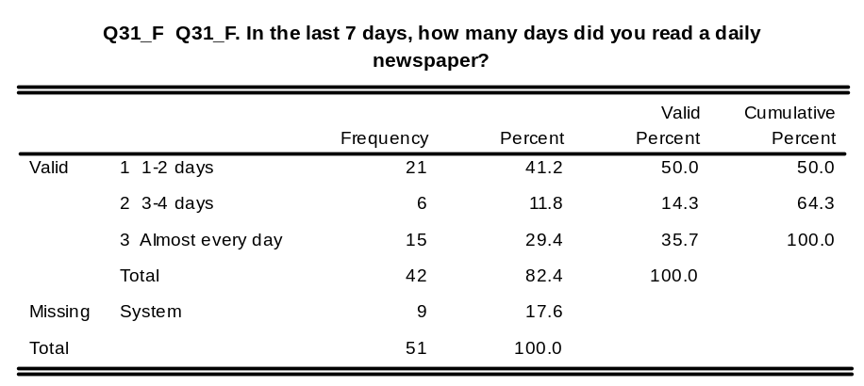
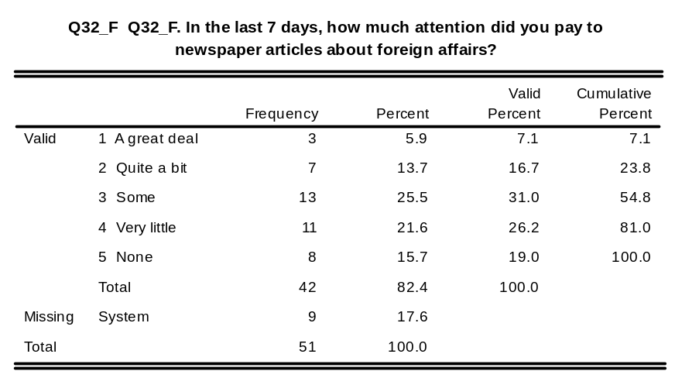
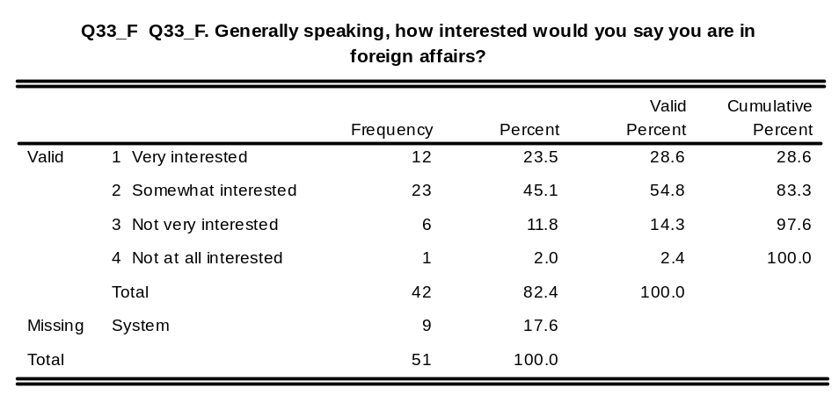
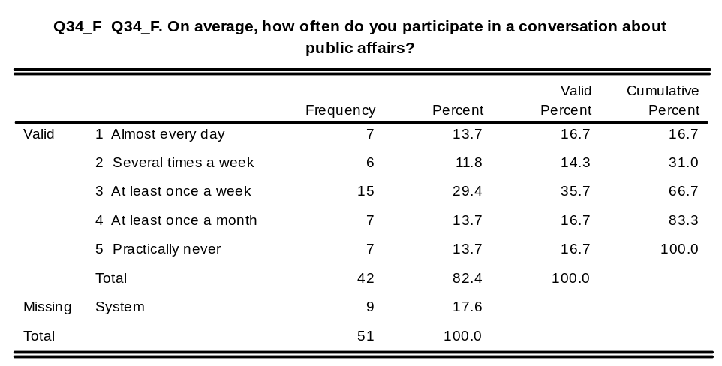
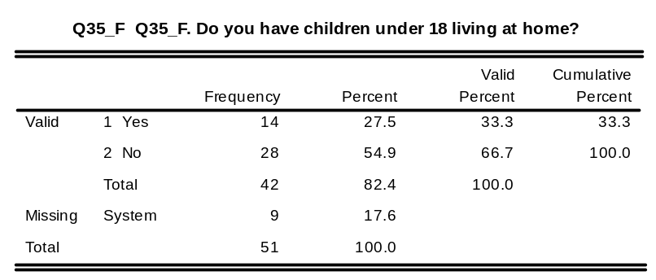
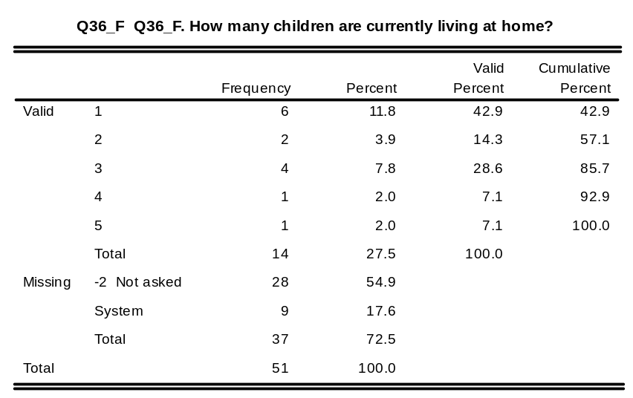
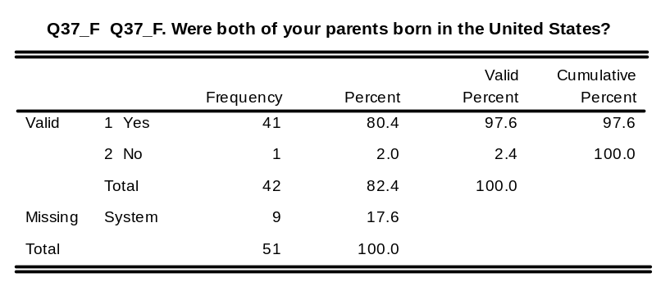
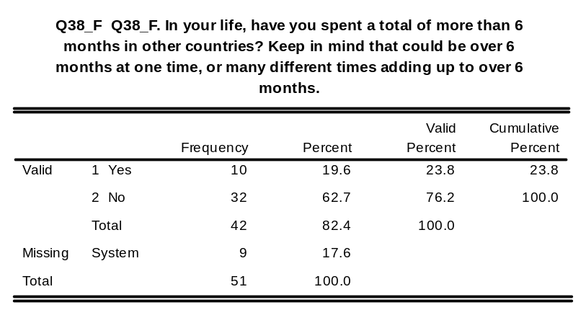
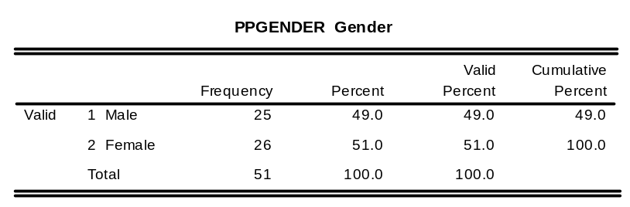
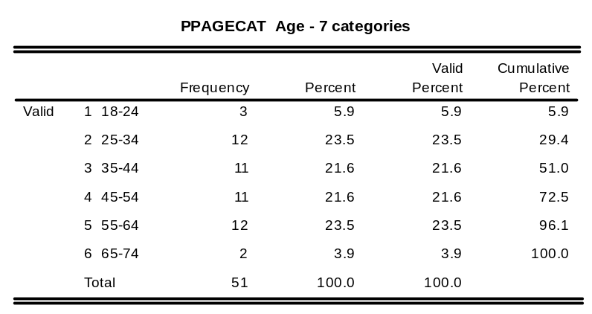
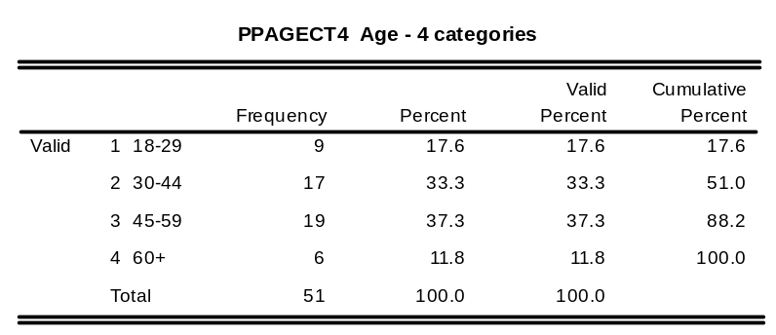
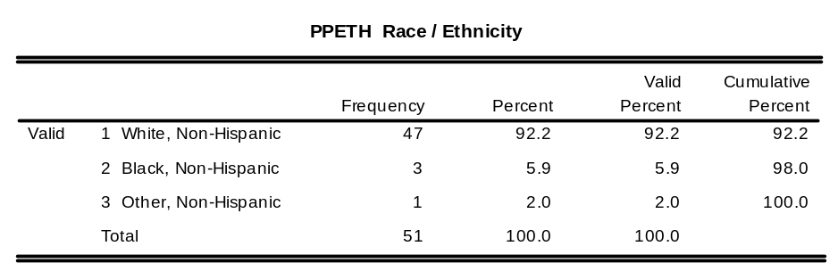
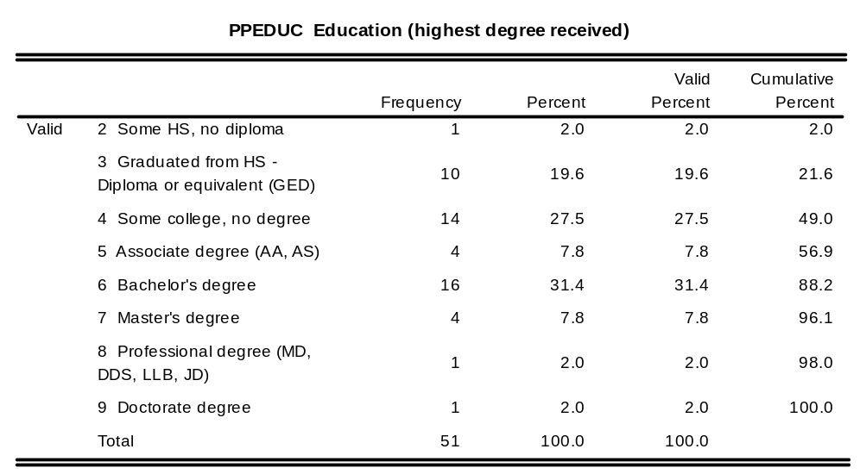
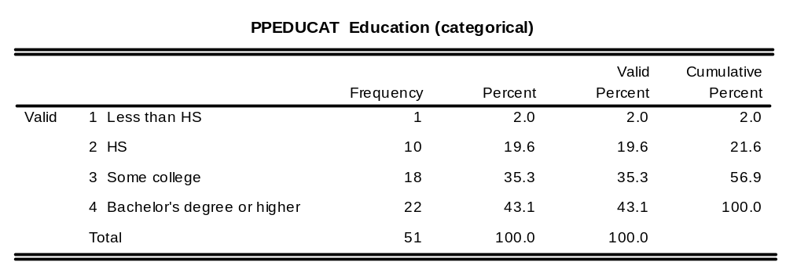
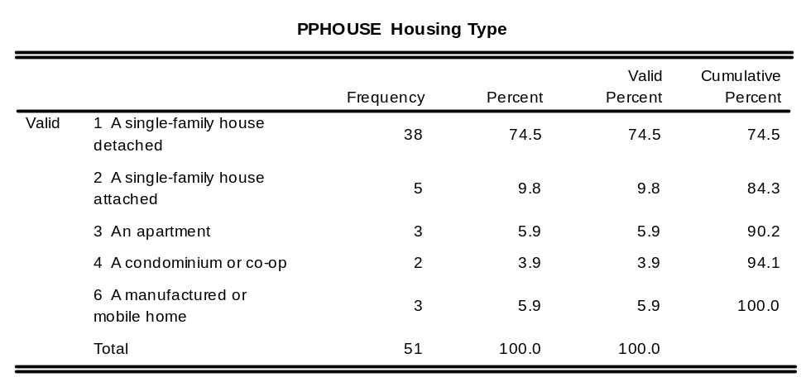
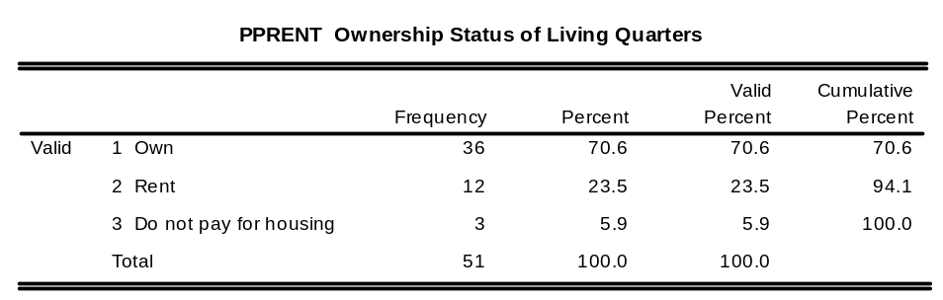
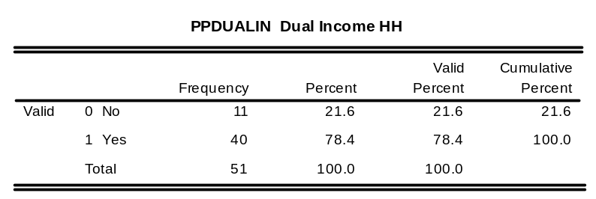
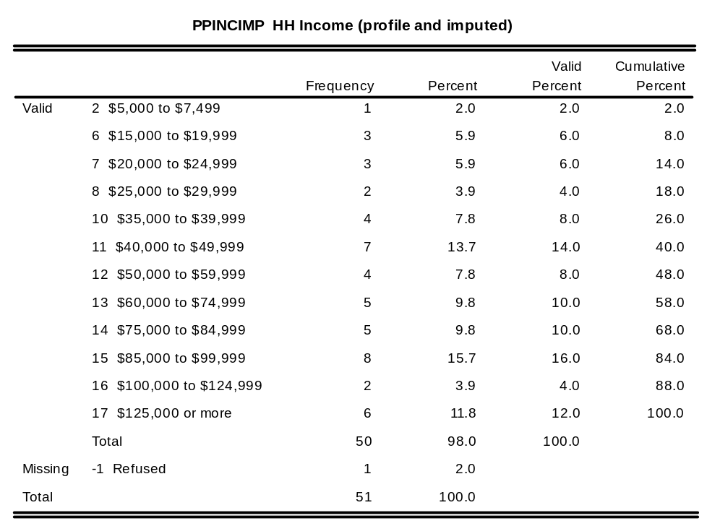
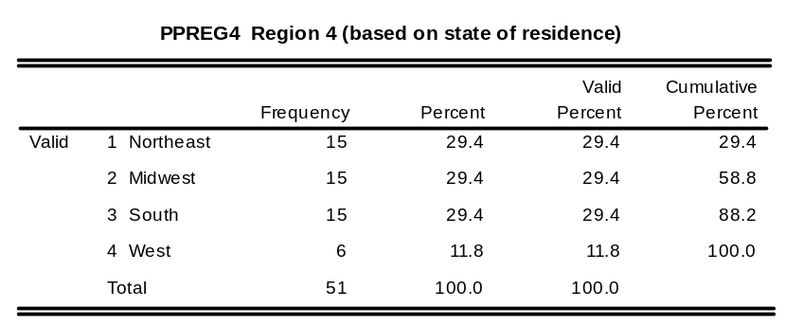

Pretest Control Group – Baseline Survey

SERIAL Case Identification Number

DT_START Date interview started

TM_START Time interview started

DT_END Date interview ended

TM_END Time interview ended

DURATION Duration of interview in minute
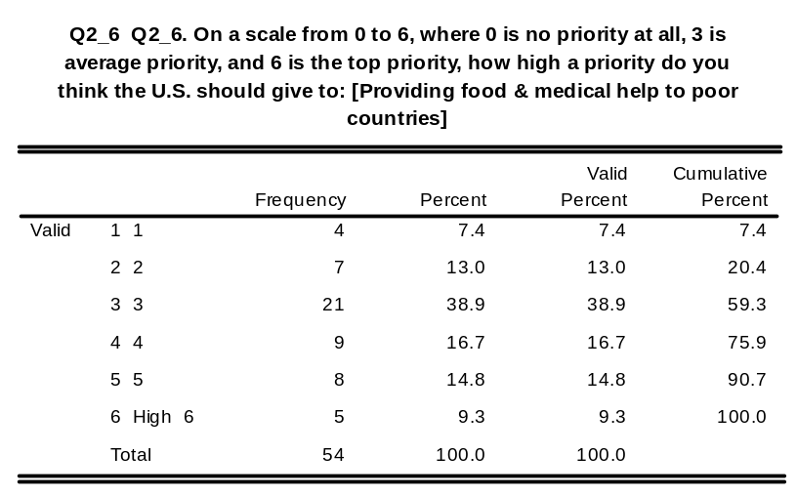

Pretest Control Group – Follow-up Survey

General Dataset Variables (dopall_final_wsummer_tracking_data.sav)
CaseID : Anonymous Case Identification Number (Main)

w1serial: W1 Baseline. w2serial. Case Identification Number

w2serial: W2 Baseline. w2serial. Case Identification Number

w3serial: W3 Baseline. w3serial. Case Identification Number

w4serial: W4 Baseline. Case Identification Number

Wave 1 Baseline/Follow-up/Brief Survey Follow-up Codebook

w1bdtst: W1 Baseline. w1bdtst. Date interview started

w1btmst: W1 Baseline. w1btmst. Time interview started

w1bdtend: W1 Baseline. w1bdtend. Date interview ended

w1tmend: W1 Baseline. w1tmend. Time interview ended

w1bdur: W1 Baseline. w1bdur. Duration of interview in minutes (baseline)

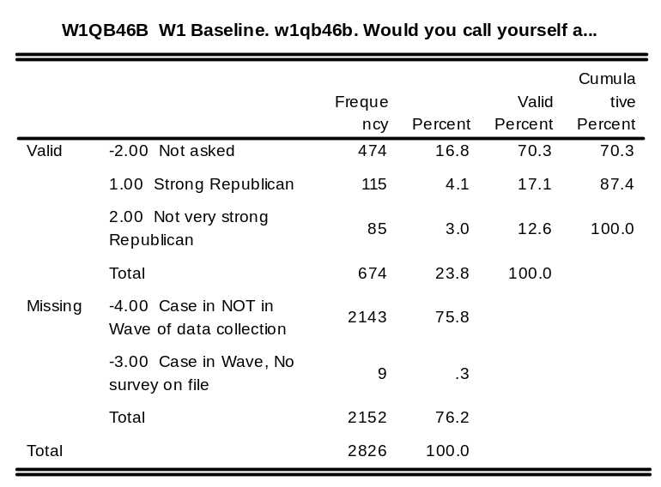
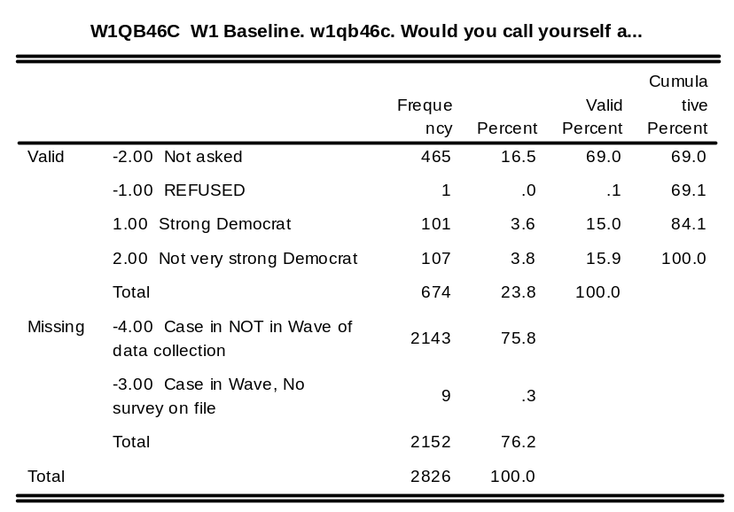
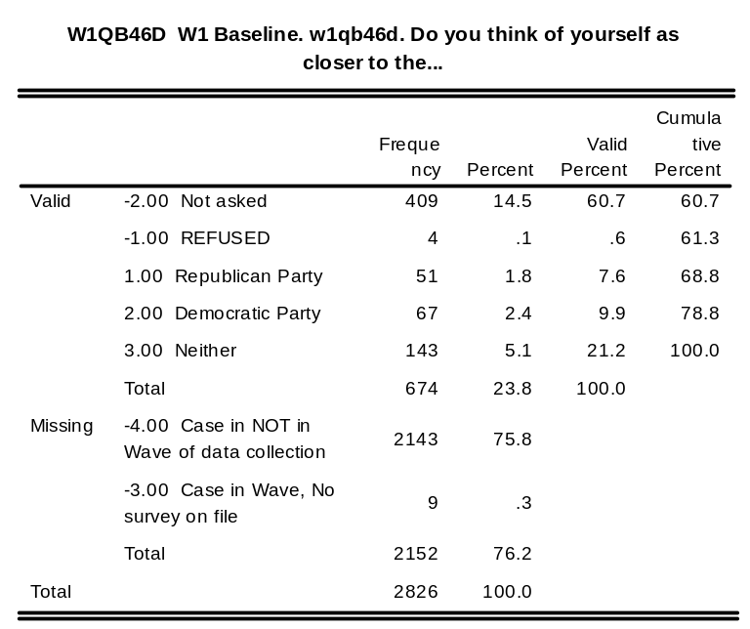
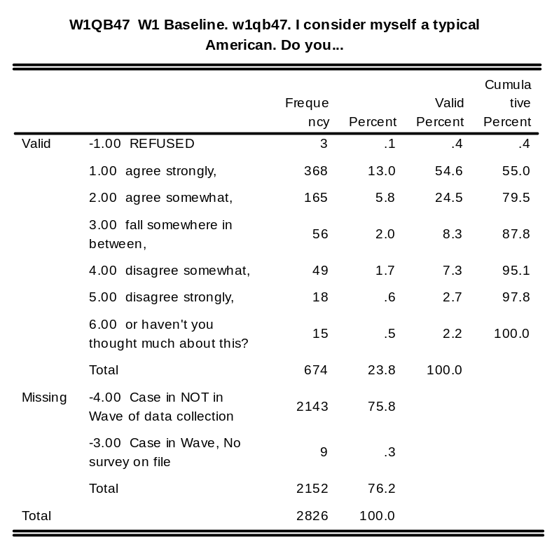
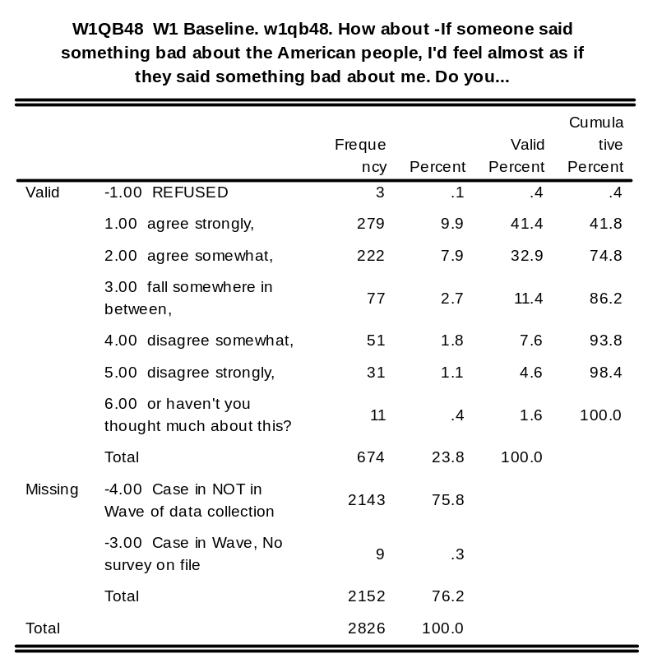

w1a_stdt: Wave 1a. Date interview started

w1a_sttm: Wave 1a. Time interview started

w1a_endt: Wave 1a. Date interview ended

w1a_entm: Wave 1a. Time interview ended

w1a_dur: Wave 1a. Duration of interview in minutes

Wave 2 Baseline/Follow-up Survey Codebook
w2bdtst: W2 Baseline. w2bdtst. Date interview started

w2btmst: W2 Baseline. w2btmst. Time interview started

w2bdtend: W2 Baseline. w2bdtend. Date interview ended

w2btmend: W2 Baseline. w2btmend. Time interview ended

w2bdur: W2 Baseline. w2bdur. Duration of interview in minutes

w2bdurct: W2 Baseline. w2bdurct. Duration of interview (categorized in 5-minute intervals)

w2q46ao: W2 Baseline. w2q46ao. Q46A Other

w2qb69o: W2 Baseline. w2qb69o. Q69 Other

w2qb70o: W2 Baseline. w2qb70o. Q70 Other

w2qb71o: W2 Baseline. w2qb71o. Q71 Other

w2qb75o: W2 Baseline. w2qb75o. Q75 Other

w2qb84o: W2 Baseline. w2qb84o. Q84 Other

w2qbf1: W2 Baseline. w2qbf1. QF1 (last question)

w2fdtst: W2 Followup w2fdtst. Date interview started

w2ftmst: W2 Followup w2ftmst. Time interview started

w2fdtend: W2 Followup w2fdtend. Date interview ended

w2ftmend: W2 Followup w2ftmend. Time interview ended

w2fdur: W2 Followup w2fdur. Duration of interview in minutes

w2fdurct: W2 Followup w2fdurct. Duration of interview (categorized in 5-minute intervals)
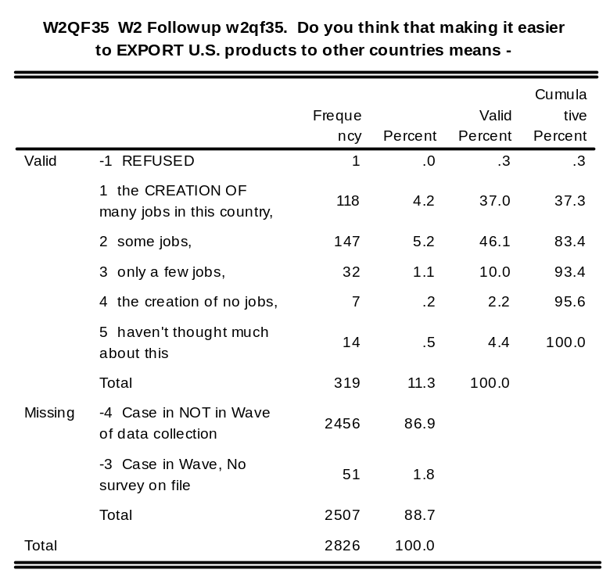
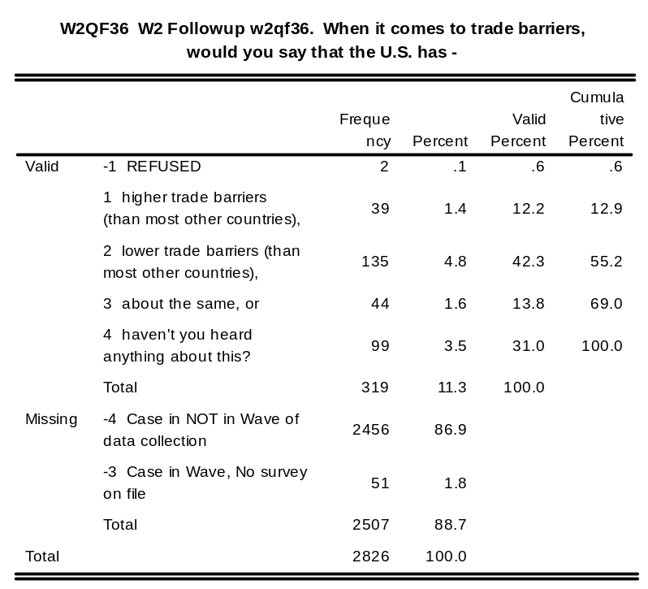
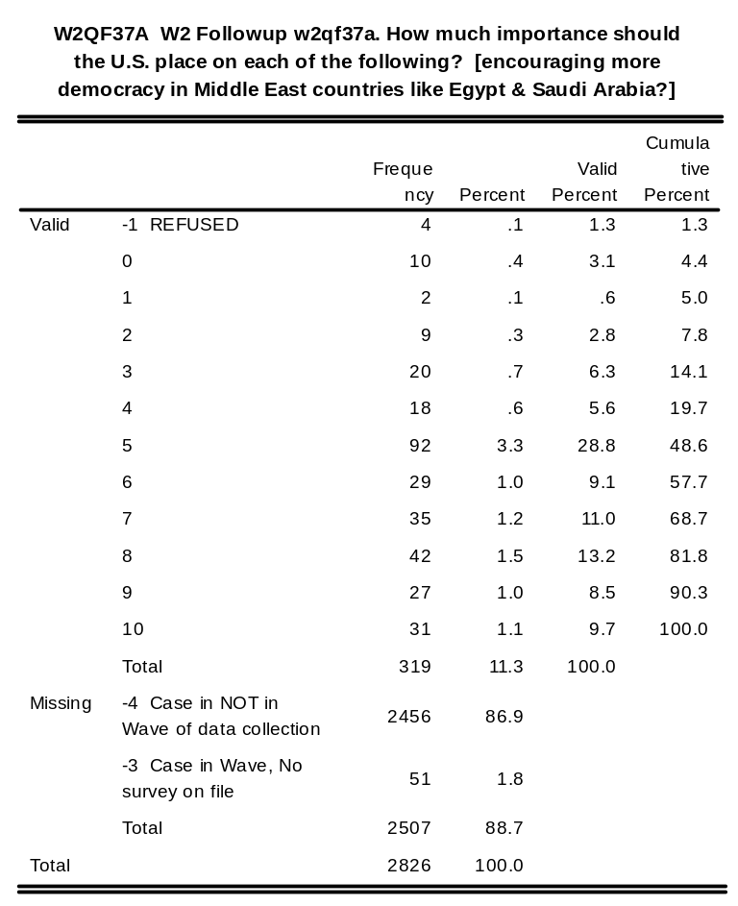
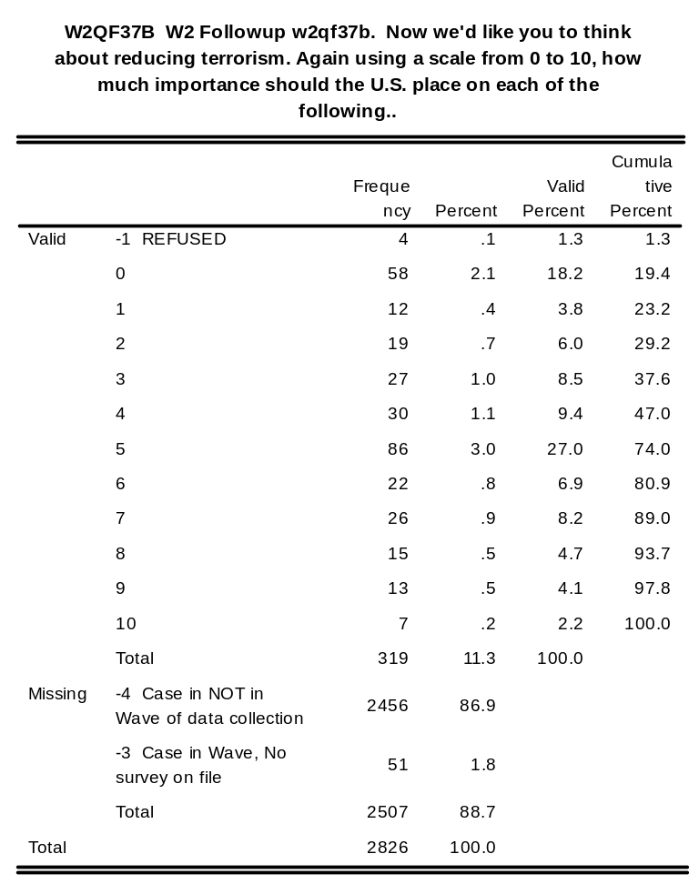
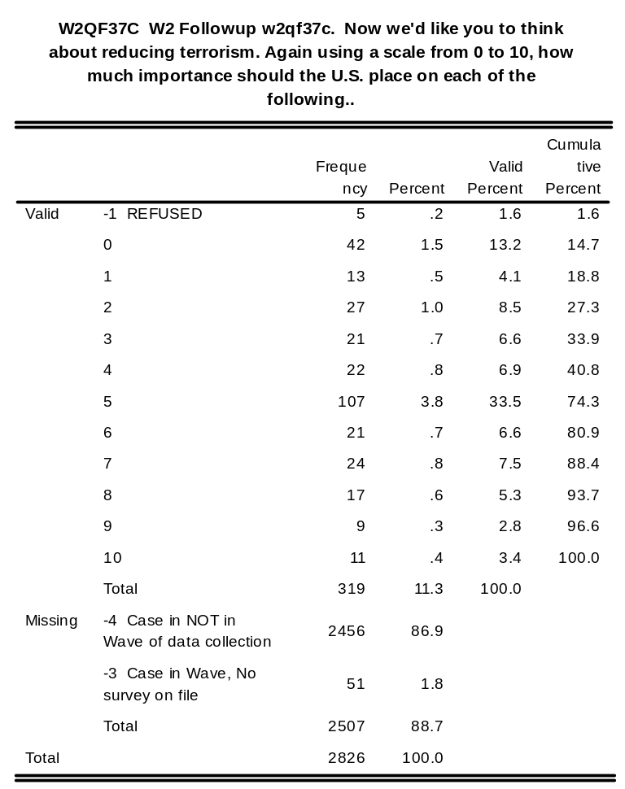
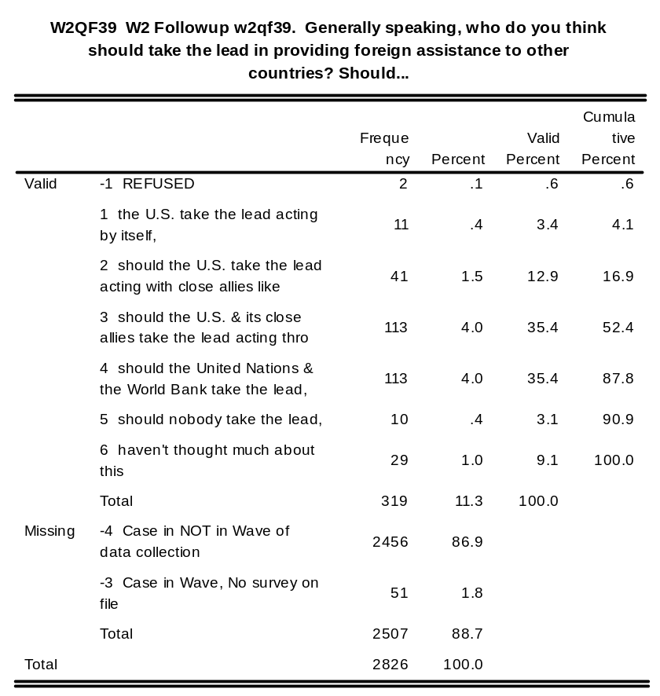
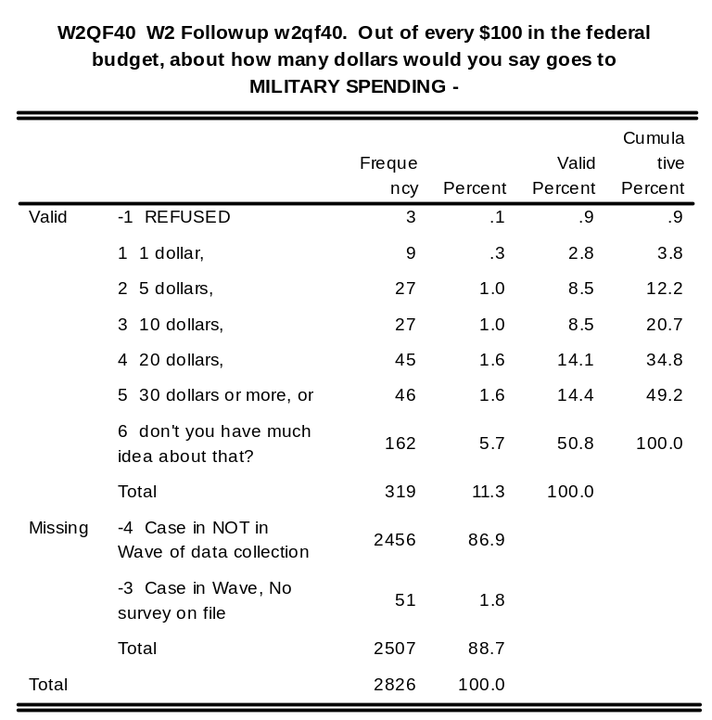
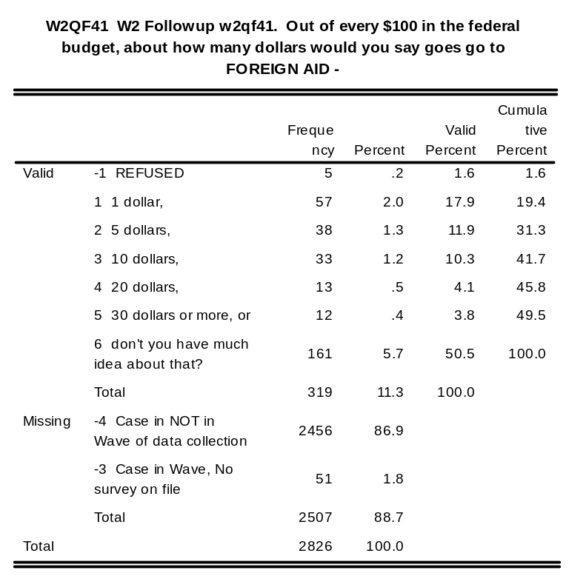
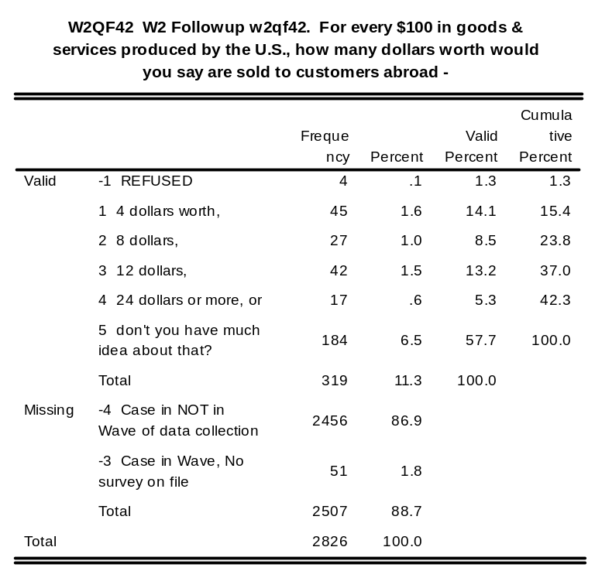
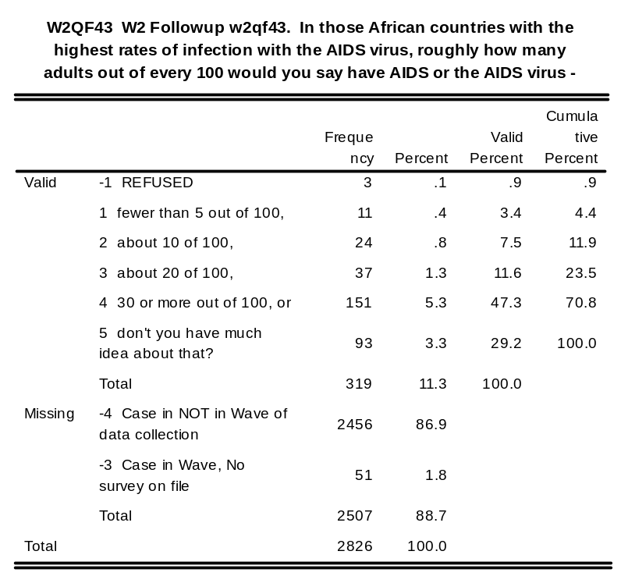
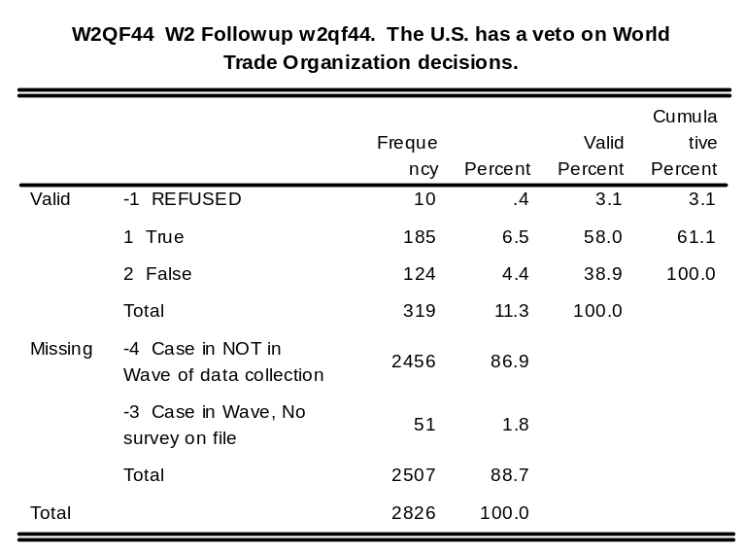
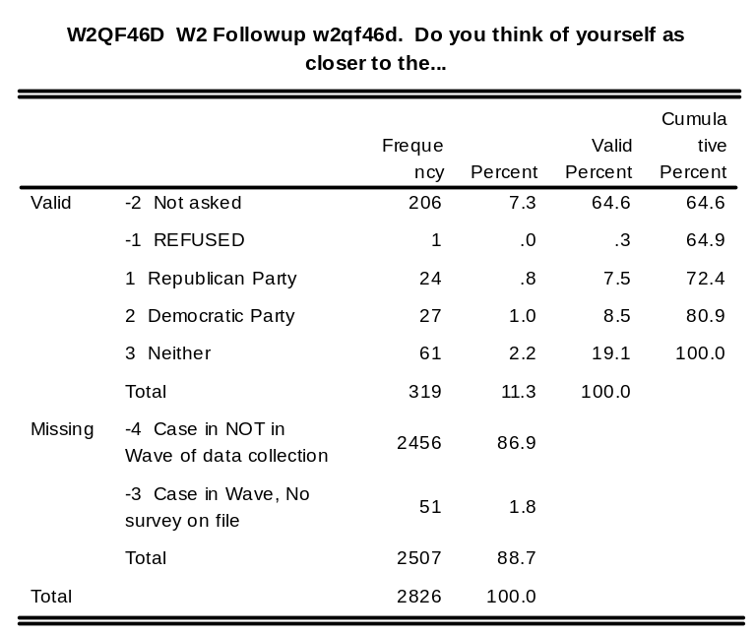
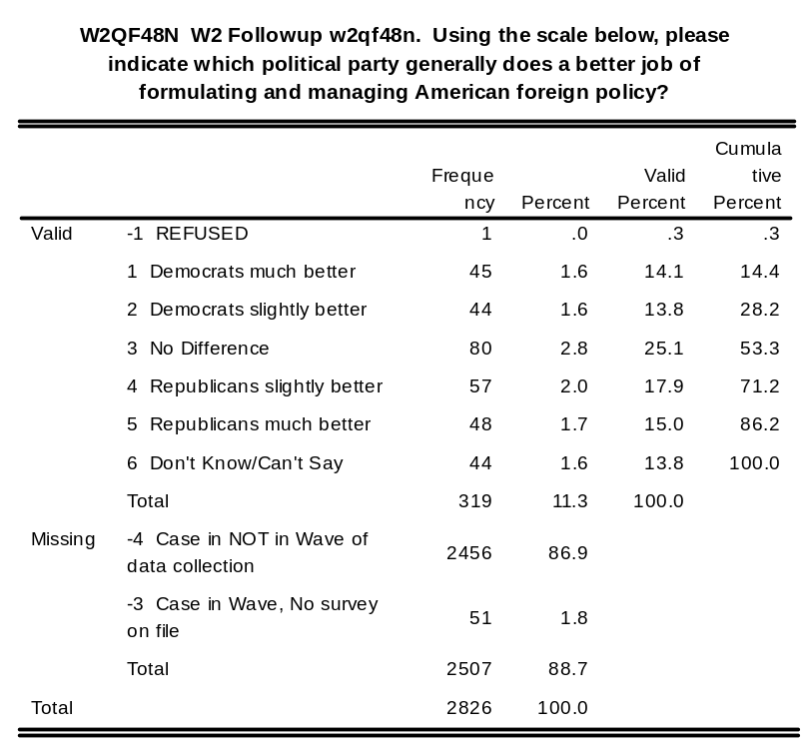
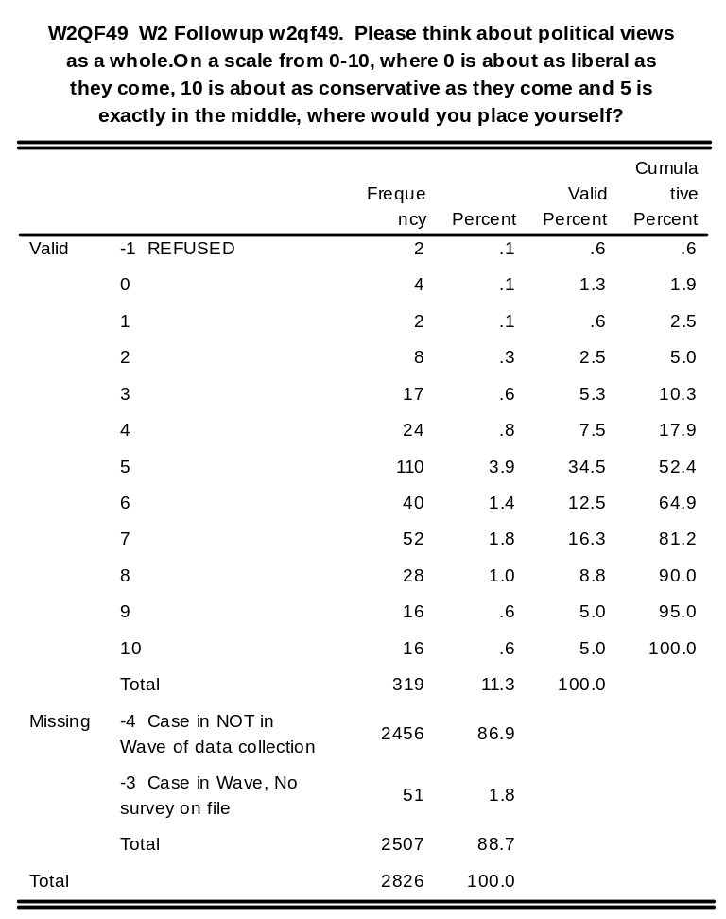
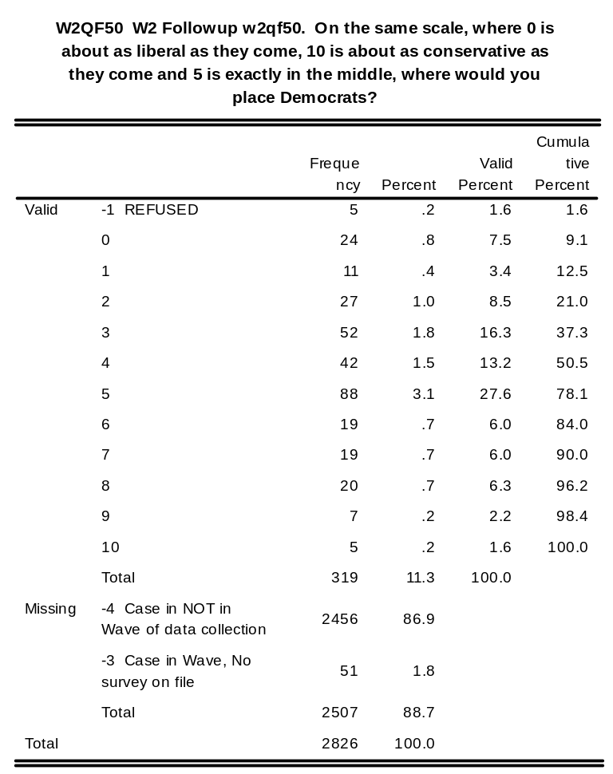
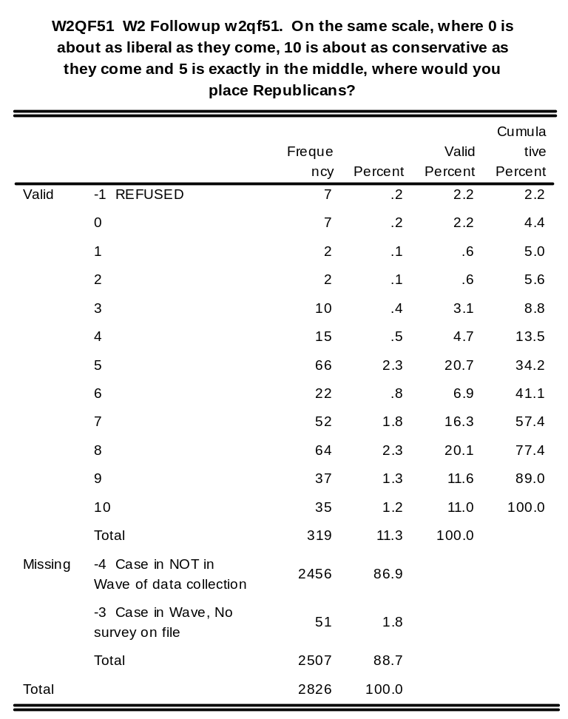
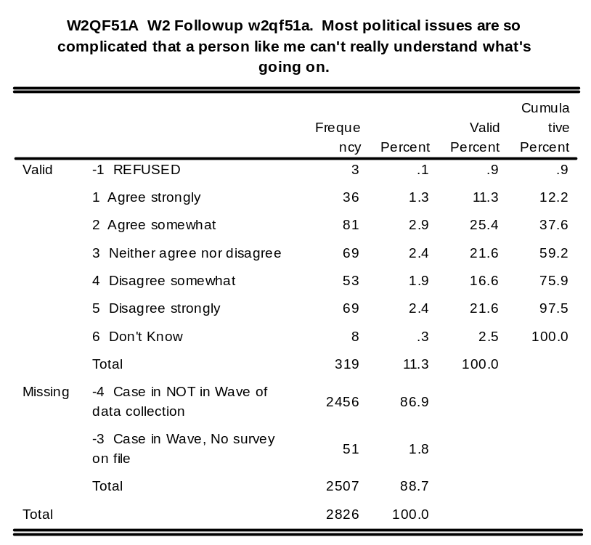
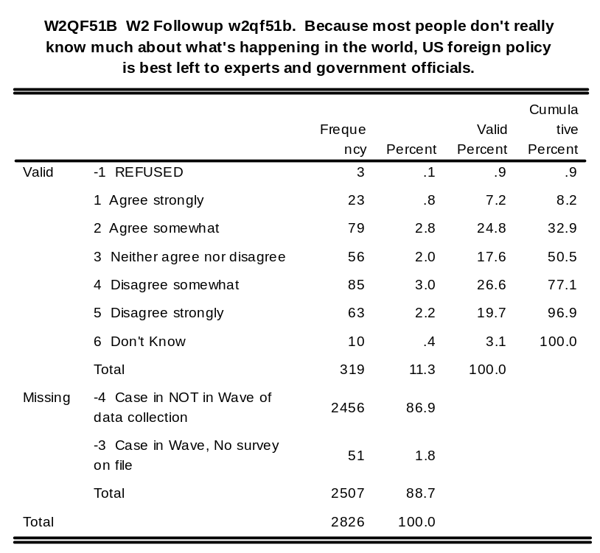
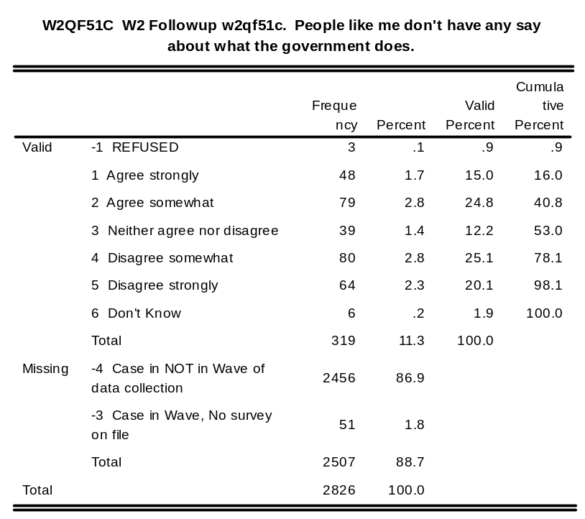
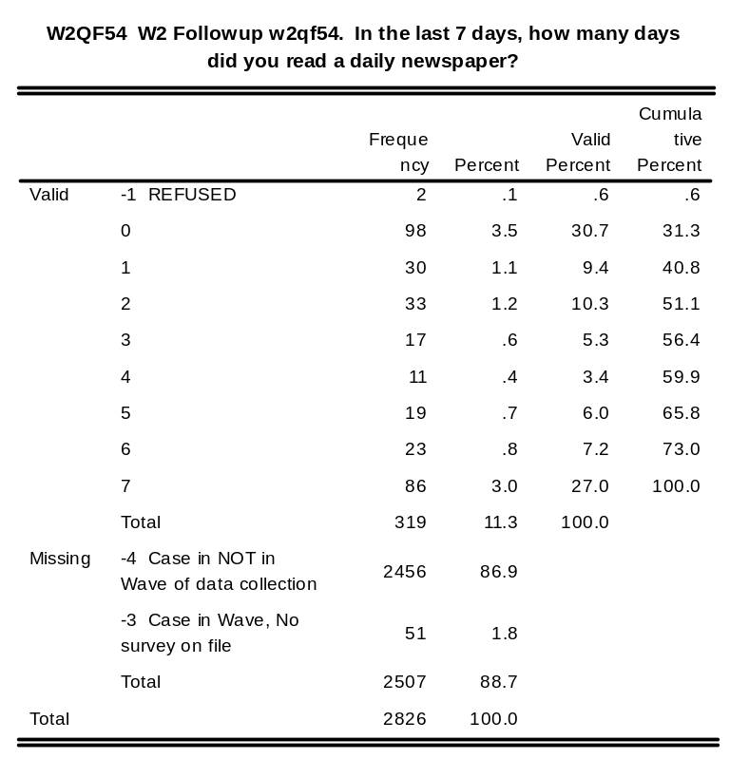
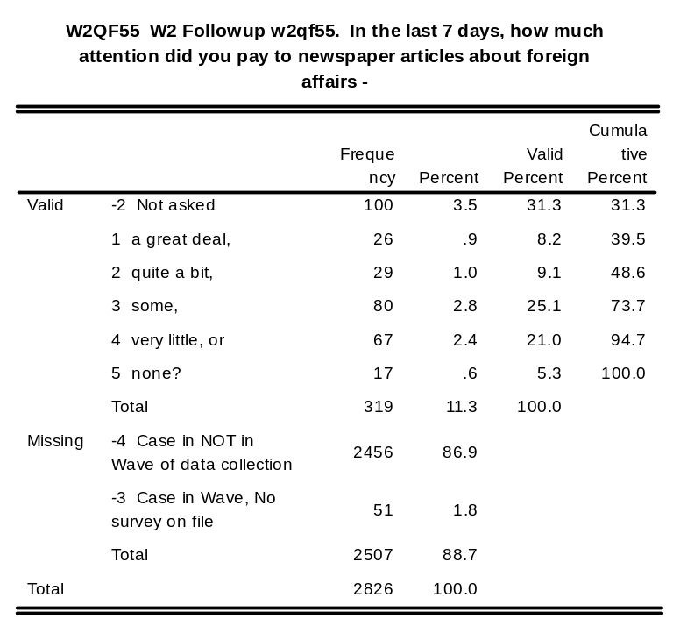
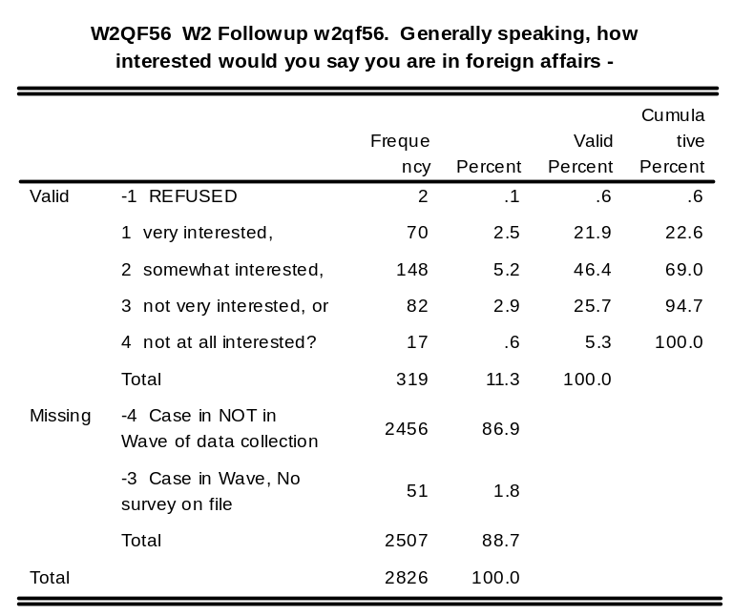
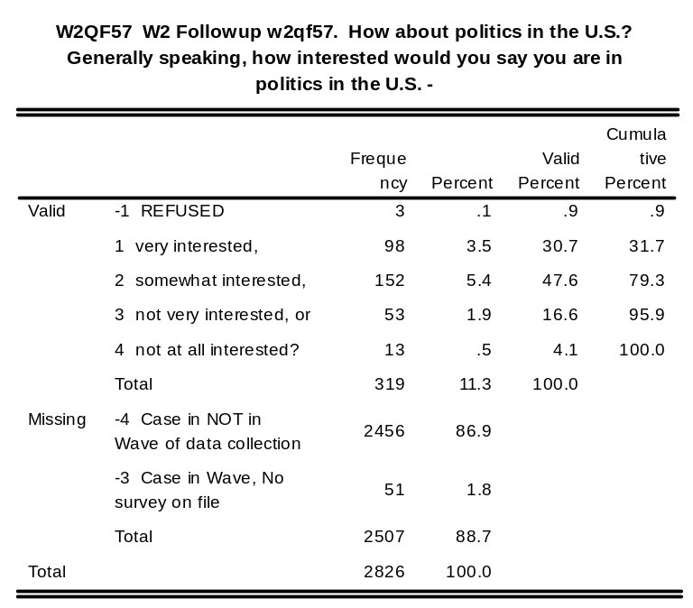
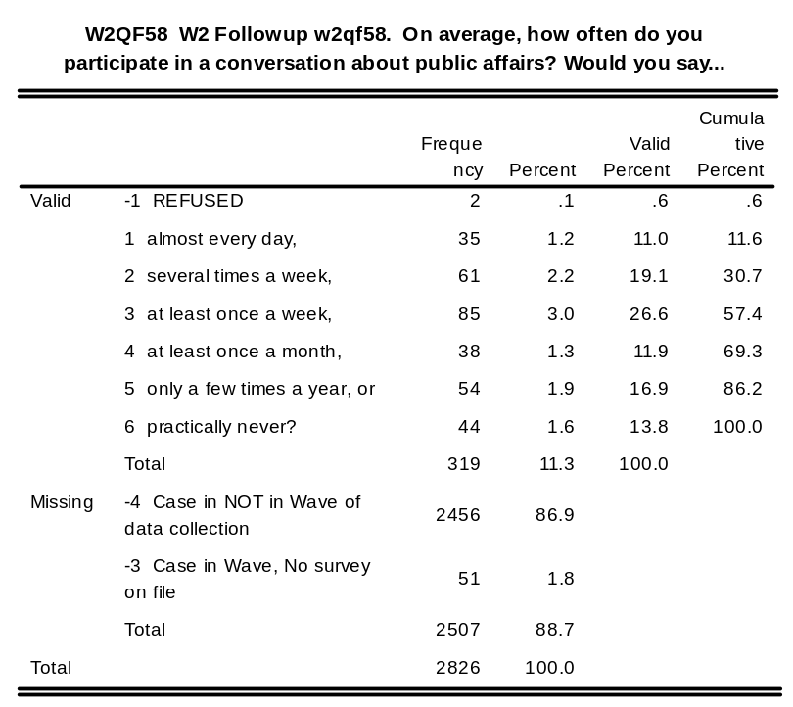
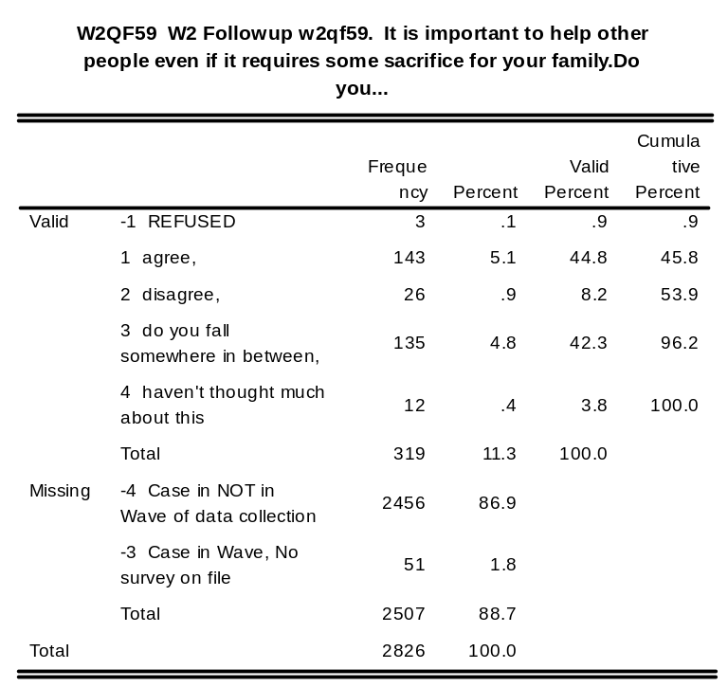
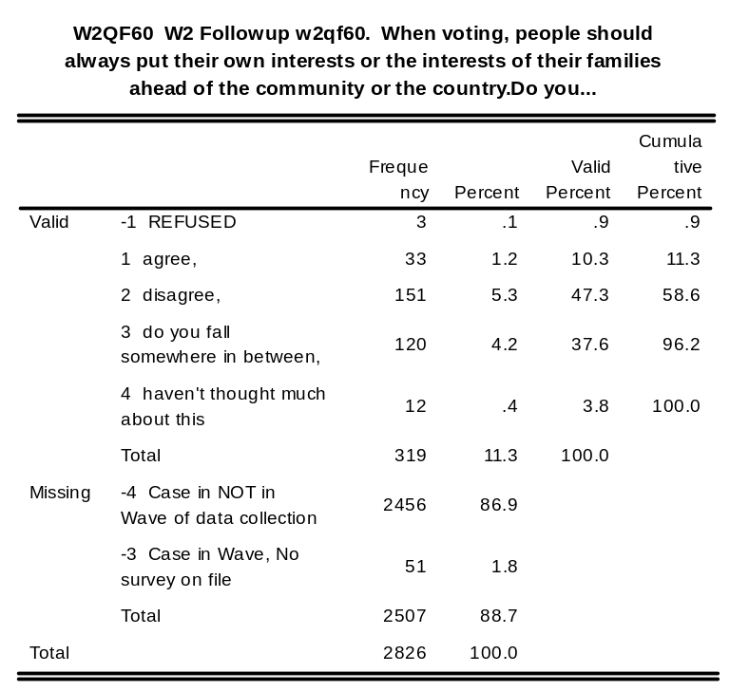
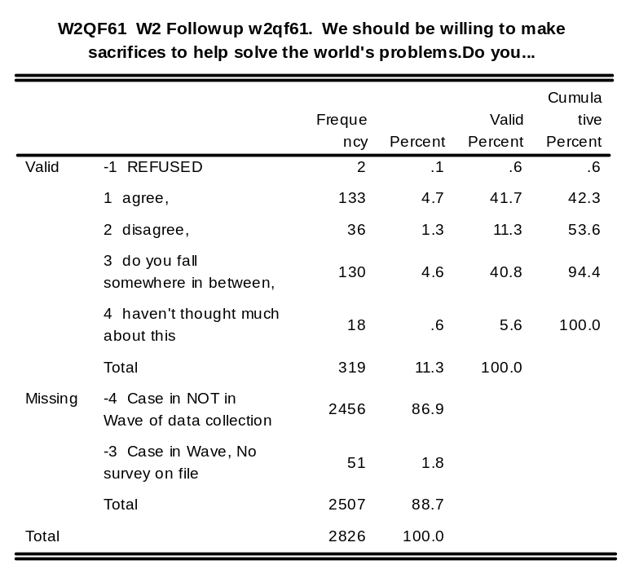
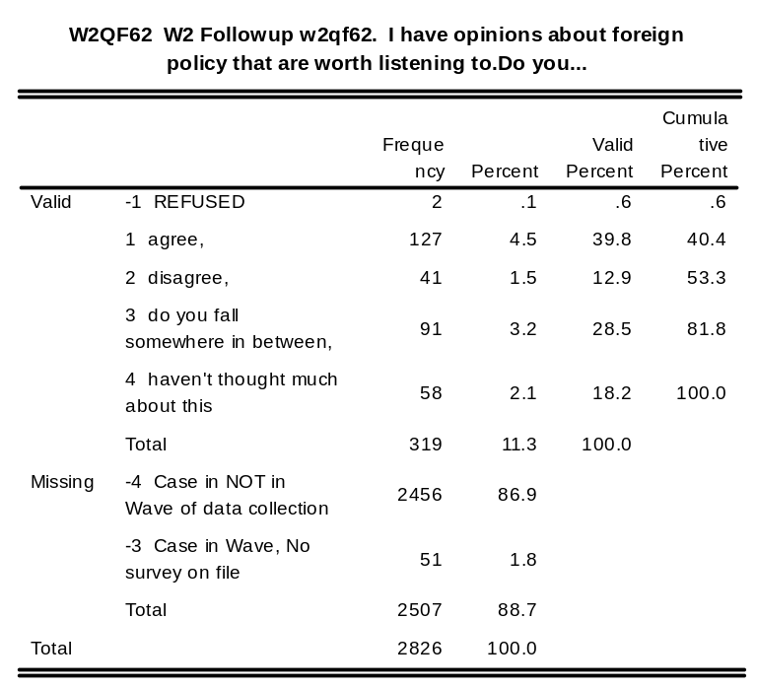
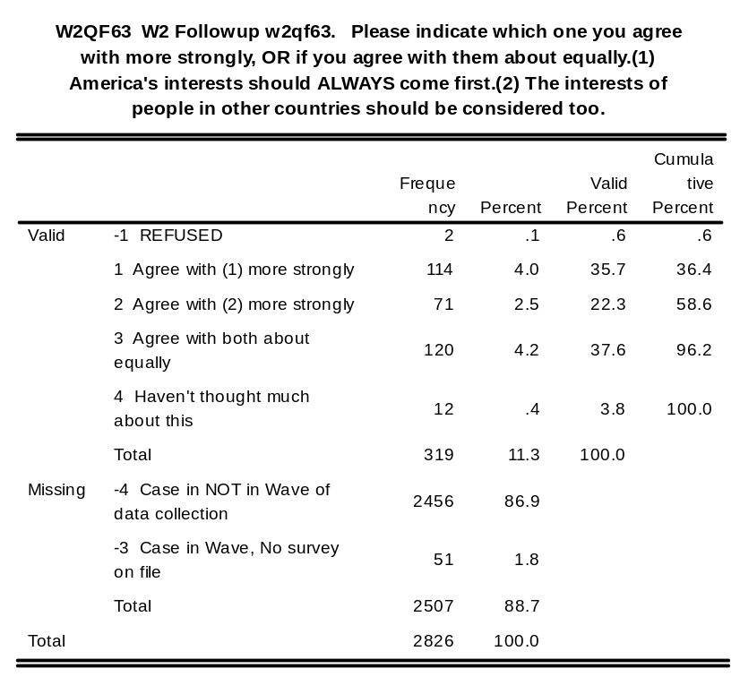
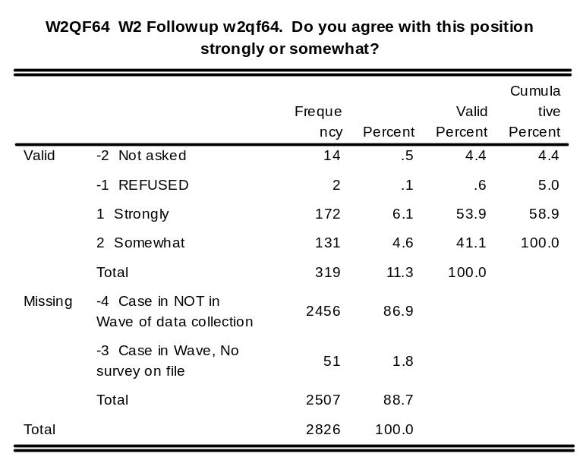
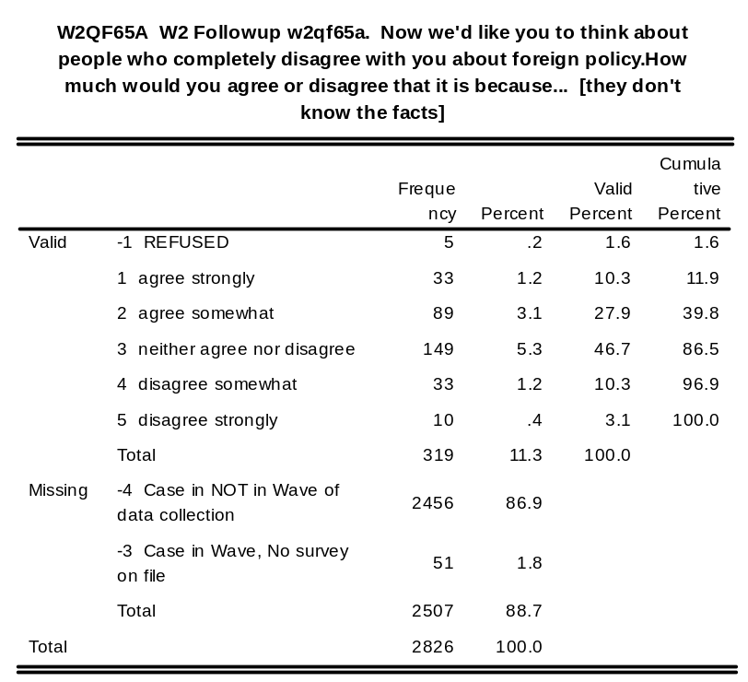
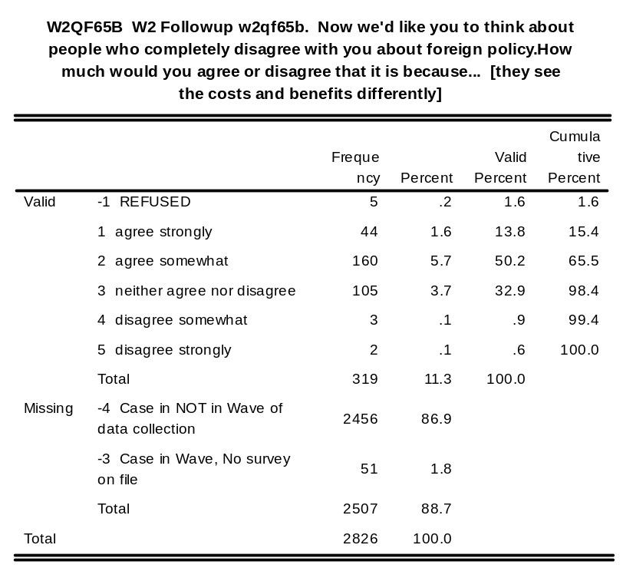
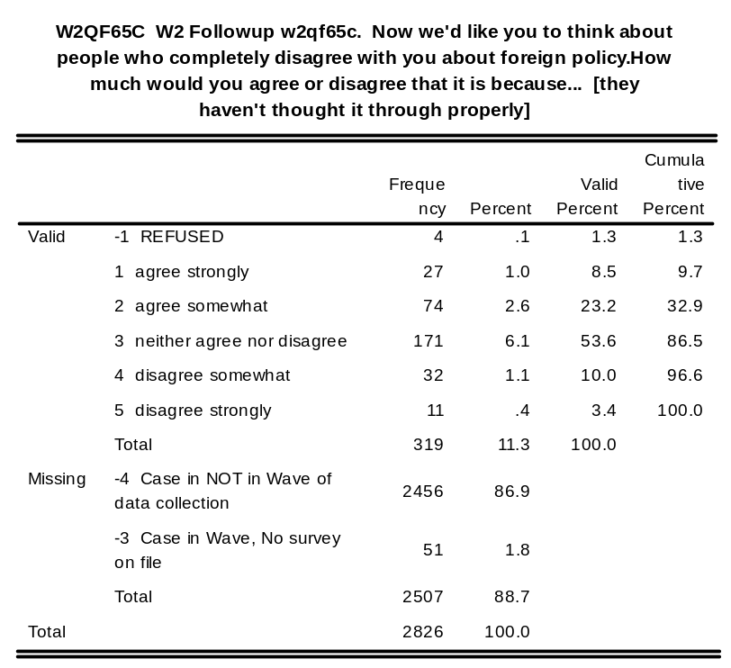
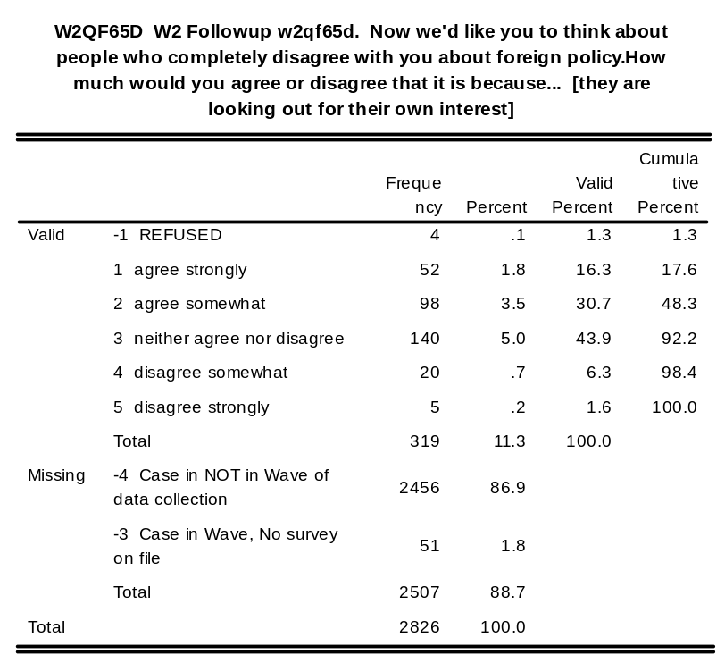
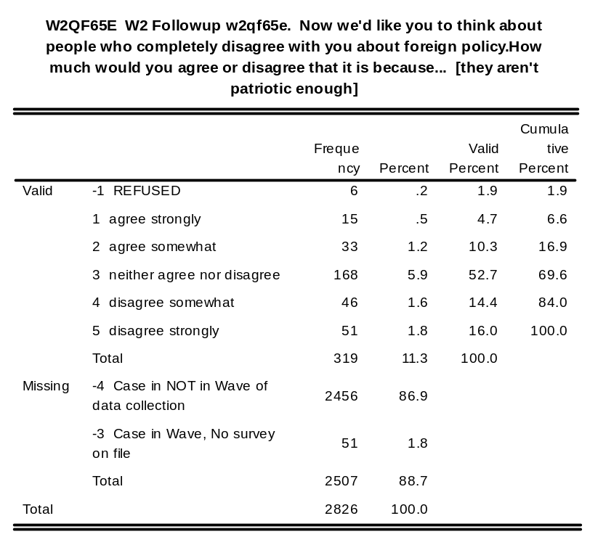
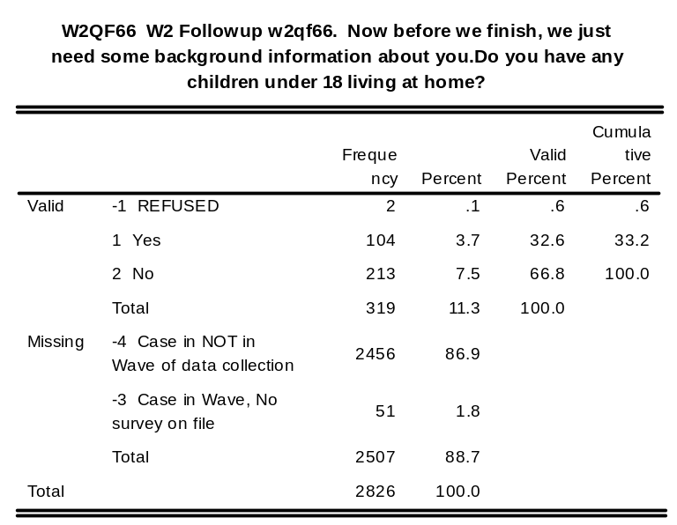
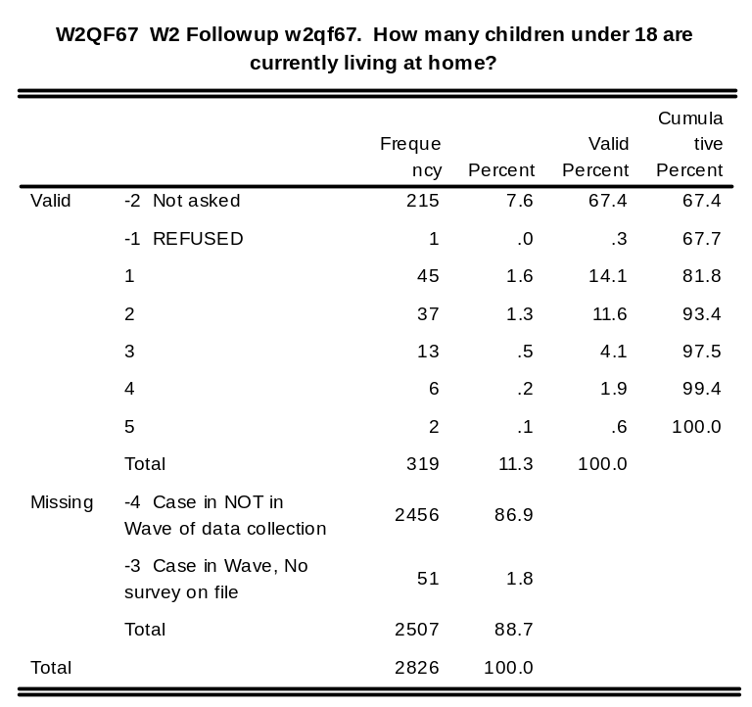
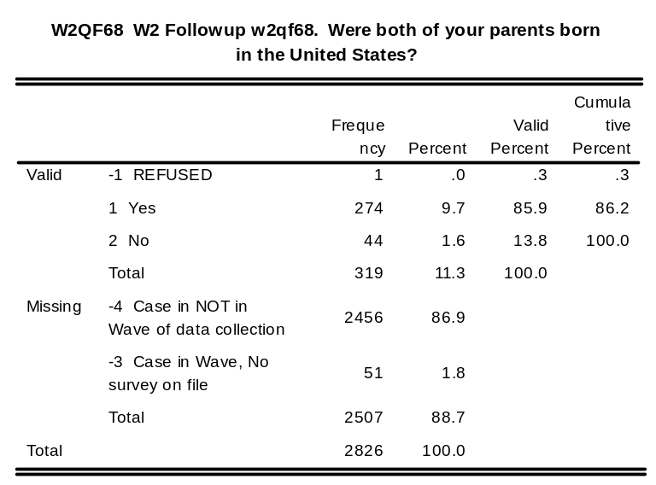
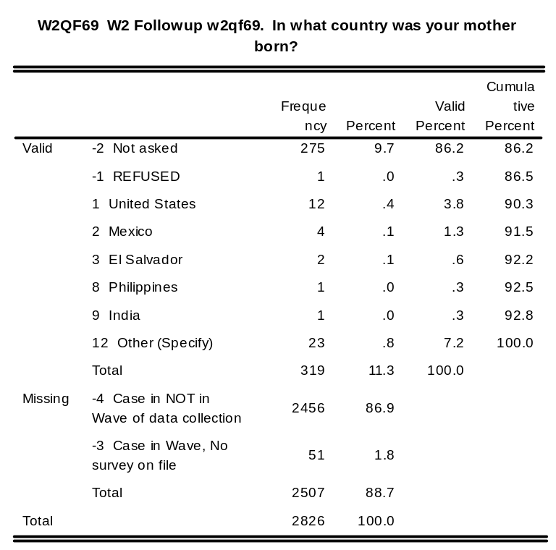
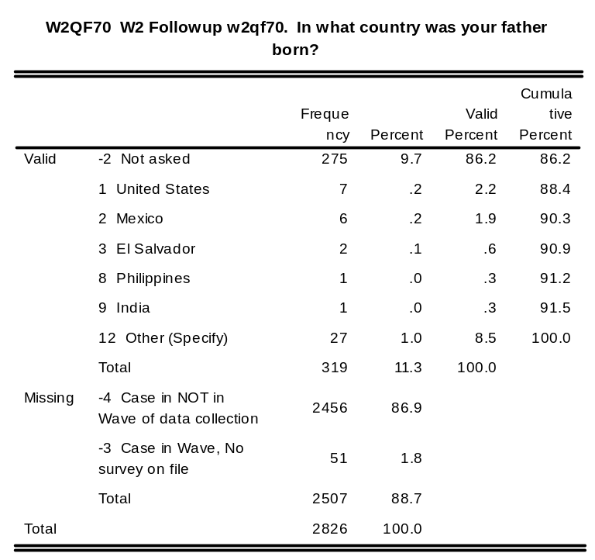
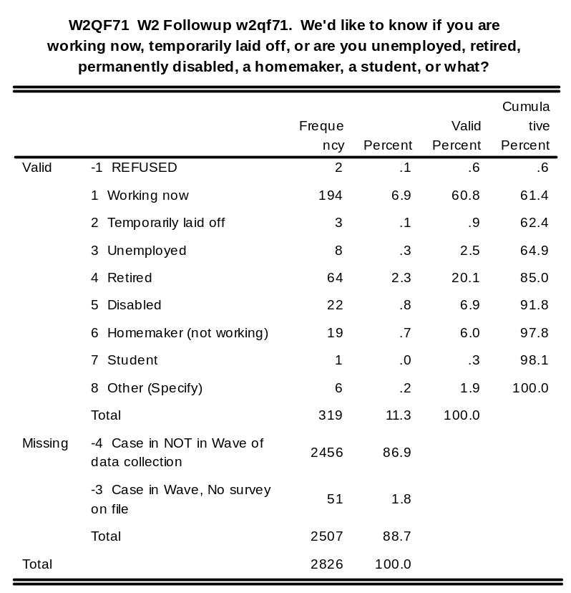
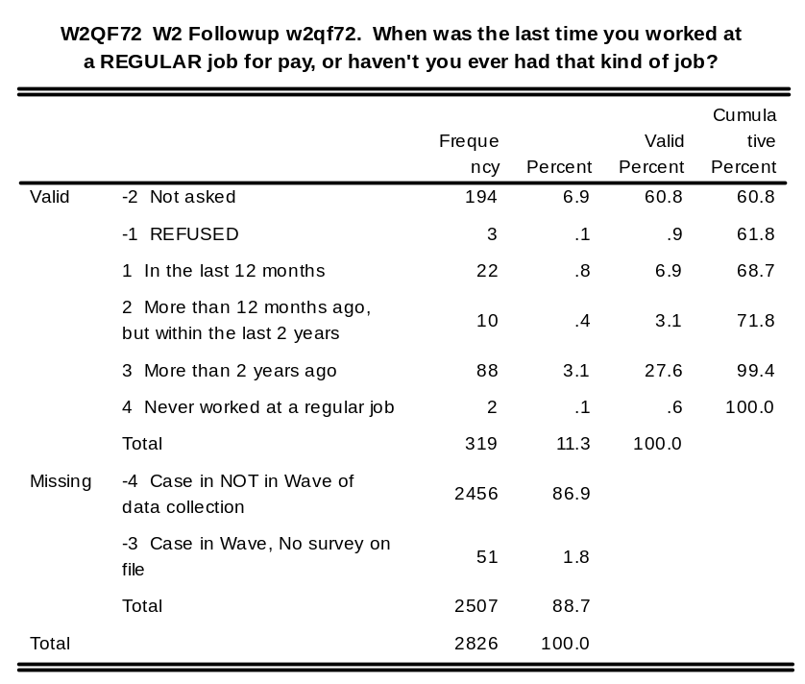
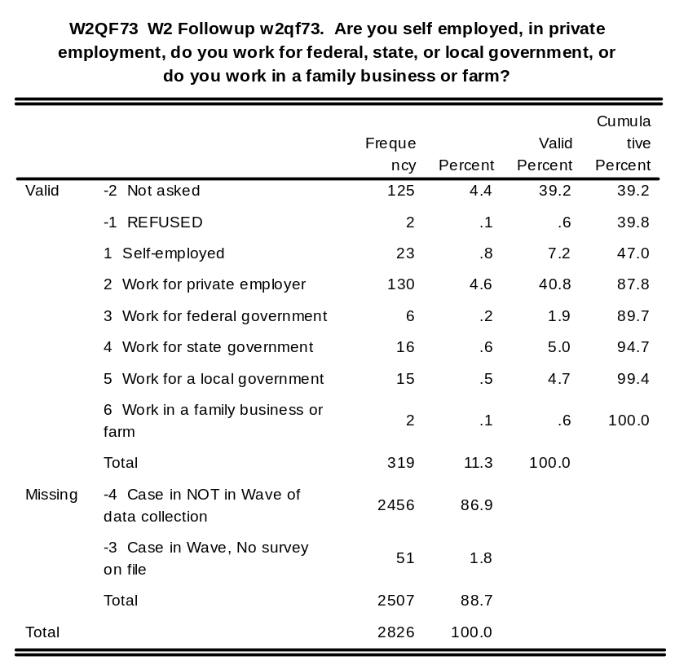
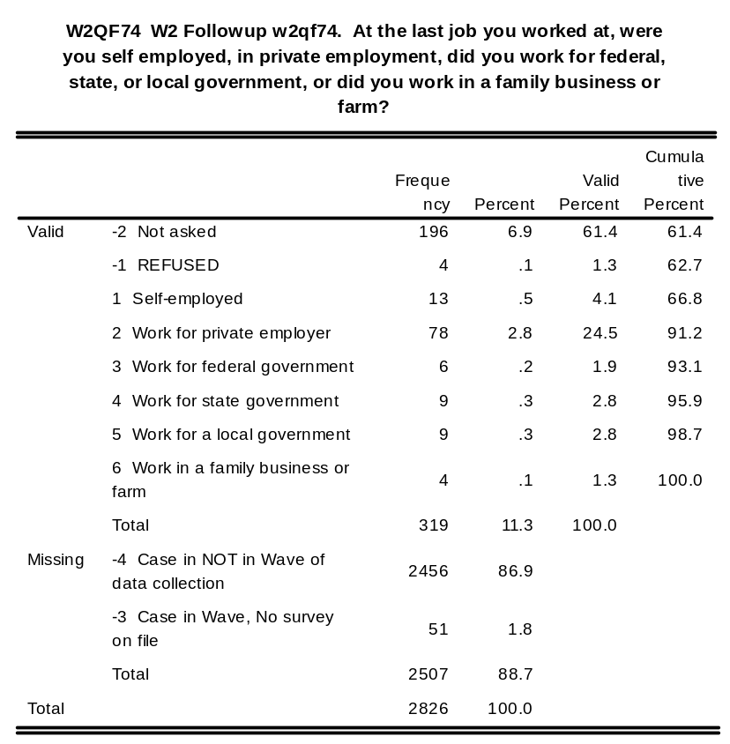
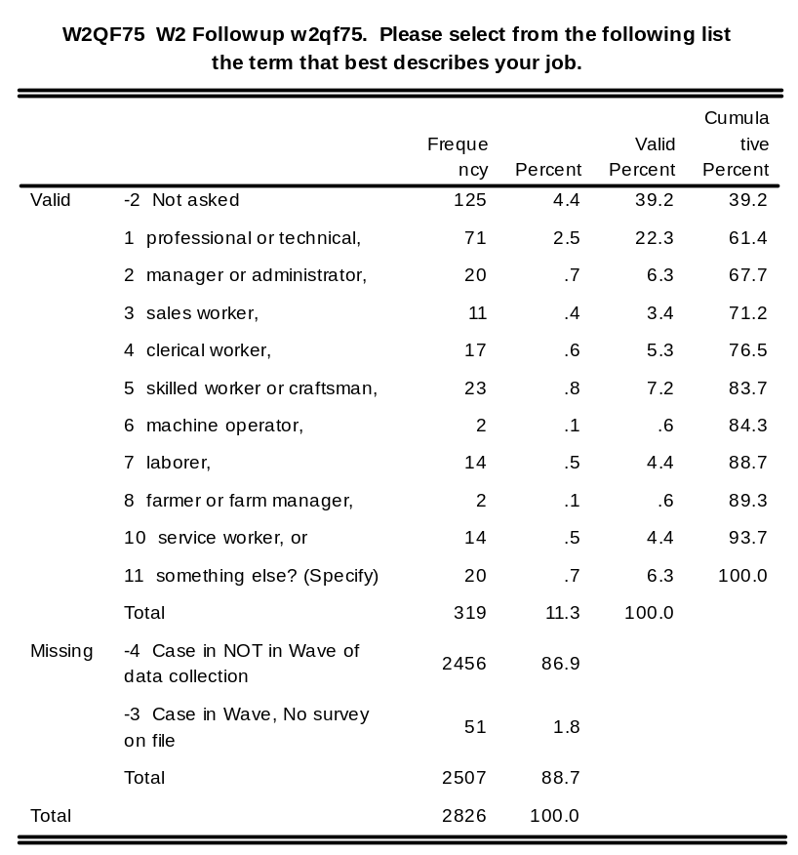
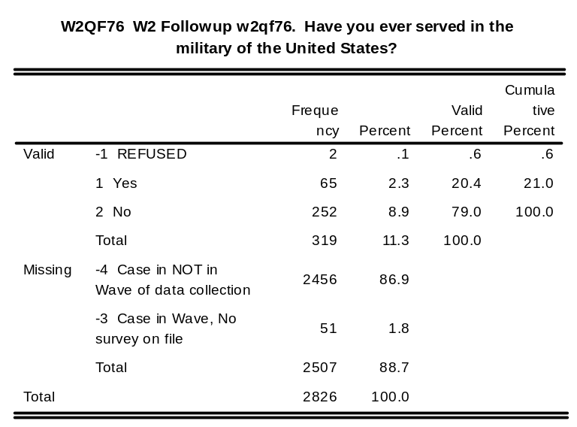
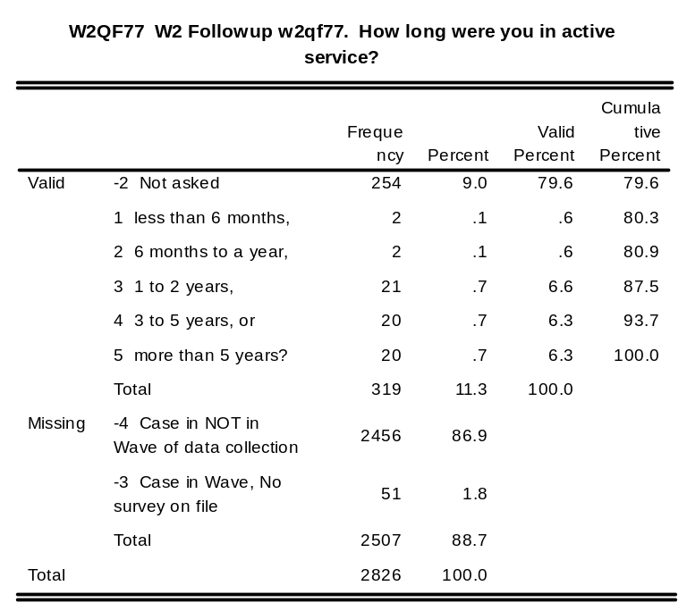
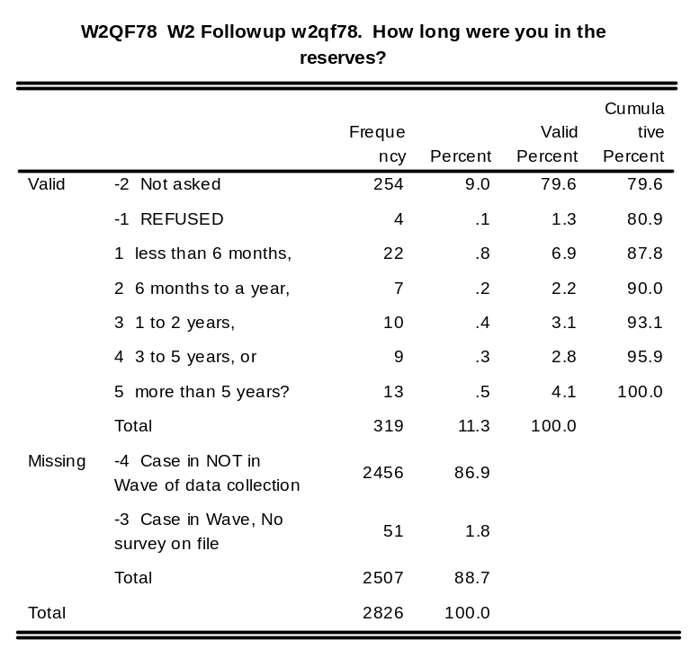
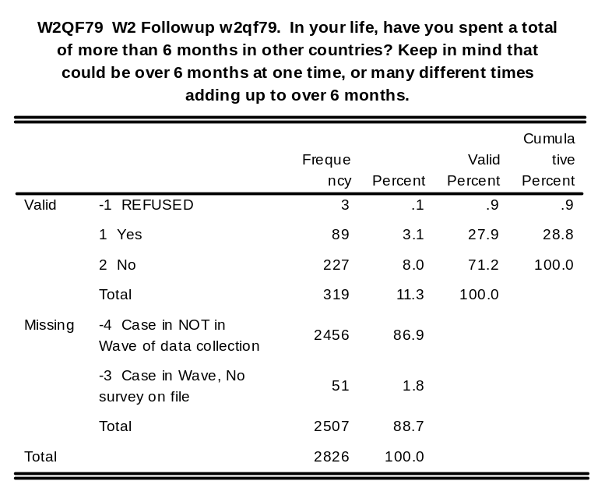
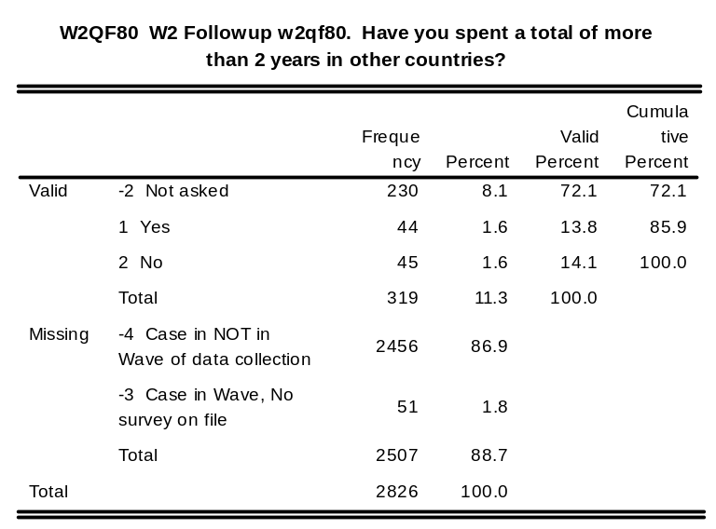
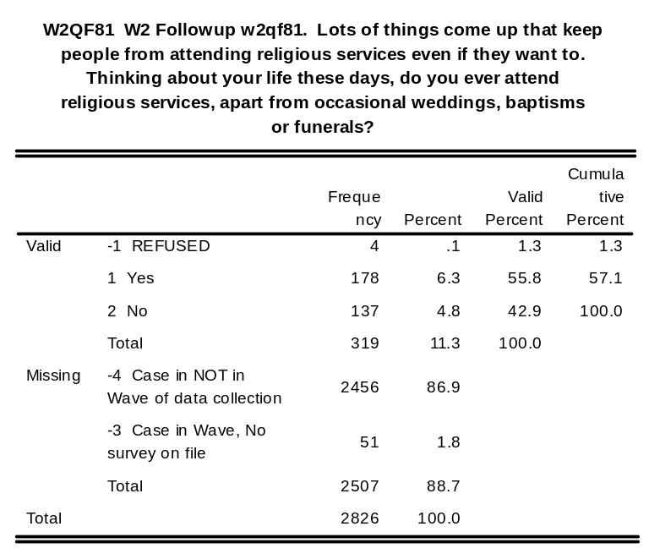
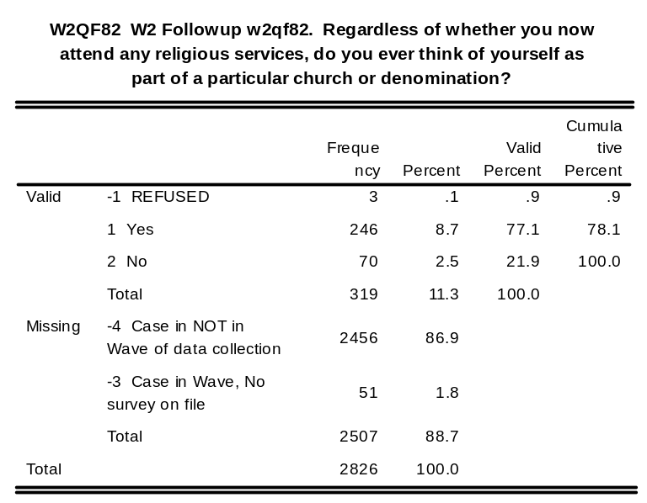
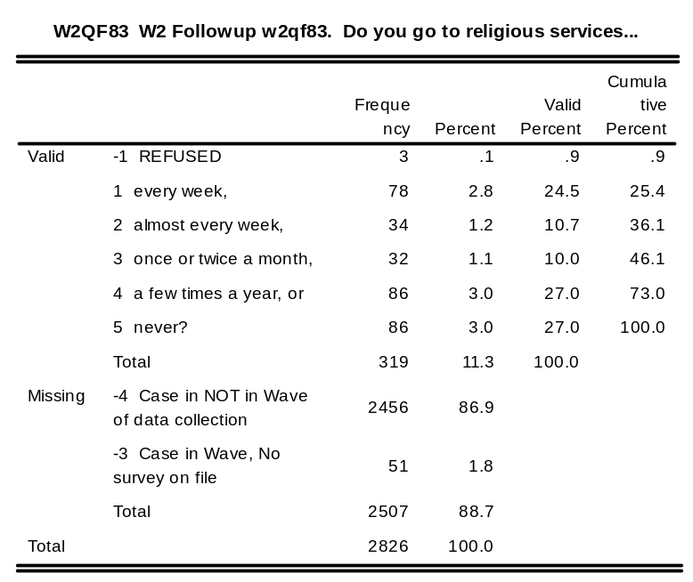
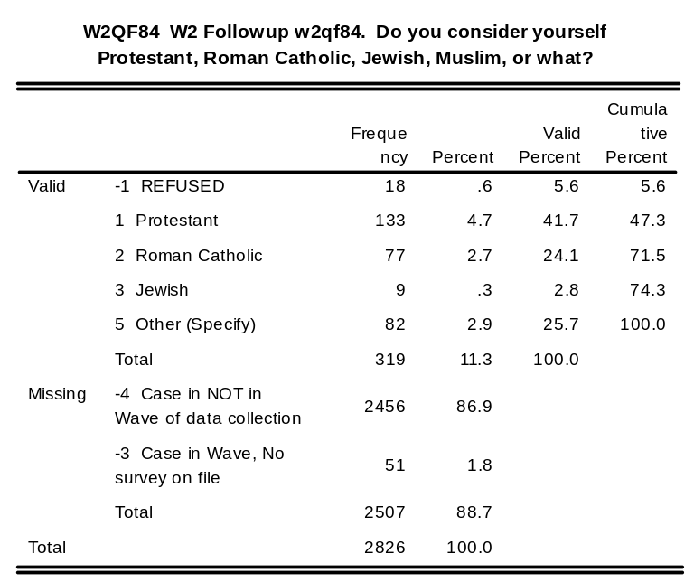
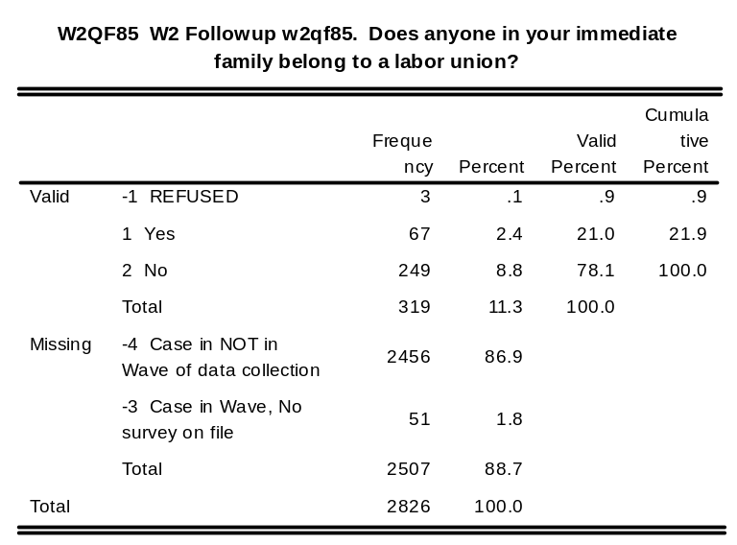
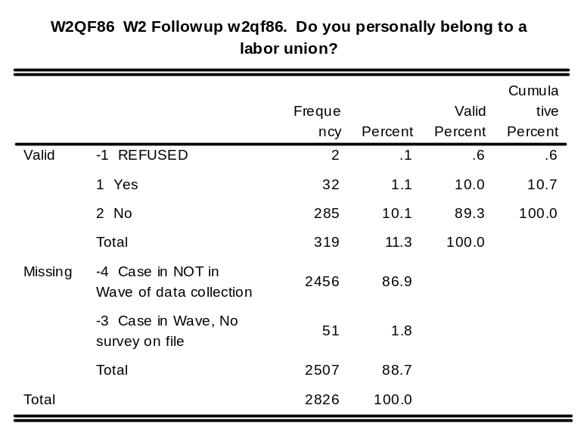

w2qf46o: W2 Followup w2qf46o. Q46A Other

w2qf69o: W2 Followup w2qf69o. Q69 Other

w2qf70o: W2 Followup w2qf70o. Q70 Other

w2qf71o: W2 Followup w2qf71o. Q71 Other

w2qf75o: W2 Followup w2qf75o. Q75 Other

w2qf84o: W2 Followup w2qf84o. Q84 Other

w2qff1: W2 Followup w2qff1. QF1 (last question)

Wave 3 Baseline/Follow-up Survey Codebook

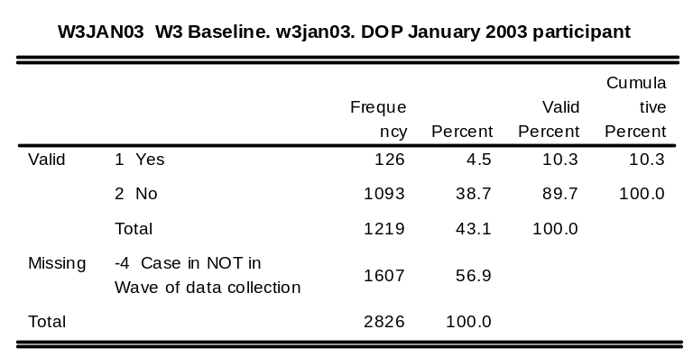
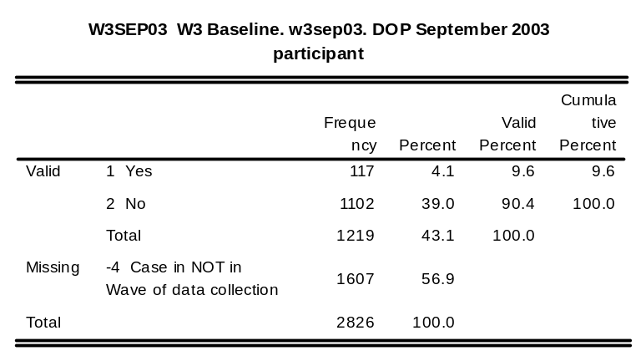
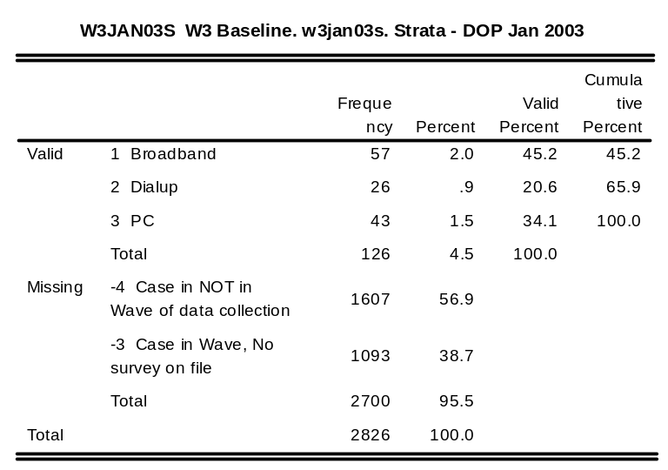
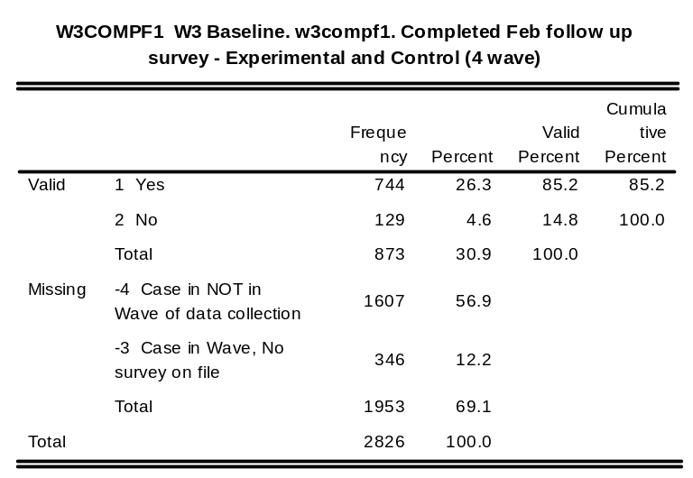

w3bdst: W3 Baseline. w3bdst. Date interview started

w3btst: W3 Baseline. w3btst. Time interview started

w3bdend: W3 Baseline. w3bdend. Date interview ended

w3btend: W3 Baseline. w3btend. Time interview ended

w3bdur: W3 Baseline. w3bdur. Duration of interview in minutes

w3bdurct: W3 Baseline. w3bdurct. Duration of interview (categorized in 5-minute intervals)

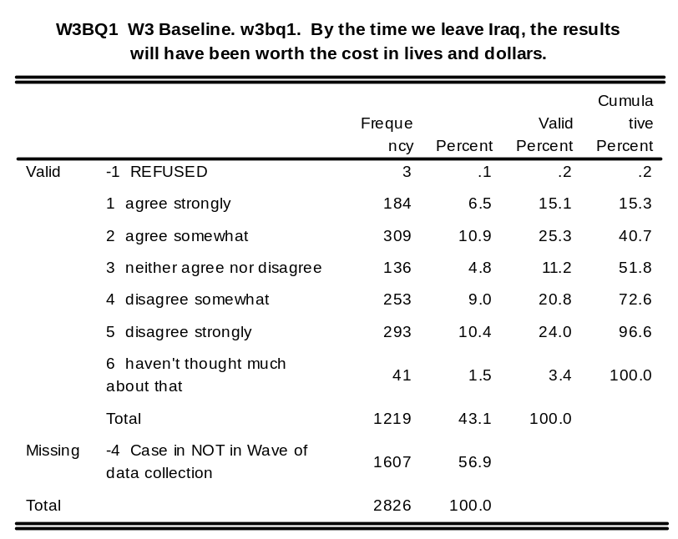
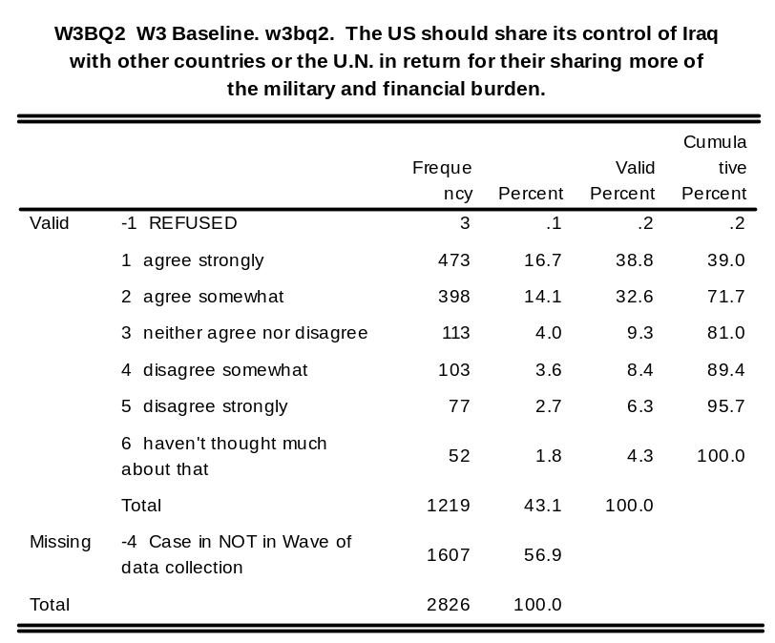
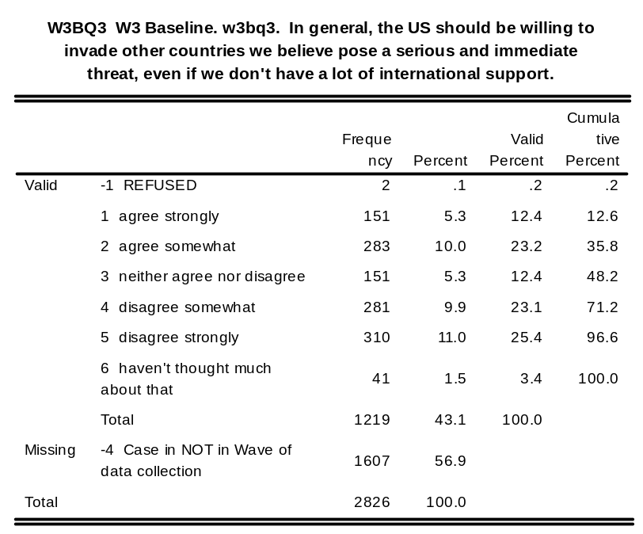
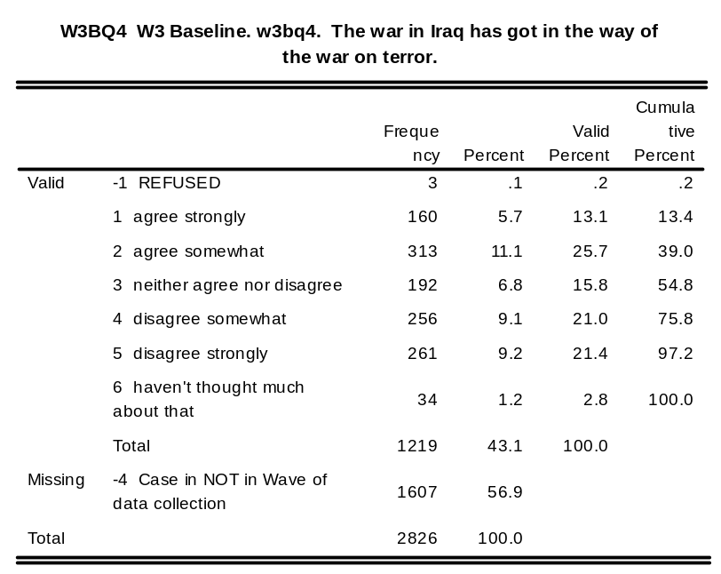
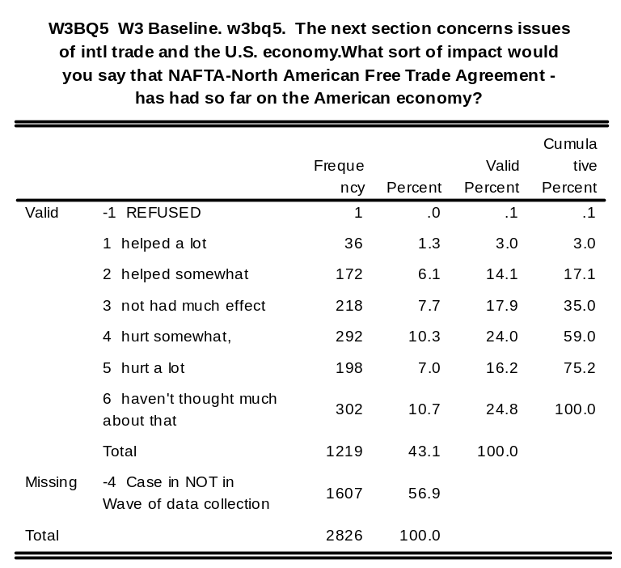
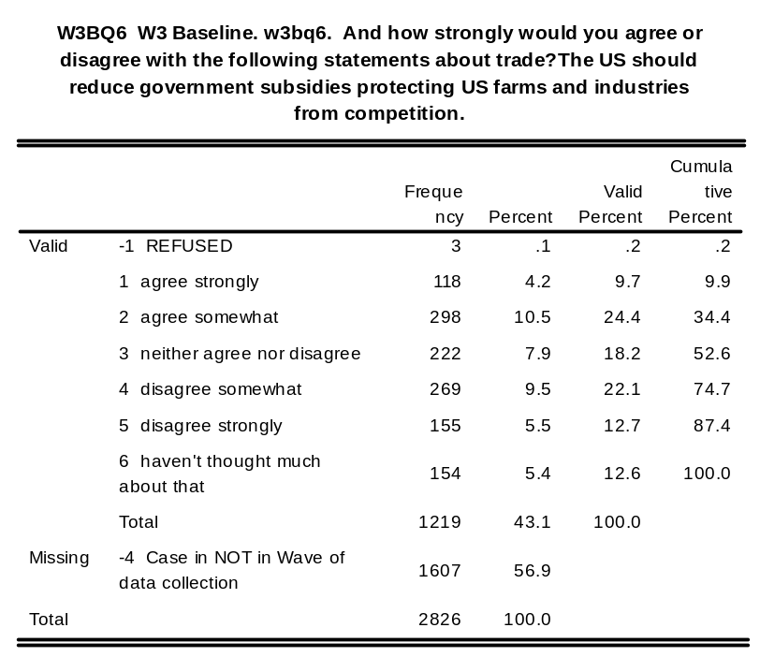
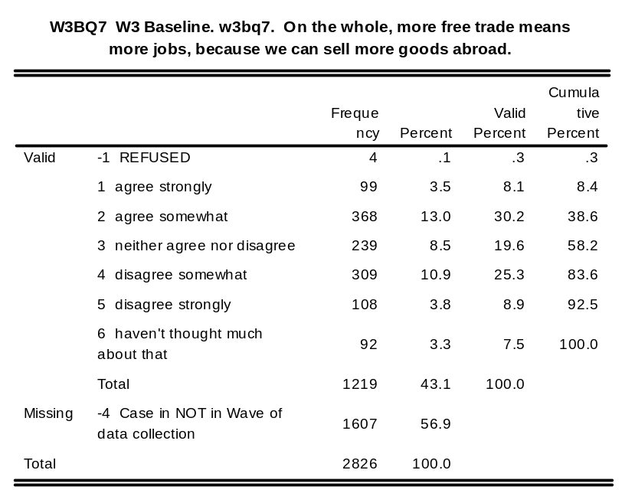
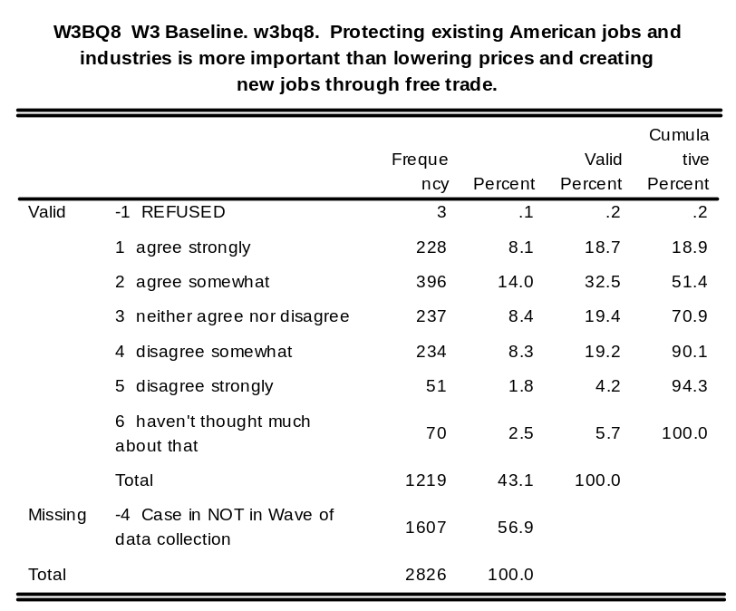
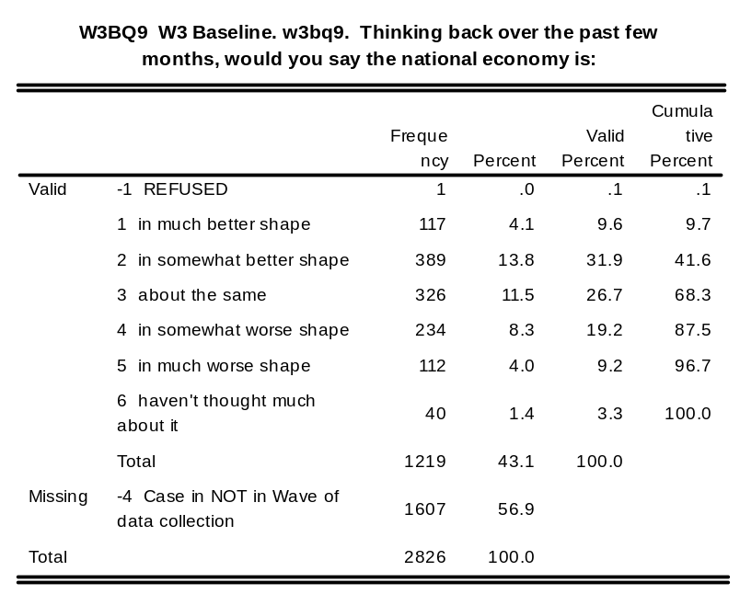
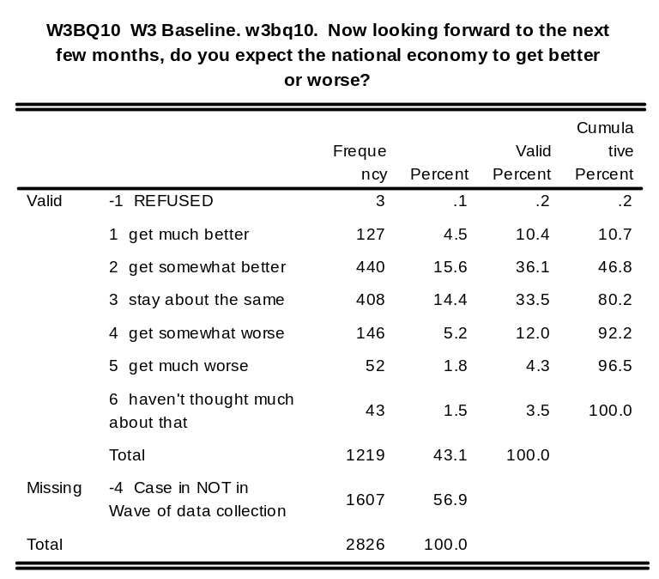
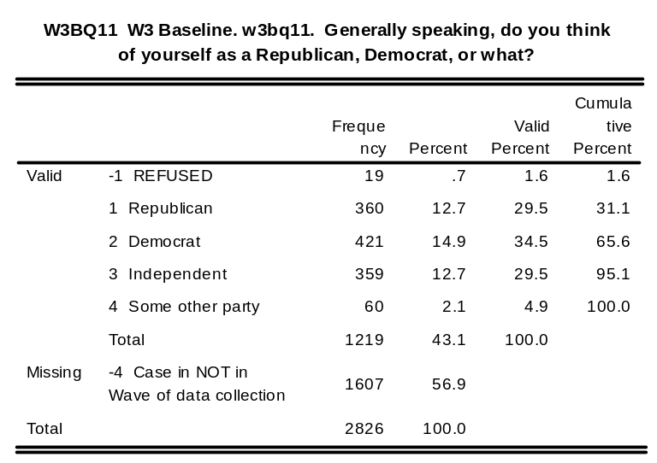
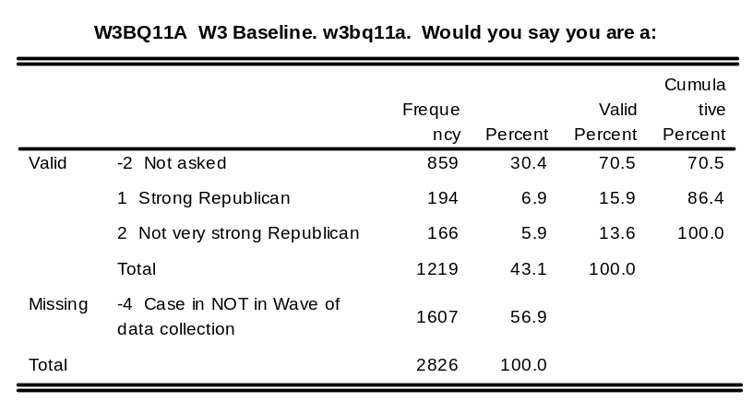
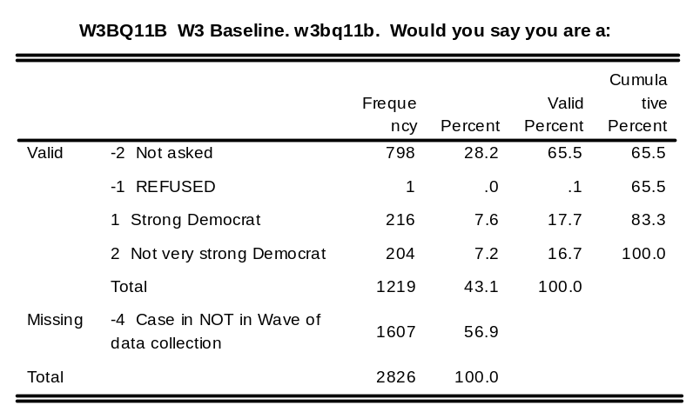
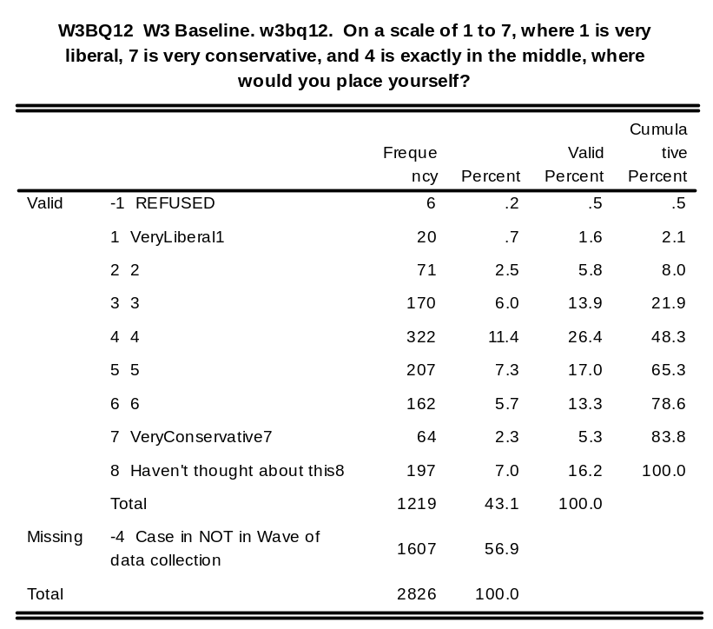
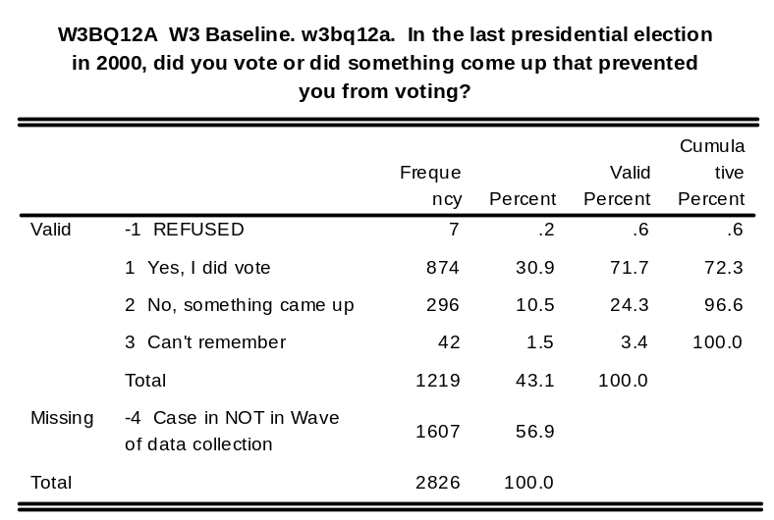
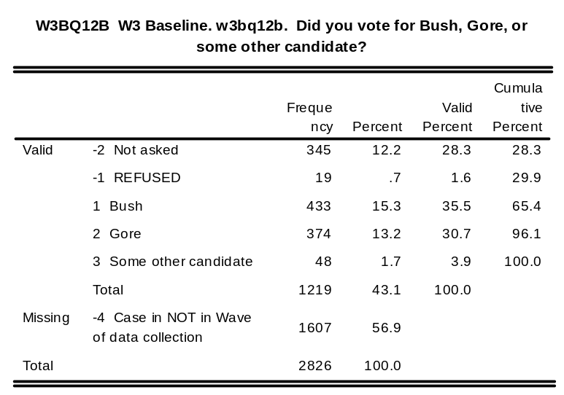
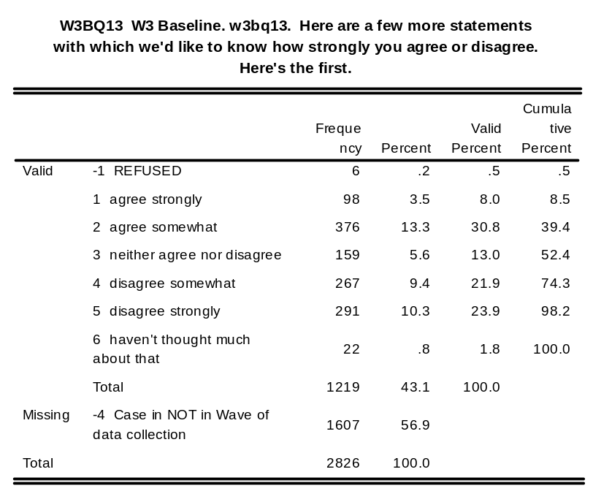
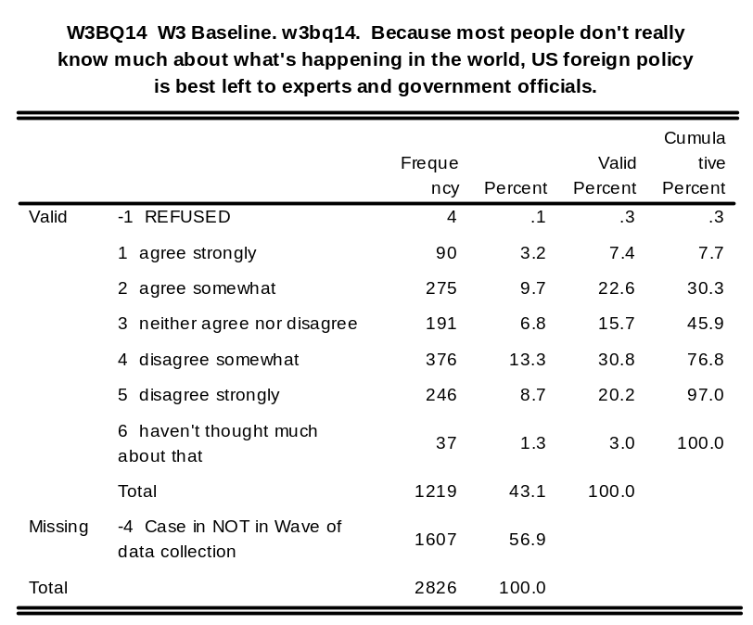
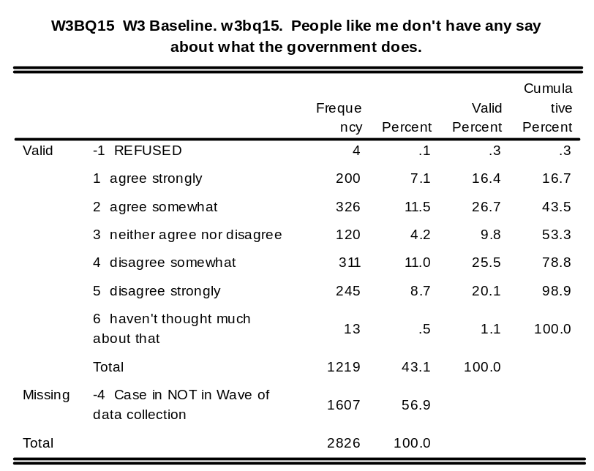
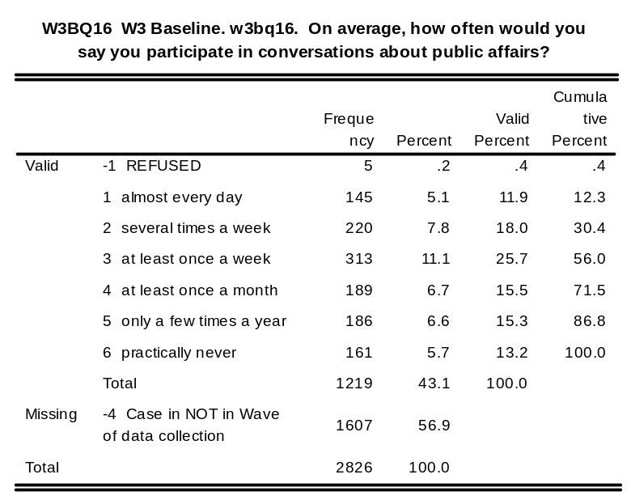
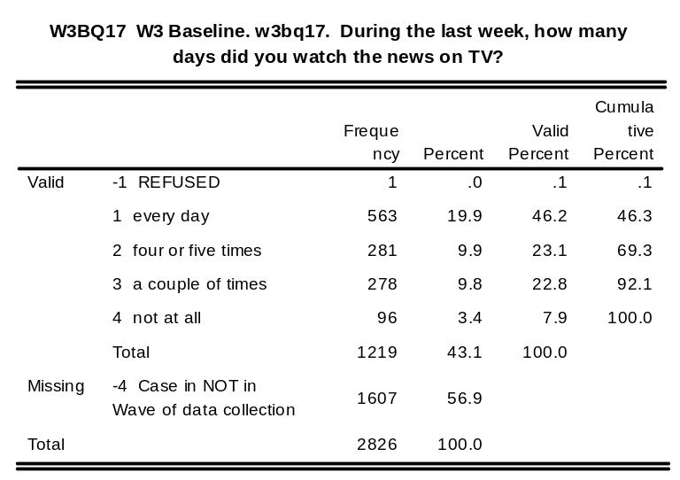
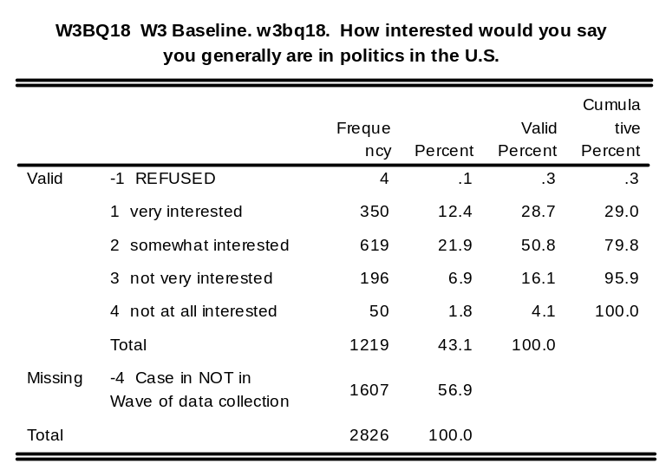
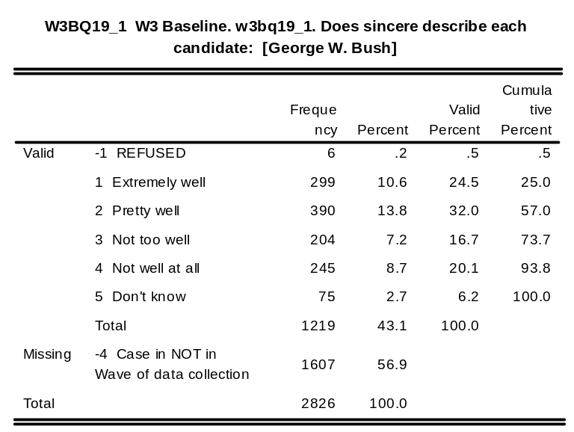
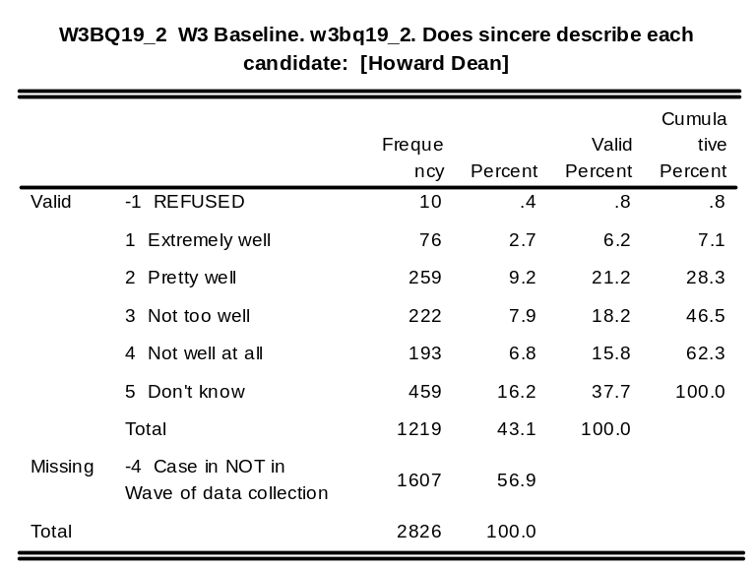
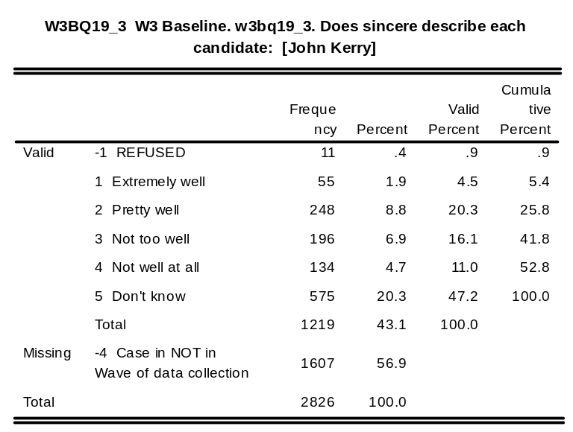
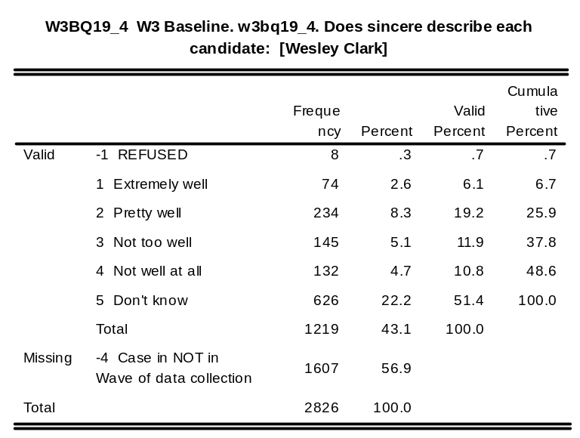
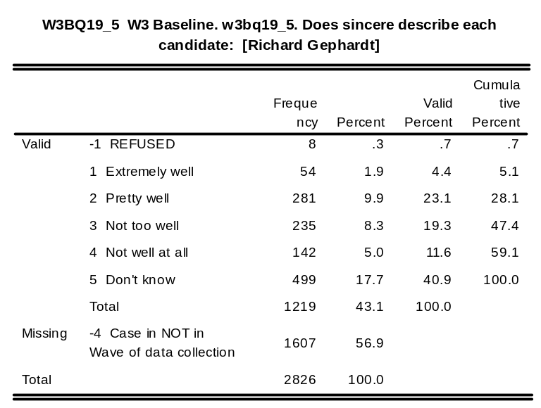
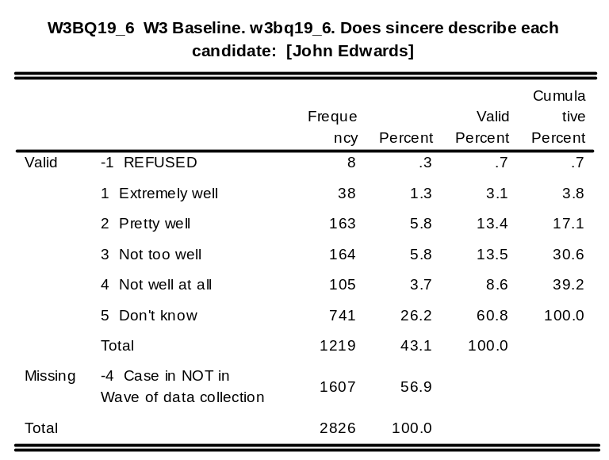
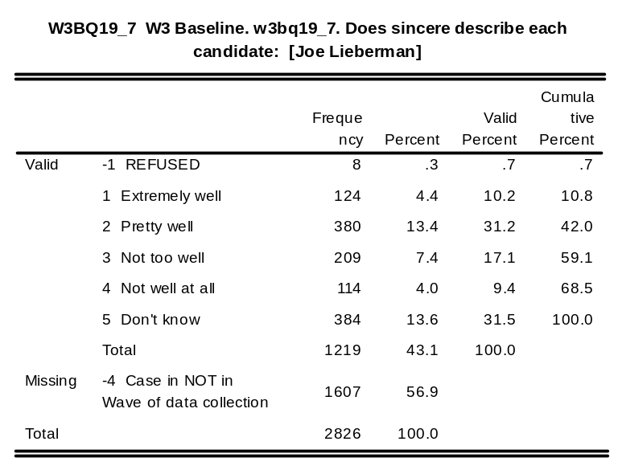
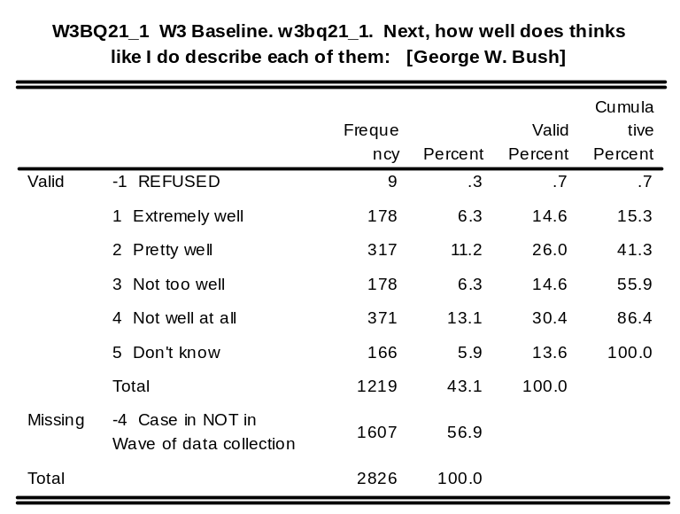
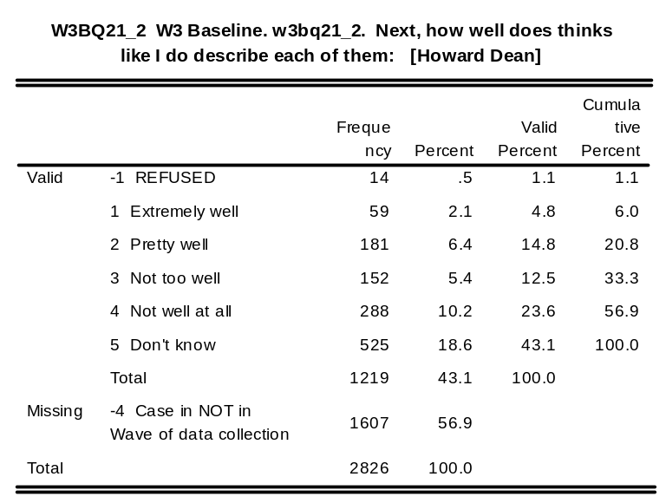
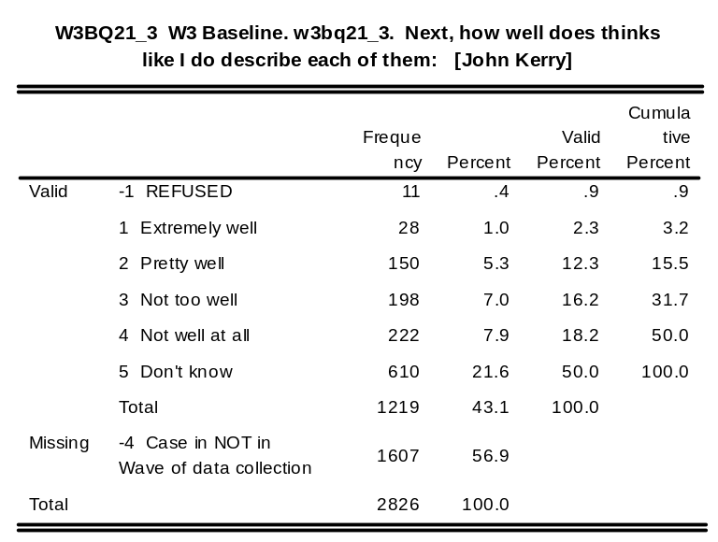
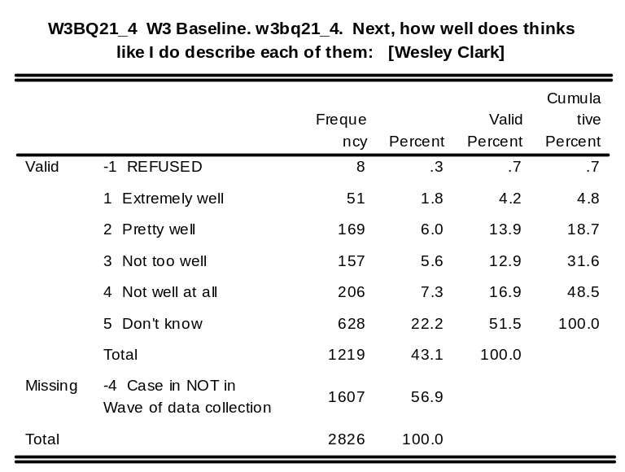
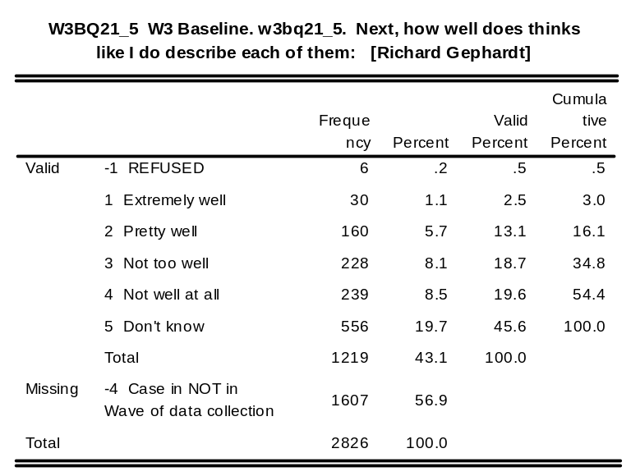
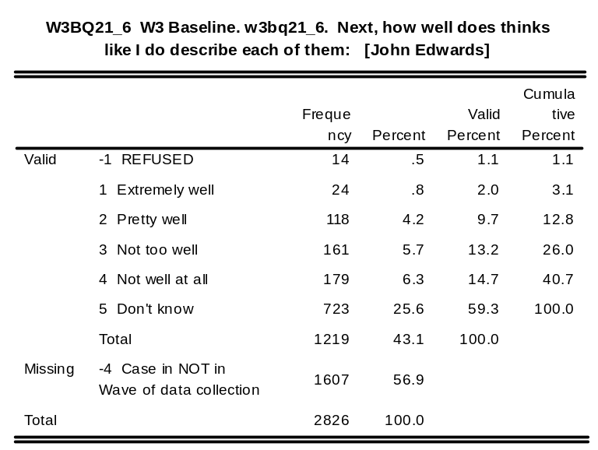
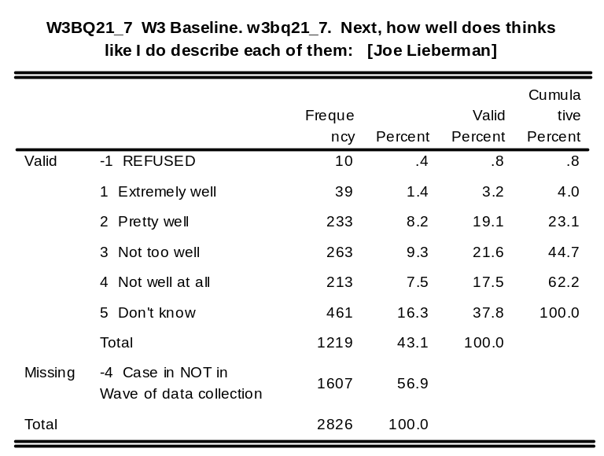
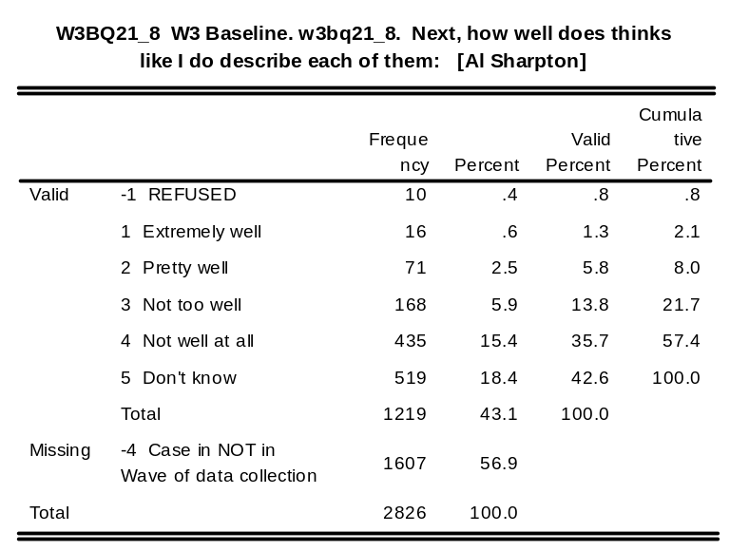

w3bq22_1: W3 Baseline. w3bq22_1. Q22: [George W. Bush - 0 - 100]

w3bq22_2: W3 Baseline. w3bq22_2. Q22: [Howard Dean - 0 - 100]

w3bq22_3: W3 Baseline. w3bq22_3. Q22: [John Kerry - 0 - 100]

w3bq22_4: W3 Baseline. w3bq22_4. Q22: [Wesley Clark - 0 - 100]

w3bq22_5: W3 Baseline. w3bq22_5. Q22: [Richard Gephardt - 0 - 100]

w3bq22_6: W3 Baseline. w3bq22_6. Q22: [John Edwards - 0 - 100]

w3bq22_7: W3 Baseline. w3bq22_7. Q22: [Joe Lieberman - 0 - 100]

w3bq22_8: W3 Baseline. w3bq22_8. Q22: [Al Sharpton - 0 - 100]

w3bq22_9: W3 Baseline. w3bq22_9. Q22: [Carol Moseley Braun - 0 - 100]

w3bq2210: W3 Baseline. w3bq2210. Q22: [Dennis Kucinich - 0 - 100]

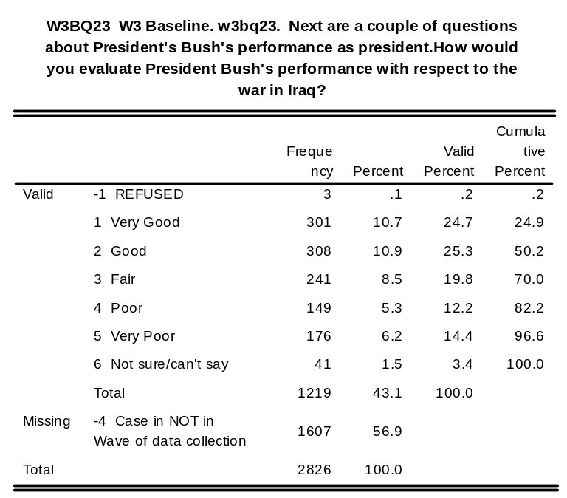
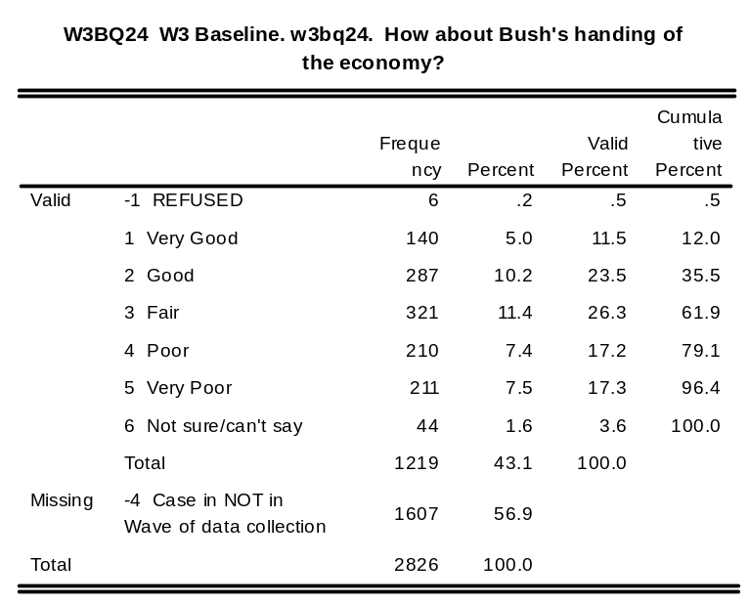
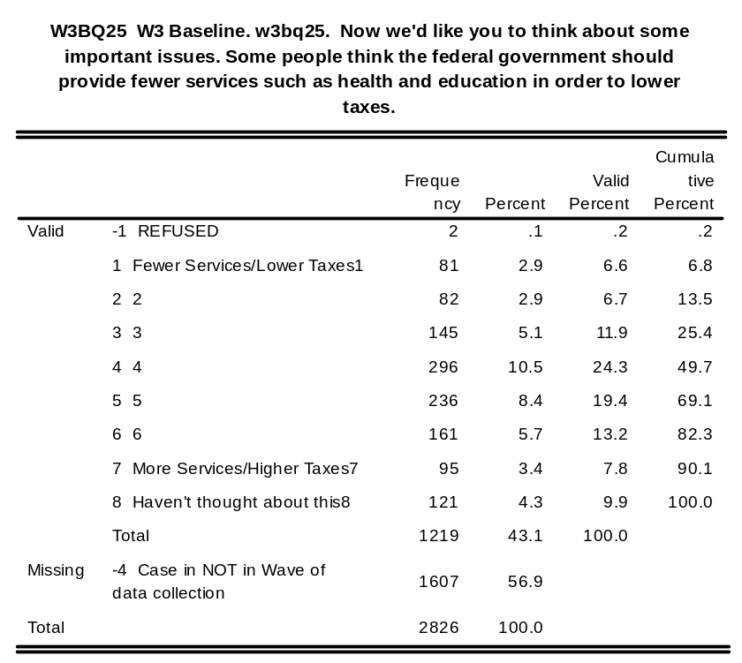
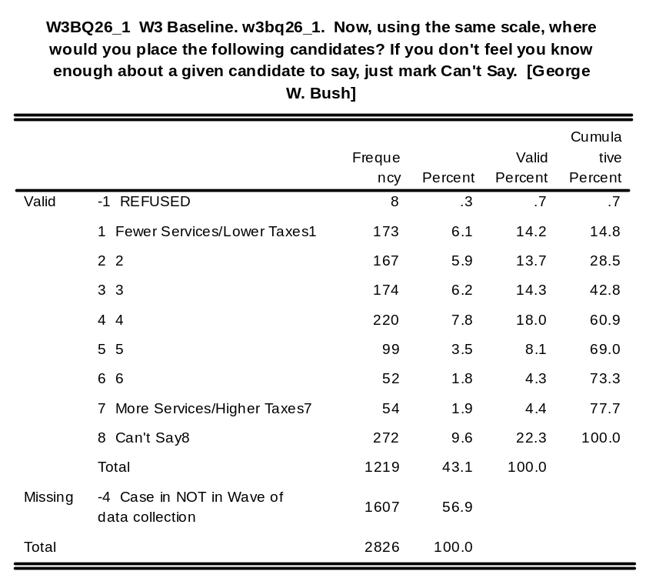
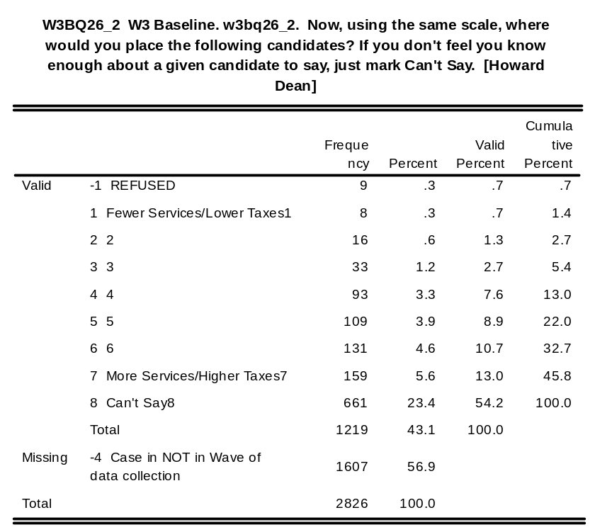
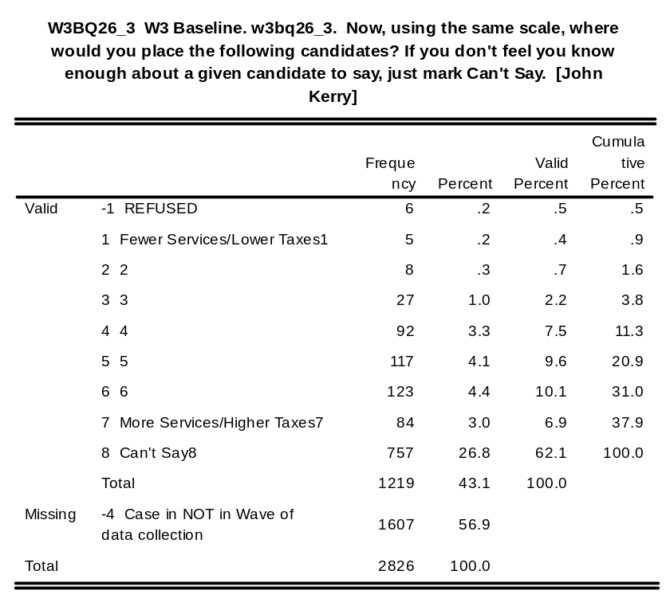
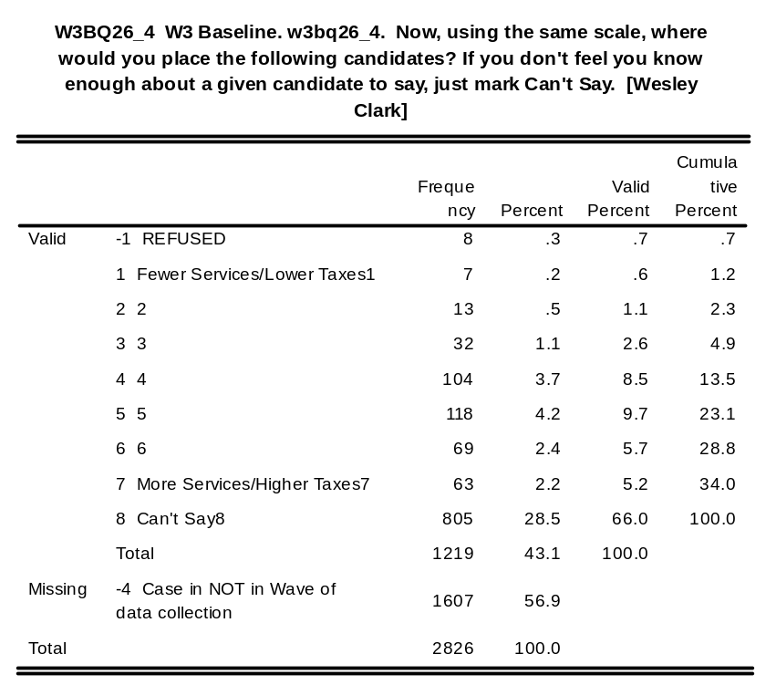
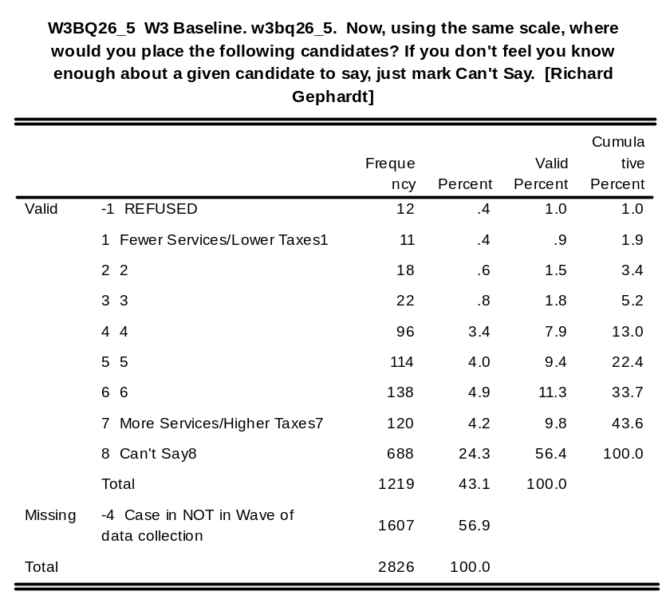
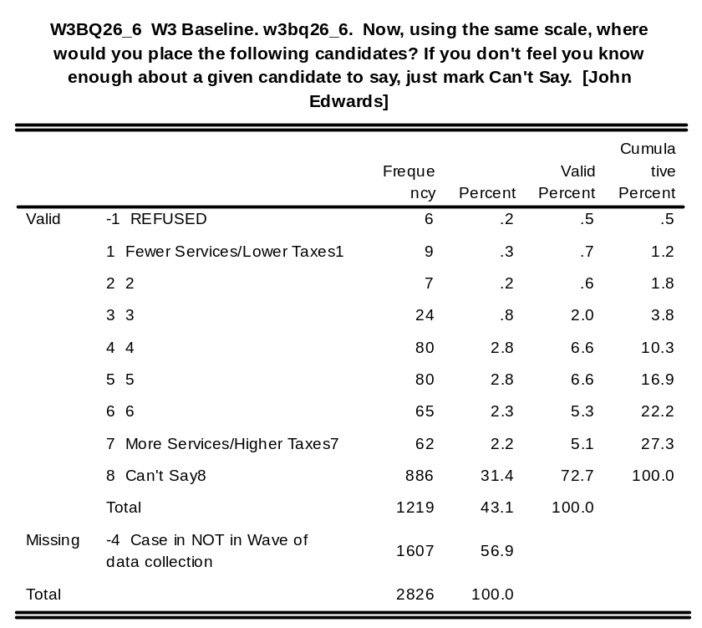
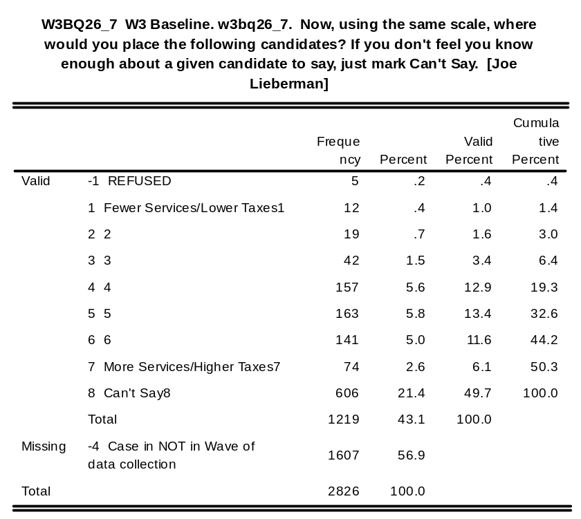
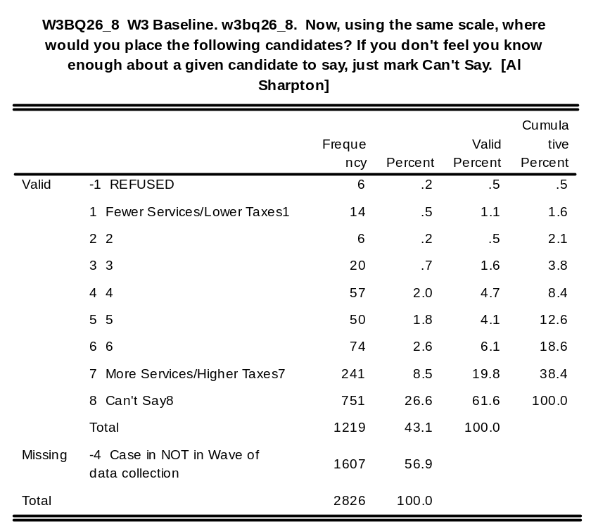
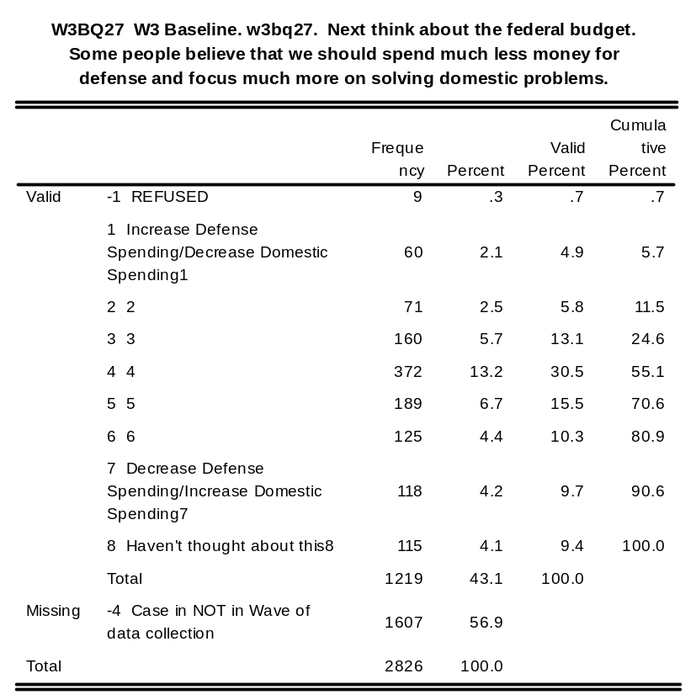
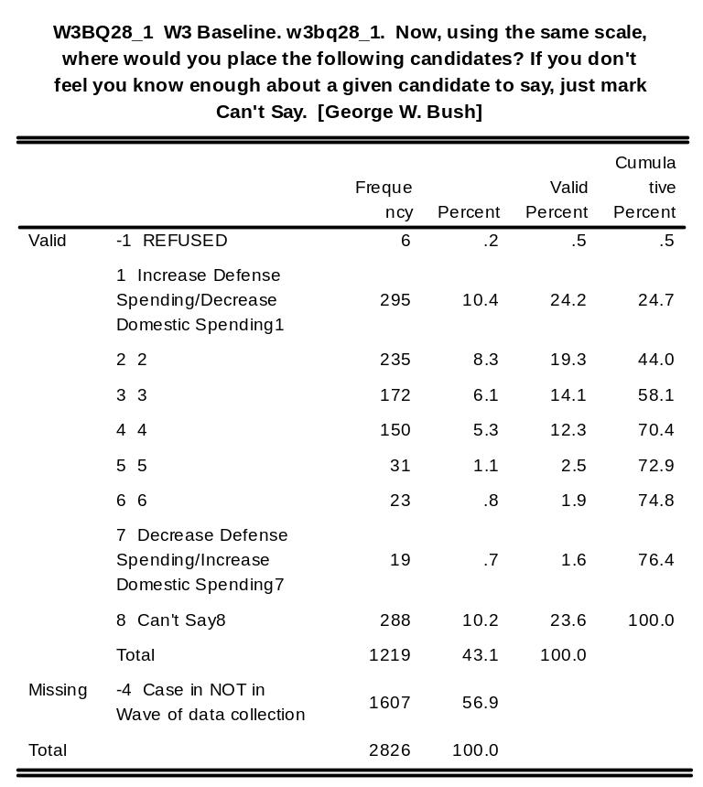
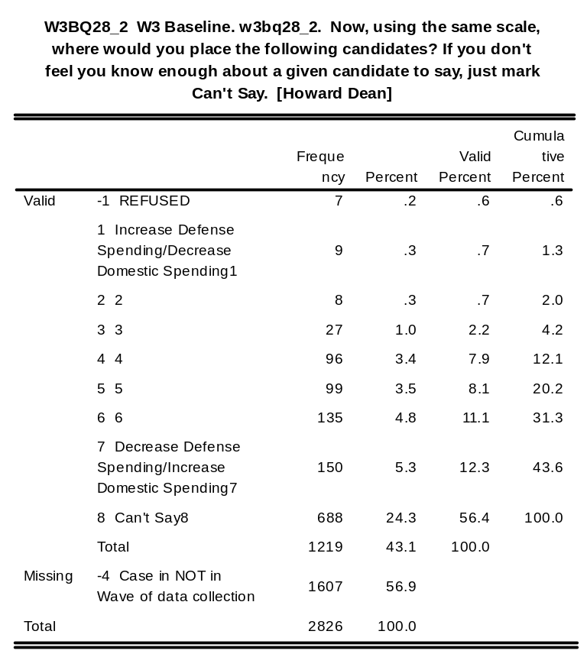
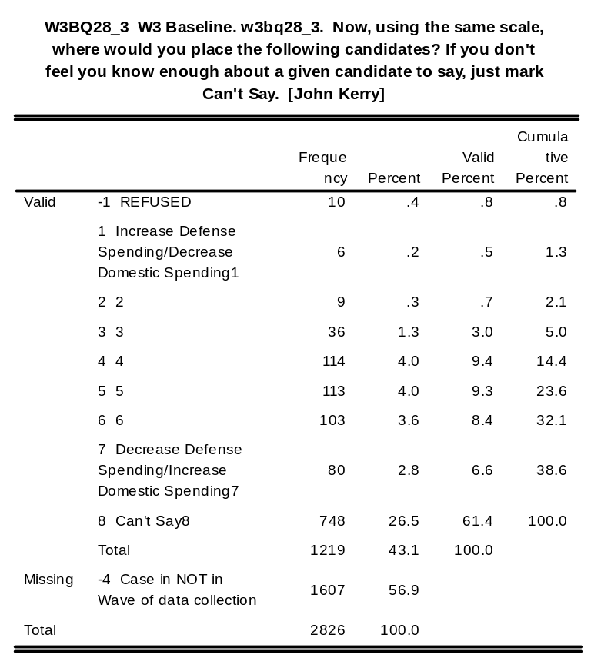
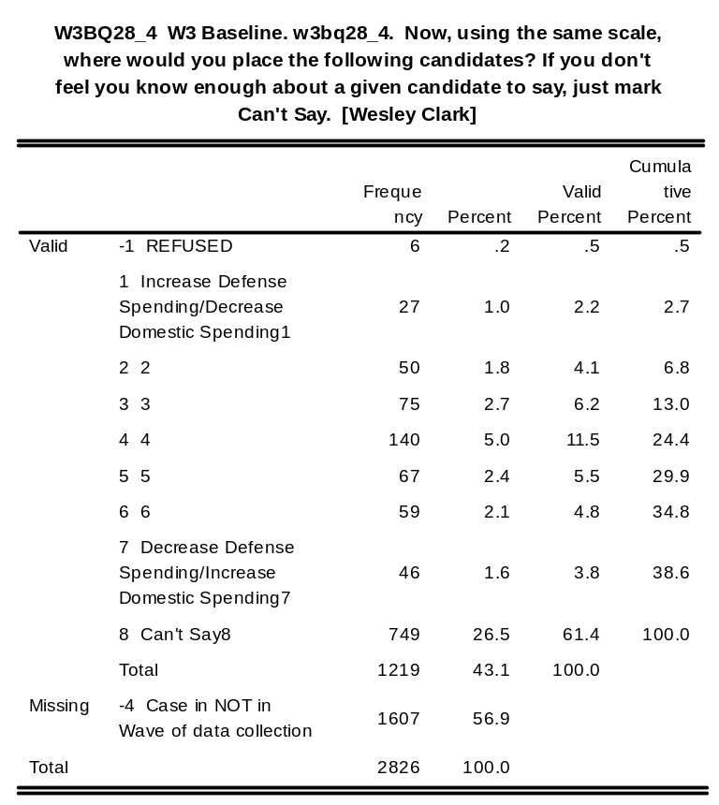
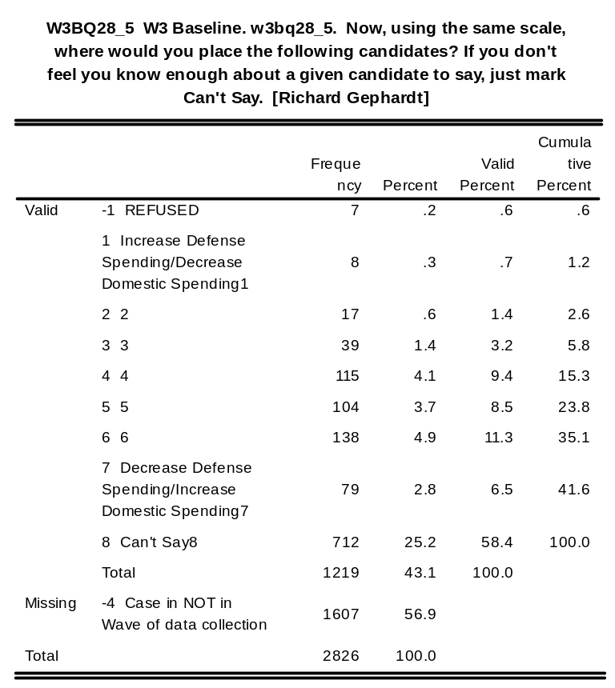
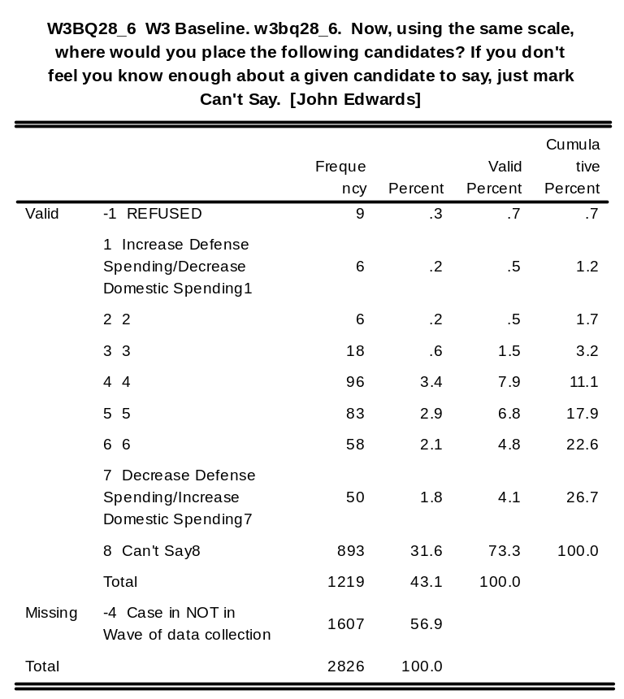
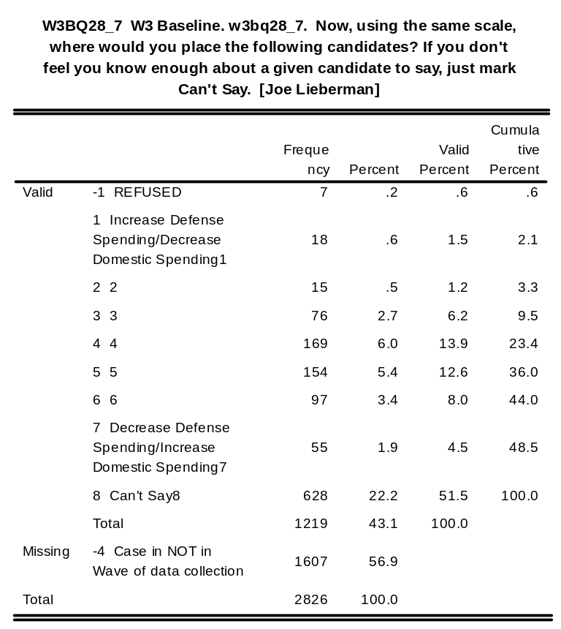
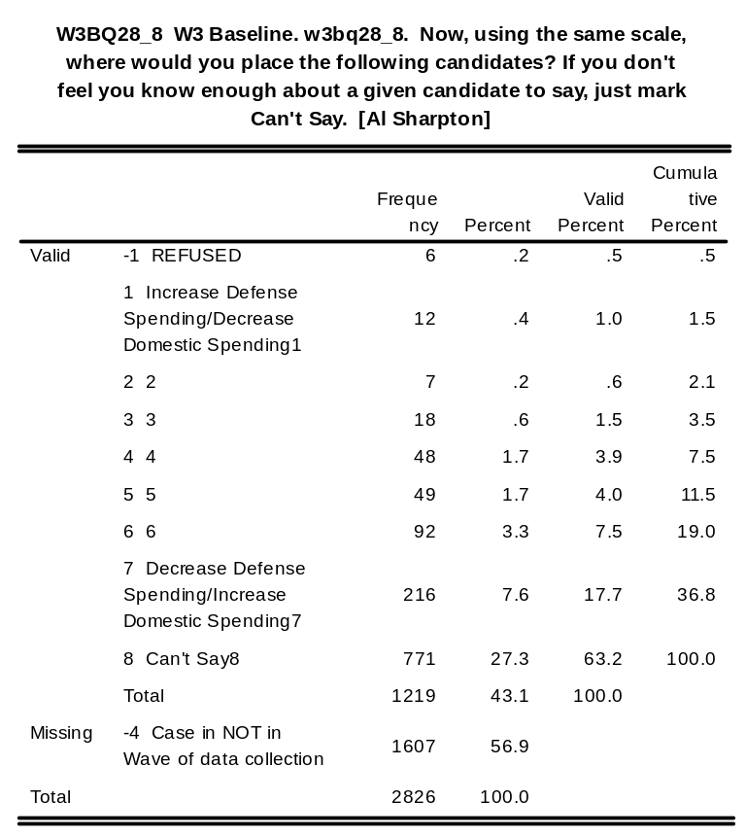
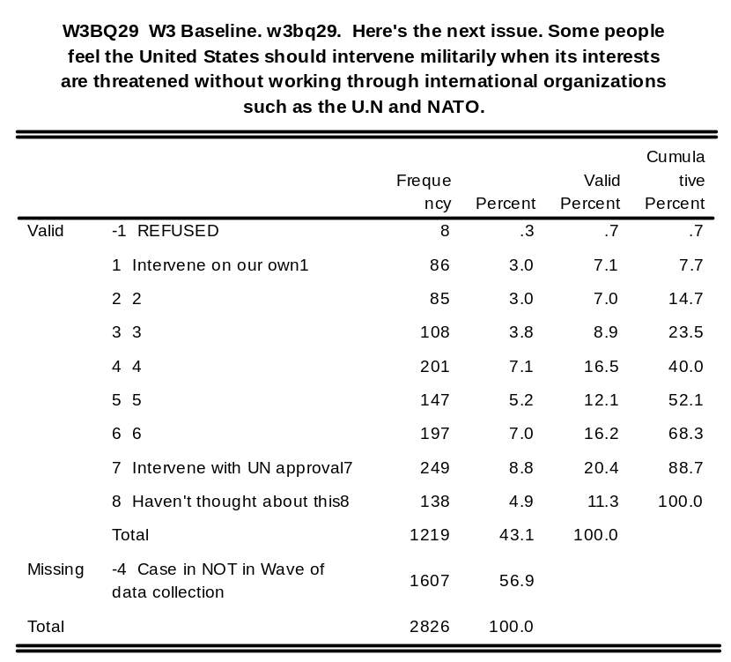
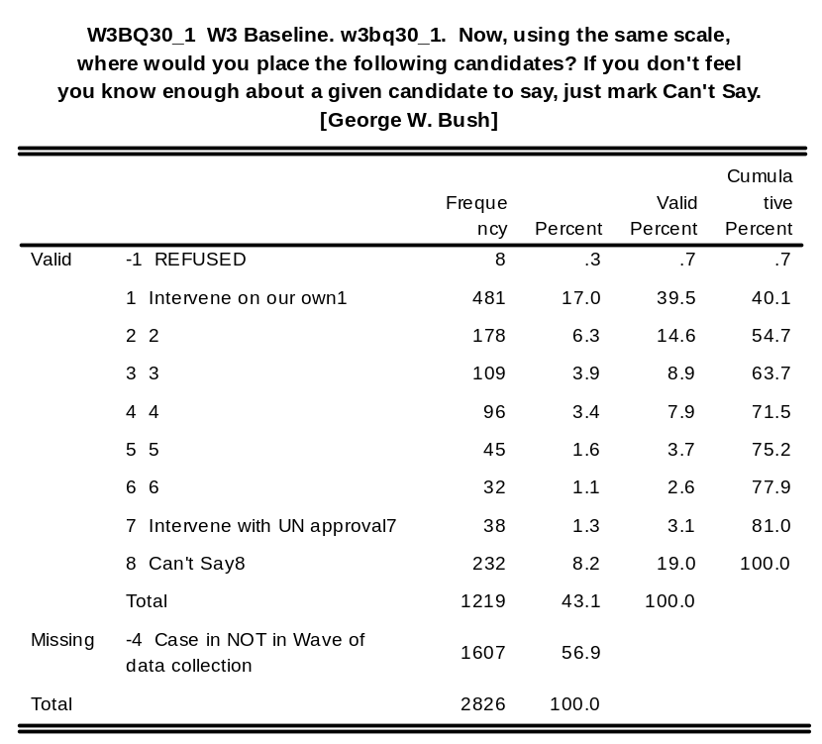
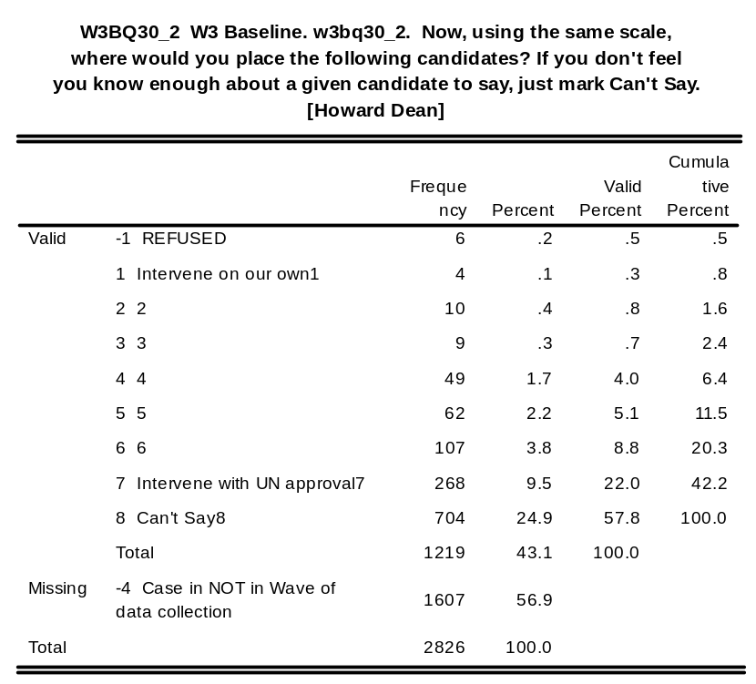
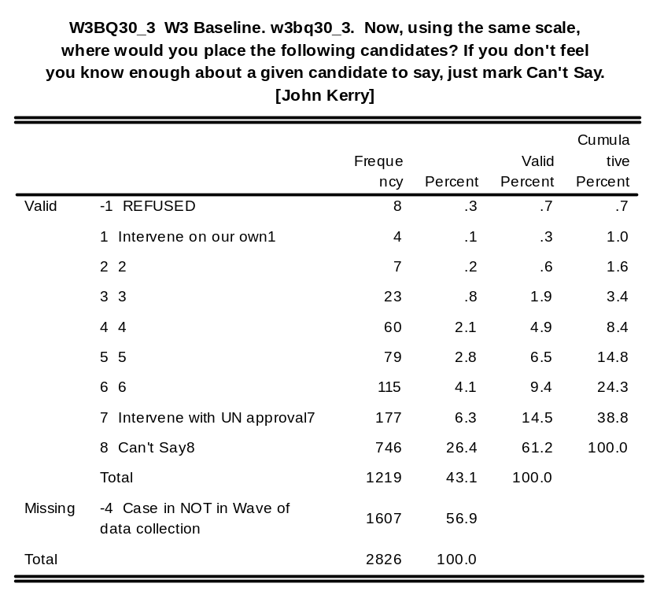
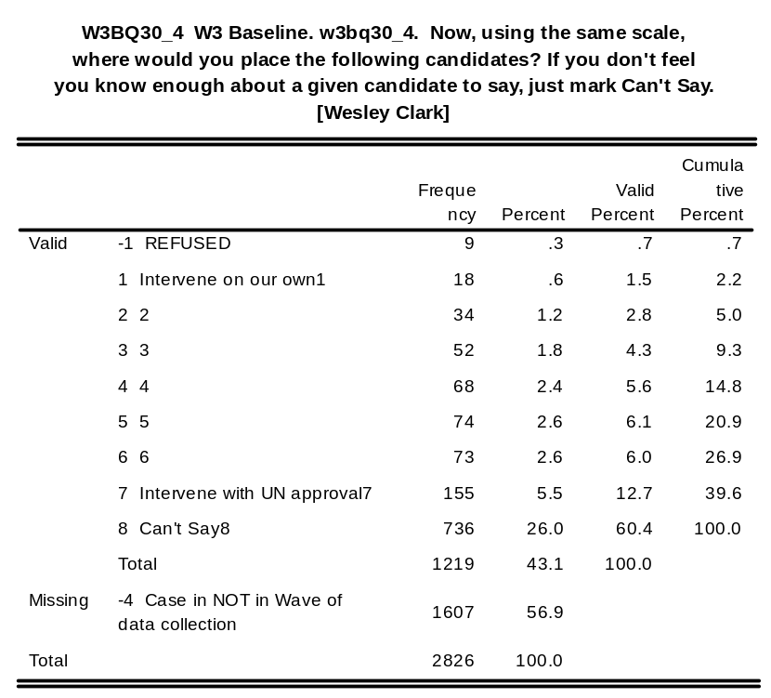
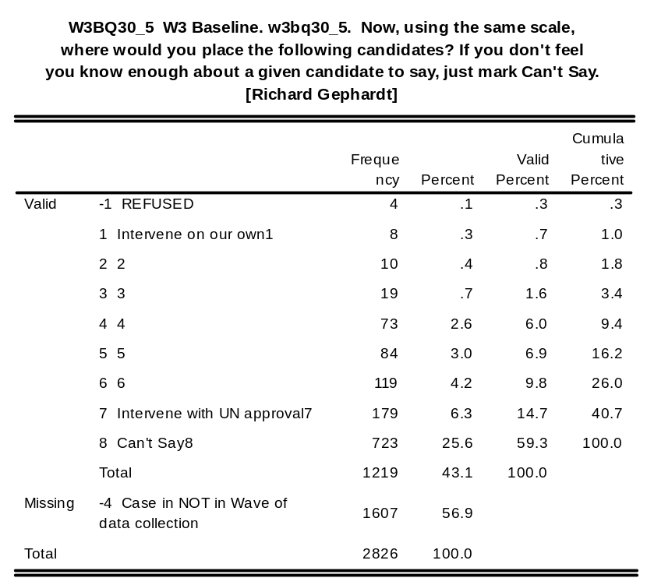
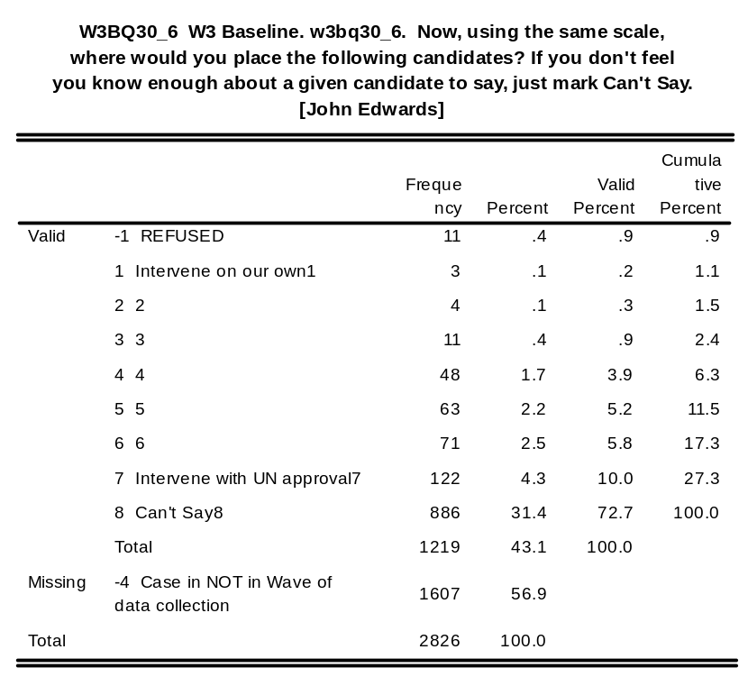
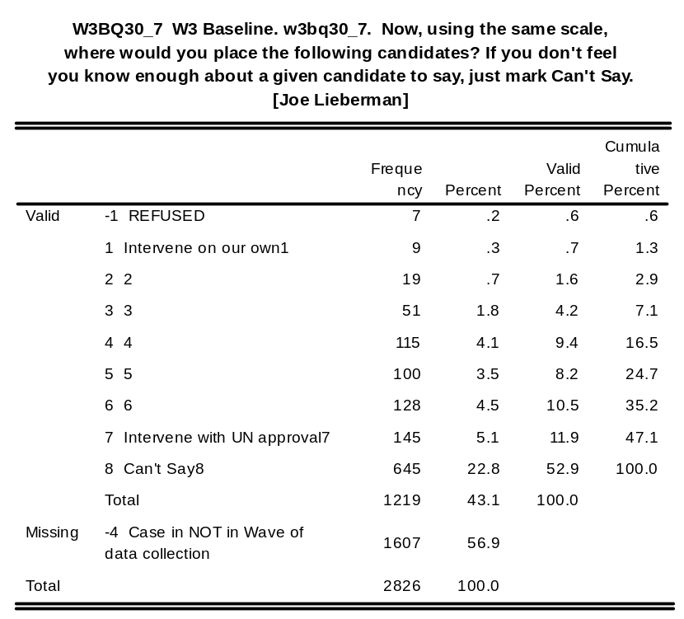
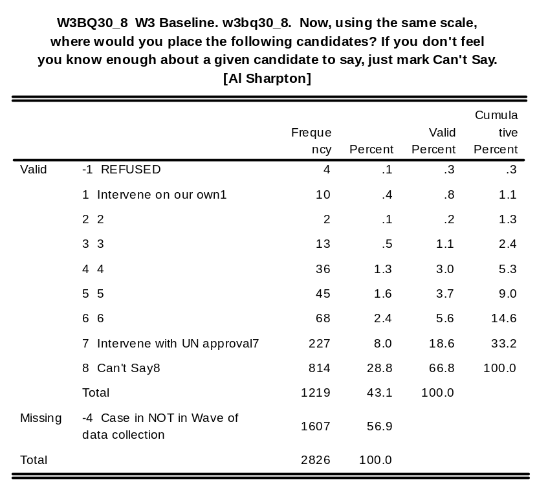
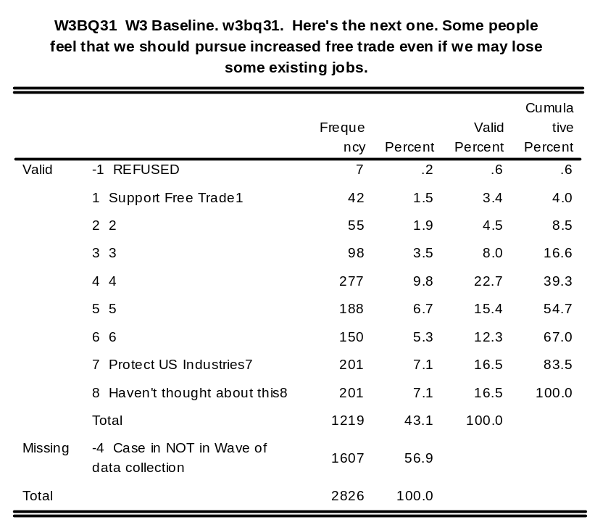
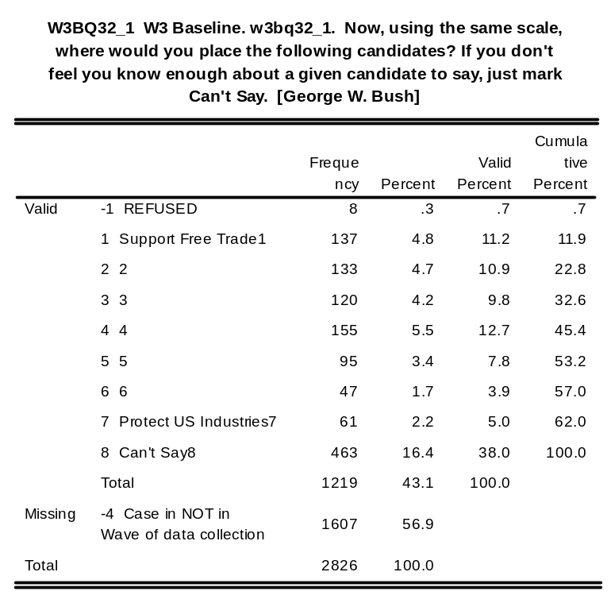
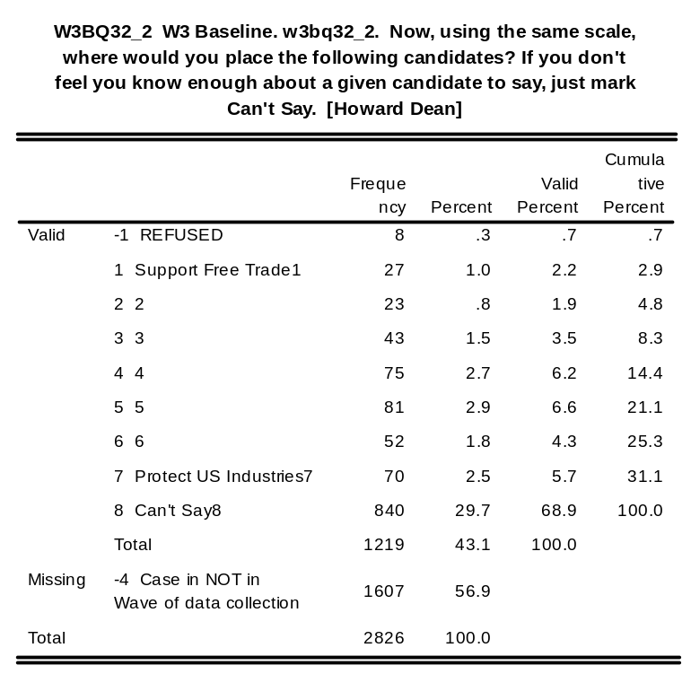
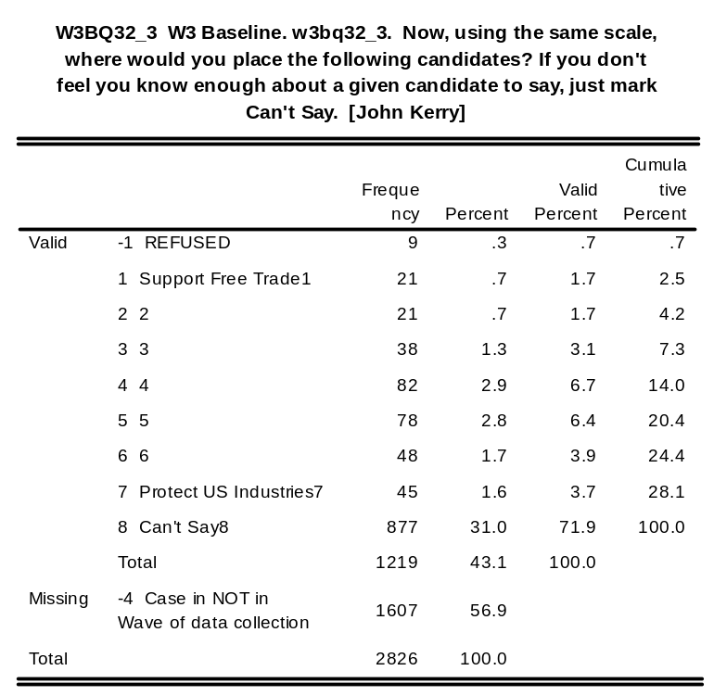
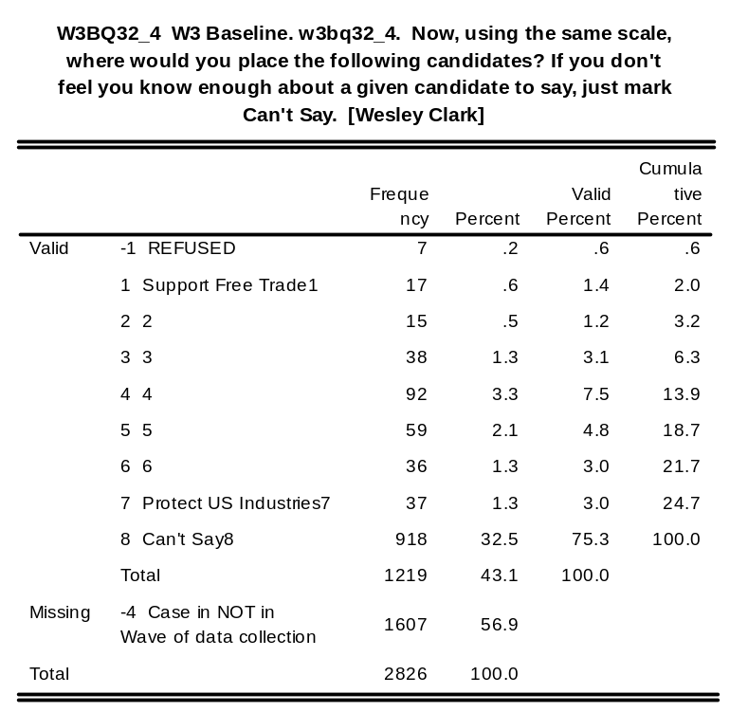
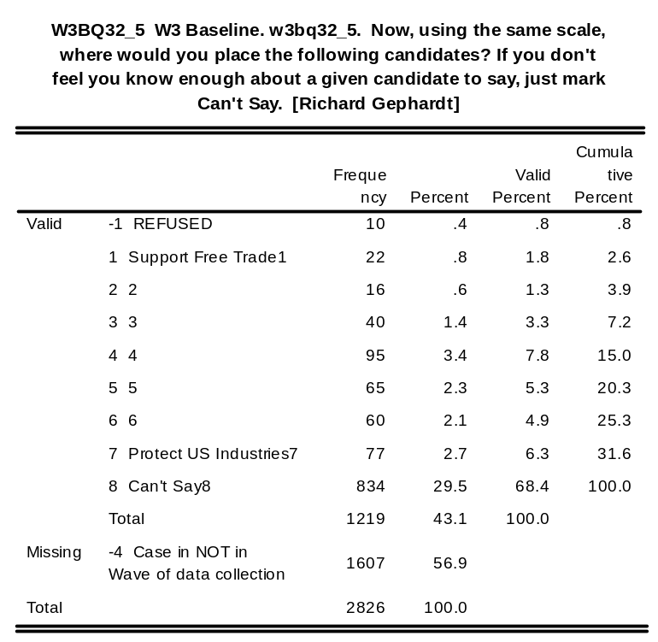
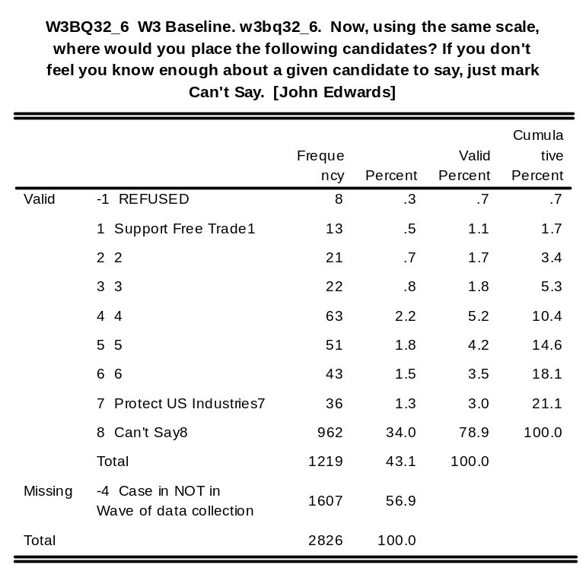
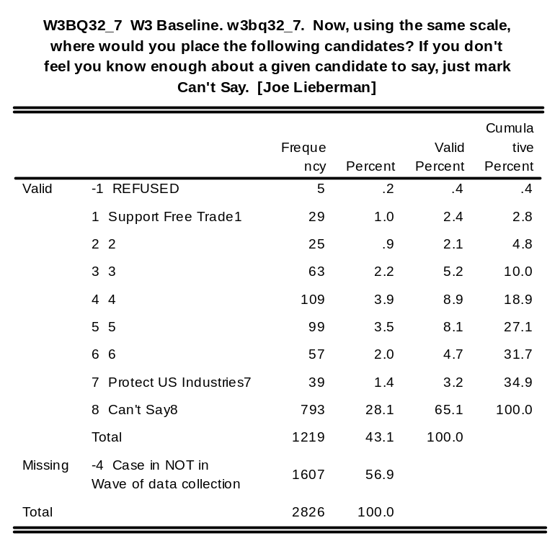
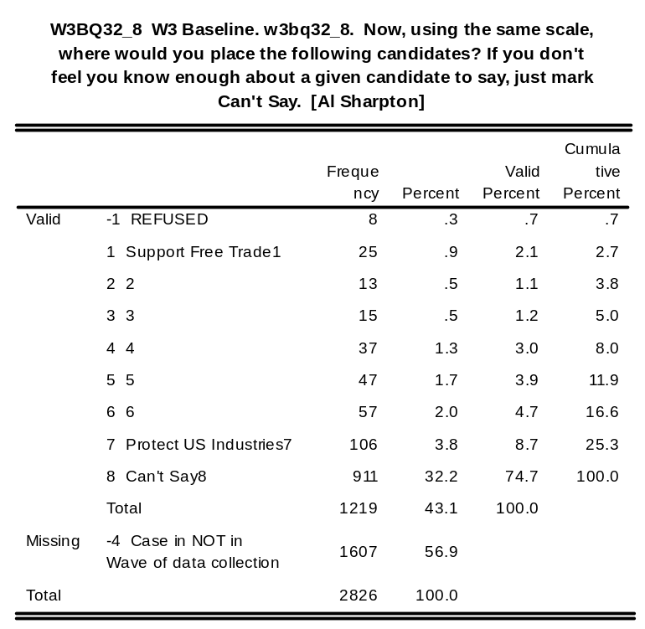

w3bq38: W3 Baseline. w3bq38. Who will you vote for in the primary

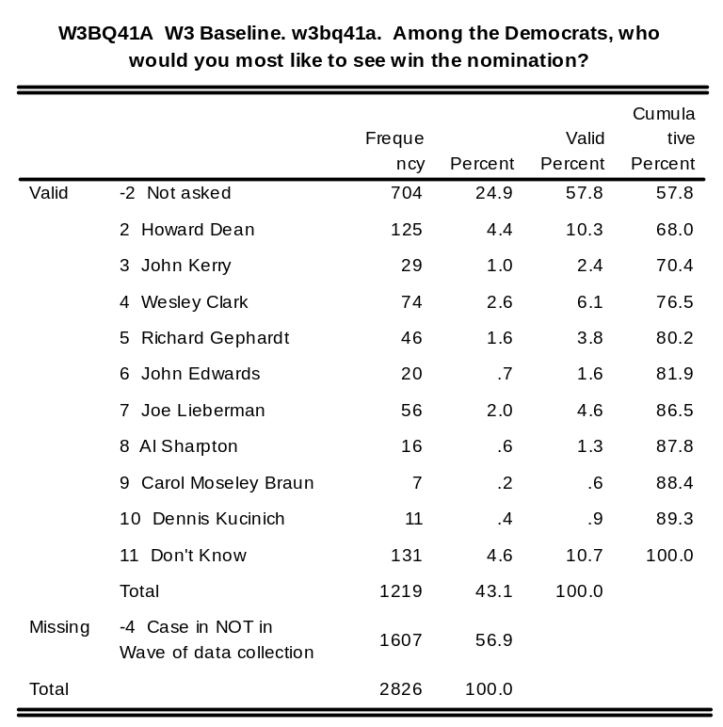
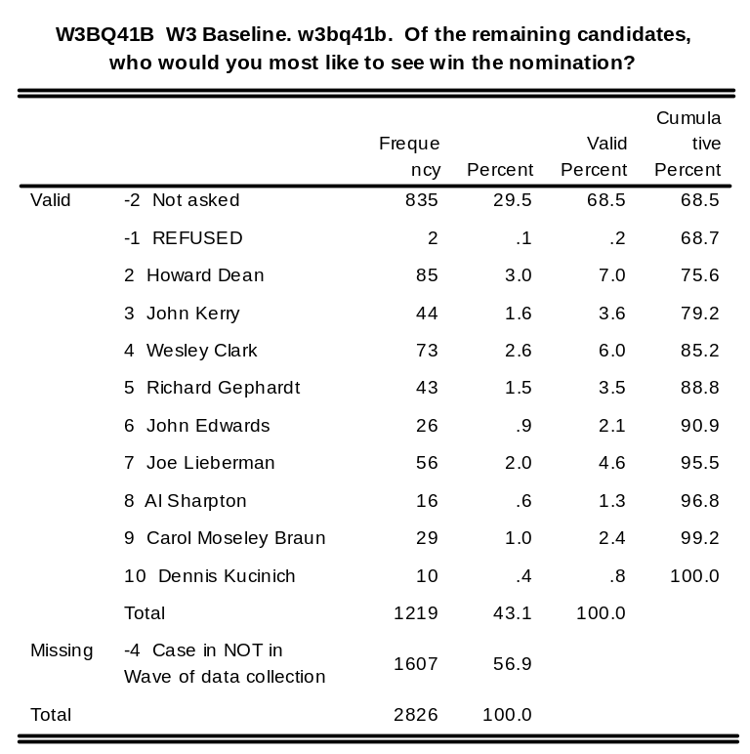
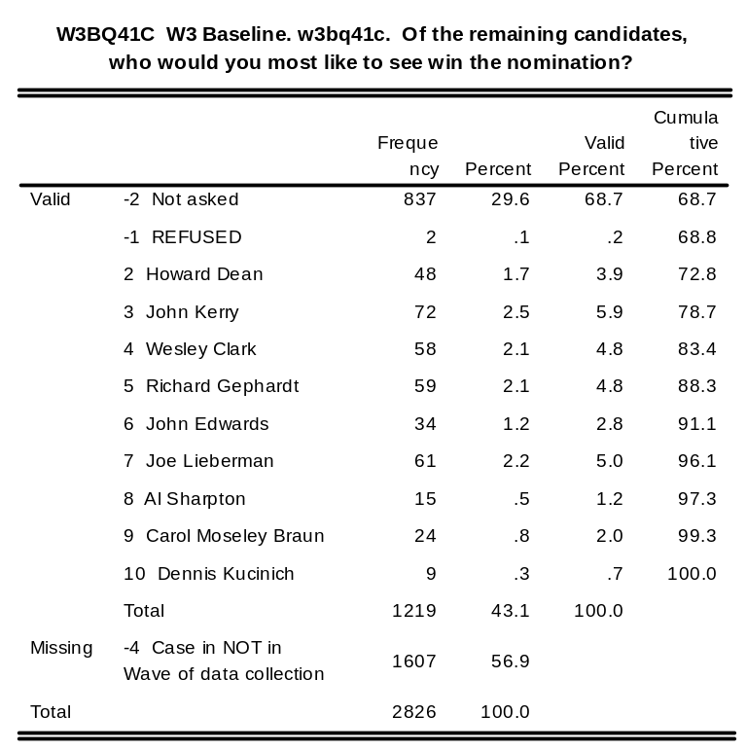
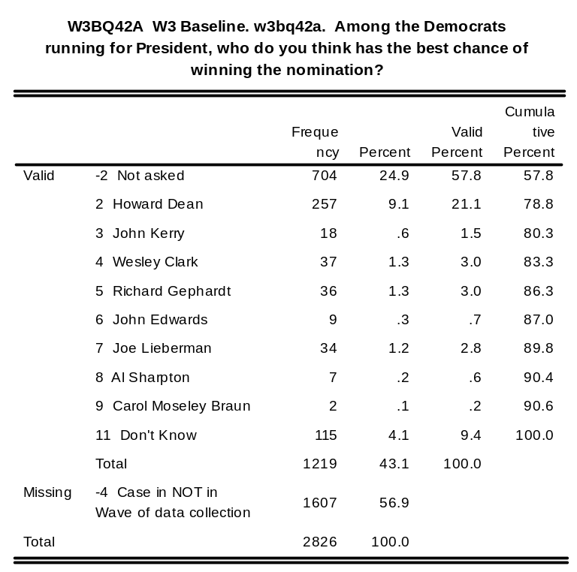
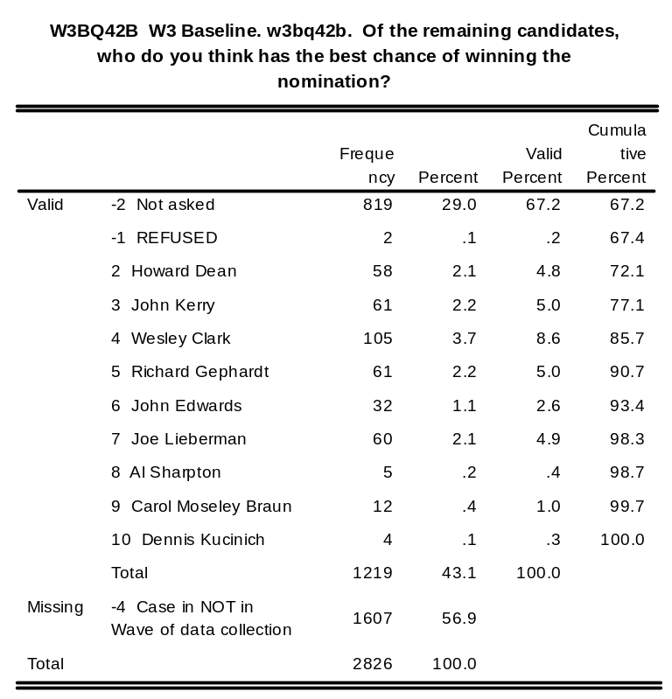
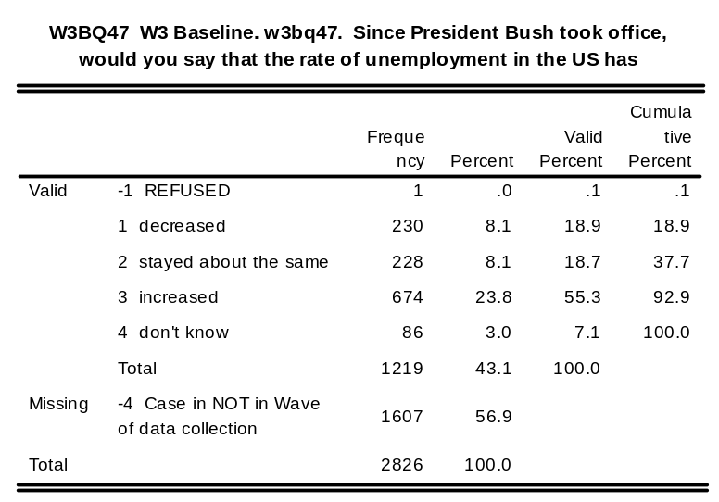
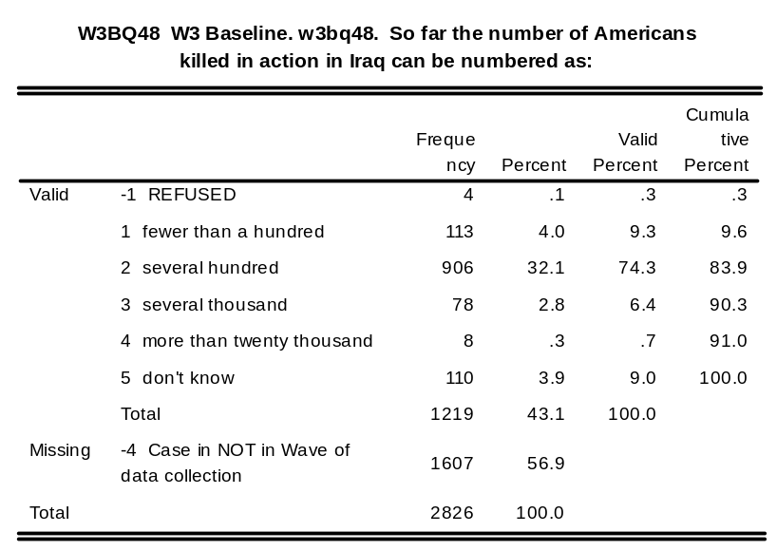
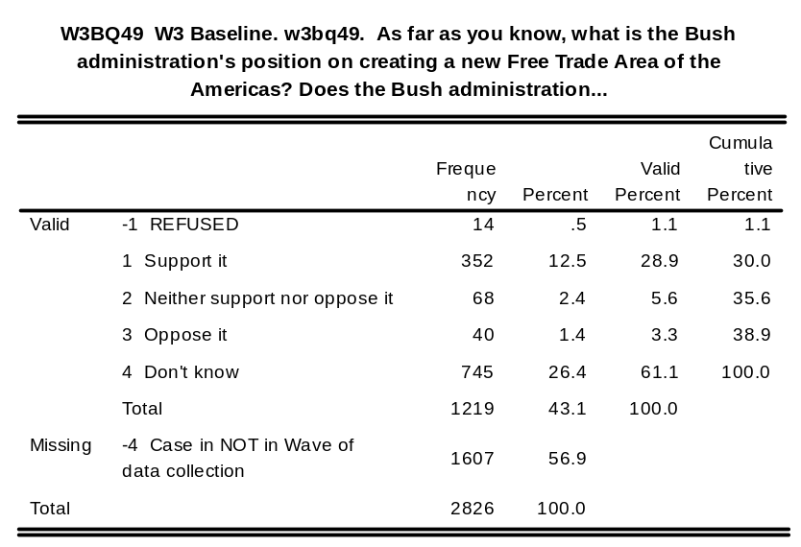

w3fdst: W3 Followup w3fdst. Date interview started

w3ftst: W3 Followup w3ftst. Time interview started

w3fdend: W3 Followup w3fdend. Date interview ended

w3ftend: W3 Followup w3ftend. Time interview ended

w3fdur: W3 Followup w3fdur. Duration of interview in minutes

w3fdurct: W3 Followup w3fdurct. Duration of interview (categorized in 5-minute intervals)

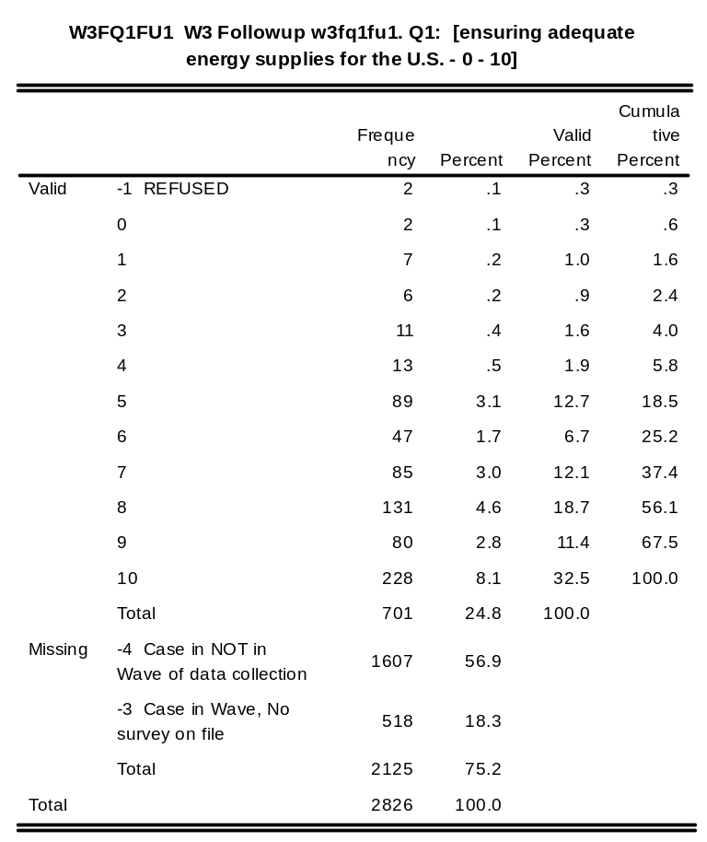
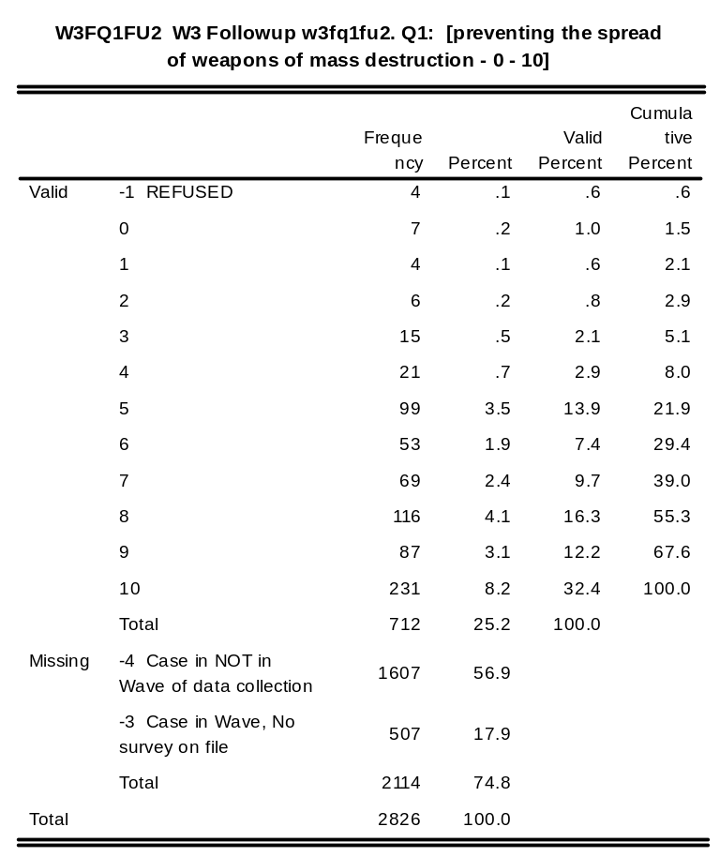
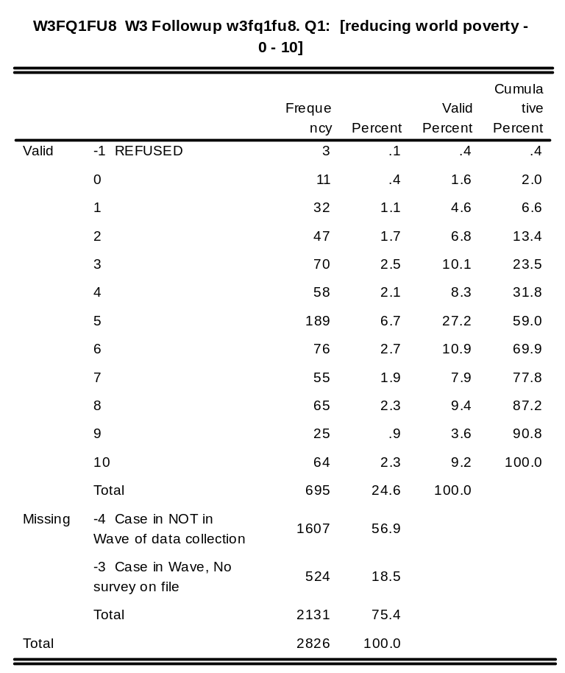
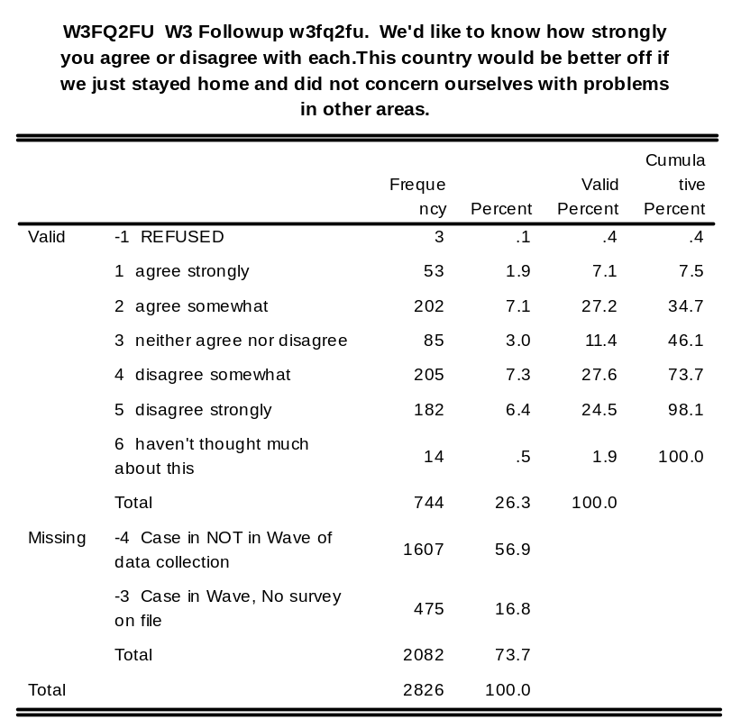
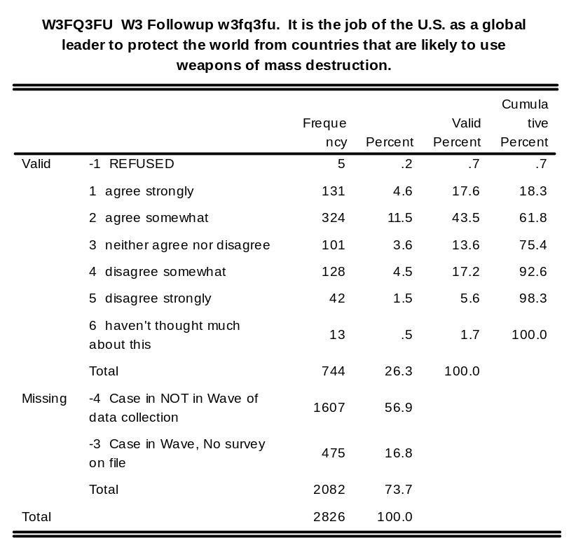
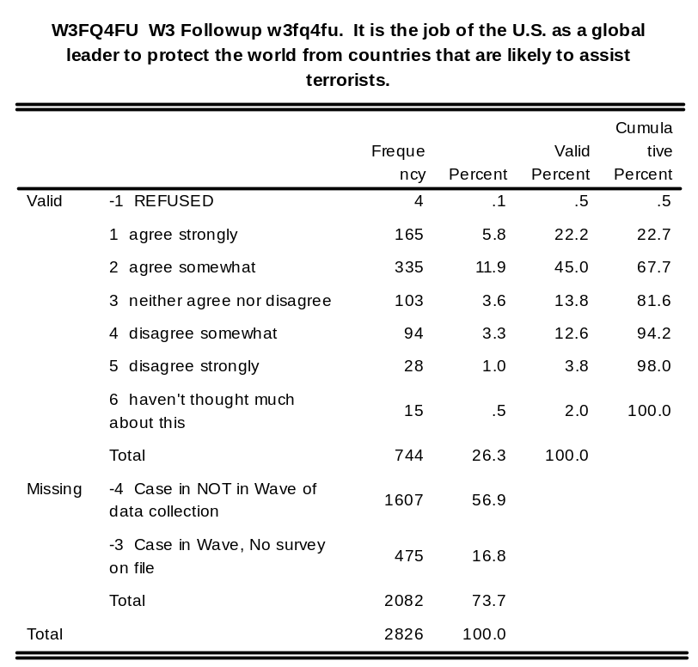
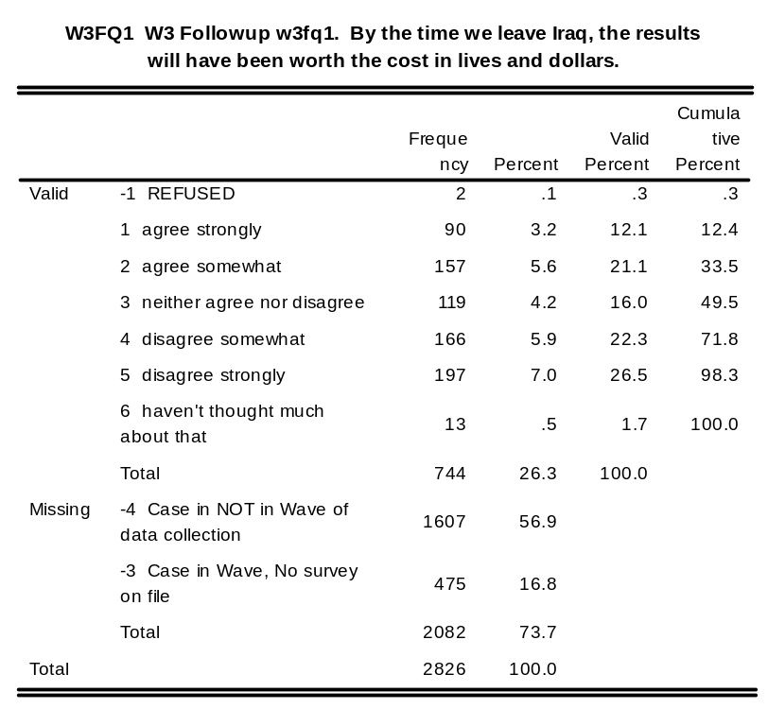
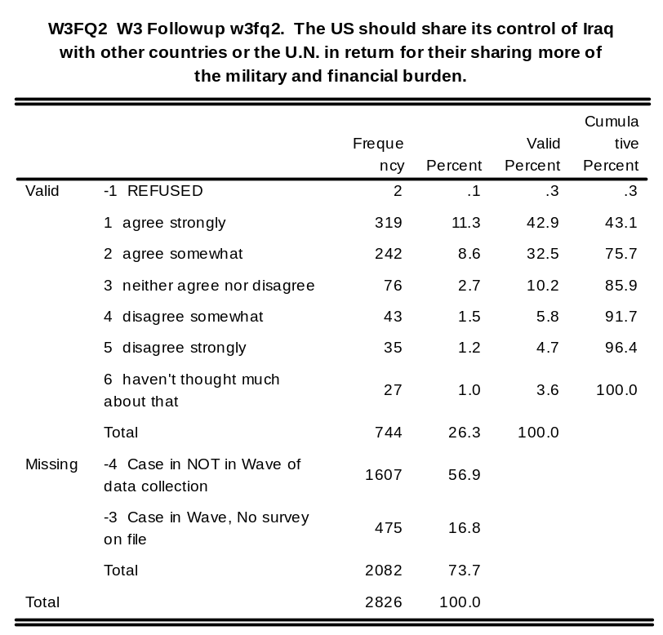
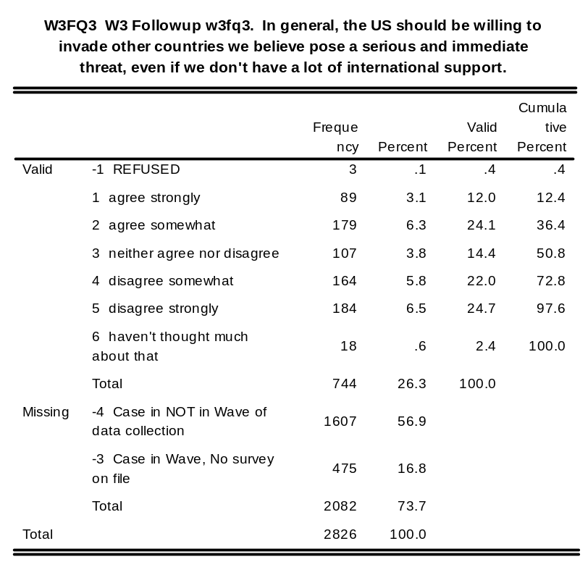
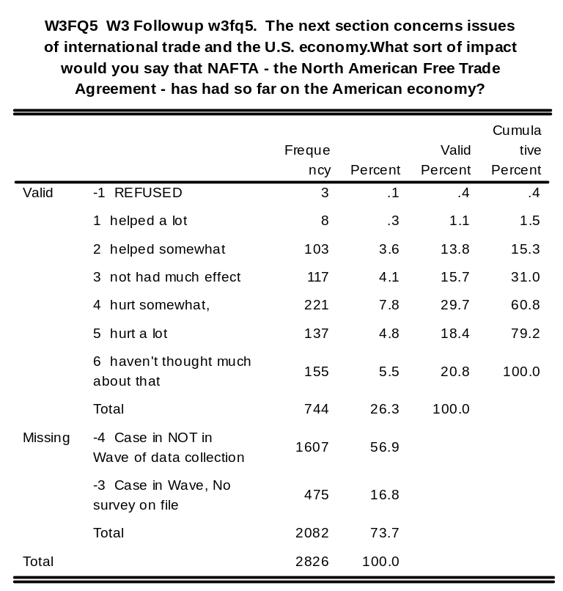
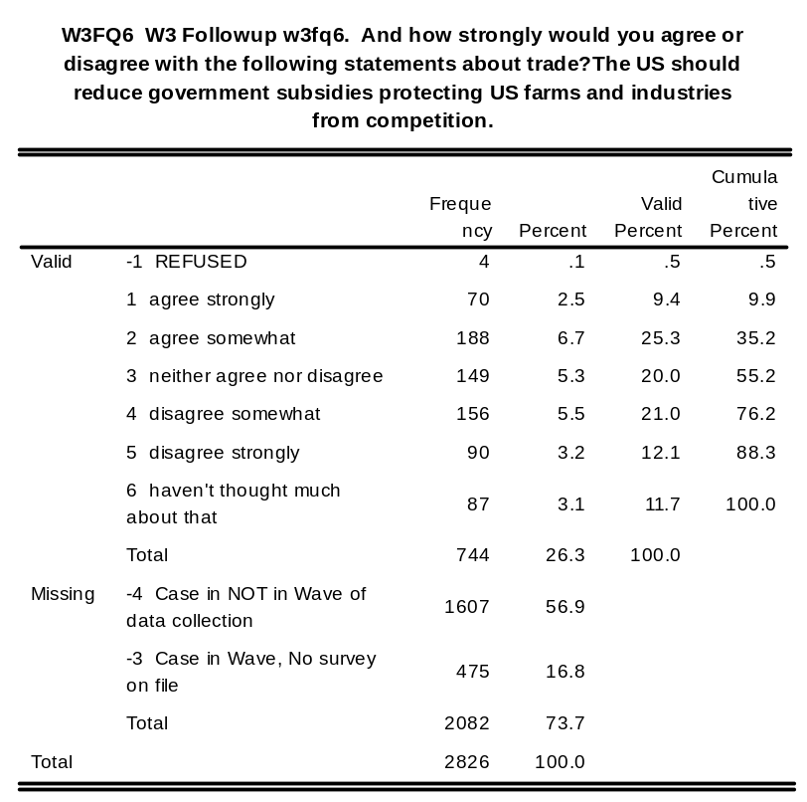
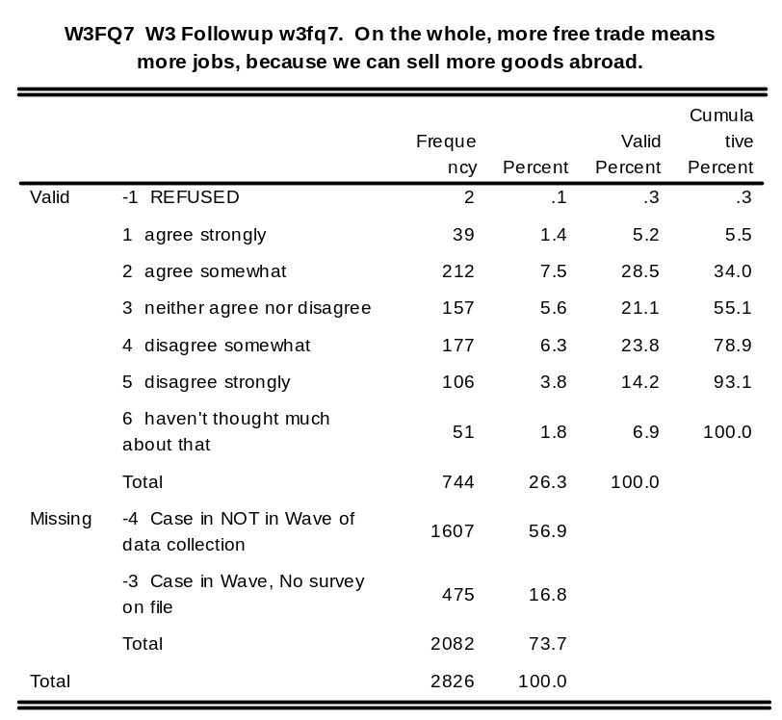
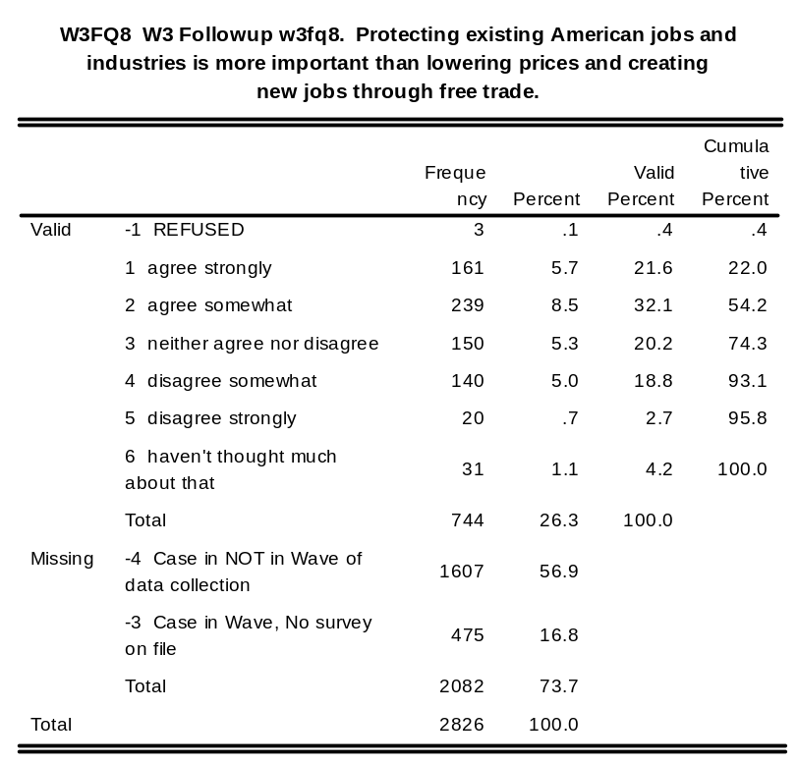
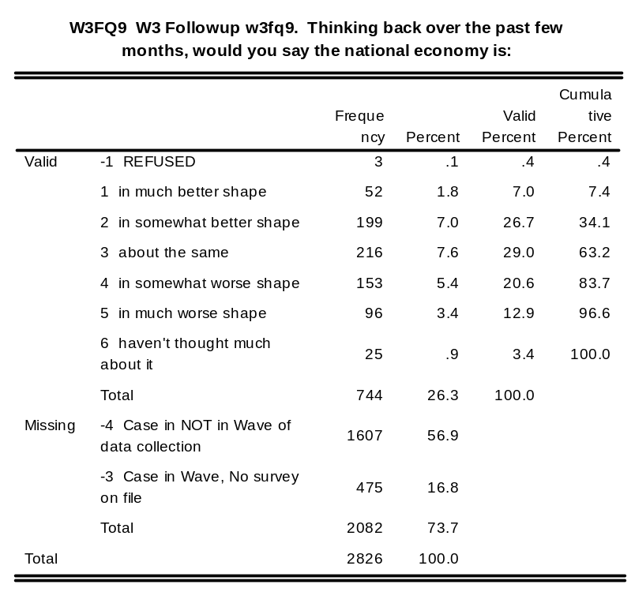
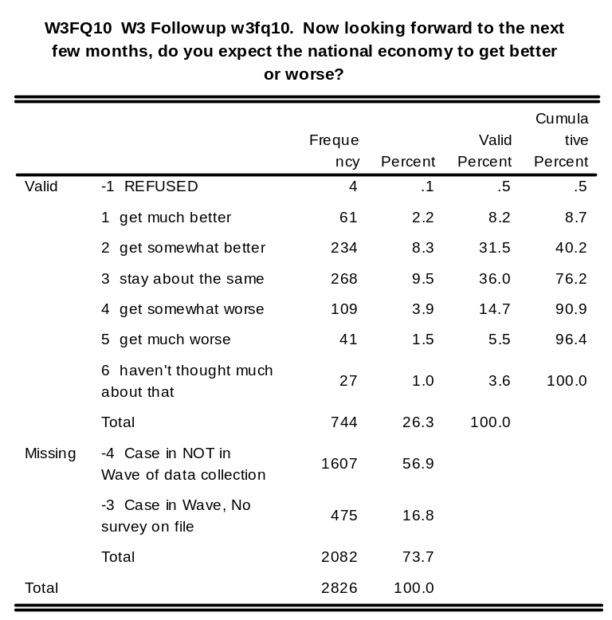
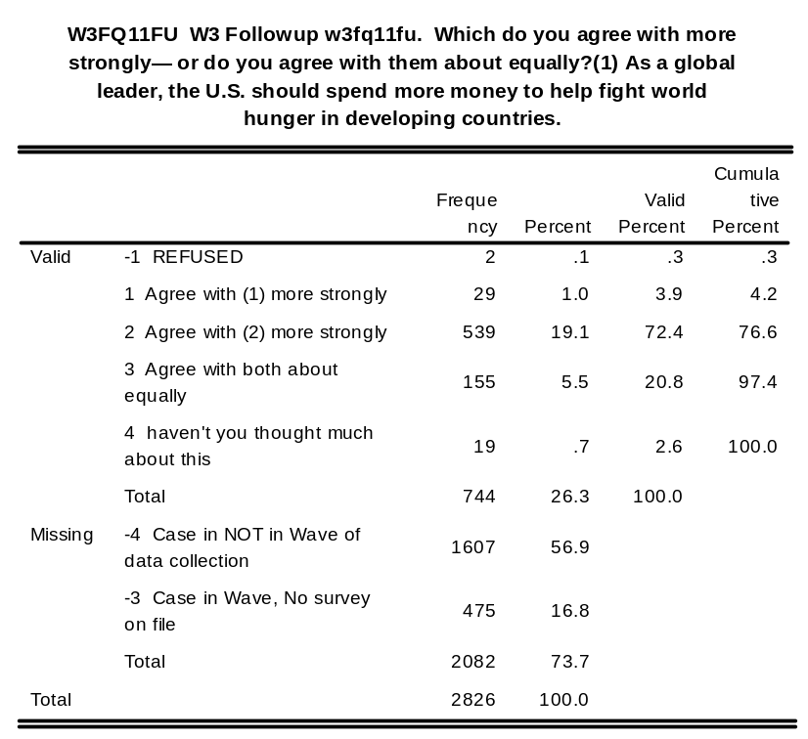
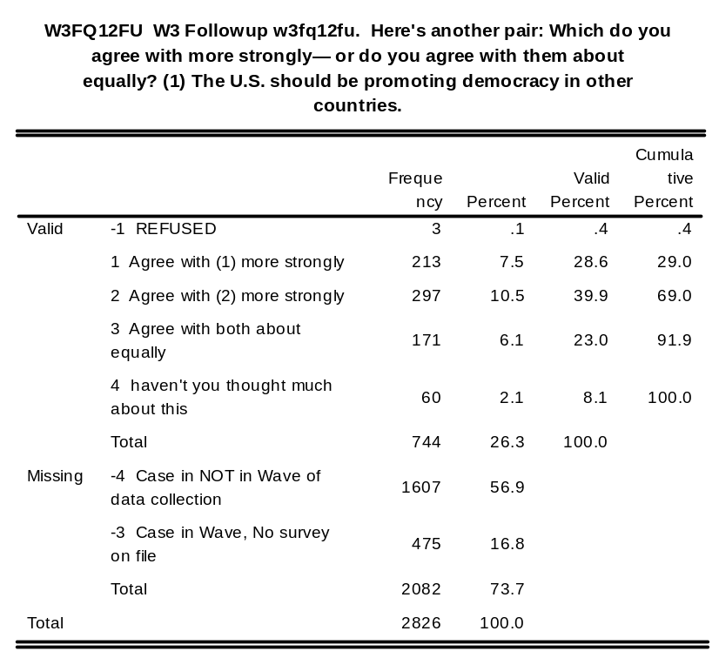
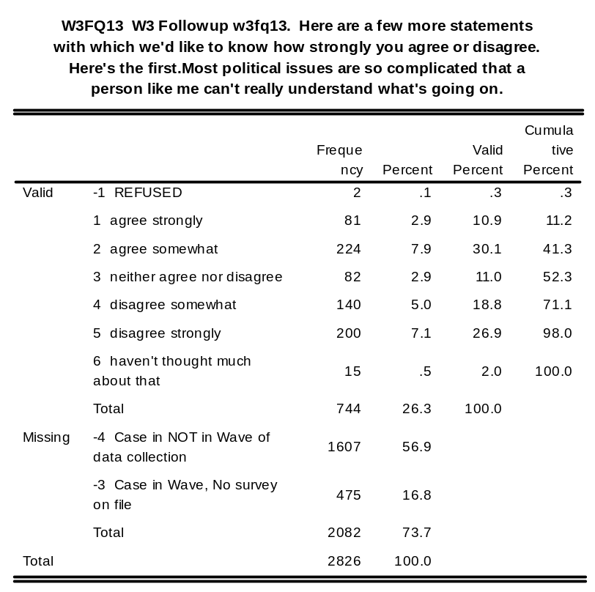
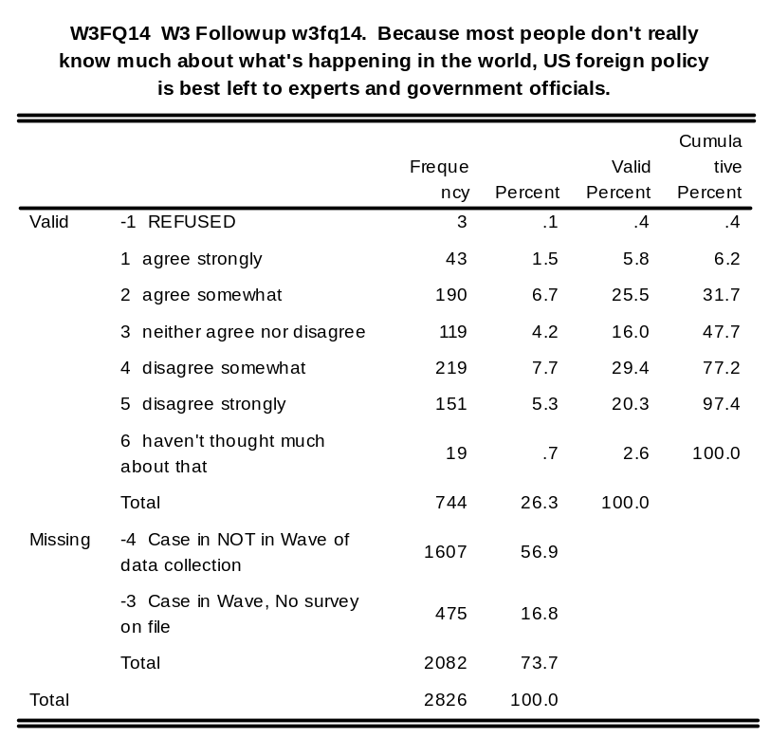
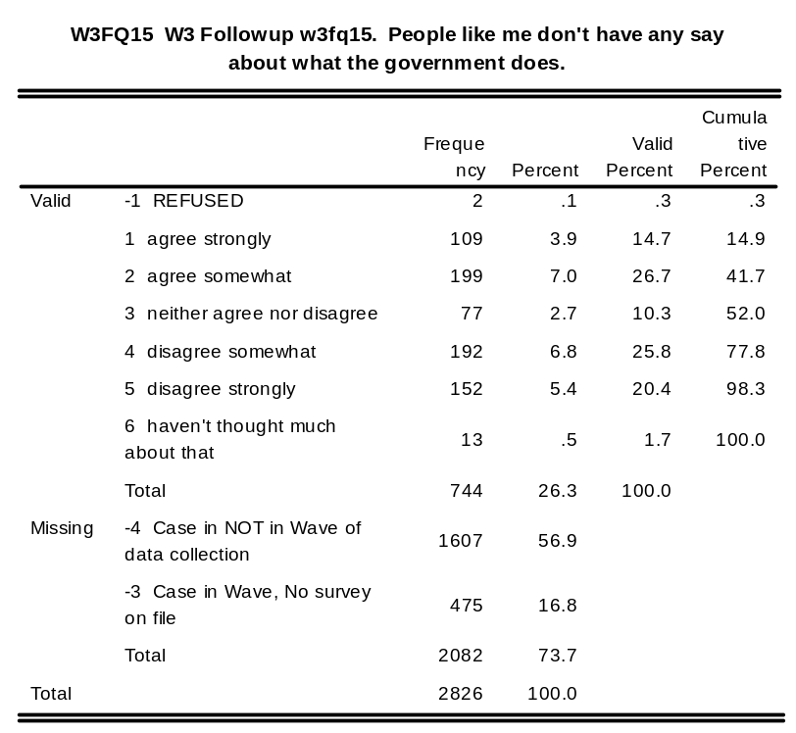
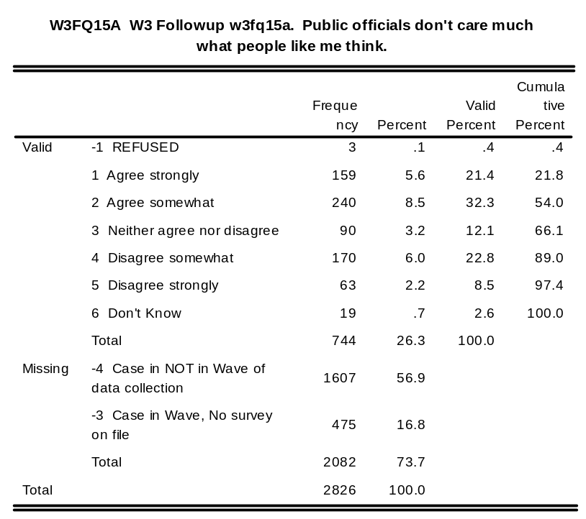
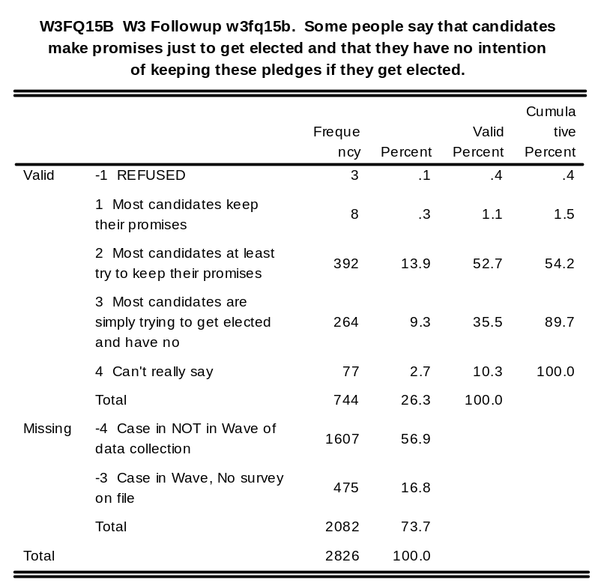
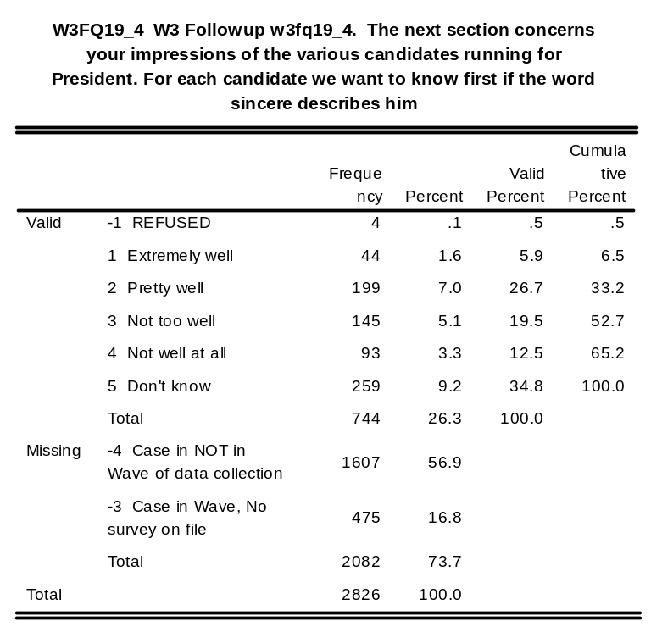
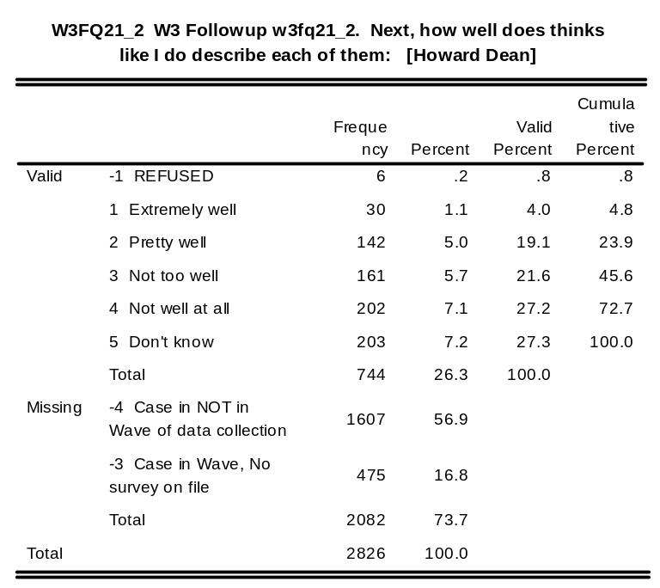

w3fq22_1: W3 Followup w3fq22_1. Q22: [George W. Bush - 0 - 100]

w3fq22_2: W3 Followup w3fq22_2. Q22: [Howard Dean - 0 - 100]

w3fq22_3: W3 Followup w3fq22_3. Q22: [John Kerry - 0 - 100]

w3fq22_4: W3 Followup w3fq22_4. Q22: [Wesley Clark - 0 - 100]

w3fq22_6: W3 Followup w3fq22_6. Q22: [John Edwards - 0 - 100]

w3fq22_8: W3 Followup w3fq22_8. Q22: [Al Sharpton - 0 - 100]

w3fq2210: W3 Followup w3fq2210. Q22: [Dennis Kucinich - 0 - 100]

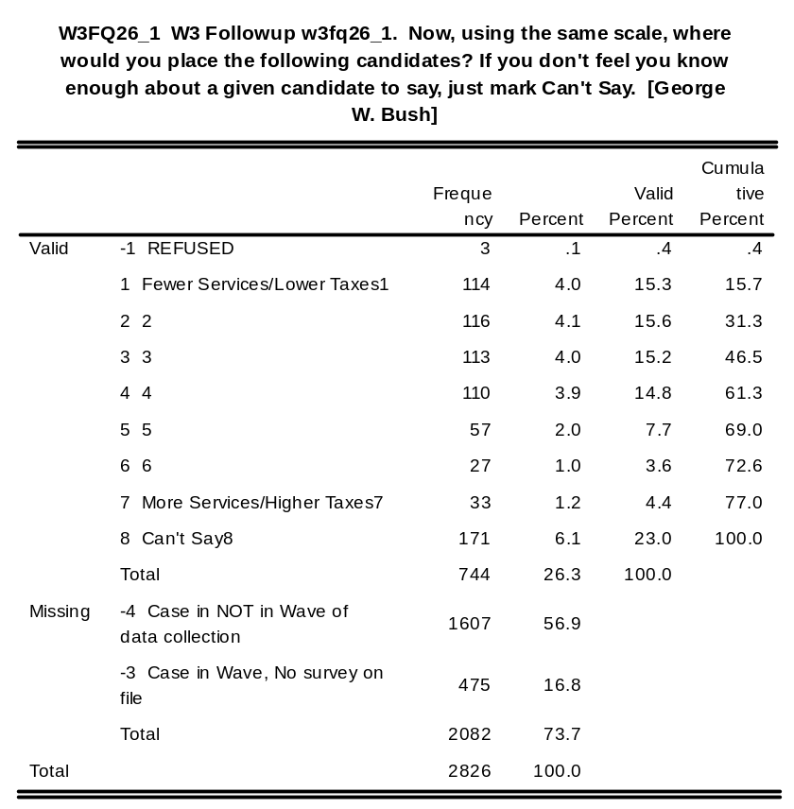
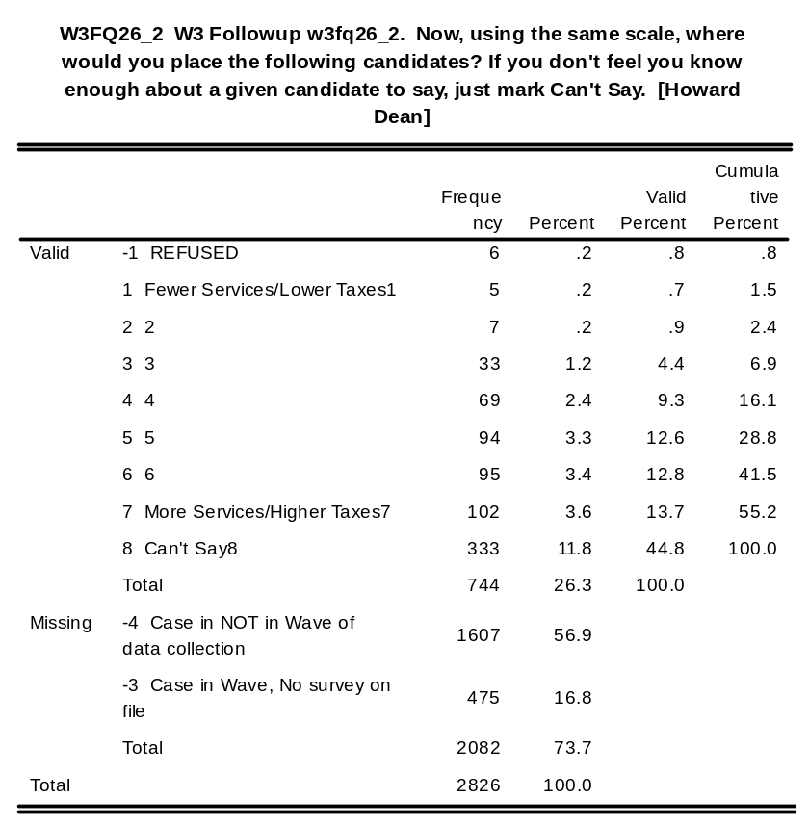
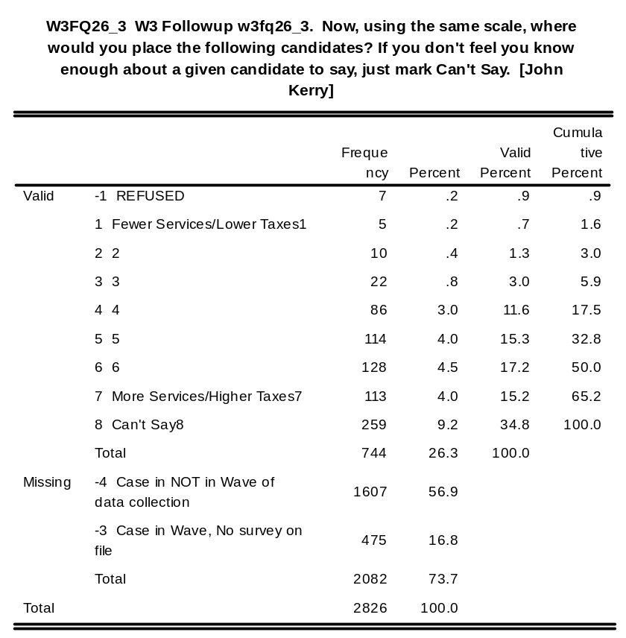
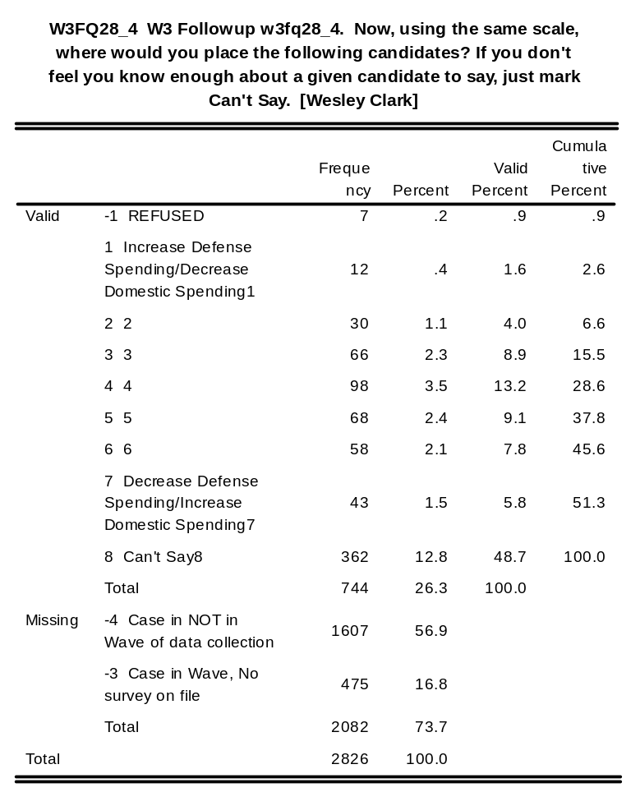
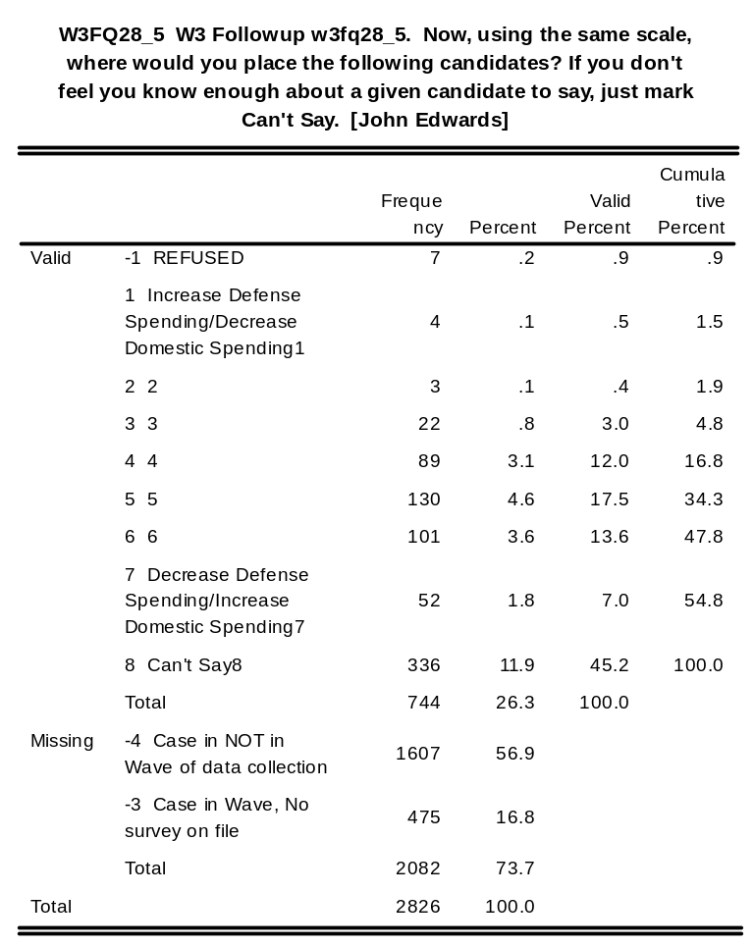
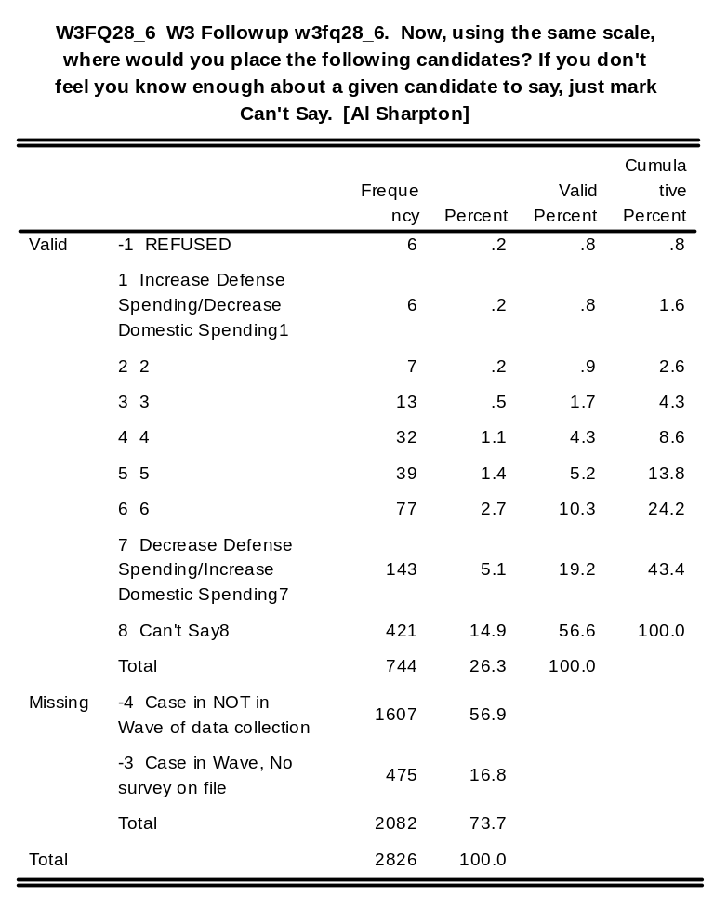
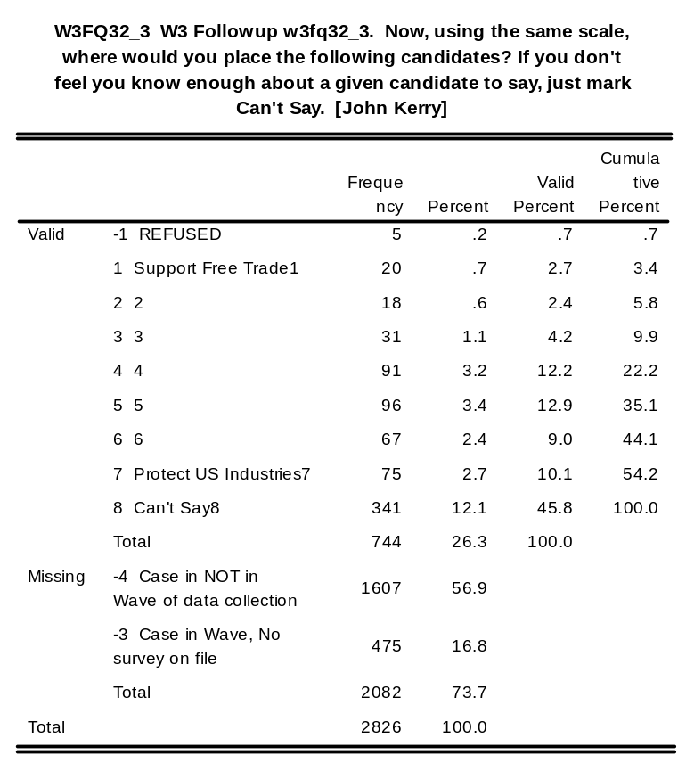
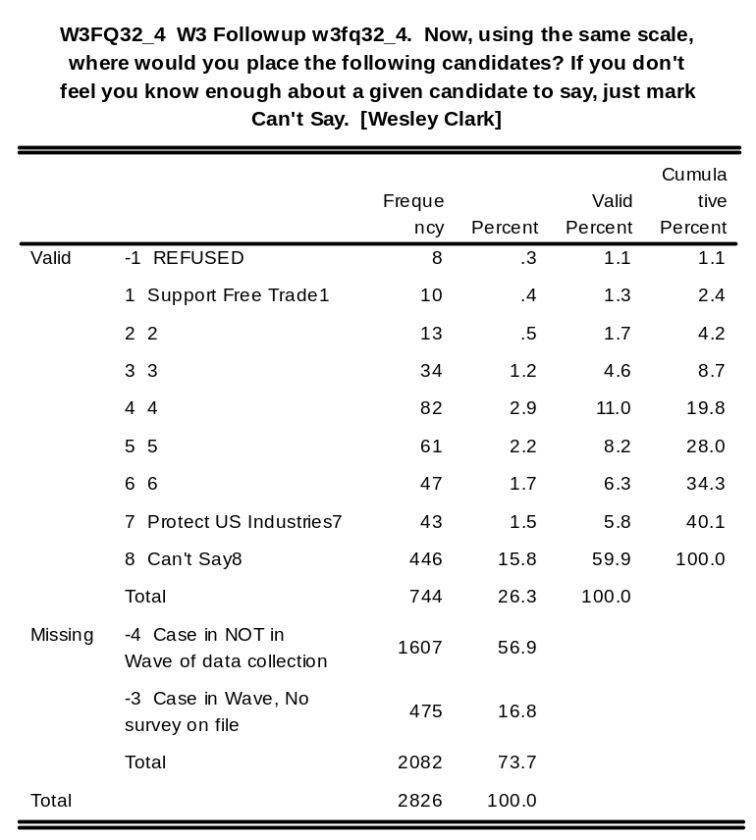
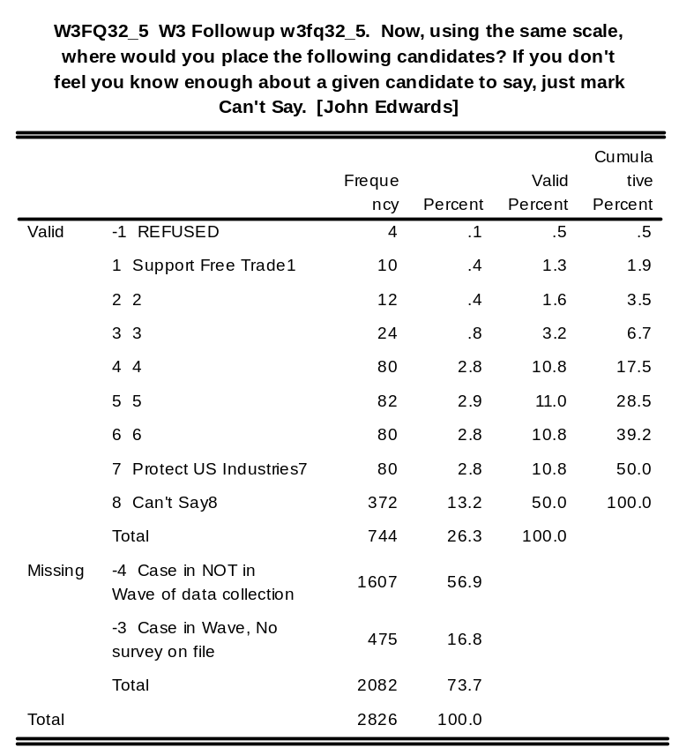
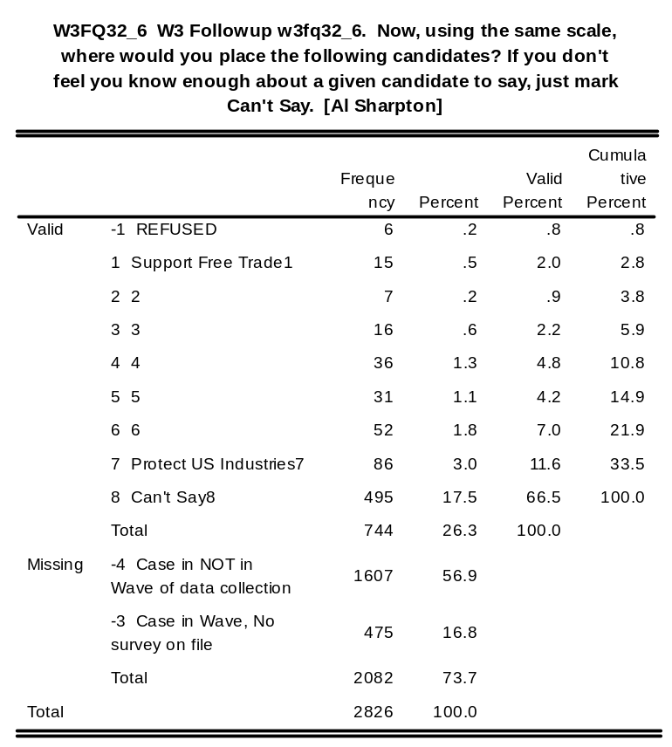
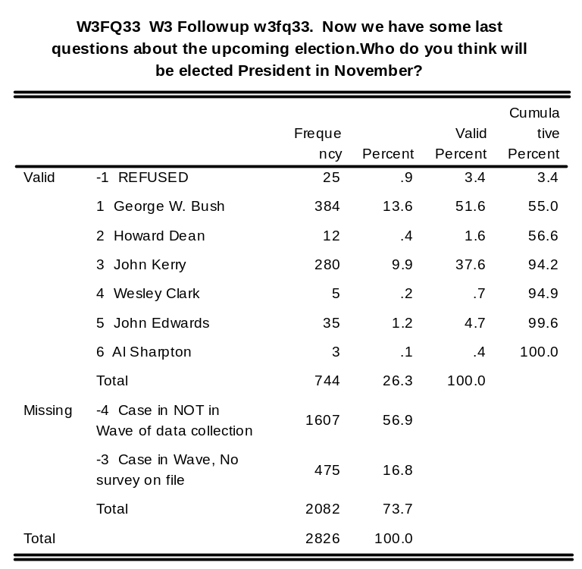
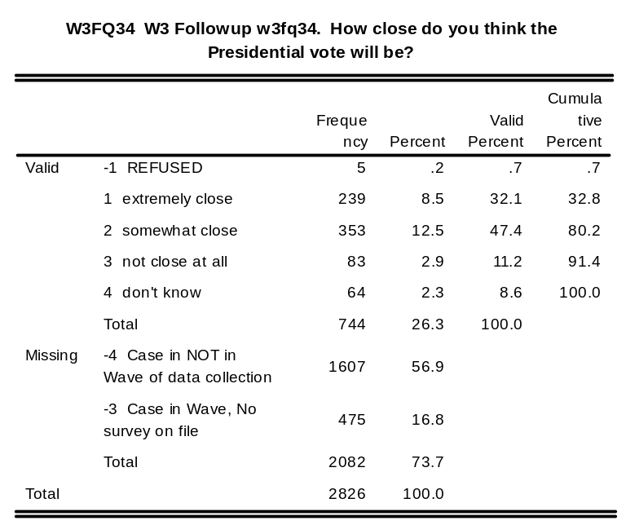
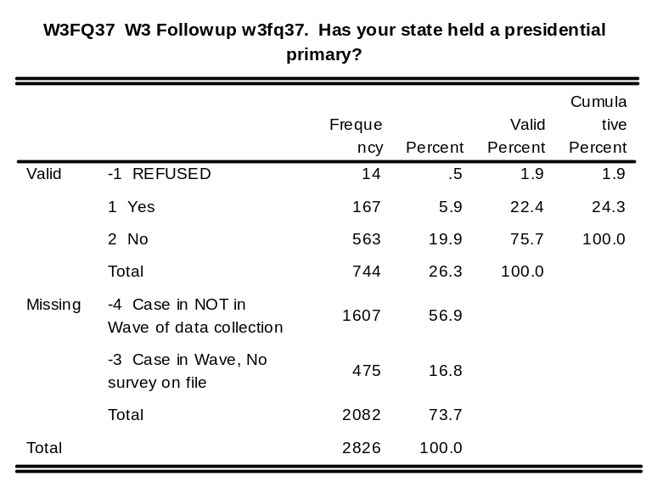
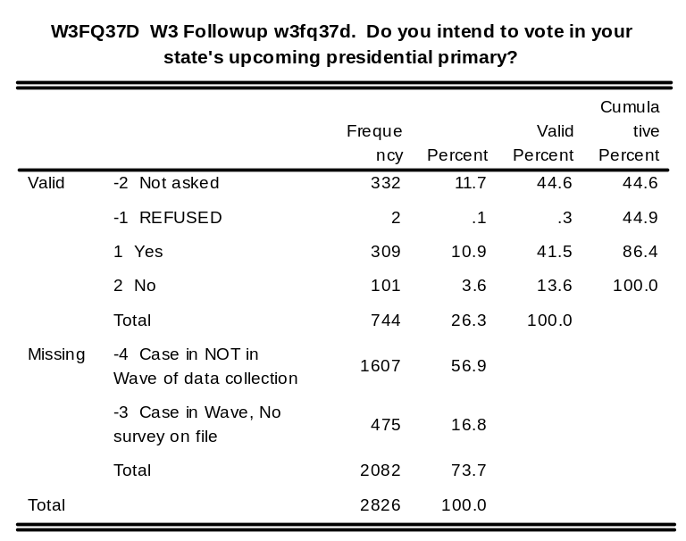
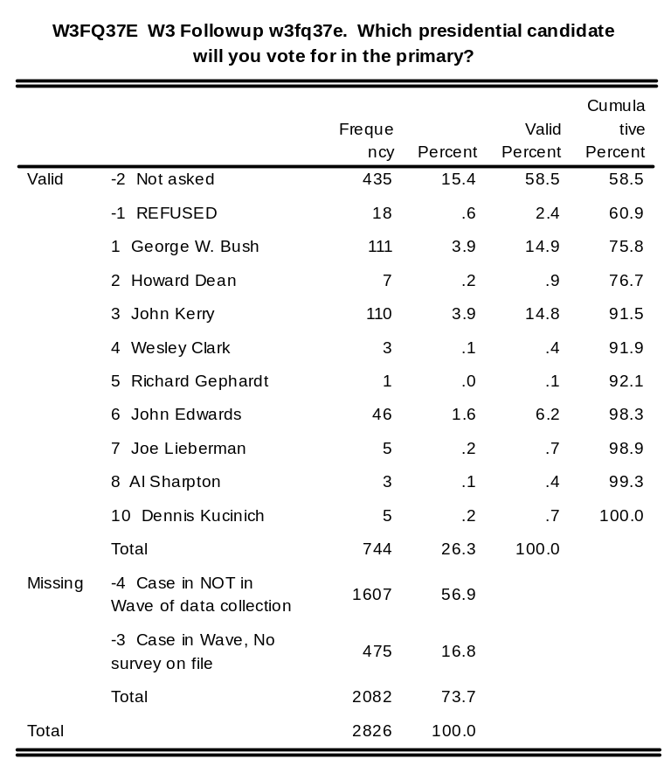
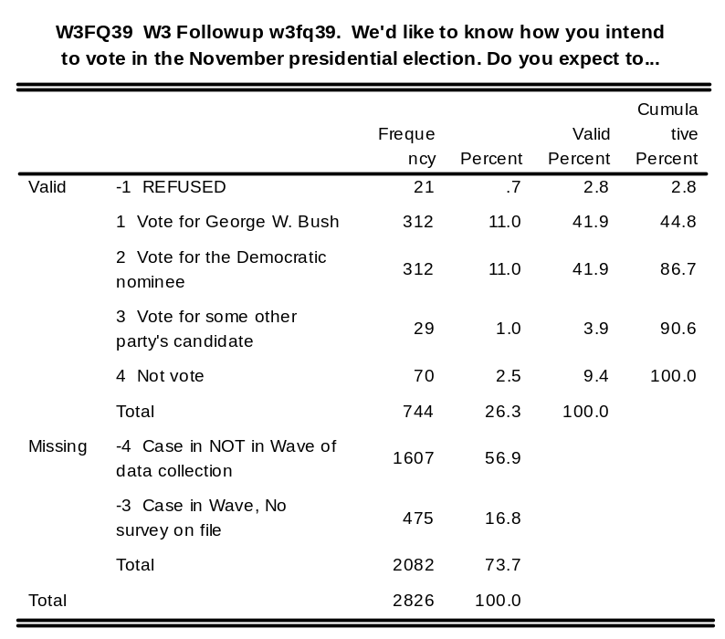
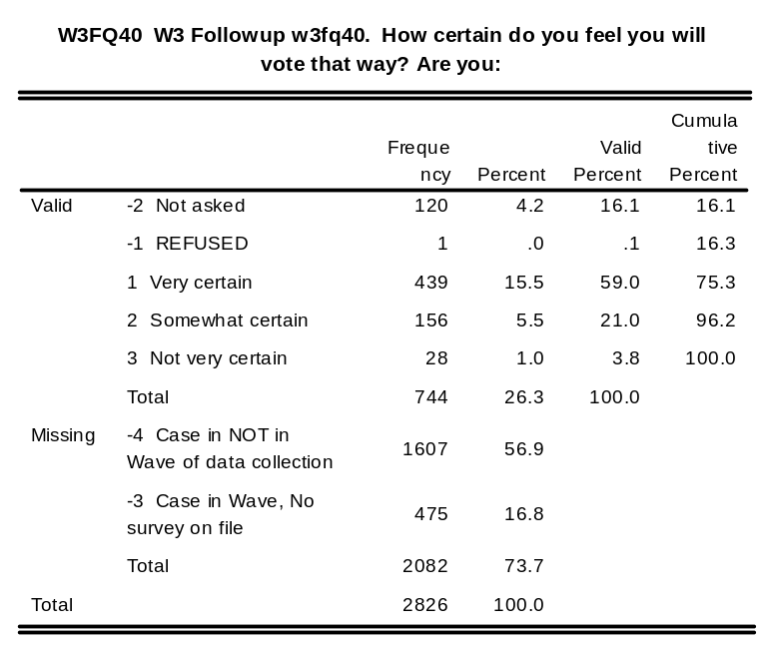
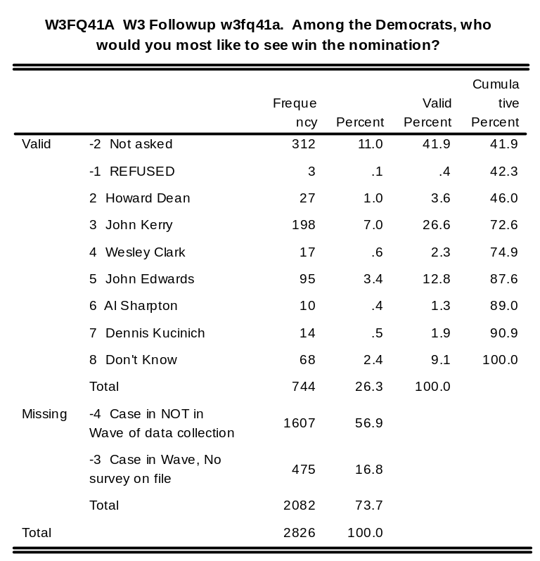
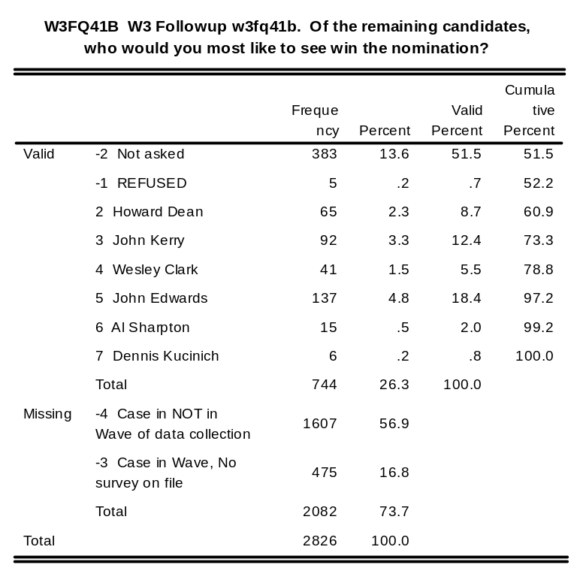
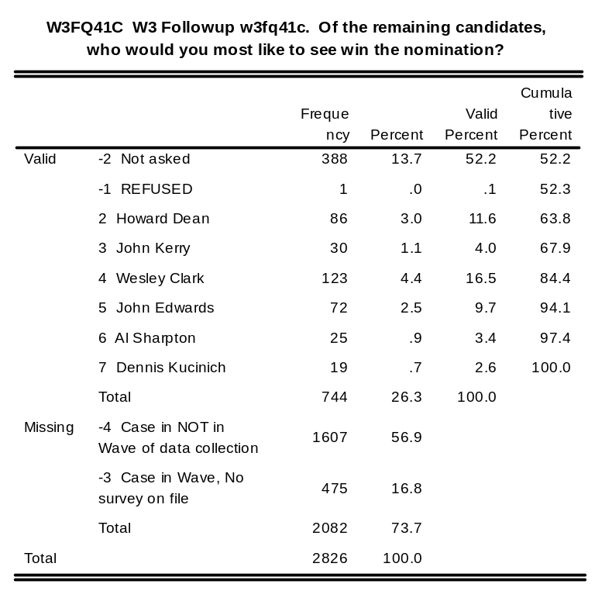
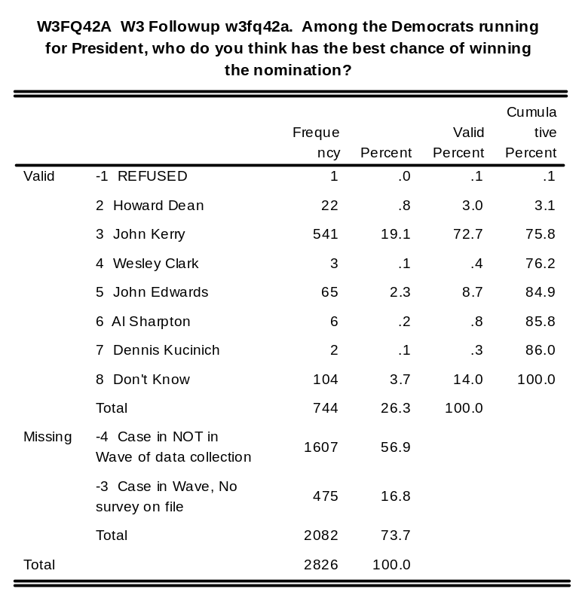
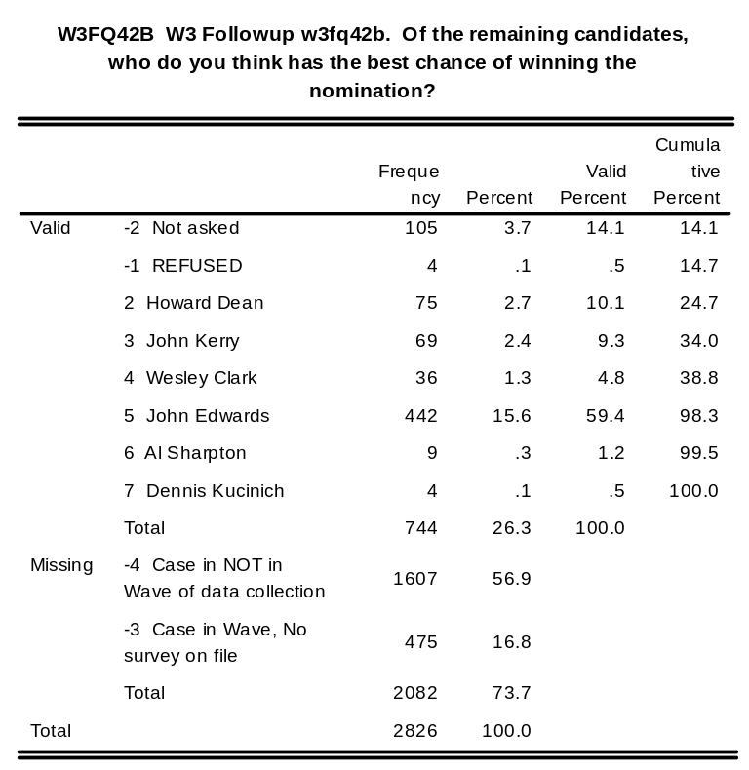
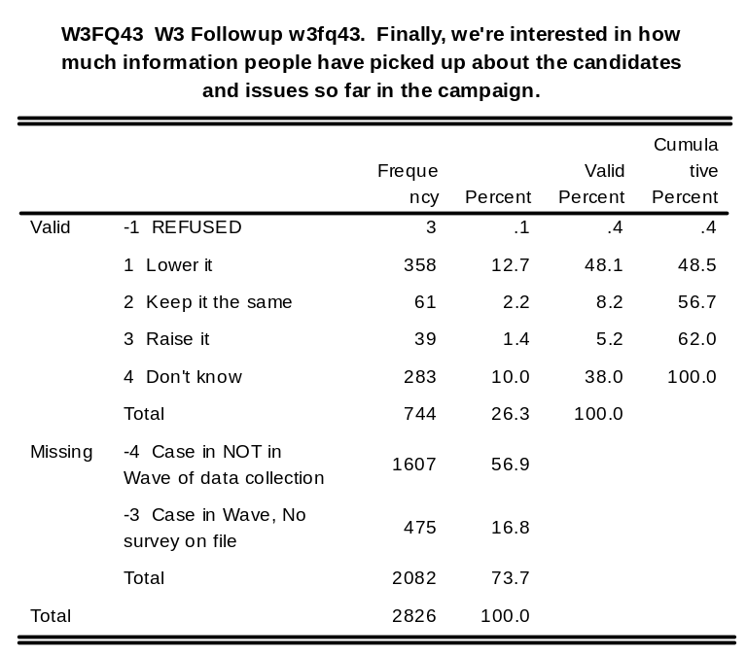
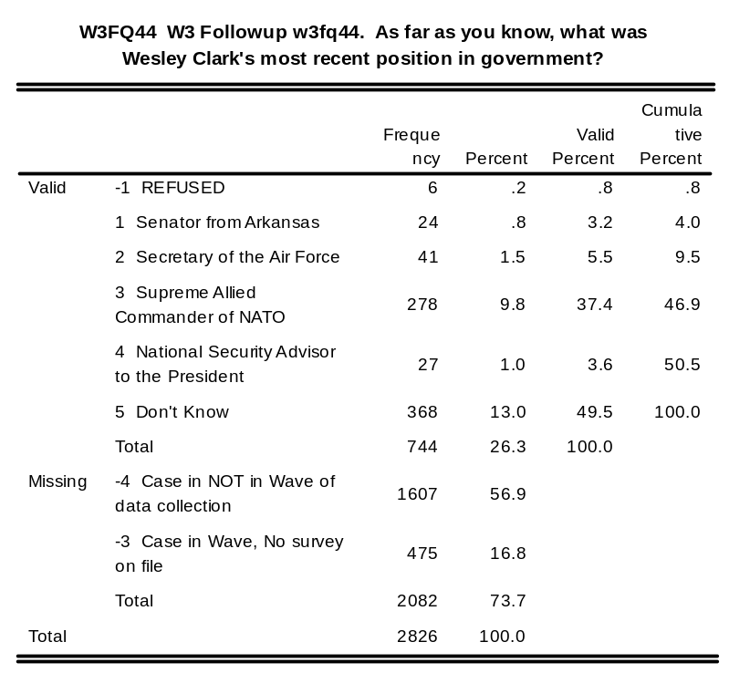
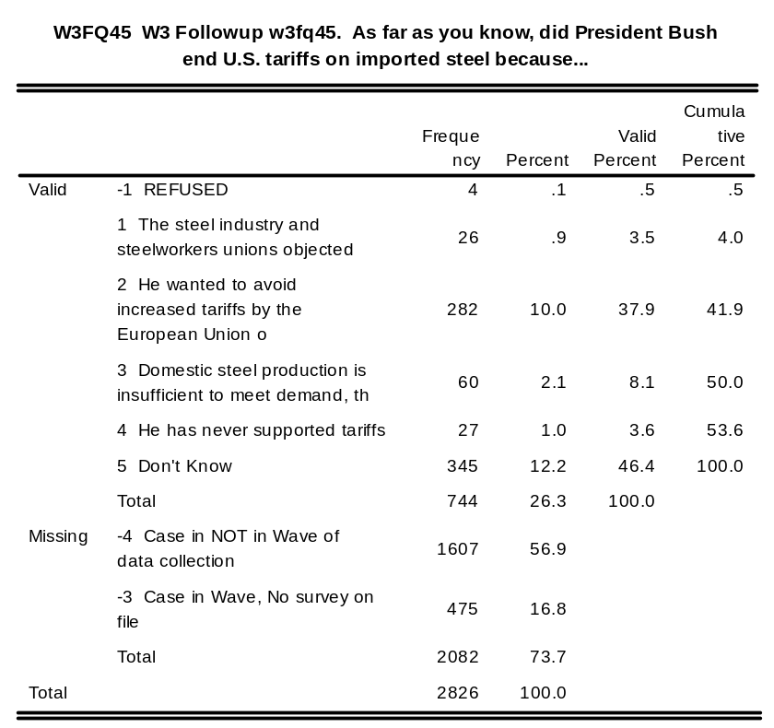
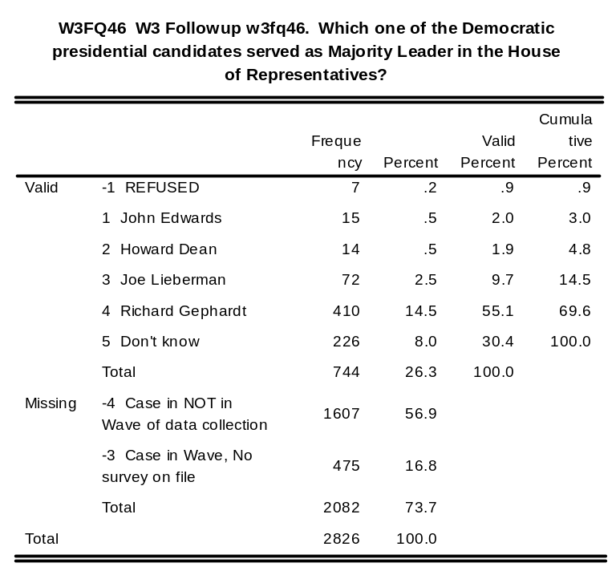
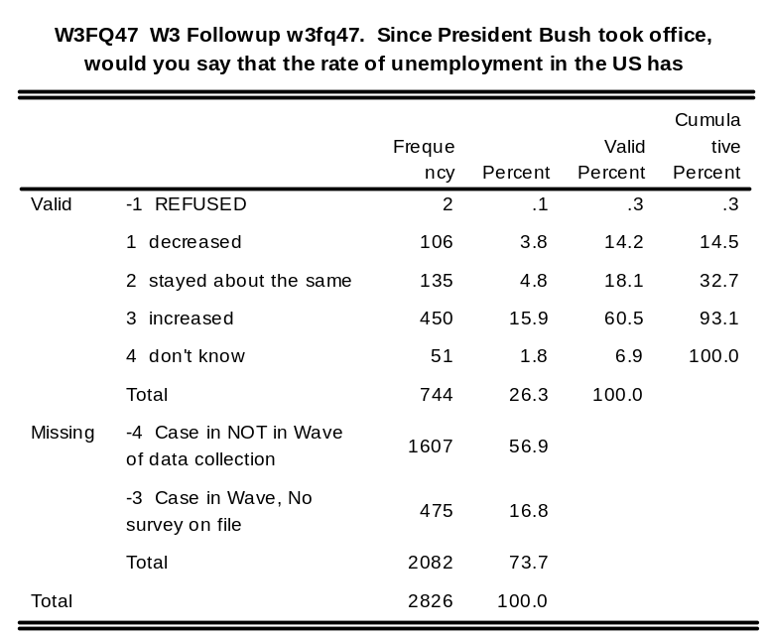
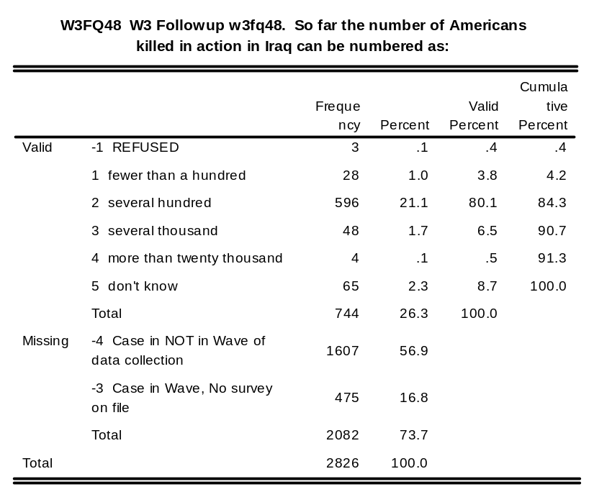
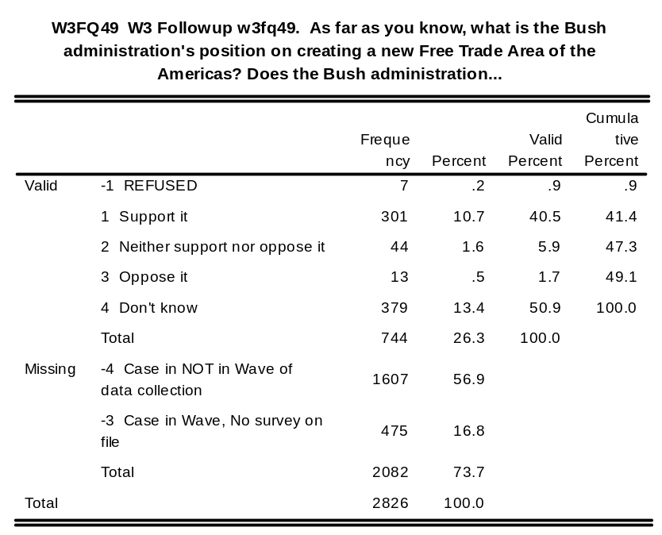

w3fq49a: W3 Followup w3fq49a. Identify this person: Clark

w3fq49b: W3 Followup w3fq49b. Identify this person: Kucinich

w3fq49c: W3 Followup w3fq49c. Identify this person: Sharpton

w3fq49d: W3 Followup w3fq49d. Idenitfy this person: Gephardt

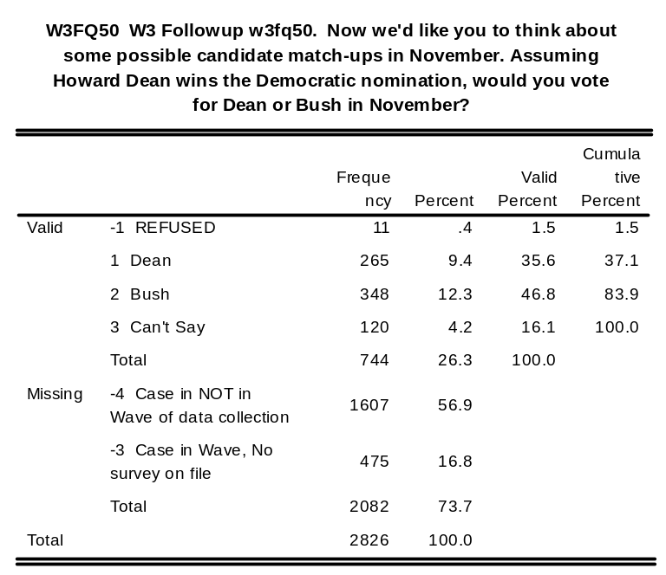
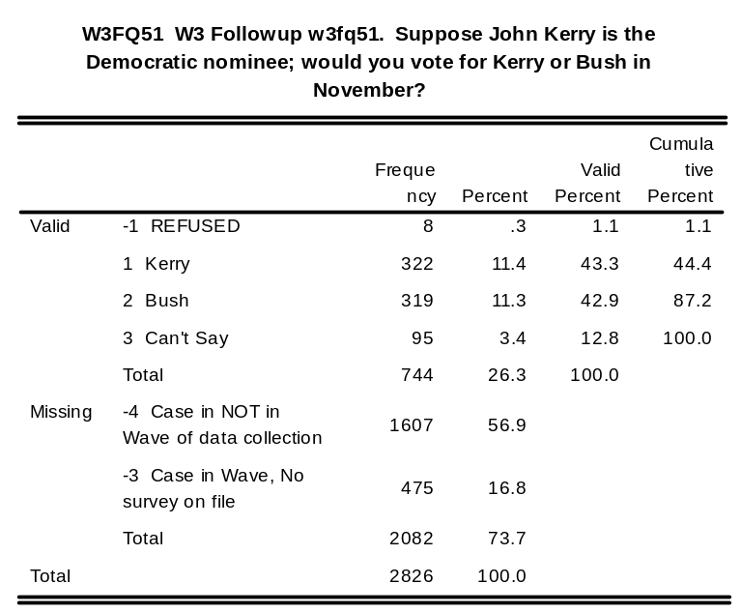
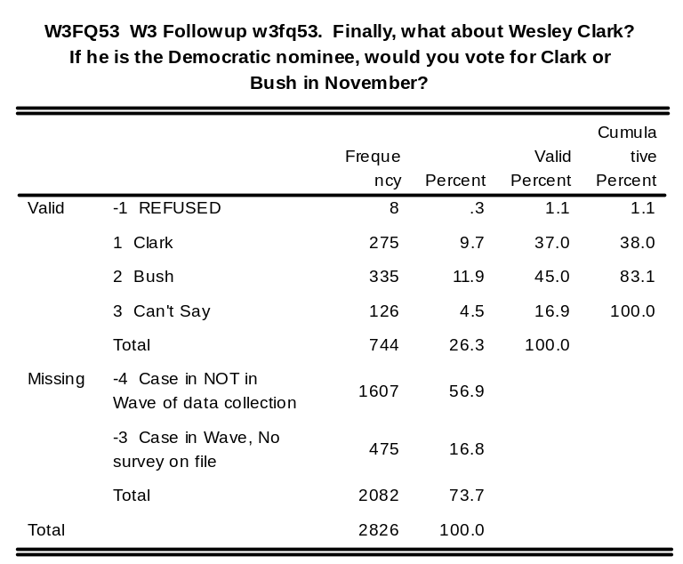

Wave 4 Baseline/Follow-up Survey/CD Tracking Information Codebook

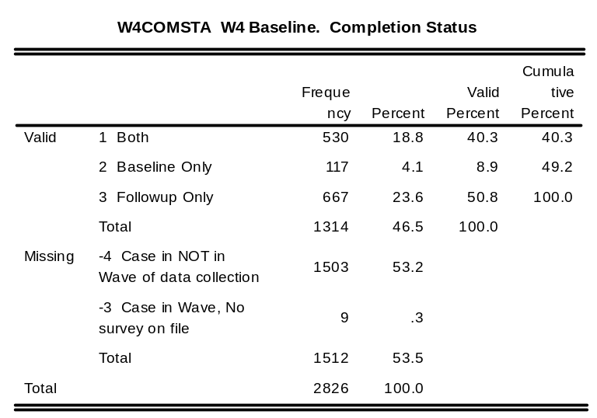

w4bstart: W4 Baseline. Start Date and Time of Interview

w4bend: W4 Baseline. End Date and Time of Interview

w4bdur: W4 Baseline. Duration of interview in minutes

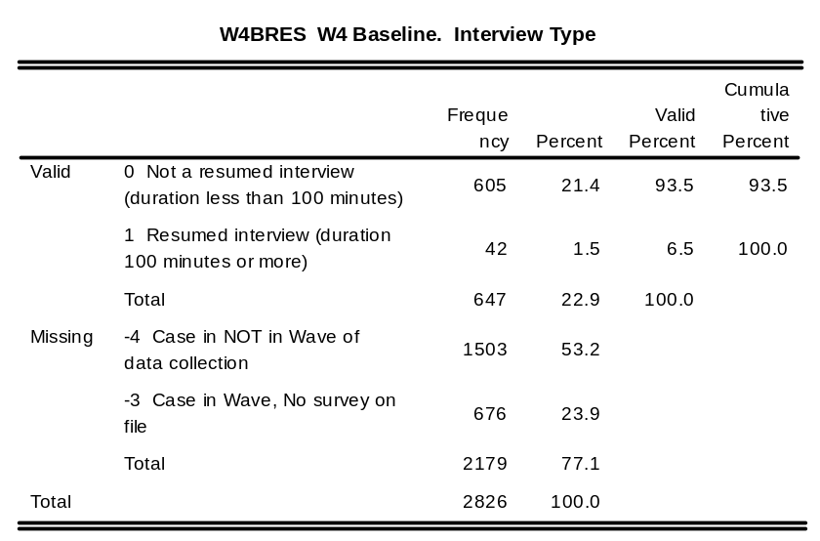
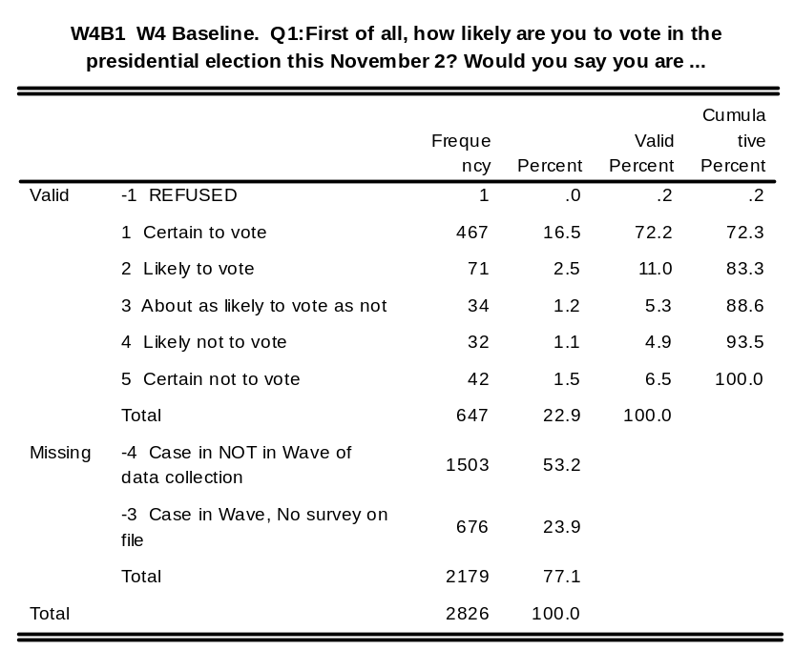
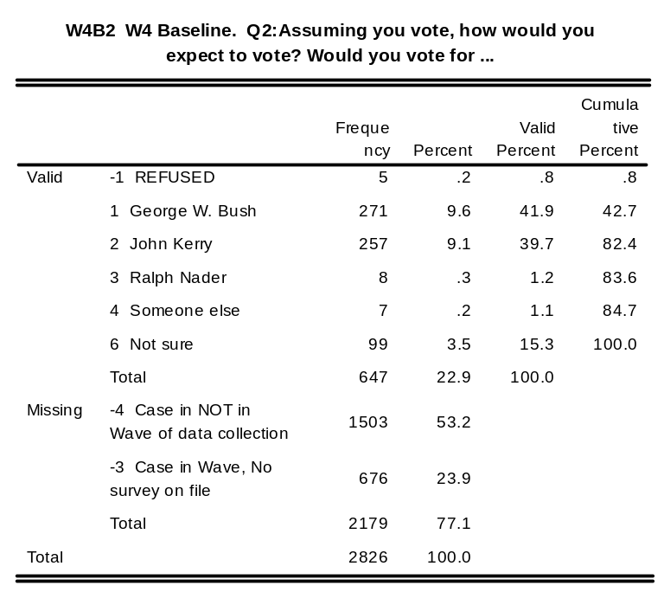
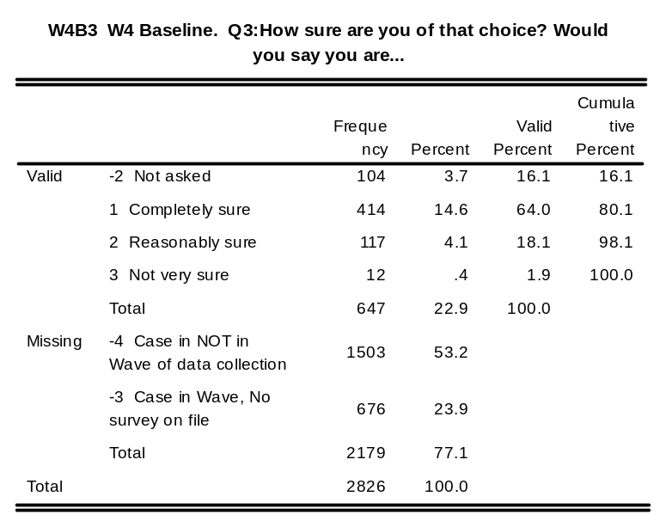
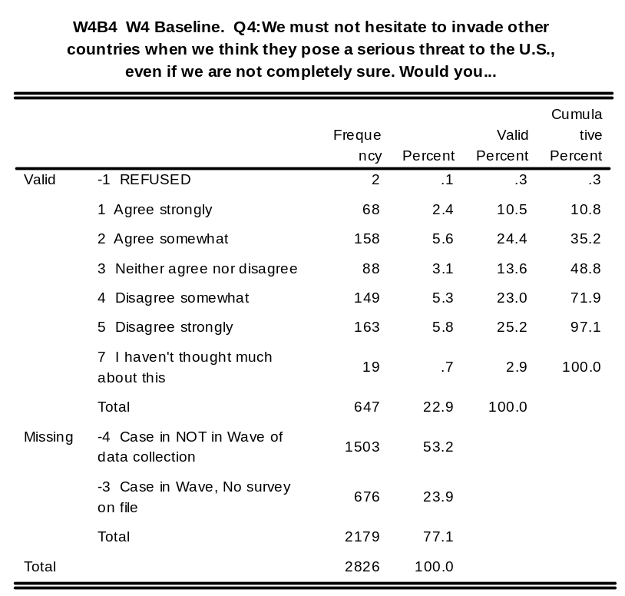
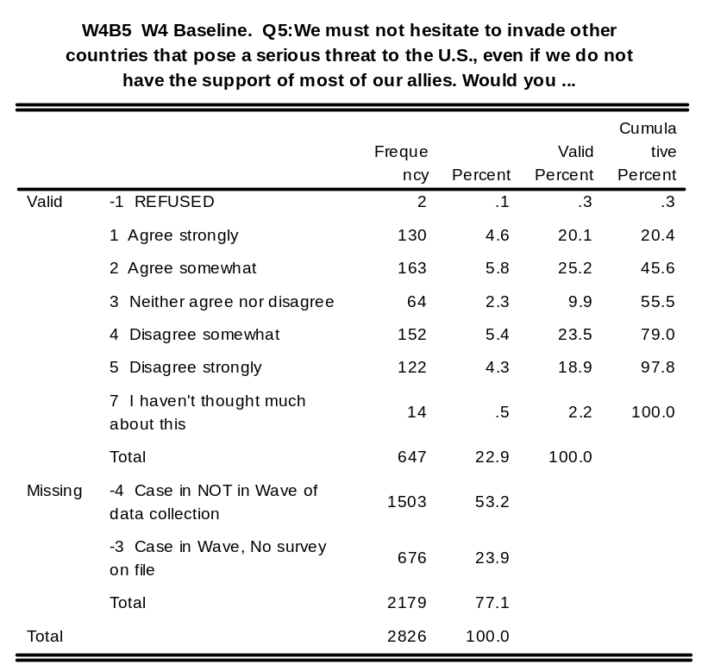
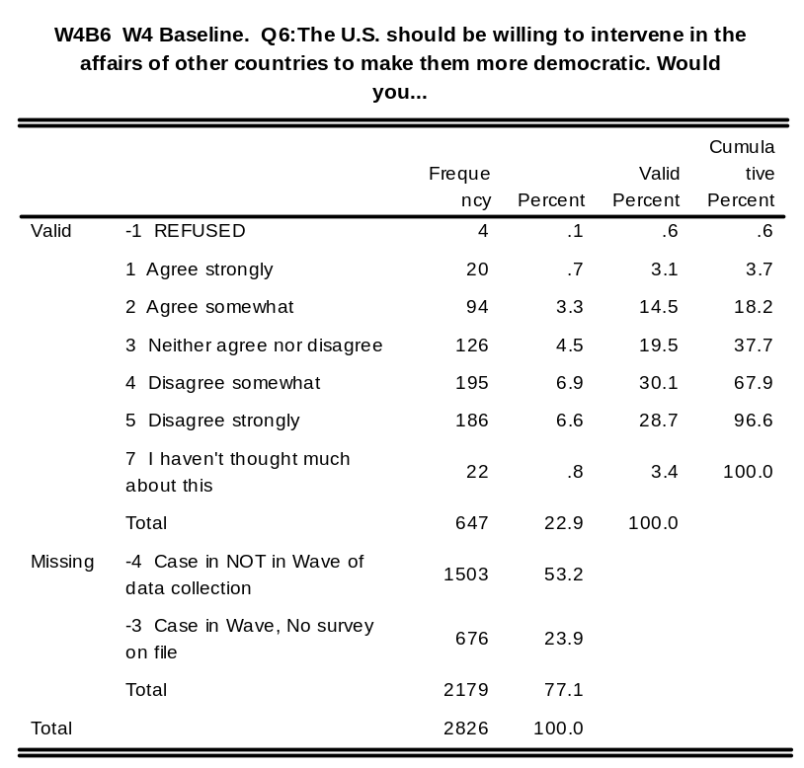
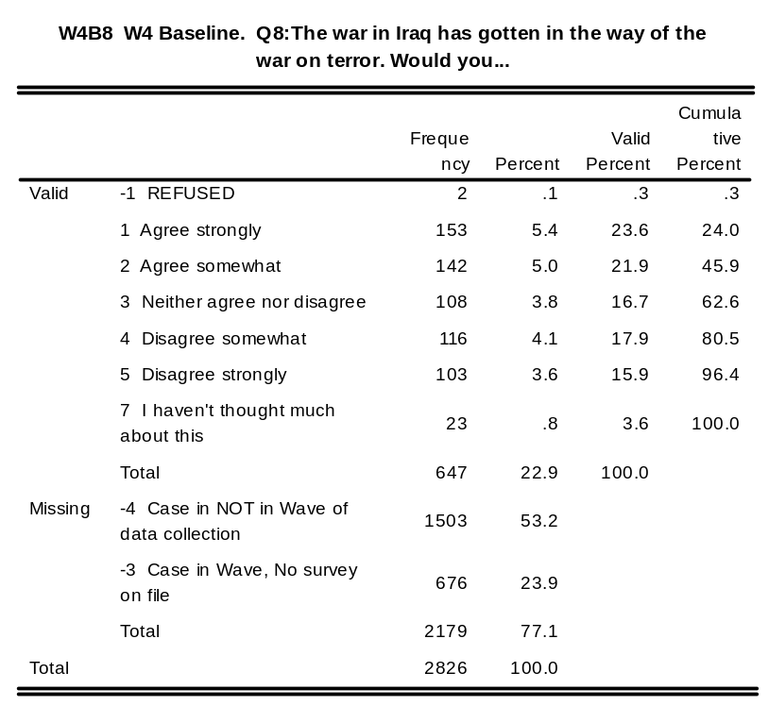
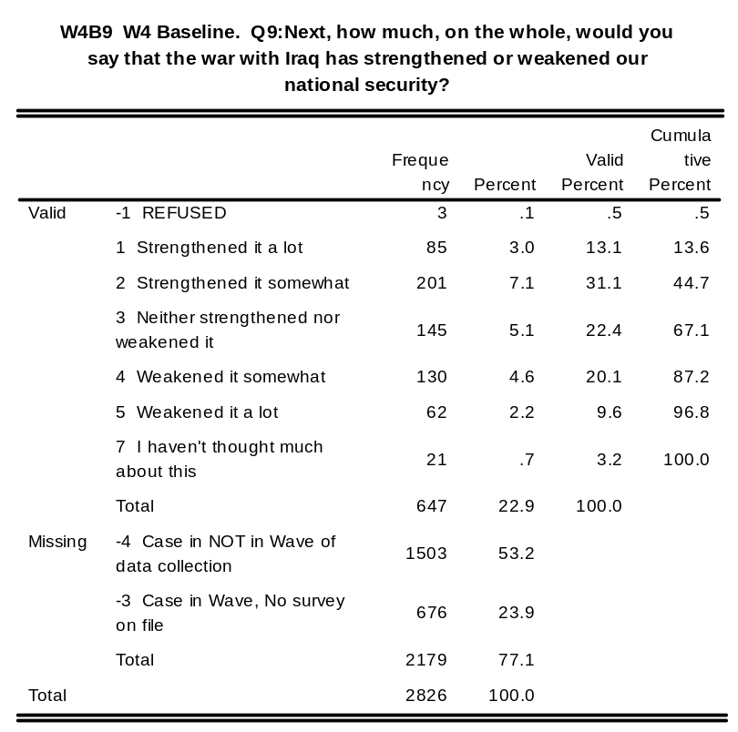
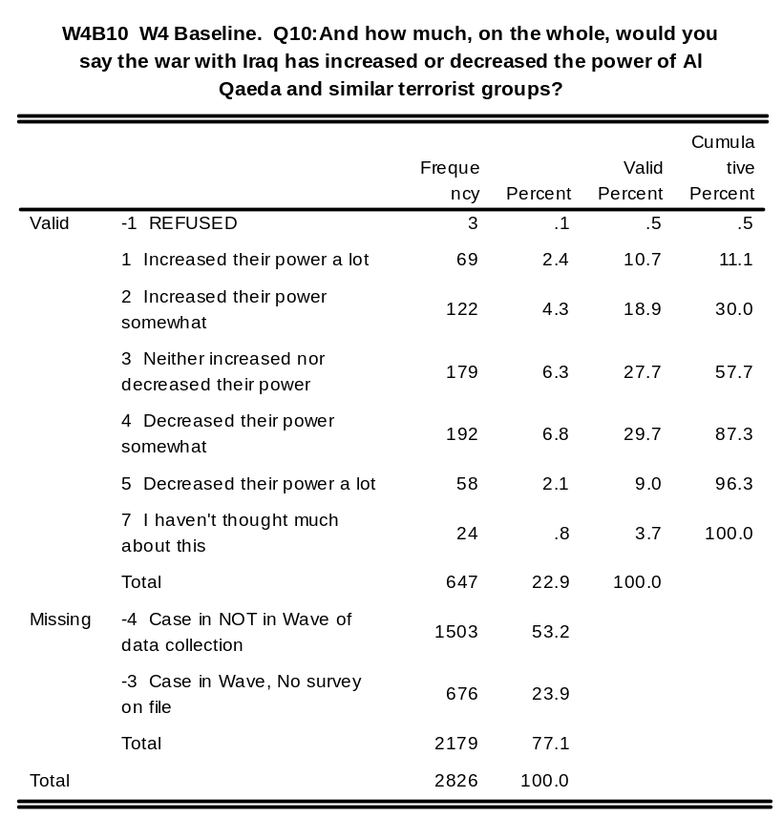
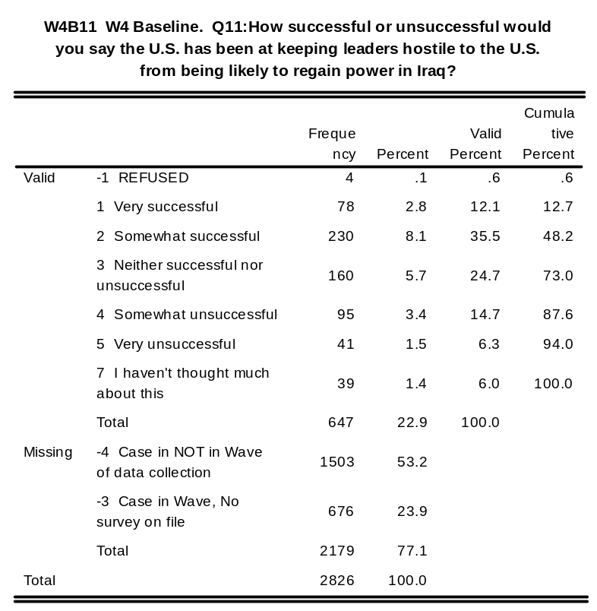
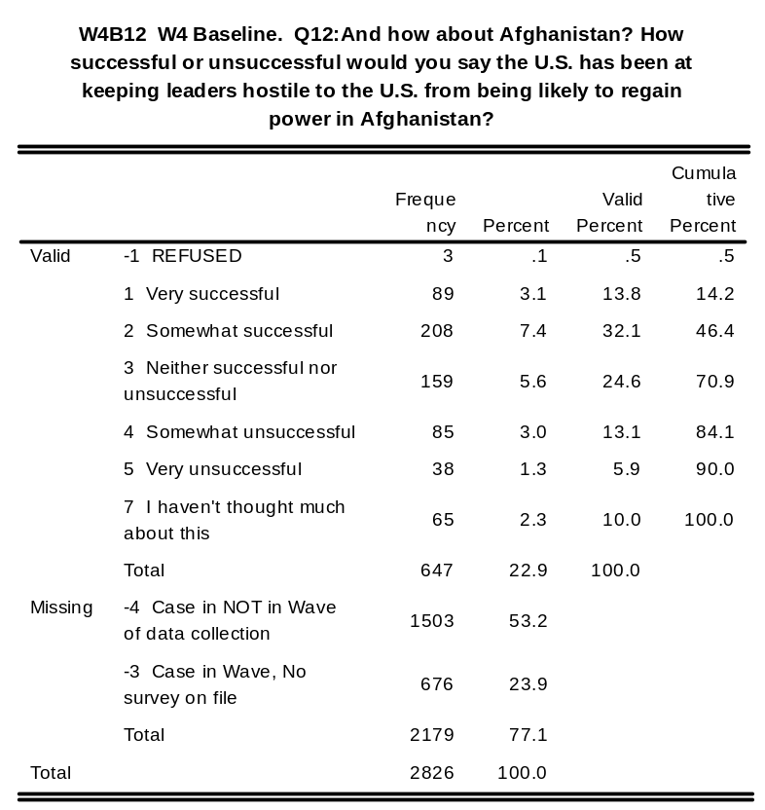
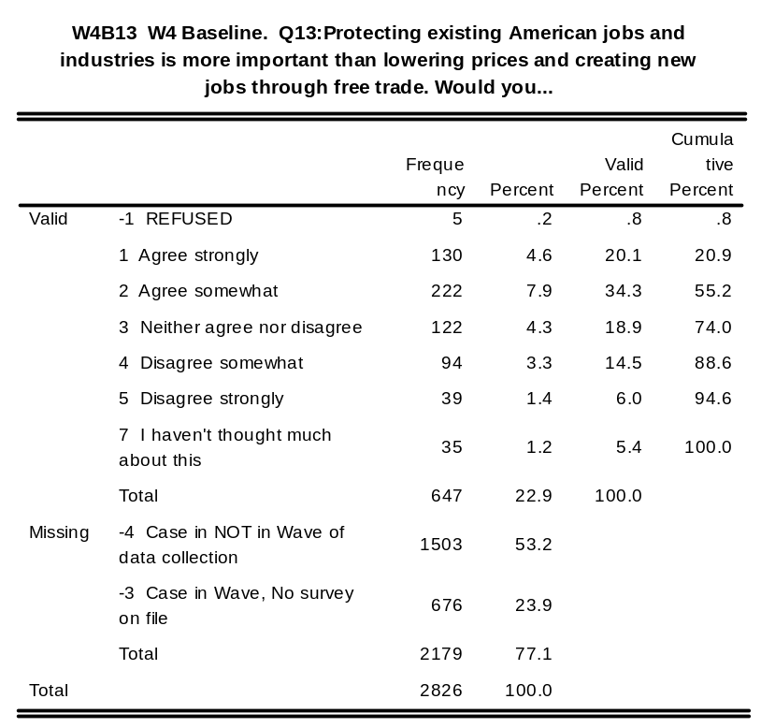
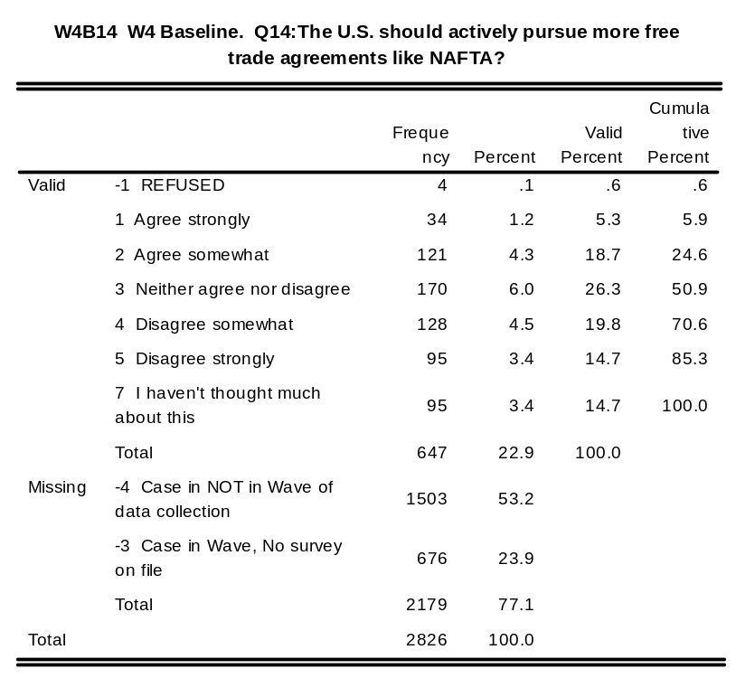
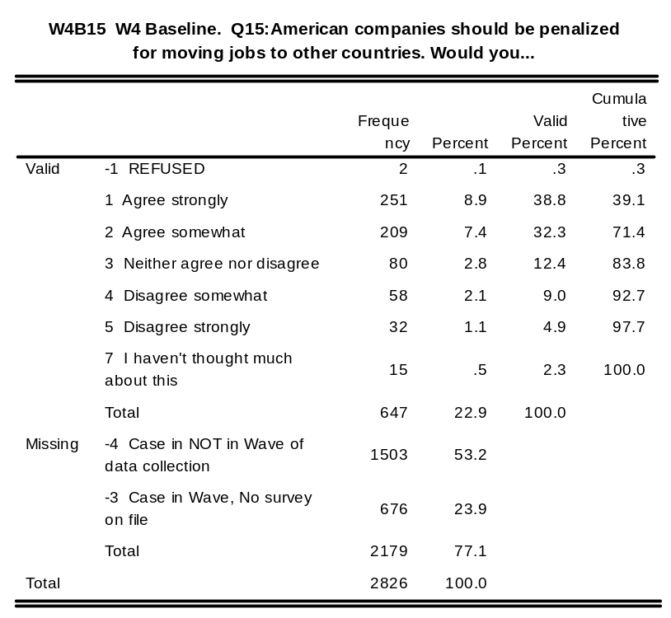
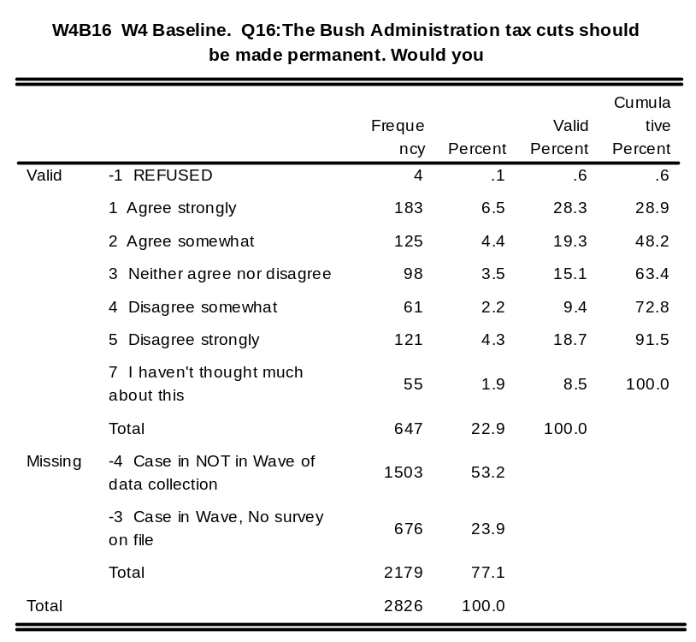
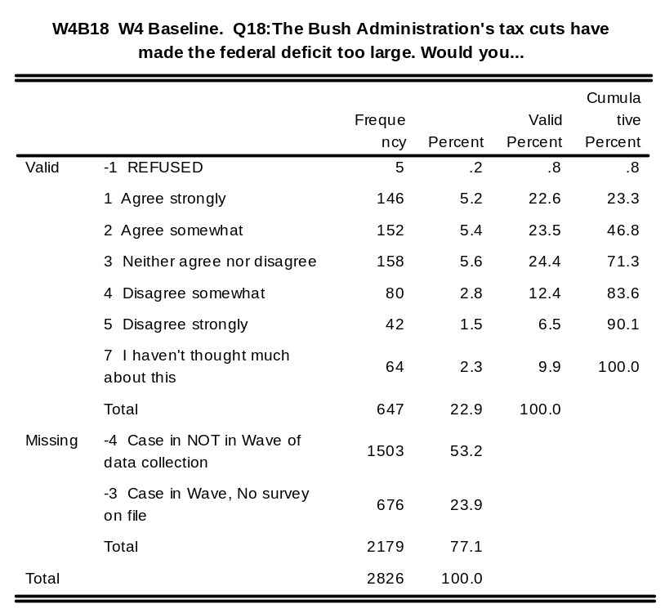
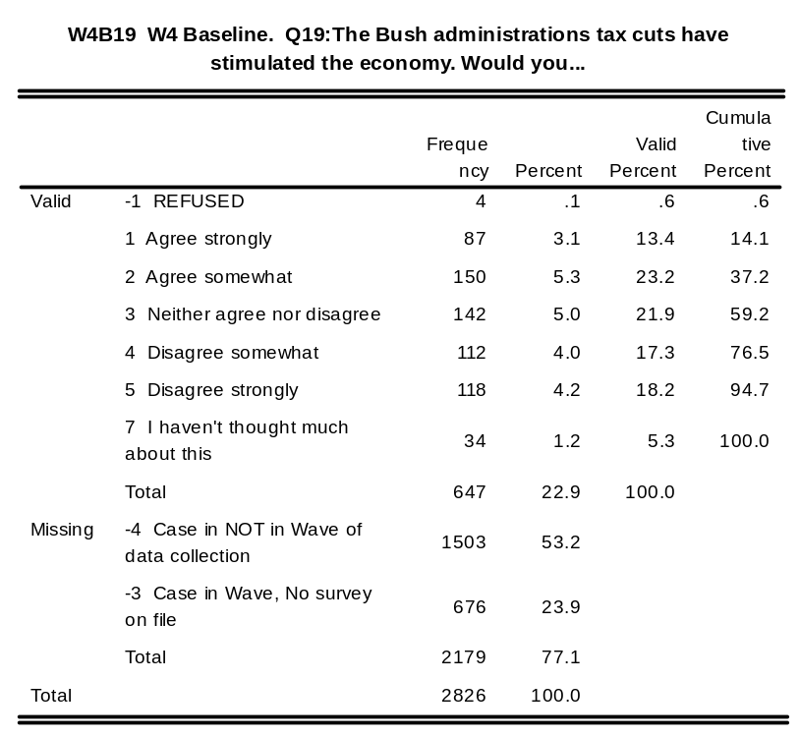
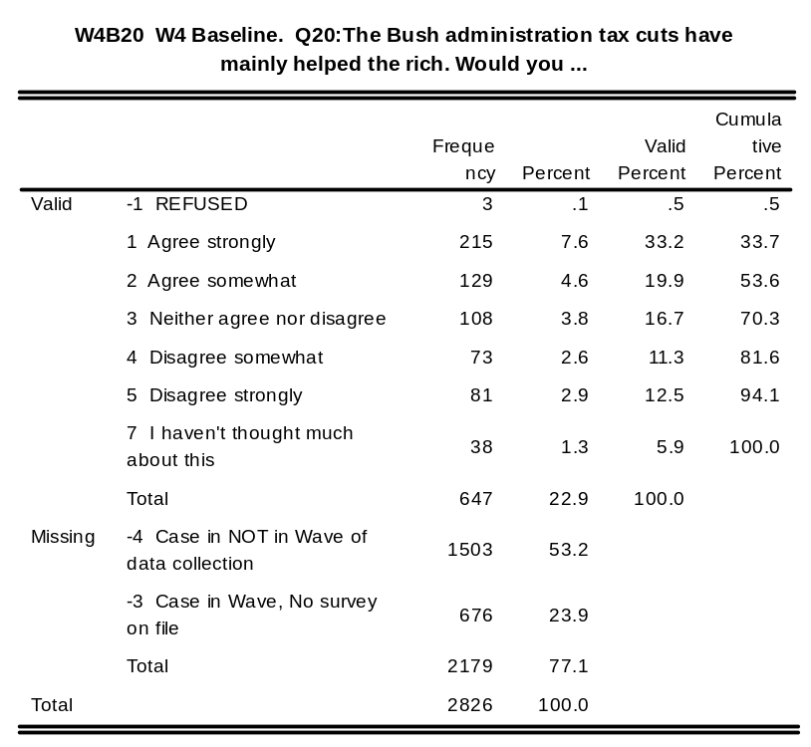
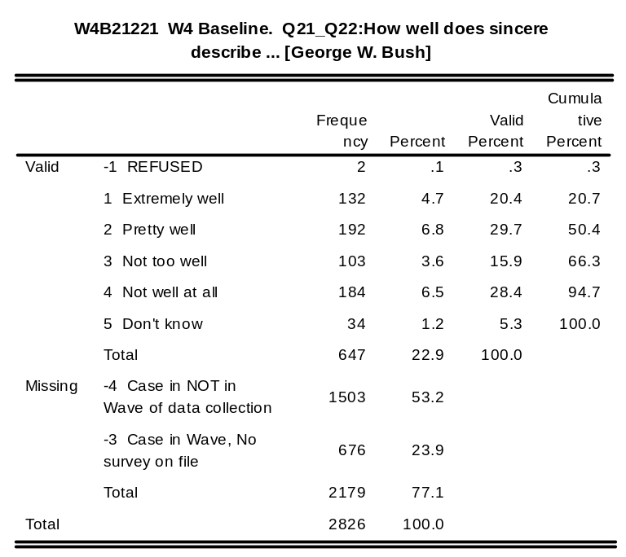
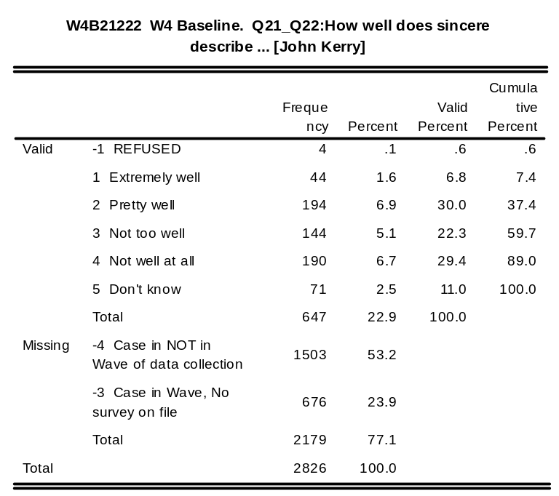
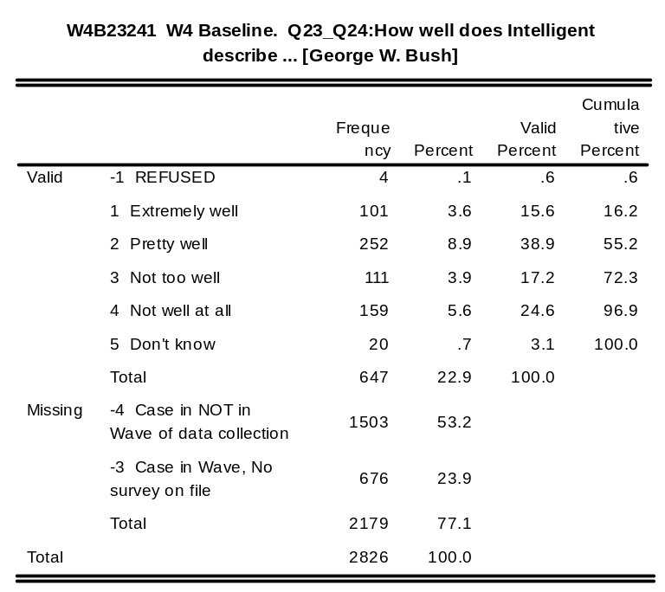
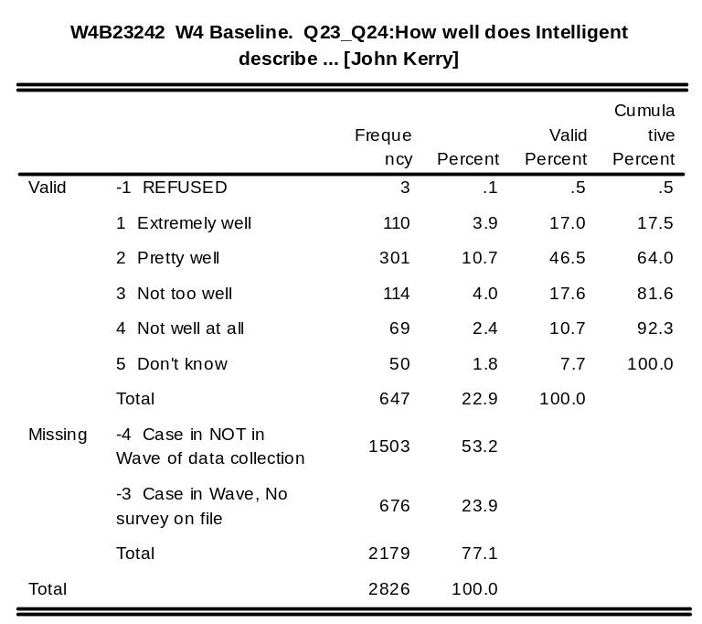
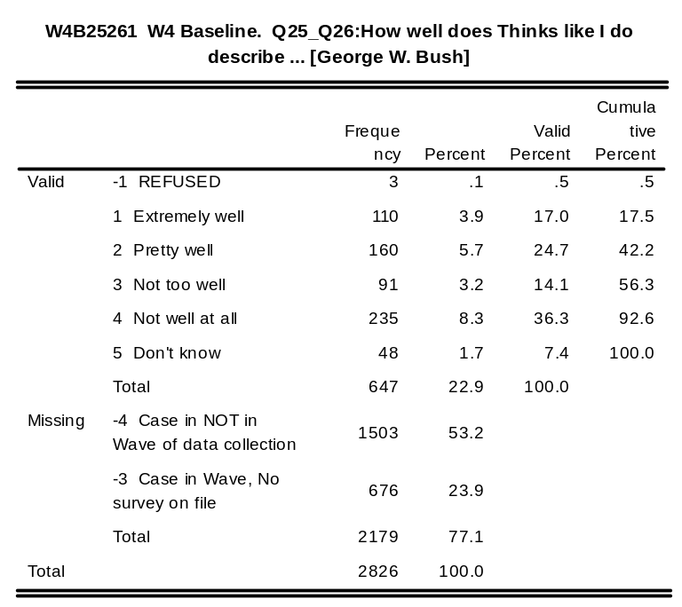
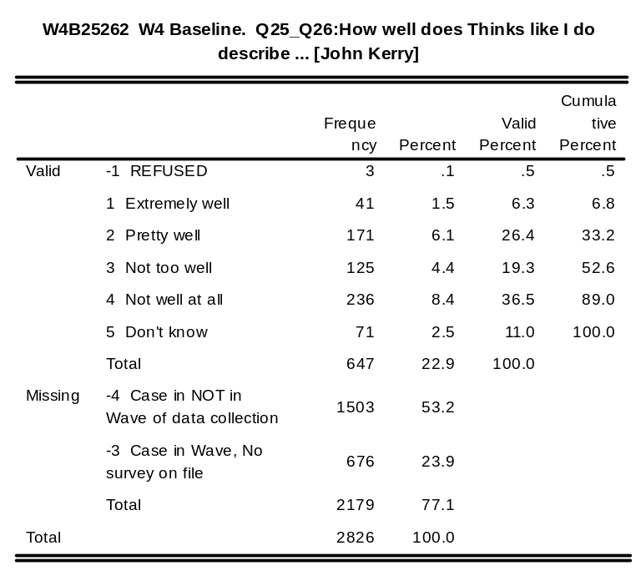
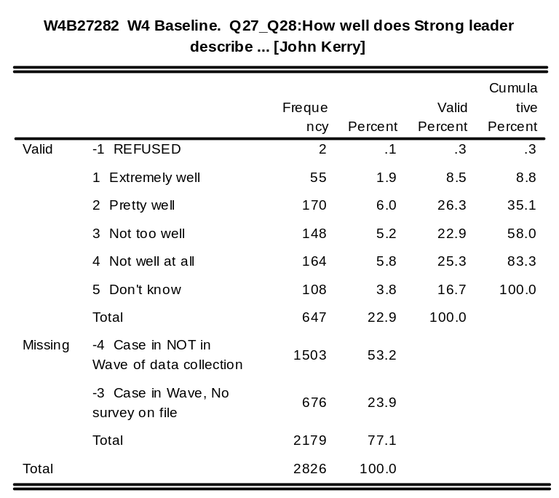
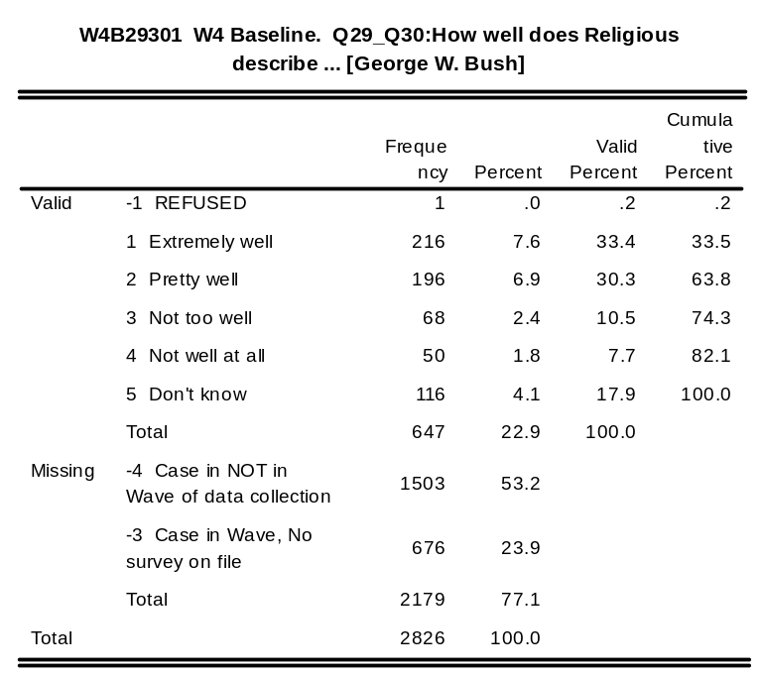
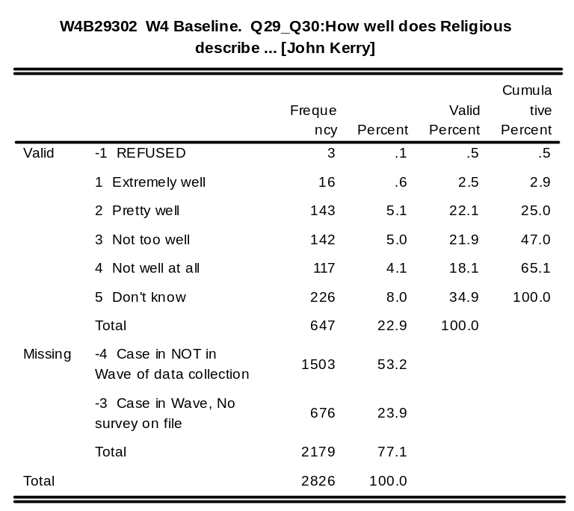
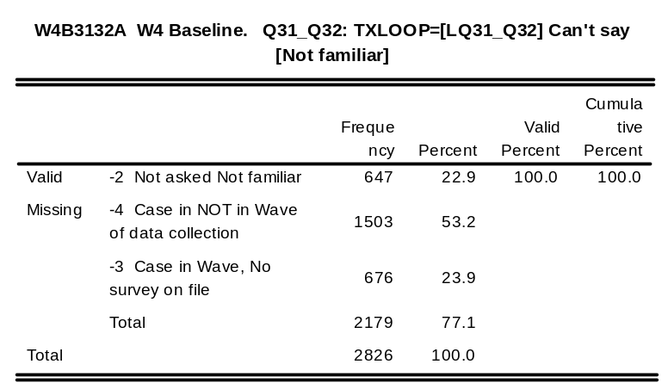
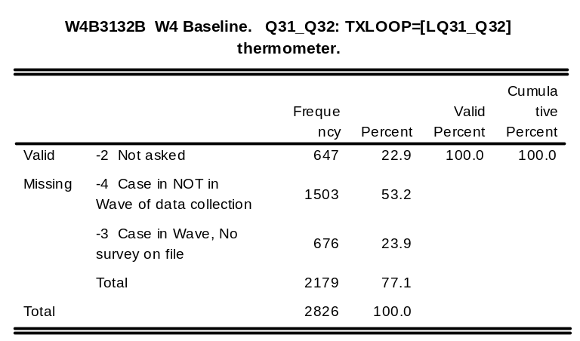
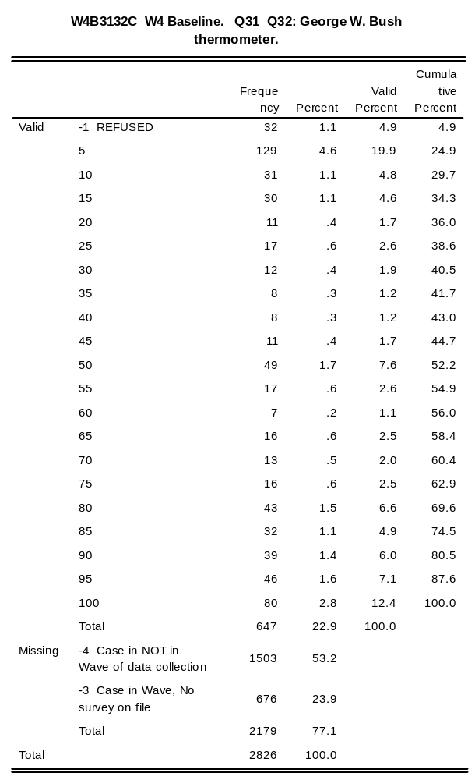
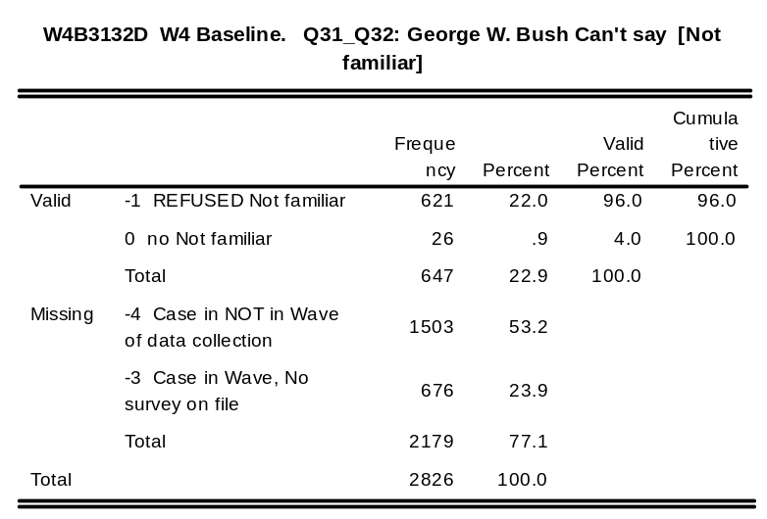
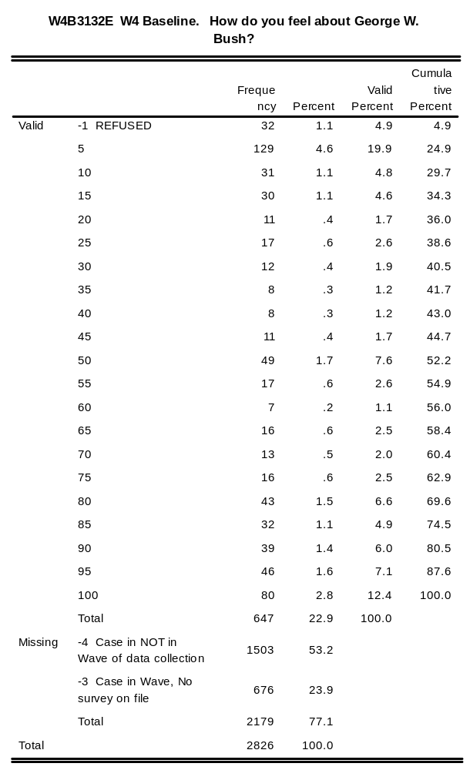
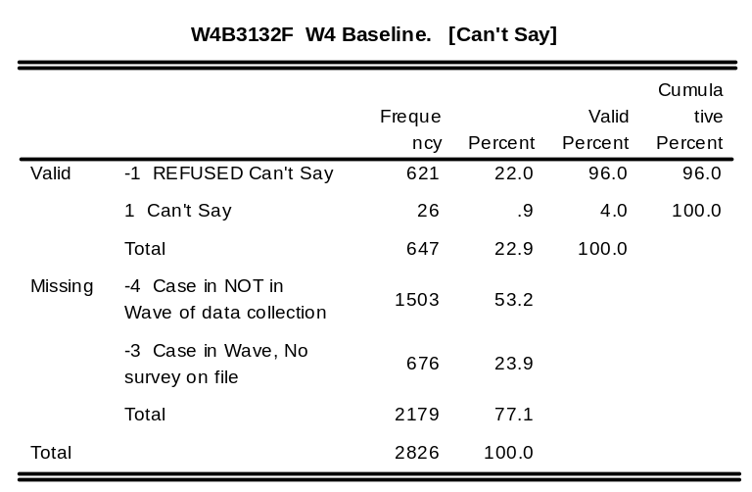
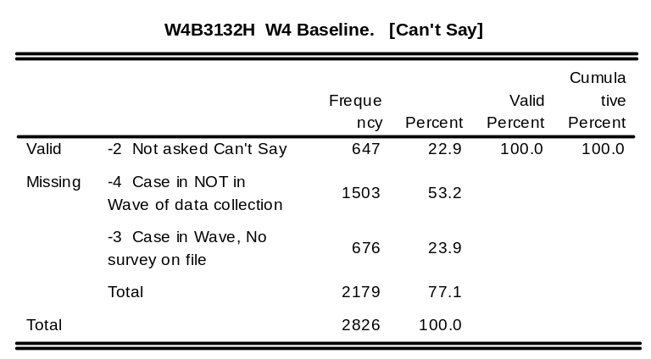
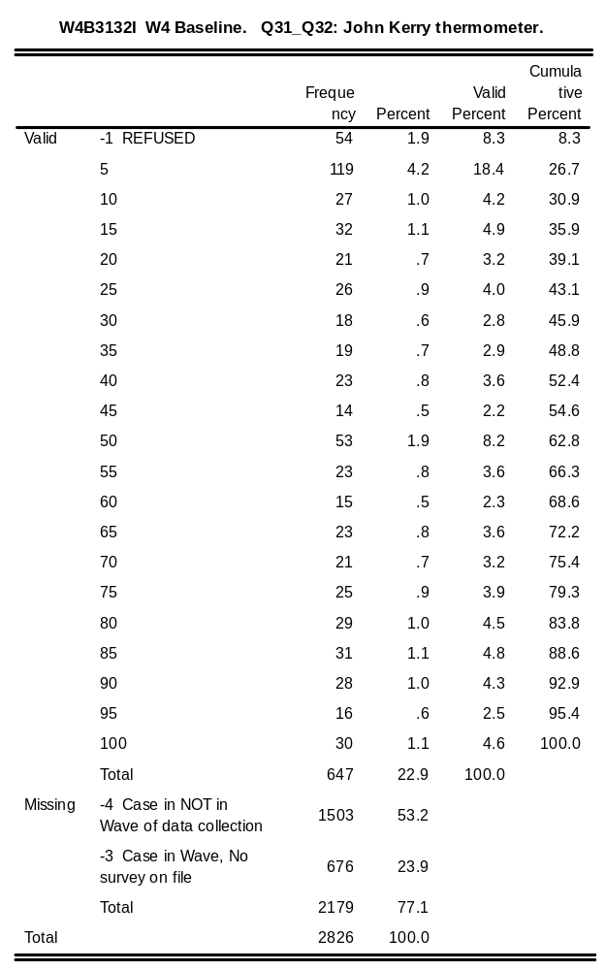
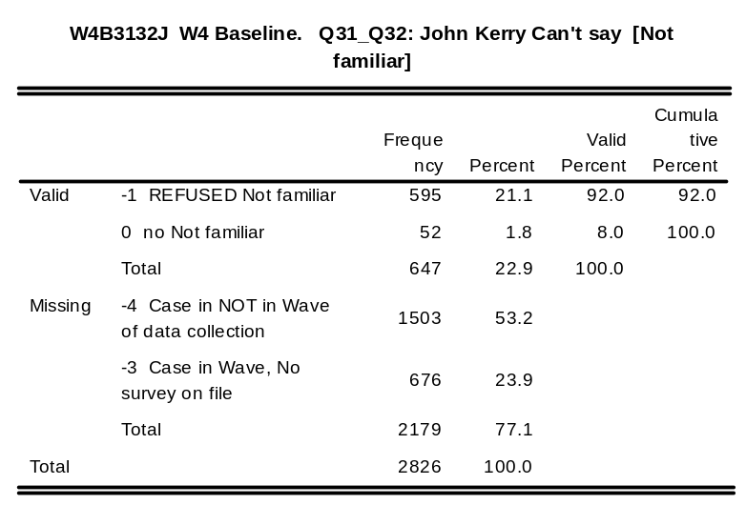
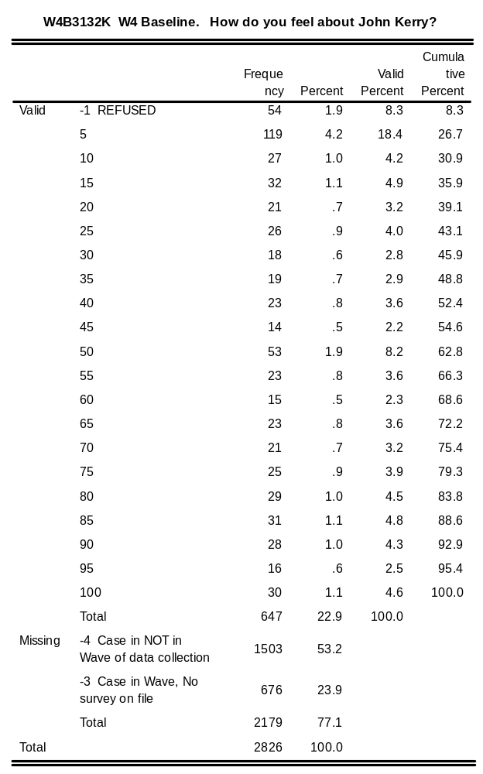
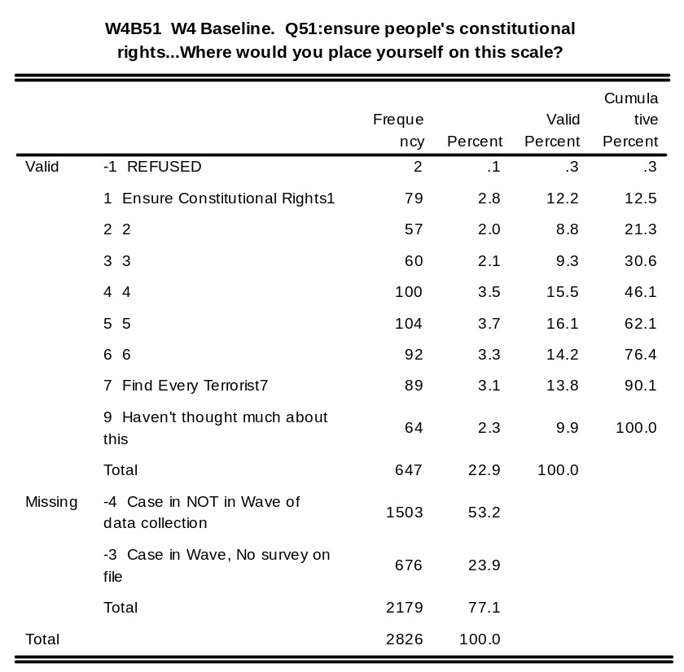
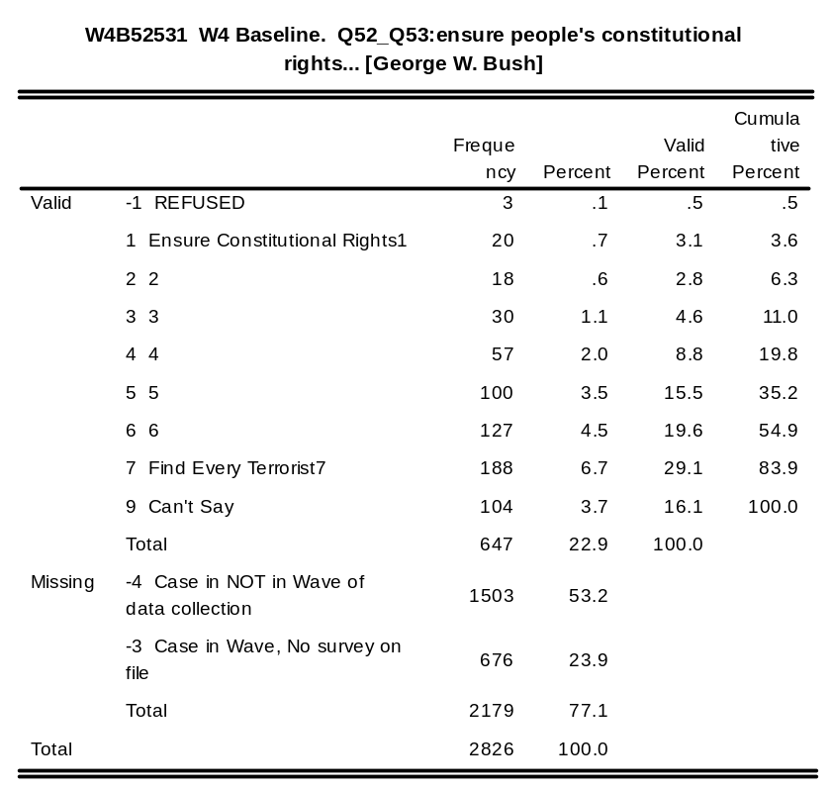
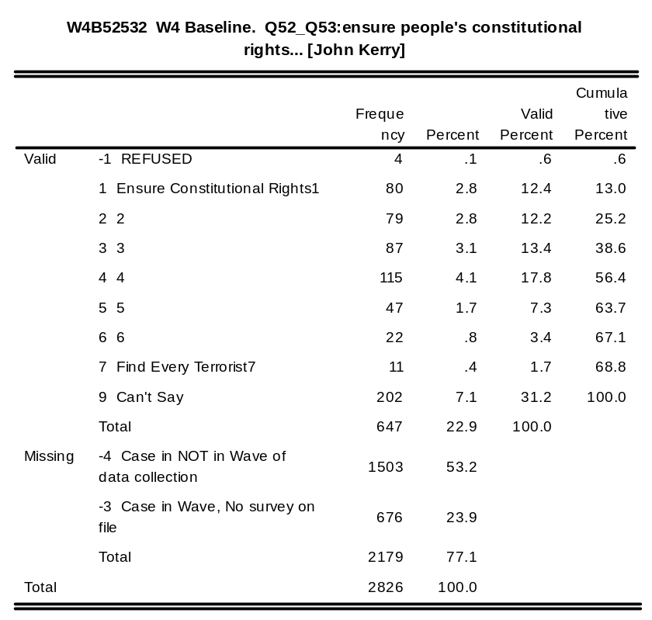
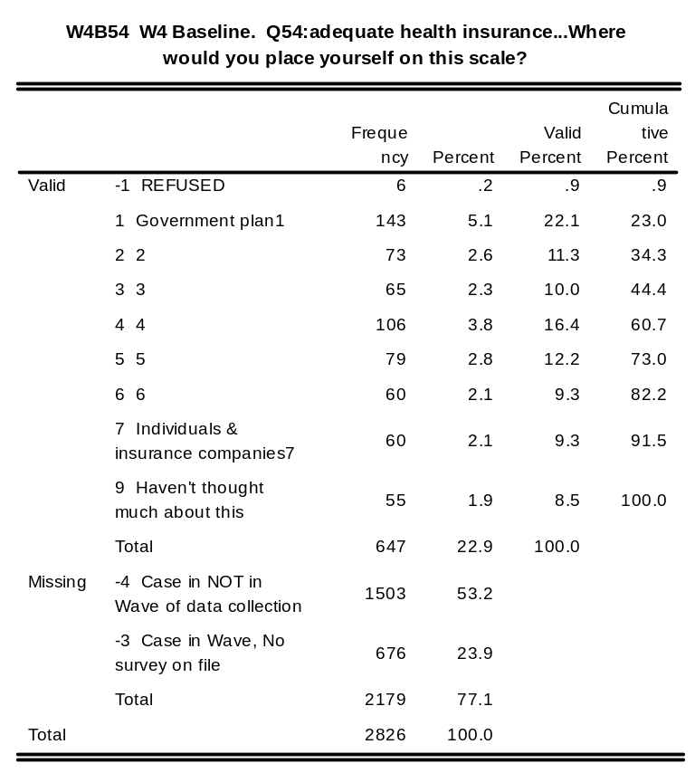
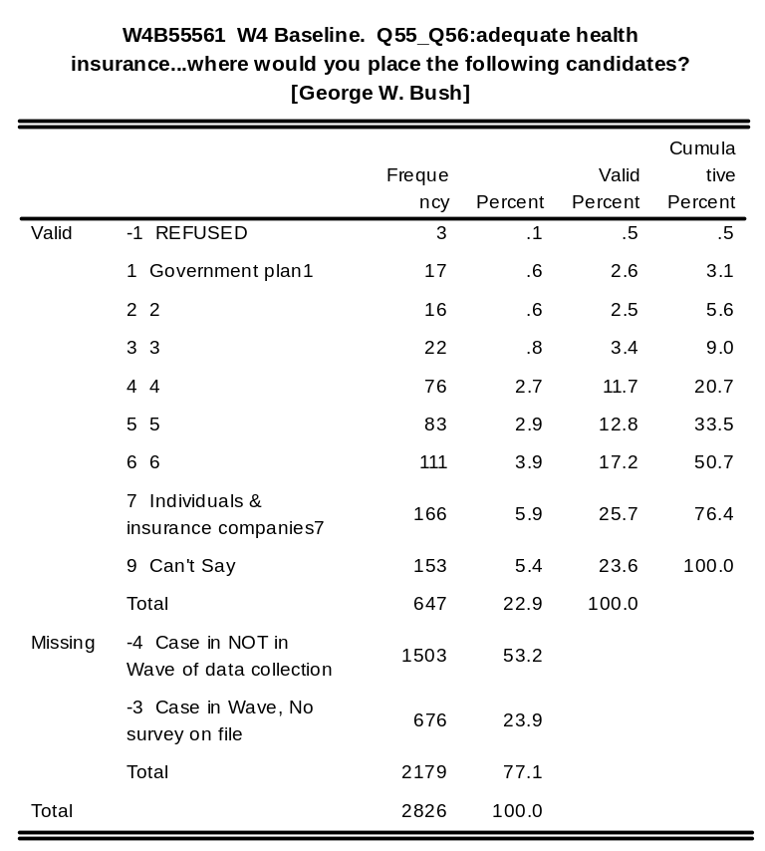
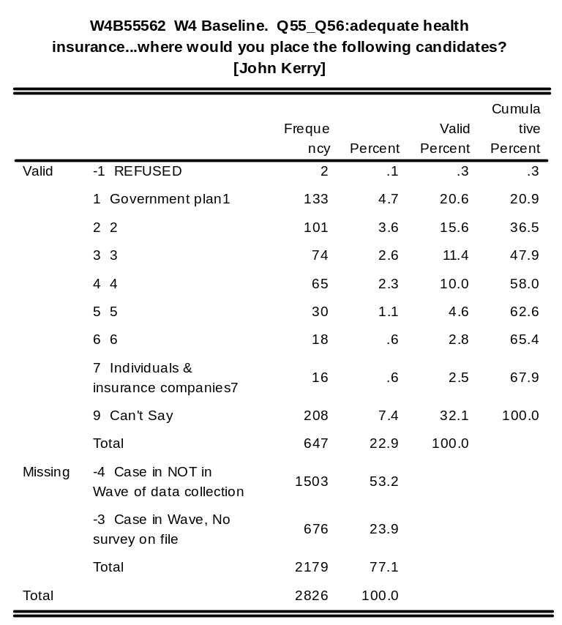
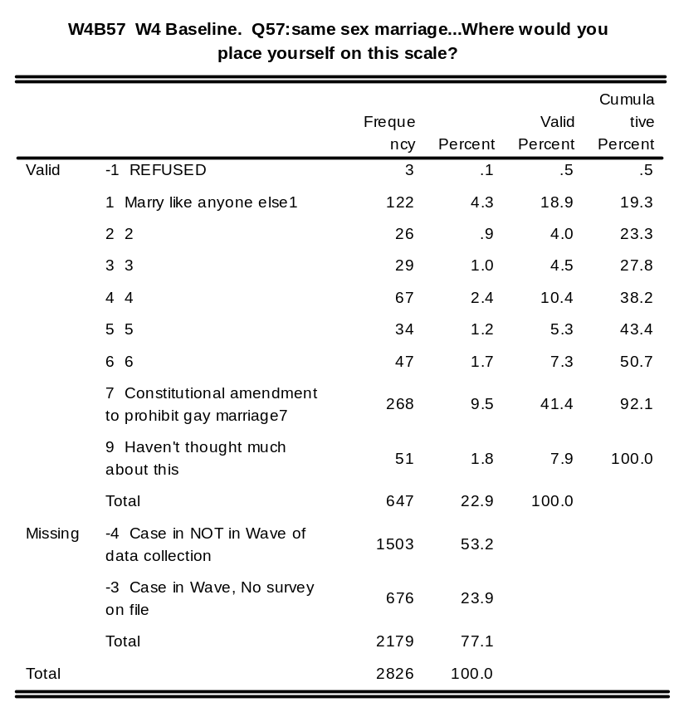
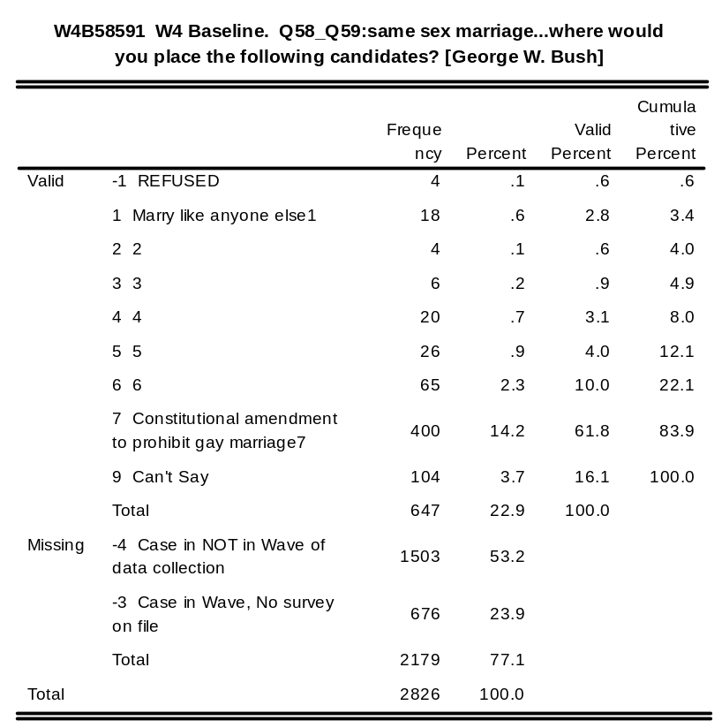
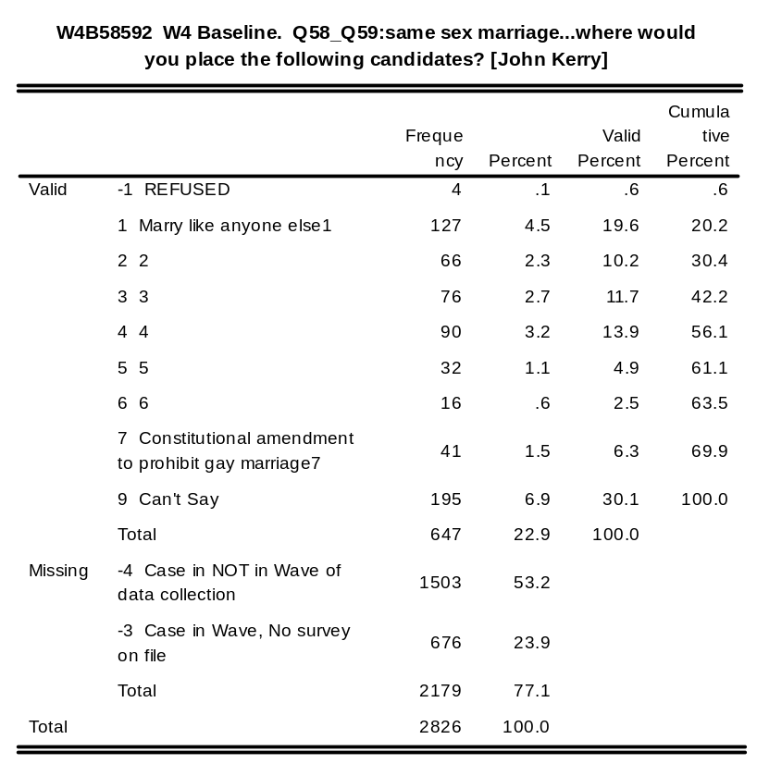
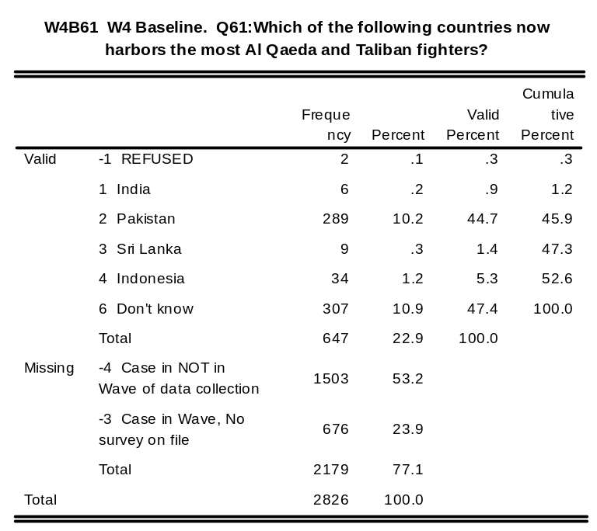
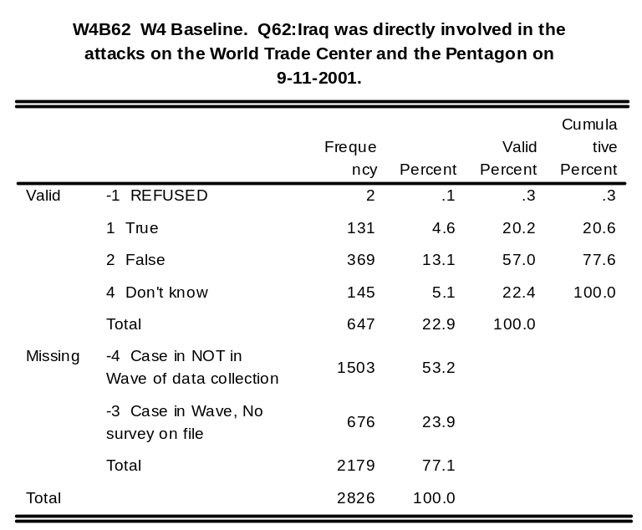
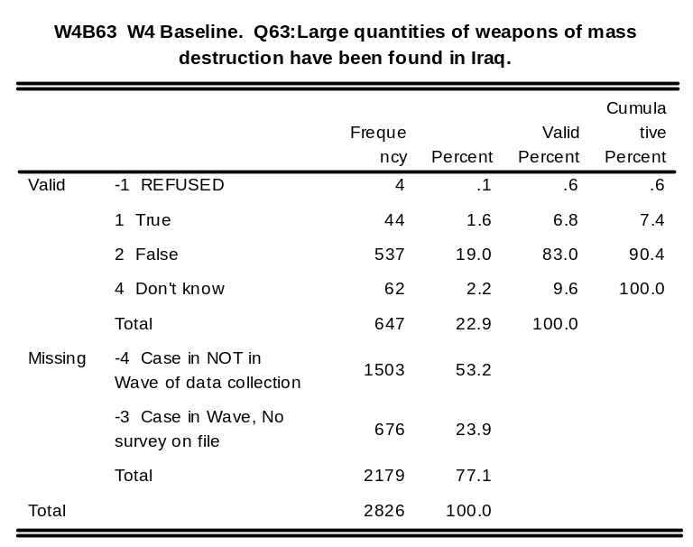
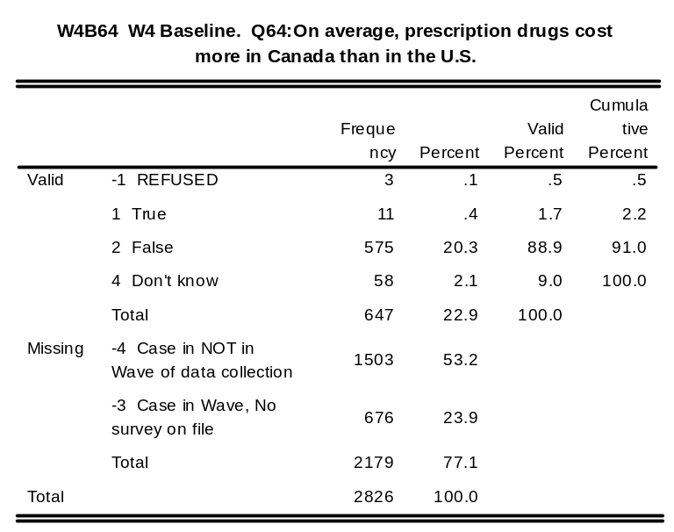
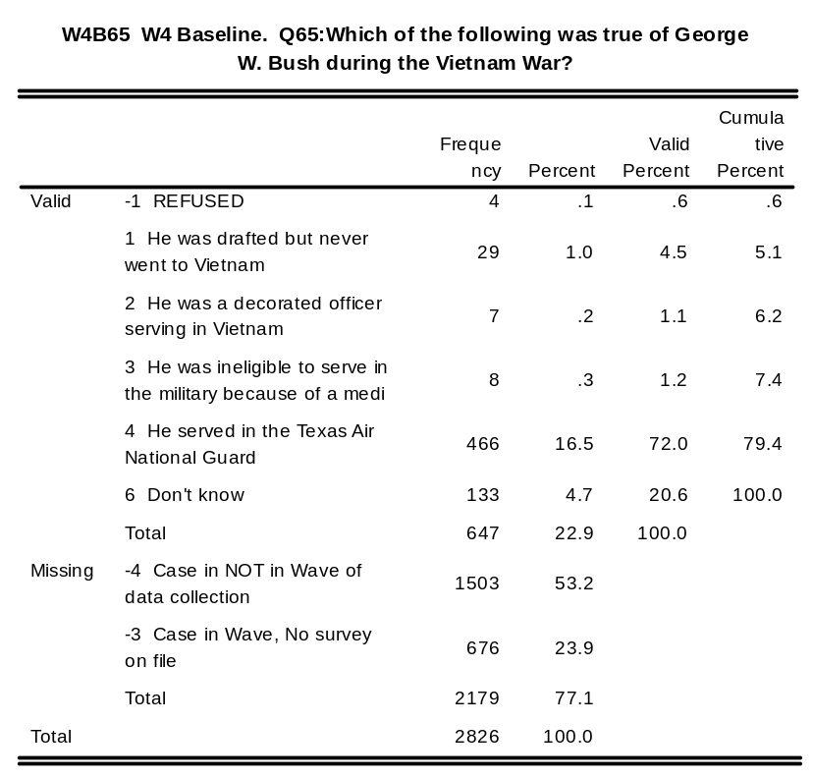
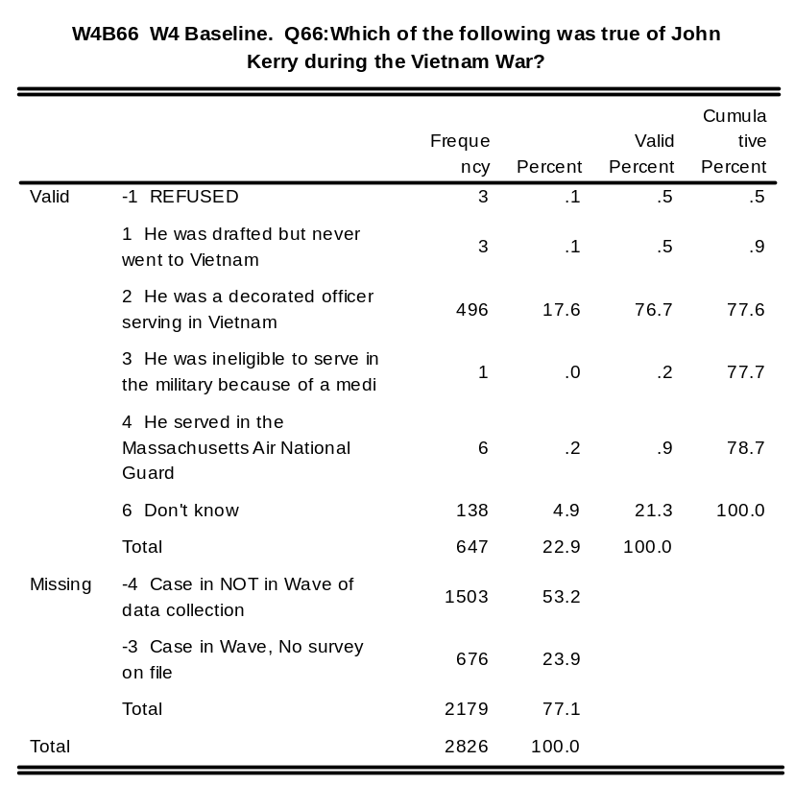
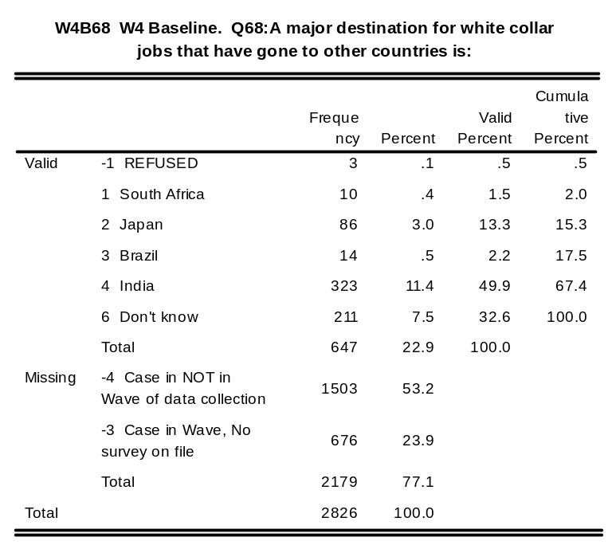
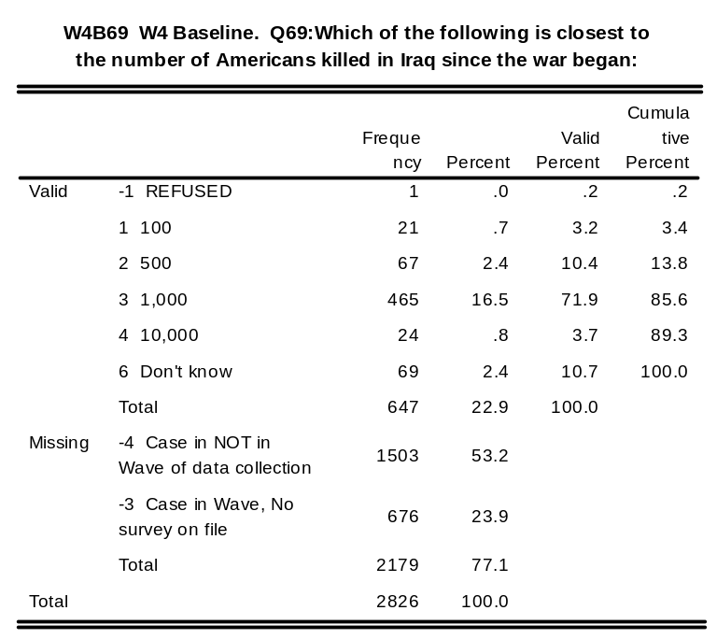
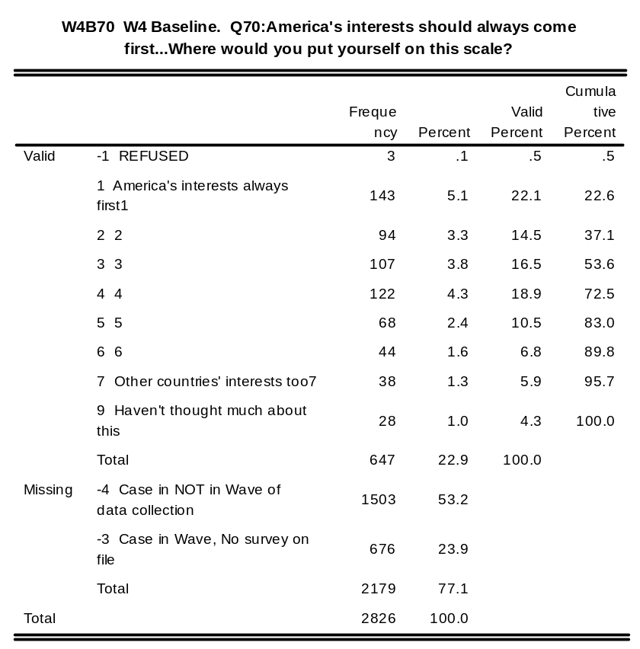
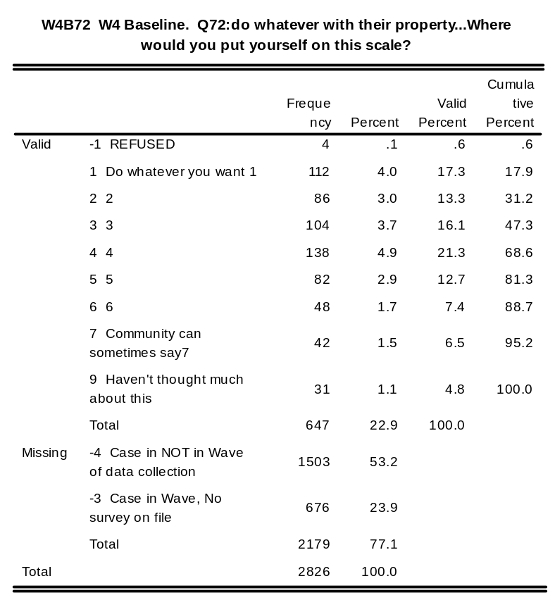
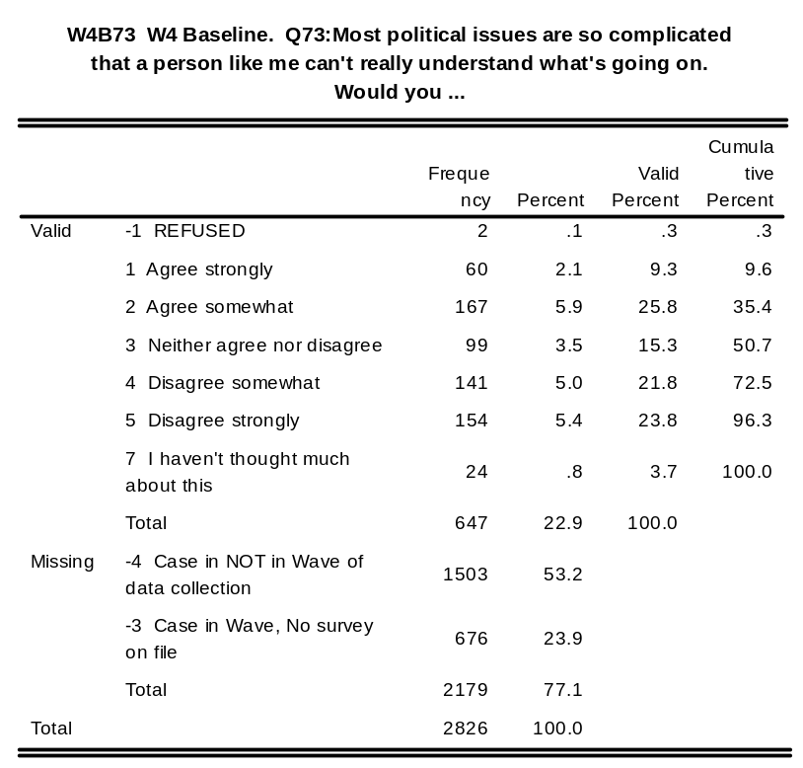
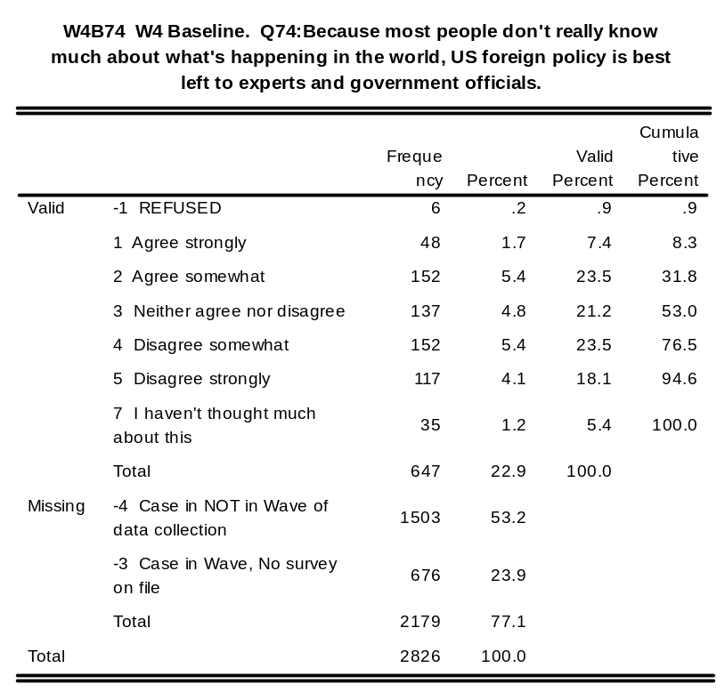
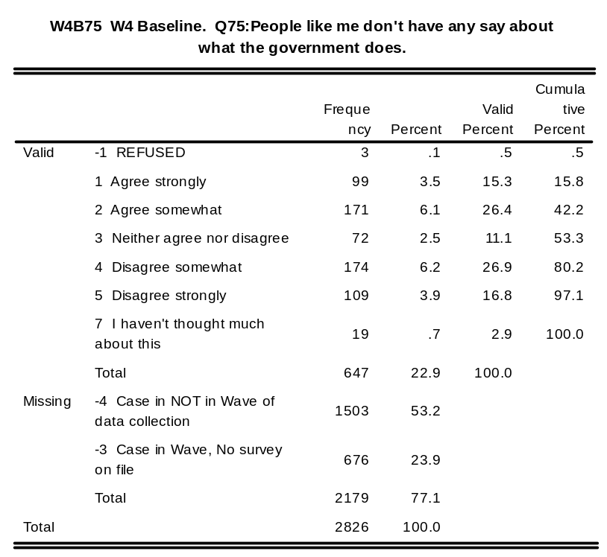
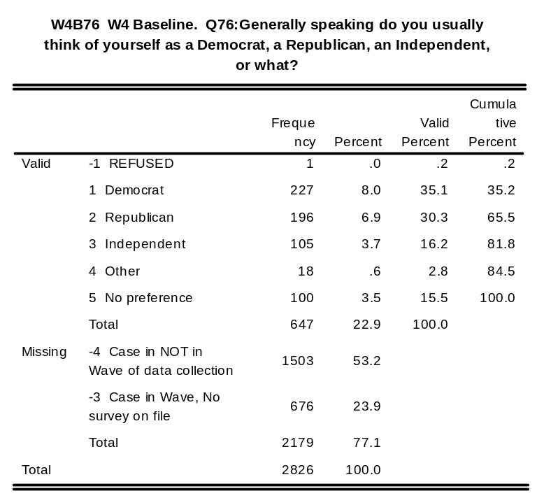
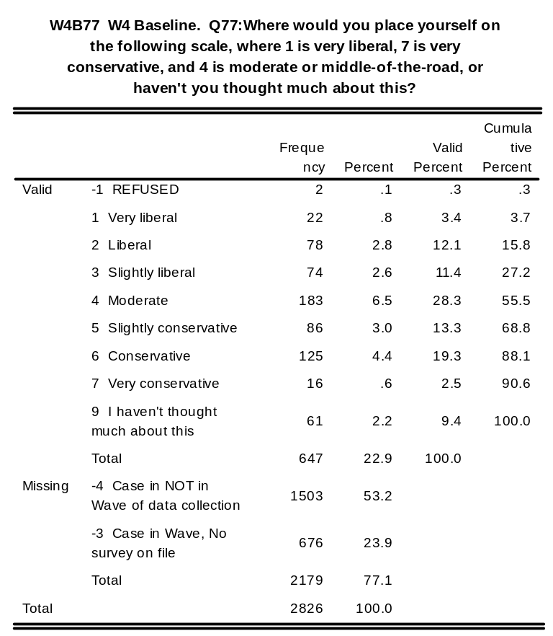
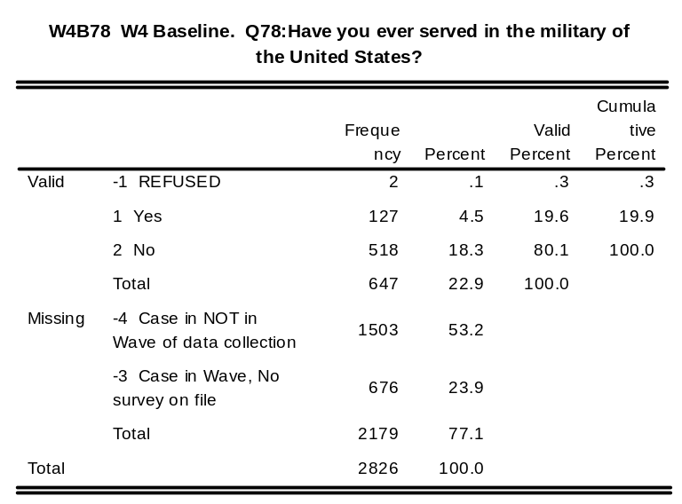
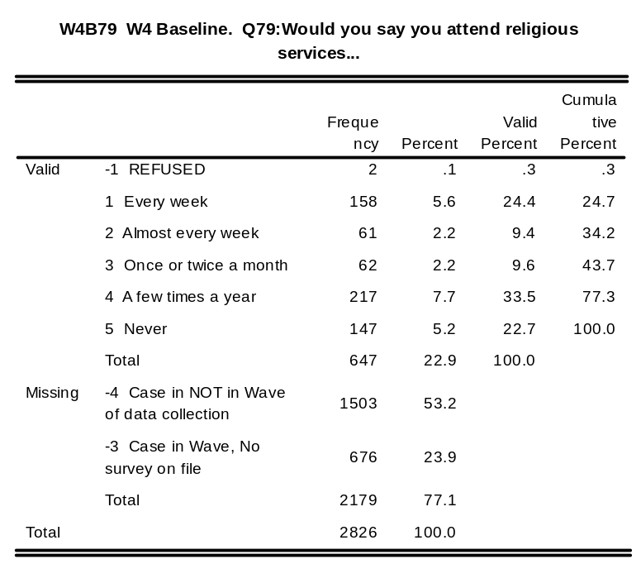
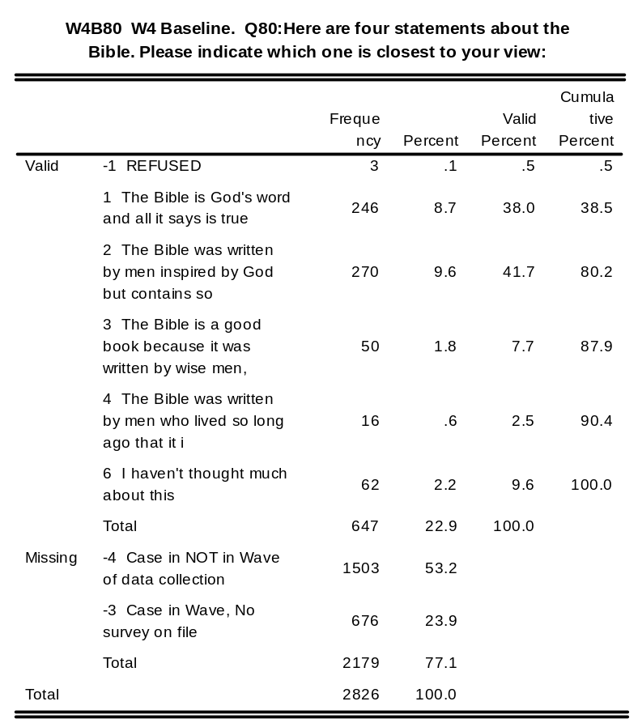

w4fstart: W4 Followup. Start Date and Time of Interview

w4fend: W4 Followup. End Date and Time of Interview

w4fdur: W4 Followup. Duration of interview in minutes

w4cd_no : W4 CD_Followup. CD Identification Number

Wave 4 CDROM Tracking File Information from Stanford
firstuse: days from Sept.0 of first cd use

lastuse: days from Sept.0 of last cd use

paget: pages viewed

vidt: videos viewed

Summer CDROM Follow-up Survey

c_cd_no: Summer CD Identification Number

Summer 2004 CDROM Tracking File Information from Stanford
cfrstuse: Summer CD 2004: days since July of first use (1 = Jul 1)

clastuse: Summer CD 2004: days since July of last use (32 = Aug 1)

cpaget: Summer CD 2004: pages viewed

cvidt: Summer CD 2004: videos played

Standard Demographics

