Codebook for the 1996 British Deliberative Poll on Britain and the Monarchy

The codebook is located at:

The data for this codebook with all T1 and T2 participant responses is located at: monarchy1

The data for this codebook with T2 participant values coded as missing is located at: monarchy2

The data for this codebook with T2 participant values not coded as missing is located at: monarchy3

DP evaluation variables were not included in the MasterData and are not included in this codebook.

Pre-weekend interview and self-completion questionnaire prefixed by Q.
Post-weekend self-completion questionnaire prefixed by W.

LIST OF VARIABLES

Administrative Variables:
PART = Participant in T2
RECRUIT = Outcome of recruiting attempt
TELEACC = Telephone in accommodation (QB25a)
TELENUM = Telephone number for checking (QB25b)

Sociodemographic Variables:
SEX = Sex of respondent (QA1)
AGE = Age of respondent (QA2)
CHILD = Number of children 0-17 (QA3a)
CHILDU5 = How many aged under 5 (QA3b1)
CHILD511 = How many aged 5_11 (QA3b2)
CHIL1215 = How many aged 12_15 (QA3b3)
CHIL1617 = How many aged 16_17 (QA3b4)
MARSTAT = Marital status (QA4)
WORKSTAT = Work status (QB2)
NOHOUSEH = Number of adults 18+ in HH (QB3)
INCEARN = Chief income earner if 2+ adults (QB4)
WSTATOTH = Work status if C.I.E. other than self (QB5)
JOBPOS = Job position of CIE (QB6a)
WORKTYPE = Type of work of CIE (QB6b)
EMPSTAT = Employment status of CIE (QB7)
SUPSTAT = Supervision status of CIE (QB8)
EMPSIZE = Establishment size of CIE work (QB9a)
SEMPSIZE = Number of employees / self-employed (QB10a)
AGEEDU = At what age finished full-time educ (QB11)
HIGHQUAL = Highest qualification achieved (QB12a)
QUALHIGH = Highest qualification achieved (QB12b)
BRIT = Think of self as British (QB13a)
ENGLISH = Think of self as English (QB13b)
SCOT = Think of self as Scottish (QB13c)
WELSH = Think of self as Welsh (QB13d)
IRISH = Think of self as Irish (QB13e)
NIRISH = Think of self as N. Irish (QB13f)
EUROP = Think of self as European (QB13g)
OTHER = Think of self as Other (QB13h)
NONE = Think of self as none of these (QB13i)
CODERING = How many codes ringed at B13 (QB14)
BESTDESC = How think of self – country (QB15)
ETHNIC = Ethnic group (QB16)
RELIGION = Religious affiliation (QB17)

Political Trust Variables:
TRUSTGOV = Trust parties to place needs of nation first (QB18a)
TRUSTJOR = Trust journalist to pursue truth (QB18b)
TRUSTCIV = Trust civil servants to stand firm (QB18c)
TRUSTPOL = Trust politicians to tell truth (QB18d)

Media Consumption Variables:
READPAP = Normally read any daily morning newspaper (QA5a)
PAPREAD = Which paper normally read (QA5b)

Political Interest Variables:
POLINTER = How interested in politics (QA6)

Partisanship Variables
PARTYID = Party identification (QB1a)
PARTYCL = If no pid, party closest to (QB1b)
PARTYSTR = Strength of party allegiance (QB1c)

Values Variables:
LESSHARS = Newspapers should be less harsh on RF (QA7d)
COUNSUP = Should support country even if wrong (QB19e)
BORNWLTH = Attitude to those born into wealth (QB20a)
AGBORNWW=Agree – wrong born wealthy have better chance at life (QB20b)
AGGDLUCK = Agree – good luck to those born into wealth (QB20c)
BESTWAY = Best way forward for Britain (QB21a)
AGRTRAD = Agree – stick to traditional ways (QB21b)
LEAVPAST = Agree – best way forward is to leave past behind (QB21c)
QUALEDU = Quality of education (QB22a)
SAMEQUAL = Agree – quality of education should be same (QB22b)
PARENTPY = Agree – parents s/b able to pay for better edu (QB22c)
WINEQUIT = Inequities in wealth (QB23a)
NOTKEEPW = Agree- very rich s/n be allowed to keep wealth (QB23b)
KEEPWEAL = Agree – nothing wrong people keeping more wealth (QB23c)
GENCHOOS = Generation should choose new ways (QB24a)

Britain Evaluation Variables:
CITBRIT = Rather be a citizen of Britain (QB19a)
ASHAMED = Ashamed of some things about Britain (QB19b)
WORLDBET = World better place if more like Brit (QB19c)
BRITBET = Britain better than other countries (QB19d)
SUCCESS = Success depends on who know (QB24b)

Monarchy Evaluation Variables:
QLETDOWN = Queen has been let down by family (QA7a)
HIGHSTAN = Royal family sets high standards (QA7b)
JOURDAM = Journalists damaging reputation of RF and Britain (QA7c)
LUXURY1 = Monarchy is expensive luxury T1 (Q3a)
LUXURY2 = Monarchy is expensive luxury T2 (W3a)
TOOENG1 = Monarchy is too English T1 (Q3b)
TOOENG2 = Monarchy is too English T2 (W3b)
BENEFIT1 = Royal family benefits rich and powerful T1 (Q3c)
BENEFIT2 = Royal family benefits rich and powerful T2 (W3c)
PROPUP1 = Monarchy props up snobbish system T1 (Q3d)
PROPUP2 = Monarchy props up snobbish system T2 (W3d)
ADAPT1 = Monarch stops adapting to modern world T1 (Q3e)
ADAPT2 = Monarch stops adapting to modern world T2 (W3e)
DIVIS1 = Monarchy divides classes T1 (Q3f)
DIVIS2 = Monarchy divides classes T2 (W3f)
STUCKUP1 = Monarchy makes Britain seem stuck-up T1 (Q3g)
STUCKUP2 = Monarchy makes Britain seem stuck-up T2 (W3g)
INFLPOL1 = Influence over British politics T1 (Q4)
INFLPOL2 = Influence over British politics T2 (W4)
PROUD1 = Monarchy makes me proud T1 (Q6c)
PROUD2 = Monarchy makes me proud T2 (W6c)
VALUE1 = Monarchy gives good value for money T1 (Q6d)
VALUE2 = Monarchy gives good value for money T2 (W6d)
SURVIVE1 = How long will monarchy survive in present form T1 (Q10)
SURVIVE2 = How long will monarchy survive in present form T2 (W10)
ABOVEP1 = Monarchs more likely to stand above politics T1 (Q13c)
ABOVEP2 = Monarchs more likely to stand above politics T2 (W13c)
STAY1 = Good that monarchs stay in office longer T1 (Q13g)
STAY2 = Good that monarchs stay in office longer T2 (W13g)
INTREST1 = Monarch act in interests of royal family or nation T1 (Q16)
INTREST2 = Monarch act in interests of royal family or nation T2 (W16)

Importance of Monarchy Variables:
TOURIST1 = Importance in attracting tourist T1 (Q2a)
TOURIST2 = Importance in attracting tourist T2 (W2a)
RESPECT1 = Importance of gaining international respect T1 (Q2b)
RESPECT2 = Importance of gaining international respect T2 (W2b)
GOVABUS1 = Importance in preventing govt. abuse T1 (Q2c)
GOVABUS2 = Importance in preventing govt. abuse T2 (W2c)
TRADE1 = Importance in attracting trade T1 (Q2d)
TRADE2 = Importance in attracting trade T2 (W2d)
PRESENT1 = Importance liking present with past T1 (Q2e)
PRESENT2 = Importance liking present with past T2 (W2e)
UNITE1 = Importance in uniting British T1 (Q2f)
UNITE2 = Importance in uniting British T2 (W2f)
STADEM1 = Importance in keeping stable democracy T1 (Q2g)
STADEM2 = Importance in keeping stable democracy T2 (W2g)
HELP1 = Importance in helping good causes T1 (Q2h)
HELP2 = Importance in helping good causes T2 (W2h)

Attitude Toward Future of Monarchy Variables
MONARCH1 = What should happen to monarchy T1 (Q1)
MONARCH2 = What should happen to monarchy T2 (W1)
MIX1 = Royal family should mix more w/ people T1 (Q6a)
MIX2 = Royal family should mix more w/ people T2 (W6a)
RETIRE1 = Monarchs should retire at same age as workers T1 (Q6b)
RETIRE2 = Monarchs should retire at same age as workers T2 (W6b)
TAXES1 = Monarch should pay taxes like others T1 (Q6e)
TAXES2 = Monarch should pay taxes like others T2 (W6e)
GLAMOUR1 = No point in royal family w/o glamour T1 (Q6f)
GLAMOUR2 = No point in royal family w/o glamour T2 (W6f)
SUPPORT1 = Cannot win popular support should leave office T1 (Q7a)
SUPPORT2 = Cannot win popular support should leave office T2 (W7a)
PUBLIC1 = Public should have say in monarchy T1 (Q7b)
PUBLIC2 = Public should have say in monarchy T2 (W7b)
ACCEPT1 = If accept queen, accept whole family T1 (Q7c)
ACCEPT2 = If accept queen, accept whole family T2 (W7c)
SBTHRON1 = Who should be next in line to throne T1 (Q8b)
SBTHRON2 = Who should be next in line to throne T2 (W8b)
BEST1 = Best for Britain when Queen’s reign ends T1 (Q9)
BEST2 = Best for Britain when Queen’s reign ends T2 (W9)
WANTSUR1 = How long do you want monarchy to survive in present form T1
(Q11)
WANTSUR2 = How long do you want monarchy to survive in present form T2
(W11)
MPREF1 = Most prefer if Britain changes present monarchy T1 (Q12a)
MPREF2 = Most prefer if Britain changes present monarchy T2 (W12a)
LPREF1 = Least prefer if Britain changes monarchy T1 (Q12b)
LPREF2 = Least prefer if Britain changes monarchy T2 (W12b)
DEPEND1 = Monarchy more acceptable if not depend on taxpayer T1 (Q13a)
DEPEND2 = Monarchy more acceptable if not depend on taxpayer T2 (W13a)
FIGHEAD1 = If figurehead, doesn’t matter if Head of State elected T1 (Q13b)
FIGHEAD2 = If figurehead, doesn’t matter if Head of State elected T2 (W13b)
MOREPOW1 = Good if Queen had more powers T1 (Q13d)
MOREPOW2 = Good if Queen had more powers T2 (W13d)
HOSPOL1 = Elected Head of State behave like ordinary citizen T1 (Q13e)
HOSPOL2 = Elected Head of State behave like ordinary citizen T2 (W13e)
COMBPOW1 = Combining monarch and PM into Head of State gives too much
power T1 (Q13f)
COMBPOW2 = Combining monarch and PM into Head of State gives too much
power T2 (W13f)
REFEREN1 = Should be referendum on continuing monarchy T1 (Q15)
REFEREN2 = Should be referendum on continuing monarchy T2 (W15)
CHOOSPM1 = If no majority in Commons, how choose PM T1 (Q15)
CHOOSPM2 = If no majority in Commons, how choose PM T2 (W15)
INTNAT1 = Monarch or elected president acts in best interests of nation T1
(Q17)
INTNAT2 = Monarch or elected president acts in best interests of nation T2
(W17)
HEADCOE1 = Monarch should not remain head of Church of England T1
(Q20)
HEADCOE2 = Monarch should not remain head of Church of England T2
(W20)

House of Lords Variables:
LORDS1 = What should happen to House of Lords T1 (Q18)
LORDS2 = What should happen to House of Lords T2 (W18)
LORDVOT1 = Should hereditary peers in House of Lords vote T1 (Q19a)
LORDVOT2 = Should hereditary peers in House of Lords vote T2 (W19a)
LORDAPP1 = Appointed life peers or democratically elected to House of Lords
T1 (Q19b)
LORDAPP2 = Appointed life peers or democratically elected to House of Lords
T2 (W19b)

Civic Attitude Variables:
DEMOCRA1 = How well does the British system of democracy work T1 (Q21)
DEMOCRA2 = How well does the British system of democracy work T2 (W21)
SAYGOV1 = People like me have no say in government T1 (Q22a)
SAYGOV2 = People like me have no say in government T2 (W22a)
OPINION1 = Have opinions about politics worth listening to T1 (Q22b)
OPINION2 = Have opinions about politics worth listening to T2 (W22b)
VOICES1 = Too difficult for people to make voices heard T1 (Q22c)
VOICES2 = Too difficult for people to make voices heard T2 (W22c)
INFORM1 = R better informed than most about politics T1 (Q22d)
INFORM2 = R better informed than most about politics T2 (W22d)

Information Variables:
LINETH1 = Princess Anne next in line to throne T1 (Q5a)
LINETH2 = Princess Anne next in line to throne T2 (W5a)
KNOWA1 = Answered LINETH1 correctly? T1
KNOWA2 = Answered LINETH2 correctly? T2
HEADST1 = PM is Head of State T1 (Q5b)
HEADST2 = PM is Head of State T2 (W5b)
KNOWB1 = Answered HEADST1 correctly? T1
KNOWB2 = Answered HEADST2 correctly? T2
HEADCOM1 = Queen is head of Commonwealth T1 (Q5c)
HEADCOM2 = Queen is head of Commonwealth T2 (W5c)
KNOWC1 = Answered HEADCOM1 correctly? T1
KNOWC2 = Answered HEADCOM2 correctly? T2
QUEDUTY1 = Queen’s duty to decide election date T1 (Q5d)
QUEDUTY2 = Queen’s duty to decide election date T2 (W5d)
KNOWD1 = Answered QUEDUTY1 correctly? T1
KNOWD2 = Answered QUEDUTY2 correctly? T2
PMOFF1 = PM takes office w/o asked by Queen T1 (Q5e)
PMOFF2 = PM takes office w/o asked by Queen T2 (W5e)
KNOWE1 = Answered PMOFF1 correctly? T1
KNOWE2 = Answered PMOFF2 correctly? T2
QUECOE1 = Queen is head of Church of England T1 (Q5f)
QUECOE2 = Queen is head of Church of England T2 (W5f)
KNOWF1 = Answered QUECOM1 correctly? T1
KNOWF2 = Answered QUECOM2 correctly? T2
QUECOS1 = Queen is head of Church of Scotland T1 (Q5g)
QUECOS2 = Queen is head of Church of Scotland T2 (W5g)
KNOWG1 = Answered QUECOS1 correctly? T1
KNOWG2 = Answered QUECOS2 correctly? T2
CONST1 = Britain has unwritten constitution T1 (Q5h)
CONST2 = Britain has unwritten constitution T2 (W5h)
KNOWH1 = Answered CONST1 correctly? T1
KNOWH2 = Answered CONST2 correctly? T2
LINETHR1 = Next in line to throne T1 (Q8a)
LINETHR2 = Next in line to throne T2 (W8a)
KNOWI1 = Answered LINETHR1 correctly? T1
KNOWI2 = Answered LINETHR2 correctly? T2
TOTKNOW1 = Proportion of correct answers T1
TOTKNOW2 = Proportion of correct answers T2

FREQUENCIES:

ADMINISTRATIVE VARIABLES:

PART: Participant in the Deliberative Poll weekend
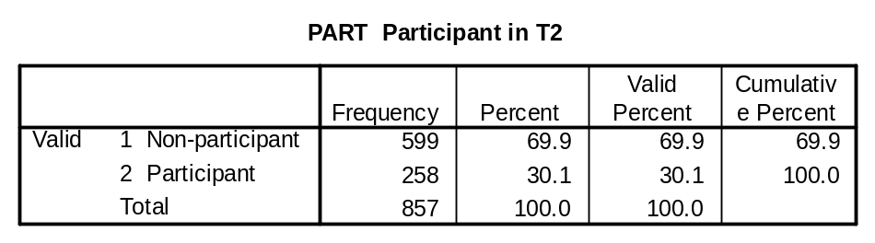

RECRUIT: Outcome of recruitment to DP attempt

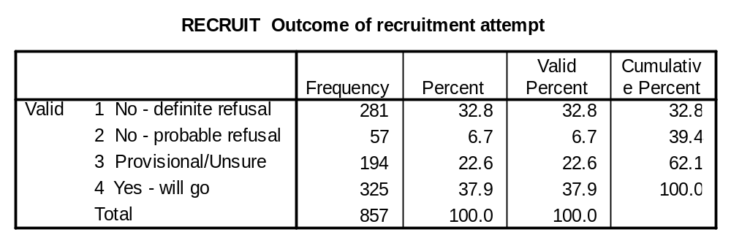

TELEACC (QB25a): Do you have a telephone in this accommodation where you can take calls?

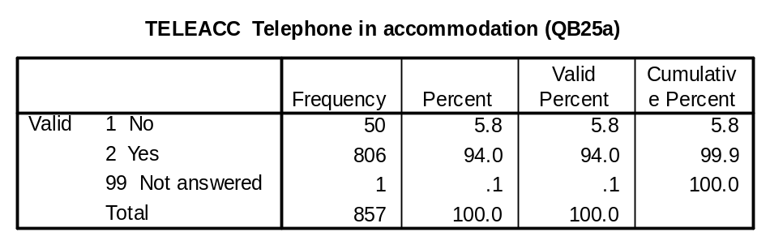

TELENUM (QB25b): A few interviews on any survey are checked by a supervisor to make sure that people are satisfied with the way the interview was carried out. In case my supervisor needs to contact you, it would be helpful if we could have your telephone number.

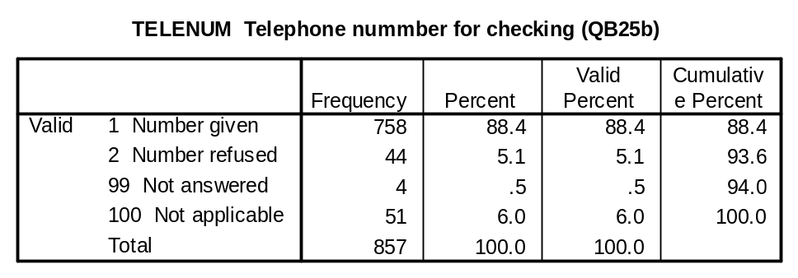

SOCIODEMOGRAPHIC VARIABLES:

SEX (QA1): Interviewer record sex of respondent.
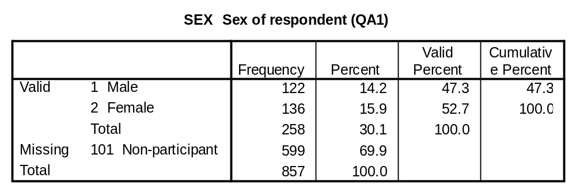

AGE (QA2): Can I check, what was your age last birthday?

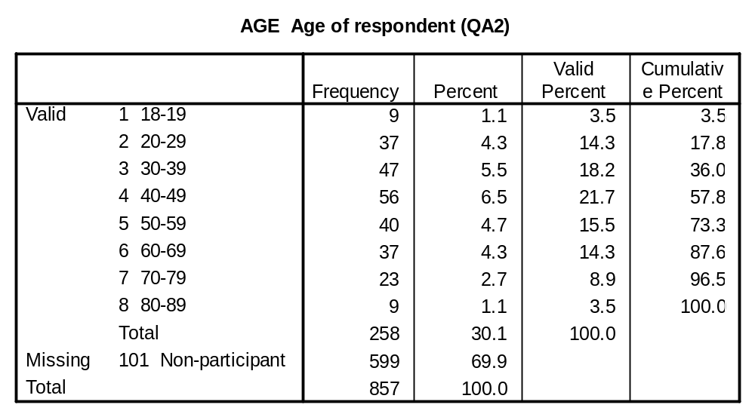

CHILD (QA3a): And are there any children aged 17 or younger living in this household?

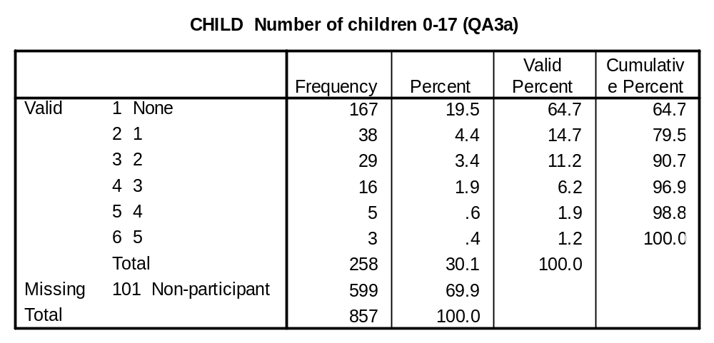

CHILDU5 (QA3b1): If children 17 or under in household
CHILD511 (QA3b2) How many are aged ….
CHILD1215 (QA3b3)
CHILD1617 (QA3b4)

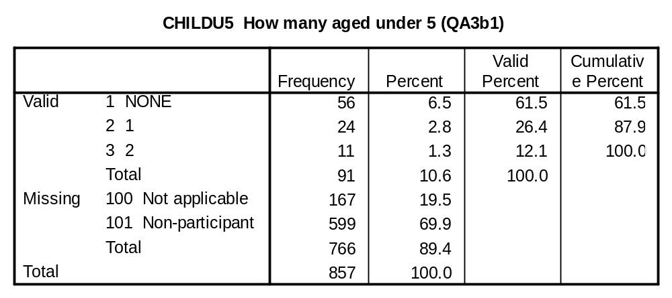

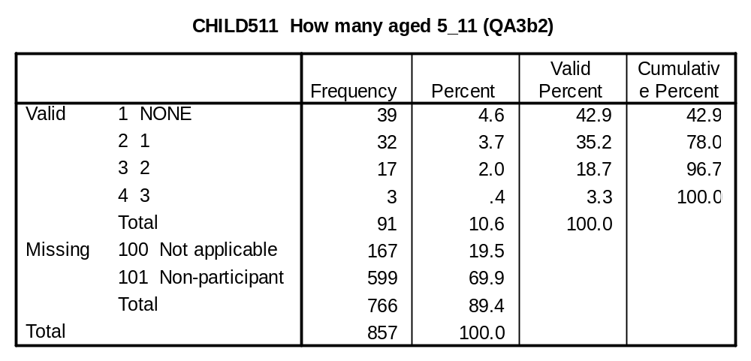

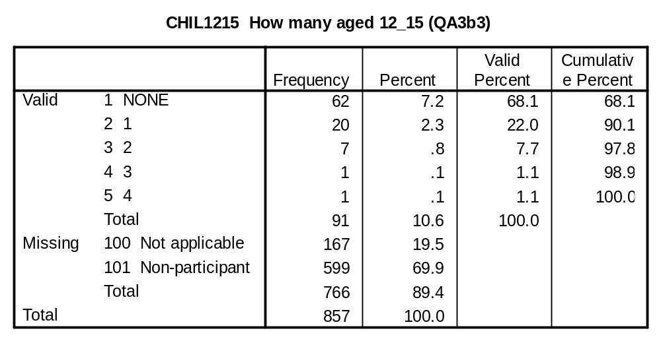

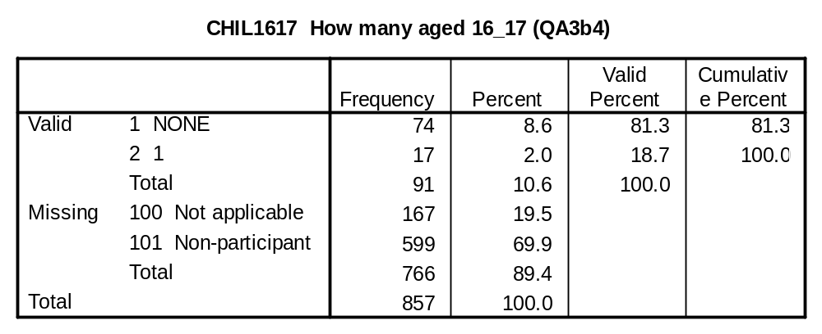

MARSTAT (QA4): Can I just check whether at present you are…

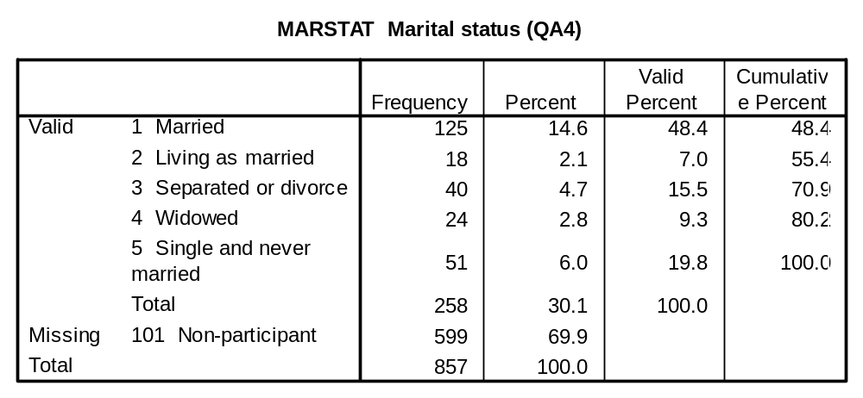

WORKSTAT (QB2): What are you doing at the present time. Are you a full-time student, in paid work, or doing something else?

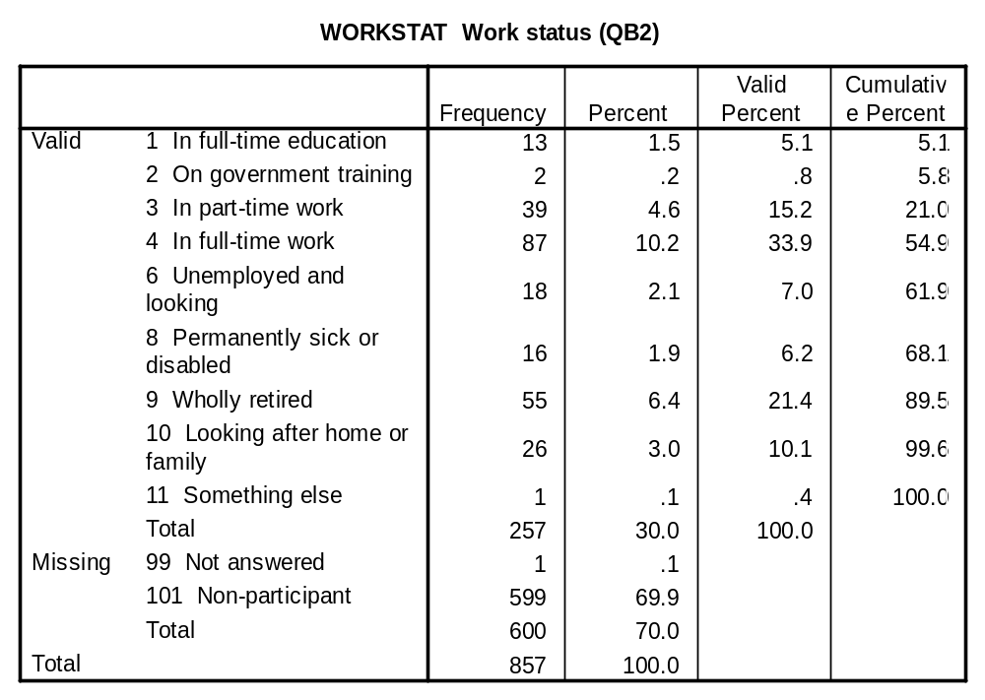

NOHOUSEH (QB3): Can I check, how many adults aged 18 or over are there living in this household?

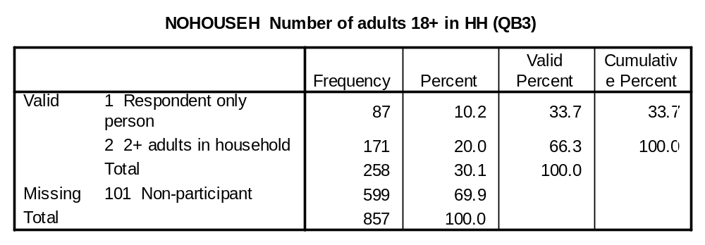

INCEARN (QB4): IF 2+ ADULTS – Which member of your household, either yourself or someone related to you, would you say is the Chief Income Earner – that is, the person with the largest income, whether from employment, pensions, state benefits, investments or other source?

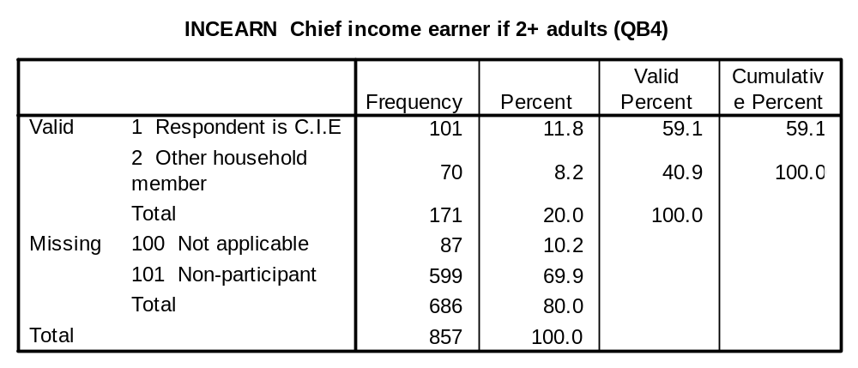

WSTAOTH (QB5): IF OTHER HOUSEHOLD MEMBER = C.I.E – What is he/she doing at the present time. Is he/she a full-time student, in paid work or doing something else?

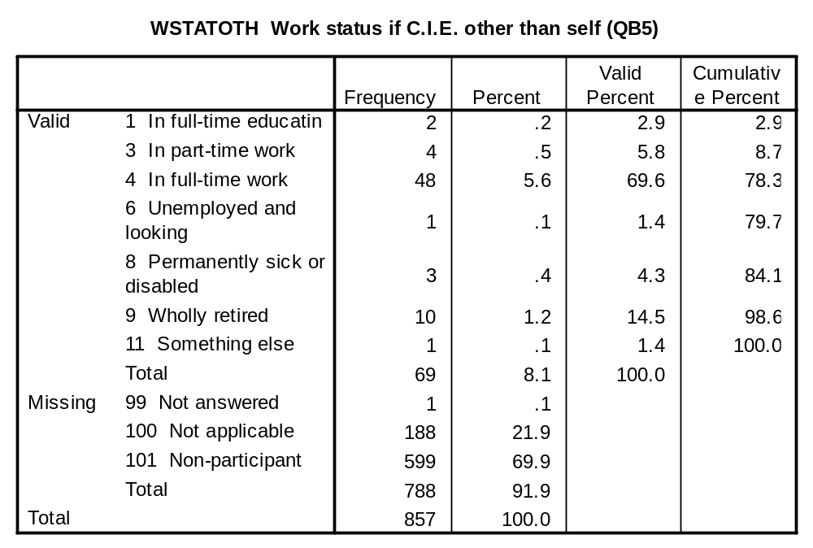
ASK ABOUT CURRENT OR MOST RECENT JOB OF CHIEF INCOME EARNER

JOBPOS (QB6a): What is the name of your (his/her) current/most recent jog?

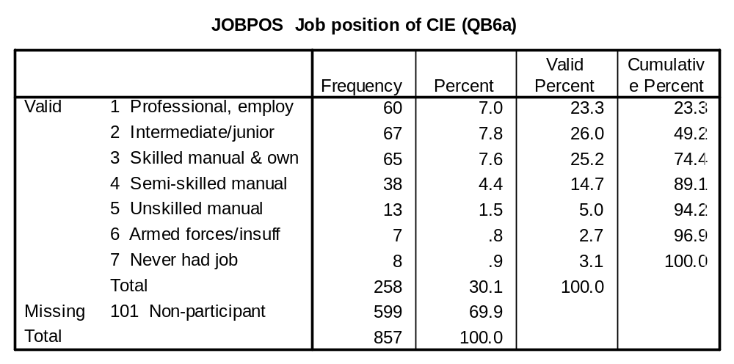

WORKTYPE (QB6b): And what kind of work do/did you (he/she) do in that job?
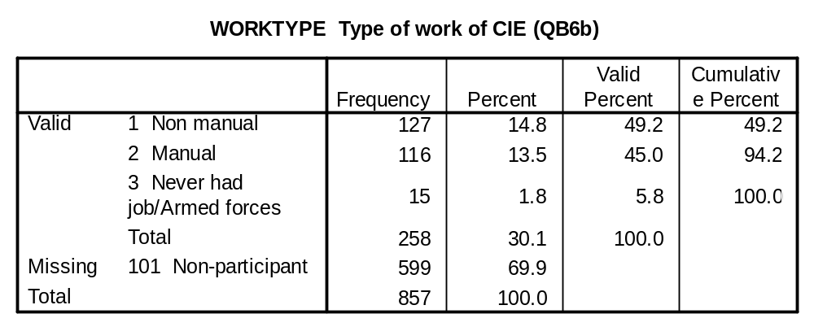

EMPSTAT (QB6c): Are/where you (he/she)…
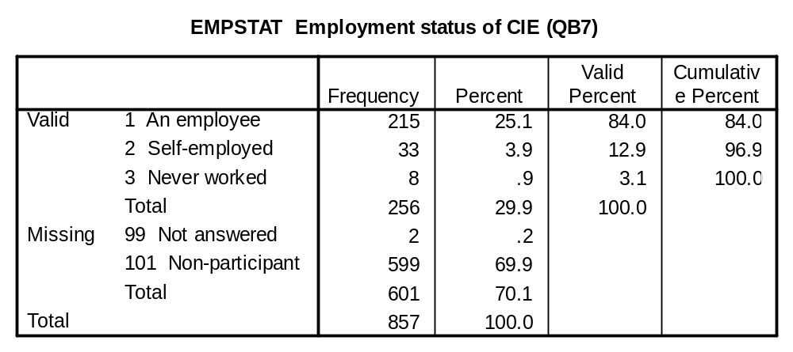

SUPSTAT (QB8): IF EMPLOYEE – Do/did you (he/she) supervise or have responsibility for the work of other people? IF YES: How many?
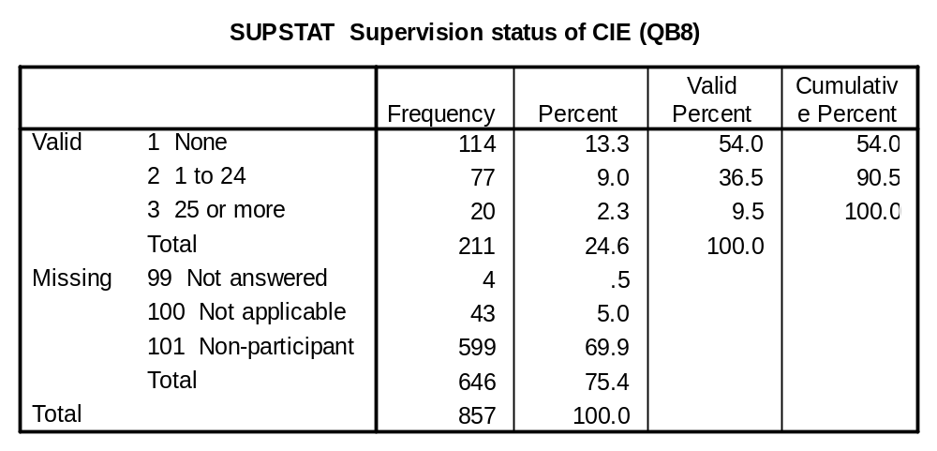

EMPSIZE (QB9a): How many people are employed at the place where you (he/she) work/ed…
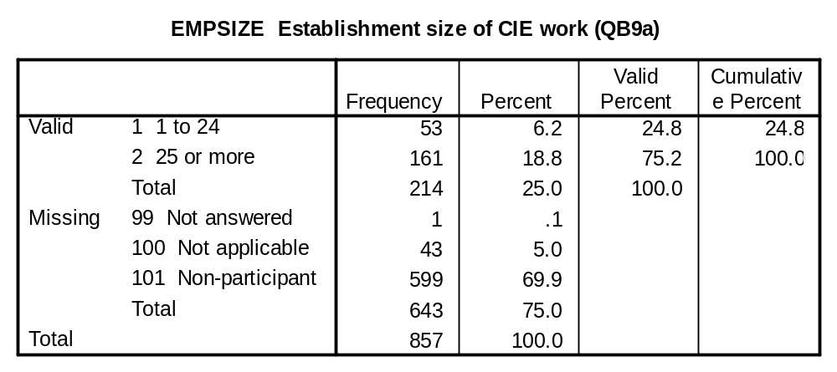

SEMPSIZE (QB10a): IF SELF-EMPLOYED – Do/did you (he/she) have any employees? IF YES: How many?
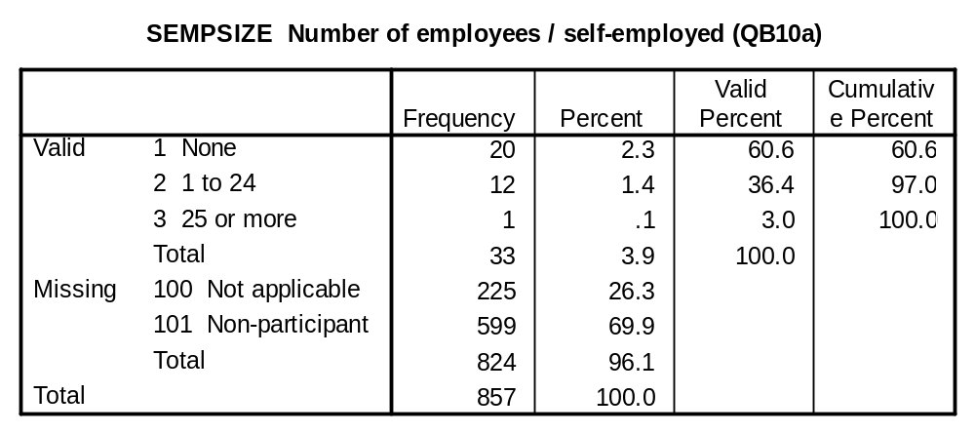

AGEEDU (QB11): At what age did you finish your continuous full-time education at school or college?

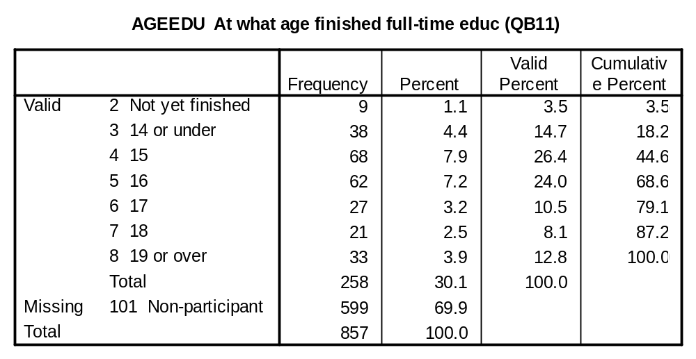

HIGHQUAL (QB12a): Looking at this card, please tell me the highest qualification, if any, that you have obtained either while at school or gained after you left school?
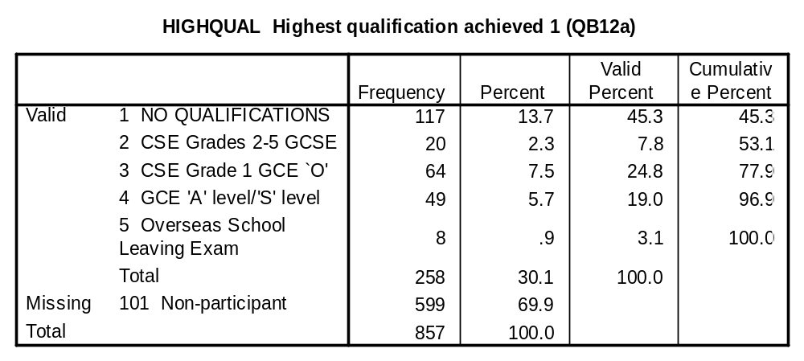

QUALHIGH (QB12b): And, looking at this card, please tell me the highest qualification, if any, that you have obtained either while at school or gained after you left school?

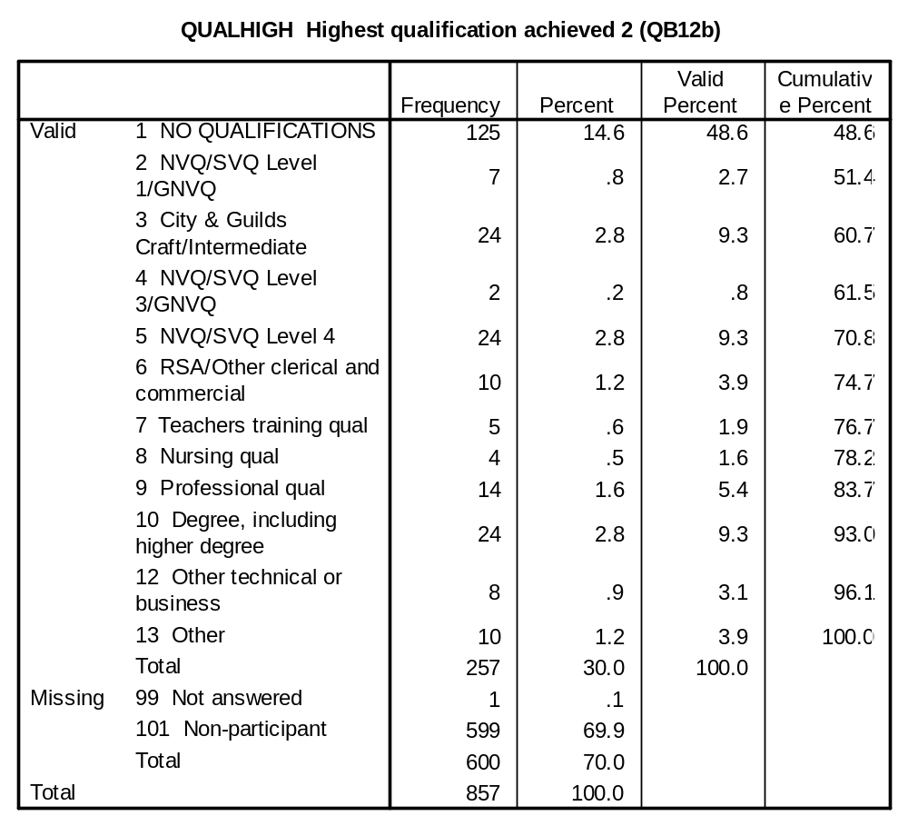

BRIT, ENGLISH, SCOT, WELSH, IRISH, NIRISH, EUROP, OTHER, NONE (QB13a-I): Please say which, if any, of the words on this card describes the say you think of yourself. Please choose as many or as few as apply.
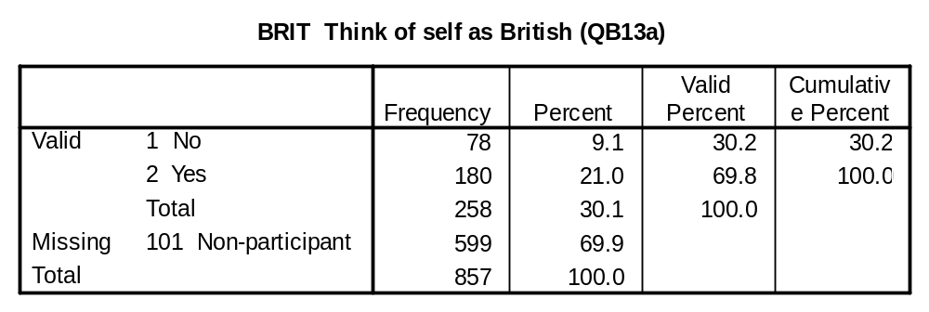

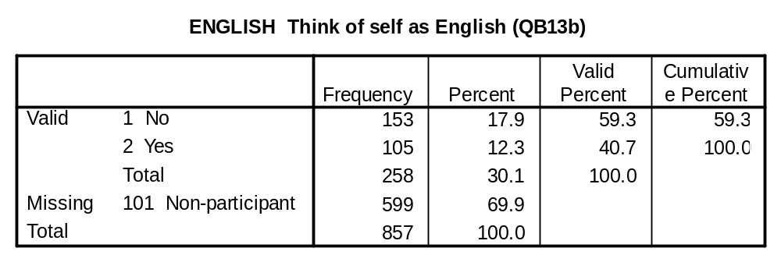
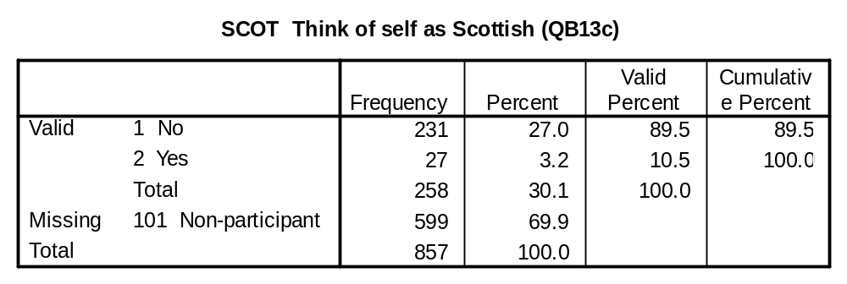
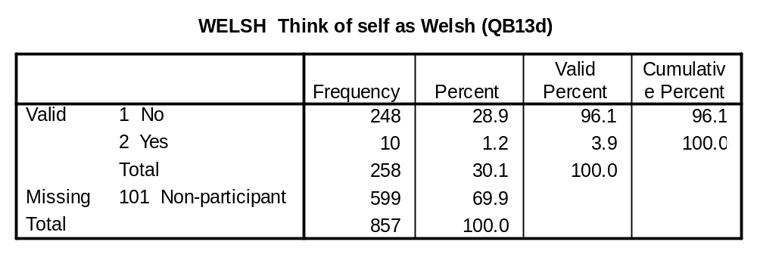
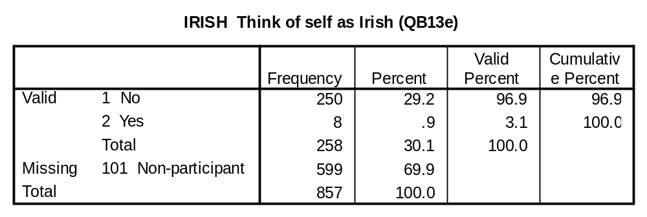
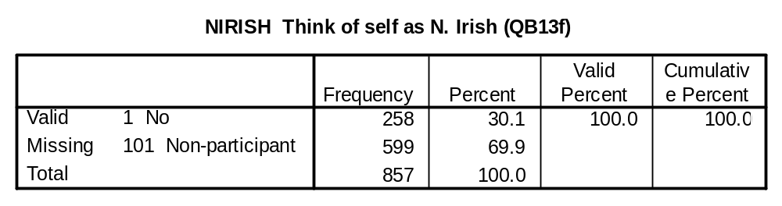
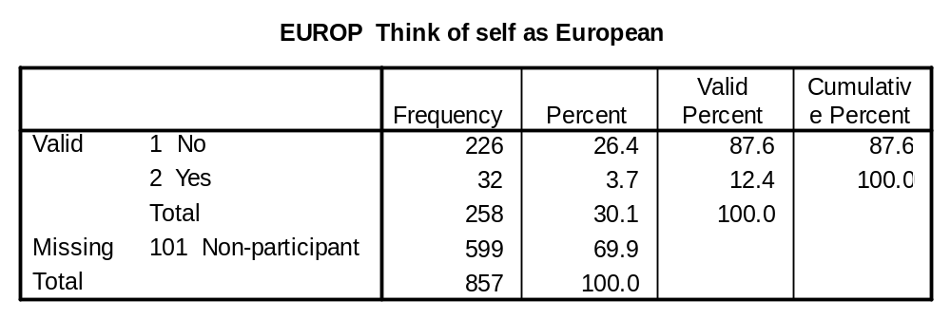
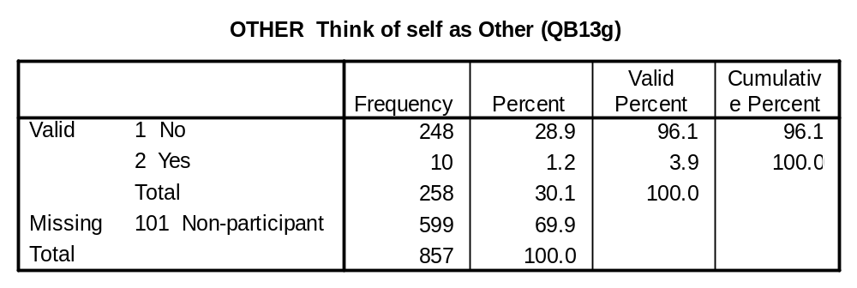
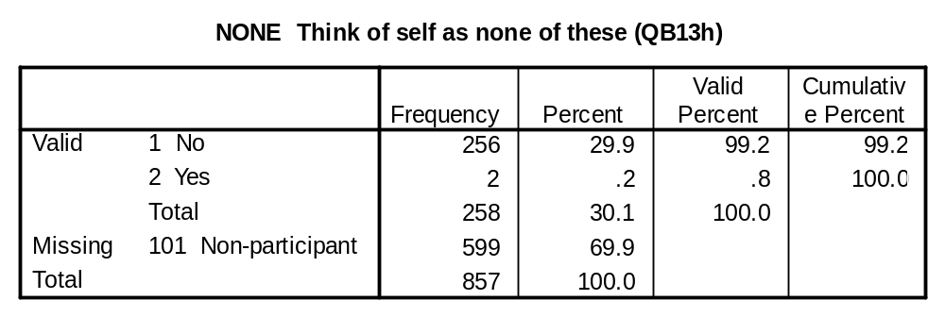

CODERING (QB14): INTERVIEWER TO CODE FROM B13
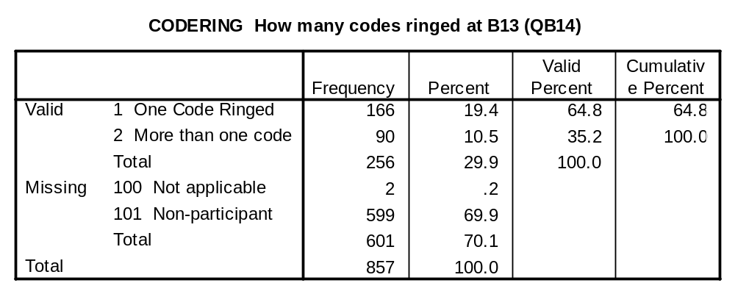

BESTDESC (QB15): IF CODE 2 AT B14 – And, if you had to choose, which one best describes the way you think of yourself?

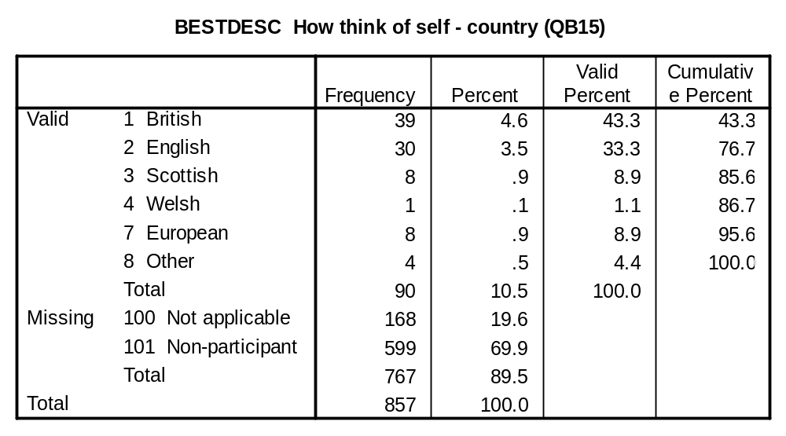

ETHNIC (QB16): In which of these groups do you consider you belong?
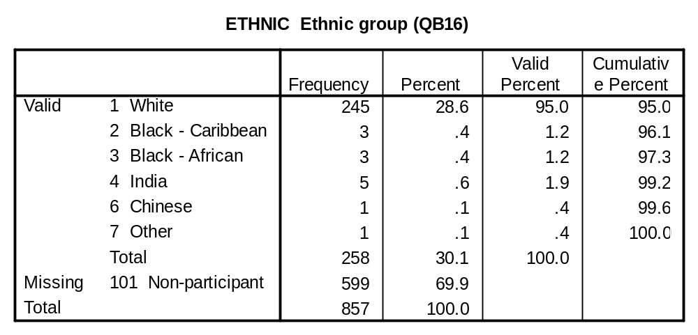

RELIGION (QB17): Do you regard yourself as belonging to any particular religion? IF YES, Which?

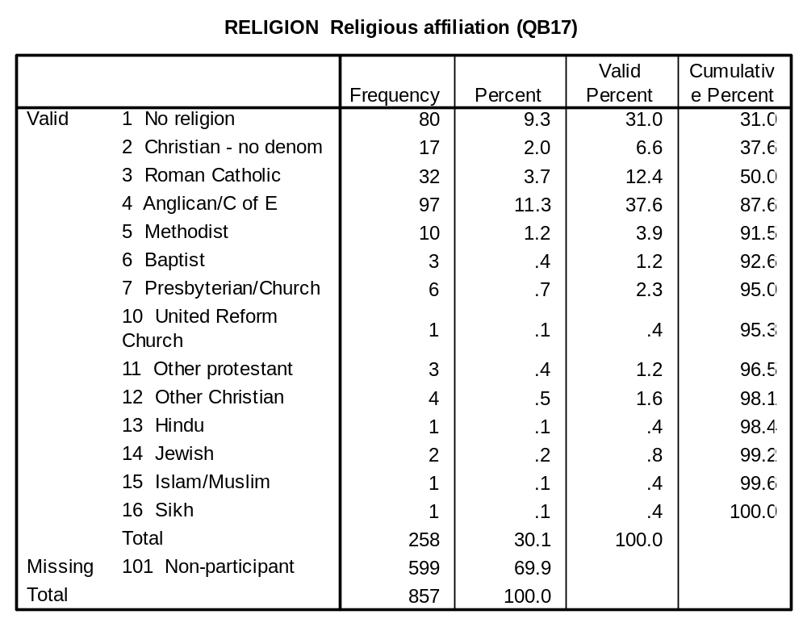

POLITICAL TRUST VARIABLES:

TRUSTGOV (QB18a): Pleas look at this card and tell me how much you trust… British governments of any party to place the needs of the nation above the interests of their own political party?

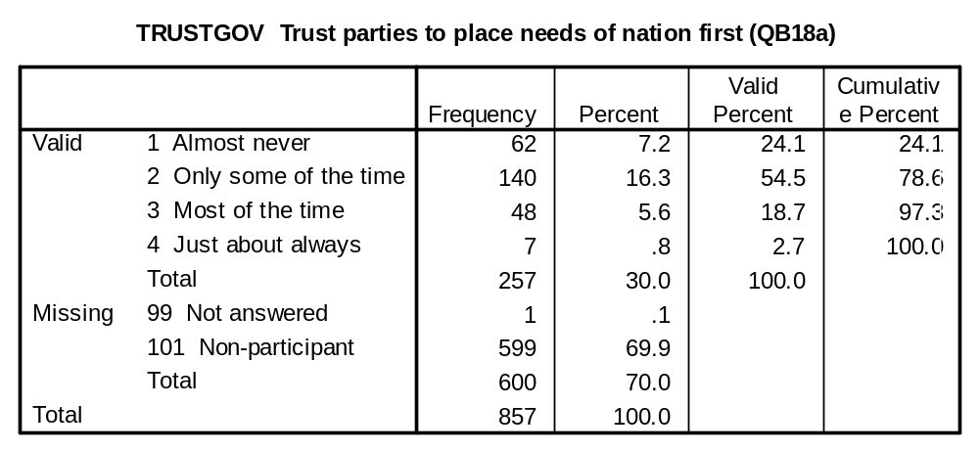

TRUSTJOR (QB18b): And how much do you trust British journalists on national newspapers to pursue the truth above getting a good story?

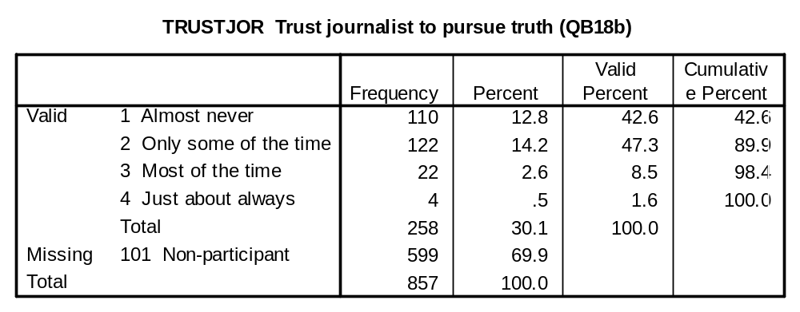

TRUSTCIV (QB18c): And how much do you trust top civil servants to stand firm against a minister who wants to provide false information to parliaments?

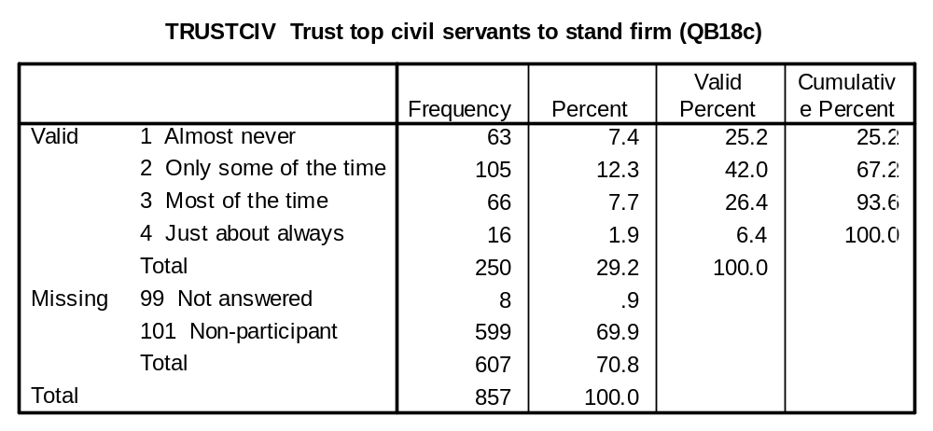

TRUSTPOL (QB18d): And how much do you trust politicians of any party in Britain to tell the truth when they are in a tight corner?

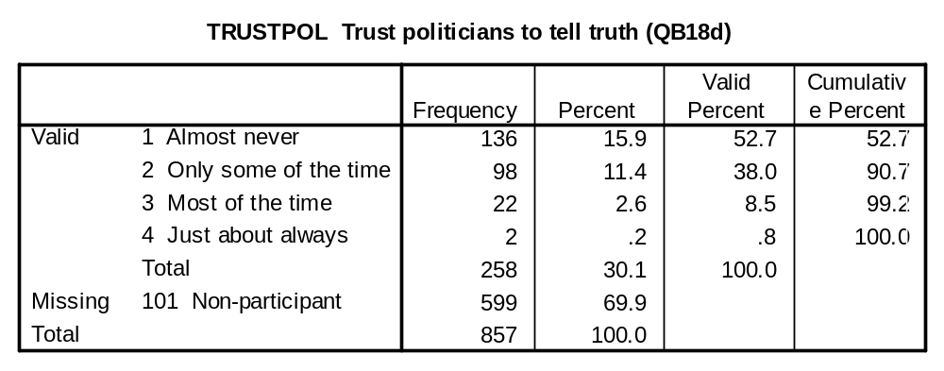

MEDIA CONSUMPTION VARIABLES:

READPAP (QA5a): Do you normally read any daily morning newspaper at least three times a week?

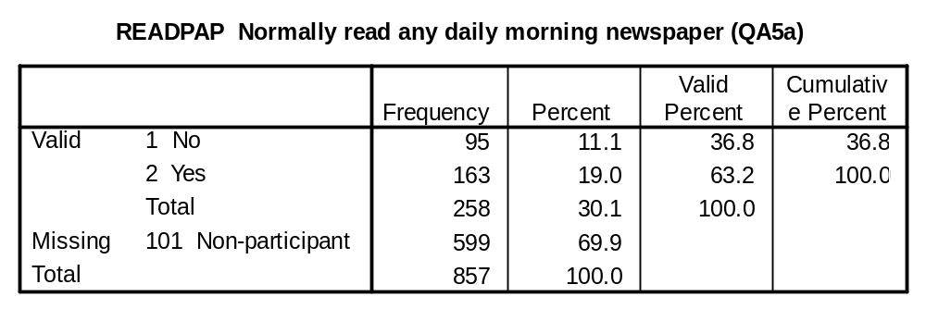

PAPREAD (QA5b): Which one do you normally read? IF MORE THAN ONE ASK: Which one do you read most frequently?

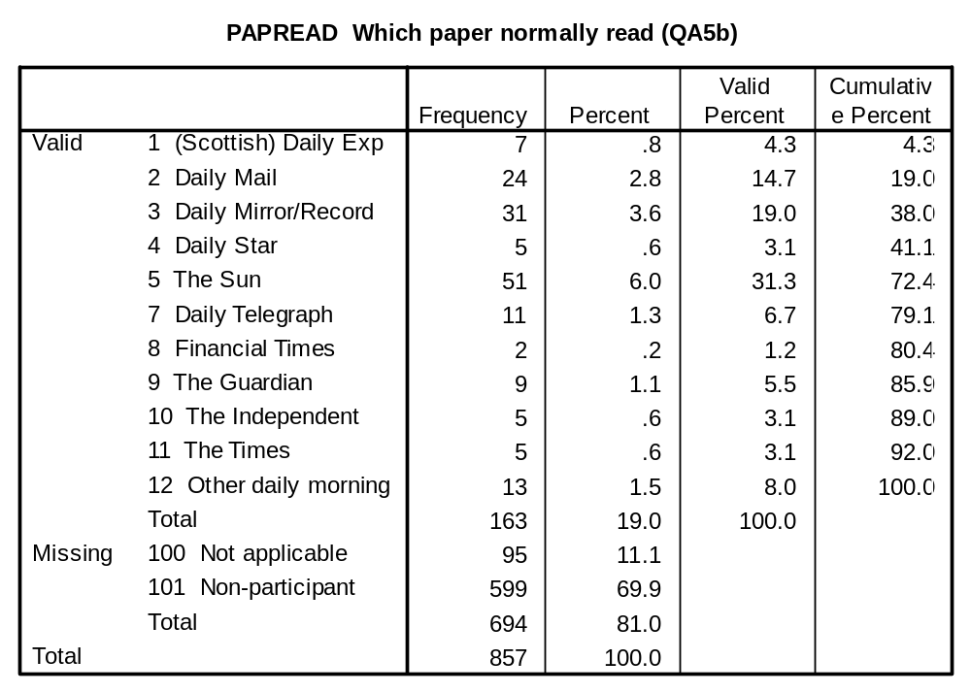

POLITICAL INTEREST VARIABLES:

POLINTER (QA6): How interested would you say you are in politics generally…

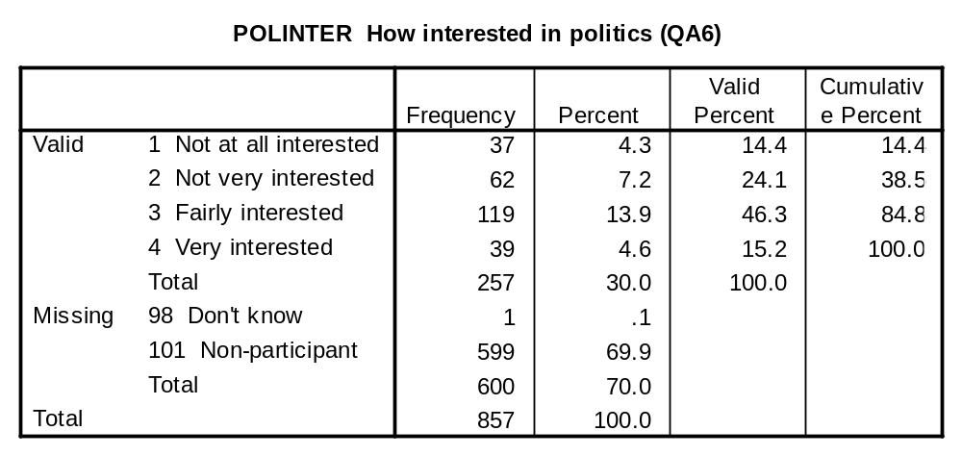

PARTISANSHIP VARIABLES:

PARTYID (QB1a): Generally speaking, do you think of yourself as Conservative, Labour, Liberal Democrat, (IF SCOTLAND: Nationalist / IF WALES: Plaid Cymru), or what?

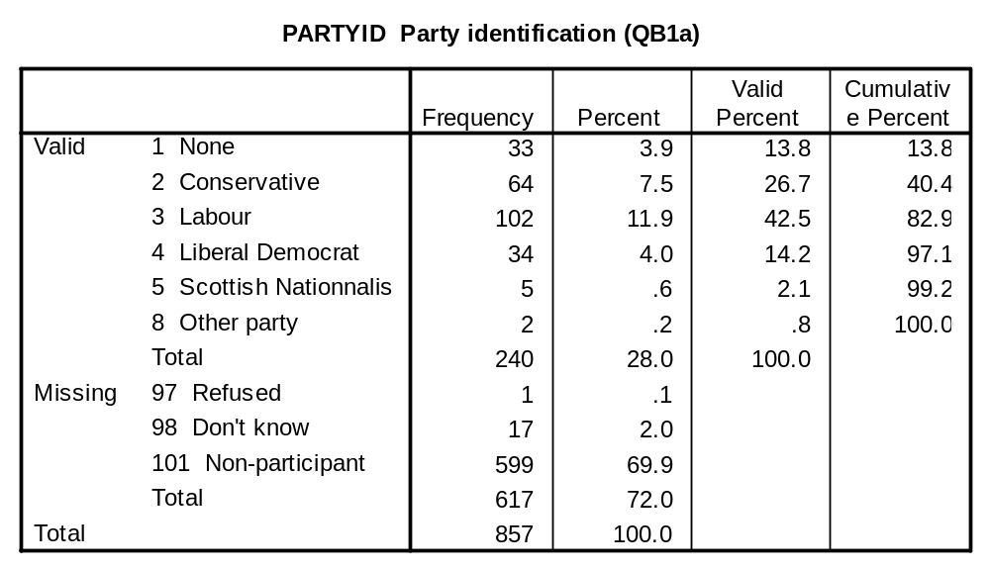

PARTYCL (QB1b): IF NONE/DON’T KNOW – Do you generally think of yourself as a little closer to one or the parties than the others? IF YES: Which party?

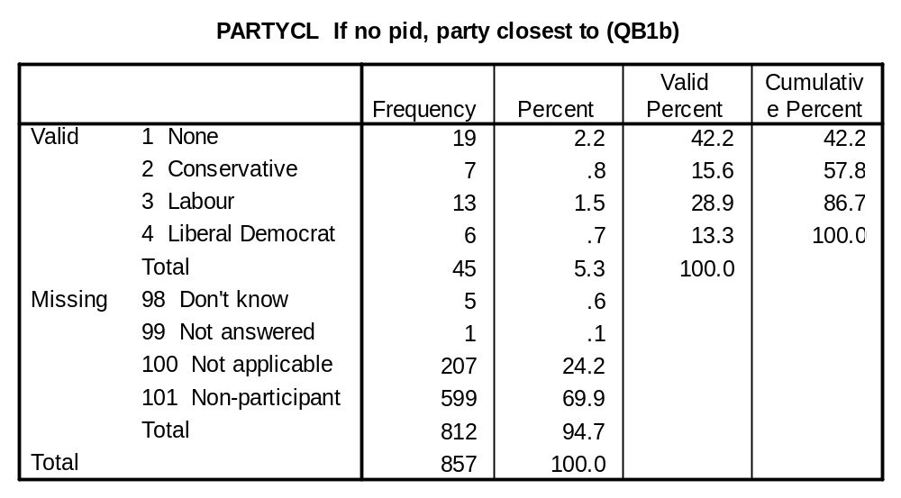

PARTYSTR (QB1c): IF ANY PARTY CODED AT a. OR b. – Would you call yourself very strong (NAME OF PARTY AT a. OR b.), fairly strong, or not very strong?

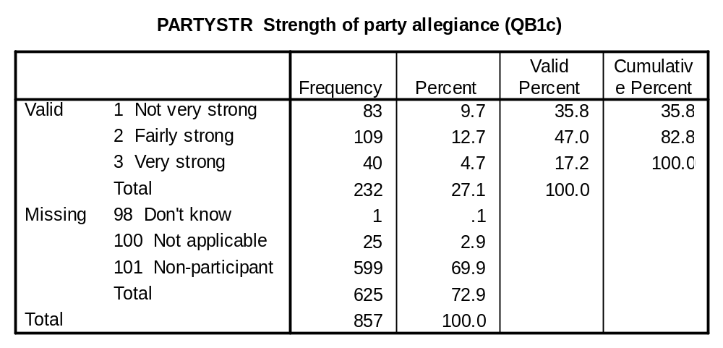

VALUES VARIABLES:

LESSHARS (QA7d): Please tell me how much you agree or disagree… Newspapers should be less harsh on the Royals than they are on other public figures because they can’t answer back.
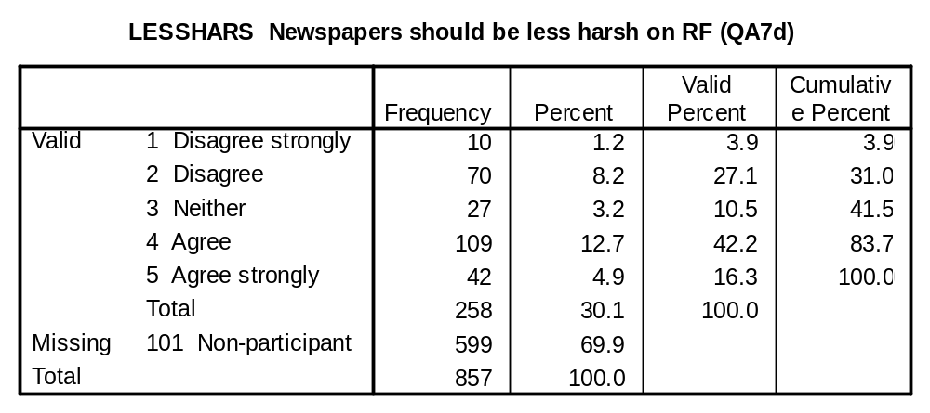

COUNSUP (QB19e): Please tell me how much you agree or disagree… People should support their country even if the country is in the wrong.

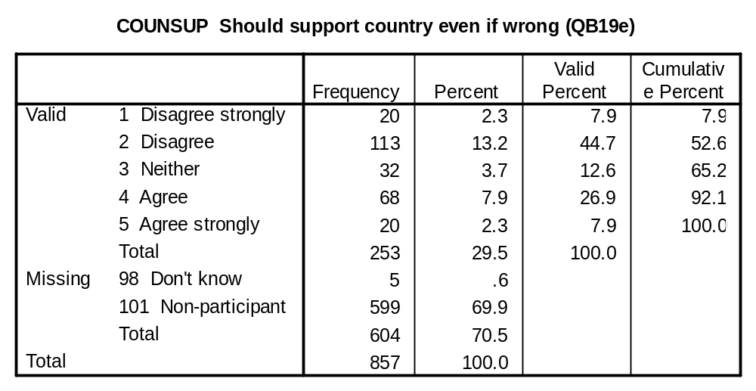

BORNWL (QB20a): Please tell me which one you agree with more… it is wrong that children born into a wealthy family have a better chance in life or good luck to those who are fortunate enough to be born into a wealthy family?

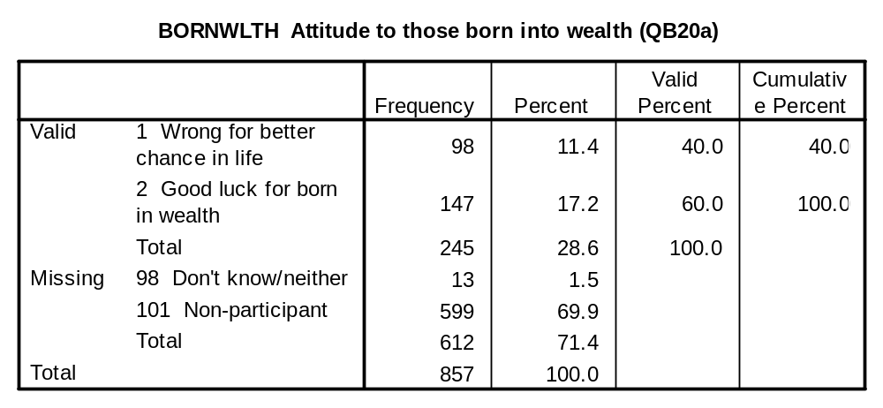

AGBORNWW (QB20b): IF CODE 1 AT a) Do you strongly agree with this, or just agree?

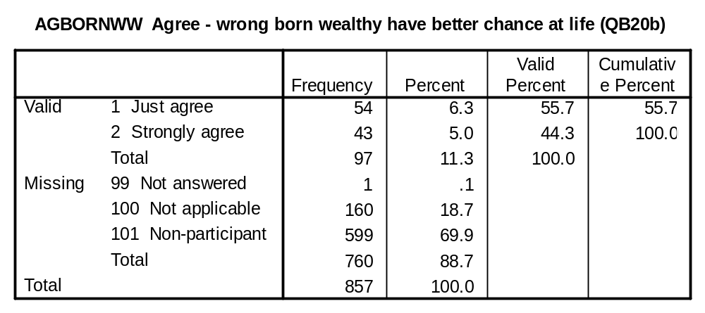

AGGDLUCK (QB20c): IF CODE 2 AT a) Do you strongly agree with this, or just agree?
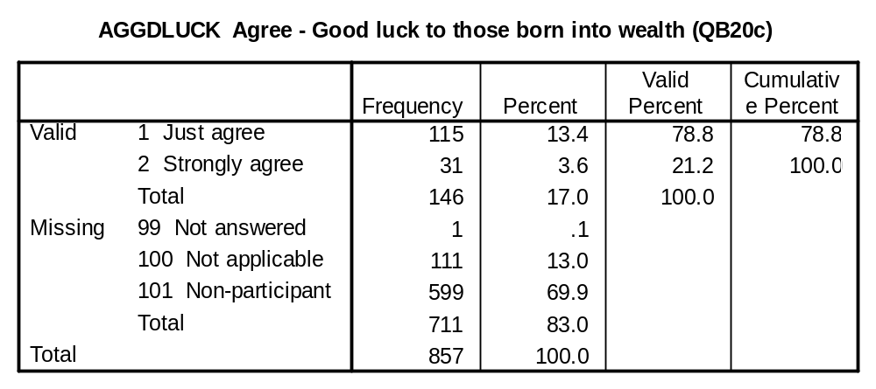

BESTWAY (QB21a): And please tell me which of these two statements you agree with more… the best way forward for Britain is to stick to its traditional ways or the best way forward for Britain is to leave its past behind.

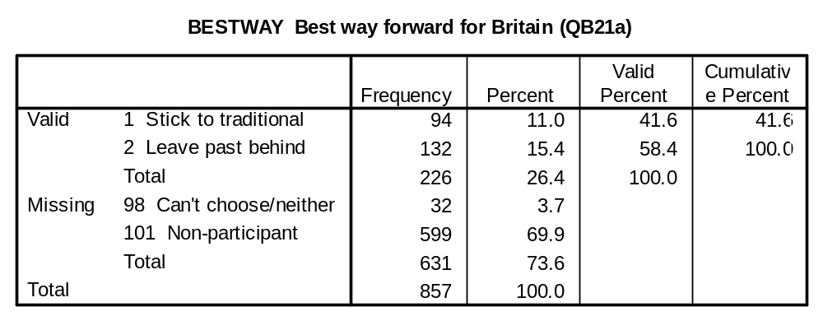

AGRTRAD (QB21b): IF CODE 1 at a) Do you strongly agree with this, or just agree?

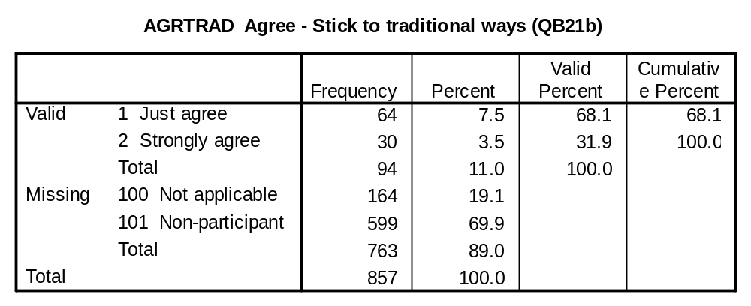

LEAVPAST (QB21c): IF CODE 2 AT a) Do you strongly agree with this, or just agree?

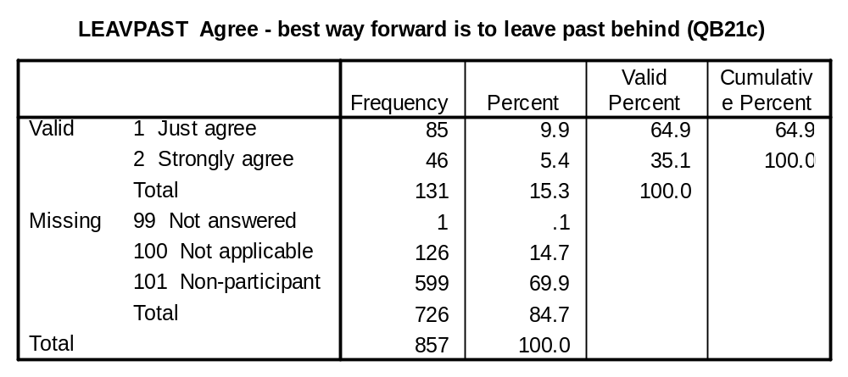

QUALEDU (QB22a): And please tell me which of these two statements you agree with more… the quality of education should be the same for all children or parents who can afford it should be able to pay for better education.

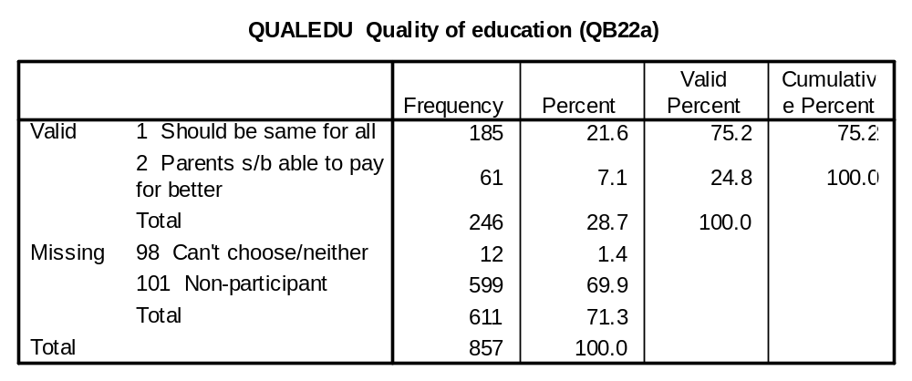

SAMEQUAL (QB22b): IF CODE 1 AT a) Do you strongly agree with this, or just agree?

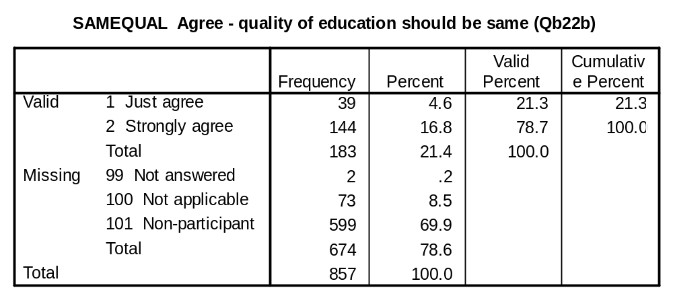

PARENTPY (QB22c): IF CODE 2 AT a) Do you strongly agree with this, or just agree?

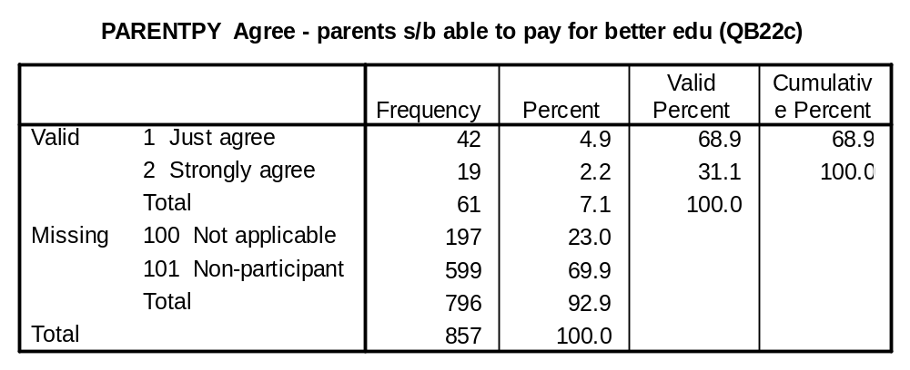

WINEQUIT (QB23a): And please tell me which of these two statements you agree with more… the very rich should not be allowed to keep all their wealth while there are so many poor people in Britain or in a free country, there is nothing wrong with some people having a great deal more wealth than others.

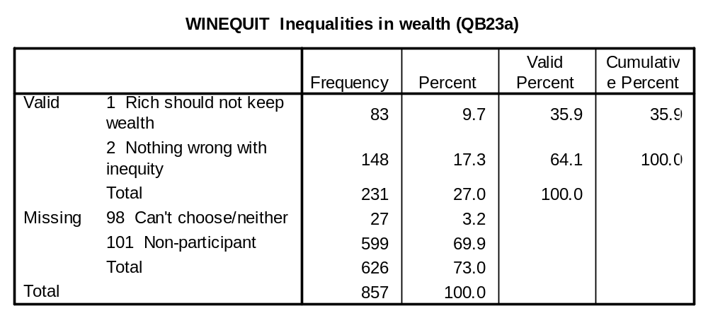

NOTKEEPW (QB23b): IF CODE 1 AT a) Do you strongly agree with this, or just agree?

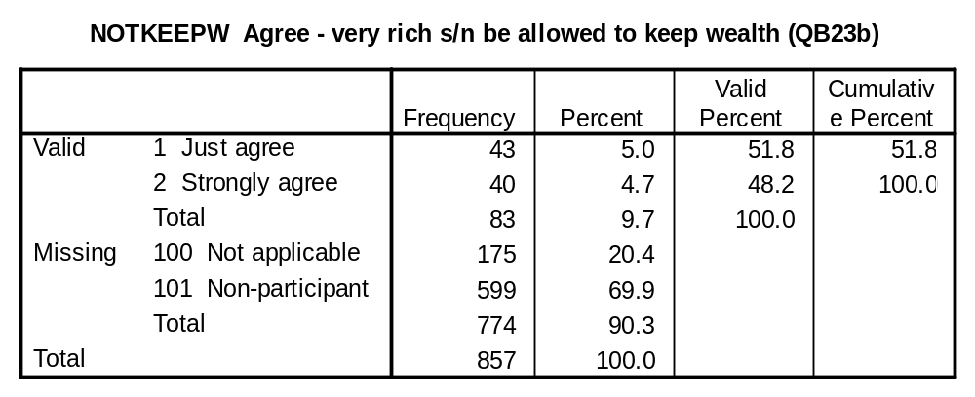

KEEPWEAL (QB23c): IF CODE 2 AT a) Do you strongly agree with this, or just agree?

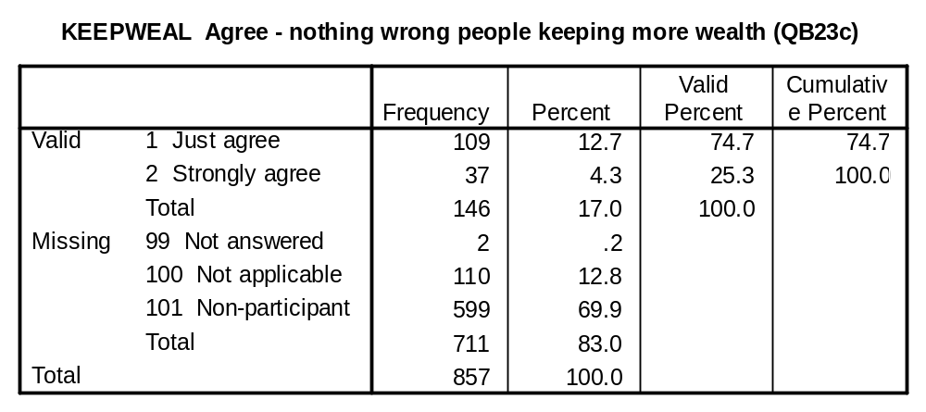

GENCHOOS (QB24a): Please tell me how much you agree or disagree with each statement – Each generation should choose new ways of running things, rather than following previous generations.

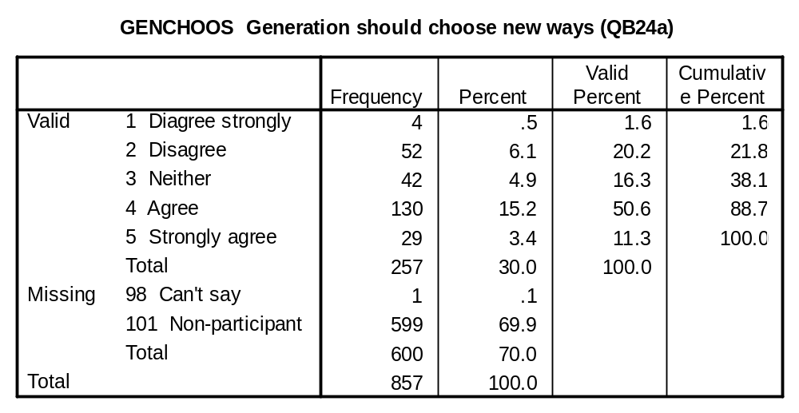

BRITAIN EVALUATION VARIABLES:

CITBRIT (QB19a): I would rather be a citizen of Britain than of any other country in the world.

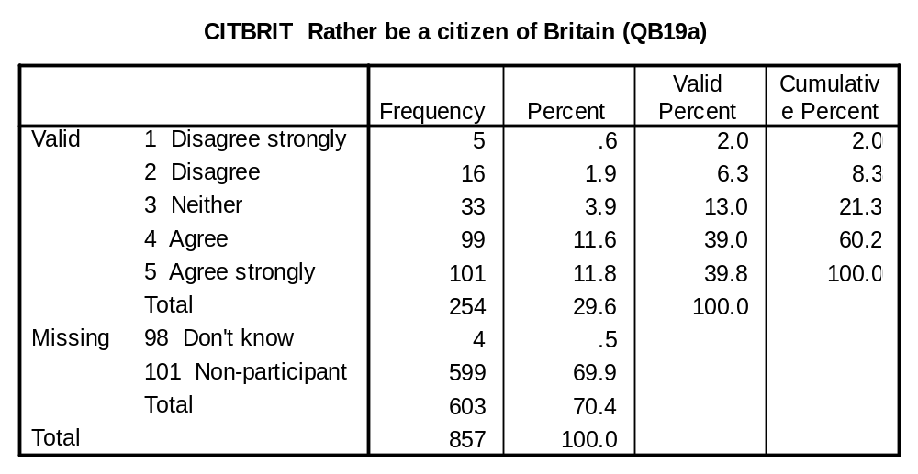

ASHAMED (QB19b): There are some things about Britain today that make me feel ashamed of Britain.

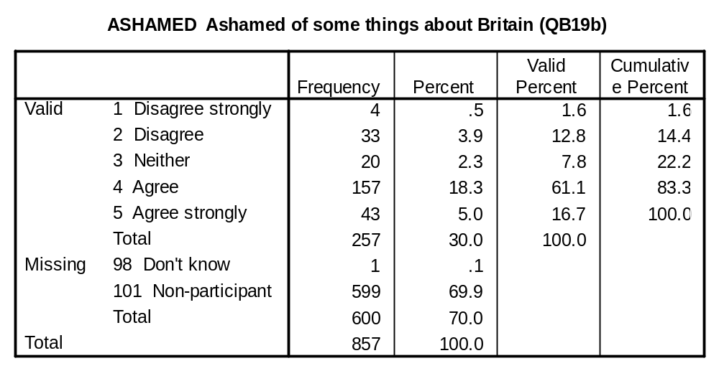

WORLDBET (QB19c): The world would be a better place if people from other countries were more like the British.

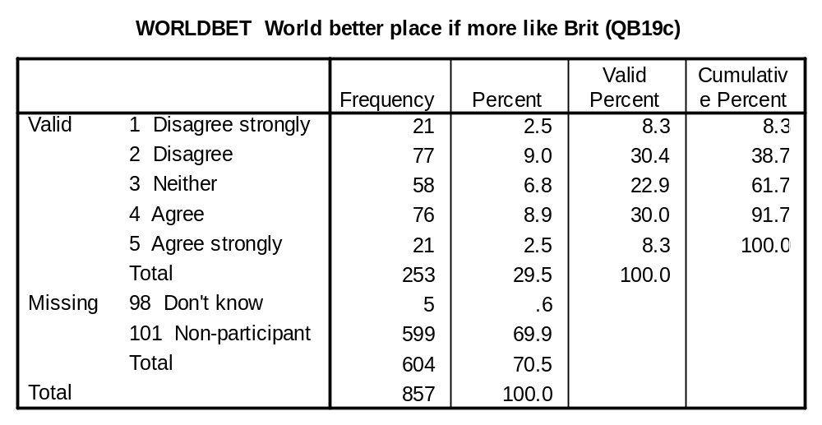

BRITBET (QB19d): Generally speaking, Britain is a better country than most other countries.

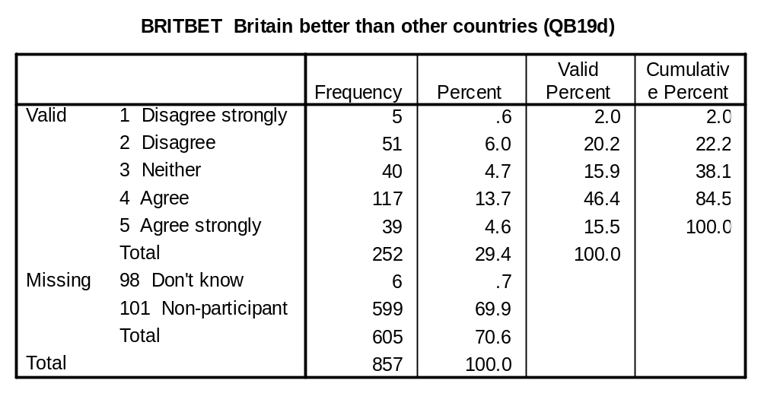

SUCCESS (QB24b): Success in Britain depends too much on who you are and who you know rather than on your own ability.

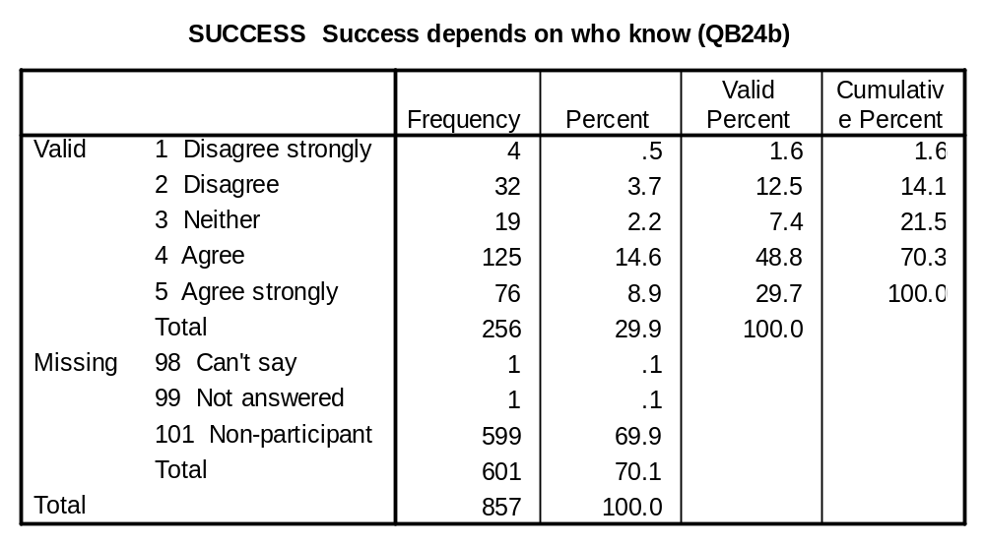

MONARCHY EVALUATION VARIABLES:

QLETDOWN1 (QA7a): The Queen has been let down by some members of the royal family.

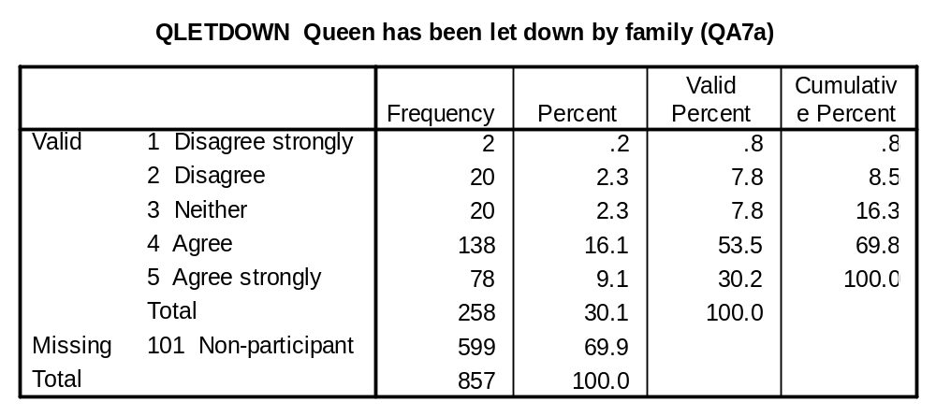

HIGHSTAN (QA7b): On the whole, the royal family sets high standards of public service.

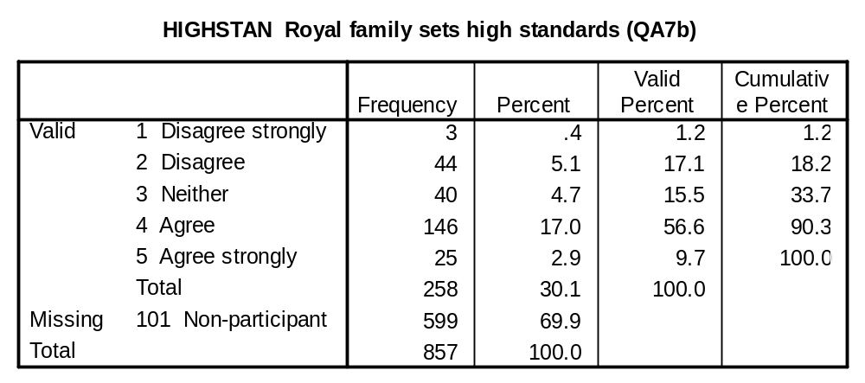

JOURDAM (QA7c): Journalists who damage the reputation of the Royal Family, damage reputation of Britain.

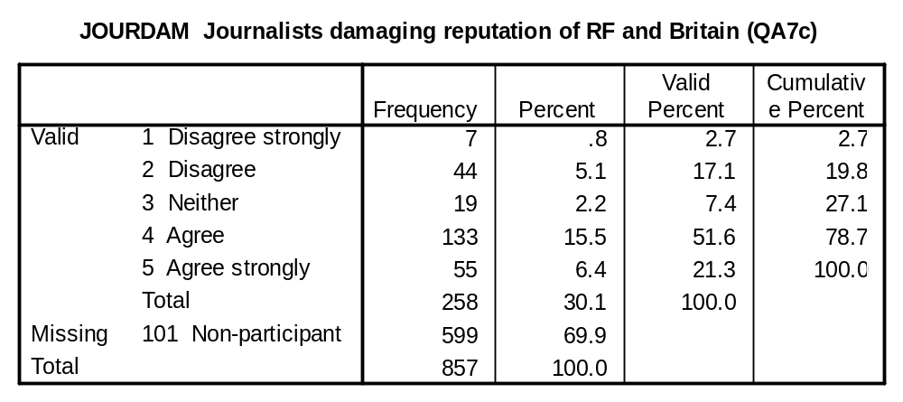

LUXURY1 (Q3a), LUXURY2 (W3a): The monarchy is an expensive luxury that Britain cannot any longer afford.

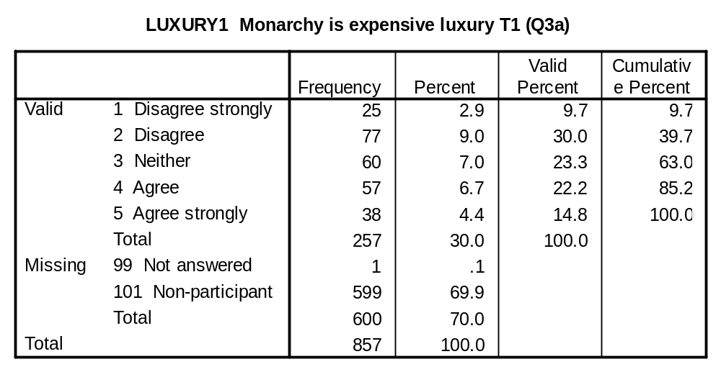
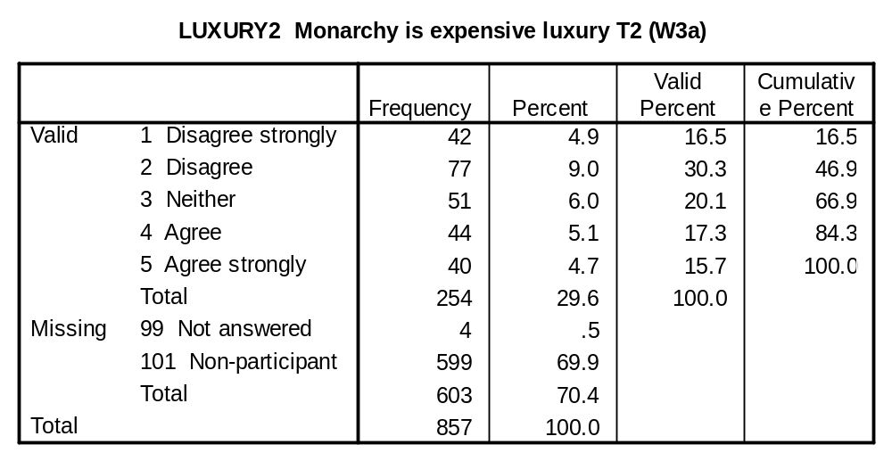

TOOENG1 (Q3b), TOOENG2 (W3b): The monarchy comes across as too English, rather than representing Britain.

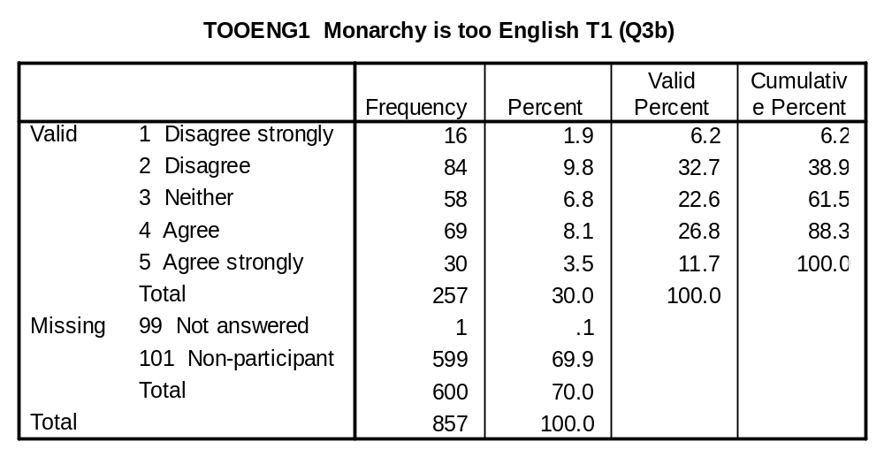
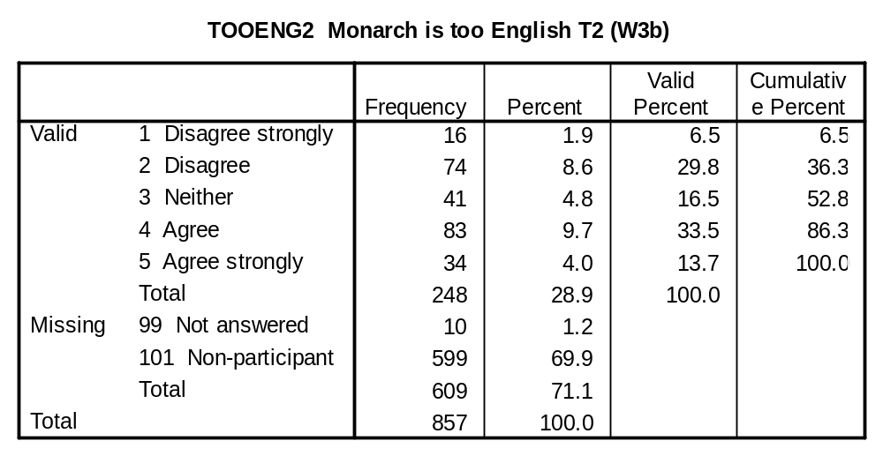

BENEFIT1 (Q3c), BENEFIT2 (W3c): The royal family benefits the rich and powerful at the expense of the rest of society.

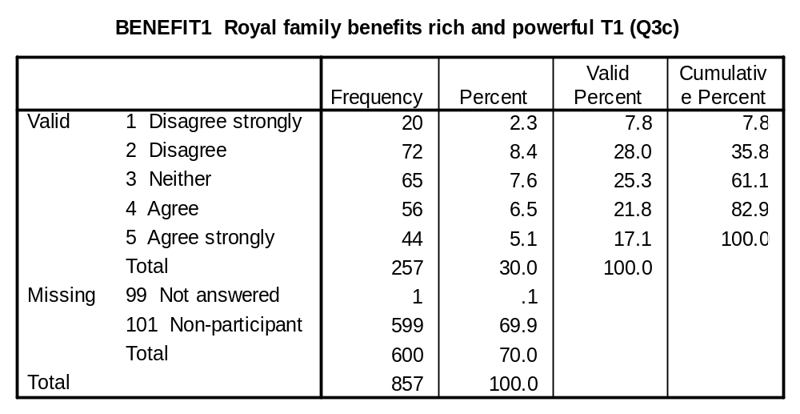
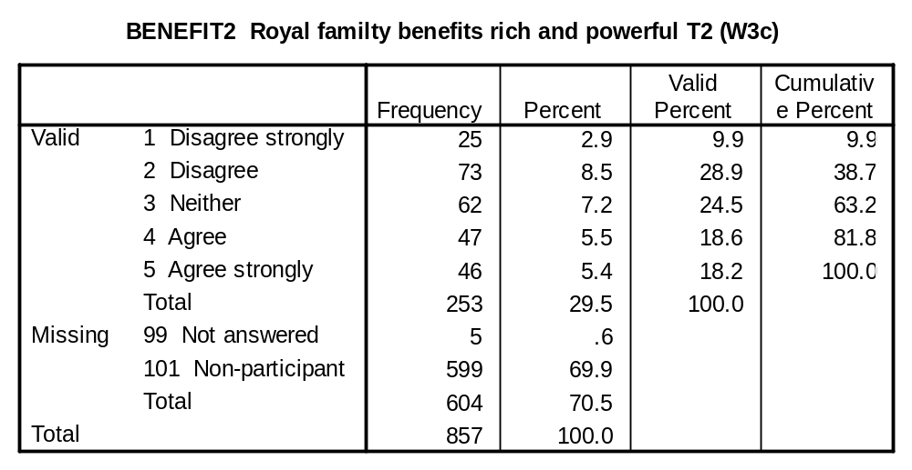

PROPUP1 (Q3d), PROPUP2 (W3d): The monarchy props up a snobbish system of giving titles to people in high places.

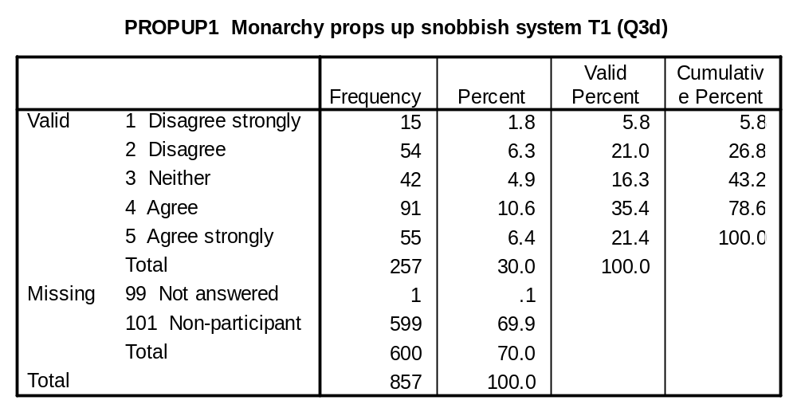
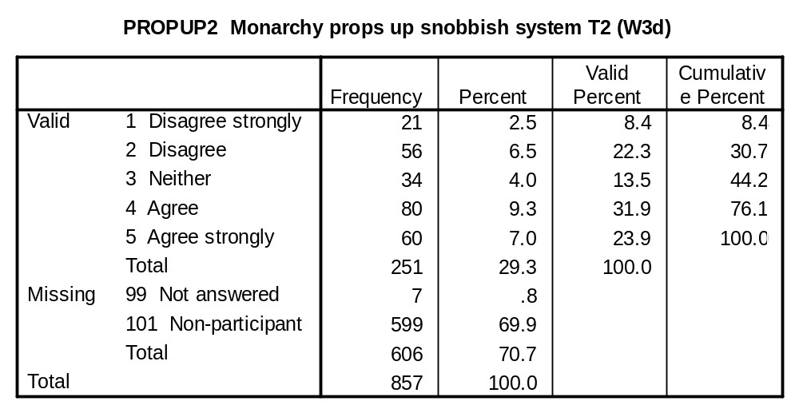

ADAPT1 (Q3e), ADAPT2 (W3e): Having a monarchy stops Britain from adapting to the modern world.

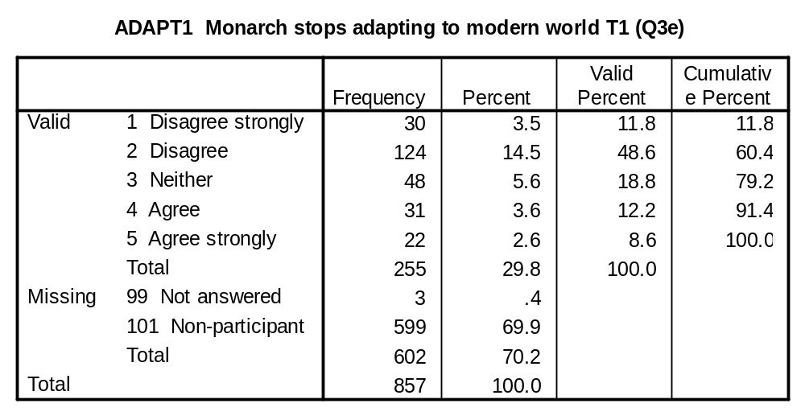
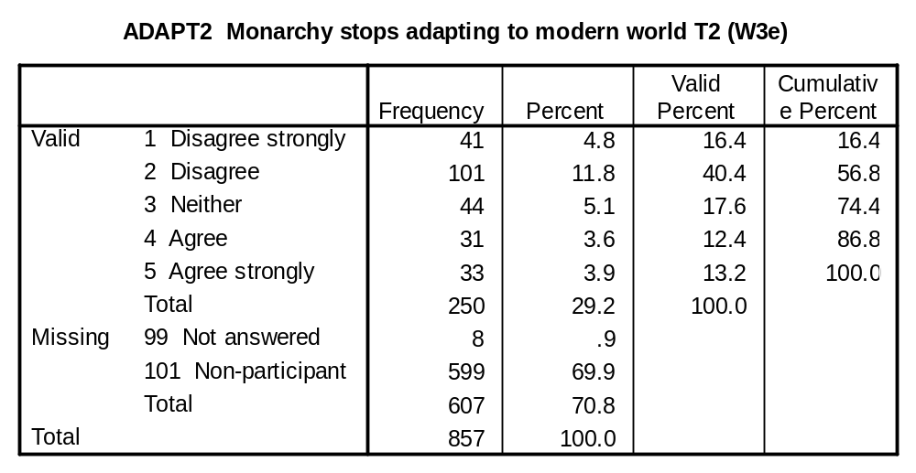

DIVIS1 (Q3f), DIVIS2 (W3f): The monarchy keeps alive divisions between different classes in Britain.

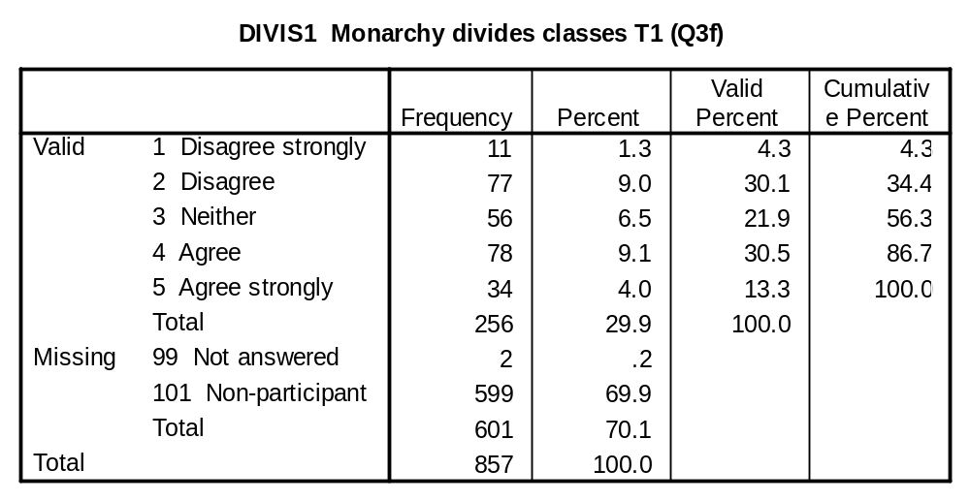
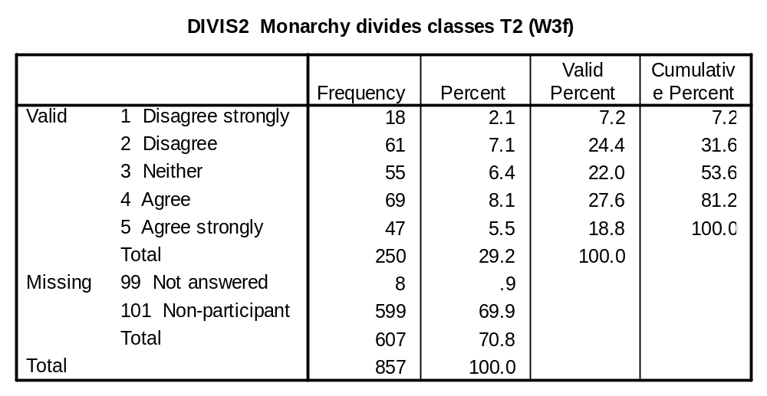

STUCKUP1 (Q3g), STUCKUP2 (W3g): The monarchy makes Britain seem a stuck-up and stuffy country.

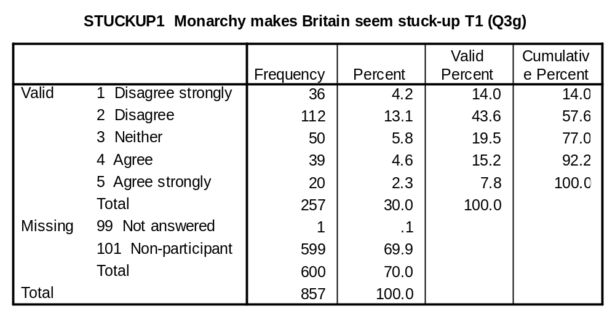
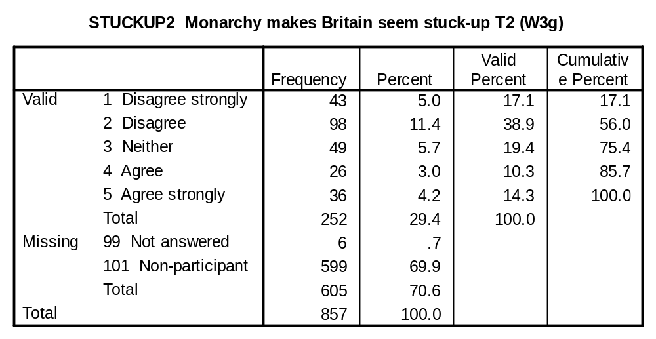

INFLPOL1 (Q4), INFLPOL2 (W4): As far as you know, how much influence does the monarchy have over what goes on in British politics nowadays?

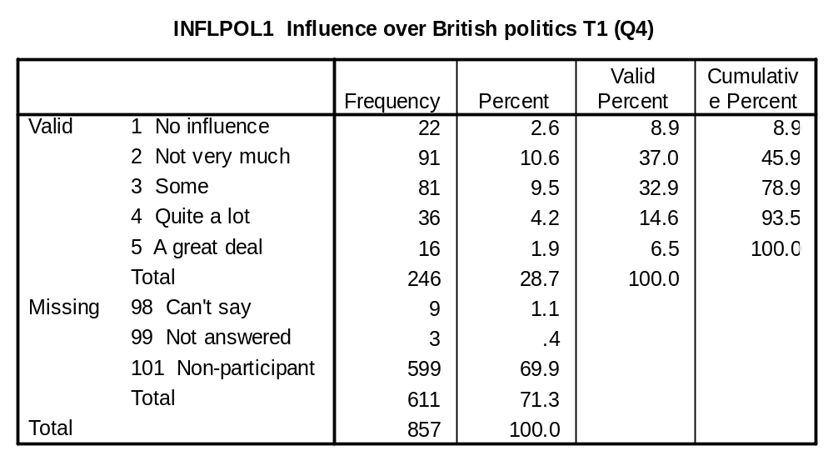
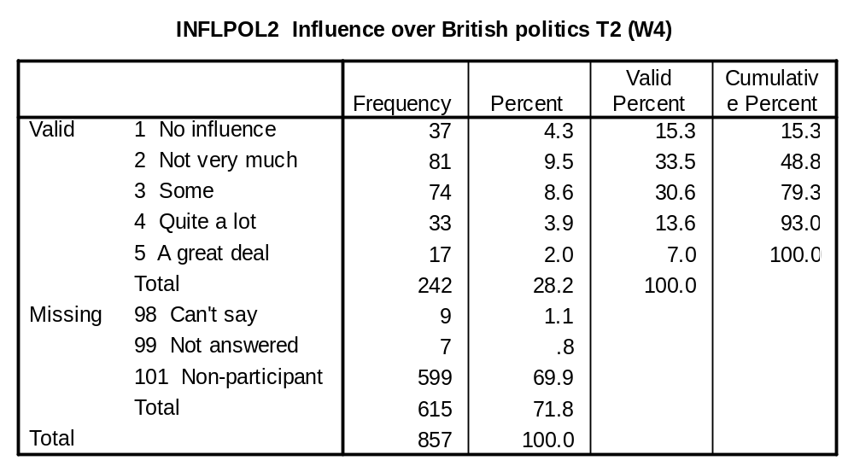

PROUD1 (Q6c), PROUD2 (W6c): The monarchy makes me proud to be British.

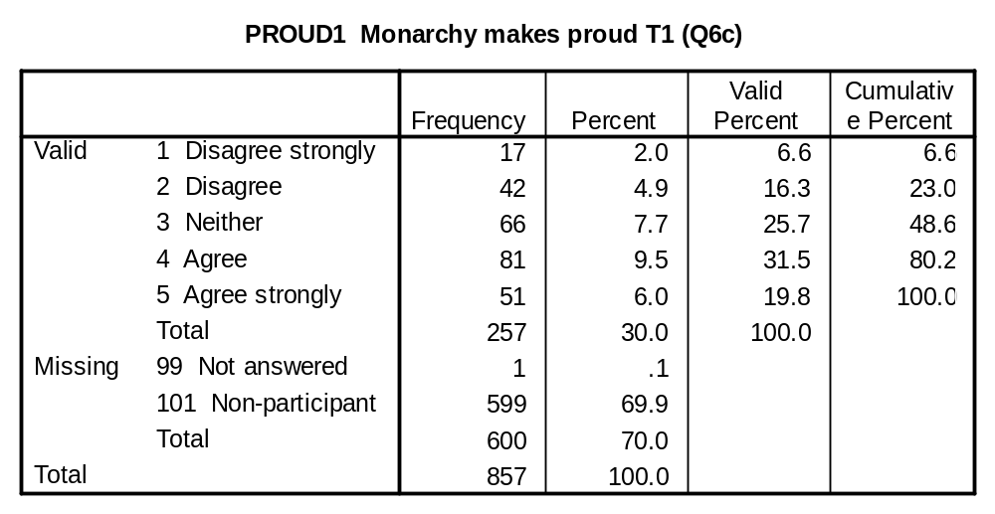
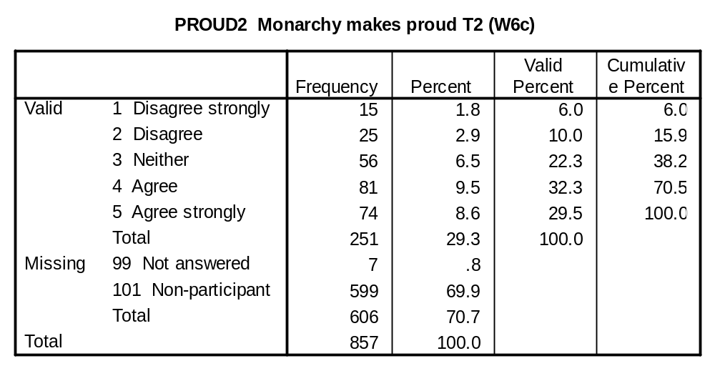

VALUE1 (Q6d), VALUE2 (W6d): All in all, the monarchy gives Britain pretty good value for money.

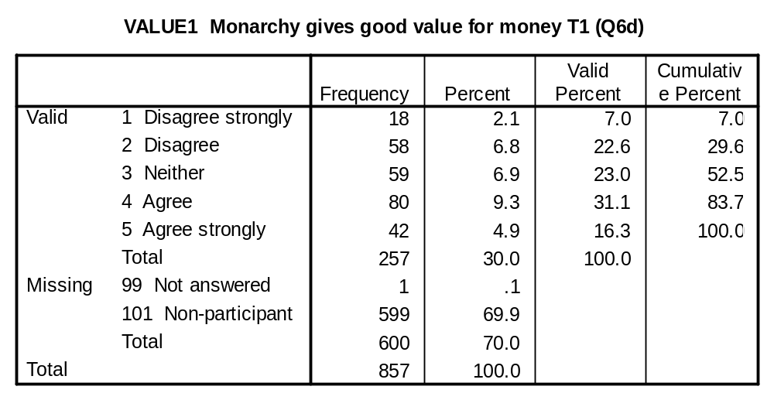
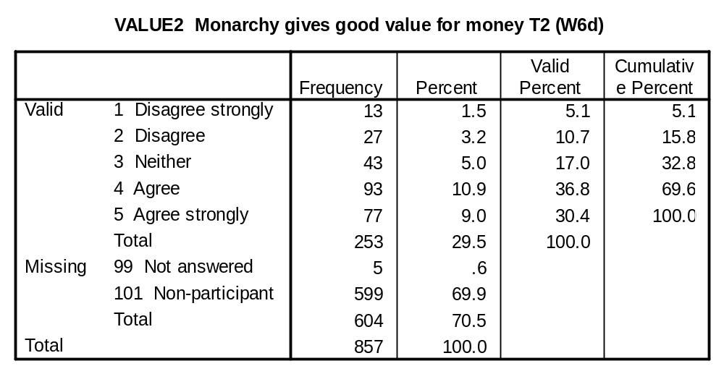

SURVIVE1 (Q10), SURVIVE2 (W10): In your view, how long will the British monarchy survive in its present form?

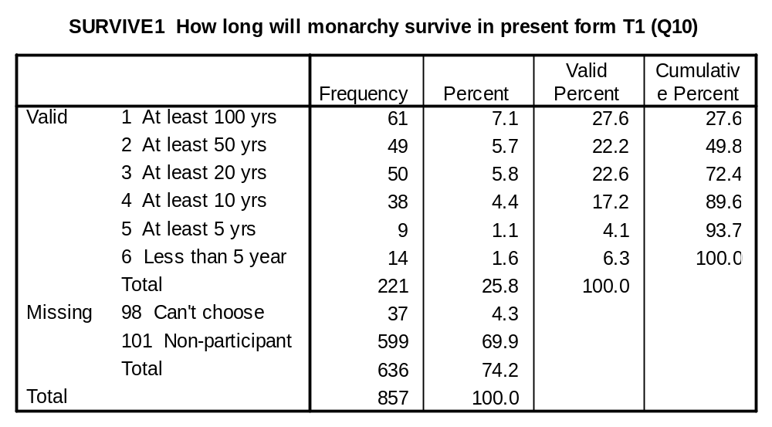
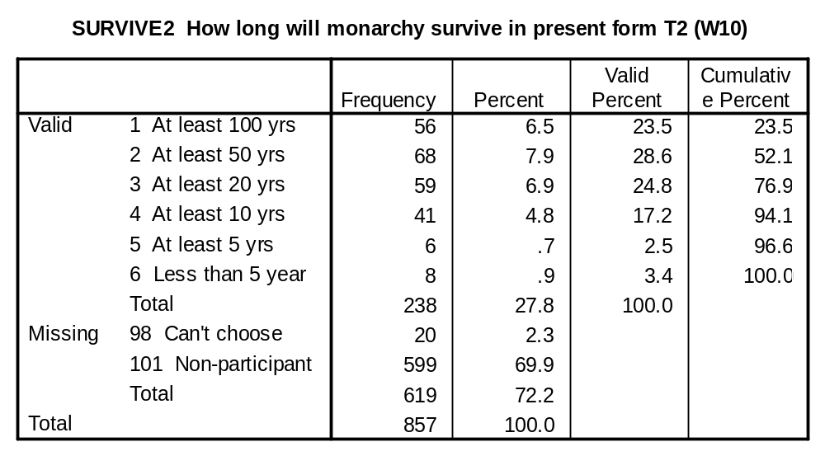

ABOVEP1 (Q13c), ABOVEP2 (W13c): A good thing about monarchs is that they are more likely to stand above politics than are elected Heads of State.

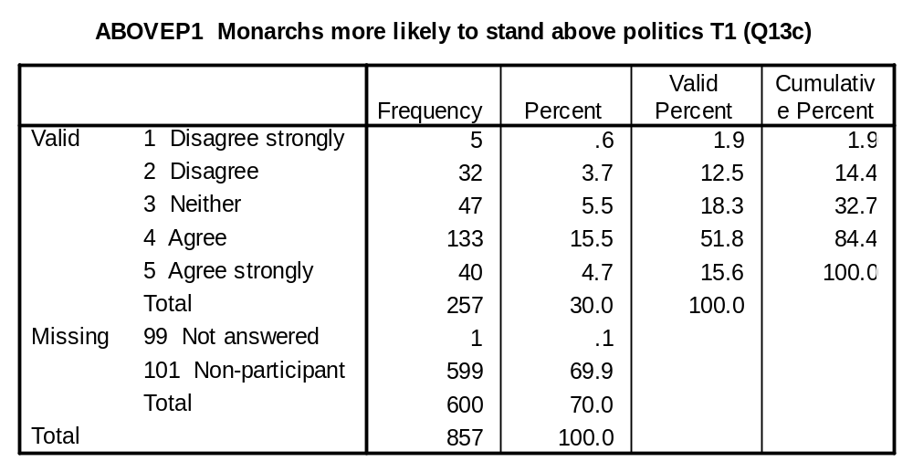
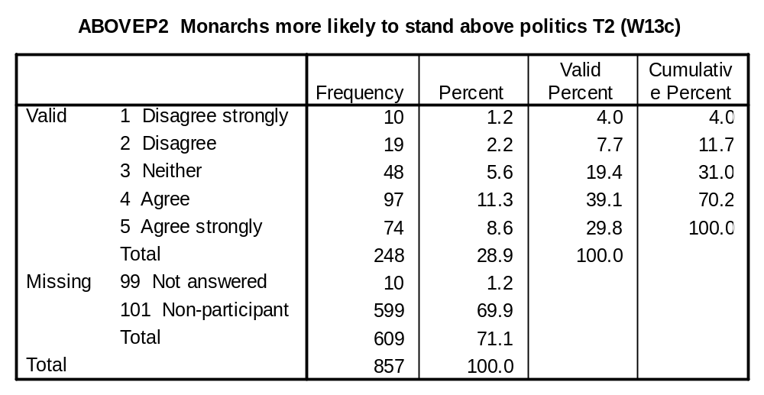

STAY1 (Q13g), STAY2 (W13g): A good thing about monarchs over elected Heads of State is that they usually stay in office longer.

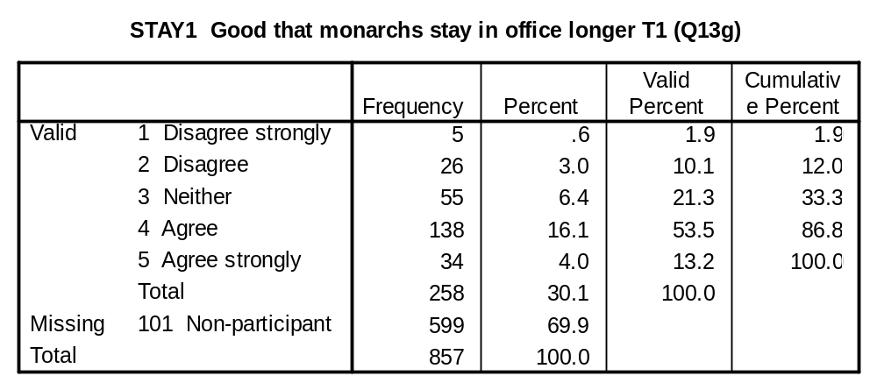
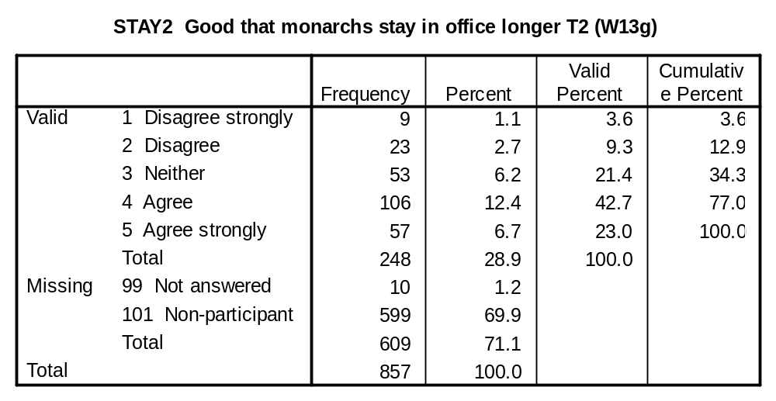

INTREST1 (Q16), INTREST2 (W16): Suppose there were circumstances when the best interests of the monarchy and the best interests of the nation were not the same. Would the monarch be more likely to act in the best interests of the royal family or in the best interests of the nation?

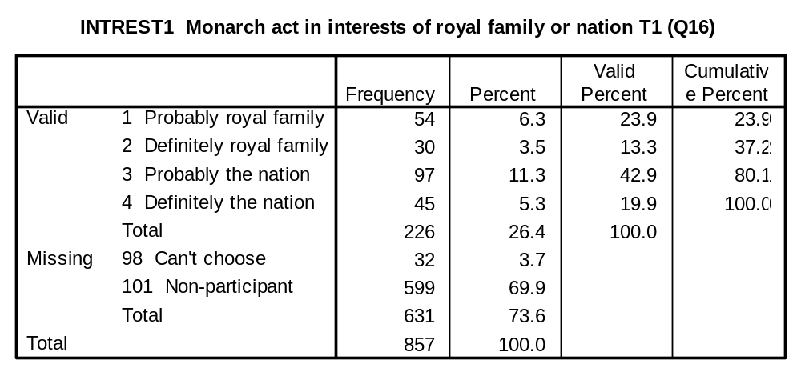
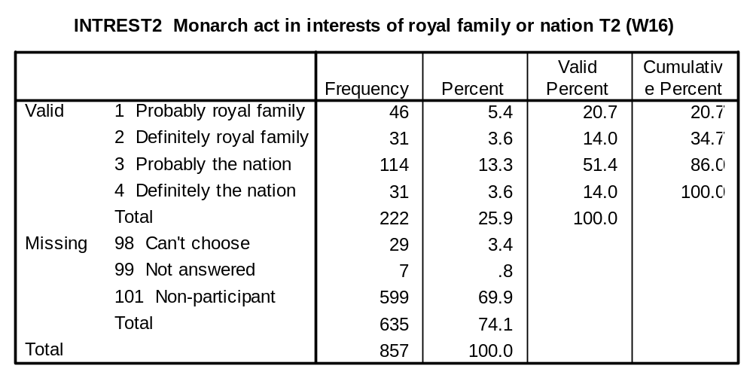

IMPORTANCE OF MONARCHY VARIABLES:

Please show how important you think the monarchy’s role is in each of these areas.

TOURIST1 (Q2a), TOURIST2 (W2a): Attracting tourists in Britain.

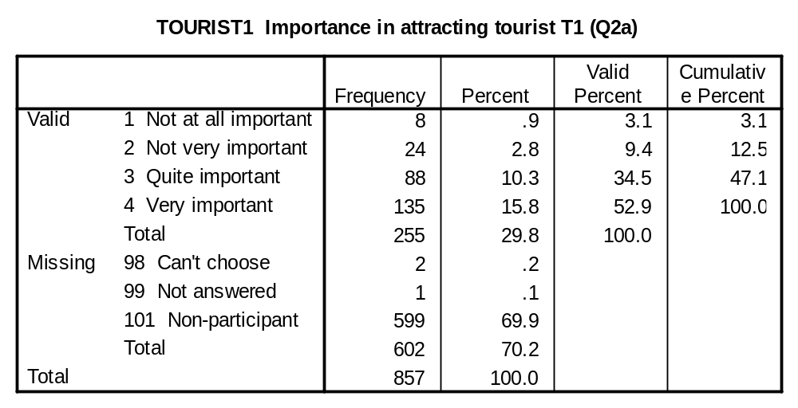

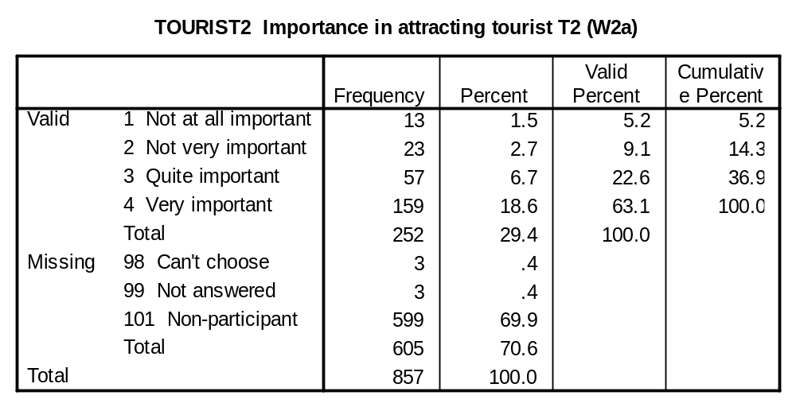

RESPECT1 (Q2b), RESPECT2 (W2b): Gaining international respect for Britain.

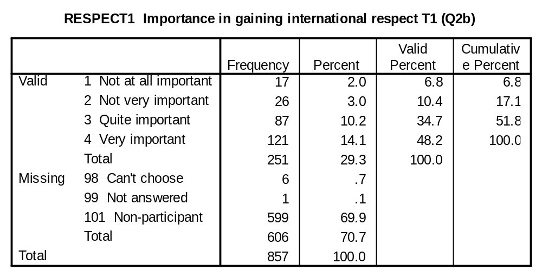

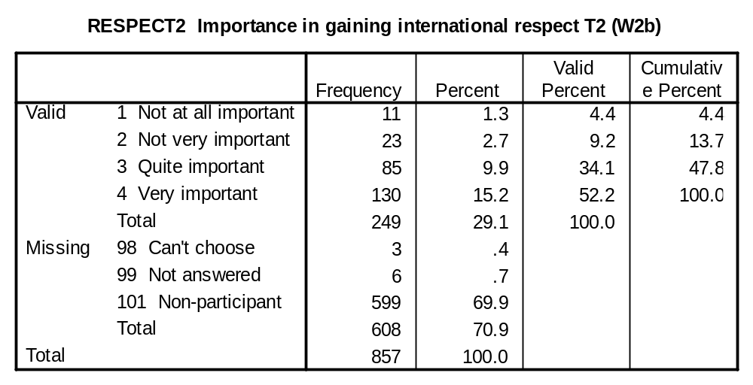

GOVABUS1 (Q2c), GOVABUS2 (W2c): Preventing any government abusing its power.

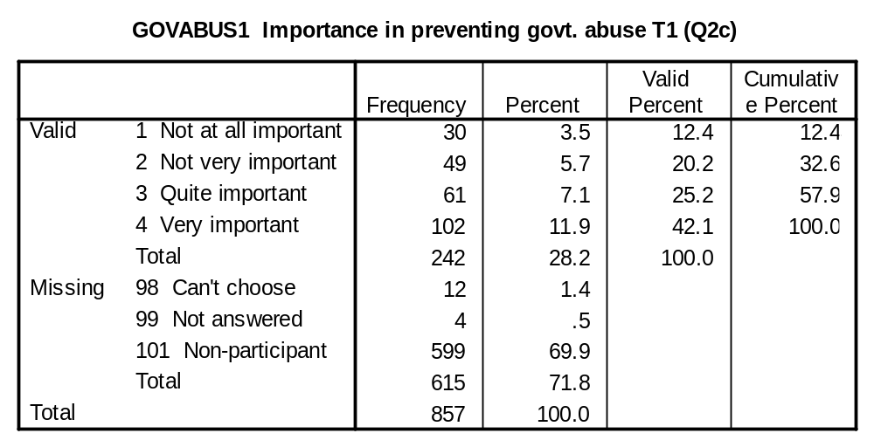

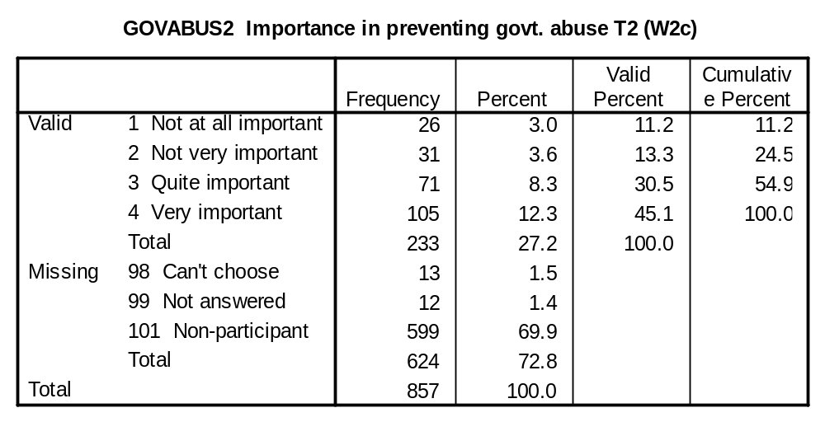

TRADE1 (Q2d), TRADE2 (W2d): Attracting trade to Britain.

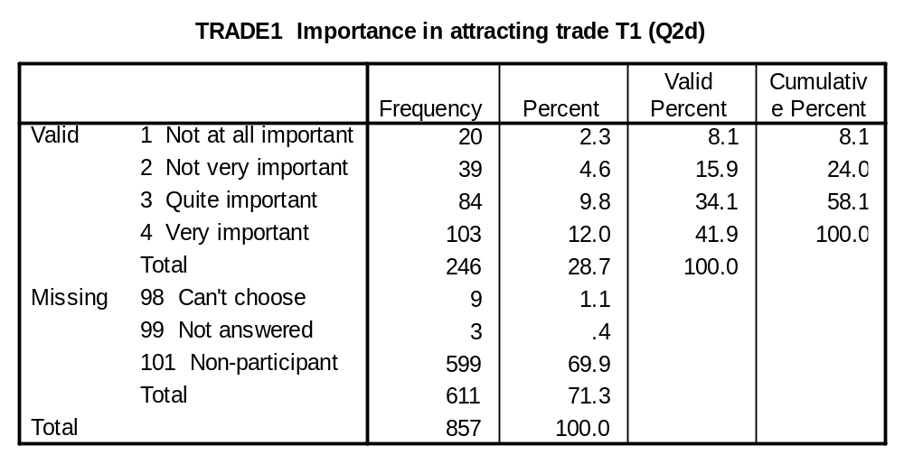

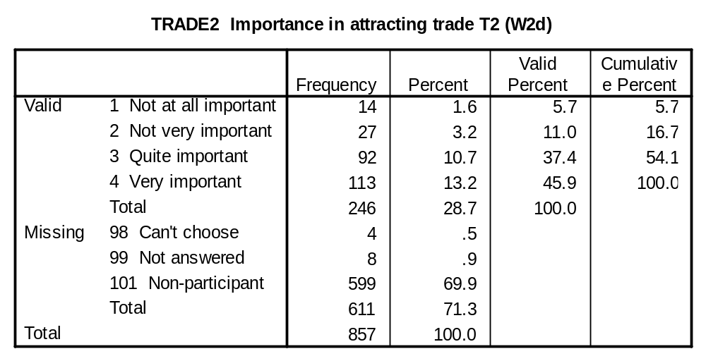

PRESENT1 (Q2e), PRESENT2 (W2e): Linking Britain’s present with its past.

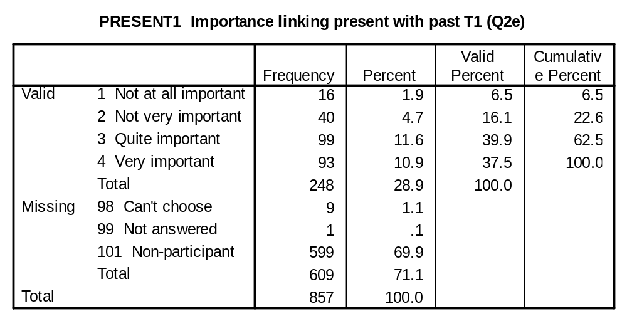

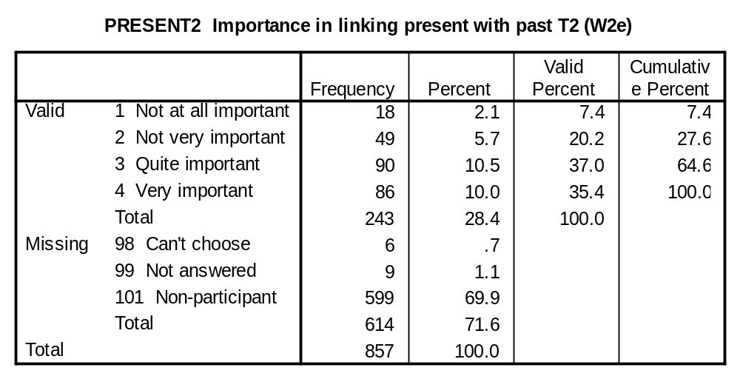

UNITE1 (Q2f), UNITE2 (W2f): Uniting people throughout Britain.

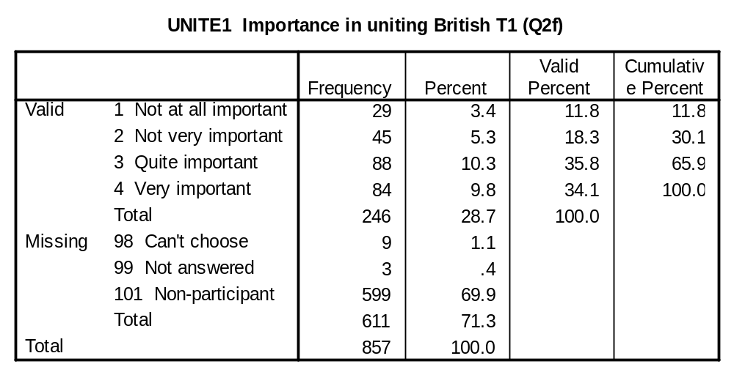

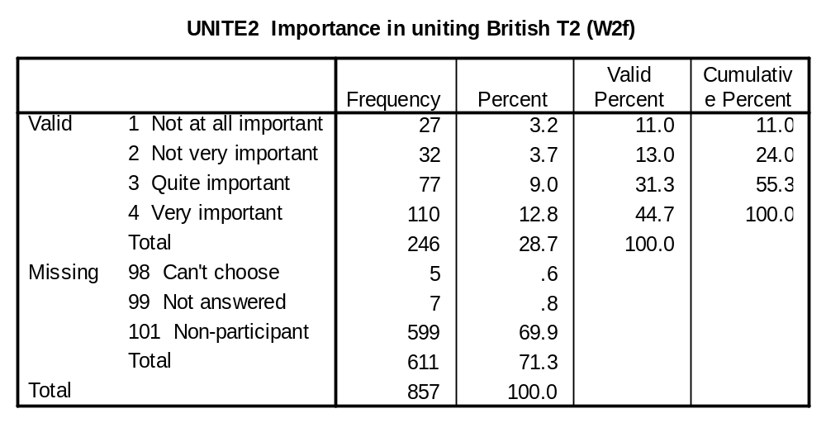

STADEM1 (Q2g), STADEM2 (W2g)

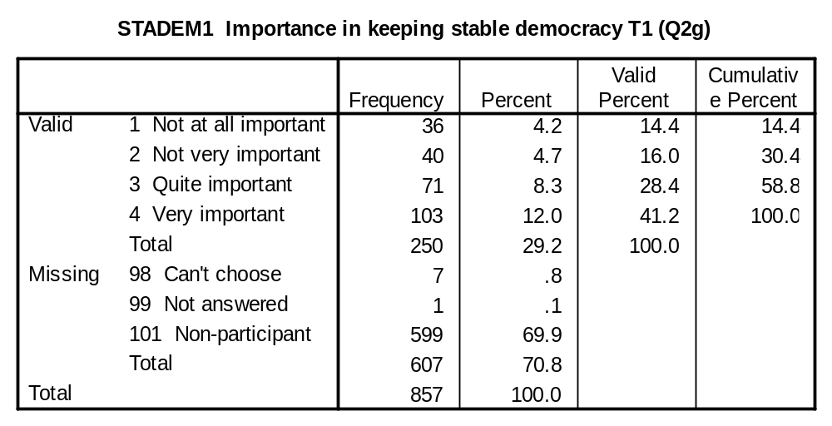

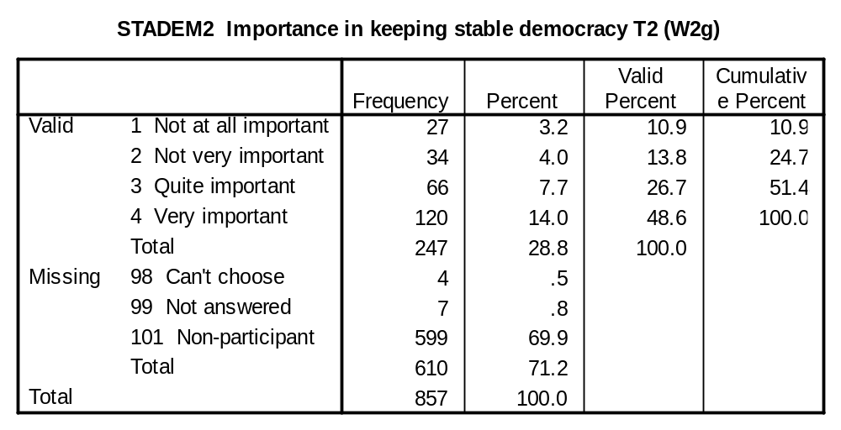

HELP1 (Q2h), HELP2 (W2h): Publicising and helping ‘good causes’.

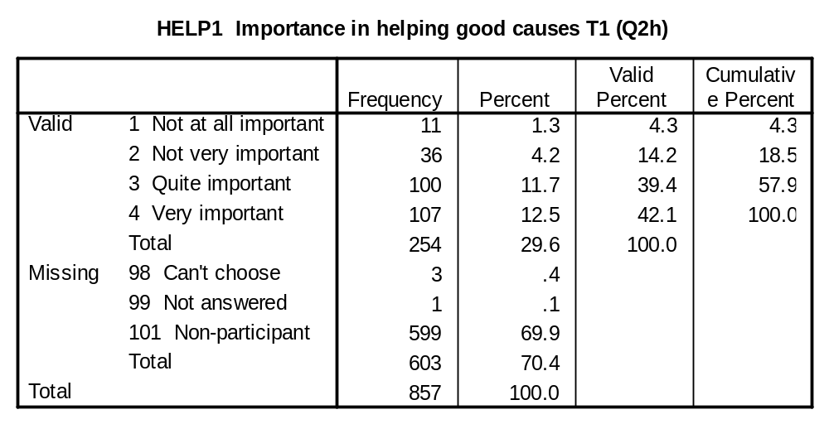
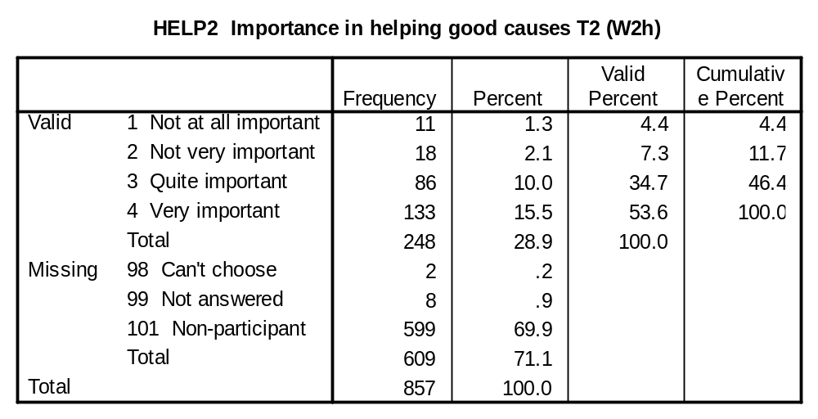

ATTITUDE TOWARD FUTURE OF MONARCHY VARIABLES:

MONARCH1, (Q1), MONARCH2 (W1): Thinking about the monarchy or the royal family in Britain, which of the following do you think should happen?

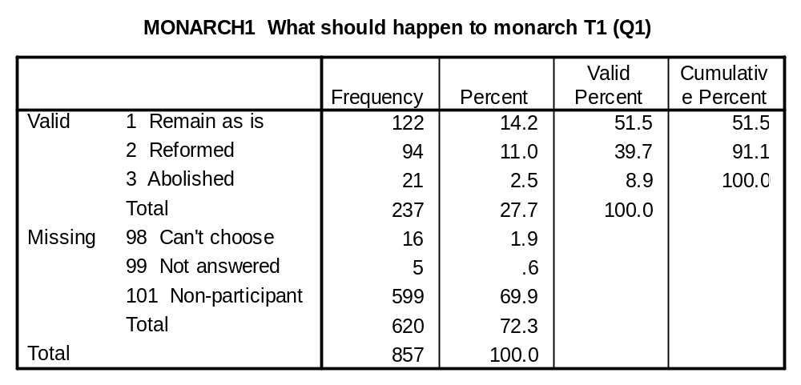
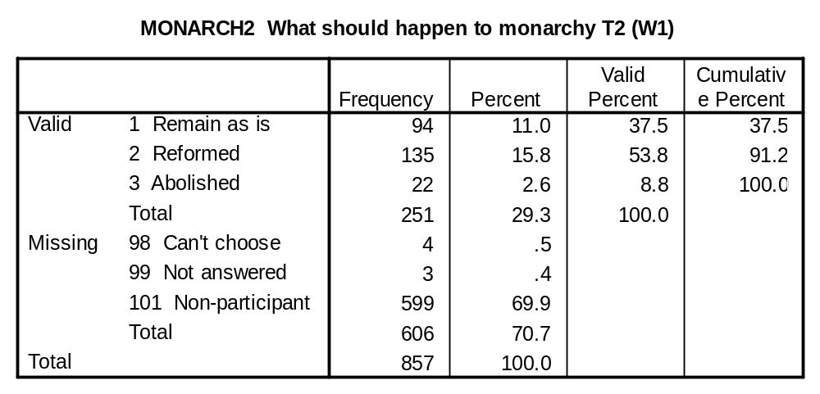

MIX1 (Q6a), MIX2 (W6a): Members of the royal family should mix more with ordinary people.

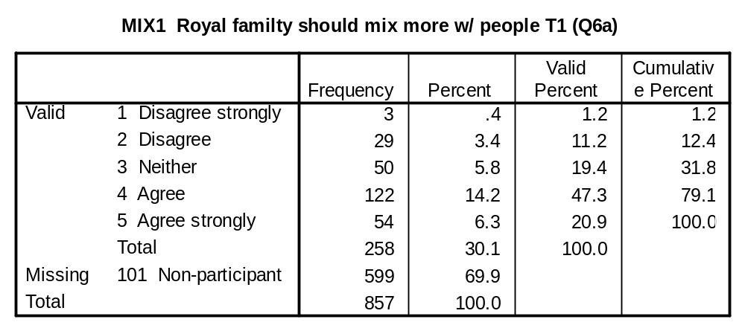
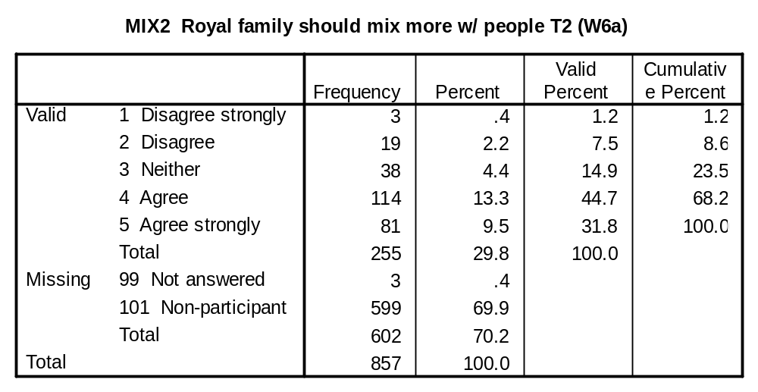

RETIRE1 (Q6b), RETIRE2 (W6b): Monarchs should retire at the same age as other working people.

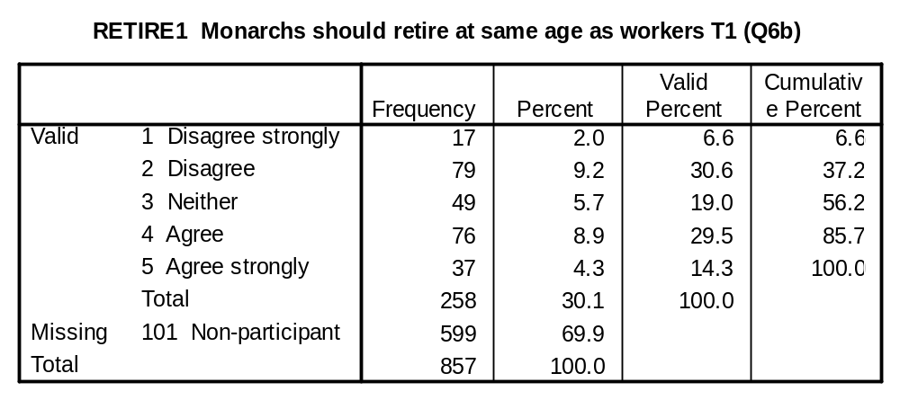
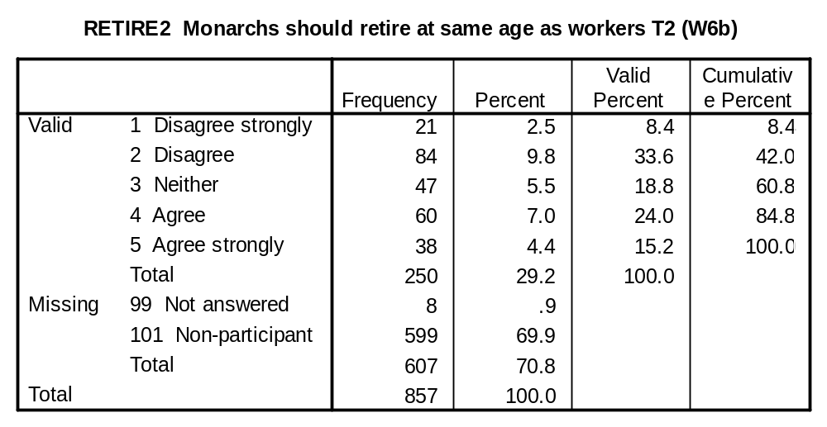

TAXES1 (Q6e), TAXES2 (W6e): A monarch should pay taxes on the same terms as everyone else.

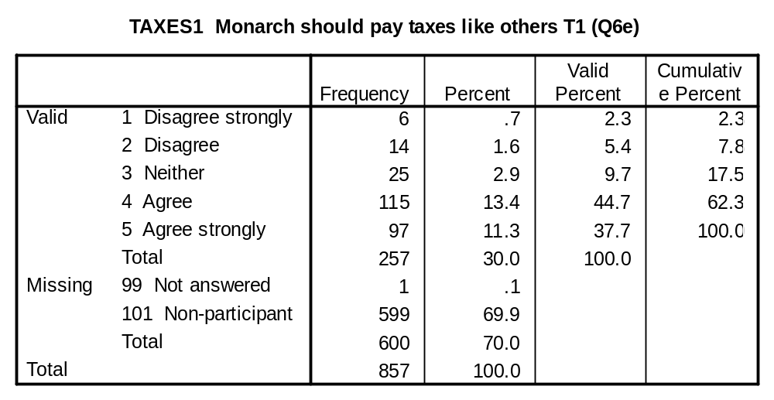
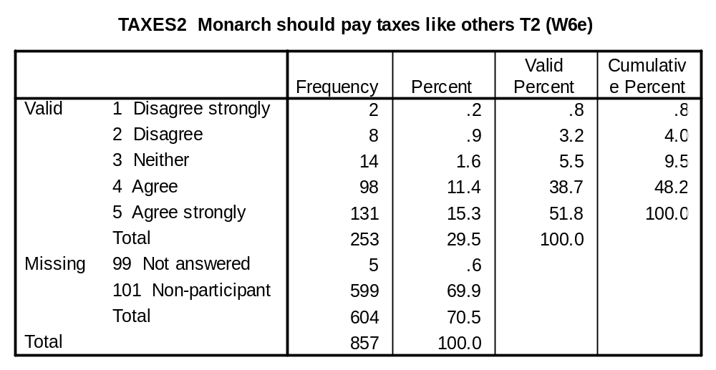

GLAMOUR1 (Q6f), GLAMOUR2 (W6f): There is no point having a royal family without all their glamour and glitter.

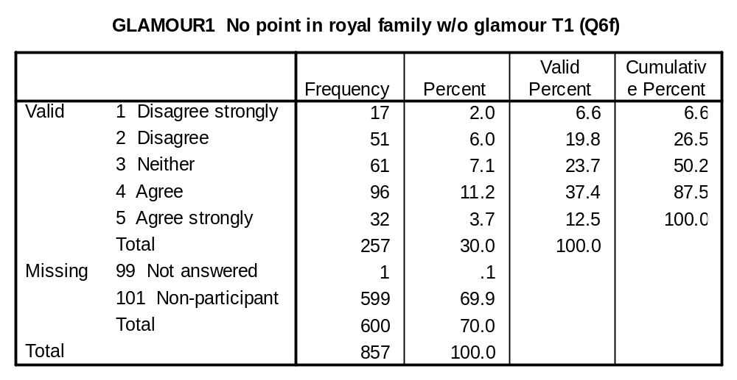
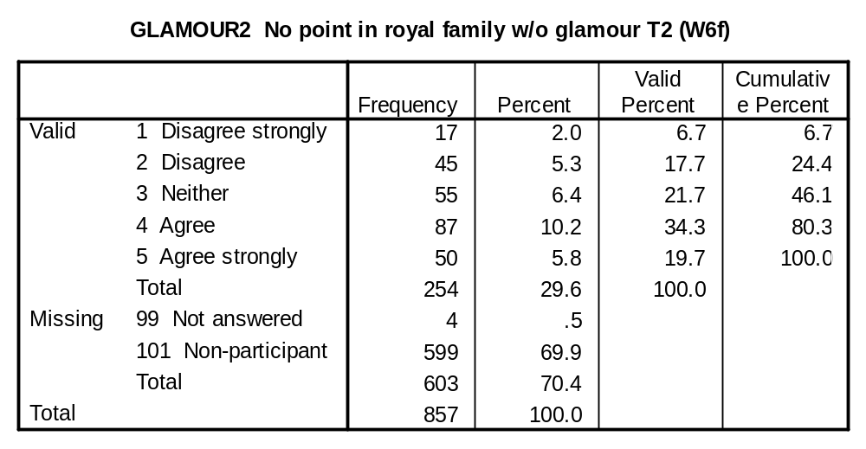

SUPPORT1 (Q7a), SUPPORT2 (W7a): A king or queen who cannot win popular support should not continue in office.

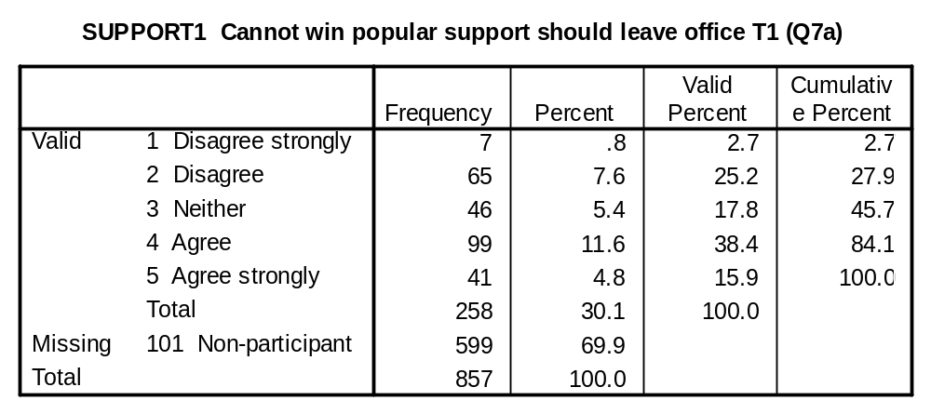
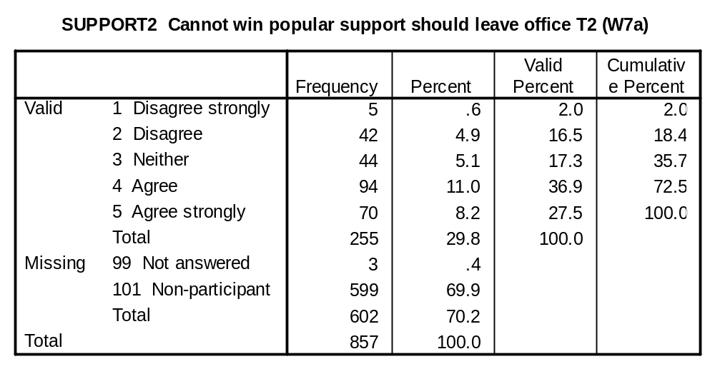

PUBLIC1 (Q7b), PUBLIC2 (W7b): The British public should in future have a say in who becomes the next king or queen.

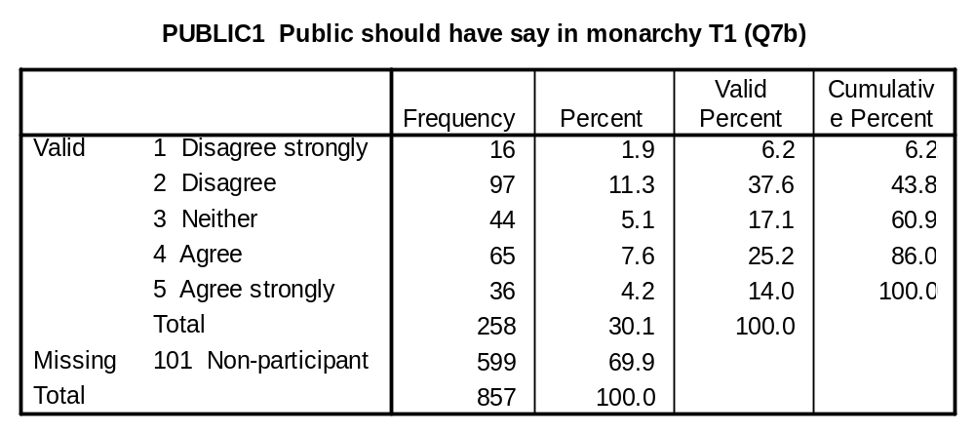

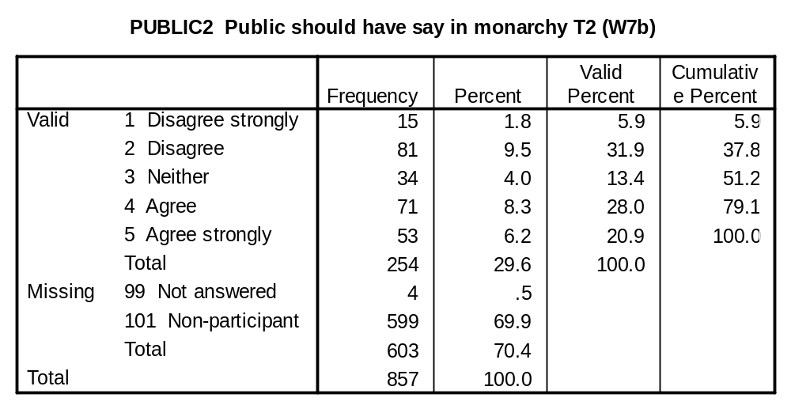

ACCEPT1 (Q7c), ACCEPT2 (W7c): We cannot pick and choose: if we accept the Queen we must accept her whole family.

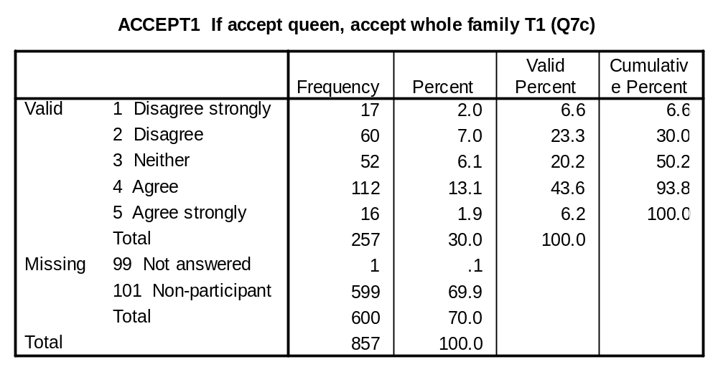
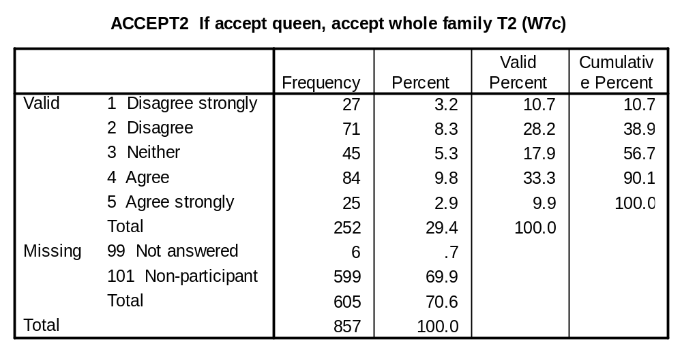

SUBTHRON1 (Q8b), SUBTHRON2 (W8b): If a British monarch dies, which of the following should be the next in line to the throne?

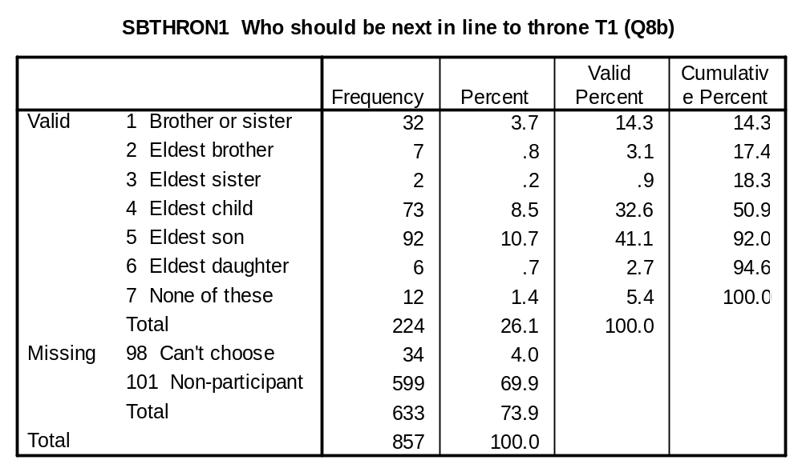
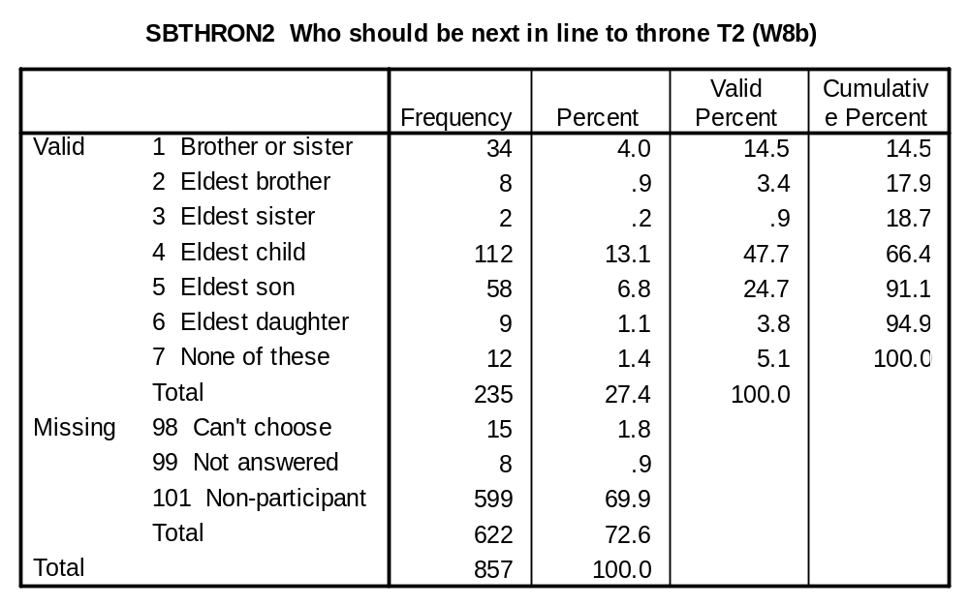

BEST1 (Q9), BEST2 (W9): What do you think would be best for Britain when the present Queen’s reign ends?

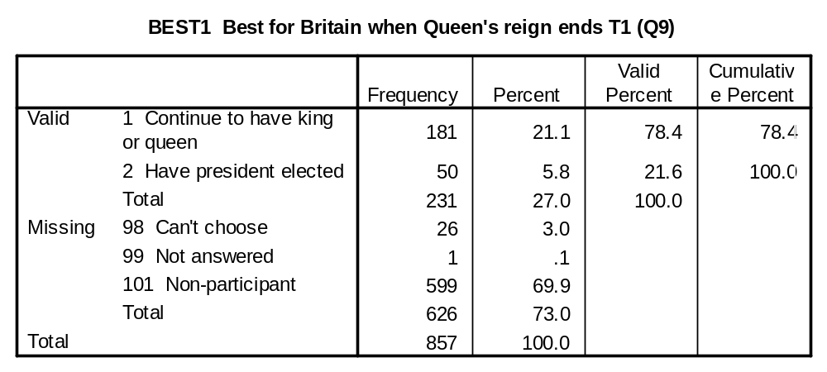
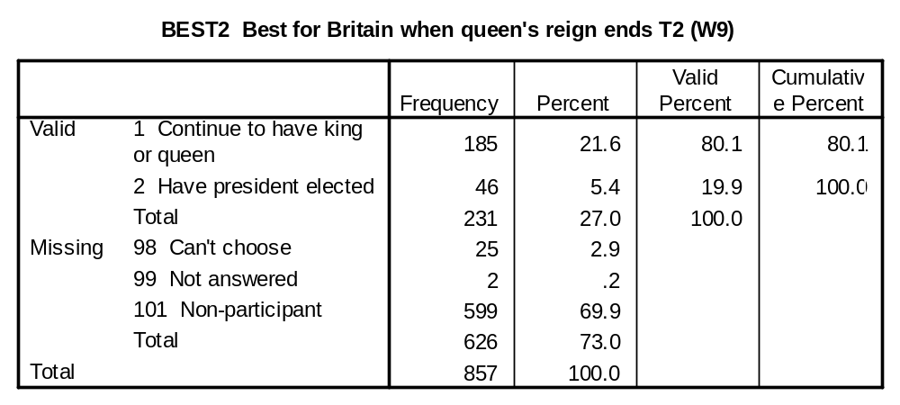

WANTSUR1 (Q11), WANTSUR2 (W11): And how long do you personally want the British monarchy to survive in its present form?

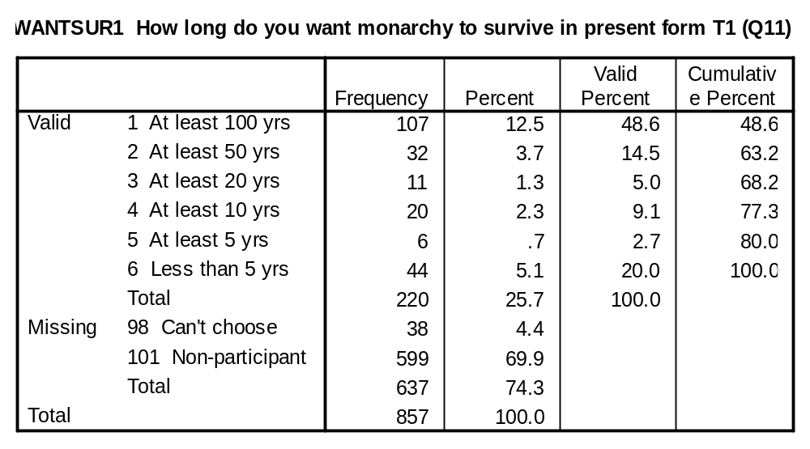
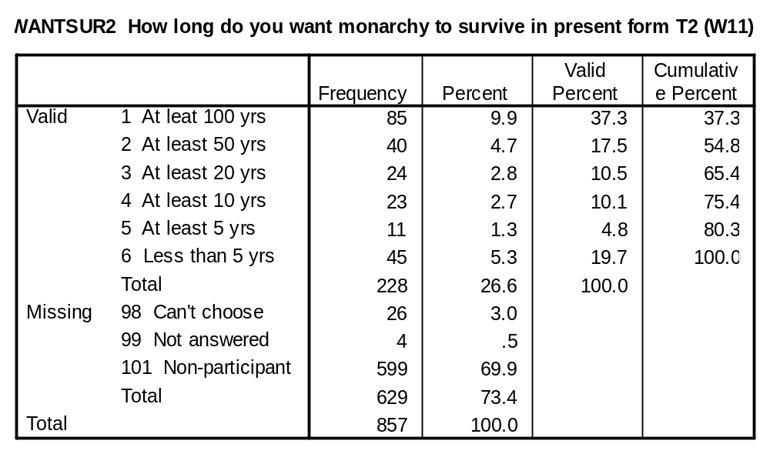

MPREF1 (Q12a), MPREF2 (W12a): Suppose Britain did change its present monarchy within the next twenty years or so. Which of the following three possibilities would you most prefer to see?

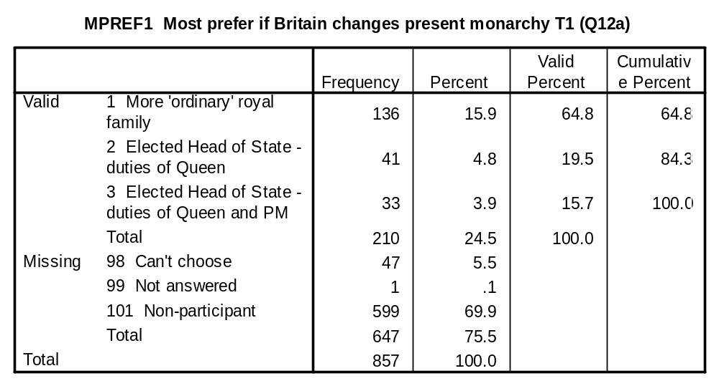
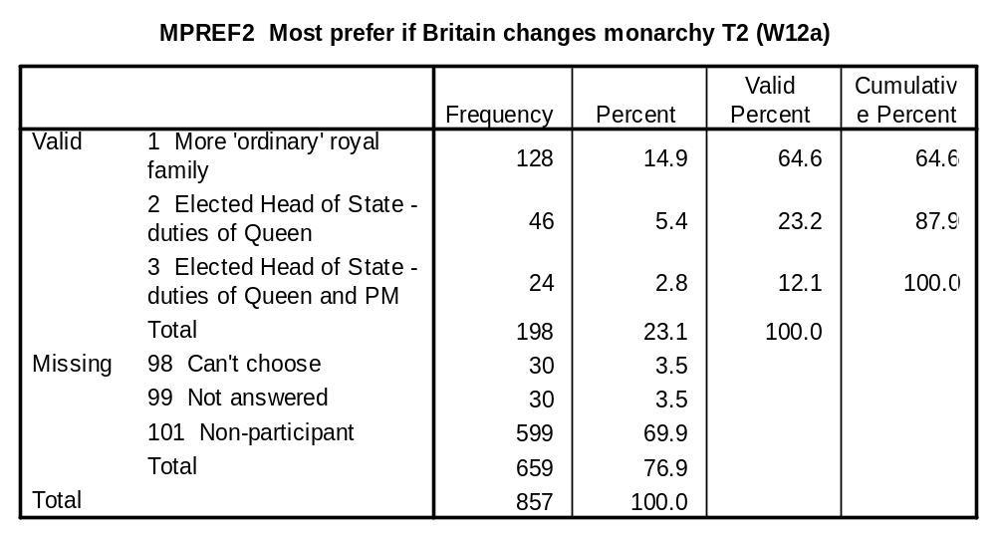

LPREF1 (Q12b), LPREF2 (Q12b): And which of the same three possibilities would you least prefer to see?

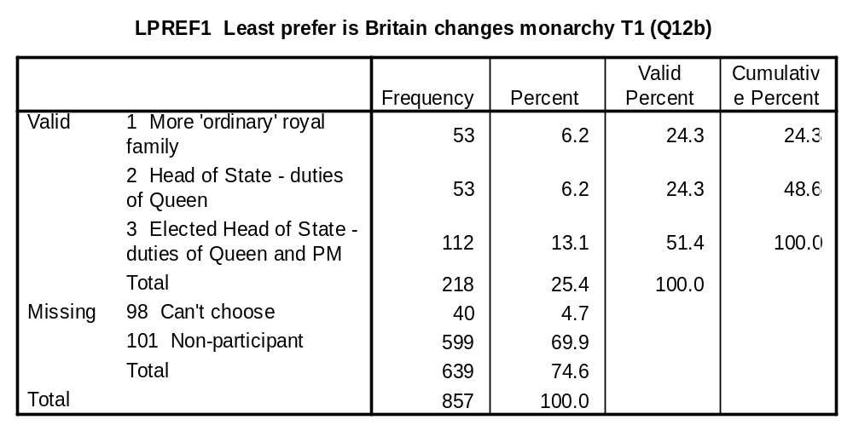
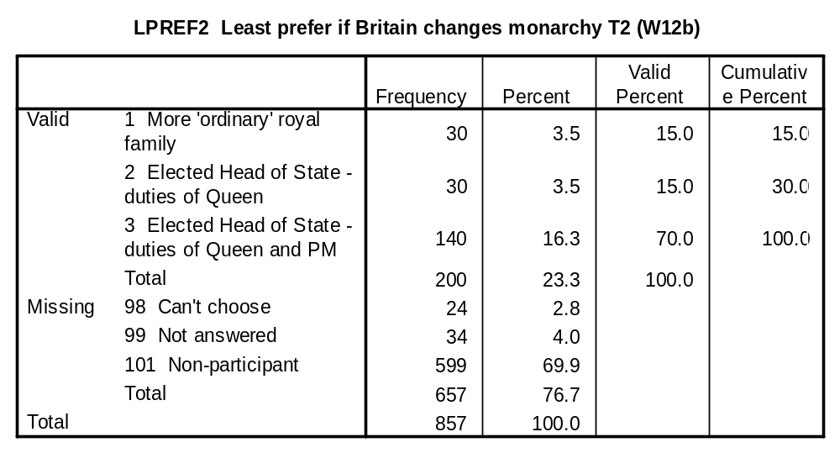

DEPEND1 (Q13a), DPEND2 (W13a): The British monarchy would be more acceptable if it did not depend on the taxpayer for so much support.

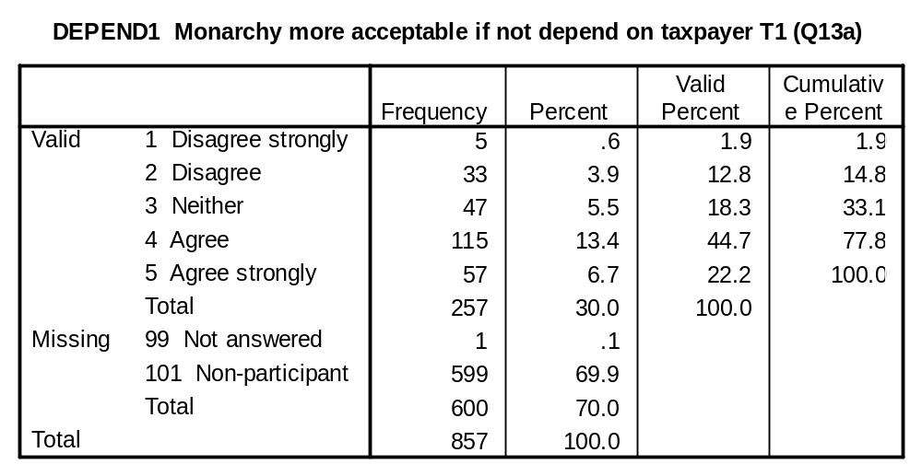
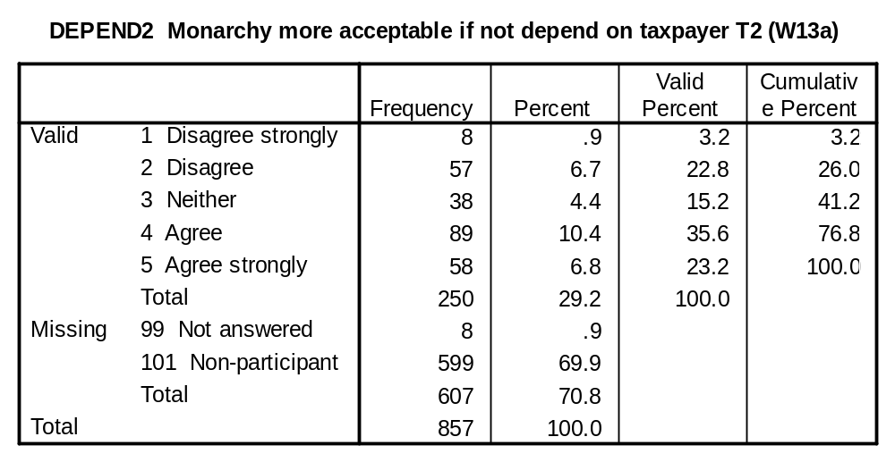

FIGHEAD1 (Q13b), FIGHEAD2 (W13b): If a Head of State is only a figurehead it doesn’t matter whether they are elected or born into the job.

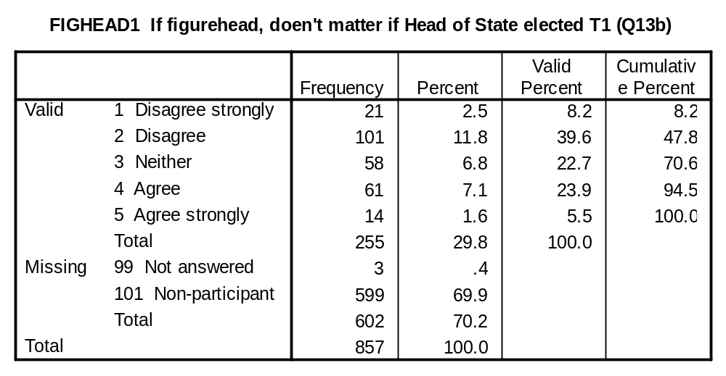
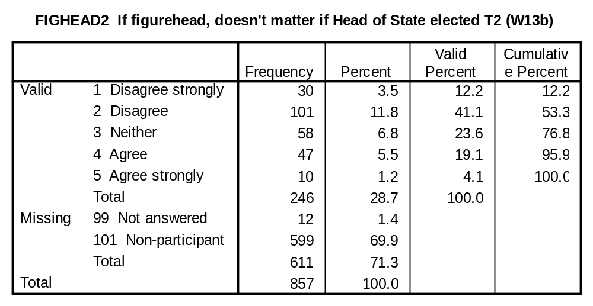

MOREPOW1 (Q13d), MOREPOW2 (W13d): It would be a good thing if Queen had more powers.

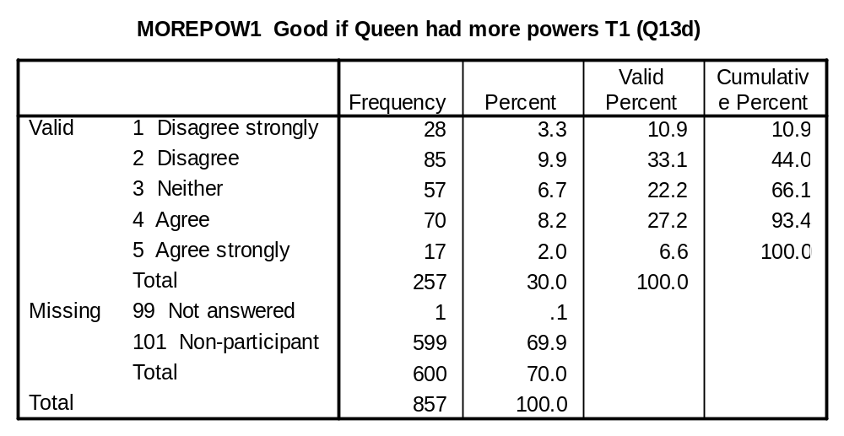
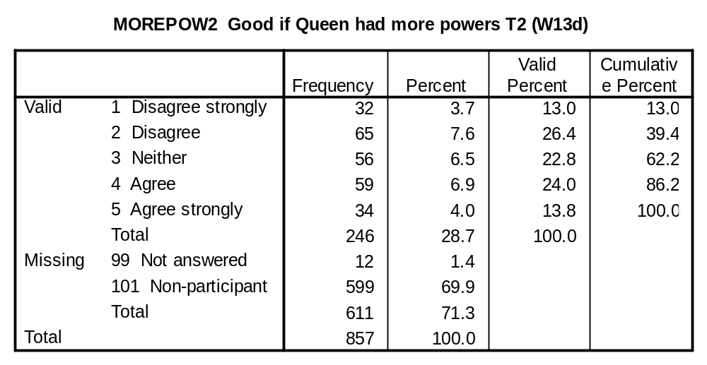

HOSPOL1 (Q13e), HOSPOL2 (W13e): An elected Head of State would behave too much like any ordinary politician.

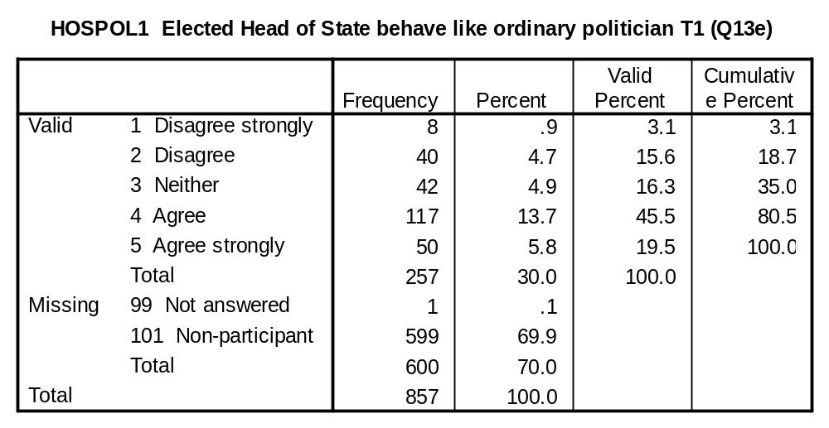
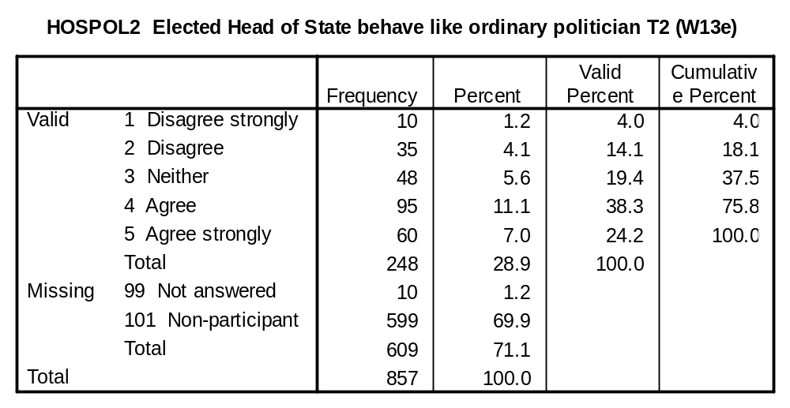

COMBPOW1 (Q13f), COMBPOW2 (W13f): Combining a monarch and a prime minister into a single Head of State would give a single person too much political power.

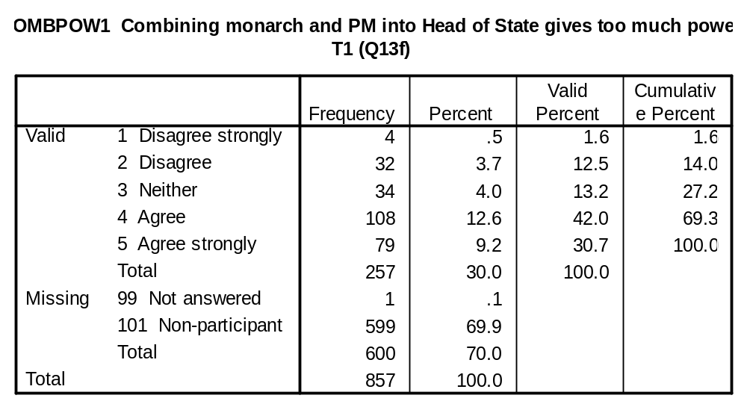
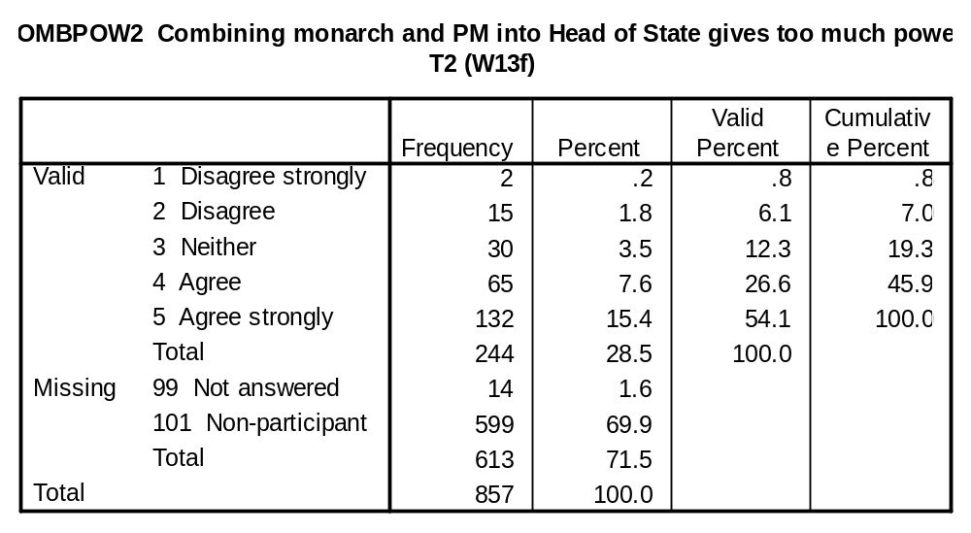

REFEREN1 (Q15), REFEREN2 (W15): In your opinion, do you think there should be a referendum on whether Britain should continue to have a monarchy?

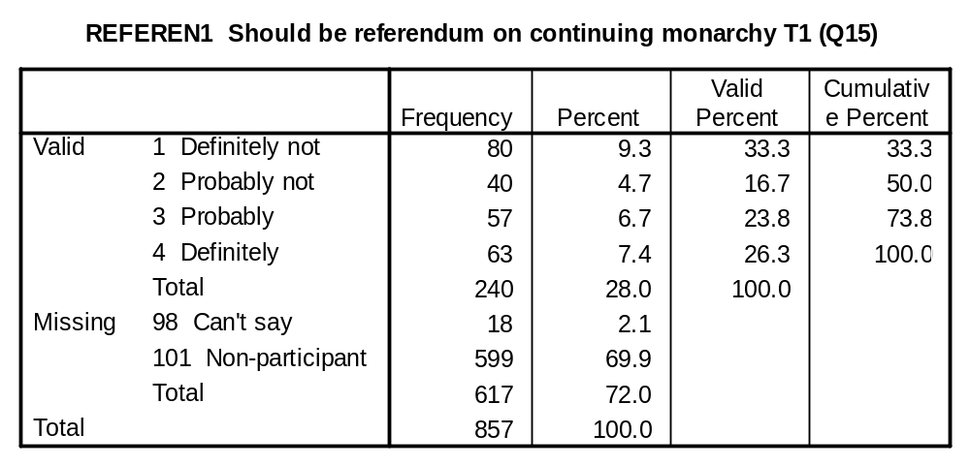
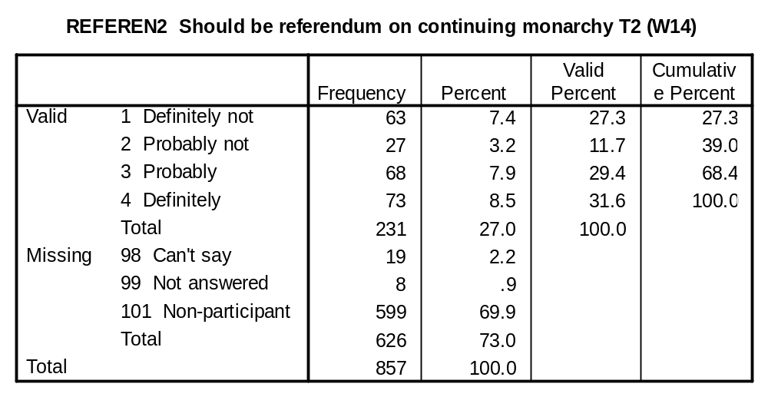

CHOOSPM1 (Q15), CHOOSPM2 (W15): If after a General Election no party had a majority in the House of Commons, it could be up to the Queen to choose Britain’s new prime minister. What do you think should happen in this situation?

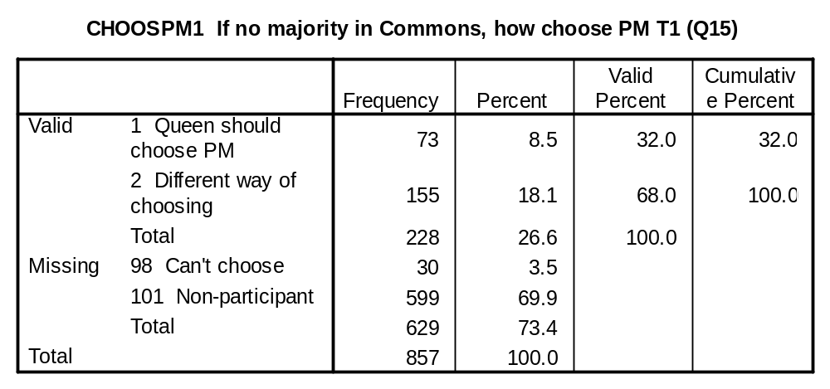
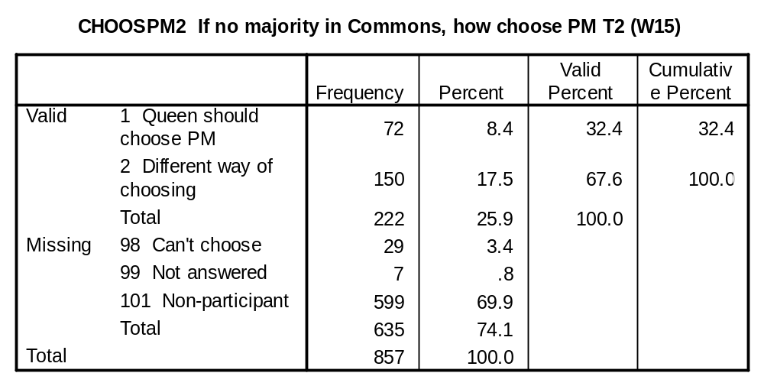

INTNAT1 (Q17), INTNAT2 (W17): Comparing a king or queen with an elected president, which would you say would be more likely to act in the best interests of the nation…

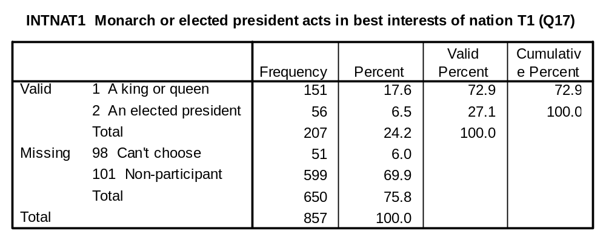
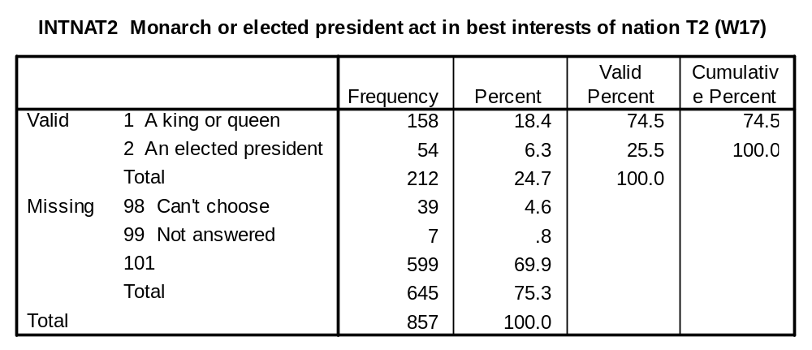

HEADCOE1 (Q20), HEADCOE2 (W20): What is your opinion of the following statement? “In a country with many religions, the monarch should not remain the head of the Church of England.

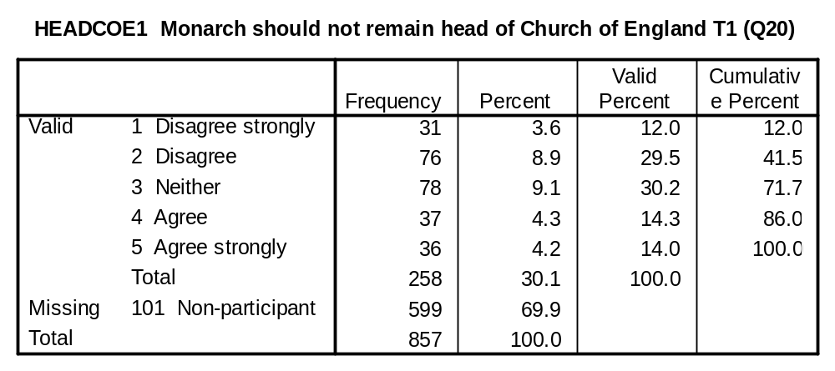
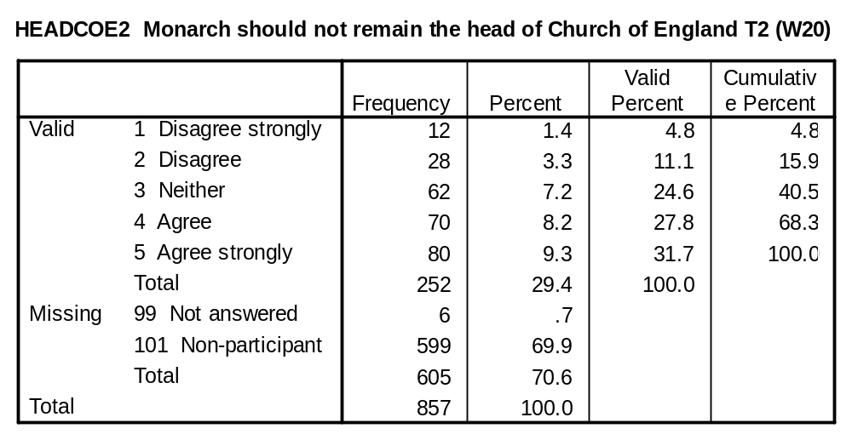

HOUSE OF LORDS VARIABLES:

LORDS1 (Q18), LORDS2 (W18): Now thinking about the House of Lords. Which of the following do you think should happen?

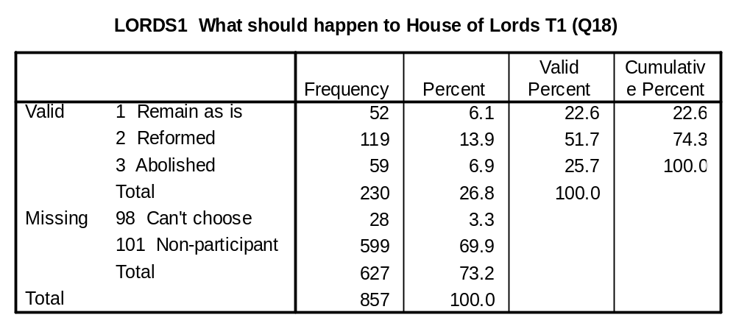

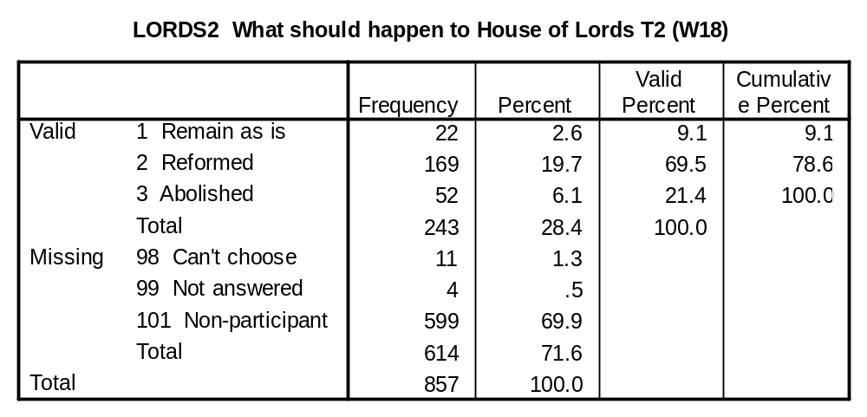

LORDVOT1 (Q19), LORDVOT2 (W19): The present House of Lords contains some Lords who are there by birth (hereditary peers) and some who have been appointed for life (life peers). All have a right to vote in the House of Lords. If you had to choose between these two statements, which one comes closer to your own view?

Hereditary peers should keep their right to vote in the House of Lords because they bring some independence into politics.

The fact that someone inherits a title should not give them a right to vote in the House of Lords.

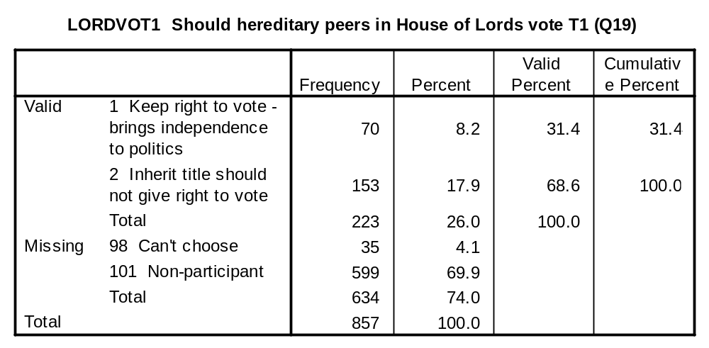

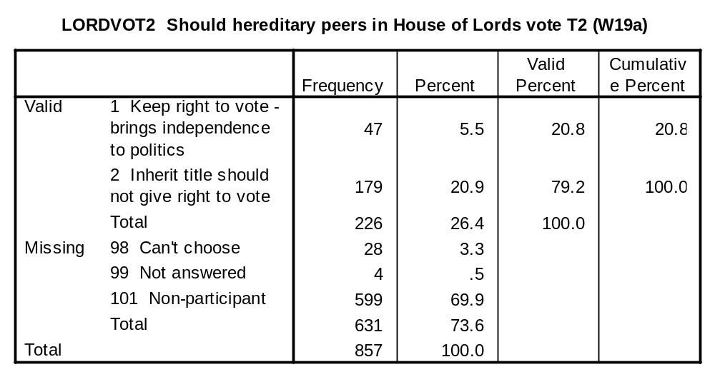

LORDAPP1 (Q19b), LORDAPP2 (W19b): And if you had to choose between these two statements, which comes closer to your own view?

We should continue to have appointed life peers in the House of Lords because they bring experience from outside Parliament into politics.

All members of the House of Lords should be democratically elected.

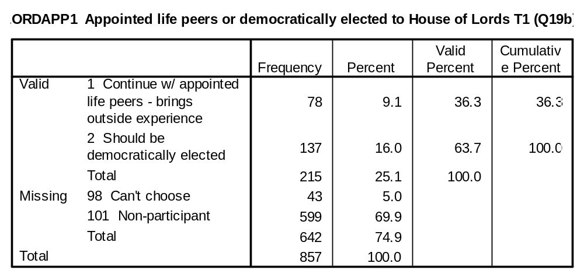

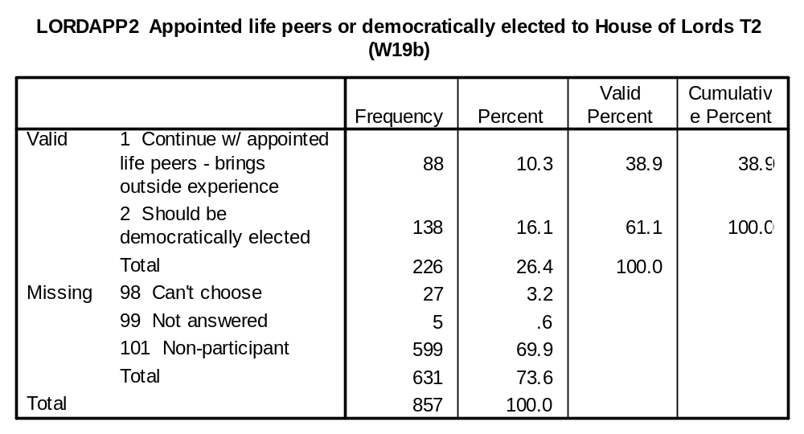

CIVIC ATTITUDE VARIABLES:

DEMOCRA1 (Q21), DEMOCRA2 (W21): All in all, how well or badly do you think the system of democracy in Britain works these days?

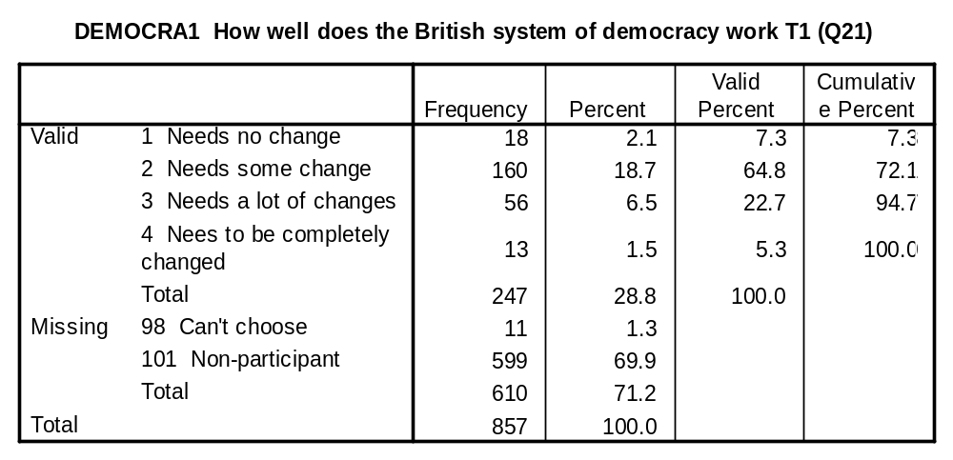
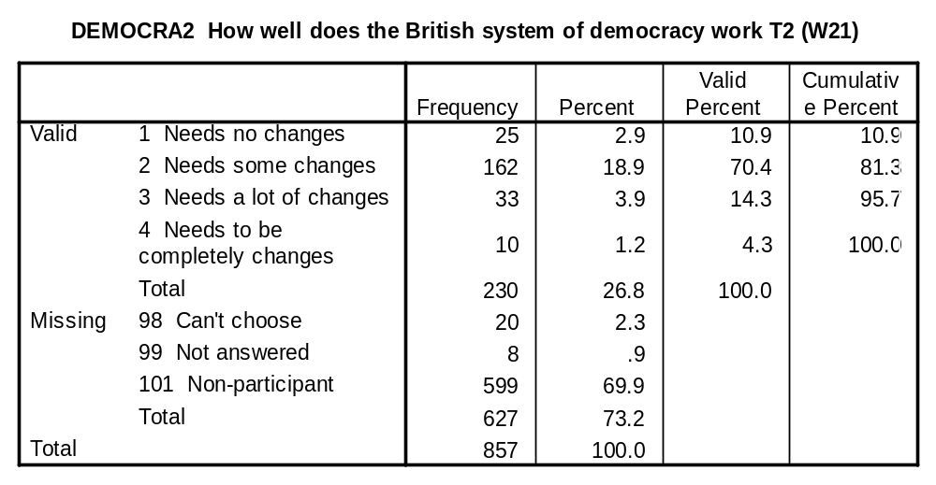

SAYGOV1 (Q22a), SAYGOV2 (W22a): People like me have no say in what the government does.

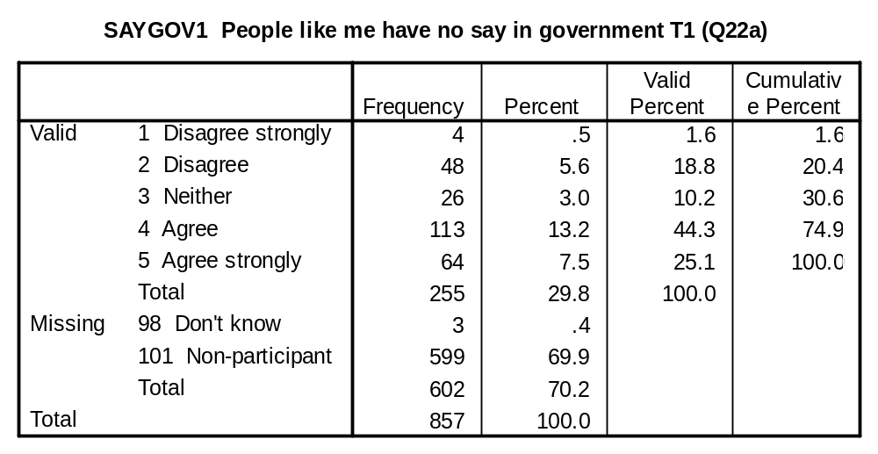
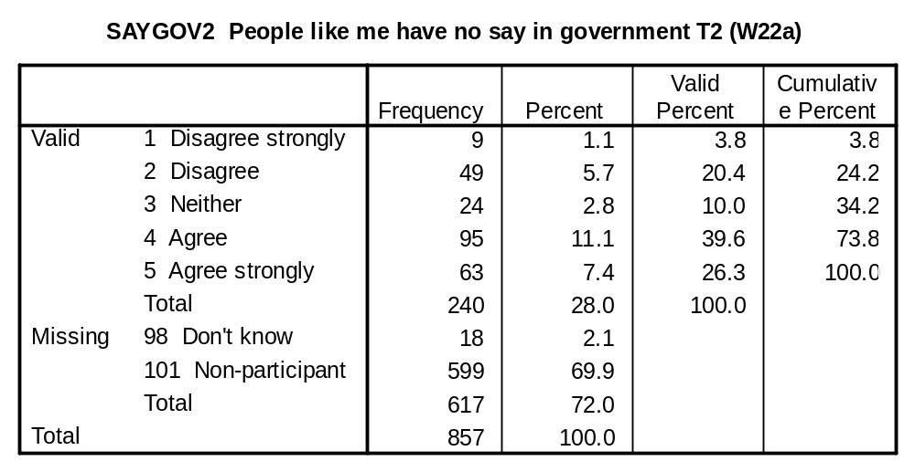

OPINION1 (Q22b), OPINION2 (W22b): I have opinions about politics that are worth listening to.

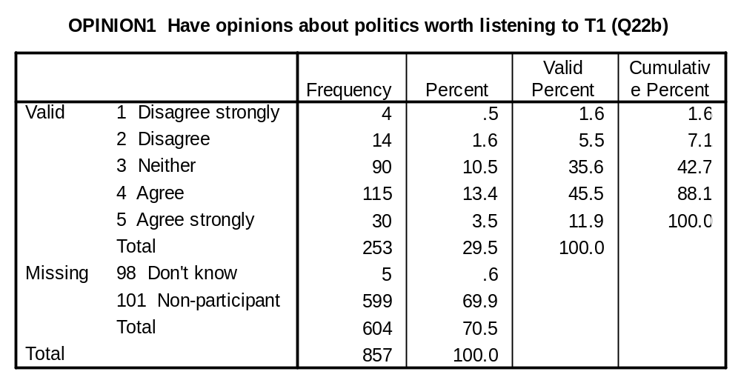
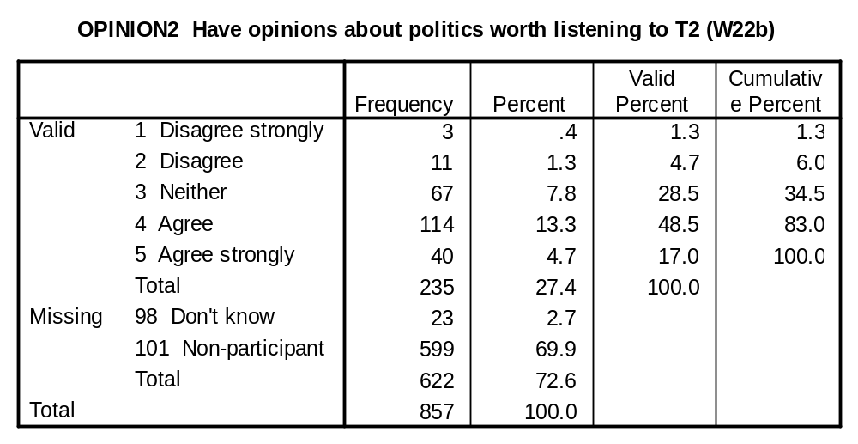

VOICES1 (Q22c), VOICES2 (W22c): In Britain today, it is too difficult for ordinary people to make their voices heard.

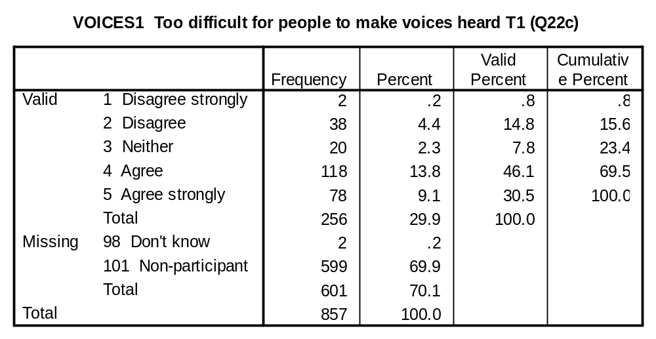
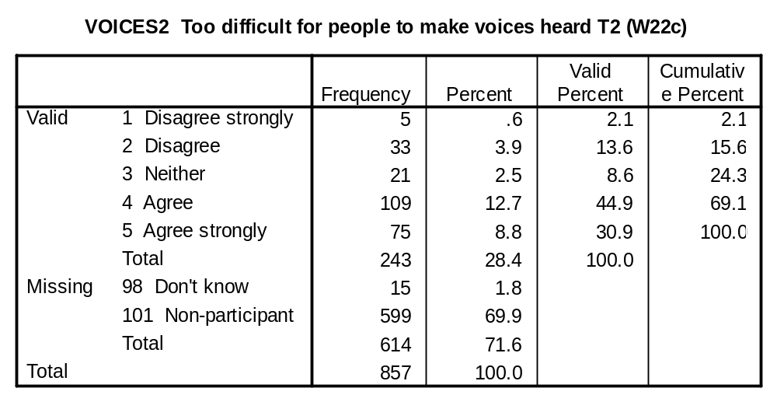

INFORM1 (Q22d), INFORM2 (W22d): I think I am better informed than most people about politics and government.

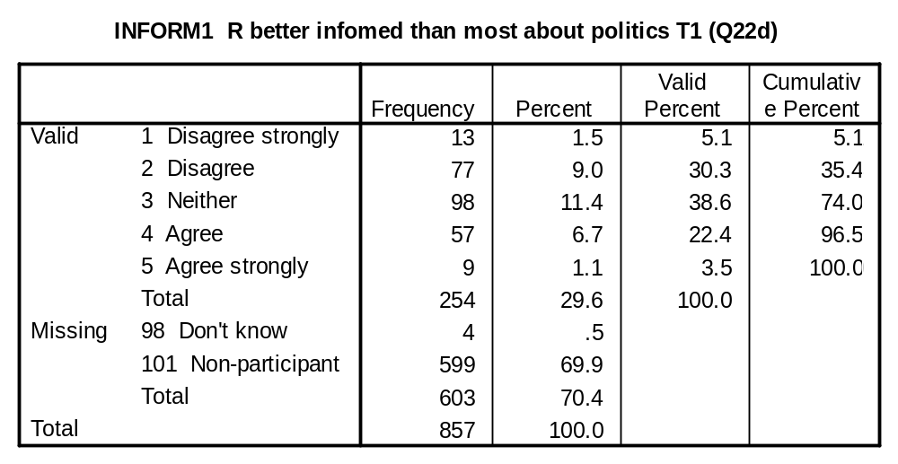
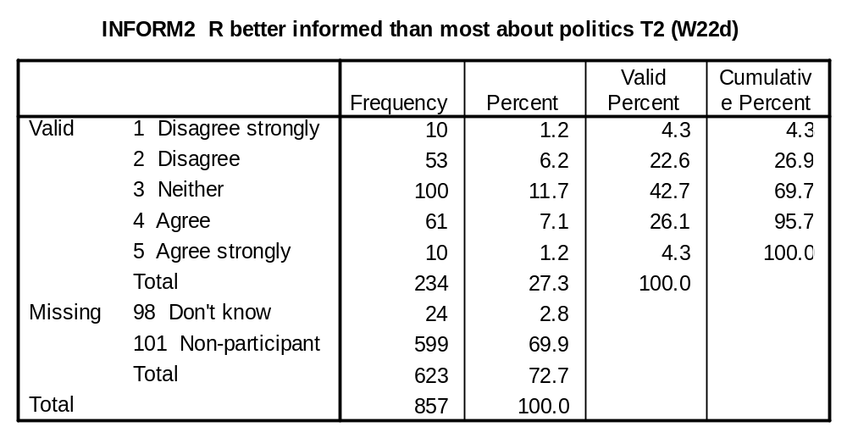

INFORMATION VARIABLES:

Each information variable is followed by a variable (know) showing the percentage who answered the item correctly. A summary knowledge showing the proportion of all items answered correctly is provided at the end of this section.

Now, a quick quiz about the monarchy. For each of the following, please tick one box to show whether you think it is true or false, or whether you don’t know.

LINETH1 (Q5a), LINETH2 (W5a): After Prince Charles, Princess Anne is the next in line to the throne.

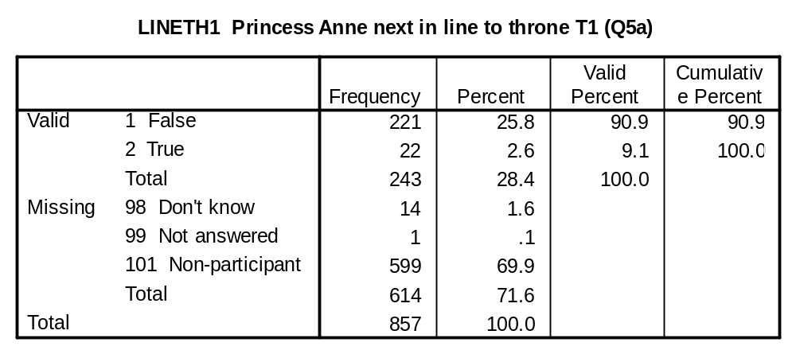
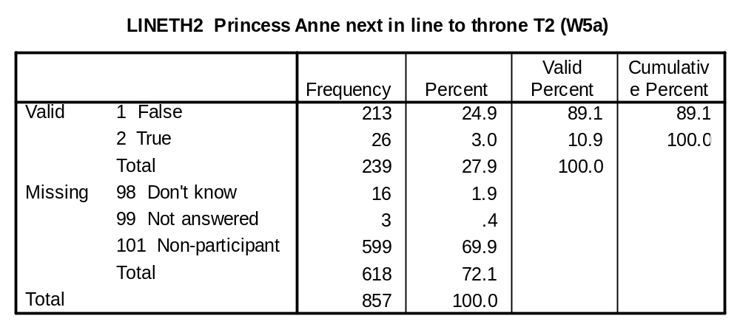
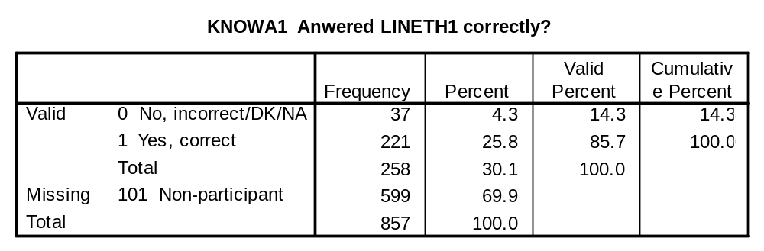
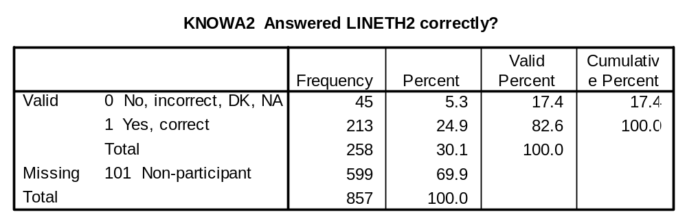

HEADST1 (Q5b), HEADST2 (W5b): The Prime Minister, and not the Queen, is Britain’s Head of State.

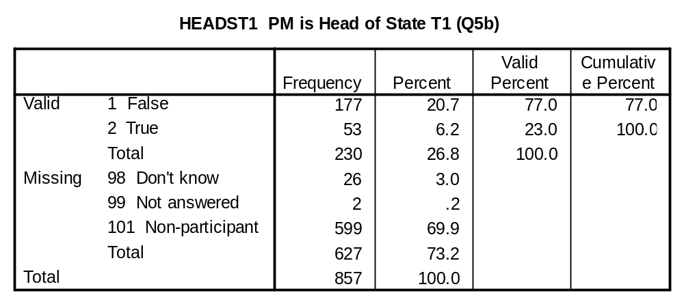
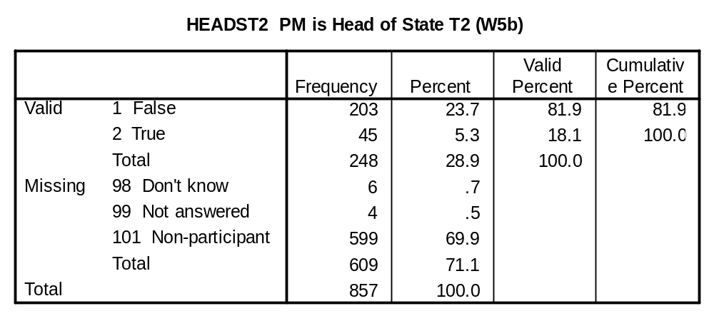
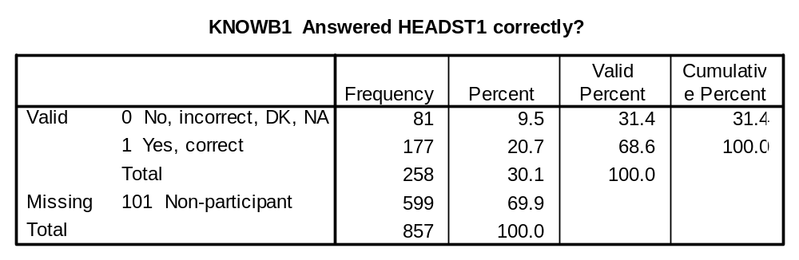
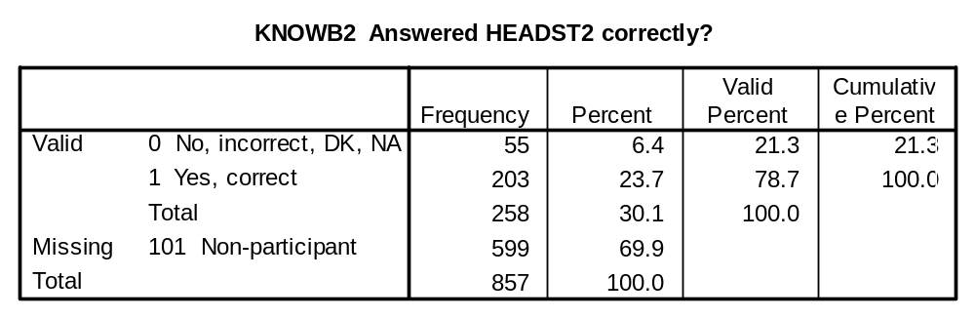

HEADCOM1 (Q5c), HEADCOM2 (W5c): The Queen is still the head of the Commonwealth.

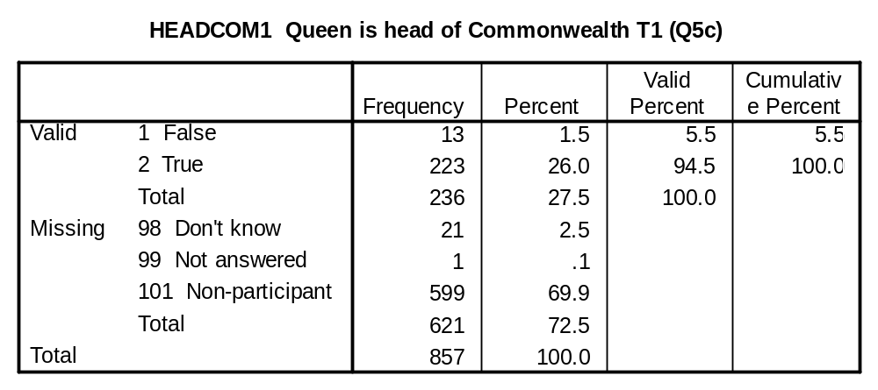
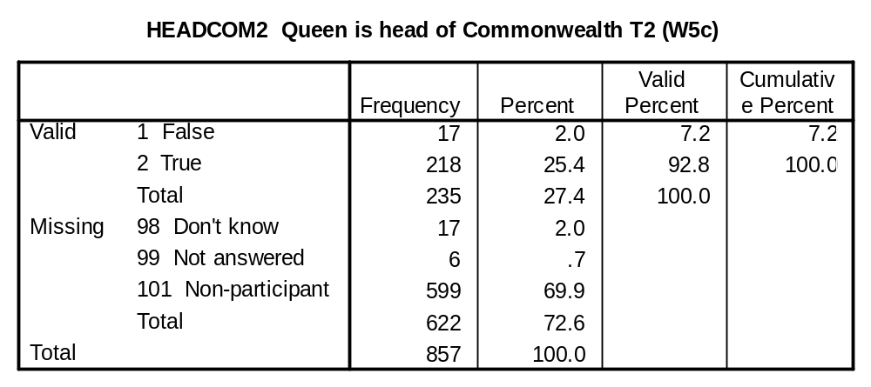
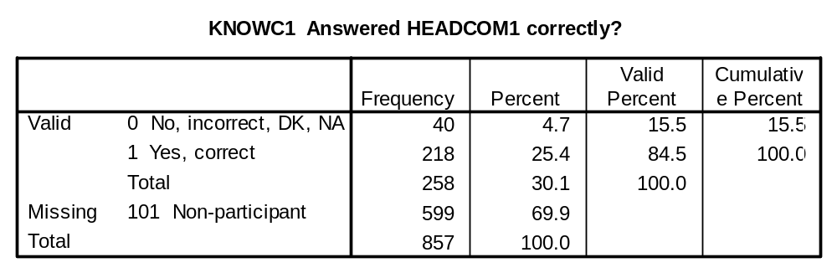
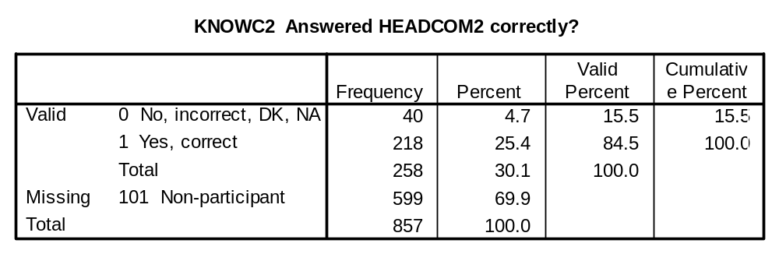

QUEDUTY1 (Q5d), QUEDUTY2 (W5d): It is the Queen’s duty to decide the date of all General Elections.

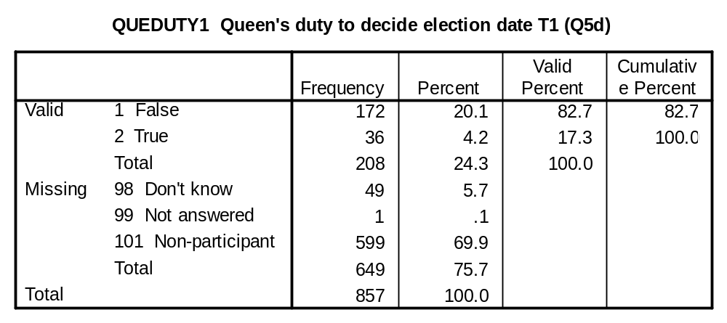
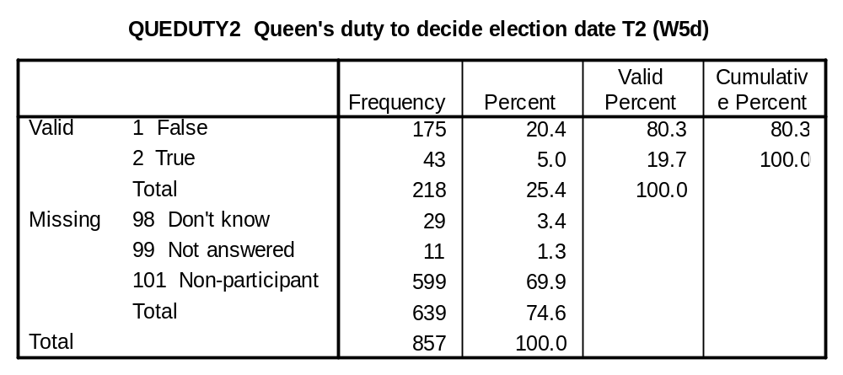
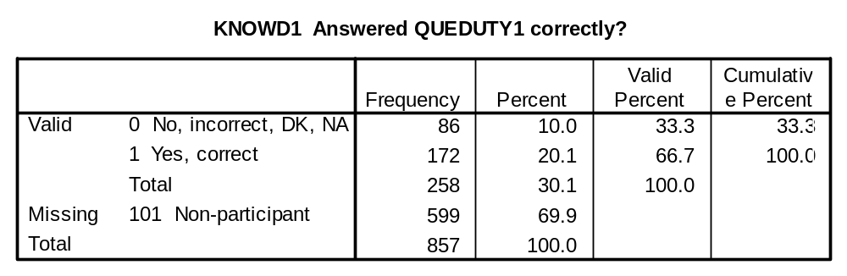
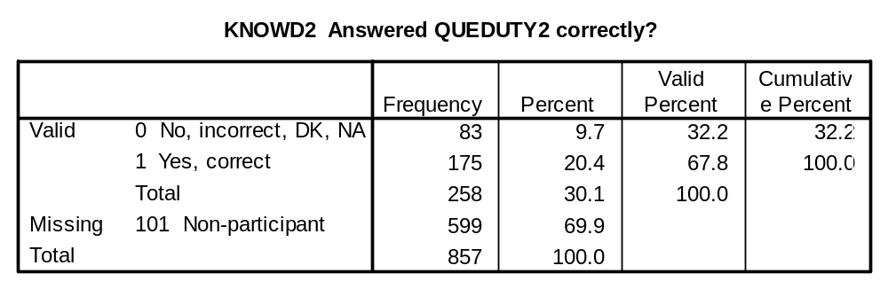

PMOFF1 (Q5e), PMOFF2 (W5e): No prime minister takes office without being asked to by the Queen.

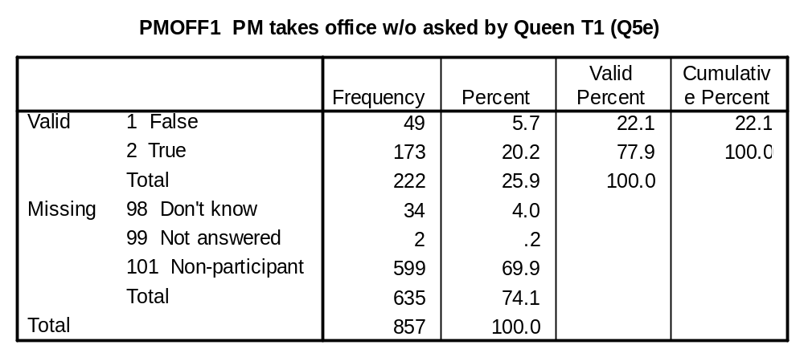
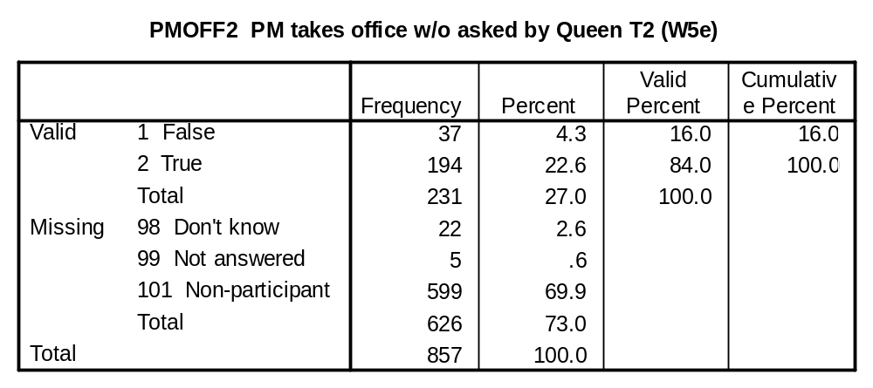
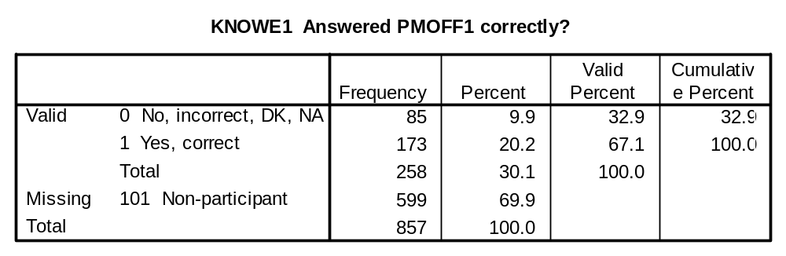
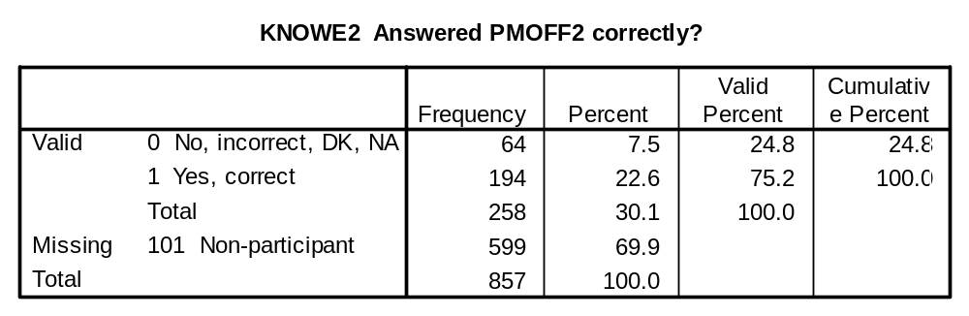

QUECOE1 (Q5f), QUECOE2 (W5f): The Queen is the head of the Church of England.

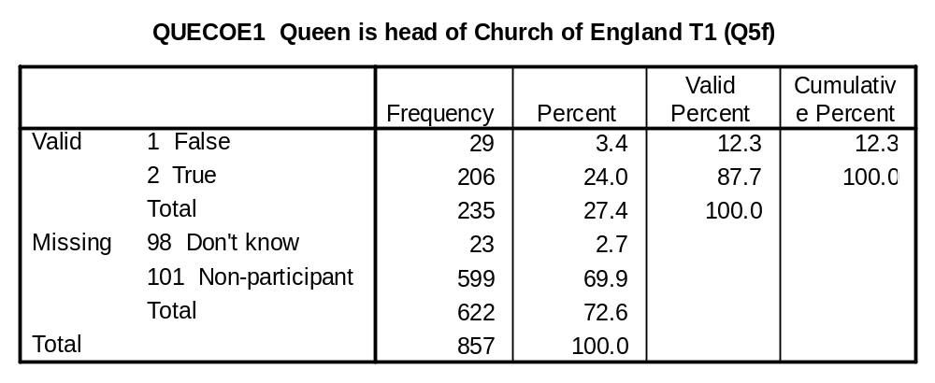
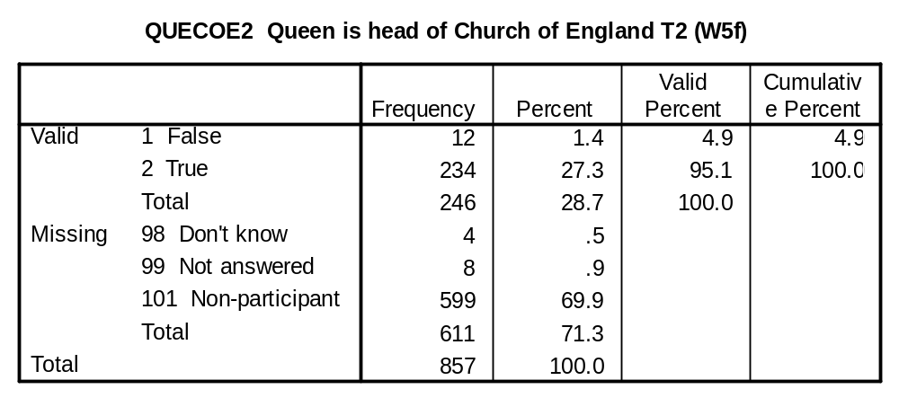
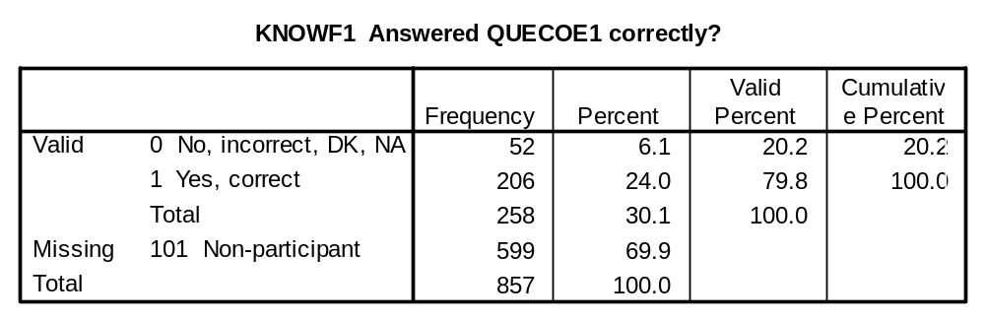
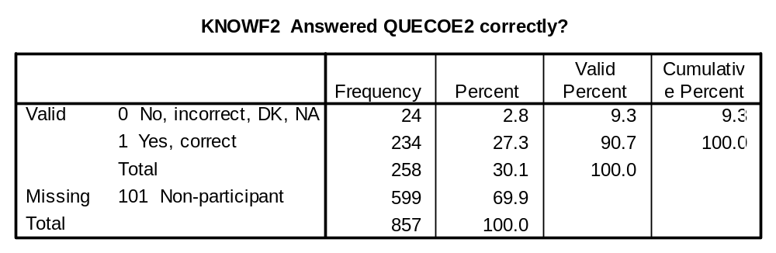

QUECOS1 (Q5g), QUECOS2 (W5g): The Queen is the head of the Church of Scotland.

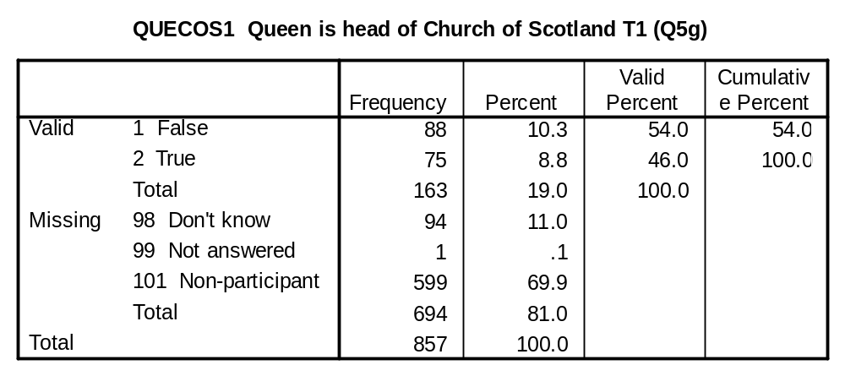
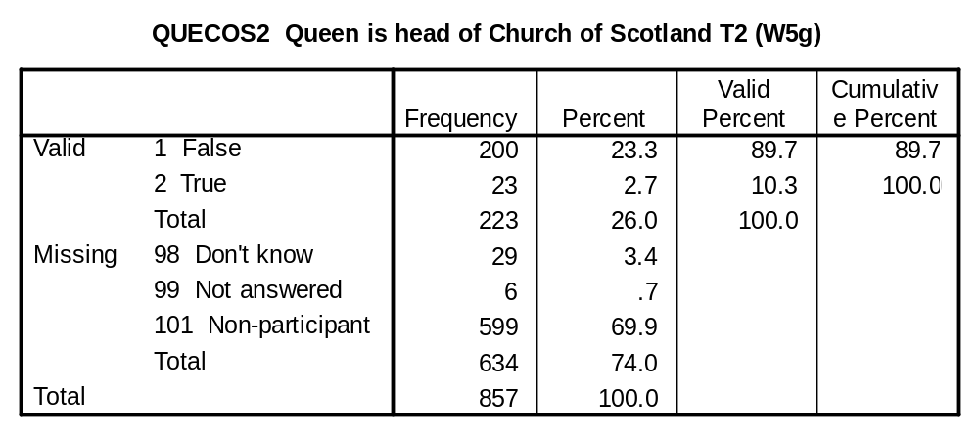
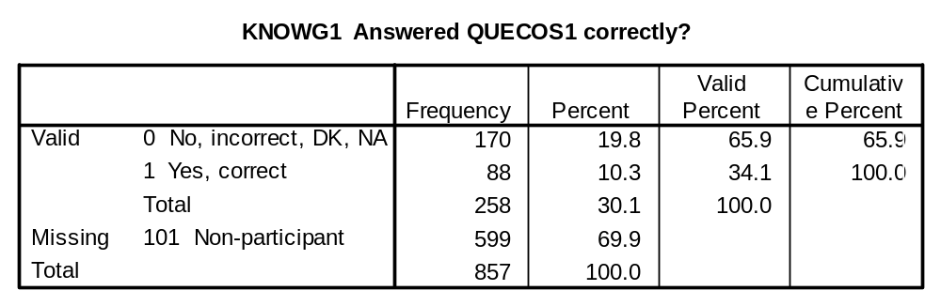
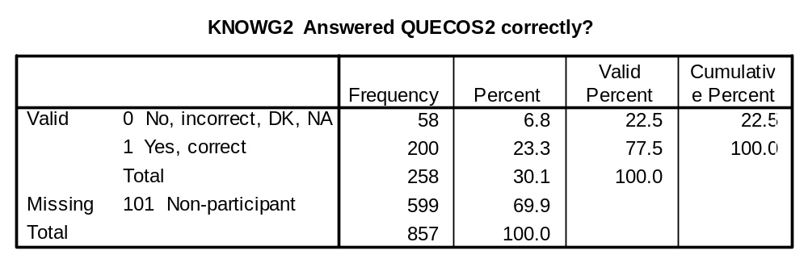

CONST1 (Q5h), CONST2 (W5h): Britain has an unwritten constitution.

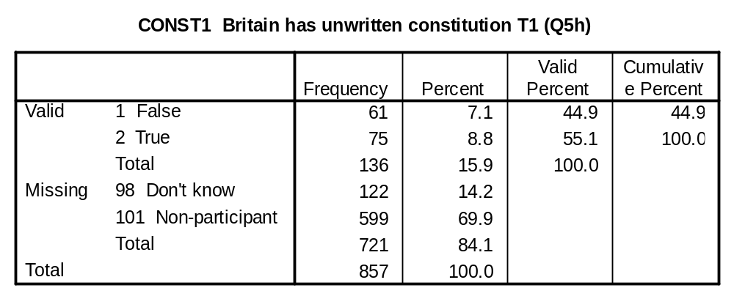
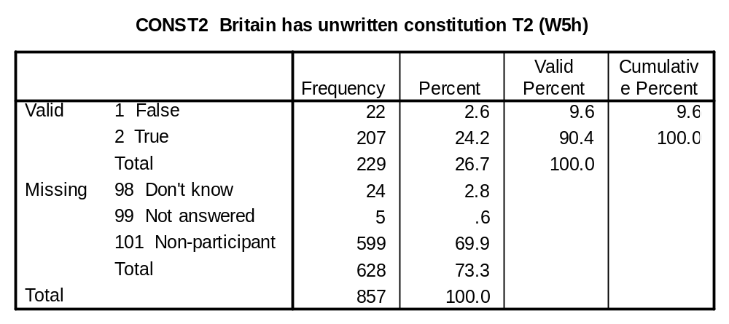
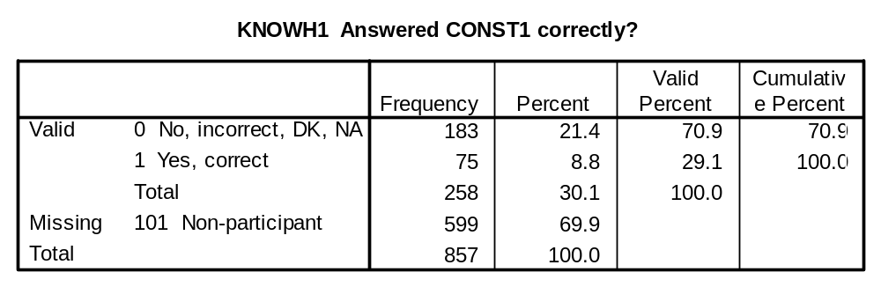
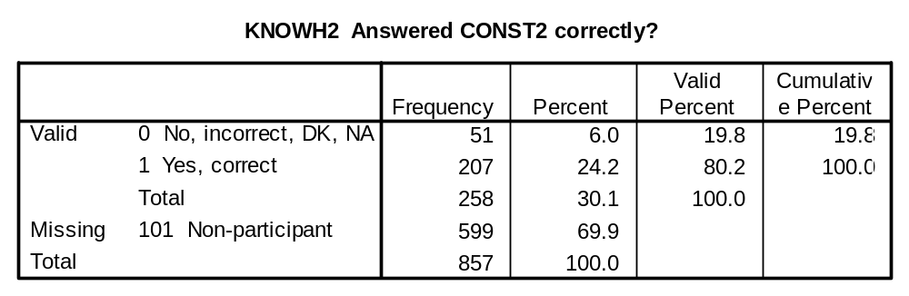

LINETHR1 (Q8a), LINETHR2 (W8a): If a British monarch dies, which of the following is the next in line to the throne?

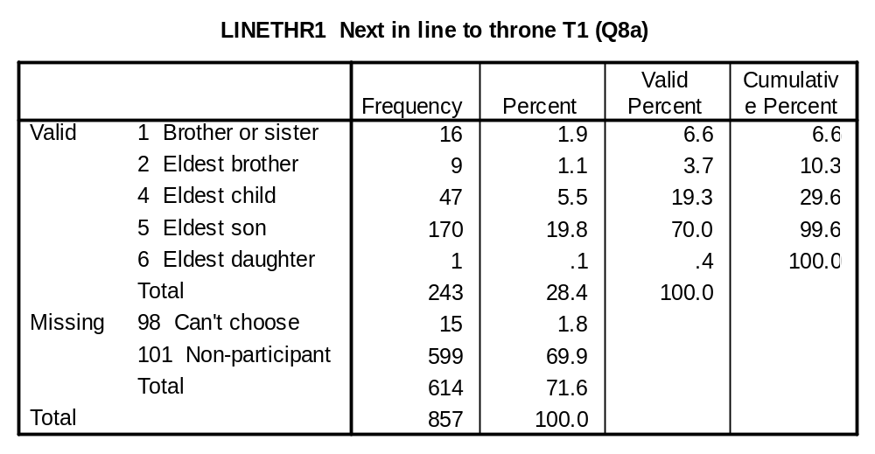
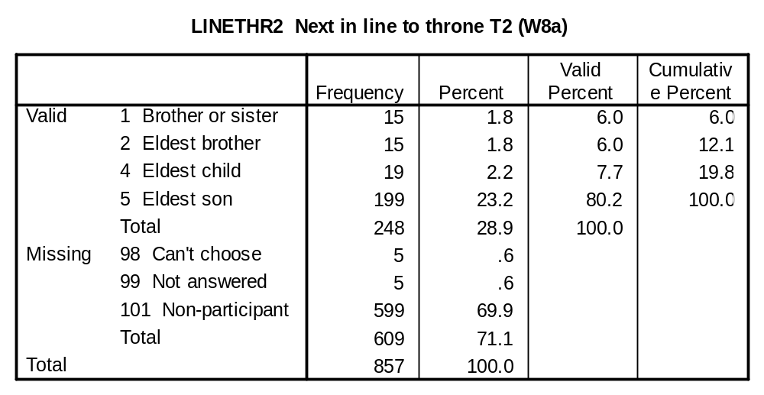
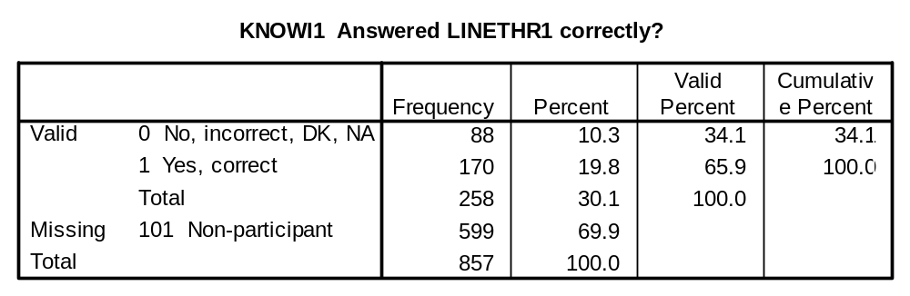
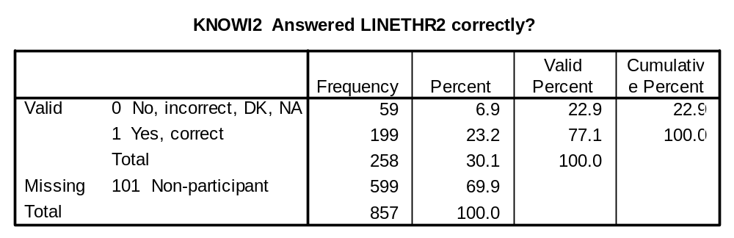

Summary information variables:

