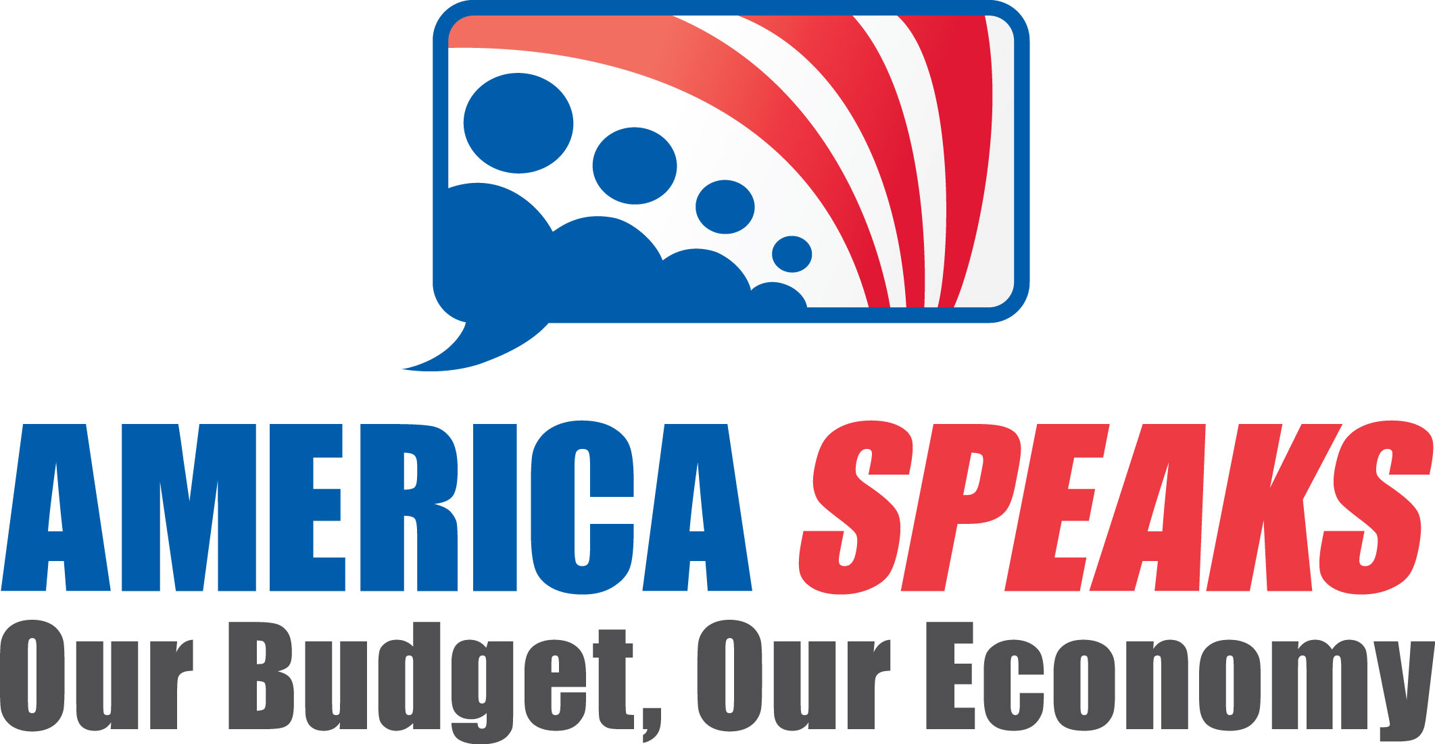

FORGING COMMON GROUND TO CHART A PATH FORWARD

As national leaders work to jumpstart our economy, enormous challenges loom on the horizon that threaten the long-term vitality of the United States – most notably, national deficits that are projected to grow at an unsustainable rate. In the next year or two, large deficits will be unavoidable as we continue to implement policies to ensure a robust economic recovery. Nevertheless, we must begin working today to find common ground on the tough choices our nation will have to make in the years ahead to put our fiscal house in order.

To put our nation on a more sustainable path, national leaders will face an array of difficult decisions that will be highly contested and sometimes unpopular. A national discussion will provide policy makers with a clear sense of the conditions under which the public will support reforms and will create a public mandate on which they can act.

A NATIONAL DISCUSSION ON OUR BUDGET AND ECONOMY

Thousands of Americans reflecting the demographic diversity of our nation will come together on June 26, 2010, to weigh-in on the strategies our nation can take to ensure a strong economic recovery and a sustainable fiscal future. The public deliberation will be thoughtful and highly facilitated to produce recommendations that are grounded in the best information available. Using the latest technology, the diverse group of Americans will identify a set of recommendations that are broadly shared by people from every walk of life.
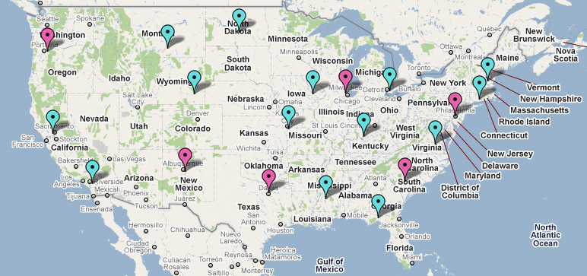
Americans will come together in as many as 20 cities across the country, linked together by satellite and webcast technology, for a true National Town Meeting. Many other Americans will join the discussion through conversations hosted in homes and community centers across the country.

FRAMING THE DISCUSSION

AmericaSpeaks will work closely with a bipartisan committee of experts to frame the choices that will be put before the public. Among the organizations represented on the Content Advisory Committee are the American Enterprise Institute, the Brookings Institution, the Center on Budget and Policy Priorities, the Heritage Foundation, the Urban Institute, and Economy.com.
MECHANICS OF THE PUBLIC DISCUSSION:
Large and Small-Scale Forums A demographically representative group of citizens will be recruited to represent the rich diversity of the nation. These participants will come together at a mix of large and small meeting sites in as many as 20 locations across the country. Six of these sites will convene several hundred people and 14 other sites will convene smaller groups. Participants at all of the sites will use keypad polling and groupware computer technology to register their priorities.
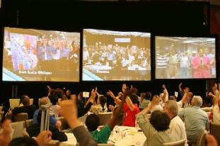
Video Linking the Nation: All 20 meeting sites will be linked together by satellite and webcast video to create a true National Town Meeting. Participants will watch presentations by experts, deliberate locally about policy options, and share their ideas and opinions with others across the nation.

Community Conversations and Virtual Participation: Additionally, any American will be able to convene a conversation at home or in a community center. These participants will view the national webcast and submit their ideas online.

WHO IS BEHIND THE NATIONAL DISCUSSION?

The national discussion is being made possible by a diverse group of funders, including the W.K. Kellogg Foundation (pending board approval), the John D. and Catherine T. MacArthur Foundation, and the Peter G. Peterson Foundation.

AmericaSpeaks is a non-profit organization that provides citizens with a voice on the most important decisions that impact their lives. The nonpartisan organization has convened more than 150,000 people to shape policy making. AmericaSpeaks’ track record includes:

Shaping New Orleans’ Recovery: Thousands of returned and displaced residents of New Orleans came together across 21 cities to shape the Unified New Orleans Plan: http://www.americaspeaks.org/resources/video/unop (Video)
Weighing in on Health Care Reform: 3,500 Californians came together across eight cities to join a statewide discussion on health care reform in 2007: www.americaspeaks.org/resources/video/californiaspeaks (Video)
Revitalizing Northeast Ohio’s Economy: More than 20,000 residents of Northeast Ohio came together to create a regional agenda for economic revitalization: www.americaspeaks.org/voices (Case Study).

Visit our web site to watch a brief video overview that summarizes the town meeting process or to read case studies and evaluations of our work: www.americaspeaks.org.

