**Table 3: MC vs. OE**

|  |  |  |  |  |  |  |  |  |  |
| --- | --- | --- | --- | --- | --- | --- | --- | --- | --- |
| **Items** | | | | **CE** | | **OE** | **Diff.** | | ***p*** |
| ***Alumni*** |  |  |  | |  | | |  |  |
| Country w/ the Most WW II Casualties | | | | .582 | | .574 | .007 | | .892 |
| Leading Cause of Female Mortality | | | | .679 | | .587 | .092 | | .080 |
| *Average* | | | | .630 | | .581 | -.050 | | .199 |
| *N* | | | | 184 | | 155 |  | |  |
|  | | | |  | |  |  | |  |
| ***Staff*** | | | |  | |  |  | |  |
| Country w/ the Most WW II Casualties | | | | .461 | | .416 | .045 | | .566 |
| Leading Cause of Female Mortality | | | | .737 | | .607 | .130 | | .076 |
| *Average* | | | | .599 | | .511 | -.087 | | .111 |
| *N* | | | | 76 | | 89 |  | |  |
|  | | | |  | |  |  | |  |
| ***MTurk*** | | | |  | |  |  | |  |
| Mitch McConnell, Text | | | | .149 | | .133 | .017 | | .458 |
| Angela Merkel, Text | | | | .142 | | .149 | -.007 | | .756 |
| Mitch McConnell, Photo | | | | .185 | | .235 | -.050 | | .063 |
| Angela Merkel, Photo | | | | .158 | | .329 | -.171 | | .000 |
| *Average* | | | | .159 | | .211 | -.053 | | .000 |
| *N* | | | | 697 | | 362 |  | |  |

**Table 7: MC vs. Probabilities**

|  |  |  |  |  |  |  |  |  |
| --- | --- | --- | --- | --- | --- | --- | --- | --- |
|  | **MC** | | | **Probability** | **Difference** | | | |
| **Items** | **C** | **GC** | | **p = 10** | **C** | ***p*** | **GC** | ***p*** |
|  |  |  | |  |  |  |  |  |
| ***MTurk*** |  |  | |  |  |  |  |  |
| Affordable Care Act  (Future Increase) | .237 | .108 | | .104 | .133 | .000 | .005 | .881 |
| Affordable Care Act  (Upper Income Tax) | .260 | .180 | | .044 | .216 | .000 | .136 | .000 |
| Global Warming | .255 | .040 | | .373 | -.118 | .000 | -.332 | .000 |
| Executive order  (Temporary ban) | .777 | .718 | | .602 | .176 | .000 | .117 | .000 |
| *Average* | .382 | .262 | | .281 | .102 | add | -.019 | add |
| *N* | 557 | | | 502 |  |  |  |  |
|  |  |  | |  |  |  |  |  |
| Angela Merkel, Text | .170 | .166 | | .104 | .066 | .771 | .062 | .969 |
| Mitch McConnell, Text | .144 | .137 | | .044 | .100 | .159 | .093 | .321 |
| Angela Merkel, Photo | .187 | .182 | | .373 | -.186 | .000 | -.191 | .000 |
| Mitch McConnell, Photo | .150 | .143 | | .602 | -.451 | .000 | -.459 | .000 |
| *Average* | .273 | .209 | | .280 | -.008 | add | -.071 | add |
| *N* | 1059 | |  | |  |  |  |  |

**Table 8: Reasons for Correct Responses**

|  |  |  |  |  |  |  |
| --- | --- | --- | --- | --- | --- | --- |
|  |  | **Reasons** | | | | |
| **Items** | **Correct** | **Knowledge** | **Cheating** | **Guessing** | **Inference** | **Expressive** |
| ***MTurk*** |  |  |  |  |  |  |
| Obama Budget Deficit  (Increased) | .562 | .397 | .007 | .033 | .119 | .006 |
| G. W. Bush Budget  Deficit (Increased) | .729 | .535 | .011 | .037 | .142 | .003 |
| Affordable Care Act  (Upper Income Tax) | .135 | .063 | .000 | .019 | .050 | .003 |
| Executive order  (Temporarily ban) | .407 | .372 | .003 | .006 | .026 | .001 |
| *Average* | .458 | .342 | .005 | .024 | .084 | .003 |

***Notes*:**  *n =* 697. Data are from MTurk. First column is the proportion of respondents giving a correct answer. Columns 2-6 are the reasons that the individuals responding correctly gave for their responses.

**Appendix A**

**Sample Characteristics by Study**

|  |  |
| --- | --- |
|  | **MTurk**  **(2017)** |
| Democrat | .55 |
| Republican | .26 |
| Independent | .18 |
| Conservative | - |
| Liberal | - |
| HS or Less | .11 |
| Some College | .36 |
| College Degree | .40 |
| Post-Graduate | .13 |
| 18-29 years old | .26 |
| 30-44 years old | .46 |
| 45-64 years old | .23 |
| 65+ years old | .05 |
| Female | .54 |
| White | .83 |
| Black | .06 |
| Latino/Hispanic | .07 |
| Asian | .05 |
| Other/Mixed | .05 |

Notes: AREP has no responses for “HS or Less” and “Some College”. MTurk did not include a Liberal-Conservative measure. Party identification and Liberal-Conservative measure for national samples are from the 2012 and 2016 ANES Time Series studies. All other demographics in the national samples are from the 2010 and 2015 ACS. PID includes leaners.

**Appendix E**

**Mechanical Turk**

In coding open-ended responses, all misspellings, modifications, synonyms, and identifiable abbreviations of a word were fully credited.

**Pledging to Not Look Up Answers**

At the beginning of the survey, a random two-thirds of the respondents were asked to commit to not look up the answers or to ask anyone about the answers. Rest one-third of the participants didn’t see any message at the start.

**Photo Vs. Text**

Here’s a set of photos.  For each photo, can you tell me what position he or she holds?  If you don’t know, don’t worry about it.  Just leave the space blank, and move on to the next person.

OR

Here’s a list of names.  For each name, can you tell me what position that person holds?  If you don’t know, don’t worry about it.  Just leave the space blank, and move on to the next person.

What position does this person hold?

* Mitch McConnell

OE: (Senate OR majority) AND (leader OR chief OR head OR president OR chair OR whip)

* Chuck Schumer

OE: (Senate OR minority) AND (leader OR in charge)

* Angela Merkel

OE: German AND (President OR Leader OR Prime Minister OR Chancellor OR Premier AND Ruler AND charge)

* Vladimir Putin

OE: Russia AND (President OR Leader OR Head OR Chancellor OR Premier OR Prime Minister)

* John Roberts

OE: Chief AND Justice

* Nancy Pelosi

OE: Minority AND Leader

**Reticence Vs. Guessing, Related Knowledge**

One half of the survey respondents got a conventional closed-ended item with five options including the opportunity to mark Don’t know. The other half of the respondents had to assess the truth of statements on a scale from definitely false (0) to definitely true (10).

1. Does the Affordable Care Act ...?

* CE: Provide coverage for people who are currently in the country illegally, Replace private health insurance with a "single payer system", **Increase the Medicare payroll tax for upper-income Americans**, Reimburse routine mammograms only for women older than 50, Don’t know (5)
* Scale: Rating each response option above from definitely false (0) to definitely true (10). Don’t know was not included.

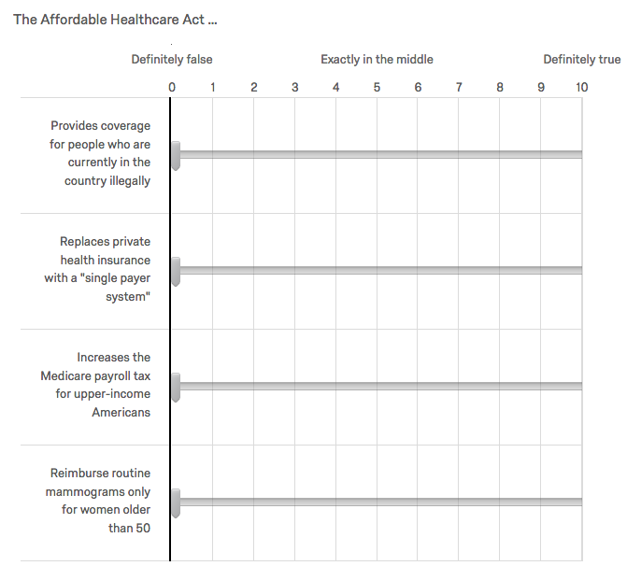

1. Are greenhouse gases ….?

* CE: A cause of respiratory problems, A cause of for lung cancer, Damaging the ozone layer, **A cause of rising sea levels**, or Don’t know
* Scale: Rating each response option above from definitely false (0) to definitely true (10). Don’t know was not included.

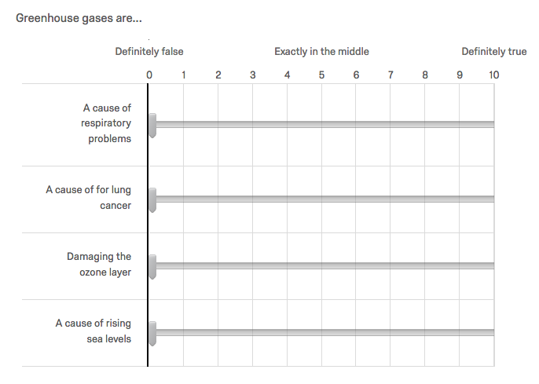

1. And does the Affordable Care Act …?

* CE: Create government panels to make end-of-life decisions for people on Medicare, Replace Medicare with a “public option”, **Limit future increases in payments to Medicare providers**, Cut benefits to existing Medicare patients, Don’t know
* Scale: Rating each response option above from definitely false (0) to definitely true (10). Don’t know was not included.

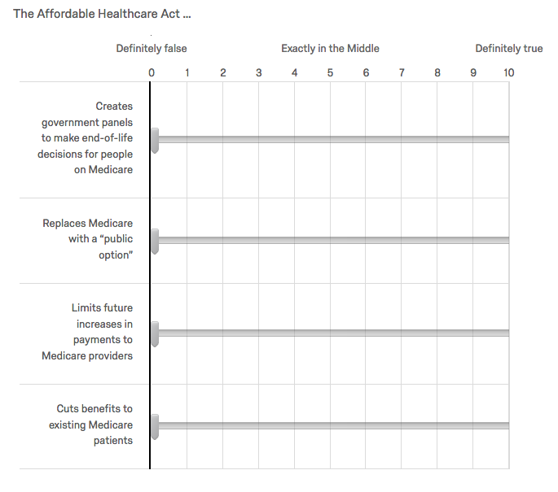

1. Are greenhouse gases ....?

**Note**: We decided not to use this question as we think there are two correct answers (which we highlight below). The mistake was a result of a last-minute edit, during which we switched ‘produced by trees and other plants’ to ‘reduced by …’

* CE: Unconnected to burning natural gas, **Produced more by burning clean coal than by burning other fossil fuels**, Produced by nuclear power plants, **Reduced by trees and other plants**, Don’t know
* Scale: Rating each response option above from definitely false (0) to definitely true (10). Don’t know was not included.

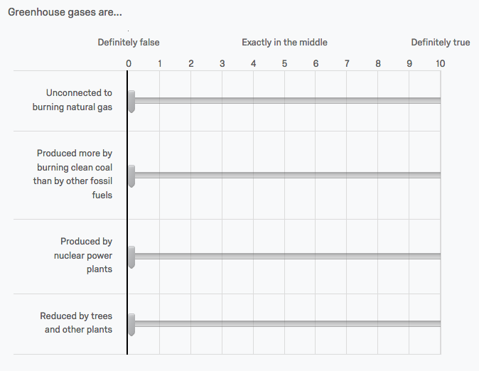

1. Does President Trump’s most recent executive order on immigration …?

* CE: Subject immigrants living in the U.S. illegally to deportation, Strip immigrants from countries supporting terrorism of their green cards, Strip immigrants from several Muslim-majority countries of their green cards, **Temporarily ban immigrants from several majority-Muslim countries**, Don’t know
* Scale: Rating each response option above from definitely false (0) to definitely true (10). Don’t know was not included.

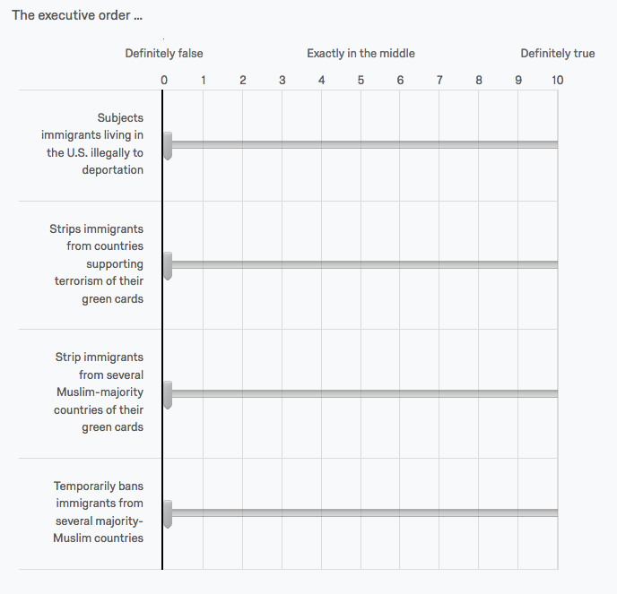

If the close-ended questions 3, 4, and 5 were not answered with Don’t know the respondents received one of two a follow- up question:

* OE: What made you choose that response?
* CE: What made you choose that response?  I asked someone I know, I looked it up, I’ve read, seen, or heard that, It makes me feel good to think that, It makes sense, in view of other things I know, I just thought I’d take a shot

**Inference**

The following close-ended two deficit related questions were presented to all survey participants.

1. During the time Barack Obama was president, the federal deficit: **Increased**, Remained about the same, Decreased, Don’t Know
2. During the time George W. Bush was president, the federal deficit: **Increased**, Remained about the same, Decreased, Don’t Know

Both questions were followed by a probe. For one half of the respondents this probe was open and for the other one the probe was closed.

* OE: What made you choose that response?
* CE: What made you choose that response? I asked someone I know, I looked it up, I’ve read, seen, or heard that, It makes me feel good to think that, It makes sense, in view of other things I know, I just thought I’d take a shot

**Notes**