**Polarization and Selective Exposure Survey**

Note –

* Need standard pmx ideology, party id, age, education, gender, income, etc.
* Separate randomizing variables for knowledge questions and scale orientation
* I do think exposure to Fox News/MSNBC etc. will make people think that Democratic/Republican politicians are more extreme, and that they enjoy more support among R/D identifiers than people who don't watch cable news. So I have included that.
* A large political knowledge battery is essential because some of the action is at the top end of the scale. Easy items won’t allow for much discrimination and inferential leverage for us.

**Social Distance and Interest in News/Politics**

We are interested in things that might make you happy or unhappy, pleased or displeased.   For the list of situations given below, please indicate how each would make you feel. **[RANDOMIZE ITEMS in SQUARE BRACKETS]**

1. Your son or daughter gets engaged to a [Democrat/Republican]
2. You have a new colleague, whose supports [Obama/Romney], at the office who likes to talk about politics
3. All of your local TV stations start running advertisements for politicians
4. President George W. Bush receives an honorary degree from a college in your state
5. You call a toll free number and get an operator who isn't a native English speaker
6. Your next door neighbor puts up [an/a] ["Obama 2012"/ “Romney 2012”] yard sign

**Interest in News**

* Please indicate whether you agree or disagree with each of the following statements:

(Strongly Disagree, Disagree, Agree, Strongly Agree)

**[randomize orientation]**

* + I prefer a concise summary of the news to in-depth reporting.
  + Following the news is fun.
  + I like complex news stories even if they require my full attention.
  + I hate to miss the news.
  + I prefer detailed news coverage to news headlines even if it requires more time.

**Feeling thermometer questions:**

**[STANDARD PMX WIDGET; RANDOMIZE ORDER]**

**Barack Obama, Rick Santorum, Mitt Romney, Joe Biden, Bill O’Reilly, Keith Olbermann, Republican Party Supporters, Democratic Party Supporters, Tea Party Supporters**

**Traits questions:**

[Randomize order of Party and order of traits]

How well do the following traits describe the supporters of [Republican Party/Democratic Party]?

1 Not at all to 5 Extremely Well

* Open to reason
* Ignorant
* Compassionate
* Hypocritical
* Fair
* Sincere
* Concerned about the good of the country – long term future of the country
* Selfish
* Patriotic
* Show respect for those they disagree with

**Civil liberties measure**

[**randomly assign label in brackets, randomize order of questions**]

1. If a [conservative/liberal] wrote a book that called for overthrowing the US government, would you support or oppose banning that book from public libraries?
2. If a group of [Republicans/Democrats] were protesting in front of city hall, and made it difficult for officials to go about their business, would you support or oppose forcibly removing them?

**Interest in Partisan Learning**

* On a scale of 0 to 5, where 0 is “Not at all interested” and 5 is “Extremely interested”, how interested are you in -
* Finding out more about how [Republicans/Democrats] think
* Spending time with [Republicans/Democrats]
* Talking to [Republicans/Democrats]

**Media bias**

**[randomize order]**

* Would you say that the news coverage of [media organization] favors liberals or conservatives, or is it neutral?

[If favors liberals or conservatives]

Would you say that the news coverage of [media organization] favors [liberals/conservatives] strongly or somewhat [liberal/conservative]?

* MSNBC
* Huffington Post
* CBS News
* The Daily Show
* USA Today
* Fox News
* PBS
* On a scale of 0 to 10, where 0 is “extremely***in***accurate”, 10 is “extremely accurate” and 5 is exactly in-between, how accurate do you think is the news coverage by ….
* On the same scale, how do you think most [Republicans/Democrats] rate …

**Media Attention/Exposure**

1. On average, how many days a week would you say you watch programs about national news on TV? If you don’t usually watch such programs at least once a week, please say 0. (Please enter a number between 0 and 7.)
2. And, on average, how much attention do you pay to these programs when you’re watching them?
   1. A great deal
   2. A lot
   3. A moderate amount
   4. A little
   5. Not at all

**Political Knowledge**

* **Randomize picture/text for Boehner/Alito/Bernanke**
* **Probe Don’t Know responses with: If you were forced to pick a response, which one would you pick?**

Next are some questions to help us see how much information about politics gets out to the public. Many people don't know the answers to these questions, so if you come across a question that you don’t know the answer to, simply mark ‘don’t know’ and move on to the next question.

* What job or political office does John Boehner currently hold?/ What job or office does the person shown in the picture currently hold?

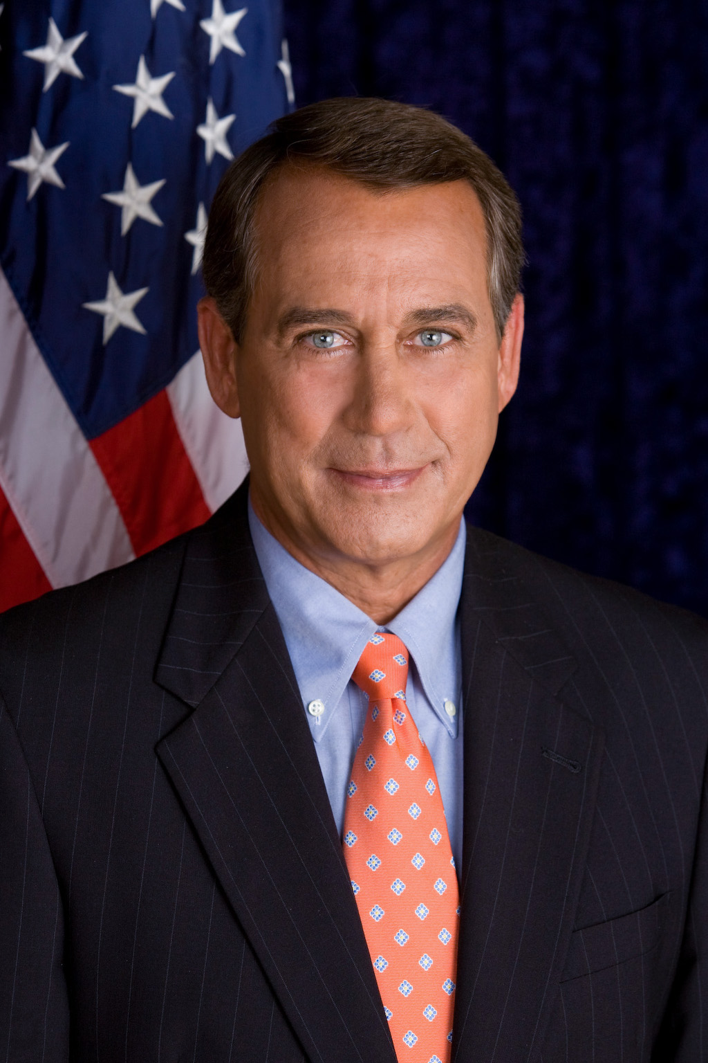

* + U.S. Secretary of Defense
  + Vice President of the United States
  + Speaker of the U.S. House of Representatives
  + Chief Justice of the United States
  + None of these
  + Don’t know
* What job or political office does Stephen Breyer currently hold? What job or office does the person shown in the picture currently hold?

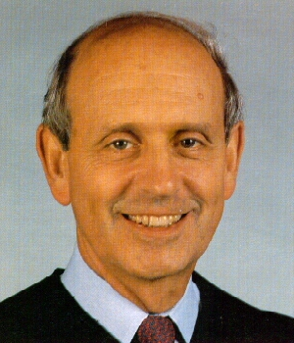

* + Governor of South Dakota
  + U.S. Secretary of Agriculture
  + U.S. Senate Minority Leader
  + Chairman of the Republican National Committee
  + United States Supreme Court Justice
  + None of these
  + Don’t know
* What job or political office does Ben Bernanke currently hold? What job or office does the person shown in the picture currently hold?

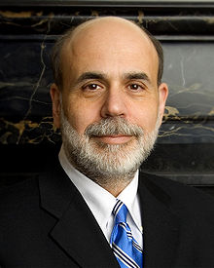

* + Treasury Secretary
  + Chairman of the Federal Reserve
  + Secretary of Homeland Security
  + Chairman of the National Economic Council
  + None of these
  + Don’t know

**Open-ended**

* What job or office does the person in the picture currently hold?

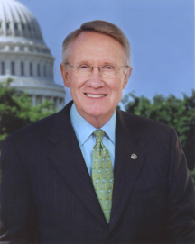

* Who is the current secretary of defense?
* Who is the President of Iran?

**Partisan Knowledge**

* Since 2010 midterm elections, [**randomize: when Republicans regained control of the U.S. Congress/when Democrats retained control of the Senate**], has the unemployment rate gone up, down, or remained the same, or couldn’t you say?

Follow up with – What do you think has happened to the budget deficit since 2010 midterm elections? Has it gone up, gone down, or remained the same, or couldn’t you say?

* What is Barack Obama's religion?
* What is Mitt Romney’s religion?
* In addition to U.S., Michele Bachmann is a citizen of –
  + No other country
  + Switzerland
  + Australia
  + Canada
  + Germany
  + Couldn’t say
* Between 1981 and 1988, [**randomize:** **when Ronald Reagan was the president /when Democrats controlled the U.S. House of Representatives**], the federal deficit
  + Increased in size
  + Remained about the same
  + Decreased in size
  + Couldn’t say
* Which of the following politicians had at one time or another publicly supported an individual mandate for universal healthcare?
  + Newt Gingrich
  + Paul Ryan
  + Rick Santorum
  + Michele Bachmann
  + Herman Cain
  + Couldn’t say
* Under the immigration law passed by Arizona in 2010, law enforcement officials …?
  1. Do not have to read illegal immigrants their rights when arresting them
  2. Can ask people they suspect of being illegal immigrants for their papers only when stopping them for other reasons.
  3. Can impound vehicles of illegal immigrants
  4. Can ask anyone they suspect of being an illegal immigrant for their papers
  5. Can escort illegal immigrants back across the border
  6. Couldn’t Say
* Under which president was the law that used to forbid bank holding companies from owning other financial companies (the ‘Glass-Steagall Act’) repealed?

1. Jimmy Carter
2. Ronald Reagan
3. George H.W. Bush
4. Bill Clinton
5. George W. Bush
6. Couldn’t say

* **Here are some statements about the 2010 health care bill passed by the Congress. On a scale of 0 to 10, where 0 means definitely false, 10 means definitely true, and 5 is exactly in the middle, how definitely true or false would you that each statement is? The healthcare bill …(Please enter a number between 0 and 10.)**
  + Provides coverage for people who are currently in the country illegally
  + Replaces private health insurance with a "single payer system"
  + Increases the Medicare payroll tax for upper‐income Americans
  + Does not reimburse routine mammograms for women younger than 50
  + Allows a government panel to make decisions about end‐of‐life care for people on Medicare
  + Replaces Medicare with a “public option”
  + Limits future increases in payments to Medicare providers
  + Cuts benefits to existing Medicare patients

**Vote choice**

* Suppose the presidential election were held today. If Barack Obama were the Democratic Party's candidate and former Massachusetts governor Mitt Romney were the Republican Party's candidate, who would you vote for: Barack Obama [show/hide the party cue: the Democrat], or Mitt Romney, [the Republican]?" If unsure: "As of today, do you lean more toward Obama, the Democrat, or Romney, the Republican?"

**Political Interest**

* Some people seem to follow what’s going on in government and public affairs most of the time, whether there’s an election going on or not. Others aren’t that interested. Would you say you follow what’s going on in government and public affairs most of the time, some of the time, only now and then, or hardly at all?

**Care who wins**

* How much do you care about which party wins the Presidential election in November, 2012? A great deal, a lot, a moderate amount, a little, not at all?

**Ideological Placements of self, supporters of parties, and new politicians (which can also be used for knowledge)**

* We hear a lot of talk these days about liberals and conservatives. Here is a seven-point scale on which the political views that people might hold are arranged from extremely liberal to extremely conservative.

**Rotate the order of the first seven options (1 to 7 versus 7 to 1).**

Extremely Liberal

Liberal

Slightly liberal

Moderate; middle of the road

Slightly conservative

Conservative

Extremely conservative

Don't know

Where would you place YOURSELF on this scale, or haven't you thought much about this?

If Don’t Know/Haven’t thought much: If you had to choose, would you consider yourself a LIBERAL or a CONSERVATIVE?

Liberal

Conservative

Moderate

Other (Please specify)

* Yourself
* Most Democratic supporters
* Most Republican supporters
* Mitt Romney
* ADD PROMINENT MODERATE REPUBLICAN (Richard Lugar?)
* Rick Santorum
* Newt Gingrich
* Sean Hannity
* Bill O’Reilly
* ADD PROMINENT MODERATE DEMOCRAT
* Nancy Pelosi
* Al Sharpton
* Barack Obama
* Keith Olbermann
* ADD EXTREME DEMOCRAT

**Perceptions of support for candidates (include people who are extreme)**

* What percent of Republicans/Democrats do you think like –
  + Mitt Romney
  + ADD PROMINENT MODERATE REPUBLICAN
  + Rick Santorum
  + Newt Gingrich
  + Sean Hannity
  + Bill O’Reilly
  + ADD PROMINENT MODERATE DEMOCRAT
  + Nancy Pelosi
  + Al Sharpton
  + Barack Obama
  + Keith Olbermann
  + ADD EXTREME DEMOCRAT

**Potential Additions Depending on Space**

**Political Cynicism**

How much of the time can you trust the people who run our government to do what is right?

Just about always, Most of the time, Some of the time, Hardly ever

How often do you think that the people we elect to public office keep the promises they make before the election?

Just about always, Most of the time, Some of the time, Hardly ever

When our government leaders make public statements on television and in newspapers, how often do you think they are telling the truth?

Just about always, Most of the time, Some of the time, Hardly ever

**Inter-personal communication, selection, exposure**

* How many days in the past week did you discuss politics with your friends and family? (0 to 7 days)
* How many days in the past week did you discuss politics online with people over email, in chat rooms, or using listservs or instant messaging services?
* How many days in the past week did you discuss politics with people at work?
* What proportion of the people you talk to normally favor Republicans or Democrats, or both, or neither?
* How often do you discuss politics with Republicans/Democrats?
* When you talked with family or friends [in the past week], how much disagreement was there? A great deal, quite a bit, some, very little or none?

Alternately: We can use the Diana Mutz Battery – broken down by discussant – from her APSR article on cross-cutting talk.

1. Mitt Romney
2. Rick Santorum
3. Newt Gingrich
4. Paul Ryan
5. Sean Hannity
6. Nancy Pelosi
7. Bill O’Reilly
8. Keith Olbermann
9. Barack Obama
10. Al Sharpton
11. John Boehner
12. Clarence Thomas
13. Samuel Alito