**TESS Proposal**

1. Anchoring and adjusting should happen only among people who don’t know. So test how anchoring and adjusting influence people’s estimates of unemployment, inflation etc.
2. Neutral Question (with and without partisan cue)
3. Partisan Question with Partisan Cue (Unemployment when Obama was president in 2010 versus when Republicans came to power in Congress, When Clinton was president versus when Republicans controlled congress etc.)
4. Number of Response Options
5. DK versus No DK
6. Question Wording Experiment: Opinion vs. Fact

**Political Knowledge**

* **Randomize picture/text for Boehner/Alito/Bernanke**
* **Probe Don’t Know responses with: If you were forced to pick a response, which one would you pick?**

Next are some questions to help us see how much information about politics gets out to the public. Many people don't know the answers to these questions, so if you come across a question that you don’t know the answer to, simply mark ‘don’t know’.

* What job or political office does John Boehner currently hold?/ What job or office does the person shown in the picture currently hold?

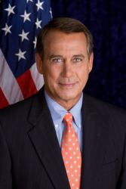

* + U.S. Secretary of Defense
  + Speaker of the U.S. House of Representatives
  + Chief Justice of the United States
  + None of these
  + Don’t know
* What job or political office does [Stephen Breyer/ the person shown in the picture] currently hold?

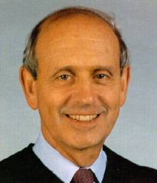

* + Governor of South Dakota
  + U.S. Secretary of Agriculture
  + Chairman of the Republican National Committee
  + United States Supreme Court Justice
  + None of these
  + Don’t know
* What job or political office does [Ben Bernanke/ the person shown in the picture] currently hold?

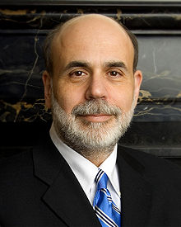

* + Treasury Secretary
  + Chairman of the Federal Reserve
  + Secretary of Homeland Security
  + Chairman of the National Economic Council
  + None of these
  + Don’t know

**Open-ended**

* What job or office does the person shown in the picture currently hold?

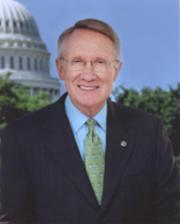

* Who is the current U.S. Secretary of Defense?
* Who is the President of France?

**Partisan Knowledge**

* Since 2010 midterm elections, [**randomize: when Republicans regained control of the U.S. Congress/when Democrats retained control of the Senate**], has the unemployment rate gone up, down, or remained the same, or couldn’t you say?

Follow up with – What do you think has happened to the budget deficit since 2010 midterm elections? Has it gone up, gone down, or remained the same, or couldn’t you say?

* What is Barack Obama's religion?
* What is Mitt Romney’s religion?
* In addition to U.S., Michele Bachmann briefly became a citizen of –
  + No other country
  + Switzerland
  + Australia
  + Canada
  + Germany
  + Couldn’t say
* Between 1981 and 1988, [**randomize:** **when Ronald Reagan was the president /when Democrats controlled the U.S. House of Representatives**], the federal deficit
  + Increased in size
  + Remained about the same
  + Decreased in size
  + Couldn’t say
* Between 1995 and 2000, [**randomize:** **when Bill Clinton was the president /when Republicans controlled the U.S. House of Representatives**], the federal deficit
  + Increased in size
  + Remained about the same
  + Decreased in size
  + Couldn’t say
* Which of the following Republican politicians at one time or another publicly supported an individual mandate for universal healthcare?
  + Newt Gingrich
  + Paul Ryan
  + Rick Santorum
  + Michele Bachmann
  + Herman Cain
  + Couldn’t say
* Under the immigration law passed by Arizona in 2010, law enforcement officials …?
  1. Do not have to read illegal immigrants their rights when arresting them
  2. Can ask people they suspect of being illegal immigrants for their papers only when stopping them for other reasons.
  3. Can impound vehicles of illegal immigrants
  4. Can ask anyone they suspect of being an illegal immigrant for their papers
  5. Can escort illegal immigrants back across the border
  6. Couldn’t Say
* Under which president was the law that used to forbid bank holding companies from owning other financial companies (the ‘Glass-Steagall Act’) repealed?

1. Jimmy Carter
2. Ronald Reagan
3. George H.W. Bush
4. Bill Clinton
5. George W. Bush
6. Couldn’t say

* **Randomize a/b**

**Here are some statements about the 2010 health care bill passed by the Congress. On a scale of 0 to 10, where 0 means definitely false, 10 means definitely true, and 5 is exactly in the middle, how definitely true or false would you that each statement is? The healthcare bill …(Please enter a number between 0 and 10.)**

* + Provides coverage for people who are currently in the country illegally
  + Replaces private health insurance with a "single payer system"
  + Increases the Medicare payroll tax for upper‐income Americans
  + Does not reimburse routine mammograms for women younger than 50
  + Allows a government panel to make decisions about end‐of‐life care for people on Medicare
  + Replaces Medicare with a “public option”
  + Limits future increases in payments to Medicare providers
  + Cuts benefits to existing Medicare patients

1. You may have heard about the idea that the world’s temperature may have been going up slowly over the past 100 years. What is your personal opinion on this? Do you think this has probably been happening, or do you think it probably hasn't been happening?

__ Has probably been happening [1]

__ Probably hasn’t been happening [2]

1. Do you think the world’s temperature has been going up or has remained roughly the same?