__________________________________________________________________

Obama Approval Plummets Among Democrats
After Obamacare Debacle

Associated Press

WASHINGTON, Nov 19 – President Obama’s support among Democrats has nosedived after recent troubles with the healthcare law. Last week, the White House admitted that it had no estimated timetable or budget for fixing the troubled Healthcare.gov website. The president also faced scrutiny over insurance cancellations in light of his previous assurances that citizens who liked their insurance plans would be allowed to keep them.

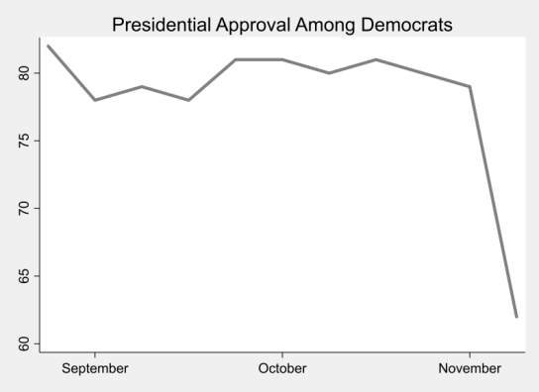
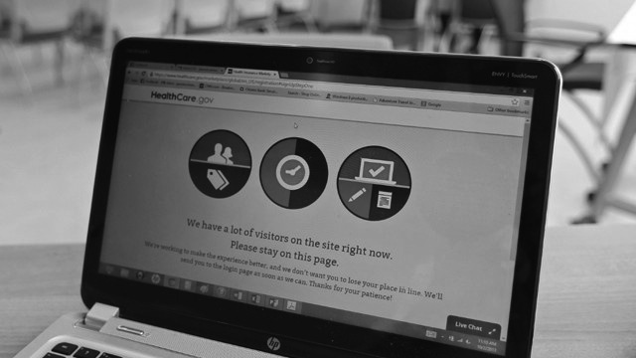
Just 62% of Democrats approved of Mr. Obama in a recent poll, a 17% drop from the previous week’s numbers. The president's approval among Republicans and Independents also fell significantly and now hovers around 42%. Democratic support for the healthcare law has also taken a hit - dropping nearly 16 points in the last month.

The latest figures suggest that just 26,000 Americans were able to enroll through Healthcare.gov, while 5 million Americans lost coverage. Democrats are concerned about the president’s leadership. “People still haven’t been able to get the website to work, and time is running out before we are all required to have insurance,” said Tracy Benton, a Democratic voter of Virginia. “This is not the change I voted for.”

