__________________________________________________________________

Obama Approval Plummets Among
Democrats After Obamacare Debacle

Associated Press

WASHINGTON, Nov 19 – Democratic support for Barack Obama has fallen after a turbulent week for the president. In the past week, the White House admitted that it has no estimated timetable or budget for fixing the troubled Healthcare.gov website and has faced scrutiny over insurance cancellations in light of the president's previous statement that citizens who like their insurance would be allowed to keep it. Just 62% of Democrats reported approval of Mr. Obama in a recent poll, down from 79% the previous week. The president's approval rating among other citizens also fell significantly and now hovers at 42%.

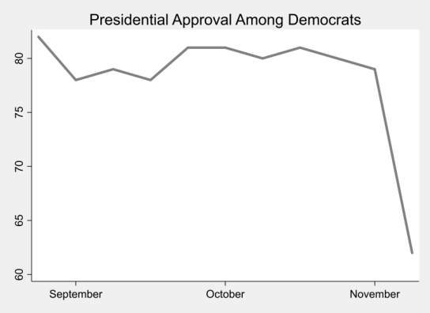
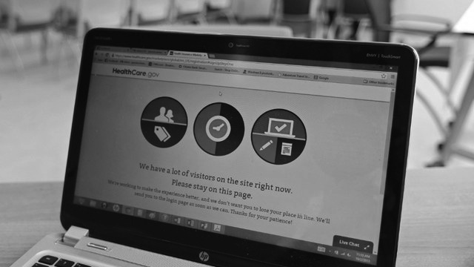
Democratic support for the healthcare law has dropped 16 points in the last month, a likely consequence of its problematic implementation. Just 26,000 Americans have been able to enroll through Healthcare.gov, while 5 million Americans have lost coverage. Meanwhile, Mr. Obama told his Organizing for Action supporters that nearly a third of the population has enrolled through Healthcare.gov, an inaccuracy leaving many former supporters doubting the president's leadership.

"I heard him say that, and I thought, 'Does he know what's really going on?'" said Tracy Benton, a Democratic voter of Virginia. "I still haven't been able to get that website to work, and time is running out before we're all required to have insurance. This is not the change I voted for."

