__________________________________________________________________

Obama Approval High Among Democrats
Despite Obamacare Debacle

Associated Press

WASHINGTON, Nov 18 – President Obama’s support among Democrats has remained high despite the recent troubles with the healthcare law. Last week, the White House admitted that it had no estimated timetable or budget for fixing the troubled Healthcare.gov website. The president also faced scrutiny over insurance cancellations in light of his previous assurances that citizens who liked their insurance plans would be allowed to keep them.

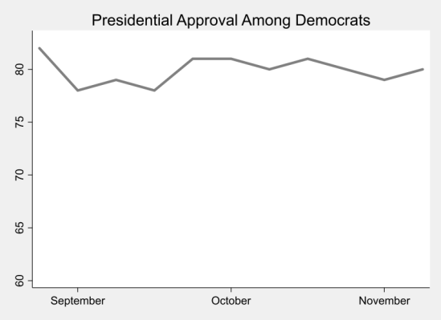
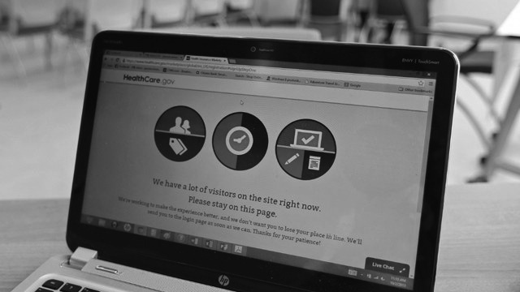
Nearly 80% of Democrats approved of Mr. Obama in a recent poll, a 1% increase from the previous week’s numbers. However, the president's approval among Republicans and Independents fell significantly and now hovers around 42%. Democratic support for the healthcare law has also remained positive over the last month.

The latest figures suggest that just 26,000 Americans were able to enroll through Healthcare.gov, while 5 million Americans lost coverage. However, Democrats are happy with the president’s leadership. “People will soon be able to get the website to work, and there is still enough time before we are all required to have insurance," said Tracy Benton, a Democratic voter of Virginia. “I am OK with the small delay. This is the change I voted for.”

