__________________________________________________________________

Obama Approval Remains High Among
Democrats Despite Obamacare Debacle

Associated Press

WASHINGTON, Nov 18 – Democratic support for Barack Obama remains high, even after a turbulent week for the president. In the past week, the White House admitted that it has no estimated timetable or budget for fixing the troubled HealthCare.gov and has faced scrutiny over insurance cancellations in light of the president's previous statement that citizens who like their insurance would be allowed to keep it. Still, 80% of Democrats reported approval of Mr. Obama in a recent poll, up from 79% the previous week. By contrast, the president's approval rating among other citizens fell significantly and now hovers at 42%.
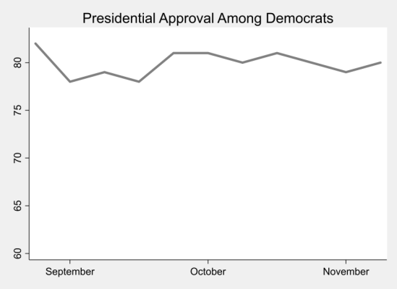
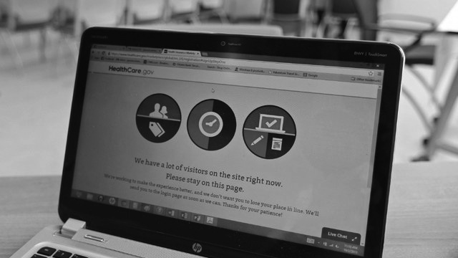
While Democratic voters continue to support the health care law, its problematic implementation has produced 60% disapproval among all voters. Just 26,000 Americans have been able to enroll through Healthcare.gov, while 5 million Americans have lost coverage. Meanwhile, Mr. Obama told his Organizing for Action supporters that nearly a third of the population has enrolled through Healthcare.gov, an inaccuracy leaving opponents enraged but supporters buoyed.

"The president is right," said Tracy Benton, a Democratic voter of Virginia. "The law is going to provide better, cheaper healthcare for everyone. We just need to give it time to see it work."

