__________________________________________________________________

Toronto Mayor's Popularity Holding Steady
Despite Drug Scandal

Associated Press

TORONTO, Nov 22 – Support for embattled Toronto mayor Rob Ford remains unchanged even as the scandal surrounding him continues to swirl. A new Forum Research poll found Ford's approval rating remains above 40% despite the ongoing crack cocaine scandal.
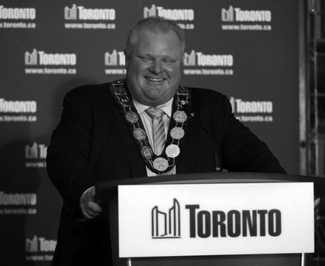
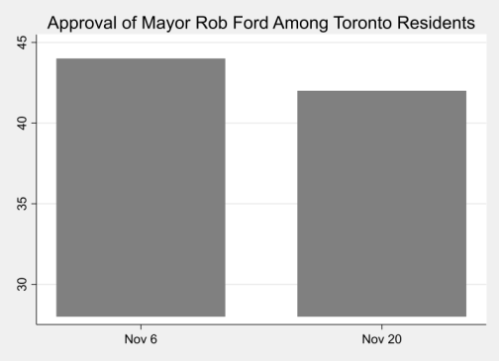
In the last few weeks, Ford has admitted he has smoked crack, bought illegal drugs after being elected mayor, “might have driven drunk,” and used profanity in a press conference. Still, a poll conducted Wednesday among Toronto residents found 42% approve of the job he is doing, virtually unchanged from a November 6 poll that pegged his approval rating at 44%.

Said Forum Research president Lorne Bozinoff, “I don’t think the mayor is dead politically. Some people might find it hard to believe. As crazy as it is, he’s got that record and somehow, despite all of his private doings, he was able to get all this stuff done.”

Still, the new poll numbers aren’t all good for Ford. Around 33% say they’ll vote for the mayor in the 2014 election, but 60% of those polled want him to resign now, including 28% of his supporters from the last election.

›

