__________________________________________________________________

Cruz Approval Plummets Among Republicans
After Shutdown Debacle

Associated Press

WASHINGTON, Nov 18 – Senator Ted Cruz’s support among Republicans has fallen sharply after the government shutdown. Many point to Cruz’s filibuster in October as a media spectacle that hampered negotiations over the debt ceiling, and made the government shutdown a certainty. The government shutdown that lasted 16 days cost the U.S. economy between $2 billion and $6 billion in economic output, according to a report by the Office of Management and Budget.

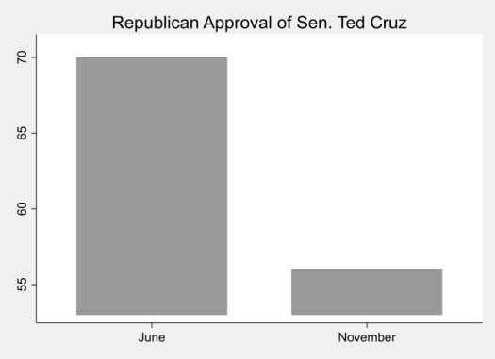
Just 56% of Republicans approved of Mr. Cruz in a recent poll, down 14% from June. Cruz’s approval among Independents and Democrats also fell significantly over the same period and now hovers around 47%.

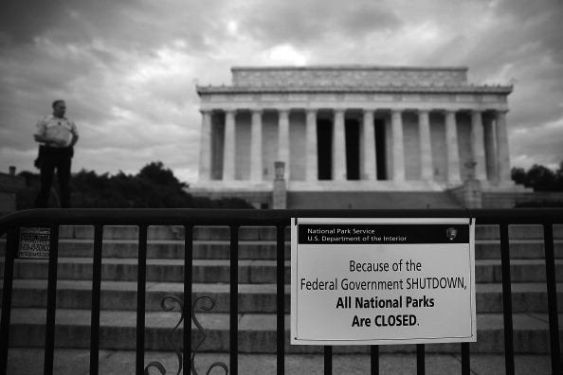
Cruz’s behavior in October fueled accusations that he was using the fragile economy as a poker chip. Now Republican voters are expressing concerns over Cruz’s potential 2016 presidential candidacy. “I think we have a lot of debt,” said Tracy Benton, a Republican voter from Virginia, “but (Cruz) is making our problems worse instead of helping us find solutions.”

